Step 1: Download eclipse IDE (2022-12) from Ubuntu software

Step 2: Clone carma-simulation from GitHub (develop branch)

Step 3: Copy folder at directory: carma-simulation/co-simulation/bundle/src/assembly/resources/scenarios to carma-simulation/co-simulation/rti/mosaic-starter/

Step 4: Open eclipse IDE and open project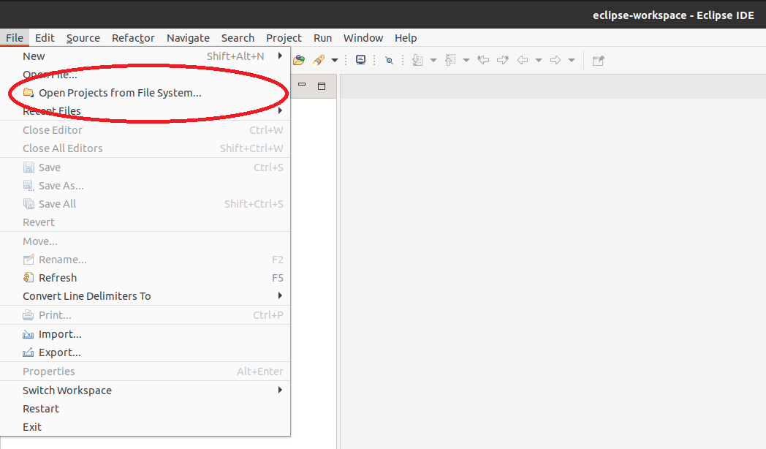

Step 5: Select co-simulation folder in carma-simulation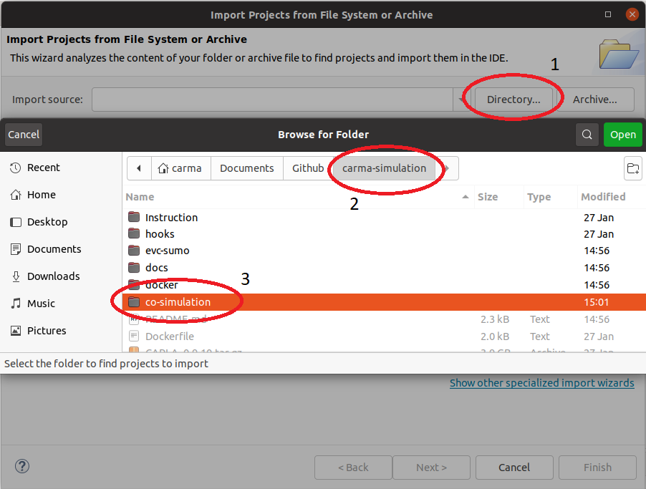

Step 5.5: wait for the build process done.

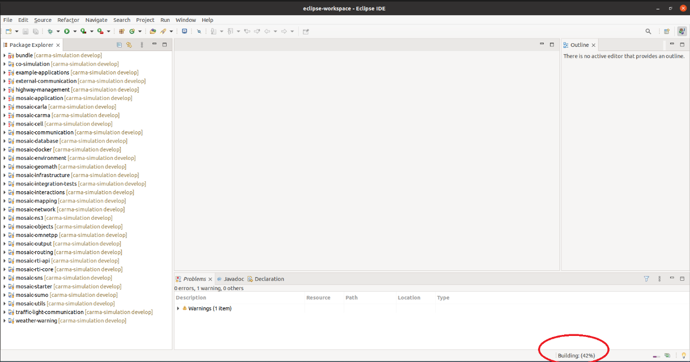

Step 6: Setup run for mosaic-starter

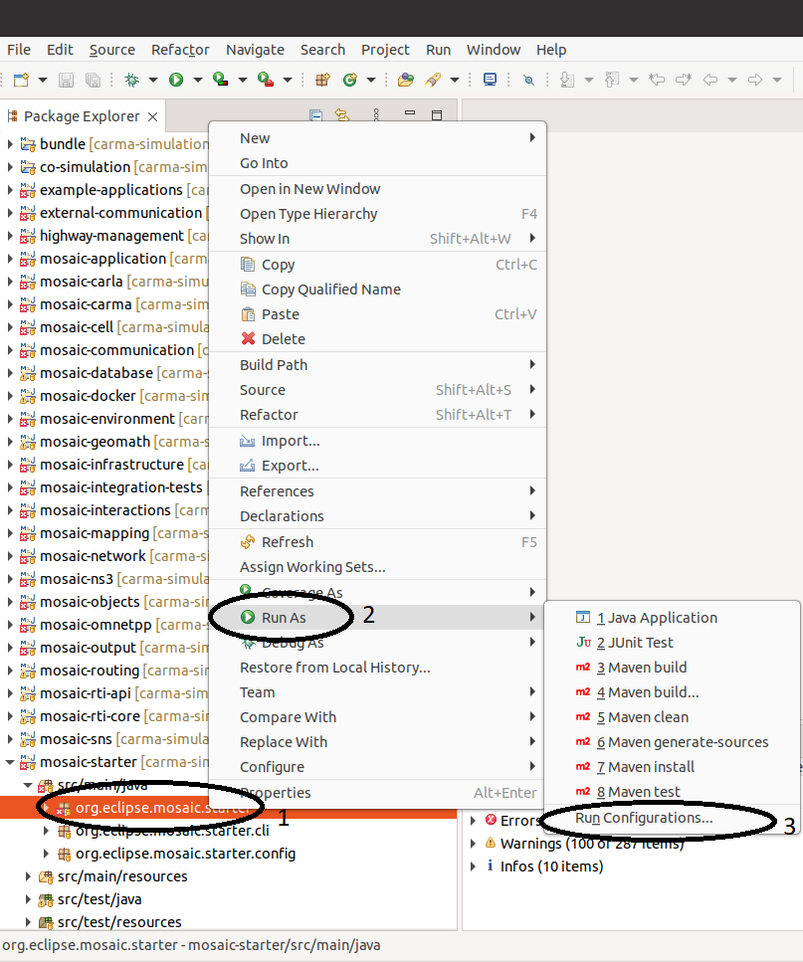

Step 7: Select class for Java application (double click Java Application to create a new configuration)

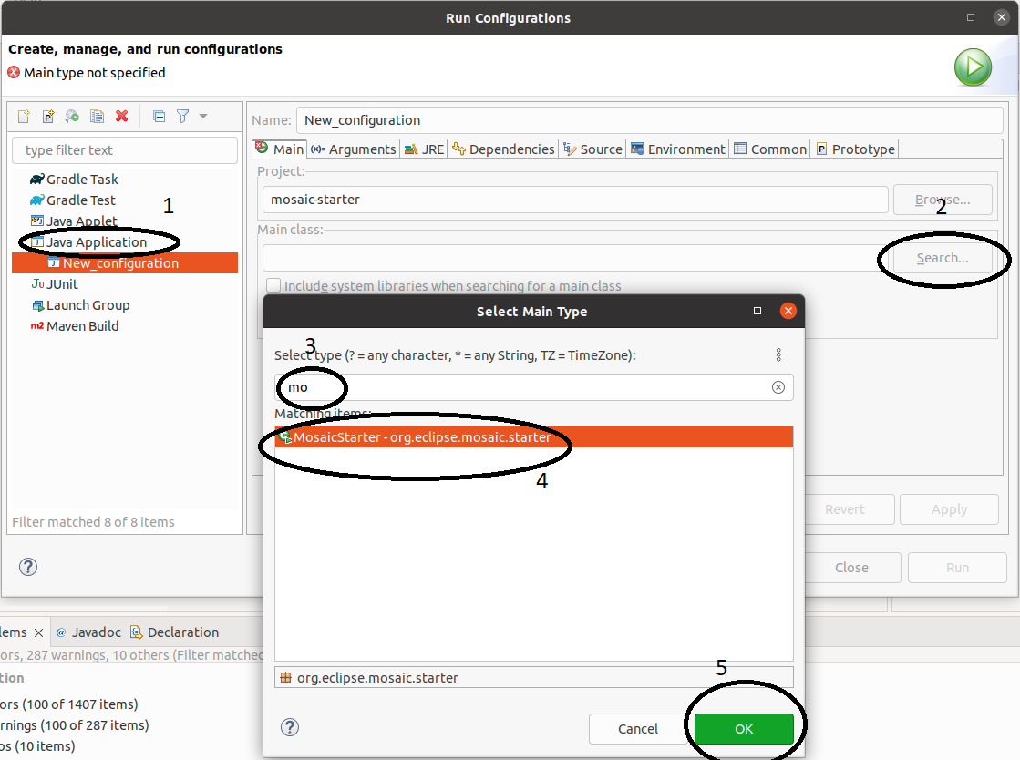

Step 8: Add arguments for the java application (HelloWorld is a sample scenario)

