## d:\Users\ASIR1-11\AppData\Local\Microsoft\Windows\INetCache\Content.MSO\619E68D7.tmp

## Práctica de laboratorioISOP304_WinLinux-Multiboot

NOMBRE ALUMNO: DAVID GÓMEZ GARCIA-ARIAS

Fecha de Entrega de práctica: 29/01/2022

511-DGómez-ISOP304-Literal.docx

# Objective of the practice

The goal of this lab is to install two operating systems on the same machine.

# Inventory of the necessary material

First of all, we will need two ISOS of the two operating systems that we are going to use (Windows 10 and Ubuntu)

In the virtual machine that we will make, we have to take into account that we must have enough space on the disk for the two operating systems.

# Execution research and development

The first step is to create our virtual machine

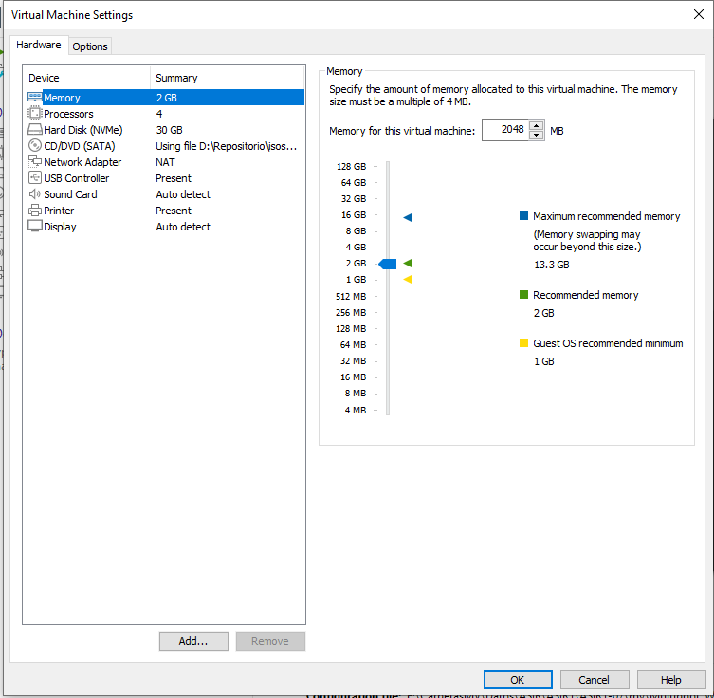

When we are installing our Windows 10 we will arrive at the disk configurartion,there we will give advanced configuration to be able to créate the partitions that we want.

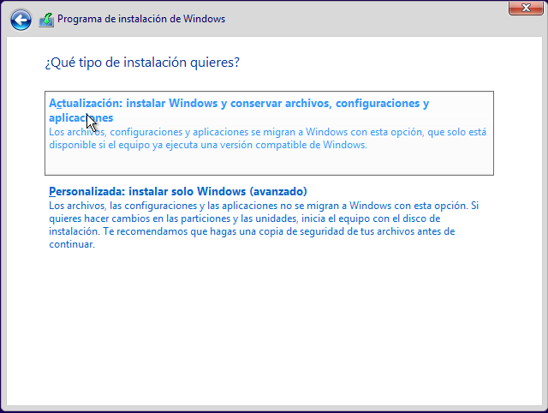

We create space for OS

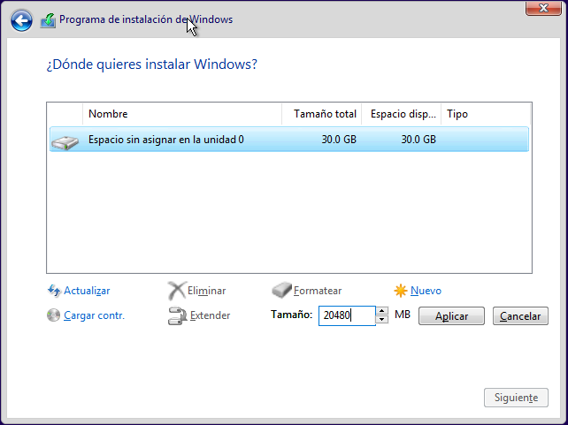

We give it to apply and the partitions will be created

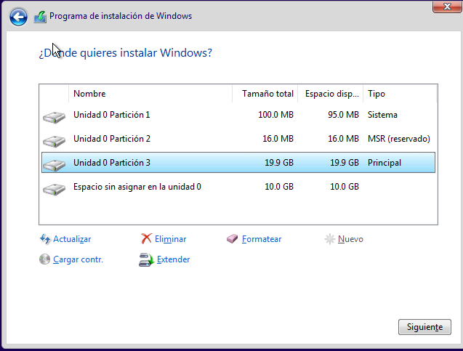

Once the Windows installation process is finished, what we will do is turn off our virtual machine and put the Ubuntu ISO in it, not without first indicating that we are going to change the operating System.

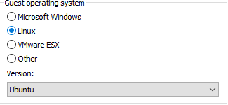

We will turn on the virtual machine again and when the VMware logo appears, we will press ESC

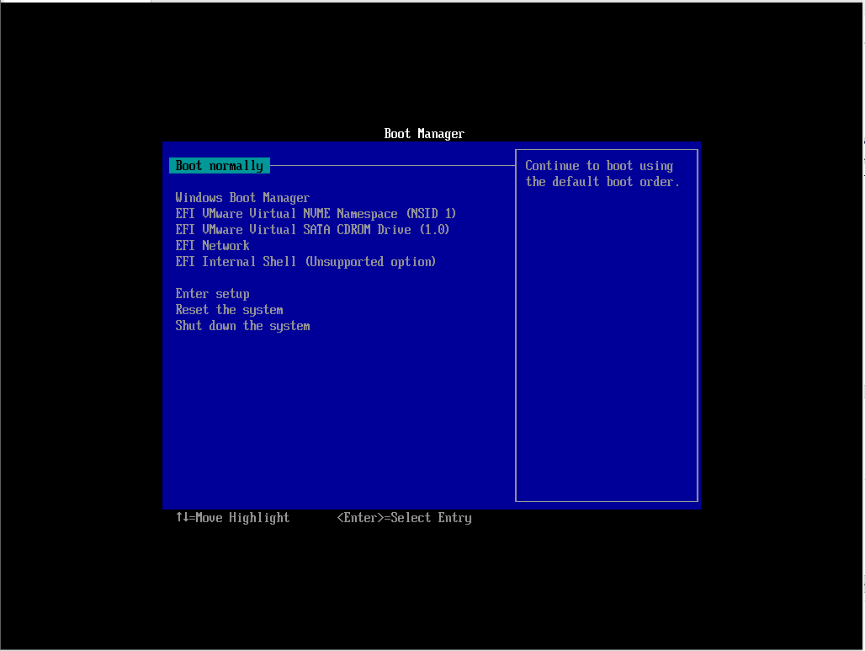

We move with the dates to the CDROM option, we will give the first option in which we will get “Ubuntu”

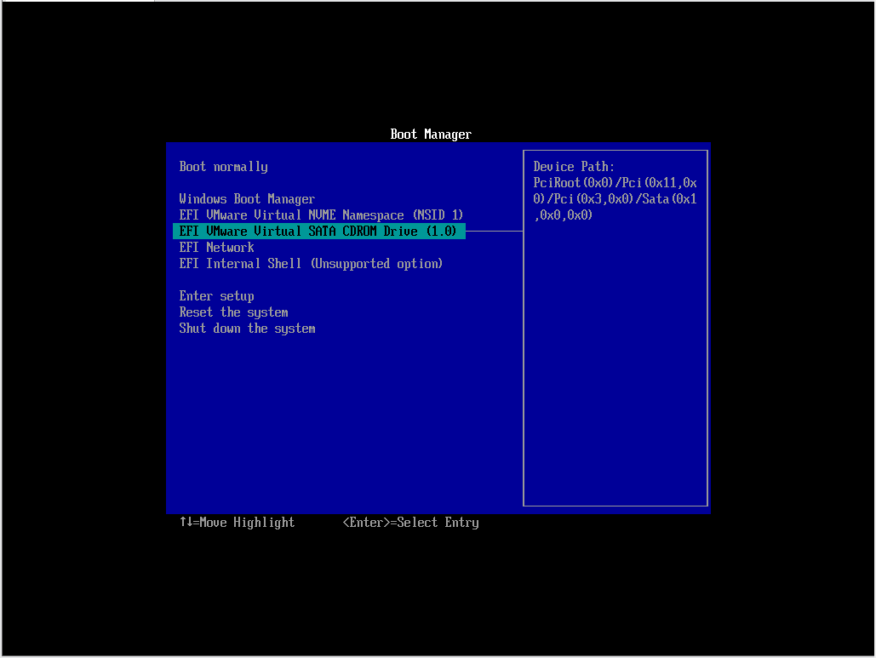

The Ubuntu installer will open and we will select to install Ubuntu.

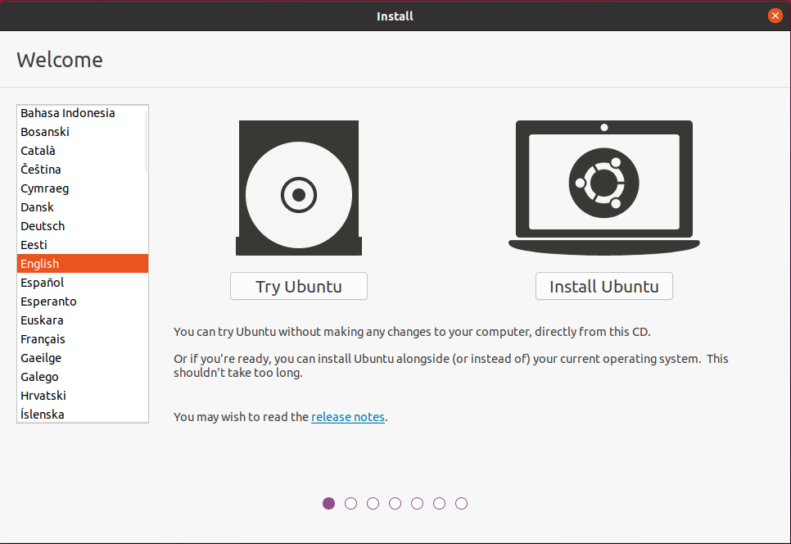

We will select the normal installation option

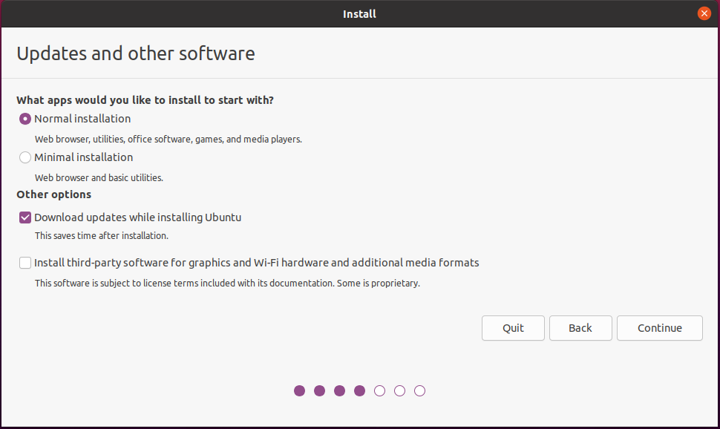

Here it is giving us the option to erase the disk or to install it together with Windows, but since we want to do a dual boot we will select to install together with Windows Boot Manager.

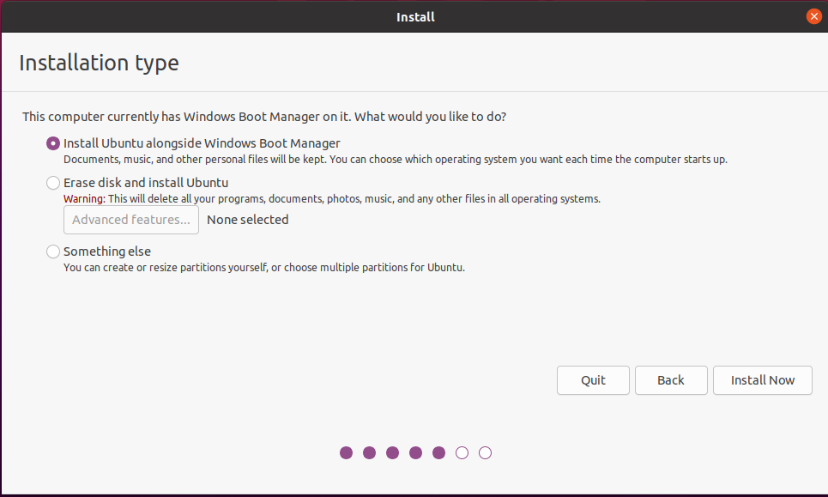

Once this is done we will have the dual boot done and every time we turn on our machine it will give us the option to start Windows or Linux.

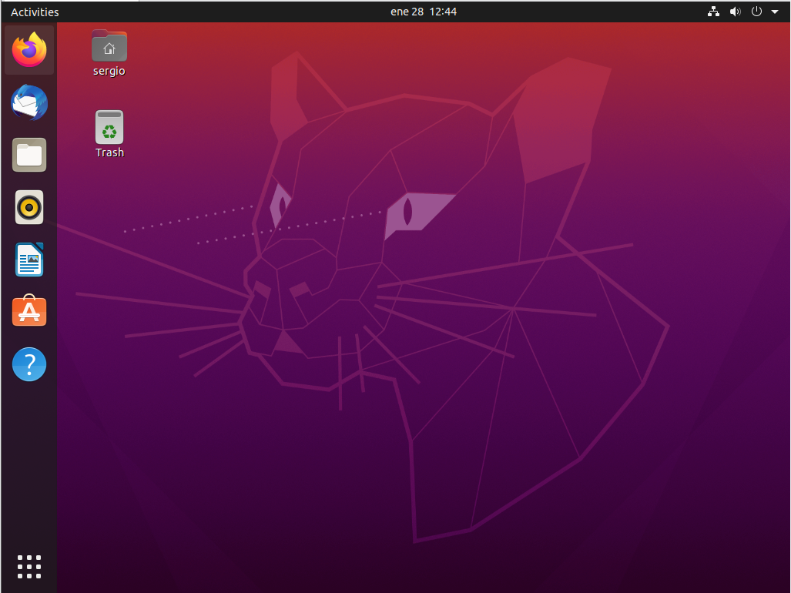

# Why we install Windows first?

We install Windows first because if we install Ubuntu first and then Windows, Windows overwrites the GRUB boot loader, so we would not be able to boot Ubuntu. However, if we install Windows first and then Ubuntu, GRUB itself will allow us to boot Windows.

# conclusion

This practice has seemed quite interesting to me since it was the first time that I installed Windows and Linux at the same time on the same machine. The only complication that I have found throughout practice is that at the time of creating the partitions at the beginning I have done them wrong and I have had to recreate the virtual machine.