

Reparación arranque

David Gómez García-Arias



5 de febrero de 2022

Implantación de sistemas operativos

Content

Objective of the practice 2

Inventory of necessary material 2

Execution, research and development 2

Single disk 2

Double disc 9

– Do you have any problems with it? If so, describe it and try to fix it. 11

Final Considerations 11

# Objective of the practice

We are going to learn the different ways to perform a repair on a computer that has Multiboot enabled but for one reason or another we lose this feature.

# Inventory of necessary material

For this practice we will need the virtual machine used in the previous practice, otherwise we will have to create it again.

Apart from that, we will need a machine with 2 disks, one from each OS.

# Execution, research and development

## Single disk

We will need to repair Windows to use its native boot system.

For this we will have to run the Windows installation CD on the machine on which we have installed the Multiboot system.

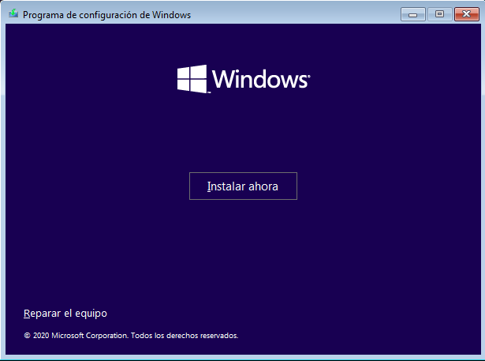

A menu will open and here we will repair it.

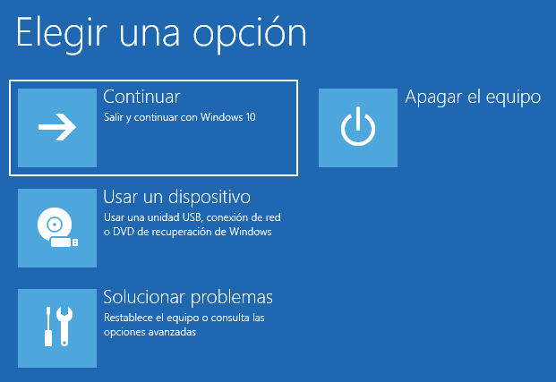

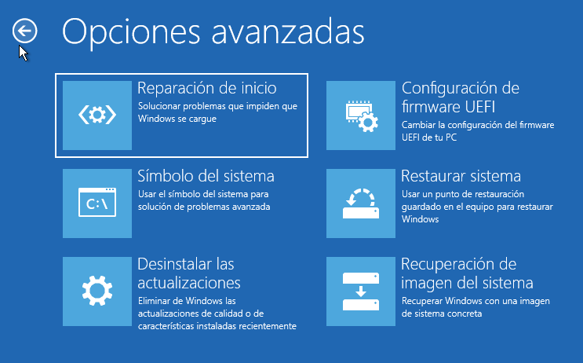

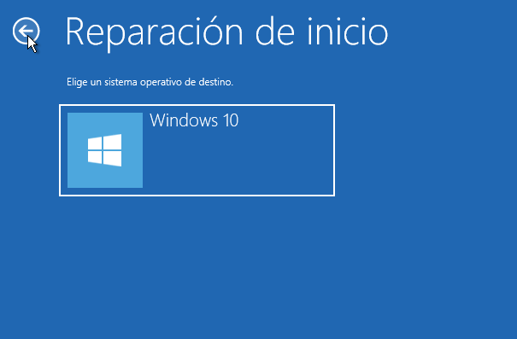

Once we select the Operating System to repair (only Windows comes out) we will get the options to fix it and choose "command prompt". 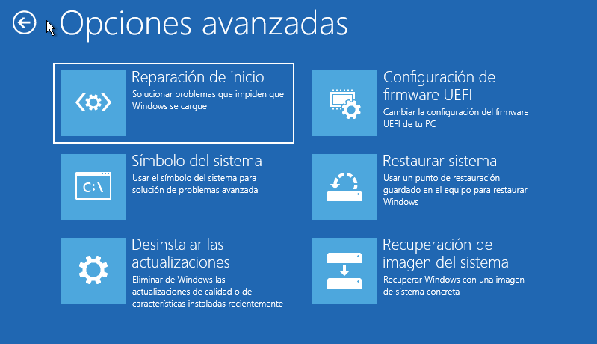

In the CMD tab we will run "bootrec /fixmbr" 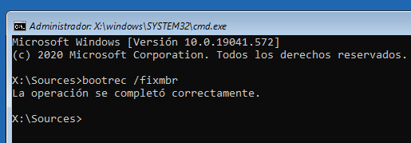

Once we run it we will leave the CMD and restart.

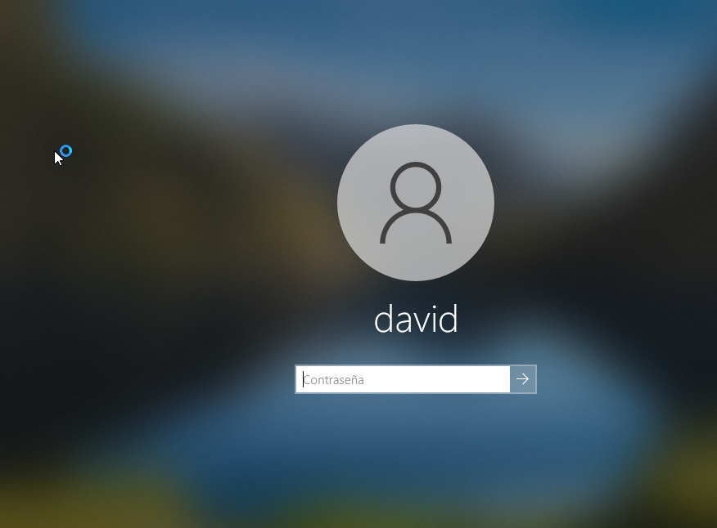

We will try Ubuntu. It starts well as well.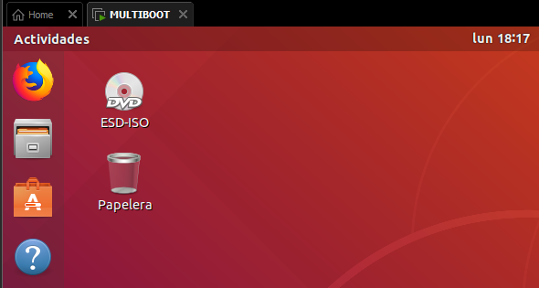

We will try to use "chkdsk /r" and "bootrec /rebuildbcd". We will have to locate ourselves in unit C to do this, we will need to put c:

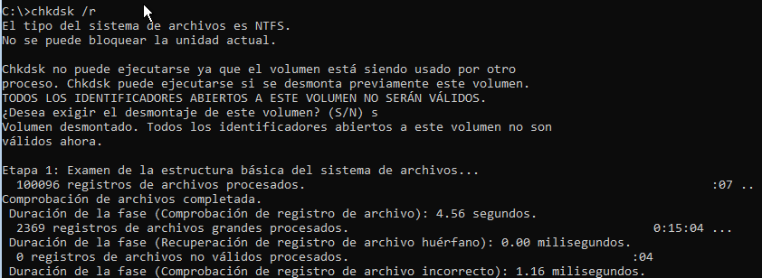

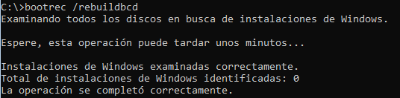

We see that it does not detect the Windows installation.

Once we run it, we will go out and restart.

We see that when starting the computer we still get the start menu of the operating systems. We see that Windows and Ubuntu keep booting.

We will do one last test using the 2 bootrec commands that we have seen "bootrec /fixmbr" and "bootrec /rebuildbcd". But I don't get anything.

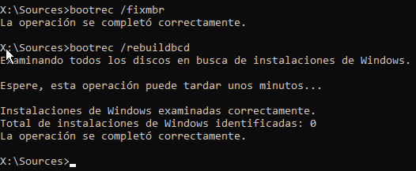

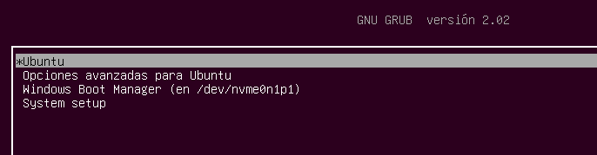

Once I ask my colleagues they tell me that they have accessed the "Recovery" tab through Windows.

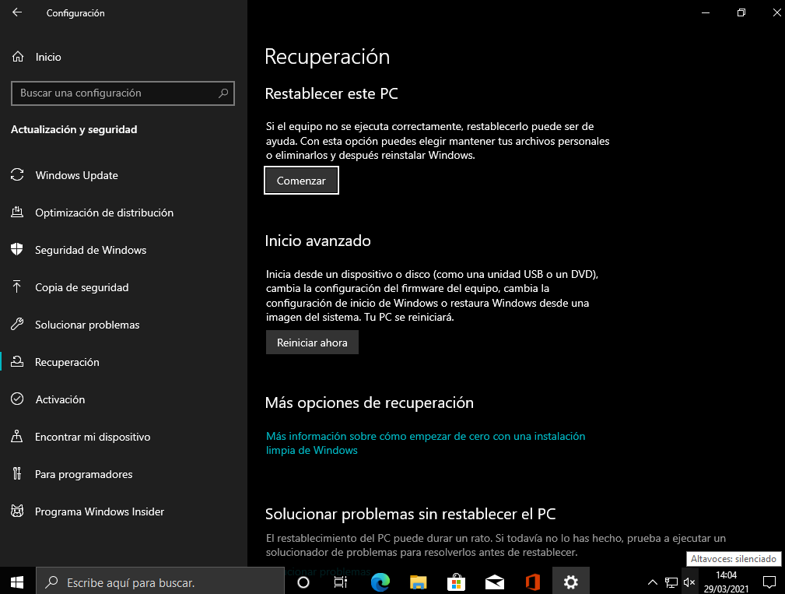

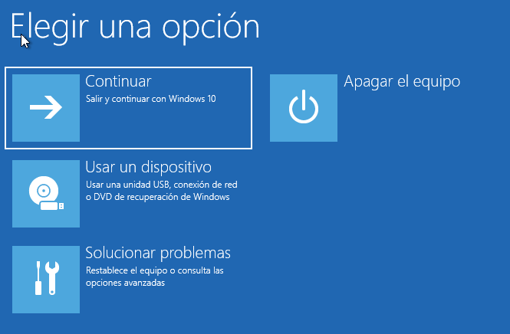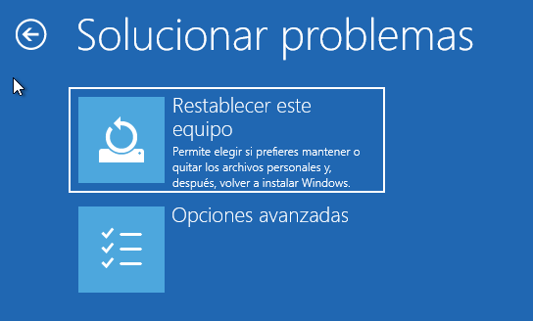

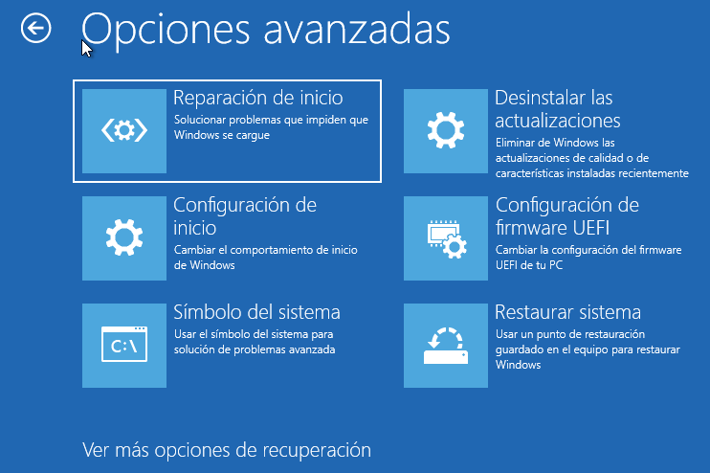

We see that once we click on Command Prompt it restarts and we get the following:

We click on our username and put the password. Once here we reopen a cmd and put the above. "bootrec /fixmbr" and "bootrec /rebuildbcd".

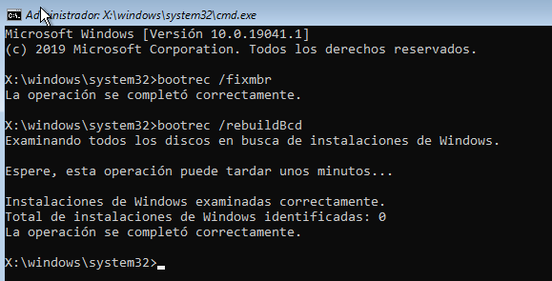

Once done we restart again but without getting it.

To repair the Ubuntu bootloader you would have to damage it with the Windows bootloader so it is not possible to show it.

To do this, you would have to mount a partition and reinstall it:

Mount the Ubuntu partition to /mnt with the command "sudo mount /dev/sdX# /mnt". Where X and # would be the disk and partition respectively that we have

To finish reinstall GRUB with the command

• sudo grub‐install ‐‐boot‐directory=/mnt/boot /dev/sdX

• where X is the corresponding disk

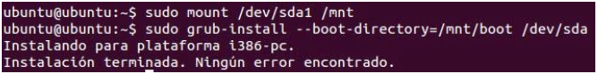

## Double disc

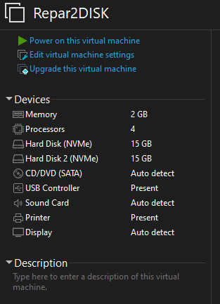

Let's install Windows on the first disk and Ubuntu on the second disk.

Once we install both Operating Systems, it will boot what we have on the first disk, for this we will have to change the boot order in the BIOS. We will have to select the disk on which we have installed Ubuntu. Texto

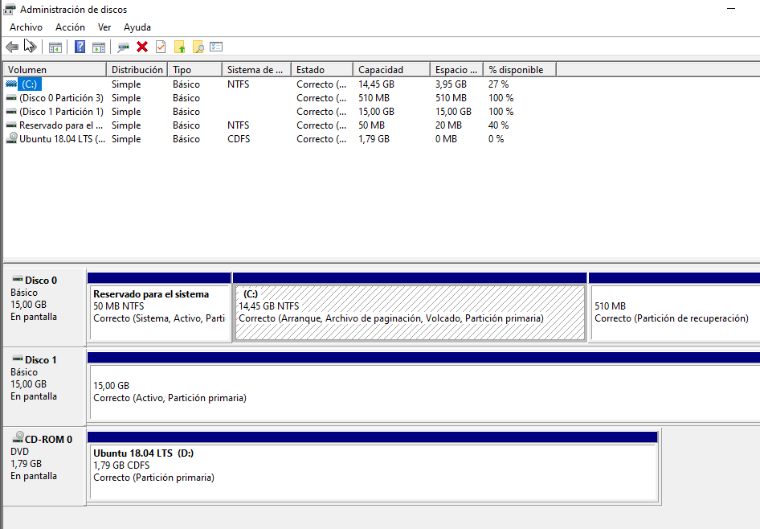

Once we install it we will start the Ubuntu liveCD. In this we will indicate to install the bootloader on disk 1 but I think we have done the installation wrong and we should have left space.

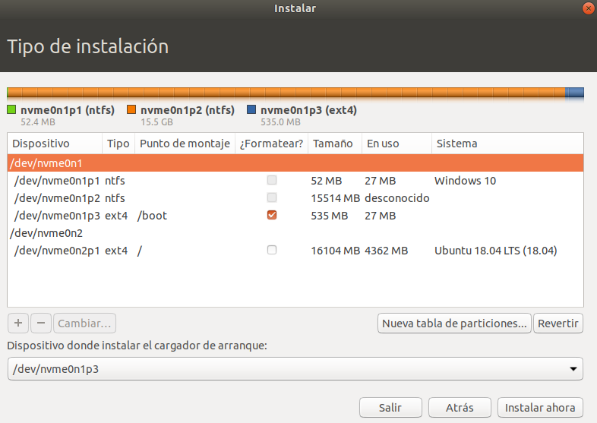

If we didn't want to lose information in the pre-Ubuntu installation we should have made a partition for /home.

But if we indicate that booting disk 1 boots Windows directly.

Let's go back to a snapshot we took before installing the second grub.

This time we will install grub on top of Windows 10.

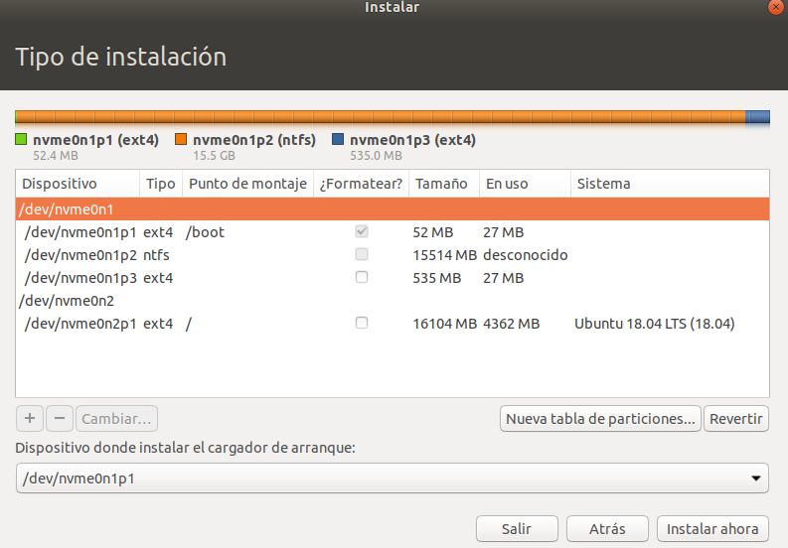

Obviously, it does not detect the Operating System.

## – Do you have any problems with it? If so, describe it and try to fix it.

As we load the Windows bootloader the operating system is not detected and for this we would have to repair Windows through the CD.

# Final Considerations

I liked the practice quite a bit for the fact of trying many things but not quite well because it has not gone my way.