## Práctica de laboratorioISOP306_InstalUbuntuMultiDiscos

NOMBRE ALUMNO: DAVID GÓMEZ GARCIA-ARIAS

Fecha de Entrega de práctica: 07/02/2022

511-DGómez-ISOP306-InstalUbuntuMultiDiscos.Docx

# Objective of the practice

# It is about installing an operating system that contain your various file systems in partitions of different disks.

# Inventory of the necessary material

First of all, we will need one ISOS of the operating systems that we are going to use (Ubuntu x64)

In the virtual machine that we will make, we have to take into account that we must have enough space on the disk for the operating systems.

# Execution research and development

The first step is to create our virtual machine

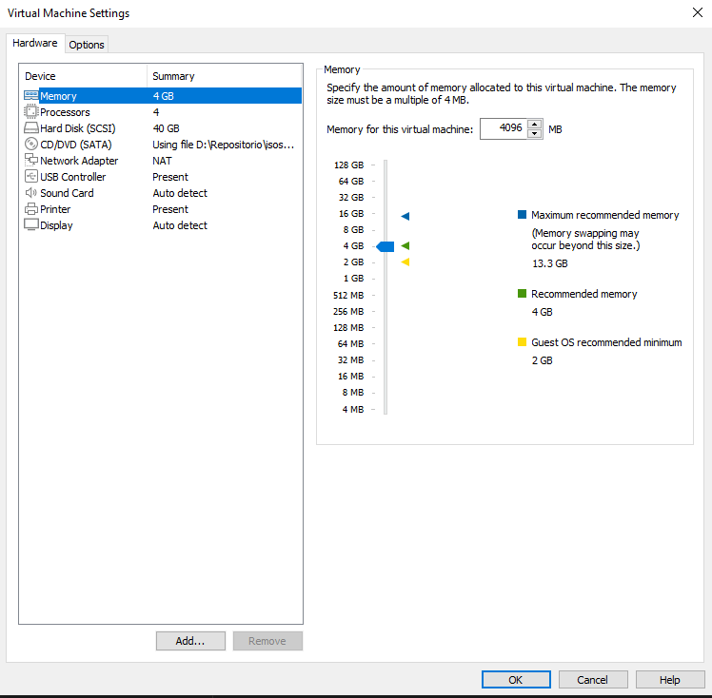

Follow the [standard installation](https://www.dell.com/support/kbdoc/000131655/how-to-install-ubuntu-linux-on-your-dell-pc) guide until you reach the **Installation Type** screen; at that time the recommended option is the last one: **Something Else**. After selecting it and clicking **Continue**, the installation will take you to **Advanced Partitioning Tool**. The **Advanced Partitioning Tool** is the installer tool that will guide you through the custom partition options.

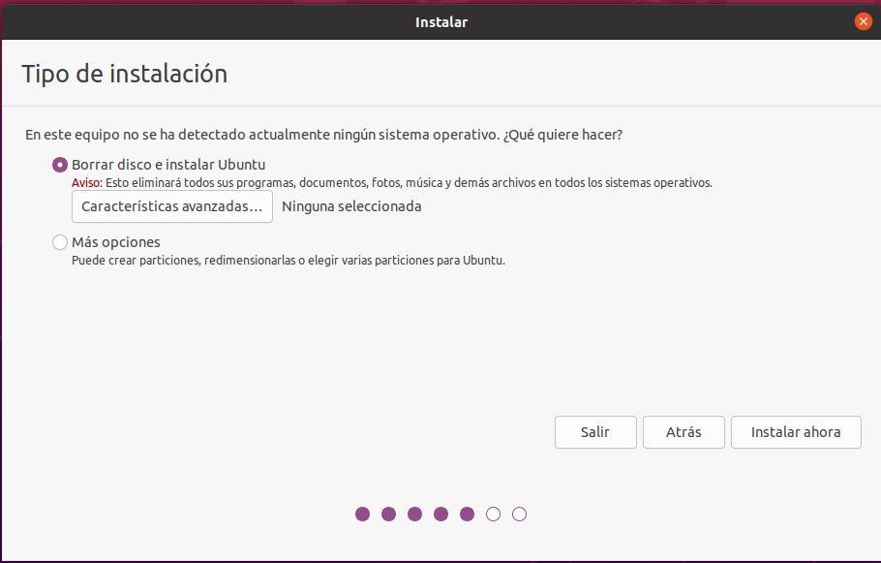

In this window, you can see all the partitions that exist on the hard disk and the unallocated free space. In this case, a blank hard disk drive is used. Select the New Partition Table button.

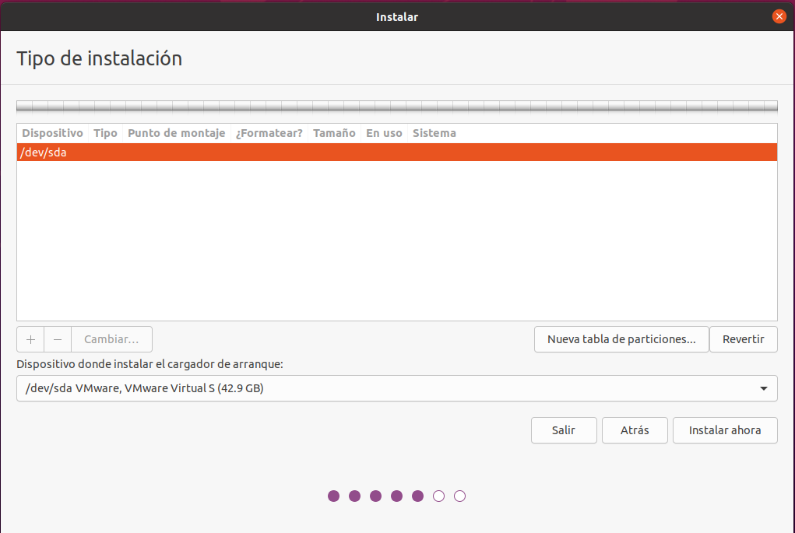

Now you should see the warning window about creating an empty partition. Click Continue to continue.

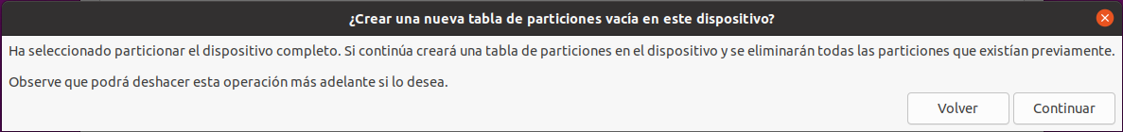

*Now you can click the + button to create a new partition. There are no special options in this tool. The installer will prompt you to create any new partition as a logical partition, if previously existing primary partitions exist. You can accept what the installer wants to use or you can modify it. *

We will select the free space and click on the + icon to add our first partition ("/boot" in this case):

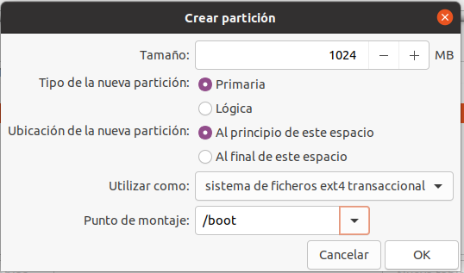

Now we will create the partition for SWAP, we could also have created it before, this in the end are tastes, let's see more information:

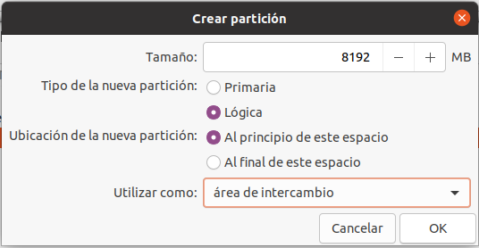

Let's go with the partition used for the Operativ System, and the programs that we install: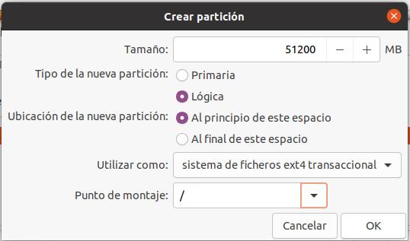

And we come to the end, the partition for /home, where users normally save torrent downloads, movies, music, thousands of photos, etc. Let's see how it looks:

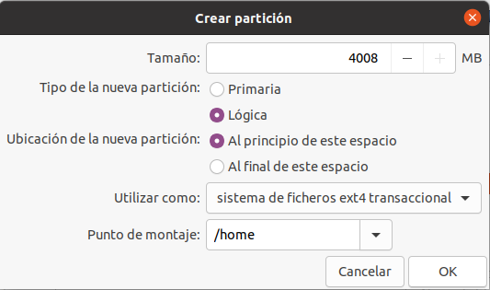

Once we have done all the steps, we should stay so colorful and well partitioned.

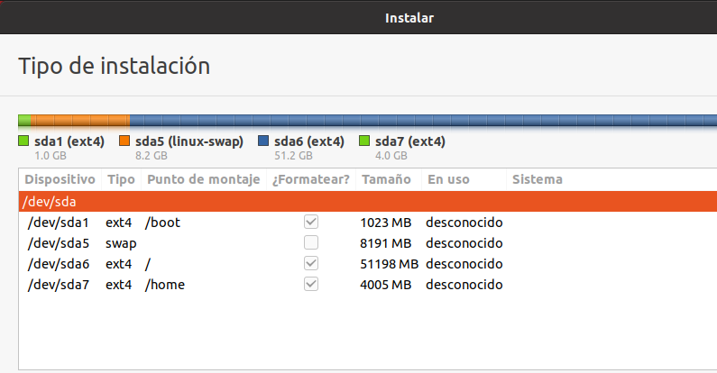

Click on the following menus, location, etc., and it will start installing.

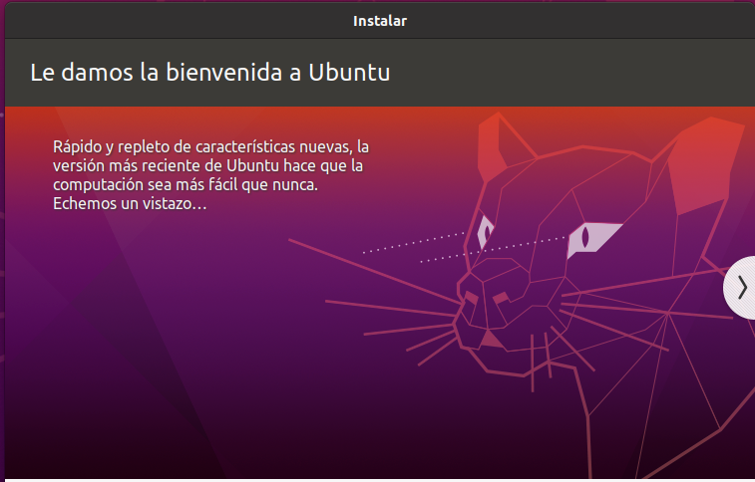

Once we boot up our Ubuntu and open our disk application, we can see something like this:

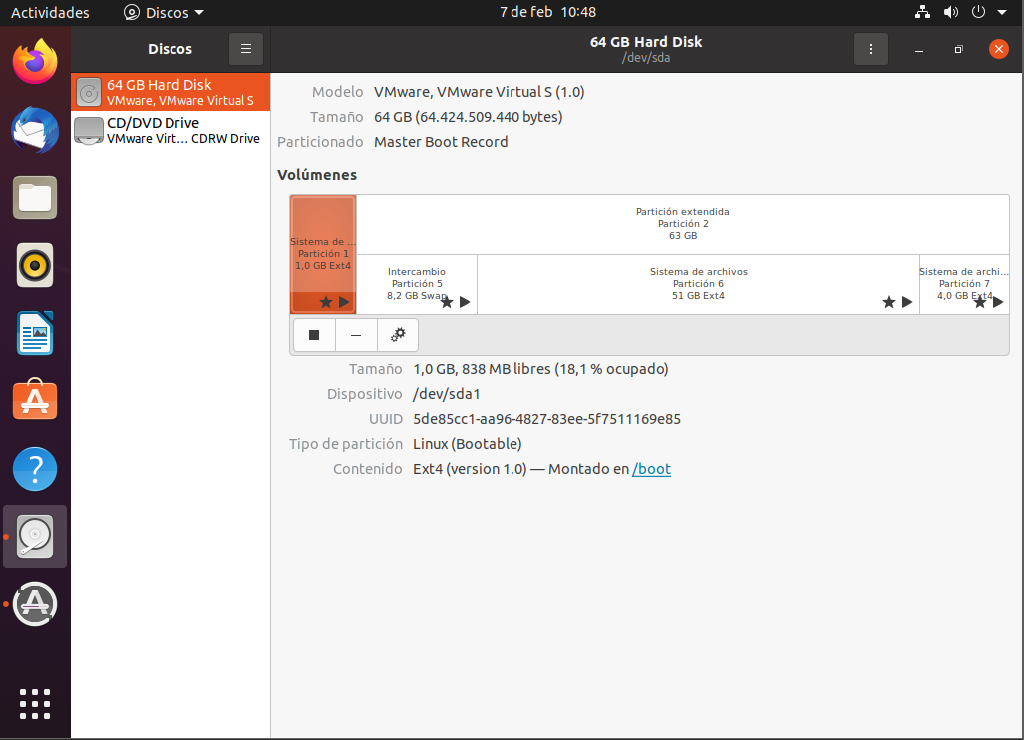

# Conclusion

This practice has seemed quite interesting to me since it was the first time that I installed Linux at the differences partitions on the same machine. The only complication that I have found throughout practice is that at the time of creating the partitions at the beginning I have done them wrong and I have had to recreate the virtual machine.