## d:\Users\ASIR1-11\AppData\Local\Microsoft\Windows\INetCache\Content.MSO\A620A207.tmp

## Práctica de laboratorioISOP310_CambioBIOS-UEFI

NOMBRE ALUMNO: DAVID GÓMEZ GARCIA-ARIAS

Fecha de Entrega de práctica: 10/02/2022

511-DGómez-ISOP310-CambioBIOS-UEFI.Docx

# Objective of the practice

Perform a conversion of an MBR partitioned and BIOS booted Windows system disk to the same UEFI and GPT partitioned system.

# Inventory of the necessary material

First of all, we will need one ISOS of the operating systems that we are going to use (Windows 10)

In the virtual machine that we will make, we have to take into account that we must have enough space on the disk for the operating systems.

# Execution research and development

The first step is to create our virtual machine.que tenga un disco MBR (BIOS)

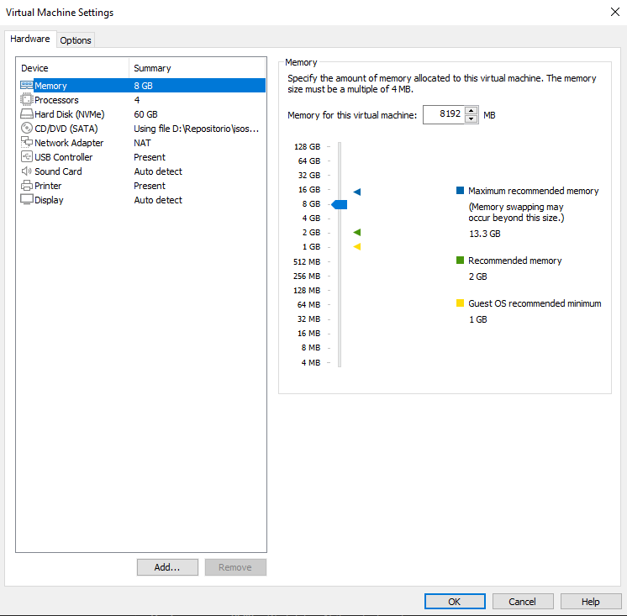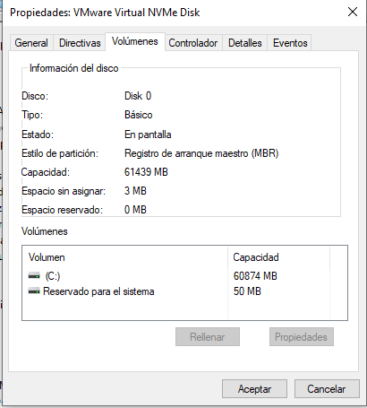

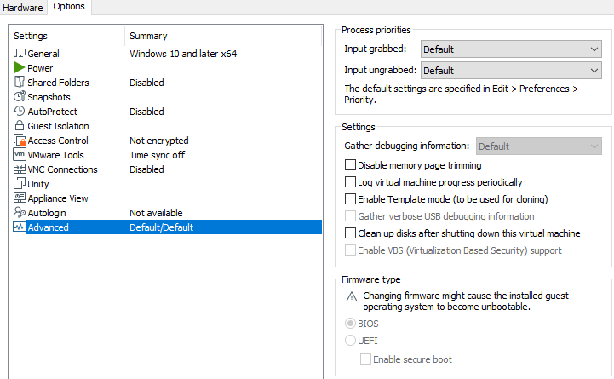

After verifying that it is an MBR system (BIOS). We will run the "MBR2GPT.exe" tool so as not to lose windows 10 boot data.

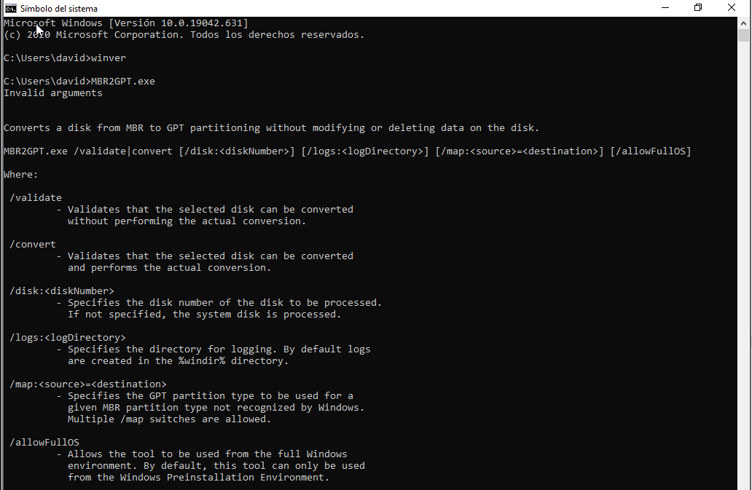

We use the "/validate" parameter to validate whether conversion is possible.



It tells us that it is a Windows PE operating system, we must use the parameter "mbr2gpt /validate /disk:0 /allowFullOS", in order to verify the conversion of the system drive.

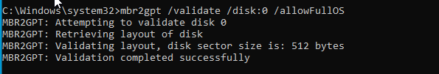

To convert a disk, just run "mbr2gpt /convert/disk:0 /allowFullOS" and the execution output will be something like this:

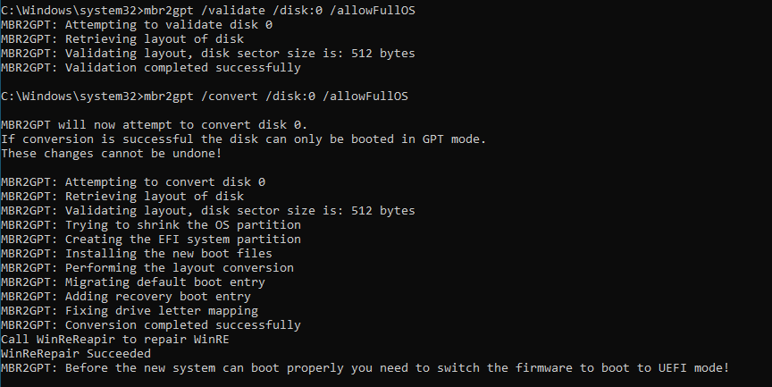

Let's adjust the machine > options > advanced > firmware type

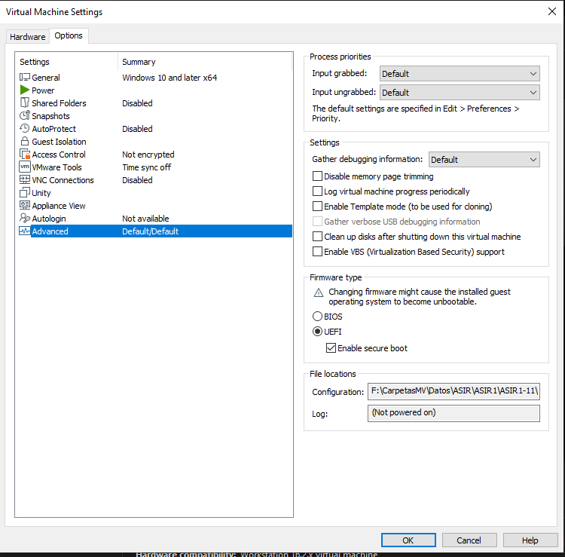

And as a last we check that the disk has changed in Device Management

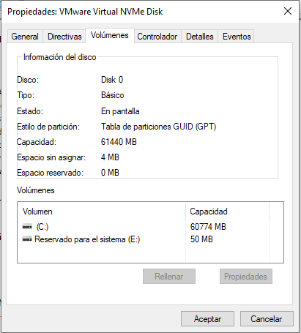

# Conclusion

This practice has seemed quite interesting to me since it was the first time that I changing BIOS to UEFI on the same machine. The only complication that I have found throughout practice is that I did not know how to use the commands and that is why it has given me many times error.