Trellis

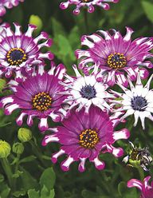By: Ken Pacquer

Answer: AFRICAN DAISY

Spin the tiles and find the vines that connect one side of the board to the other.

When you make a connection from one side of the board to another, mark the letter.

