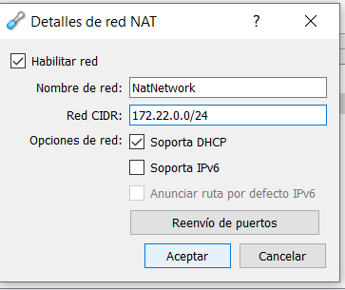

Servidor a Desktop

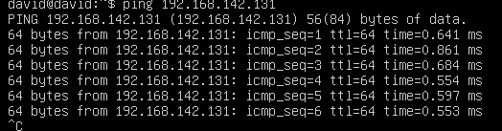

Desktop a Servidor

