SACCO Loan Management System Workflow Reference
User Workflow Edition
Source document reviewed: restructured_lms_workflow_v2.pdf
Generated on: 2026-04-23
Prepared as an export-ready Word/PDF guide with clear workflow explanations for every screenshot.

Table of Contents
Right-click and update the table of contents in Word if fields do not refresh automatically.

1. Document Overview

1.1 Purpose And Scope
This document turns the raw LMS workflow reference into a clean, export-ready guide that explains what each screen is showing in simple user language.
Each screenshot is matched with a clear workflow explanation so readers can understand what the user is doing, what the system is checking, and what happens next.
- The document covers the shared login and registration pages, admin workspaces, member pages, manager pages, board pages, and printed output.
- Workflow names are kept consistent with the labels shown in the system so the explanations remain easy to follow.
- External-system notes are included only where the workflow depends on the Foresight financial app or the Members Portal.

1.2 Workflow Reading Convention
Every screenshot is followed by a Workflow Explanation block with the same reading pattern: what the screen does, what happens when the user submits something, and how the process moves to the next step.
- Read-only dashboards and lists are explained as viewing points in the workflow, even when no data is being changed.
- Action screens explain the visible checks first, then the result of the action, then the next review step where relevant.
- When a screenshot already shows a completed state, the explanation describes that completed state instead of inventing an extra action.

2. Shared Entry Screens

2.1 Staff Login
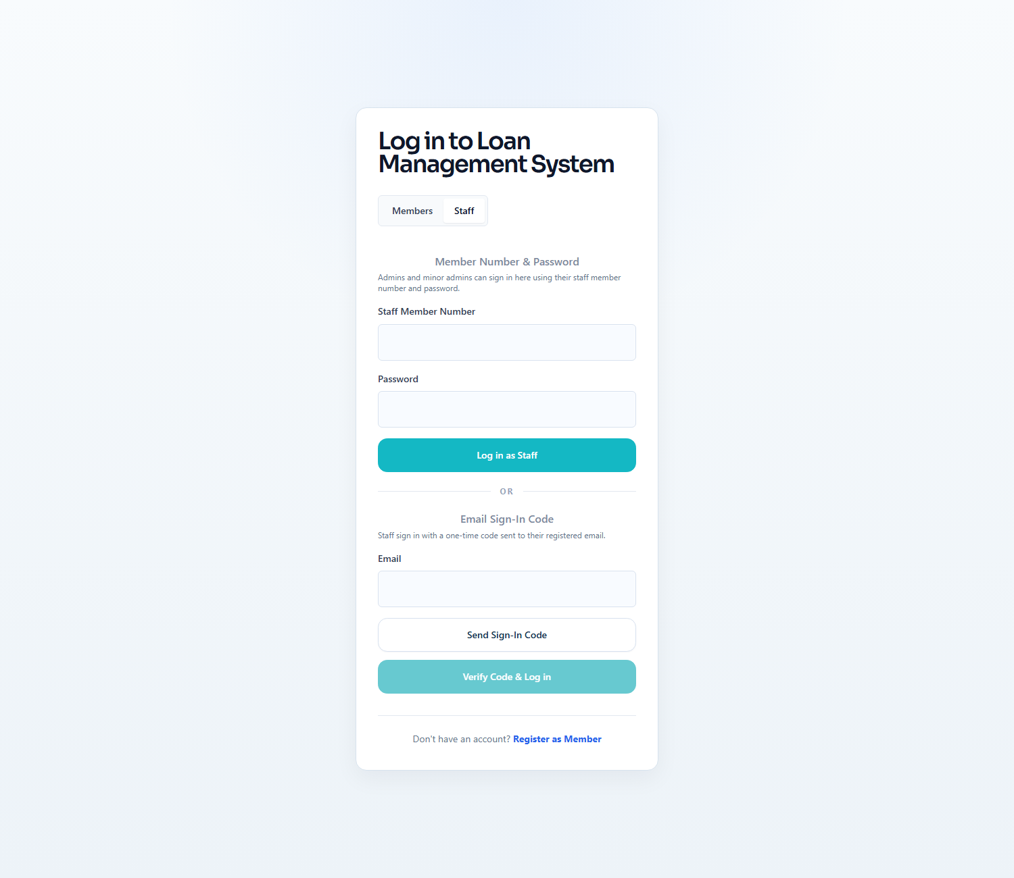
Workflow Explanation:
What happens:
- The login page exposes the staff tab for password login and email OTP login on the same shared entry screen.
- The page lets staff sign in with a password or use a one-time code when that option is available for their account.
On submit:
- If the password is correct, the user is signed in and taken to the correct work area.
- For one-time-code sign-in, the system sends the code, checks it, and then signs the user in.
Approval flow:
- No loan status changes happen on this screen.
- After sign-in, the user is taken to the correct dashboard or review queue based on their role.

2.2 Member Registration
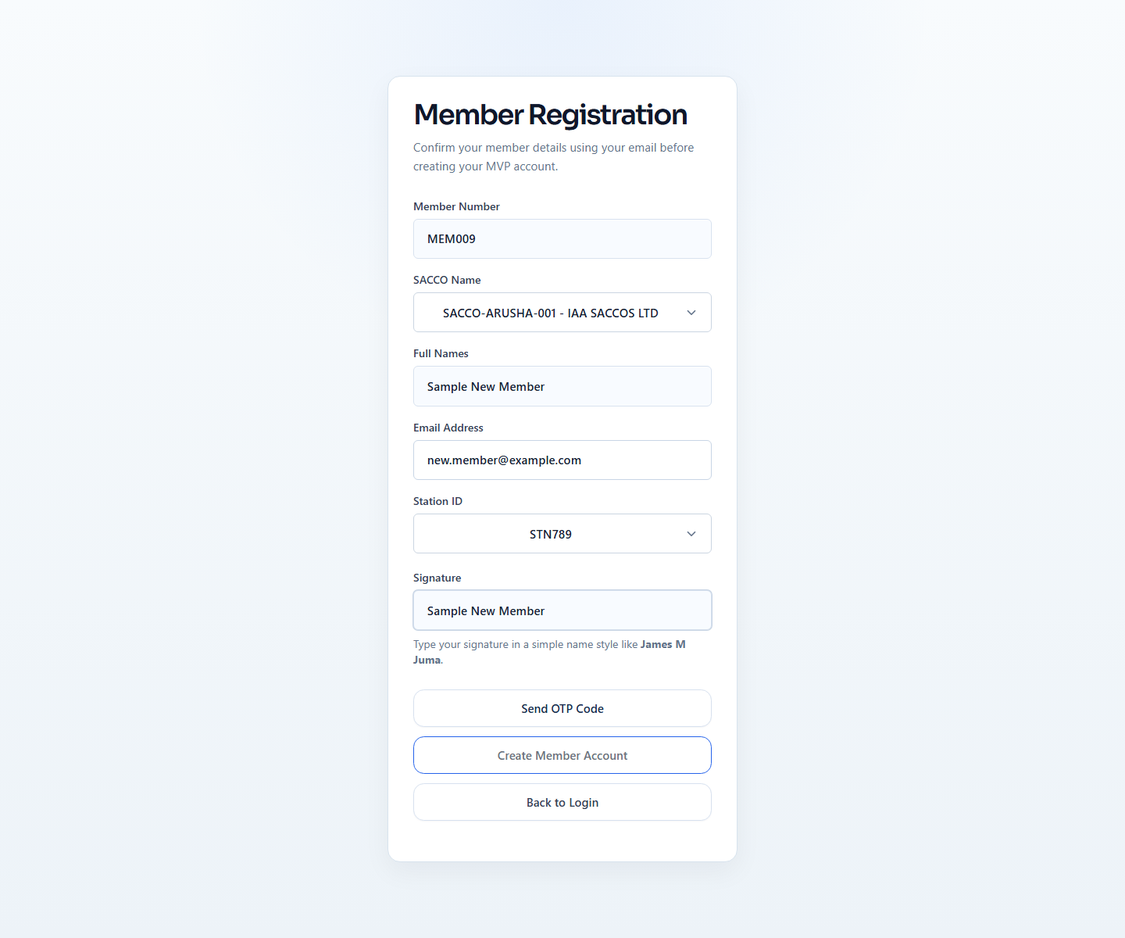
Workflow Explanation:
What happens:
- The registration form captures member number, name, email, SACCO, station, and OTP so the member can be bound to one SACCO and one station at creation time.
- This is where the member chooses the correct SACCO and station, and those details stay linked to the account after registration.
On submit:
- When the member requests a one-time code, the system checks the entered details, confirms the member belongs to the selected SACCO and station, and stops duplicate registration.
- The final submit step confirms the one-time code, creates the member account, prepares the supporting account details, and returns the user to the login page.
Approval flow:
- This is an onboarding step rather than a loan approval step.
- The result is an active member account that can sign in and apply for loans in the selected SACCO.
External system communication:
- During registration, the system checks the member's details against the Foresight financial app endpoint before the account is created.
- If the returned details do not match the form, registration is stopped and the member is asked to correct the information before continuing.

3. Platform Administration (Super Admin)

3.1 Super Admin Dashboard
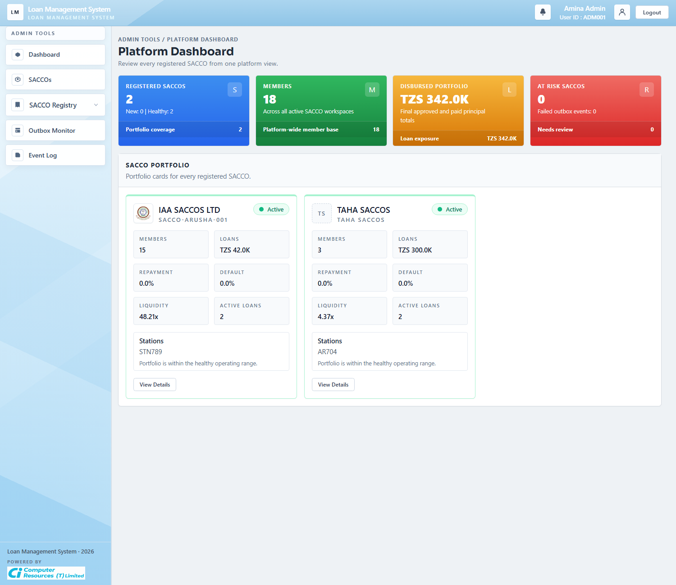
Workflow Explanation:
What happens:
- This dashboard gives platform administrators a full view across all SACCO workspaces.
- The cards summarize registered SACCOs, active members, total disbursed amounts, failed message deliveries, and recent platform activity across every active SACCO.
On submit:
- This dashboard is read-only and does not submit business data.
- It is the starting point for SACCO portfolio management, registry maintenance, delivery monitoring, and activity history.
Approval flow:
- No loan application status is updated here.
- The screen supports oversight before a super admin drills into a specific SACCO or platform administration task.

3.2 SACCOs Portfolio
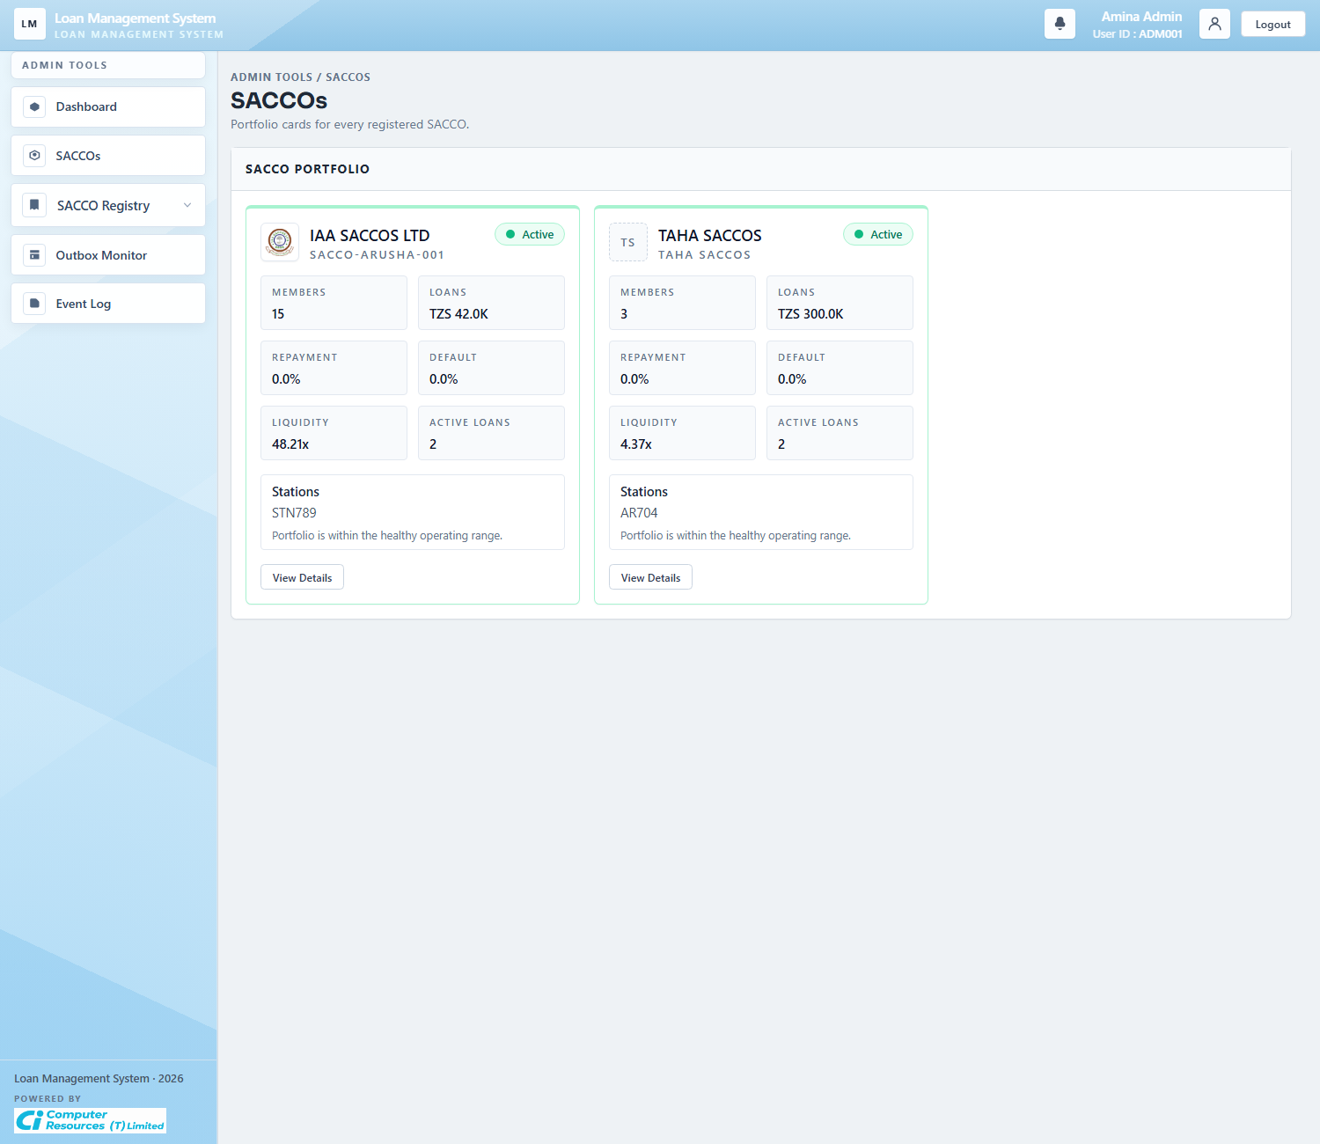
Workflow Explanation:
What happens:
- The SACCO portfolio screen lists the active SACCO workspaces and highlights each portfolio's stations, members, exposure, and health indicators.
- This is the visual summary view of platform tenancy rather than the formal registry maintenance table.
On submit:
- The screen itself is read-only.
- The user moves from here into SACCO detail by opening a single workspace record.
Approval flow:
- No workflow state changes happen on the portfolio cards.
- The cards help platform staff decide which SACCO needs closer review before opening its detail page.

3.3 SACCO Registry
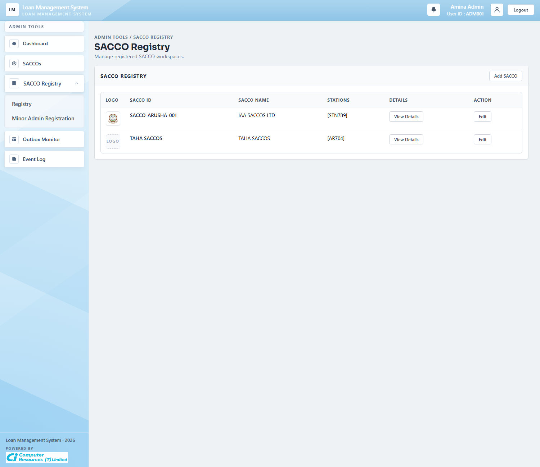
Workflow Explanation:
What happens:
- The SACCO registry is the formal list of registered SACCO workspaces and their station sets.
- Unlike the portfolio view, this table is a maintenance screen used to inspect or launch edit actions against registered SACCO metadata.
On submit:
- Selecting Add SACCO opens the form for creating a new workspace, while the row actions open details or editing options.
- No loan records are changed directly on the list page.
Approval flow:
- The approval chain is administrative rather than credit-related.
- The outcome of this page is a controlled set of active SACCO IDs and stations that later constrain registration, scoping, and reporting.

3.4 Add SACCO Modal
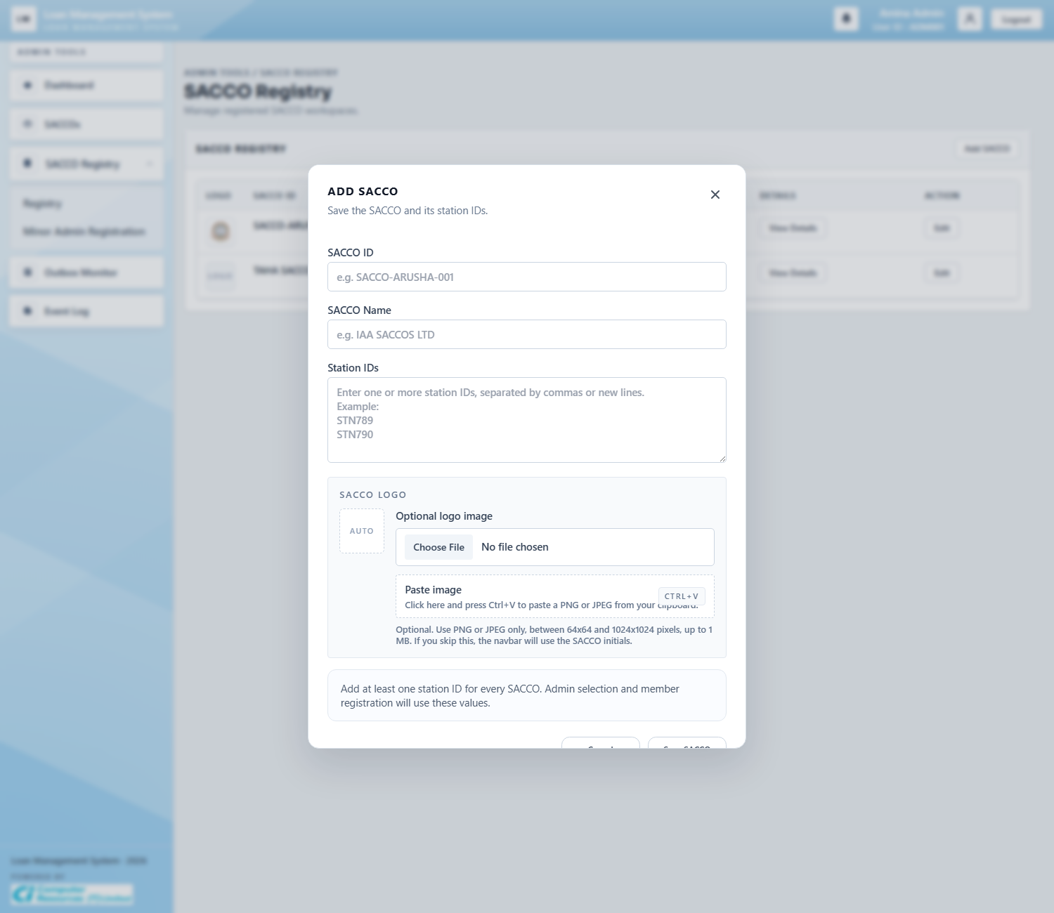
Workflow Explanation:
What happens:
- The modal captures SACCO ID, SACCO name, station IDs, and an optional logo in one platform-admin action.
- It is the controlled entry point for creating a new workspace that the rest of the platform can reference safely.
On submit:
- Submitting the modal normalizes the SACCO ID and stations, requires at least one station, stores the logo if supplied, and creates default SACCO configuration.
- The listed stations are activated and the SACCO's basic settings are prepared at the same time.
Approval flow:
- No loan status moves here.
- The important downstream effect is that member registration, admin scoping, and SACCO-specific loan configuration can now target the newly registered workspace.

3.5 SACCO Detail
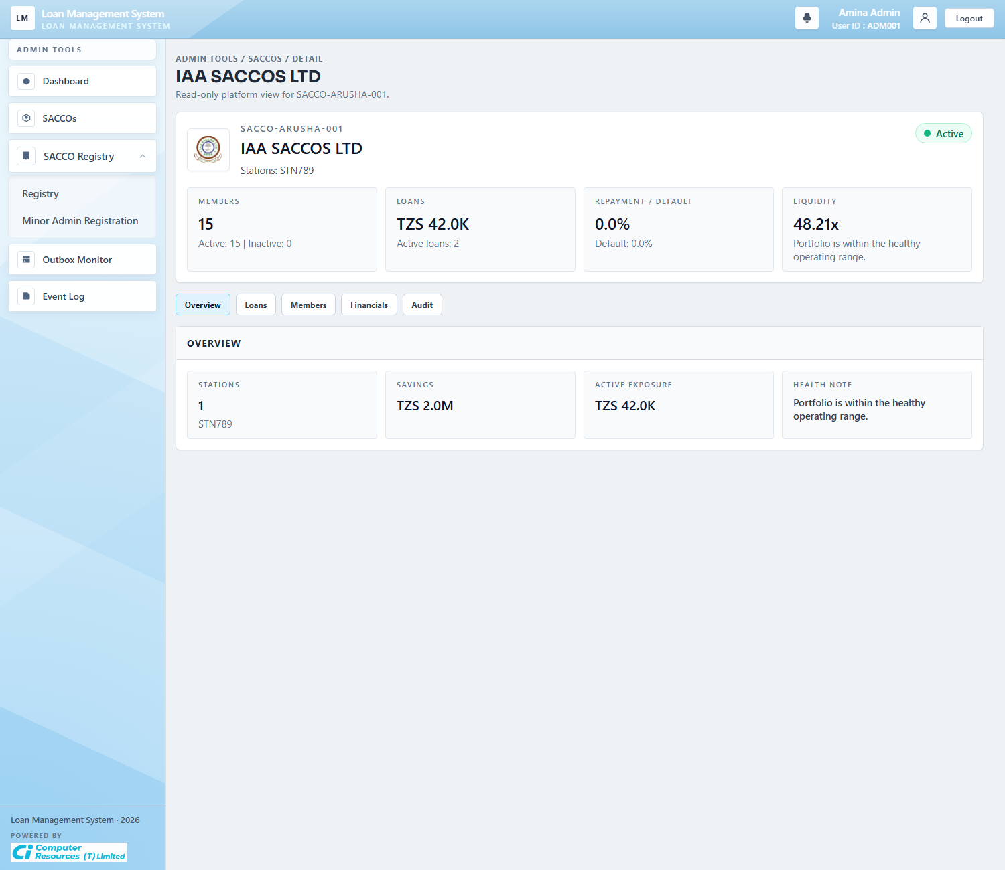
Workflow Explanation:
What happens:
- The SACCO detail page is the platform-level drill-down for one registered workspace.
- It summarizes member counts, disbursed exposure, paid and overdue loans, and recent audit activity for the selected SACCO.
On submit:
- This screenshot is a read-only overview state.
- Administrative edits are launched from the SACCO registry actions or update flows rather than typed directly into the overview cards.
Approval flow:
- No live approval action is taken here.
- The page helps platform administrators judge portfolio health before changing registry data or investigating workspace operations.

3.6 Minor Admin Registration
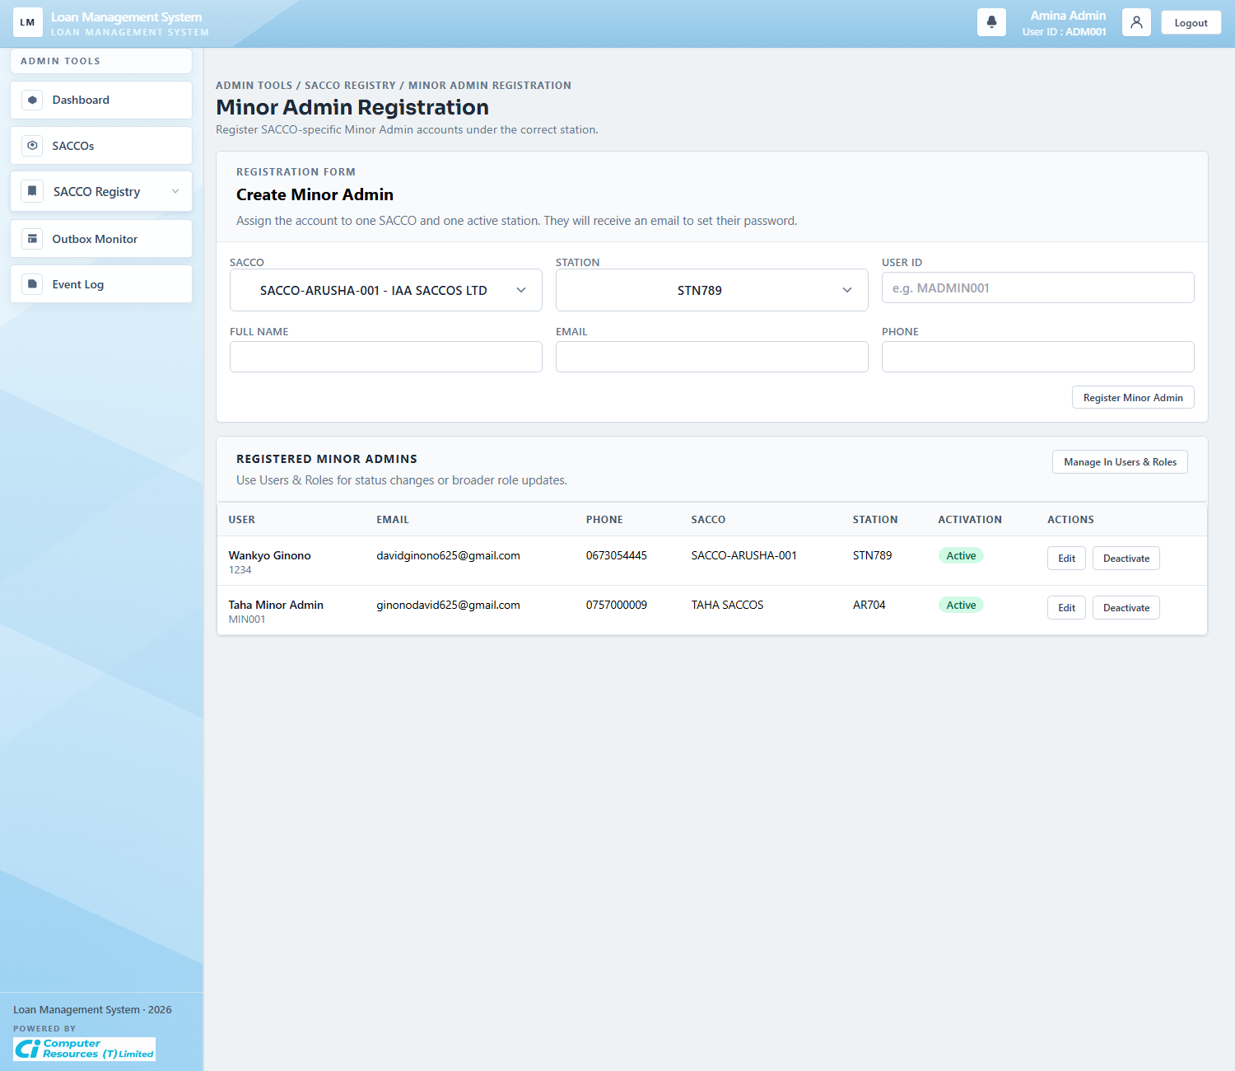
Workflow Explanation:
What happens:
- This screen is used by the platform admin to invite or maintain Minor Admin accounts for a specific SACCO and station.
- The form links each invited staff member to one SACCO and one station so their access stays limited to the correct workspace.
On submit:
- Registering a Minor Admin validates the SACCO, validates the station, reserves a unique member number and email, and issues an activation link.
- Existing rows can also be updated, re-invited, revoked, or deactivated through the actions shown in the table.
Approval flow:
- The workflow outcome is administrative access, not a loan approval transition.
- Once active, the invited account can sign in and administer only its assigned workspace.

3.7 Platform Outbox Monitor
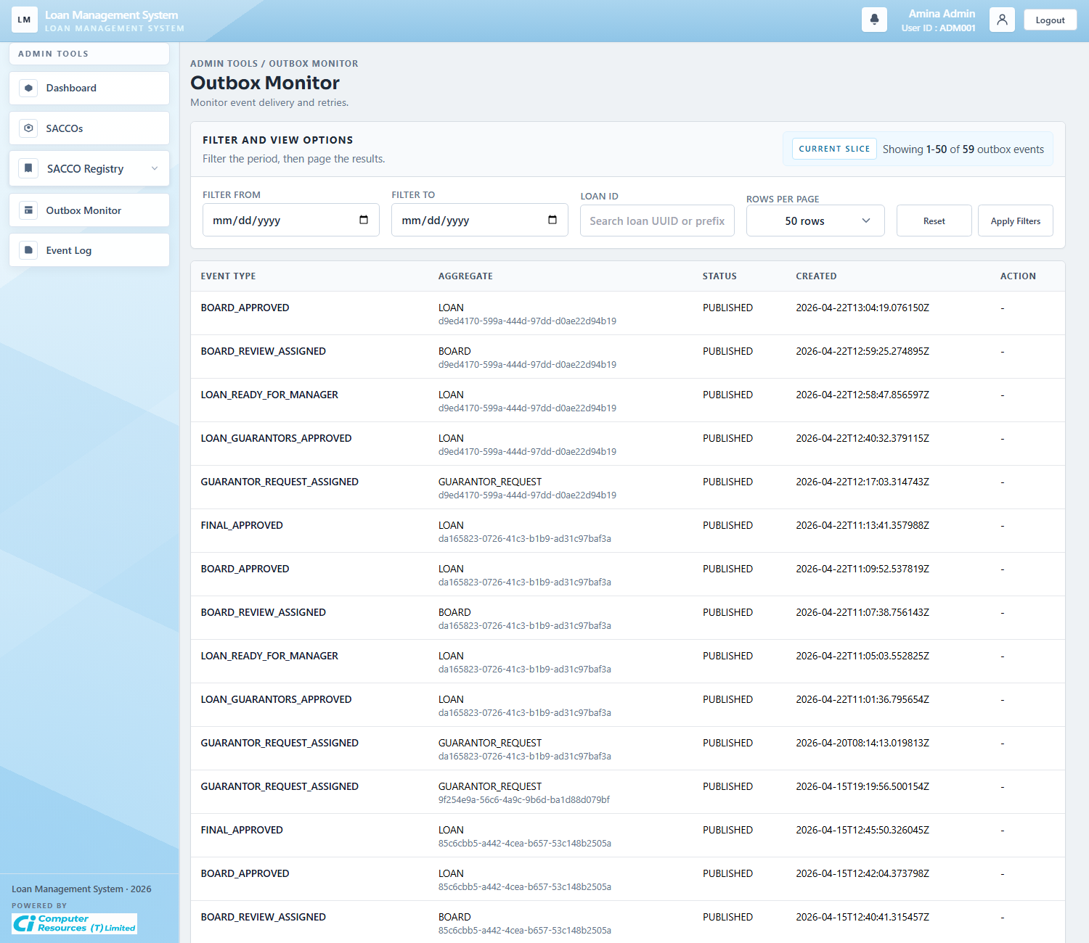
Workflow Explanation:
What happens:
- The outbox monitor lists system messages created by workflow actions such as guarantor assignment, board assignment, approvals, and disbursement updates.
- The filter row lets administrators narrow by date range, page, and loan reference when tracing message delivery.
On submit:
- The main action on this screen is retrying a failed or blocked message.
- Retrying returns the failed item to the queue so the system can try sending it again.
Approval flow:
- This screen does not create new loan decisions; it only tracks message delivery.
- It reflects already-recorded business events and helps operations verify that downstream notifications or integrations were queued correctly.

3.8 Platform Event Log
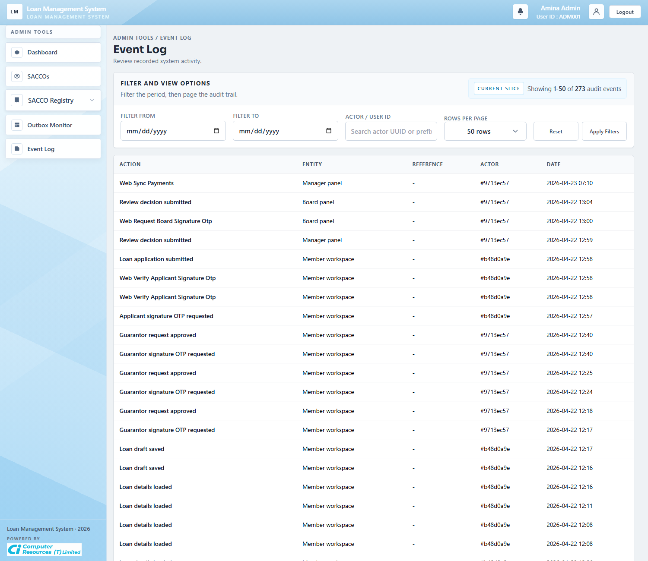
Workflow Explanation:
What happens:
- The event log is the platform-wide audit trail of who did what, against which entity, and when it happened.
- It is used for traceability across member, manager, board, and administration actions.
On submit:
- This screen is read-only.
- Filter controls narrow the audit history by date and actor so support staff can reconstruct a workflow path.
Approval flow:
- No approval state changes occur here.
- The event log is evidence of transitions that were already committed elsewhere in the system.

4. Workspace Administration (Minor Admin)

4.1 Admin Dashboard
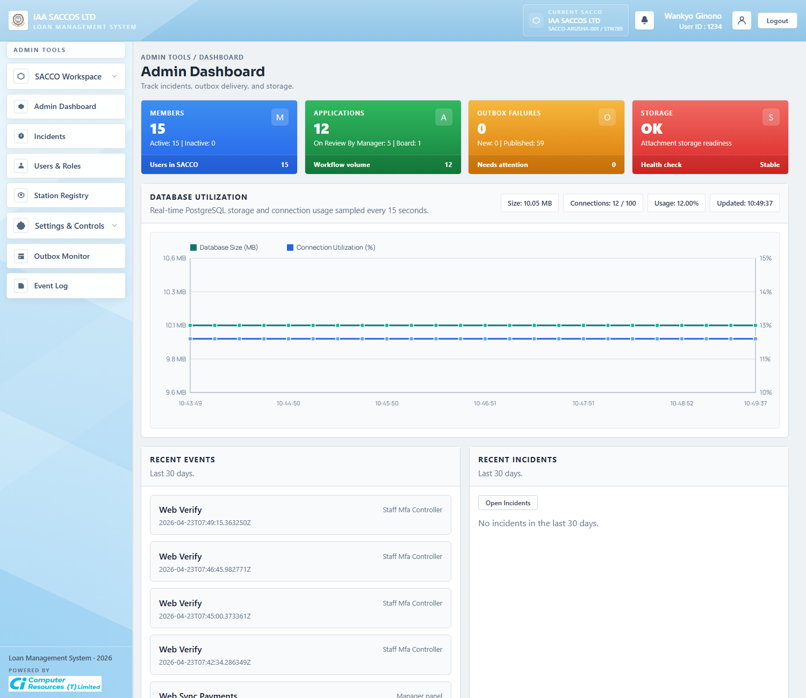
Workflow Explanation:
What happens:
- The workspace dashboard shows the operational summary for the currently selected SACCO and station.
- Cards, database utilization, recent events, and recent incidents help the Minor Admin assess workspace health quickly.
On submit:
- The dashboard itself does not write business data.
- It gives the admin quick access to incidents, users, settings, outbox, and event history for the selected workspace.
Approval flow:
- No loan moves directly from this screen.
- The dashboard is a monitoring layer for the administrative side of the workflow.

4.2 Incidents
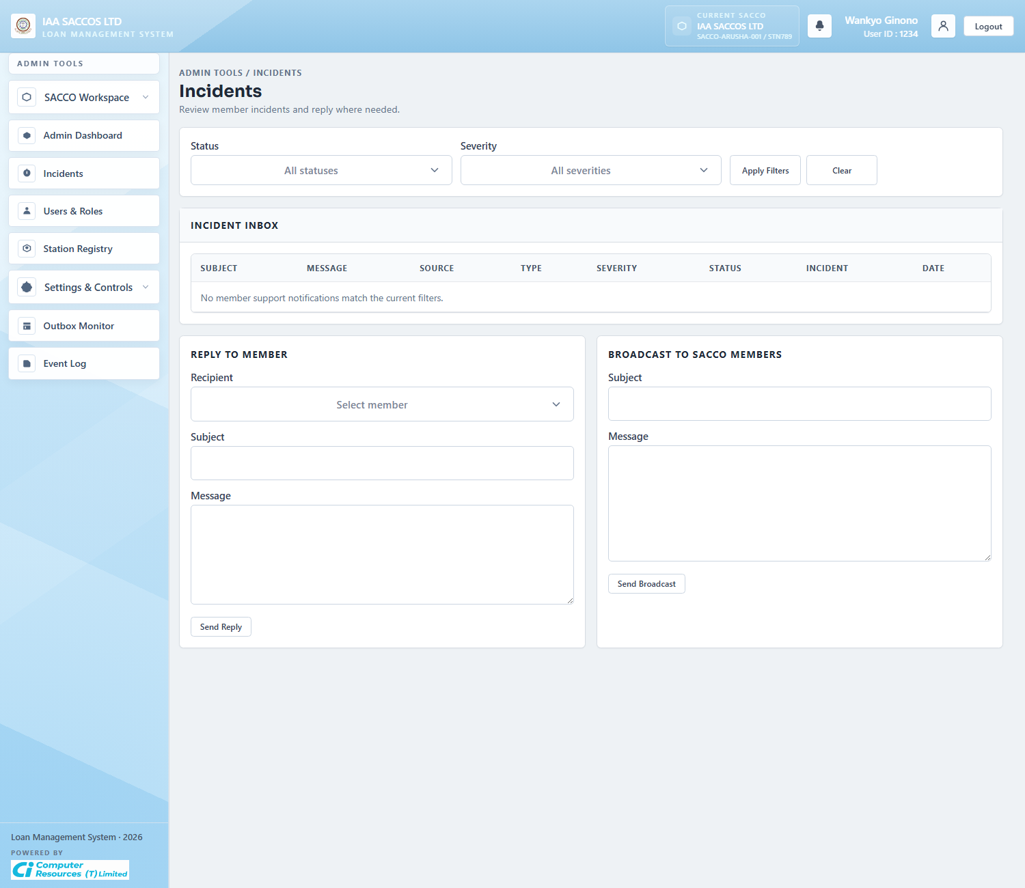
Workflow Explanation:
What happens:
- The incidents page combines incident tracking with admin reply and broadcast tools for the active workspace.
- It surfaces support messages that members have sent from the Support screen and lets the admin act on them inside the same SACCO scope.
On submit:
- Updating an incident writes severity, status, and optional resolution notes.
- Replying sends a message to a selected member, while broadcasting pushes a message to active members in the current SACCO.
Approval flow:
- This is not part of the loan approval ladder, but it affects support and operational follow-up around loan issues.
- The next step after an incident change is usually a member notification rather than a workflow status transition on the loan itself.

4.3 Users And Roles
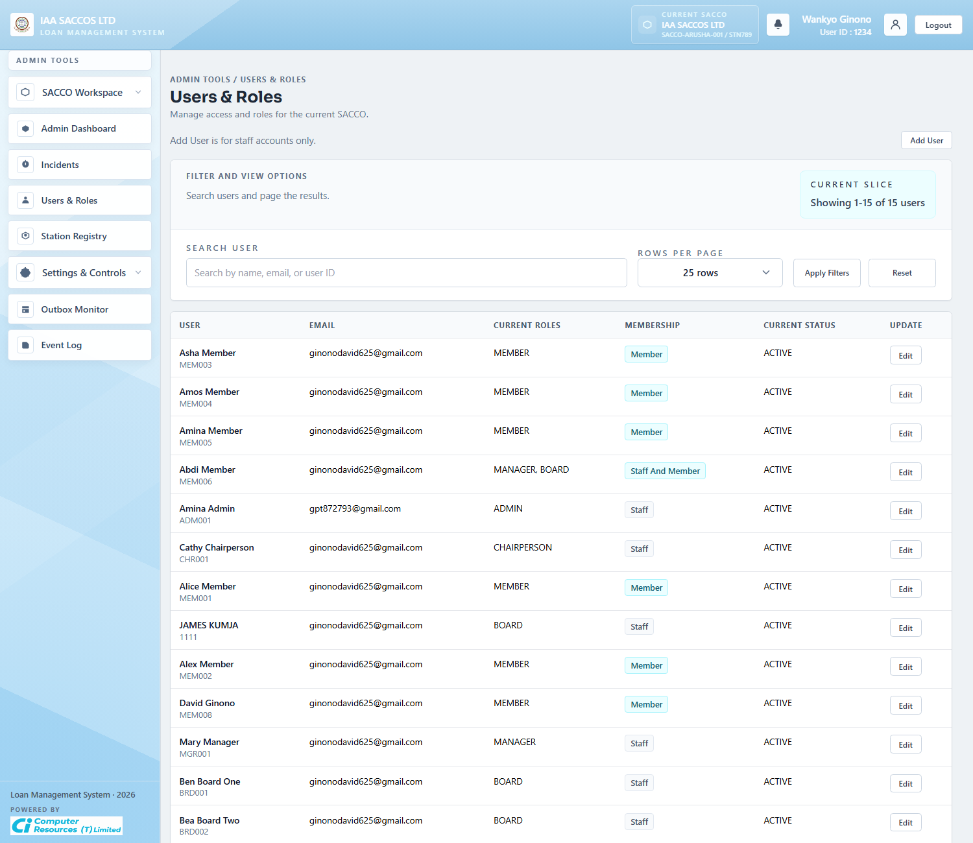
Workflow Explanation:
What happens:
- The Users and Roles table lists workspace accounts, staff role assignments, membership label, and current account status.
- The search and page controls help the admin manage a growing user list within the current SACCO.
On submit:
- Creating a user checks the selected role and then adds a new staff account to the current SACCO.
- Updating a row changes staff roles or the account status through the edit modal.
Approval flow:
- This screen changes access control, not loan state directly.
- The practical downstream effect is who can later review manager queues, board queues, or workspace settings.

4.4 User Edit Modal
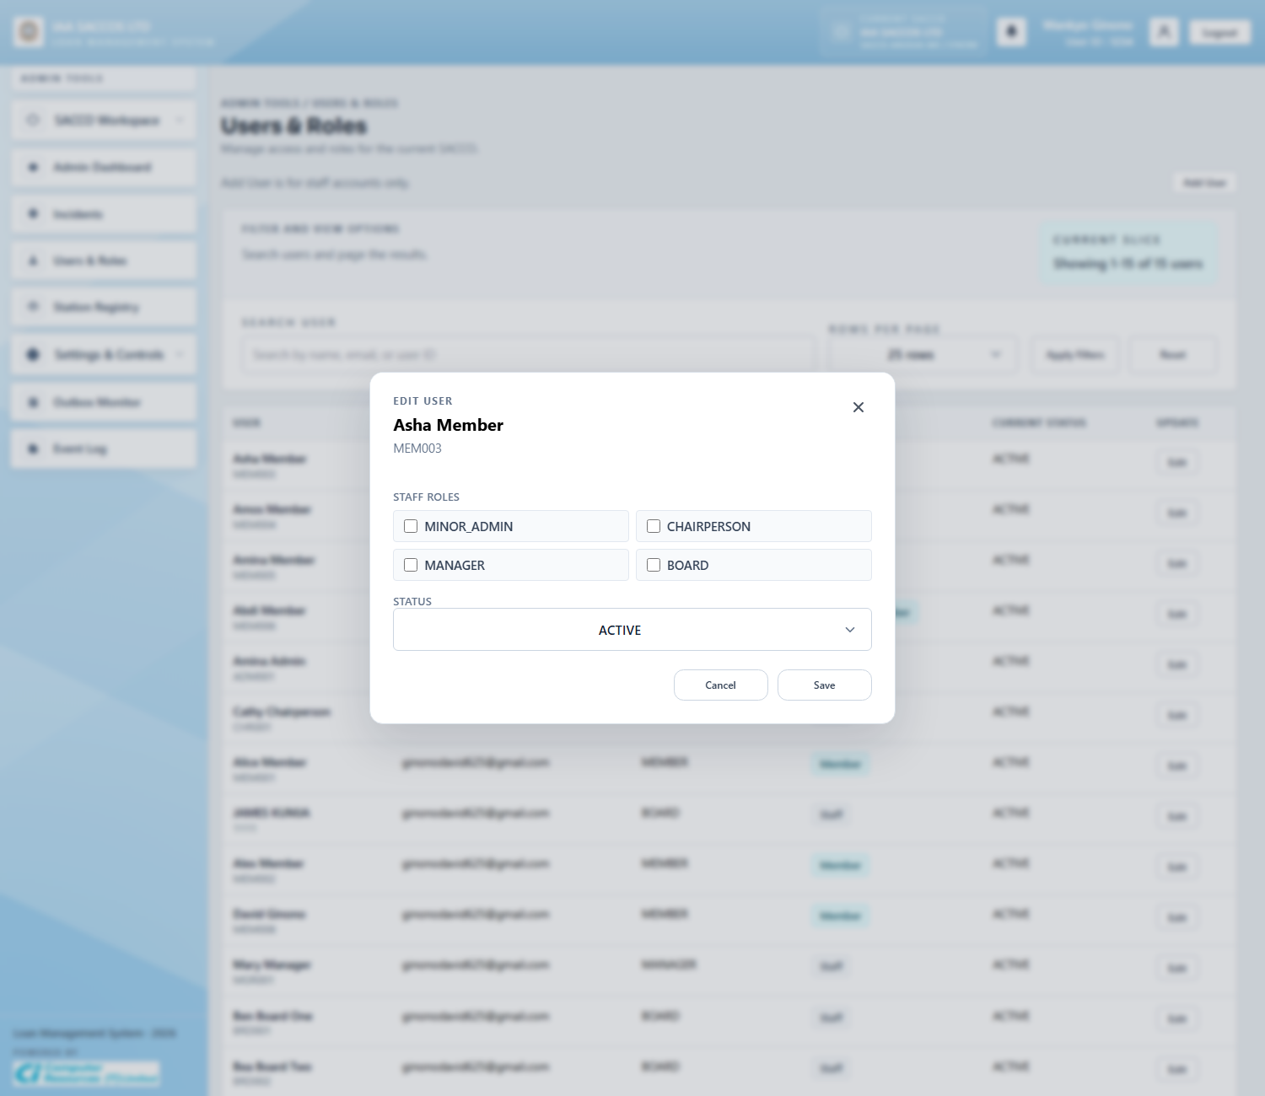
Workflow Explanation:
What happens:
- The edit modal exposes the role checkboxes and account status controls for one selected workspace user.
- It is the focused write surface for role correction, staff reassignment, and status management.
On submit:
- Submitting the modal calls the update-user flow, validates allowed roles for the acting admin, and persists the chosen status.
- The modal updates the member record rather than creating a new user.
Approval flow:
- No credit approval state changes happen here.
- The effect is administrative entitlement change, which controls who can see or act on later workflow queues.

4.5 Station Registry
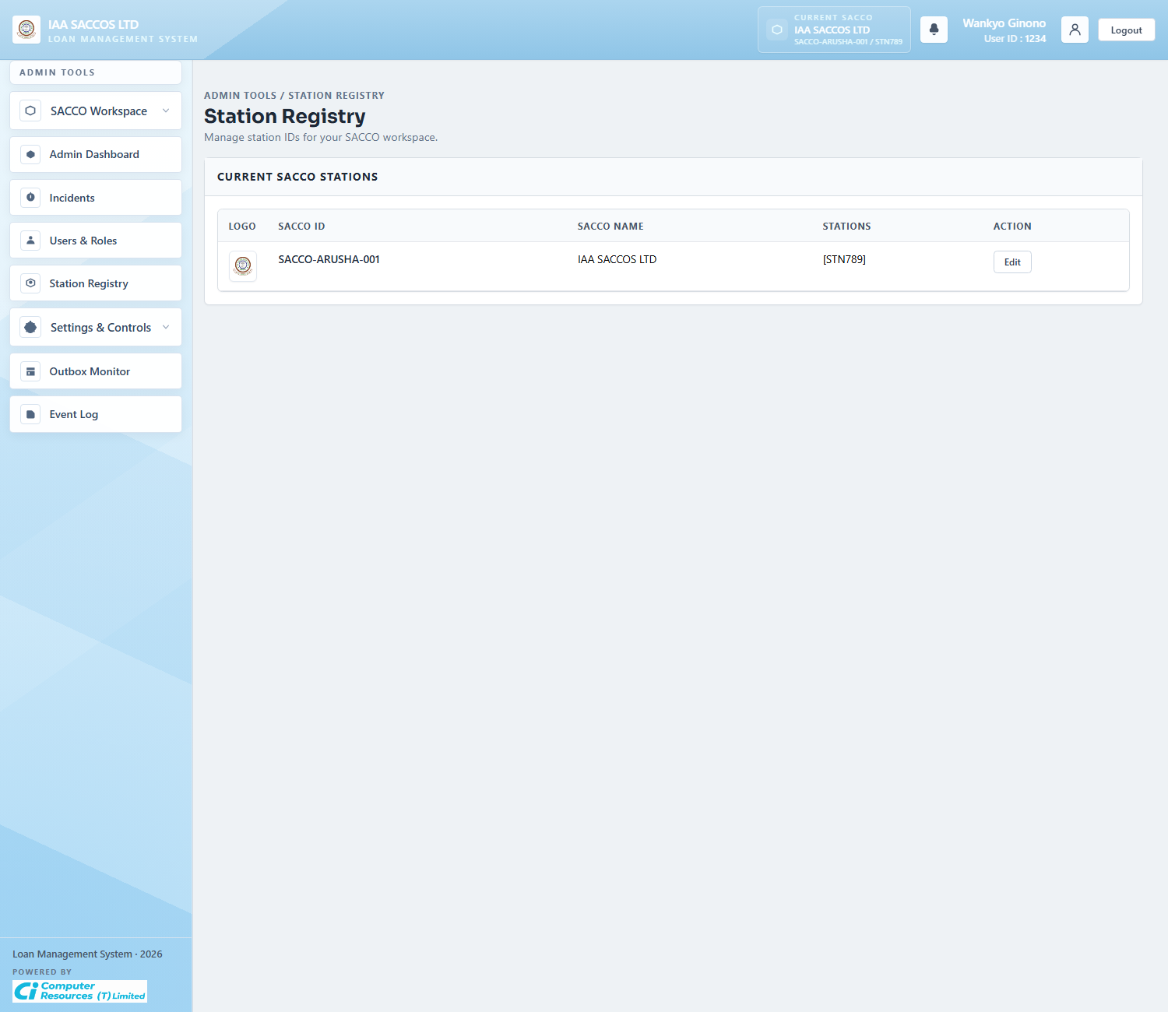
Workflow Explanation:
What happens:
- The station registry shows the stations that belong to the current SACCO.
- For Minor Admins, this is a narrowed operational view rather than a cross-platform registry.
On submit:
- Edits to the station list are saved through the SACCO update flow, but Minor Admins can only manage stations for their own SACCO.
- This keeps workspace identifiers aligned with member registration and external account lookups.
Approval flow:
- No loan approval step happens here.
- The value of this screen is keeping station identifiers valid so registration and external financial checks continue to resolve correctly.

4.6 Loan Application Settings
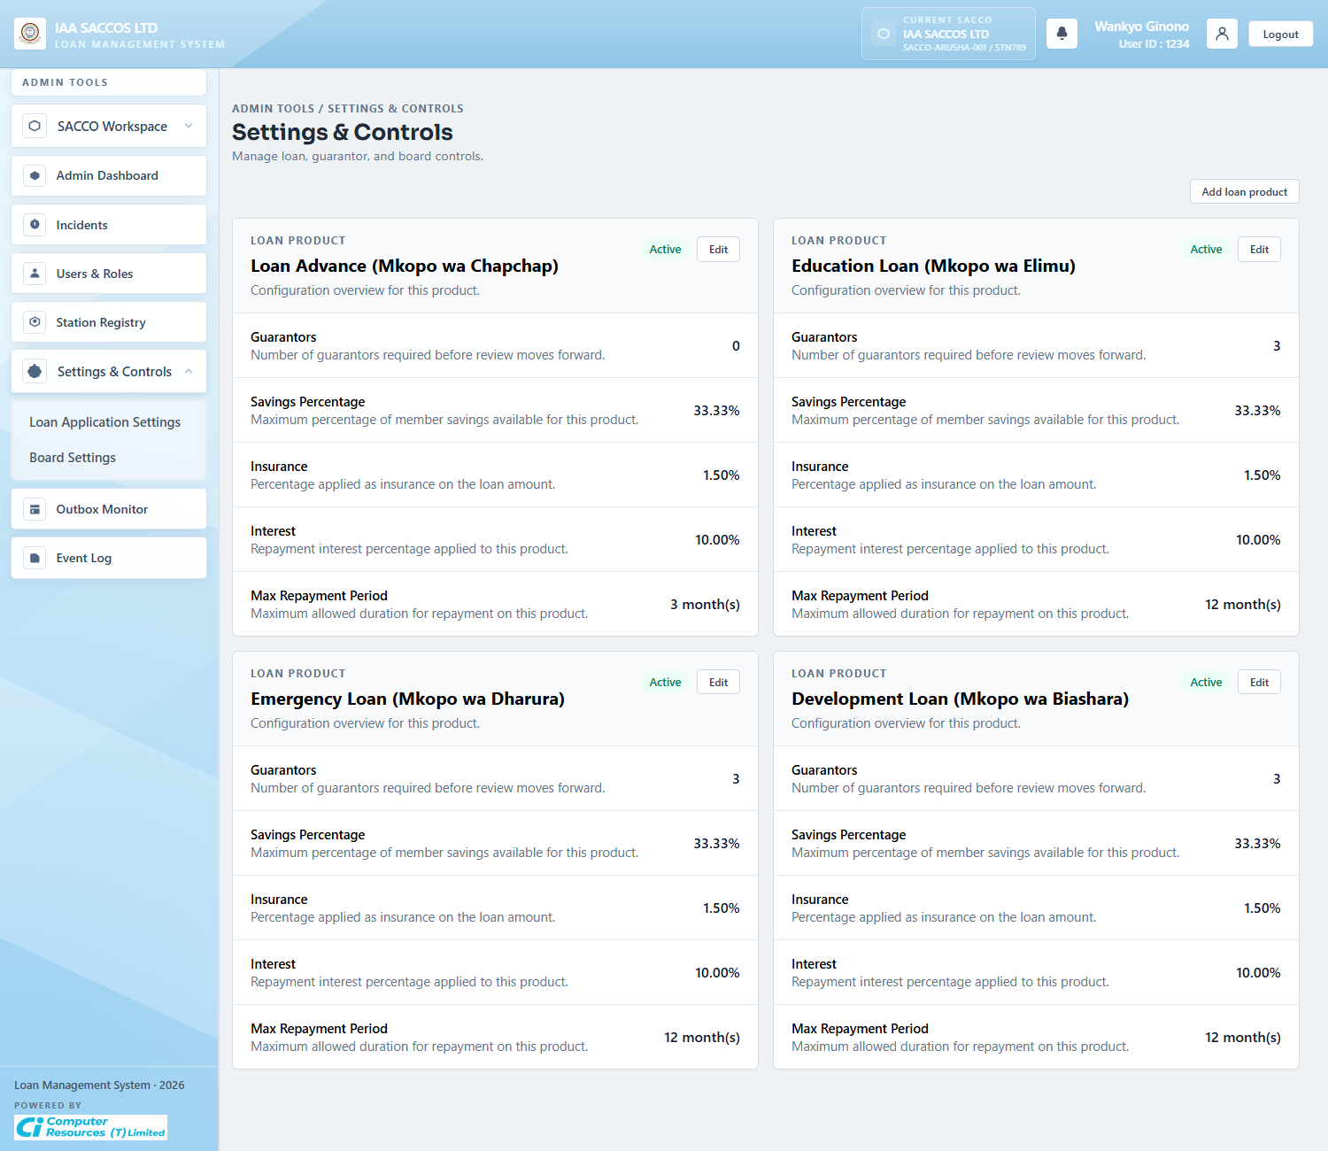
Workflow Explanation:
What happens:
- This screen lists the loan products active for the current SACCO together with guarantor count, savings ratio, insurance rate, interest rate, and repayment limits.
- It is the workspace control point for product-aware loan behaviour.
On submit:
- The screen itself is read-focused until the admin chooses edit or create actions.
- From here the admin can change the product rules that members must meet when preparing loan applications.
Approval flow:
- No existing application status is changed immediately by opening the list.
- The important effect is on future drafts, financial previews, guarantor requirements, and validation boundaries.

4.7 Edit Product Modal
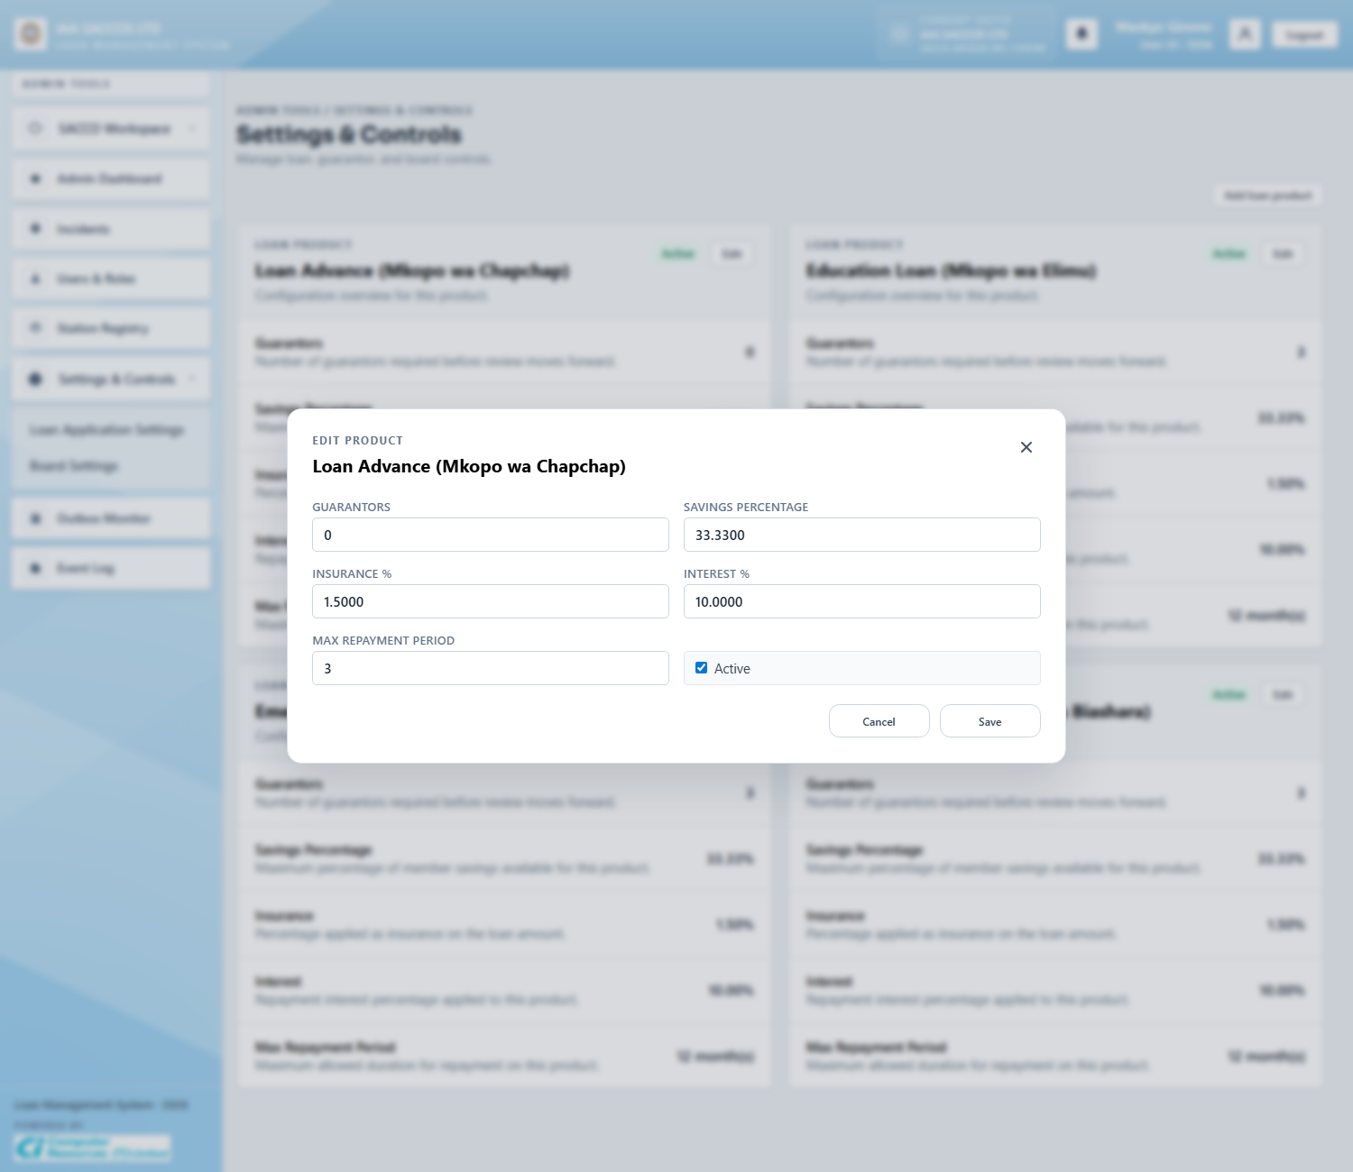
Workflow Explanation:
What happens:
- The product modal exposes the exact editable rules that drive product behaviour: guarantors required, savings percentage cap, insurance, interest, repayment months, and activation state.
- This is the fine-grained point where workspace policy becomes executable system configuration.
On submit:
- Saving the modal converts percentage inputs to ratios, validates the product identity, and persists the updated settings.
- A workspace can also add a customized product through the related create flow.
Approval flow:
- Existing applications are not retroactively re-approved by this save.
- The real impact is on subsequent drafts and previews that read current SACCO product configuration.

4.8 Board Settings
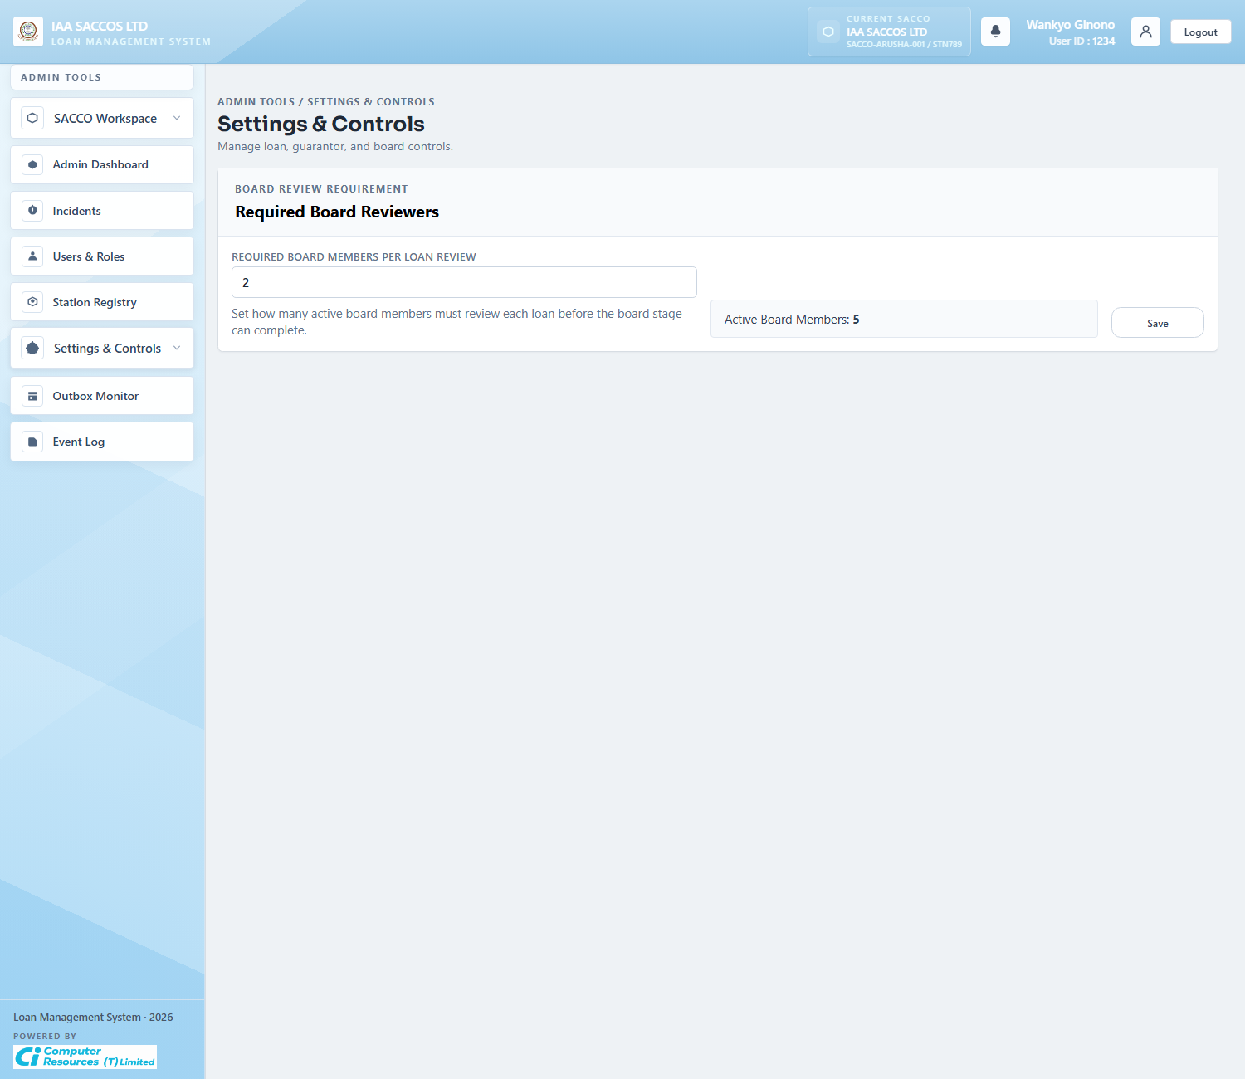
Workflow Explanation:
What happens:
- The board settings view controls how many board approvals are required before a loan can leave board review.
- This setting is important because it decides how many board decisions are needed before a board result becomes final.
On submit:
- Submitting the form updates the board-review requirement for the current SACCO.
- The value is saved at settings level and later read every time board decisions are evaluated.
Approval flow:
- This screen does not alter the state of a specific loan immediately.
- Any change here affects future board reviews by changing how many decisions are needed.

4.9 Workspace Outbox Monitor
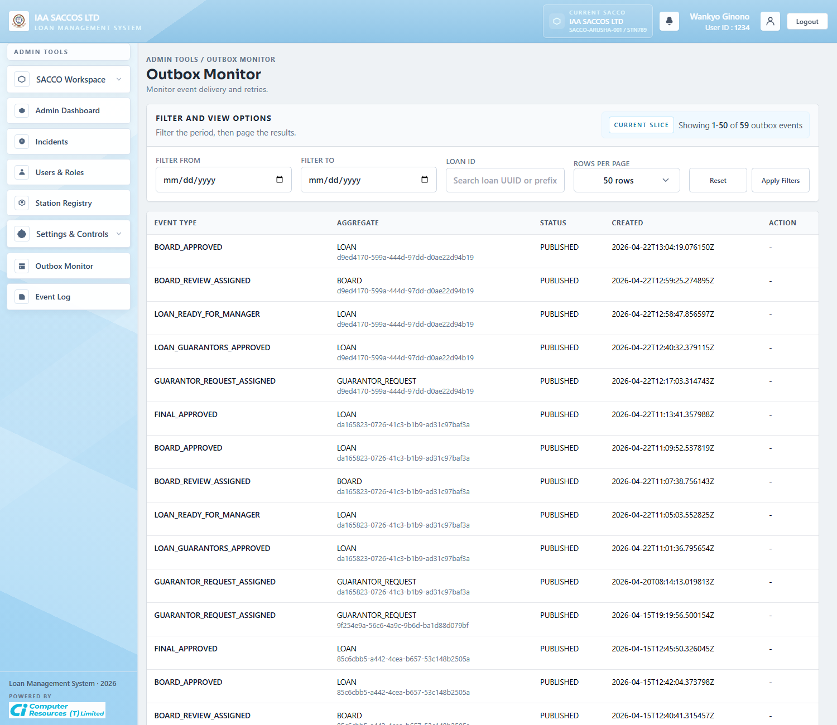
Workflow Explanation:
What happens:
- The workspace outbox monitor is the SACCO-level version of the platform outbox screen.
- It is used to inspect workflow events generated inside the current SACCO, including guarantor, manager, board, and final-status notifications.
On submit:
- The main write action is retrying an event that should be republished.
- Filters help isolate one loan or one date window before the admin retries the event.
Approval flow:
- This screen reflects workflow changes after they happen; it does not create them.
- Operationally, it answers whether a committed business event was queued and whether a retry is needed.

4.10 Workspace Event Log
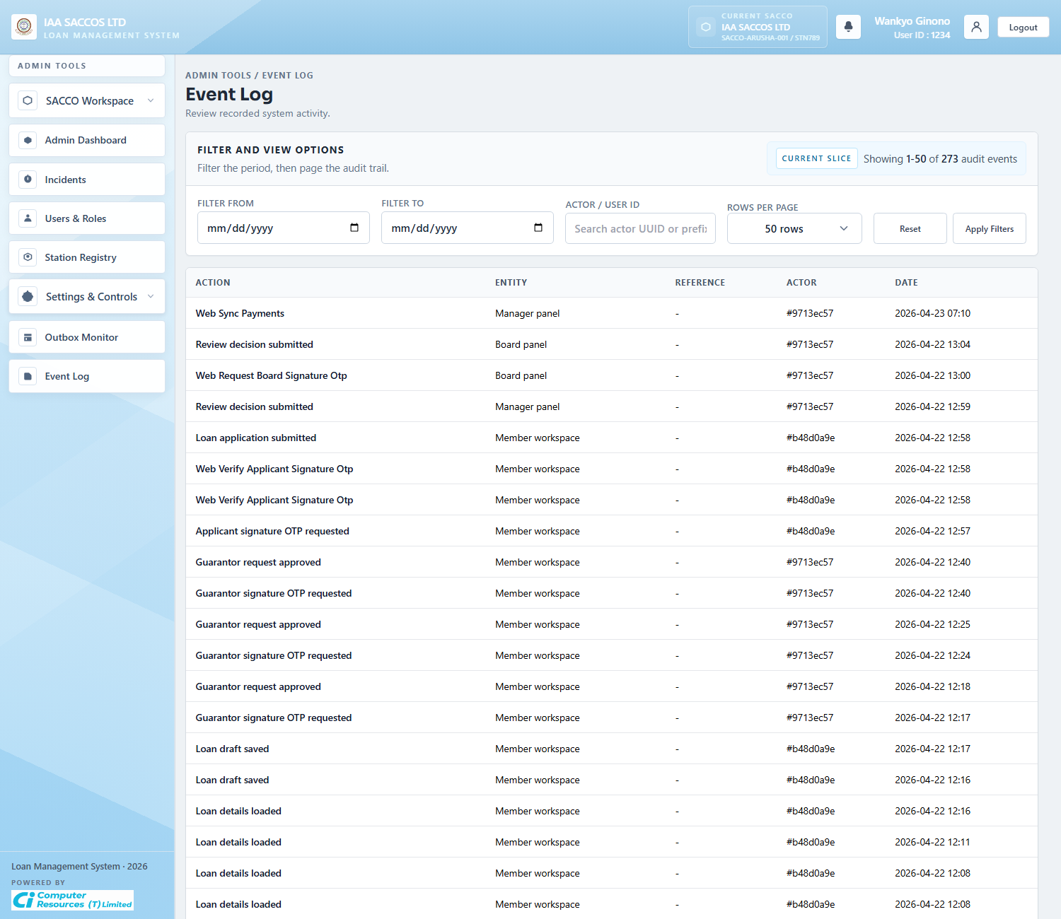
Workflow Explanation:
What happens:
- This audit view narrows operational history to events that matter to administrators monitoring one workspace.
- It is the forensic screen for tracing who approved, rejected, retried, invited, or updated something.
On submit:
- The filter bar is read-only and affects only the query window.
- No persistent workflow mutation occurs on this screen.
Approval flow:
- The approval chain has already happened by the time an entry appears here.
- The screen is useful during support and compliance review because it records the observable history of those actions.

5. Member Workflow Screens

5.1 Member Dashboard
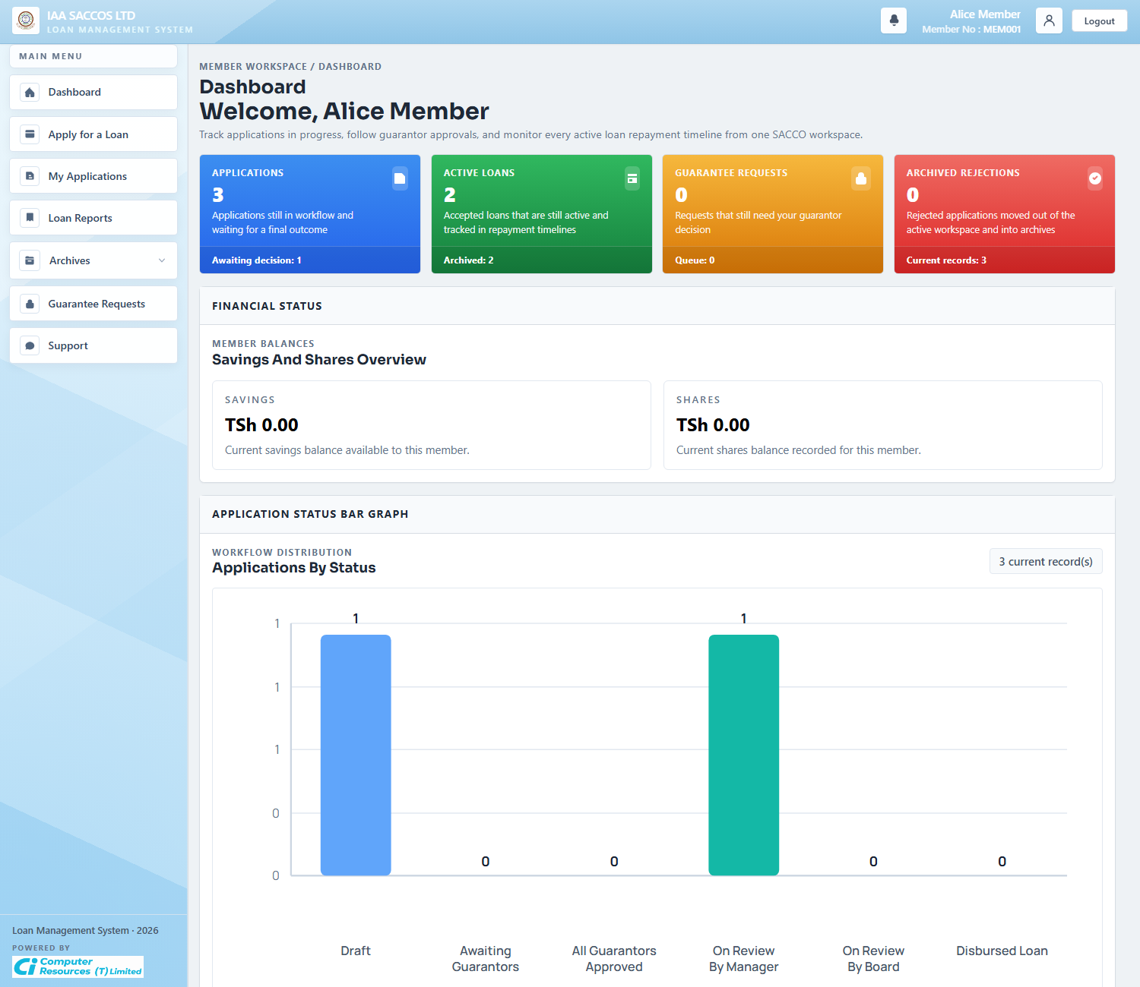
Workflow Explanation:
What happens:
- The member dashboard shows current applications, pending guarantees, active repayment exposure, and application status distribution for the signed-in member.
- It is the summary landing page after member authentication succeeds.
On submit:
- The dashboard itself does not submit a loan.
- It gives the member quick access to product selection, application detail, archives, guarantees, reports, and support.
Approval flow:
- No workflow state changes occur here.
- The dashboard reflects the member's current stage across draft, guarantor, manager, board, and disbursed-loan views.

5.2 Loan Products
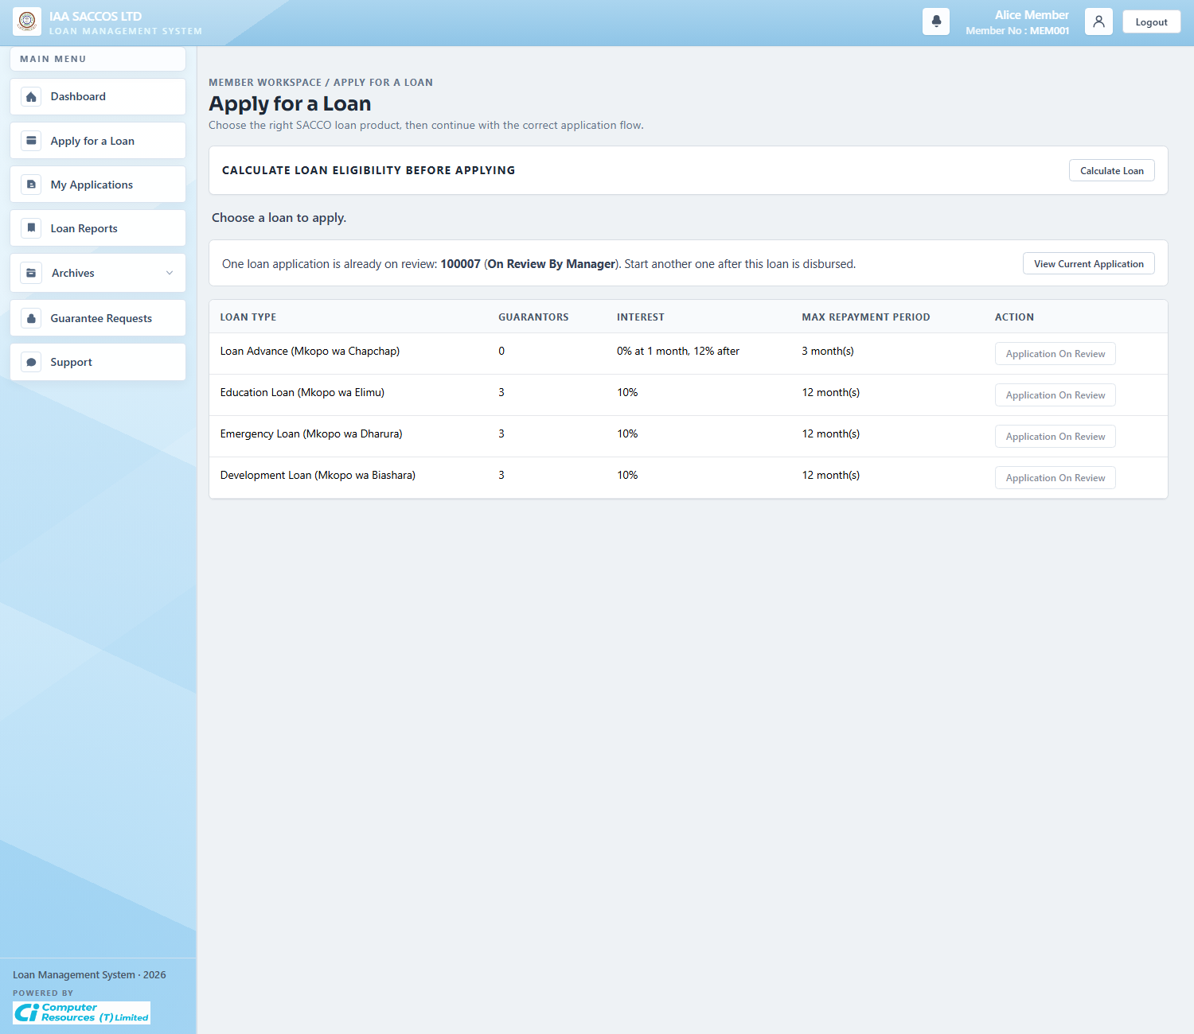
Workflow Explanation:
What happens:
- The Loan Products page lists the active products for the member's SACCO and exposes the apply or calculator actions for each product.
- Members only see the loan products available in their SACCO.
On submit:
- Selecting Apply opens the application form for the chosen product.
- If the member already has a review-locked application, the page shows the lock and prevents starting another one.
Approval flow:
- No application status is created by simply opening the product list.
- The next step is opening a new application draft for that product.

5.3 Loan Calculator Modal
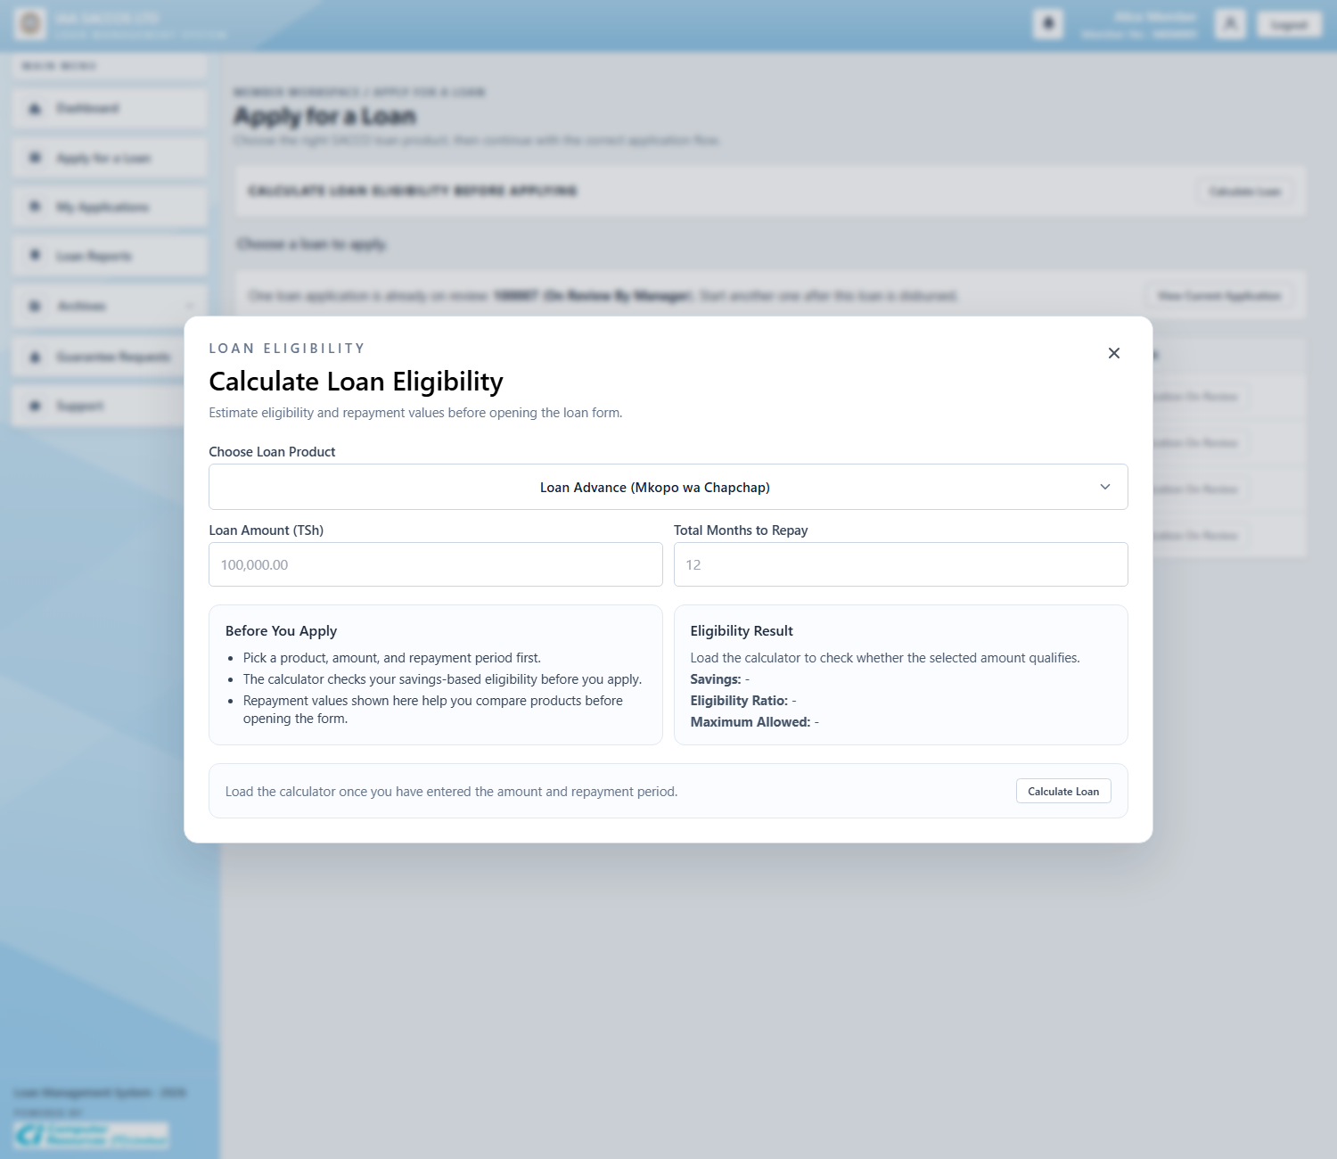
Workflow Explanation:
What happens:
- The calculator modal gives the member a pre-application estimate of eligibility and repayment values before a draft is saved.
- It helps the member choose a realistic amount and tenor using the current SACCO's product rules.
On submit:
- This modal does not create a loan record by itself.
- Its role is to preview values that the form will later persist into the draft's financial snapshot.
Approval flow:
- No approval stage begins here.
- The member moves next to the actual application form once the estimate looks acceptable.

5.4 New Loan Application With Financial Details
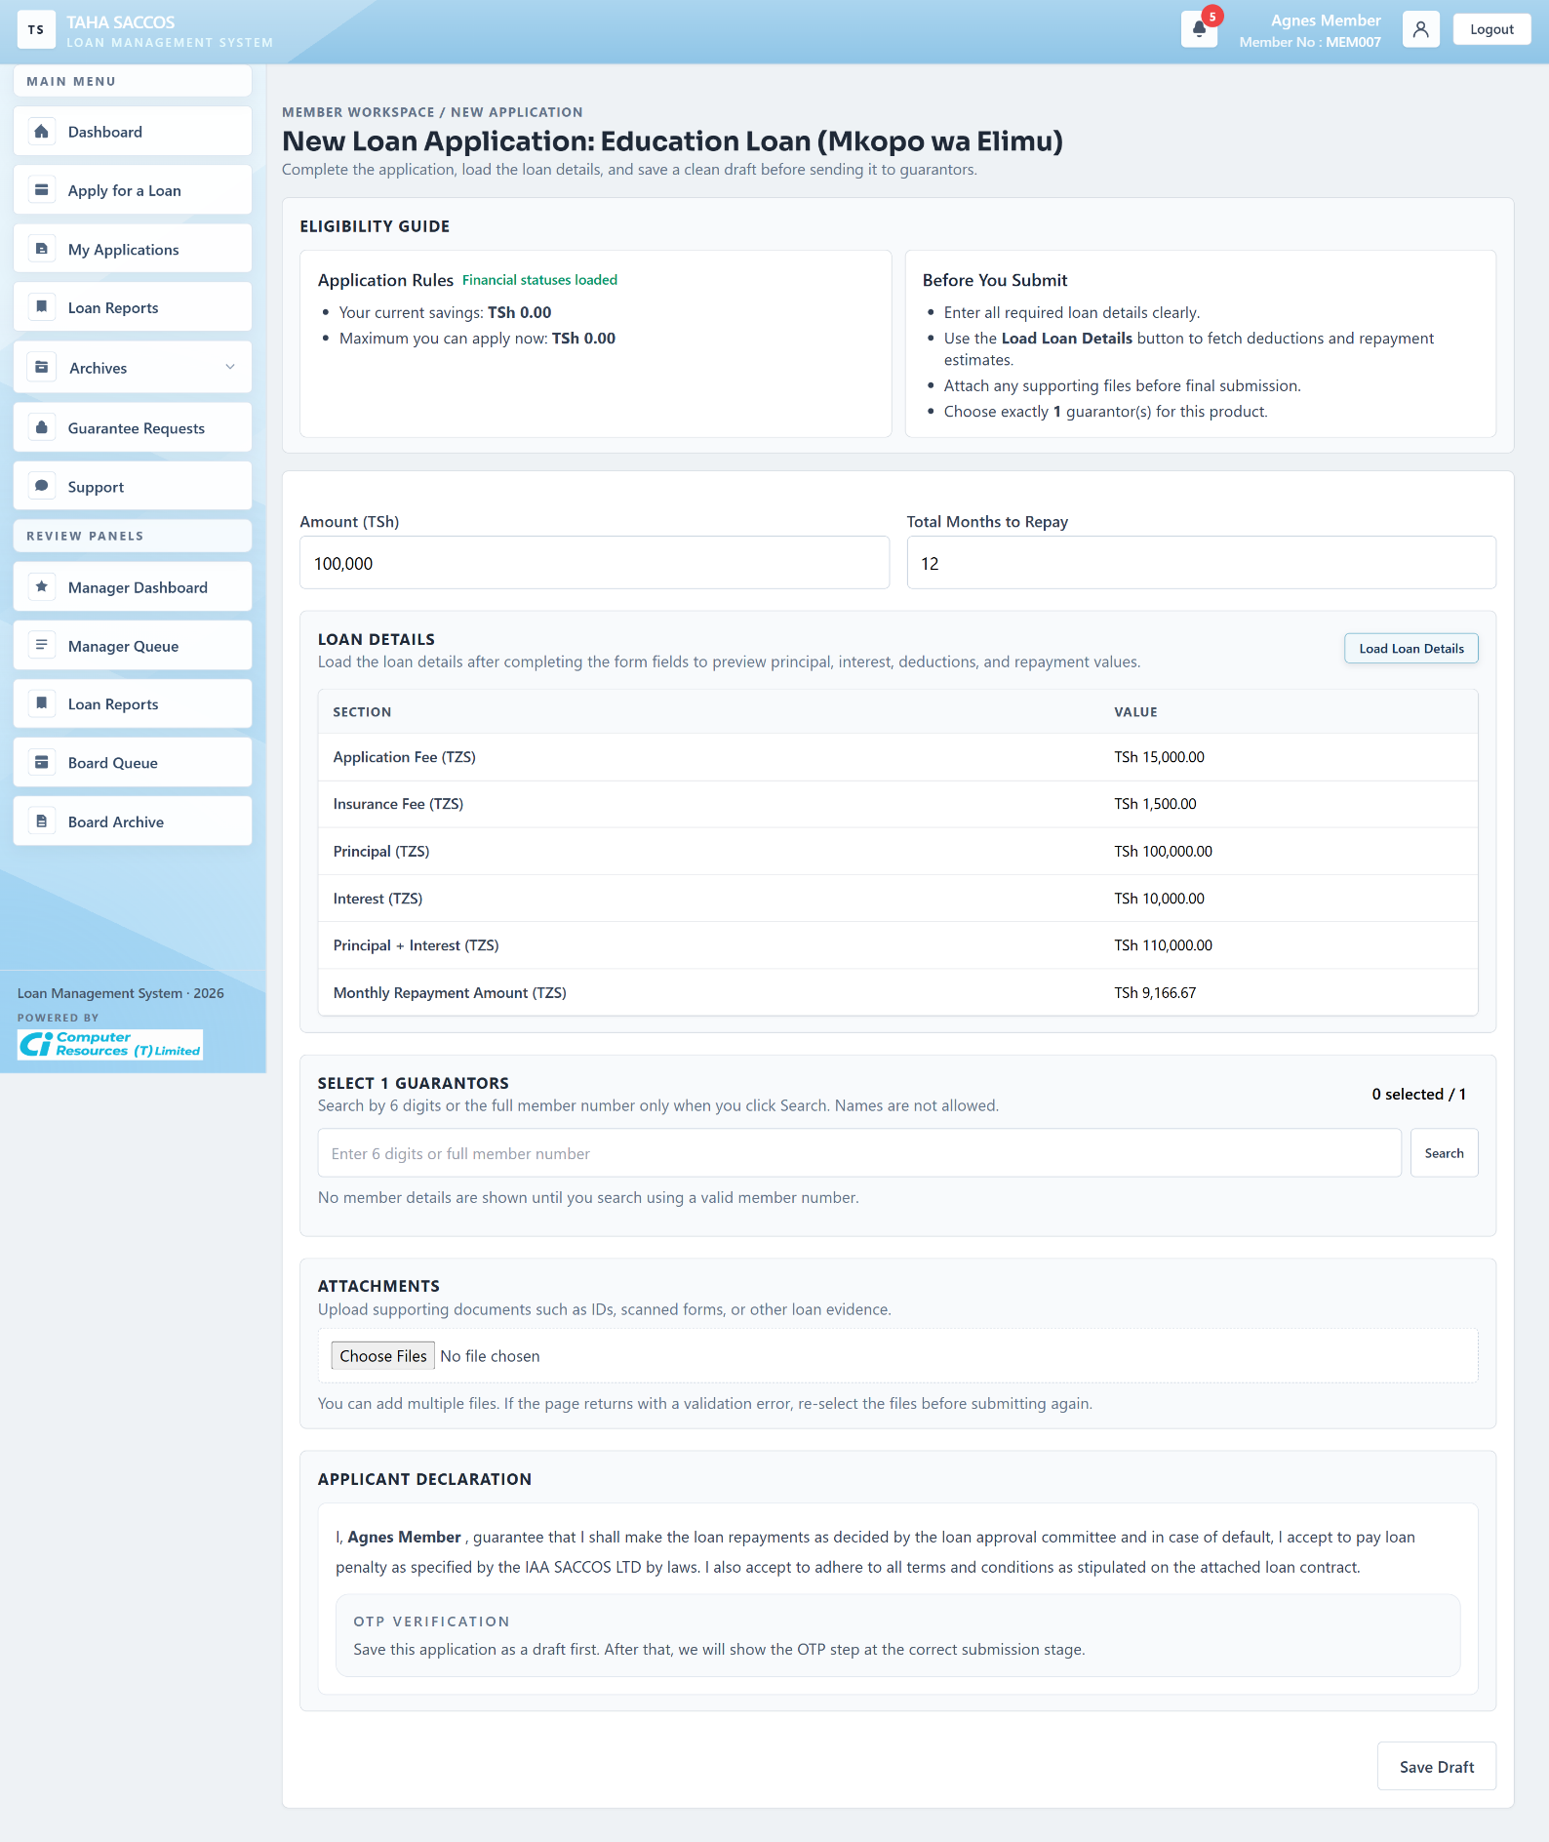
Workflow Explanation:
What happens:
- This screenshot shows the product-aware application form after the member has entered amount and tenor and loaded the official SACCO financial details.
- The page now displays the calculated fees, interest, principal, repayment amount, guarantor selector, attachment uploader, and applicant declaration in one transaction-ready draft form.
On submit:
- Saving keeps the application as a draft after checking the repayment period, required form details, guarantor count, and current eligibility rules.
- At this stage the OTP area is informational because the member must first save the application before the submit path becomes available.
Approval flow:
- The normal next step is draft persistence first, then later submission to guarantors or directly to manager review depending on the product's guarantor requirement.
- The required number of guarantors comes from the loan product rules set for that SACCO.
External system communication:
- While the member is filling this form, the system can pull current savings and related financial status from the Foresight financial app endpoint.
- That live check helps the form show the latest borrowing limit and prevents the member from continuing with outdated financial information.

5.5 Application Ready For Manager Submission
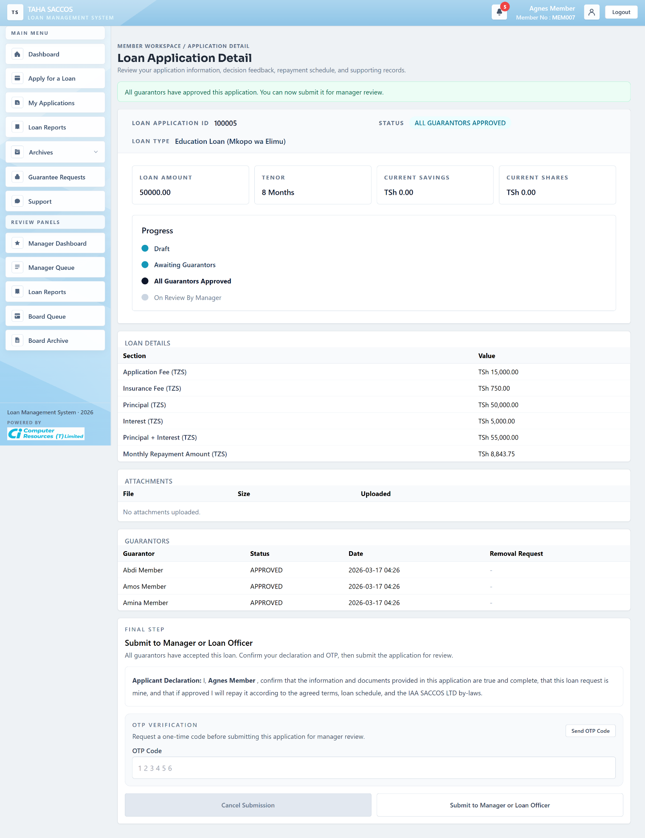
Workflow Explanation:
What happens:
- This detail screen shows the application after all required guarantors have approved, so the status is ALL GUARANTORS APPROVED and the final member submission block is now unlocked.
- The member can review the approved guarantor rows, the loaded financial details, and the final declaration before handing the application to manager review.
On submit:
- Submitting here asks the member to confirm with a one-time code and then forwards the application to the manager.
- If the member clicks cancel while the application is still at an early review step, the system handles that cancellation formally instead of removing it without trace.
Approval flow:
- After this step, the application moves to manager review.
- A handoff message is prepared so the manager side can react to the submission.

5.6 My Applications
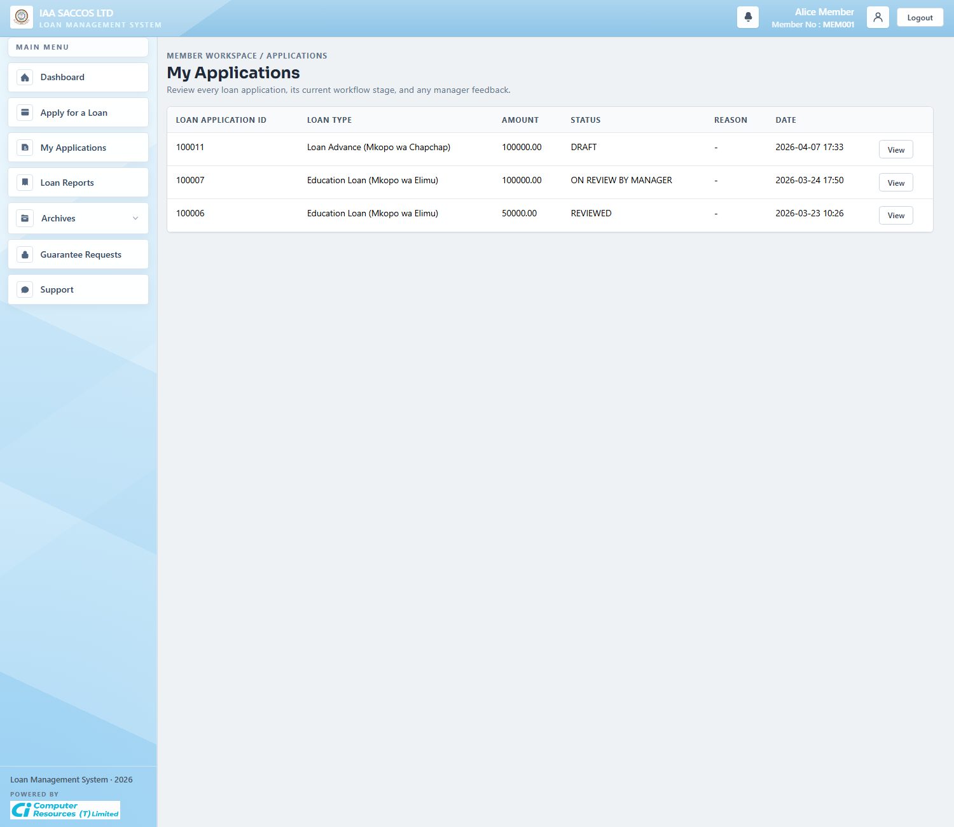
Workflow Explanation:
What happens:
- The My Applications list is the member's registry of current drafts and submitted applications that are not yet archived.
- It surfaces the current workflow stage and gives the member a direct path into each application's detail page.
On submit:
- This list page is read-only until the user opens a record.
- Actions such as edit, submit, cancel, or delete are handled on the detail or draft form, not on the list itself.
Approval flow:
- No status changes occur here.
- The value of the screen is quick status inspection and navigation into the exact application that needs attention.

5.7 Loan Application Detail (Draft And OTP State)
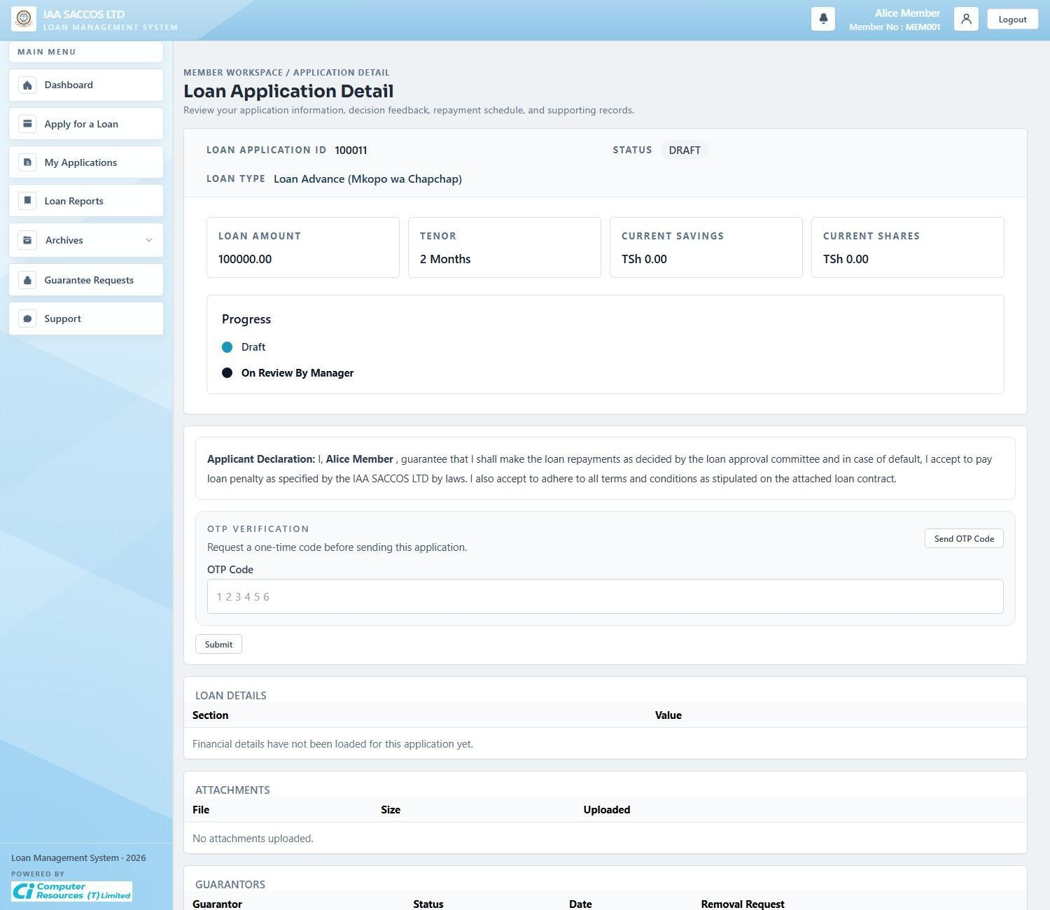
Workflow Explanation:
What happens:
- This screen shows a member's application while it is still being prepared, before it leaves the member area.
- Because the financial details are not yet loaded here, the screen explicitly shows that the official deductions section is still empty.
On submit:
- The member can return to edit the draft, load the financial details, request an OTP, and then submit when the product rules allow it.
- While it is still a draft, the member can keep updating it. Once submitted, it moves either to guarantor review or straight to manager review, depending on the product rules.
Approval flow:
- Draft is the last fully editable state.
- Once the application leaves draft, it becomes more controlled and other reviewers can start seeing it.

5.8 Member Loan Reports
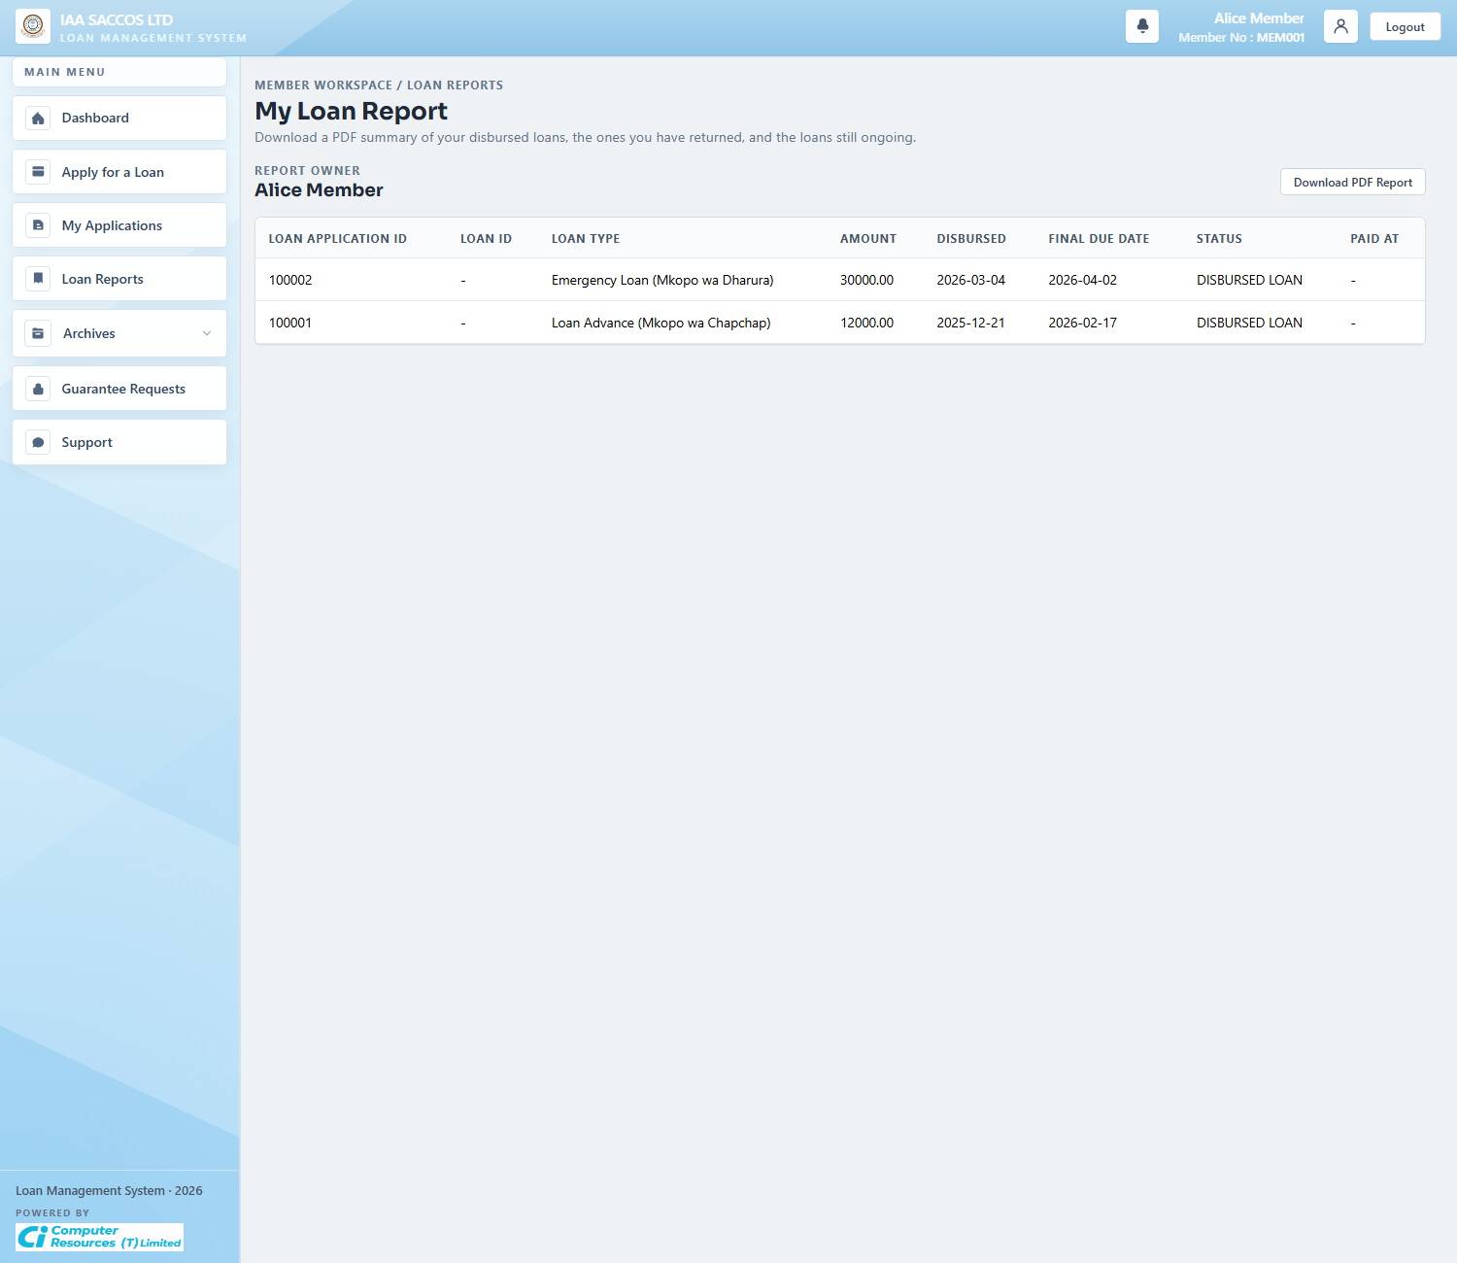
Workflow Explanation:
What happens:
- The report screen summarizes the member's disbursed, paid, and ongoing loans in a flat reporting table.
- It is a historical and analytical view rather than a live approval workspace.
On submit:
- This screen is read-only.
- The main action is exporting the report when the member needs a printable or shareable summary of loan history.
Approval flow:
- No workflow transition occurs here.
- The report depends on already-recorded disbursement, paid, and defaulted states.

5.9 Disbursed And Loan Archive
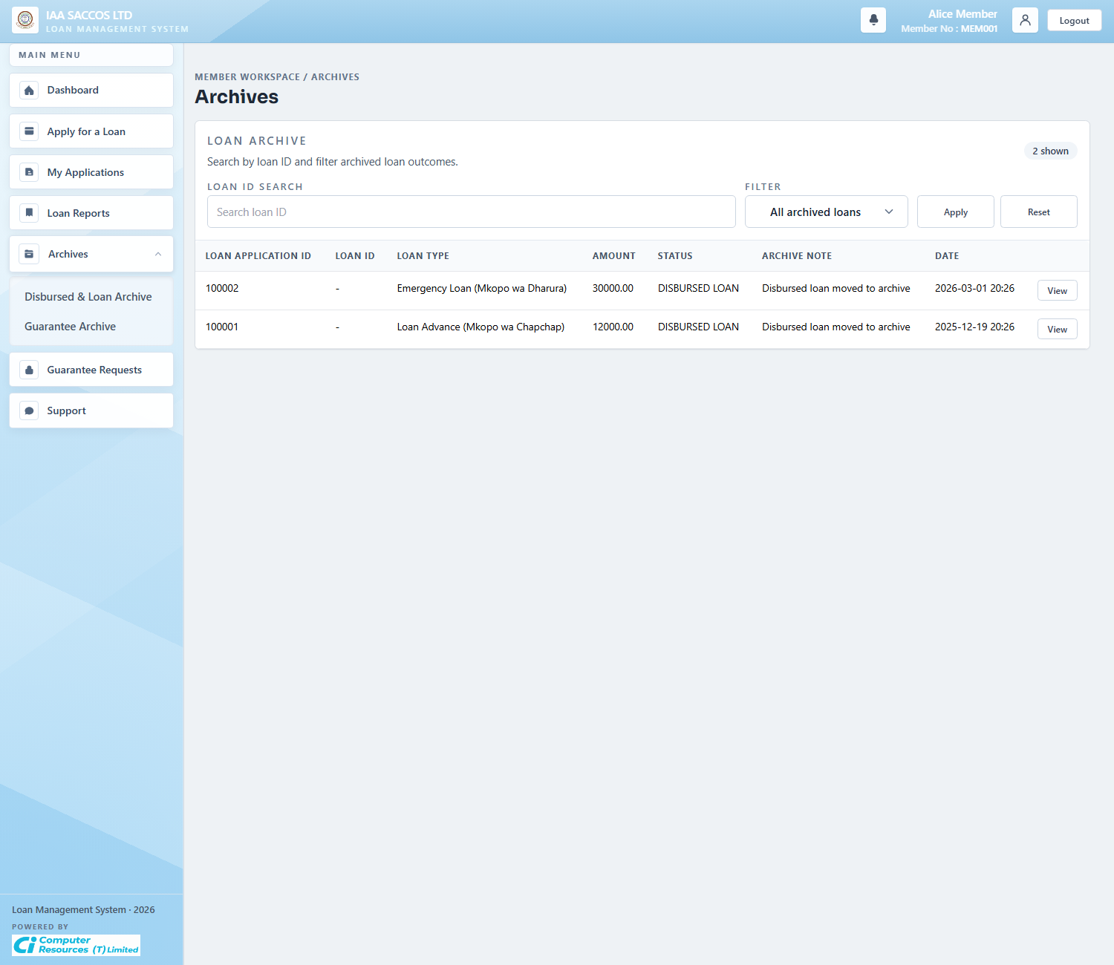
Workflow Explanation:
What happens:
- The loan archive shows historical applications that have already left the member's active work queue.
- It separates archived loans from current applications so the main list remains focused on actionable records.
On submit:
- This archive view is read-only and filter-based.
- The member uses it to inspect past disbursed, rejected, or closed application records without interfering with active items.
Approval flow:
- Archived rows are the output of earlier workflow completion, rejection, or settlement.
- No approval chain runs from this screen; it is the evidence side of the workflow.

5.10 Guarantee Archive
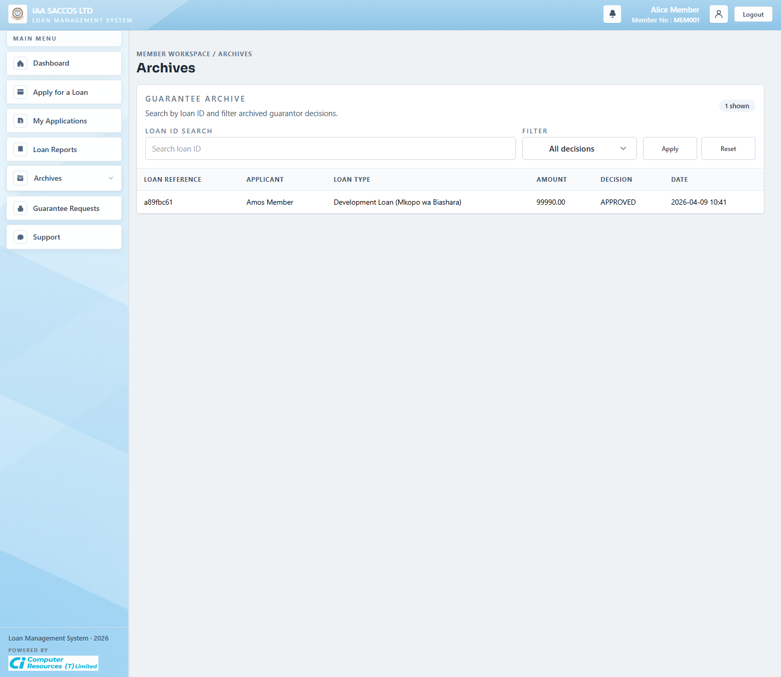
Workflow Explanation:
What happens:
- The guarantee archive stores past guarantor decisions separately from the active guarantee-request queue.
- It lets the member review which guarantee commitments were approved, rejected, or otherwise completed historically.
On submit:
- The archive is read-only.
- Removal requests and active approval actions are handled on the live Guarantee Requests screen instead.
Approval flow:
- No new guarantor approval decision is made here.
- The archive documents completed guarantor history after the live action window has passed.

5.11 Guarantee Requests
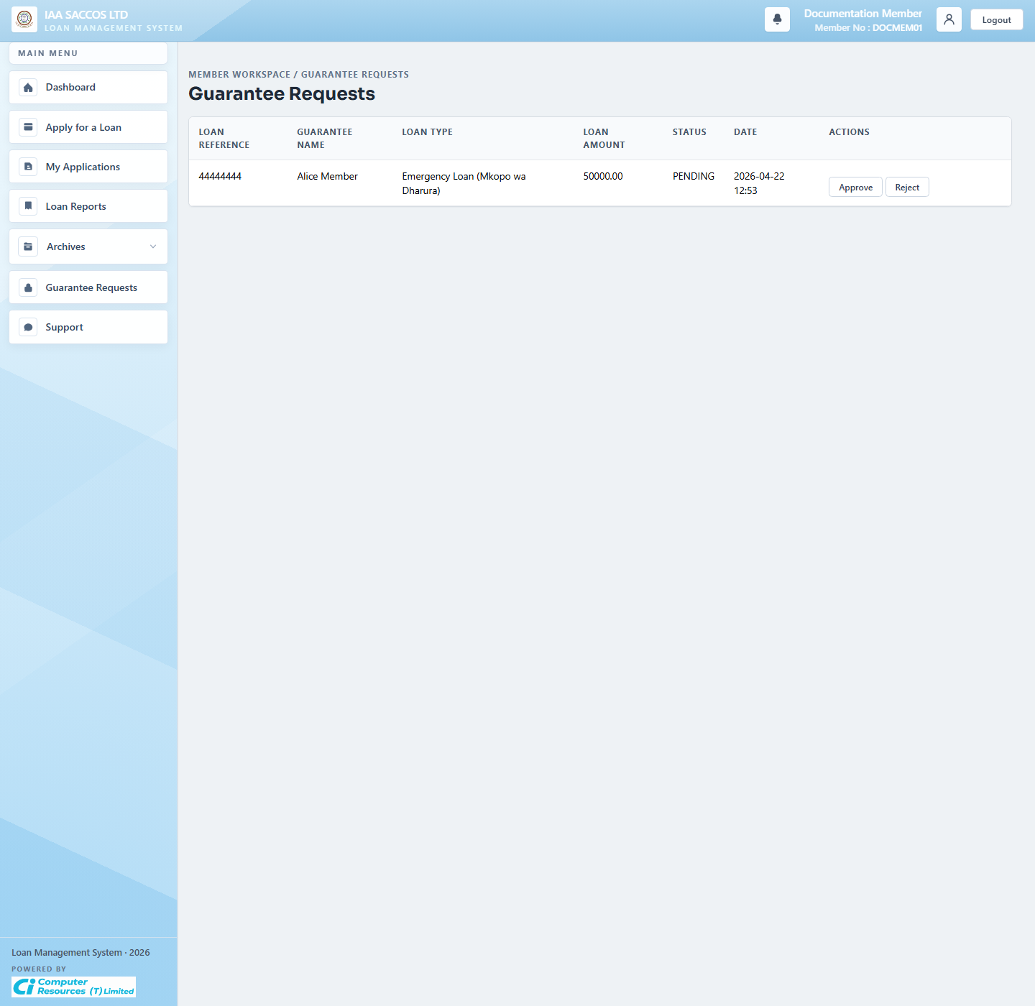
Workflow Explanation:
What happens:
- This is the guarantor's active work queue, showing the applicant, loan type, amount, current status, and actions for a pending guarantee request.
- The visible Approve and Reject buttons are the entry points into the guarantor decision flow.
On submit:
- To approve, the guarantor confirms the declaration, requests a one-time code, verifies it, and submits the decision.
- Rejection immediately records the refusal, which blocks the application from reaching All Guarantors Approved until the applicant replaces or resolves the guarantor requirement.
Approval flow:
- When all required guarantors approve, the application becomes ready for the member to send to the manager.
- That transition unlocks the applicant's final submit-to-manager step.

5.12 Support
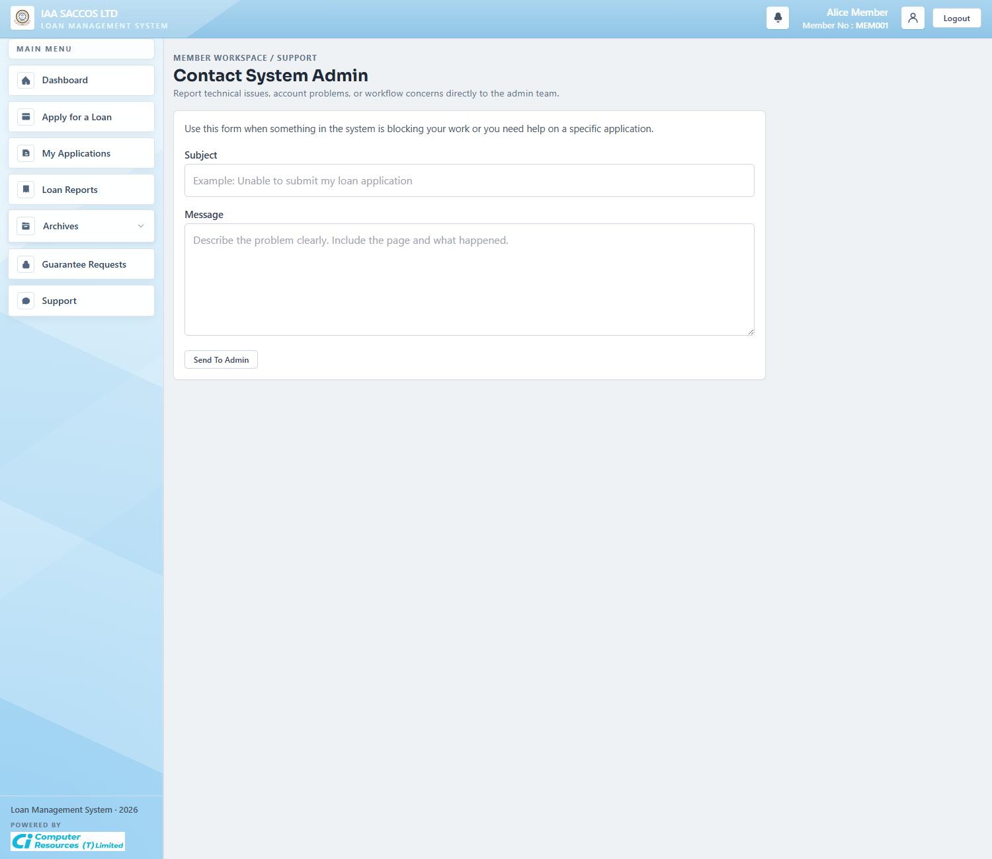
Workflow Explanation:
What happens:
- The support form lets a member report technical, account, or workflow issues directly to workspace administration.
- It is the member-facing intake point that feeds the admin incidents and message-handling workflow.
On submit:
- Submitting the form creates a support message for the current SACCO admin team.
- The member only enters the subject and message, and the system links the request to the correct SACCO and member account automatically.
Approval flow:
- This does not alter loan approval state directly.
- The next operational step is usually an incident review or an admin reply from the administration workspace.

6. Manager Workflow Screens

6.1 Manager Dashboard
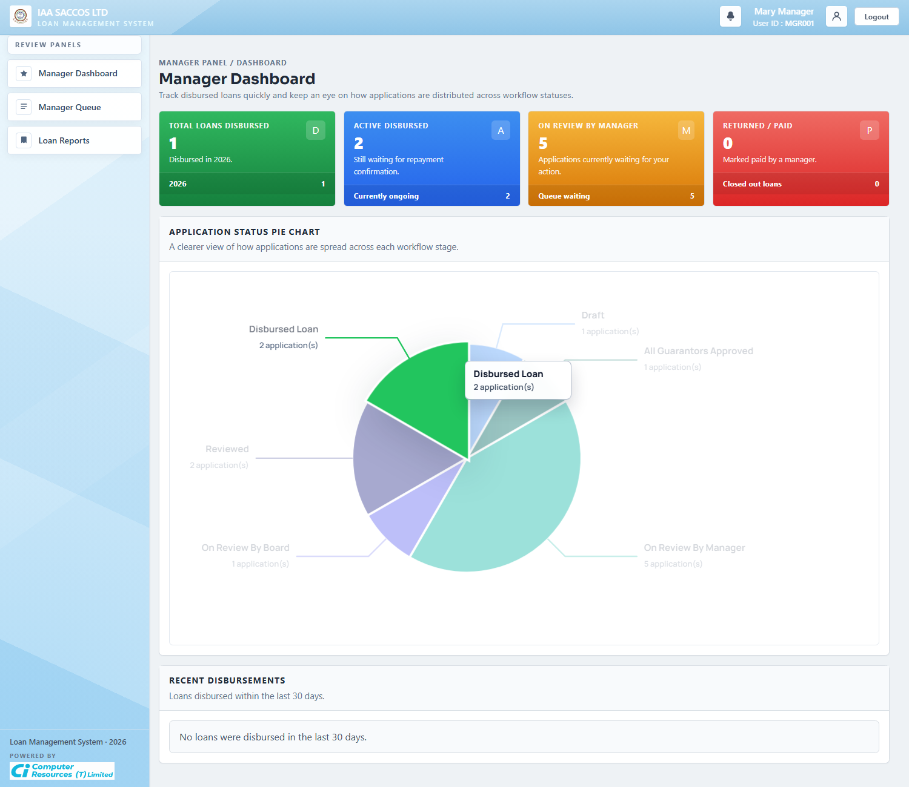
Workflow Explanation:
What happens:
- The manager dashboard summarizes how many loans are disbursed, awaiting repayment completion, waiting in manager review, or already returned and paid.
- It also visualizes status distribution so the manager can see queue pressure and recent disbursement activity quickly.
On submit:
- The dashboard itself is read-only.
- The manager uses it to jump into the queue or reports rather than making a decision directly from the chart.
Approval flow:
- No application status changes on this page.
- It is the monitoring layer for manager workload and disbursement trend visibility.

6.2 Manager Queue (On Review By Manager)
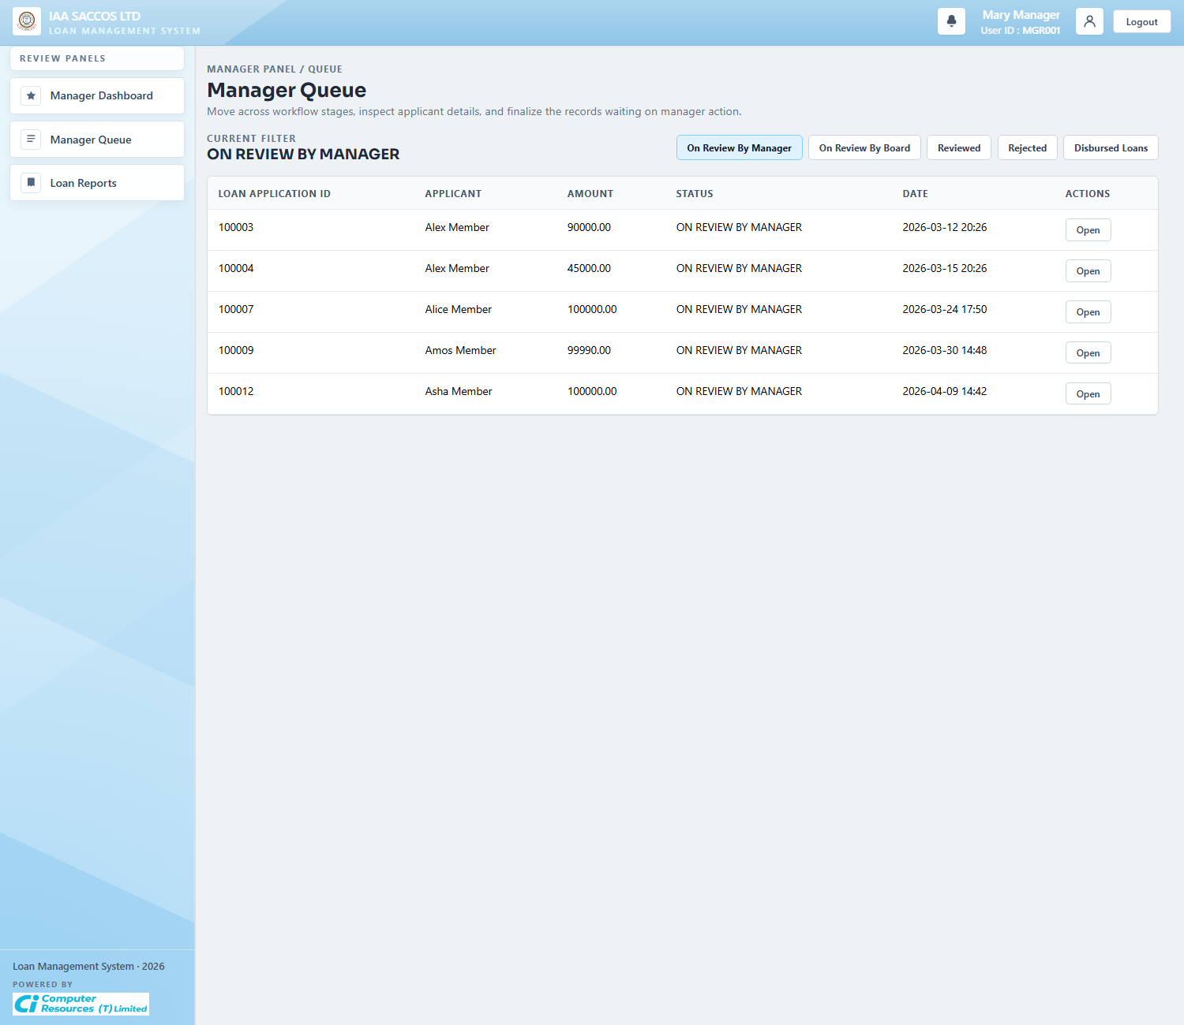
Workflow Explanation:
What happens:
- This queue shows applications that have reached manager review and are waiting for a decision.
- Each row represents a member application that has already satisfied the guarantor stage when guarantors were required.
On submit:
- Opening a row sends the manager into the full review detail page.
- No decision becomes final until the manager accepts or rejects the application from the detail screen.
Approval flow:
- From here, the manager can either reject the application or send it forward for board review.
- This queue is therefore the last purely manager-owned decision gate before board review begins.

6.3 Manager Queue (On Review By Board)
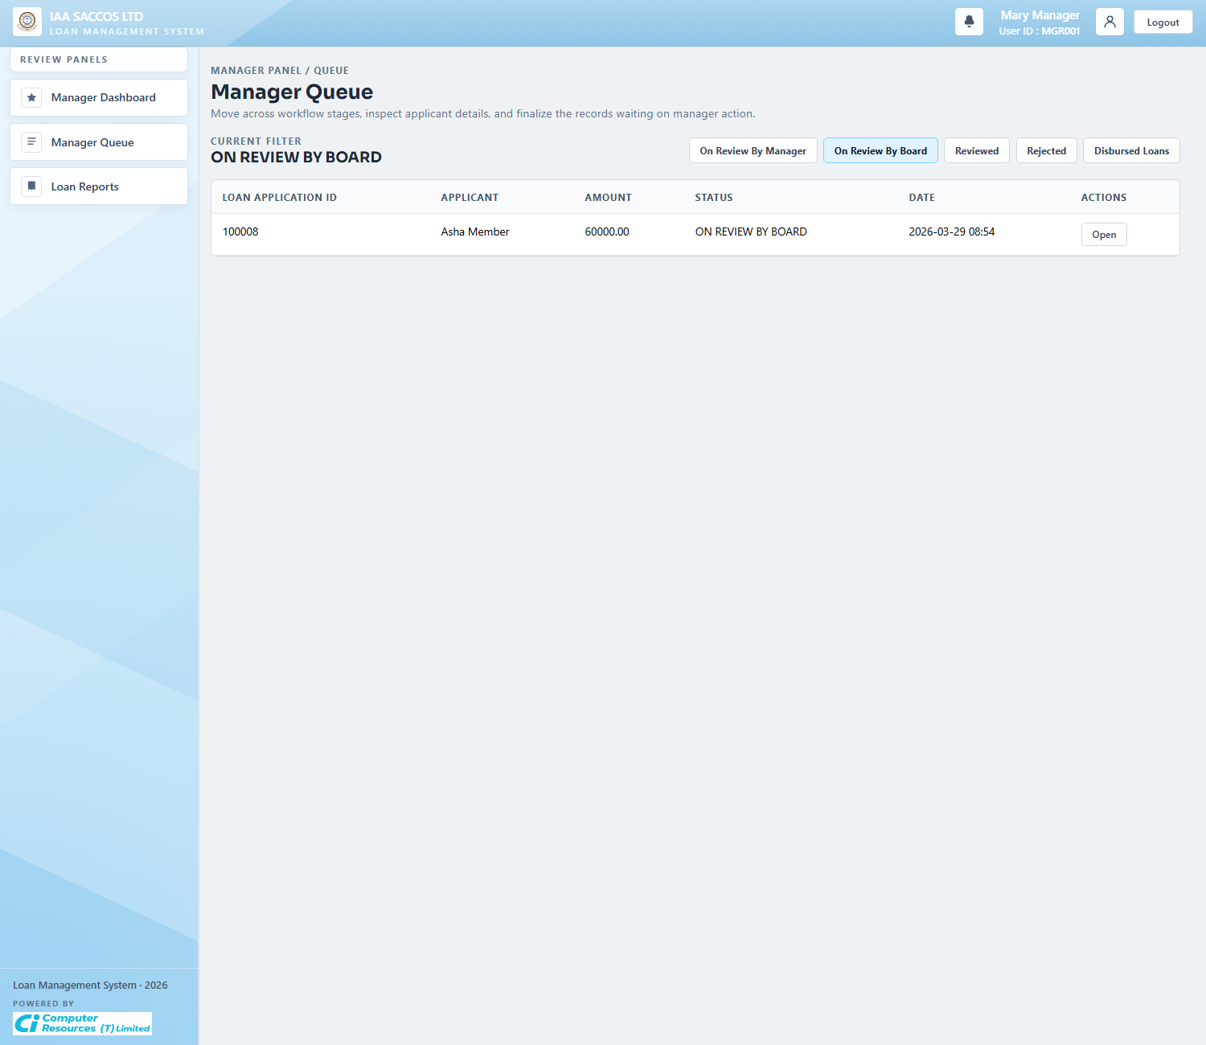
Workflow Explanation:
What happens:
- This queue view switches the manager's list to applications that already moved beyond manager acceptance and are now in board review.
- It helps the manager track items that have left the direct manager queue but still need finalization later.
On submit:
- The list itself does not write data.
- The manager opens a row when they need to inspect the current board-stage detail or prepare for later finalization.
Approval flow:
- The next step is a board result, which becomes either approved or rejected once enough board decisions have been recorded.
- The manager cannot disburse until board approval is reached.

6.4 Manager Review Detail
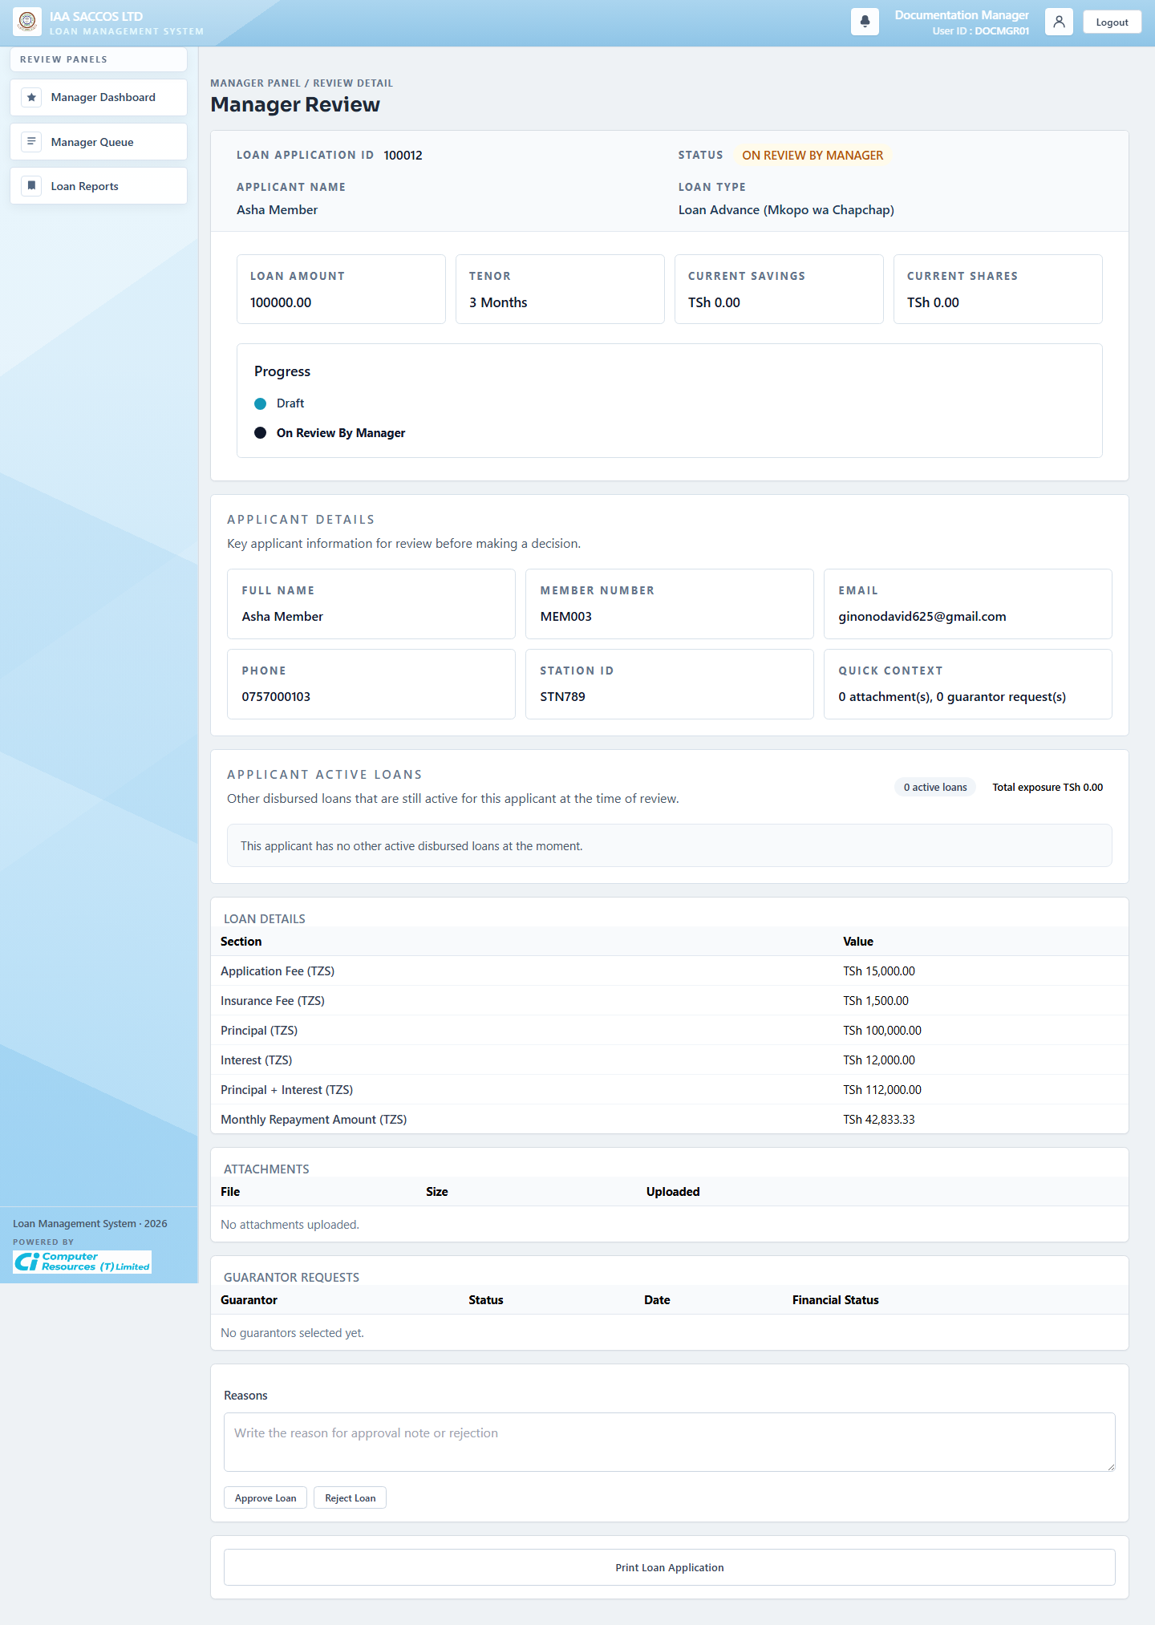
Workflow Explanation:
What happens:
- The manager review detail page consolidates applicant identity, active-loan exposure, financial details, attachments, guarantor rows, and the decision box needed for manager review.
- It is the first deep review screen where the manager can confirm the member's data before recording an approval or rejection.
On submit:
- Rejecting records the manager's reason and marks the application as rejected.
- Accepting records the manager's decision, assigns the application to the board, and moves it into board review.
Approval flow:
- After acceptance, the application appears as being on review by the board.
- If the manager rejects, the workflow returns the loan to the applicant as a rejected item rather than entering board review.
External system communication:
- When the manager checks a guarantor's financial status, the latest summary is pulled from the Foresight financial app endpoint.
- This helps the manager review the guarantor's current position before making a decision.

6.5 Manager Review Ready For Disbursement
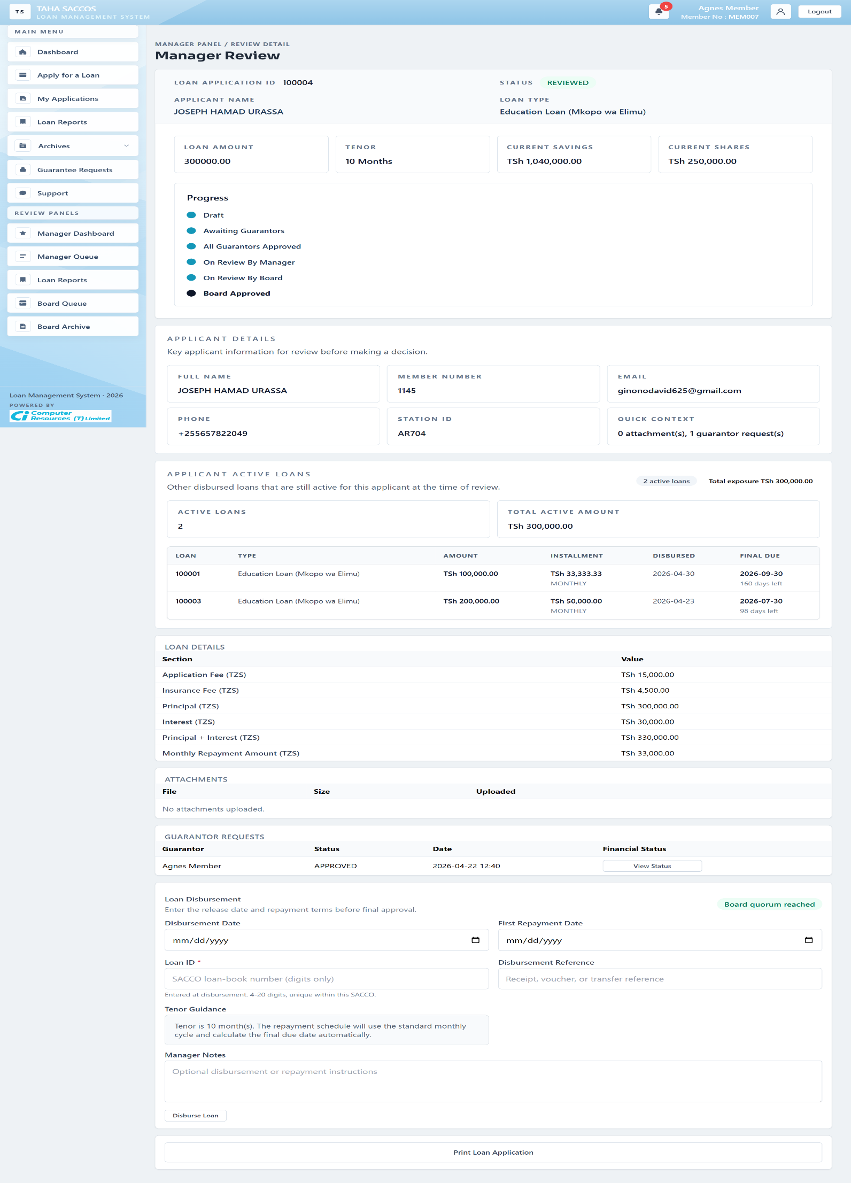
Workflow Explanation:
What happens:
- This reviewed-state screenshot shows the same manager detail page after board quorum has been reached and the loan is ready for final disbursement data entry.
- The manager now sees the disbursement block for dates, loan ID, disbursement reference, and repayment notes, alongside the applicant's other active disbursed loans and total exposure.
On submit:
- Final approval confirms the disbursement details, creates the repayment schedule, and marks the loan as approved for release.
- If the board outcome were rejection instead, the final manager action would move the loan to Final Rejected instead of disbursing it.
Approval flow:
- After successful final approval, the loan appears as a disbursed loan.
- That disbursement state is what later enables repayment tracking and payment synchronization.

6.6 Manager Review For A Disbursed Loan
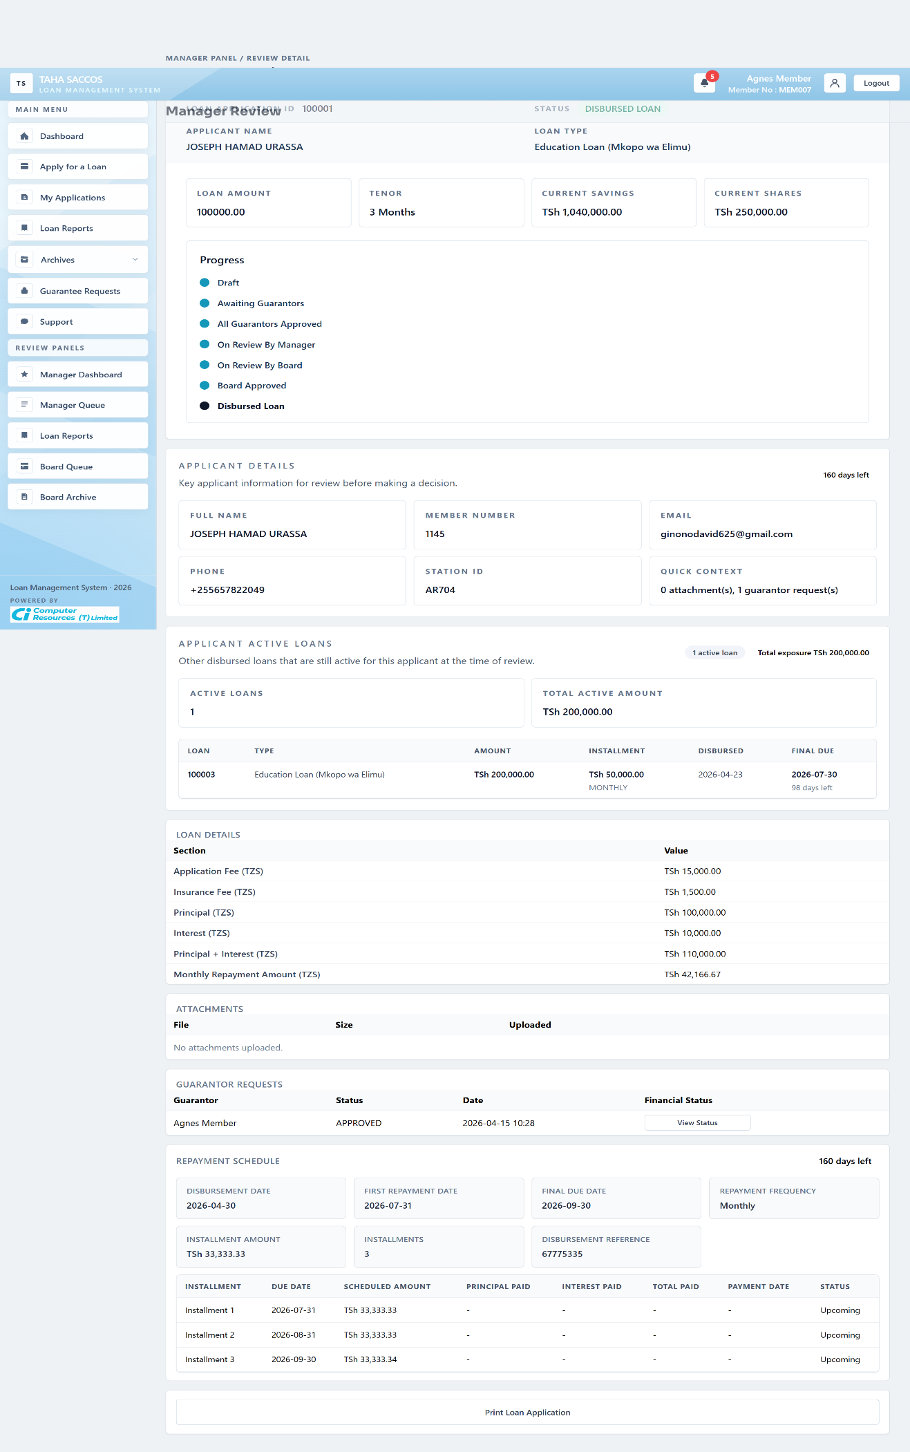
Workflow Explanation:
What happens:
- This state shows the manager detail page after disbursement, with the repayment schedule and countdown now visible beneath the core loan summary.
- The manager can inspect installments, due dates, payment dates, and current repayment status from the same workflow record.
On submit:
- At this point the loan is no longer being approved; the manager is monitoring repayment execution and reconciliation.
- When needed, the manager can trigger payment synchronization so newly fetched transactions and outstanding-balance summaries are reflected on the record.
Approval flow:
- The loan can later move from Final Approved to Paid when the outstanding balance reaches zero after the relevant period, or to DEFAULTED when the due date passes with outstanding balance remaining.
- Those repayment-state transitions are post-disbursement workflow transitions rather than credit-approval transitions.
External system communication:
- When payment information is refreshed, the system pulls the latest loan payments and repayment summary from the Members Portal endpoint.
- That returned information helps the system show the current repayment progress and decide whether the loan should remain active, move to Paid, or move to Defaulted.

6.7 Manager Loan Reports
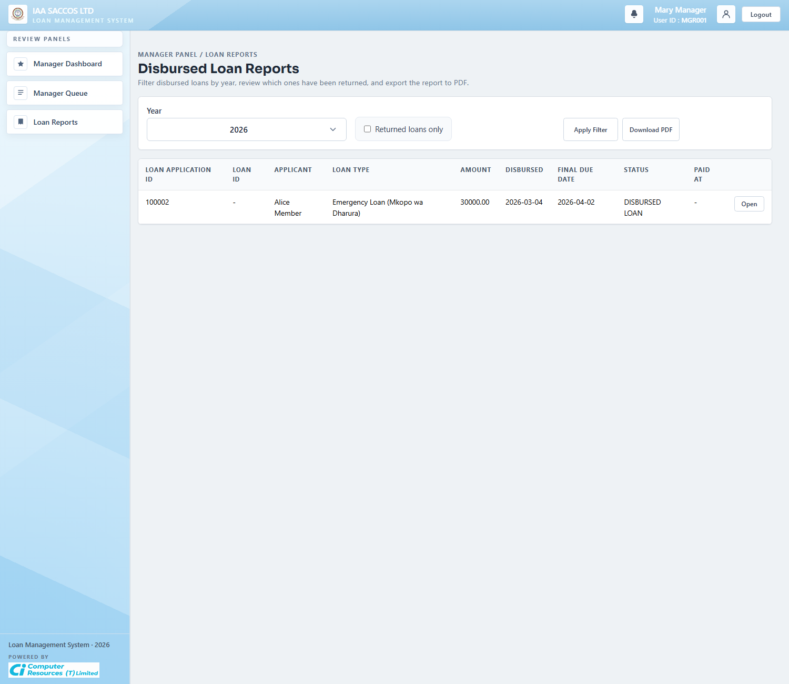
Workflow Explanation:
What happens:
- The manager report consolidates disbursed-loan performance, final due dates, paid dates, and portfolio-level return monitoring for the current SACCO.
- It is the reporting complement to the transactional review screens.
On submit:
- The screen is read-only and filter-based by year or returned-only view.
- The primary action is exporting the report when the manager needs a PDF portfolio summary.
Approval flow:
- No approval or repayment state changes are written from this page.
- The report depends on already-recorded final approval, paid, and default states.

7. Board Workflow Screens

7.1 Board Queue
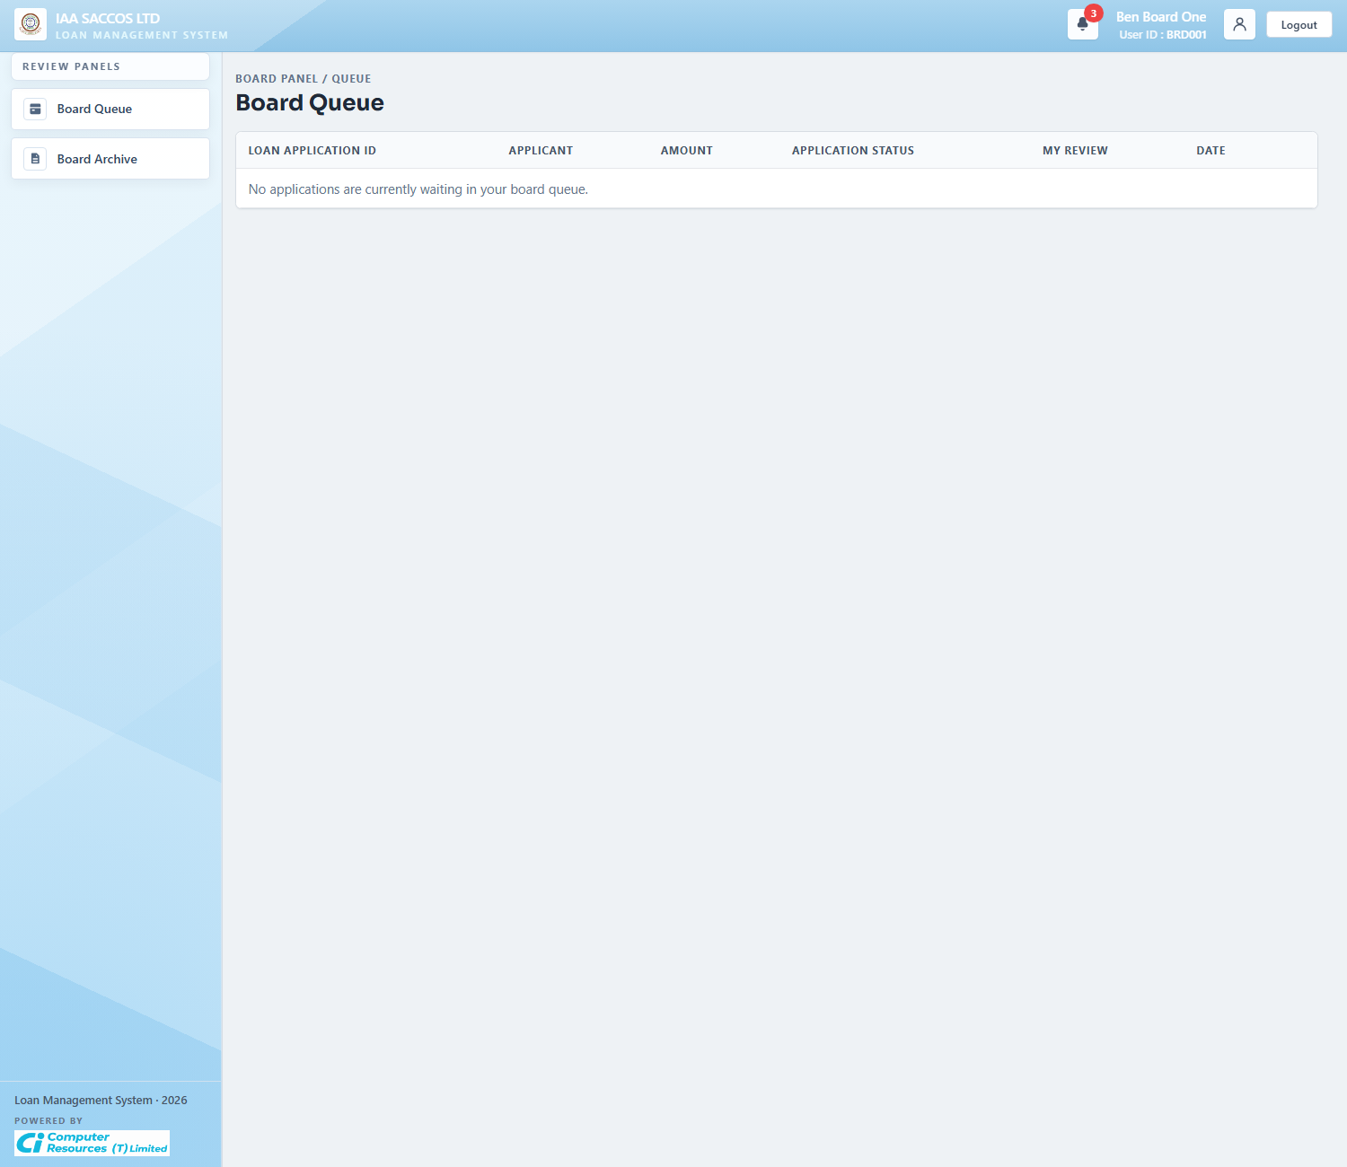
Workflow Explanation:
What happens:
- This queue shows the applications assigned to the current board member that still need a decision.
- It is a personal assignment queue, not a general list of every board-stage loan in the SACCO.
On submit:
- Opening a row moves the board member into the review detail page where they can see the committee context and record their decision.
- This queue view itself does not persist a board decision.
Approval flow:
- The application stays in board review until enough board decisions have been recorded.
- The queue shrinks as the member submits their own decisions.

7.2 Board Review Detail
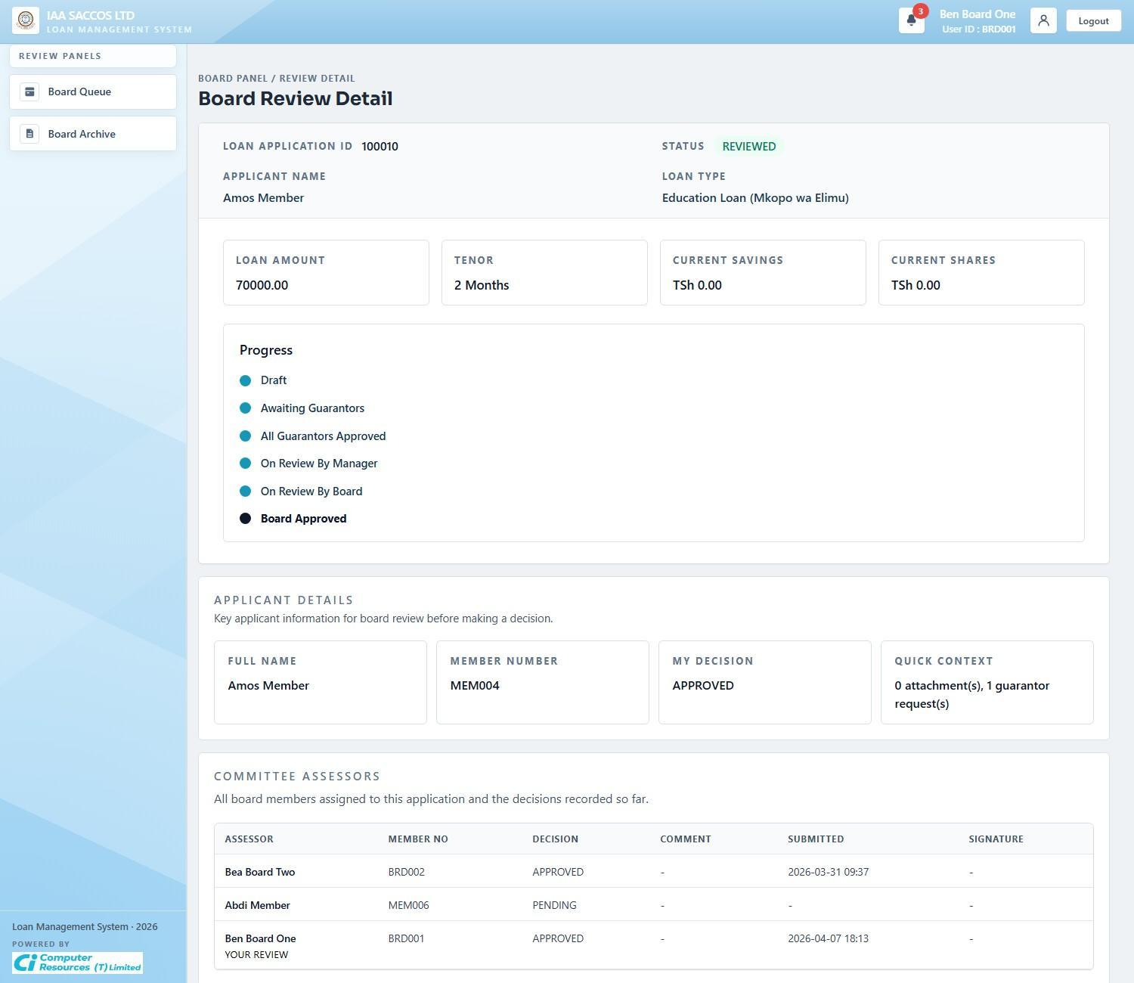
Workflow Explanation:
What happens:
- This reviewed-state screenshot shows a board review record after at least one decision has already been recorded and the page is presenting the assessor table, applicant summary, and current board-stage status.
- The screen makes the committee's recorded decisions visible in one place so each assessor can see how the review evolved.
On submit:
- When the current board member has not yet decided, this page shows the approve or reject form and the one-time-code steps. After a decision is recorded, the page becomes a read-only history view.
- The guarantor financial-status buttons allow the board member to pull savings and shares information for each guarantor on demand.
Approval flow:
- The application stays in board review until enough approvals or rejections have been recorded to reach the required threshold.
- Once that threshold is reached, the board result becomes final and the manager handles the last step.
External system communication:
- When a board member checks a guarantor's financial status, the latest summary is pulled from the Foresight financial app endpoint.
- This gives the board member up-to-date financial context before approving or rejecting the application.

7.3 Board Archive
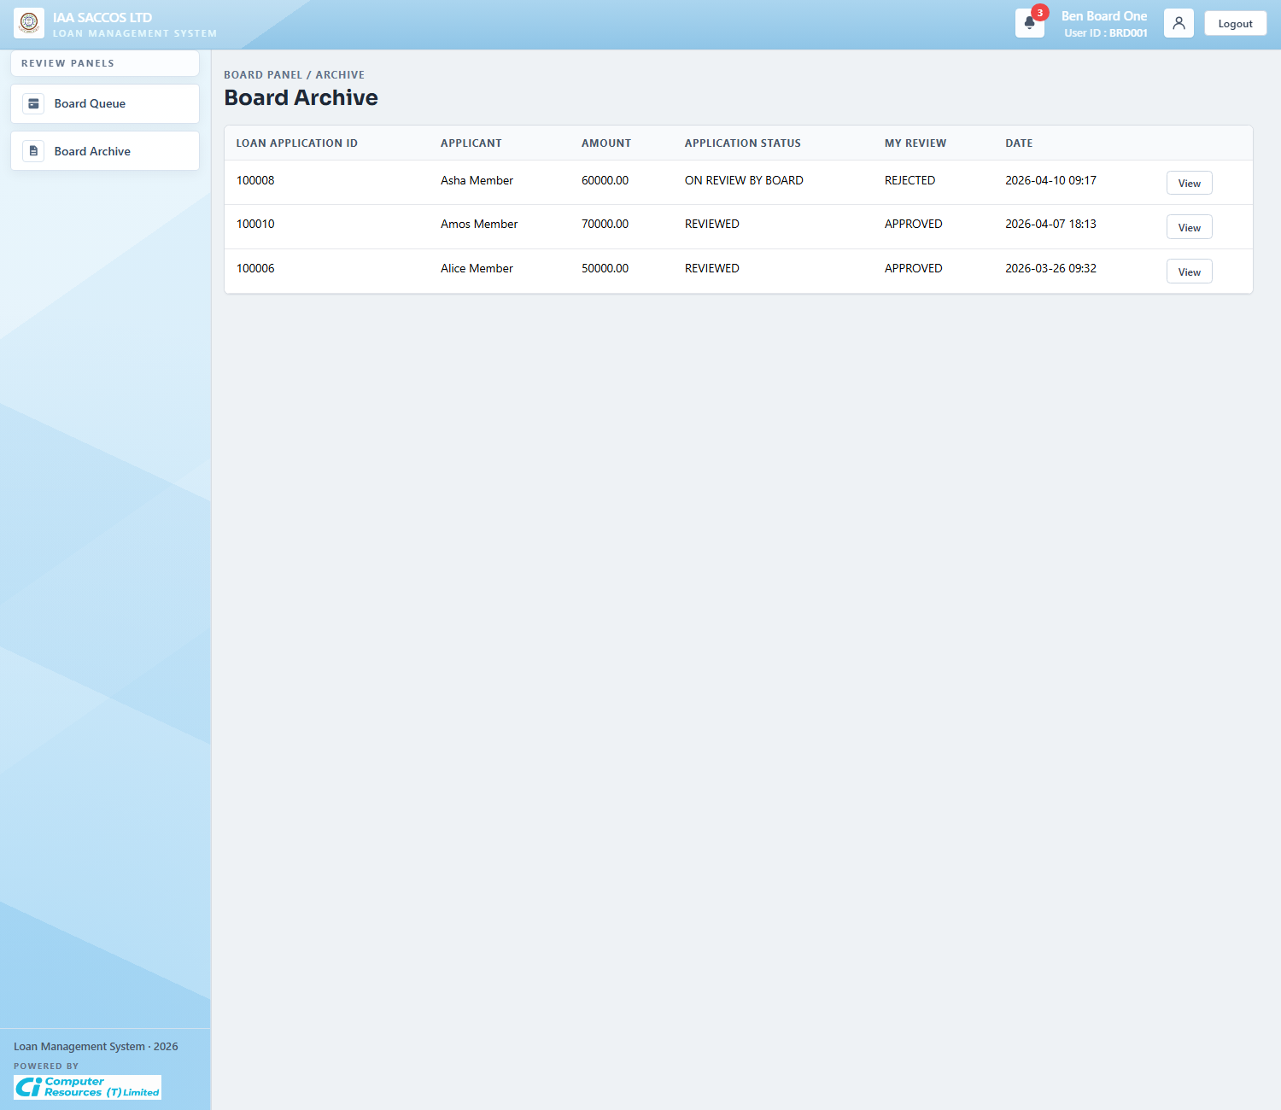
Workflow Explanation:
What happens:
- The board archive keeps completed or previously decided board assignments separate from the live board queue.
- Each row lets the assessor review how they voted and which applications have already left their active queue.
On submit:
- This screen is read-only.
- Board members use it for history lookup rather than for fresh decisions.
Approval flow:
- By the time a row appears here, the current assessor's decision is no longer pending.
- The broader loan may still be waiting on other assessors, already reviewed, or already finalized by the manager, depending on quorum outcome and later actions.

8. Printable Output

8.1 Printed Loan Application
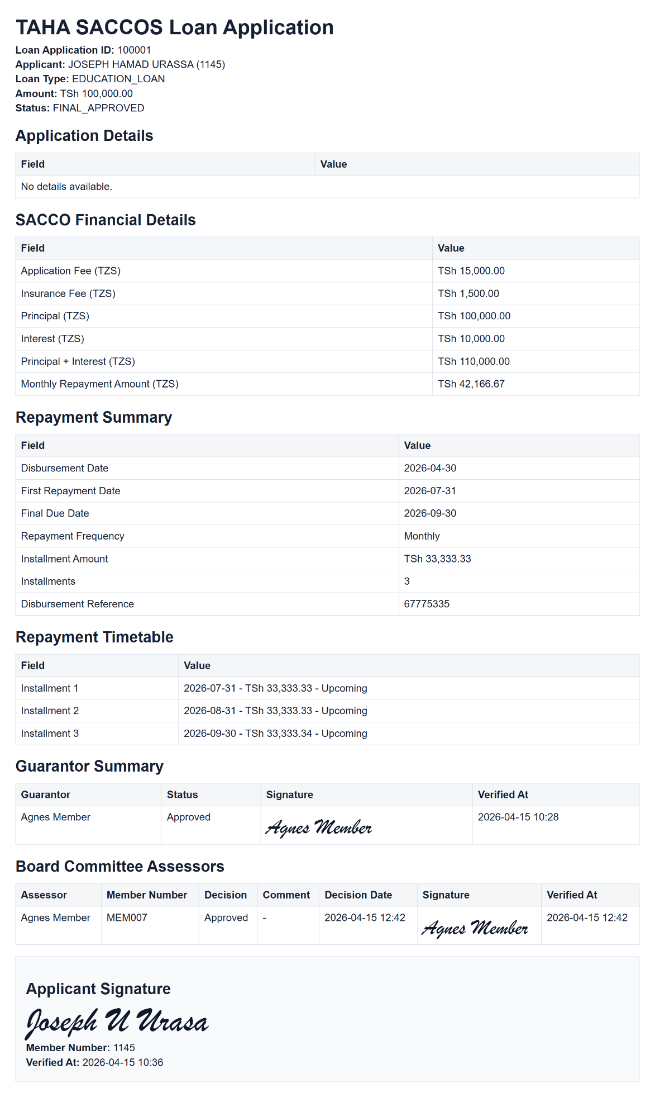
Workflow Explanation:
What happens:
- The printable loan application is the consolidated record of the approved workflow state, showing the application header, SACCO financial details, repayment summary, repayment timetable, guarantor signatures, board-assessor signatures, and the applicant signature block.
- This output is intended for document circulation, audit, or archival after the workflow has progressed far enough to make the printable record meaningful.
On submit:
- The print action does not alter the workflow state.
- The system only allows printing when financial details exist and the required guarantor approvals are already satisfied; draft and early guarantor-stage records are blocked from printing.
Approval flow:
- The printed document is an end-product view of the workflow, not a new approval stage.
- It reflects whichever approval and repayment metadata were already committed onto the loan row at print time.

