THE INTERNATIONAL FINANCIAL ARCHITECTURE
SEEN THROUGH THE LENS OF THE CRISIS:
SOME ACHIEVEMENTS AND NUMEROUS CHALLENGES
Stephany Griffith-Jones and José Antonio Ocampo

1 INTRODUCTION
This chapter looks at the process of international financial and monetary reform in terms of the basic objectives which international financial architecture should meet. Those objectives are essentially five: (i) to regulate the financial and capital markets in all countries, as well as cross-border transactions, in order to avoid the excessive risk accumulation which has caused frequent and costly crises, both in developing as well as in developed countries; (ii) to offer emergency financing during crises, especially to ensure liquidity, complementing the functions of the central banks as lenders of last resort at a national level; (iii) to provide adequate mechanisms at an international level to manage problems of excessive indebtedness; (iv) to guarantee the consistency of national economic policies with the stability of the world economy system, and to avoid the macroeconomic policies of some countries having adverse effects on others; and (v) to guarantee an international monetary system which contributes to the stability of the international economy and is seen as fair by all parties. The Monterrey Consensus, approved by the United Nations International Conference on Financing for Development, which took place in 2002, might come closest to the definition of those goals although it does not include some of them explicitly (especially not the last one).
While some of those objectives refer to crisis prevention, others relate to the management of crises once they have been unleashed. Nevertheless, such a division is not a straightforward one since some good instruments for handling crises also have preventive effects as the history of central banks throughout the world indicates. Nor is the distinction between micro and macroeconomic matters clear-cut since, as we shall see, financial regulation should include an important element of macro-prudential regulation.
This chapter is divided into four parts. Given the importance of the debate under way on financial regulation as a central mechanism to prevent crisis, the first section tackles this theme as well as corresponding institutional reform issues. The last section of that part analyses a question which is partially interrelated to the previous ones which has emerged strongly in recent debates: the role of an international tax on some financial transactions. The second part considers some of the main problems concerned with the prevention and management of crises in the developing world. That part concentrates, therefore, on the second and third objectives and the way in which developing countries have responded to the flaws in international financial architecture; this section will also look at a closely related question of the increasing demand by developing countries to participate in international financial organizations. The third part analyses the fourth and fifth objectives mentioned which, as we will see, are related. After briefly considering some of the problems associated with how to guarantee the consistency of national macroeconomic policies, we look more closely at reform of the international monetary system and propose a reform based on a significant expansion by the IMF (International Monetary Fund) of the use of Special Drawing Rights (SDRs). To conclude, the last part presents an overview of the reform of the international financial system since the Asian crisis; here we also study some of the characteristics of global economic governance.
It is worth highlighting that the chapter focuses on monetary and financial architecture and leaves aside, therefore, recent events on matters of financing for development, which also show a clearly complex panorama, but where some positive developments stand out: the clear recovery of the official development aid after the Monterrey Conference and the aggressive response of multilateral development banks to provide financing during the recent crisis. We discuss these topics in another chapter of this book.
2. DEFICIT AND GOVERNANCE OF FINANCIAL REGULATION
2.1 The regulatory deficit
The seriousness of the global financial crisis laid bare the magnitude of the regulatory deficit that the global financial system faced. This problem was particularly acute in developed countries, since many developing countries had responded to the series of financial crises they faced since the decade of the 1980s by strengthening their regulatory and supervisory frameworks. This regulatory deficit has two different dimensions. On the one hand, although the banking system was regulated, the regulation was insufficient in key areas and enforcement was not adequate due to deficiencies in the supervisory systems. On the other hand, there were significant areas of financial activity and financial agents (the so-called “shadow banking system”) that lacked any form of regulation.
The main effort made at an international level before the crisis was the negotiation of the Basel Agreement on banking regulation (Basel II). Although this agreement had various positive elements, it also contained a series of important flaws. One of its most worrying features, highlighted by a few commentators in the early 2000s (Griffith-Jones, Segoviano and Spratt 2002; Goodhart 2002), and clearly recognized after the global crisis was the fact that it reinforced the naturally pro-cyclical behavior of bank loans. In fact, the main failure of the financial markets is the tendency, both of lenders and borrowers, to assume excessive risks during boom periods. Those risks lead to significant losses later in bank portfolios when growth slows down, which can set off financial crises. Basel II exacerbated this pro-cyclical behavior by giving increasing weight to the risk evaluation models of the banks themselves in the determination of suitable capital levels, which exacerbates the inherent pro-cyclical pattern in the behavior of banks.
The need to introduce specific counter-cyclical mechanisms in banking regulation had been recognized by some analysts since the end of the 1990s, especially by the United Nations and the Bank for International Settlements (Ocampo, 2003; Griffith-Jones and Ocampo, 2009). In this field, one of the most important innovations was the Spanish system of counter-cyclical provisions for loan losses, initially introduced in 2000. However, neither those analyses nor the Spanish practice received adequate attention and were ignored by Basel II.
Another problem of Basel II was the tendency to overestimate the risk of bank loans made to developing countries, overlooking the benefits, in terms of risk reduction, of diversifying international portfolios. As a result of this flaw, its application can result in excessive capital requirements for loans to developing countries, reducing those loans and/or increasing their costs. This problem has not been corrected till now.
The areas which lacked regulation included, first of all, off-balance sheet bank transactions, which were in fact one of the most important sources by which the global crisis in the mortgage- and other asset -backed securities spread to the banks. In the same way, problem loans at some banks spread to other agents in the financial markets. The problems inherent in rating assets by rating agencies have also been the subject of a lot of attention in recent debates, particularly the tendency to poorly evaluate the risk of loans which are not going to be kept on a bank’s own books but which are to be sold off. Those loans heavily contributed to the crisis.
Another area with poor regulation before the crisis were the derivatives market and the alternative investment funds (generally called hedge funds, although their operations go beyond hedging operations), which are particularly active in derivatives markets. Given the multiple flaws which characterize those markets (which are very incomplete and are very imperfect, particularly during crises), it is crucial to improve regulation in this area. Lastly, the lack of regulation of the ratings agencies has also been the subject of a great deal of debate, as well as the possible conflicts of interest between their rating business and their business advising agents whose market products they rate. (Goodhart, 2010).
One of the most important breakthroughs in the international debate of the last two years was the recognition that the international financial crisis was clearly associated with inadequate, insufficient supervision of financial activities. This is precisely the sphere in which the G-20 has played a role, especially in reaching agreement on certain principles, the implementation of which, nevertheless, remains the subject of debate and on which slow progress is being made especially in Europe. In the United States, the Dodd-Frank bill on financial regulation implied significant progress, as we discuss below, but the fact it was finalized earlier than European reforms, shows that progress in different regions has not been sufficiently coordinated internationally, which will result in regulatory systems that have important divergences.
The Basel Committee on Banking Supervision (which we will refer to from now on as the Basel Committee) had already started to discuss among its members some practices as a complement to the regulations that Basel II introduced (Basel Committee 2009a and 2009b). Far more importantly, even though still insufficient, is the proposal approved in principle in September 2010 as Basel III (Basel Committee, 2010).
The proposals agreed in principle by the 27 countries in September 2010 have a number of positive elements. Firstly, it raises Tier 1 capital requirement (the core form of loss absorbing capital) from 2% to 4.5% of risk-weighted assets, as well as defining far more strictly the assets that make up this capital, to strengthen the solvency of financial institutions. The proposals also increase the capital for banks’ operations in the financial markets (the so called trading book) and require an additional capital conservation buffer of 2.5%. This implies banks should have 7% of common equity. It also implies introducing additional buffers of counter-cyclical capital, in a range of 0 to 2.5% of common equity, which would be implemented nationally, along lines we discuss below. Finally, the liquidity requirements are made explicit, which were practically non- existent in Basel II; it also introduces a maximum leverage ratio, calculated on total assets and not on risk-weighted assets, whose aim is to restrict the total of assets in relation to capital.
Nevertheless, Basel III has several serious problems (for a more detailed analysis see for example Griffith-Jones Silvers and Thiemann, 2010) First of all, many observers consider that the increases of capital requirements are not enough, especially for banks with very risky assets. A second important critique relates to the excessively long time period in which they will they be implemented, culminating in 2022. The main reason is that there have been strong pressures by the banks, both to avoid even higher capital increases and for delaying the reforms. This was combined, in the latter case, with the fear by regulators that an early increase in capital requirements would discourage even more the ability and willingness of banks to lend, which is considered key for the recovery.
A more radical critique is that maintaining risk-weighted assets capital requirements may be inadequate, and that it would be better to give a larger role to leverage. Furthermore it seems likely that the leverage indicator has been put at an excessively high level, as it can reach 33. Another set of questions relate to the design of the liquidity buffers, which may end up by discriminating against loans to SMEs, which play a key role in job creation. There is also an important concern whether stricter regulation of banks will not cause financial activity to move even more to the less or unregulated entities.
It should be emphasized, finally, that –as already mentioned— the possible discrimination in the regulation against developing countries has not been corrected in the new proposals. Therefore, it would be highly desirable if Basel III would incorporate a factor that takes account of the benefits of diversification towards that type of assets, as has already been done for loans to small and medium enterprises in the previous Accord (Griffith-Jones, Segoviano and Spratt, 2002). In fact, the recent crisis, and above all the following evolution, in which developing countries have in general had higher growth rates than developed ones, confirms the need to introduce the benefits of diversification in Basel III.
These national and international proposals have followed two basic principles that are worth analyzing in detail: those that guarantee a comprehensive, as well as a counter-cyclical, or more broadly macro-prudential regulation. But they have also tackled other matters, among them consumer protection and the need to downsize excessively large financial institutions.
The first principle mentioned is that regulation should be comprehensive, or that it should at least have a broad scope in terms of instruments, institutions and markets (D’Arista and Griffith-Jones, 2010), in order to avoid, as we have highlighted, serious evasion of regulation through non-banking intermediaries (or barely regulated banking intermediaries), which contributed to the crisis. Moreover, that should be accompanied by an increase in the capital base, that should also be better quality, consistent, transparent and cover all the risks which financial institutions face (including those associated with securitization, investment in shares, bonds and other securities which form part of the “trading book”, and the counterparty risk associated with derivative operations and the financing of operations in the capital market), as recognized in the Basel Committee proposals mentioned.
For many analysts, an essential element is the obligation for all markets to be open and transparent and, therefore, to limit over the counter trades. The new US legislation, which obliges all standard derivatives to pass through clearing-houses is a positive step to improve transparency and reduce counterparty risk and it should be applied to all derivative transactions. It is therefore unfortunate that the US legislation has maintained a series of exceptions, especially for derivatives used by non-financial companies. A positive aspect of the US legislation is that it imposes margin requirements on all the derivatives that go through clearing houses, which diminishes their risks, though again there are exceptions for those that do not go through clearing houses. We can expect European regulation to follow these US reforms on transparency in the derivatives markets, but it is to be feared that they will also allow important exceptions.
In the case of alternative investment funds, especially for hedge funds, it is the European Union that has taken initiatives to improve transparency by requiring their registration, as well as proposing some precautionary regulatory measures; those proposals have now been approved in spite of opposition from financial players and the reservations of some countries. As regards alternative investment funds, the US legislation not only took initiatives to improve their transparency, but also opened the possibility that the newly created Systemic Risk Council can declare these funds as systemically important, when they are large financial players, and thus impose limits on their leverage or other risk mitigating measures.
The creation of this Council, as well as its equivalent at European level –the European Systemic Risk Board—, whose objective is macro-prudential regulation, are institutional innovations that are potentially very positive. It is also very positive that a rather ambitious architecture has been created at European level of three pan-European regulators for key financial sectors (one for banks, another for insurance and pensions, and a third one for capital markets).
These steps imply that it has been recognized that financial intermediaries that are systemically important should be subject to particularly rigorous supervision, and even to stricter regulatory norms. This issue has received particular attention in the United States where the Treasury Department announced in 2009 that capital requirements of large financial intermediaries would be proportionally higher. In 2010, President Obama went further and announced limits on the size of banks. Since 1994, there are limits on the ratio of total deposits (10%) that can be held by one bank; the new rule would also apply to other liabilities.
Another important measure announced by President Obama proposed to ban the use of bank resources in their own trading (so-called “proprietary trading”). In fact, the US legislation approved has introduced the so called “Volcker rule”, which forbids the use of the banks’ own resources and that of its depositors for its own capital market business. However, this rule was diluted in the debates in Congress, when banks were allowed to maintain property of alternative investment funds (hedge funds and equity funds) up to 3% of their Tier 1 capital.
The Financial Stability Board has welcomed this initiative but has highlighted that this is just one of various options designed to tackle the issue of organizations being too large to fail, as well as to separate traditional banking business from its more speculative and risky activity. Those options include, for instance, capital, leverage and liquidity requirements being based on size and the complexity of the structures of financial conglomerates.
The question of regulating the bonuses of executives and traders at financial companies has similarly ignited heated national and international debate. The key problem has been not only that the salaries are excessive but also that they are structured in such a way that they generate incentives to undertake highly profitable short-term activities which are, nonetheless, excessively risky in the medium-term, which implies risks both for the individual financial institution as well as for the financial system as a whole. Those bonuses are also asymmetric since they are high when short-term profits are high but never negative (and even continue to be high) when there are large losses. The Financial Stability Board has stated its intention to raise the capital requirements of institutions that have bonus systems that increase future risk. Several countries have taken partial measures in this respect although they are insufficient.
The second principle which we have highlighted, and which represents an important step forward in recent discussions, has been the recognition that prudential norms should have a clear counter-cyclical, as well as a more broadly macro-prudential, focus. The creation of the already mentioned institutions in charge of avoiding accumulation of systemic risks is an element of this process. The crisis generated, also, a large consensus on the need to adopt counter-cyclical regulations both at the G-20 level (2009a and 2009b) as well as in diverse international reports on regulatory matters (the United Nations, 2009, and the Warwick Commission, 2009, for instance). As a result of this, the Basel Committee included some suggestions in this area in its December 2009 proposals, and even more clearly in its September 2010 proposed agreement.
The most important rules would be those to oblige financial institutionaccumulate more capital (or non-distributable reserves) and/or provisions fordebts that are unlikely to be collected, or provisions to be set aside in boom periods to increase the capacity of financial institutions to act during crises. One alternative, the one that had been introduced by the Spanish system, would be to make the provisions when the loans are made, based on the expected losses (“potential losses”), estimated on the basis of a full economic cycle. The advantage of this system is that it allows provisions to be accumulated against losses during the phases of rapid expansion of credit, giving a “rainy day provision” to absorb losses during crises. This can also contribute to putting a curb on the credit boom – although that did not happen in the Spanish case (Saurina, 2009). Capital and provision requirements should also take into account the nature of the financing which financial institutions use (short-term versus long-term, as the Warwick Commission, 2009, highlights).

Another equally important element to counter-cyclical regulation are rules to avoid the heavily pro-cyclical behavior of financial asset and real estate prices multiplying during the booms through an artificially high value being attached to the credit guarantees. The rules should therefore restrict the value of the guarantees accepted during the periods of asset inflation, make additional compulsory provisions for credits guaranteed with assets that have rapidly increased their value (maximum loan-to-value ratios), or increase the capital requirements in those cases. Any system of this type would have avoided or softened the highly costly crisis in low quality mortgages in the United States, and also in European countries like Spain, Great Britain and Ireland.

In the case of developing countries, the problems of currency mismatches are also very important, especially due to the tendency of exchange rates to appreciate during booms and to depreciate during crises. In the absence of appropriate counter-cyclical norms –or better still, of restrictions or bans on those exposures– the risks assumed during the booms tend to be reflected in large capital losses during crises, as developing countries learnt during various crises –and as various countries in Central and Eastern, as well as Southern Europe learnt during the most recent one.
Among the debates that co-exist in this field, an important one is related to the decision whether to opt for rules or to issue norms in a discretional way during boom periods. There seems to be a global preference for pre-established rules, which would reduce the risk of regulatory capture by financial interests or of the excessive enthusiasm which characterizes economic authorities during boom periods. Rules could be made stricter, but never looser during boom periods. Appropriate indicators (such as credit growth and/or asset prices) need to be chosen in order to ensure that the counter-cyclical capital set aside corresponds effectively to the cycle.
One matter which has received relatively less attention in the field of counter-cyclical regulations is that of liquidity requirements, an area in which the Basel Committee has already approved some norms.
Accounting rules have also been a subject of much debate. They should satisfy both the need for transparency as well as for financial stability. One interesting alternative which has been suggested is that two accounting balances be estimated: one in which current earnings and losses are reported, according to valuations at market prices, and another in which future provisions are deducted from current earnings or for a non-distributable “business cycle fund” to be established, which could only be used to cover future losses.
In order to avoid regulatory arbitrage, it is important for counter-cyclical regulation to be applied to all institutions, instruments and markets, and both nationally as well as internationally. However, since business cycles do not completely coincide, the regulations should be applied by the host countries, although in accordance with internationally agreed principles. This is what seems to be implicit in the decisions of September 2010 of the Basel Committee, but the norms there are still not fully developed. One fundamental reason for which coordination is essential has to do with contagion. A crisis in an important country (especially if it is an important creditor, debtor or trade partner) can seriously affect the financial stability or the economy of other countries even if those countries did not accumulate any systemic risk. Therefore, in a globalized economy all countries have a legitimate interest in avoiding pro-cyclical excess in other countries.
Two matters connected to the comprehensive and counter-cyclical nature of the regulations are related to the best moment to introduce the new norms and to the effect on credit availability. On the first issue, it is clear that it is important to agree regulation during crises when the political appetite for regulatory reforms is high and new rules also help to restore the confidence in the financial system. In particular, increasing the scope of regulation should also be immediately applied. However, those rules involving more capital, provisions and liquidity should be gradually introduced and only fully implemented after the economy is on a clear recovery path. However, as pointed out, the slowness in implementing Basel III is debatable.
In terms of access to credit, it is worth highlighting that stronger regulations should result in higher spreads, as well as excluding those agents from credit that are considered particularly risky. That could generate less financing for small and medium-sized companies or for poorer households. Therefore, it might be necessary to introduce additional instruments to guarantee access to credit. Higher margins could also mean companies with direct access to international credit markets could have an incentive to seek loans abroad, increasing the probability of currency exposure in the portfolios of those agents. This is why it is particularly important to introduce rules aimed at handling currency mismatches, as mentioned previously.
Among the other issues worth highlighting in the process of strengthening regulation is the issue of consumer protection, which has been particularly important in the US debates. Due to the quality of toxic mortgages and high-risk investment vehicles, which were being offered in recent years to households that were not financially sophisticated, consumer protection needs to be strengthened, as well as the principle that financial instruments should be as simple as possible since complexity leads to information problems and difficulties for the markets in valuing the corresponding instruments. A positive step in the US regulatory reform was, therefore, the creation of an independent authority to protect consumers, with universal power over all the firms that provide financial services to them.
It is also probable that the crisis under way ends by generating a larger market share for some companies in the financial industry. That means restrictions on monopolies and even the possibility of dividing up the largest institutions should also figure in the new regulations. That includes differential treatment to the largest institutions, mentioned earlier. Lastly, and very importantly, it is essential for safeguards to be applied with rigor and for supervision to be carried out to the highest standards. Some of the most serious errors that led to the current crisis were the result of a lack of supervision and strict application of the current norms.
2.2 The governance of international financial regulation.
Despite their growing importance, due to the integration of financial markets, global regulatory institutions have been and continue to be perceived as undemocratic and of limited effectiveness. One central problem here is the representation of developing countries, as the Monterrey Consensus,, various academics and non-governmental organizations across the world, and of course, the developing countries themselves have higlighted. Nevertheless, while the Bank for International Settlements had selectively increased its members, institutions like the Financial Stability Forum (FSF) and the Basel Committee continued to exclude developing countries. An exception to this rule was the International Organization of Securities Commissions (IOSCO), the organization of stock exchanges regulators, which had a wide representation from developing countries. However, its Technical Committee –which generates regulatory initiatives– only has OECD countries as members.
Given its importance and authority in establishing international banking standards, the Basel Committee had been the target of most criticisms. The exclusion of developing countries from the Committee had doubtlessly distorted the policies designed, which proved ineffective in guaranteeing financial stability and were biased against the interests of the developing world (Griffith-Jones and Persaud, 2008). However, despite all this criticism, it was not until the global crisis and the subsequent declaration by the G-20 in November 2008 that some significant changes to the governance of the international regulatory institutions were made.
As is obvious, representation of different members in the governance of an institution is translated into decision-making. That has been extremely well-discussed in the case of the IMF in which voting rights on the Managing Board influence significantly the decisions of that institution (Rustomjee, 2004; Woods and Lombardi, 2006). A similar effect is observed in regulatory organizations whose support of global financial stability proved less effective due to their very biased governance structures.
If changes had been introduced to the country representations that make up the regulatory organizations, the very concentrated interests of the large private financial players could have been diluted. Many of the approaches, assumed and promoted by the large banks, such as use of sophisticated, but flawed, microeconomic risk models, reflected a confidence in the large banks being able to measure risk parameters themselves. Various developing countries were skeptical about the viability and effectiveness of those approaches, and they were worried about the pro-cyclical dimensions of the regulation developed. Developing countries had experienced a series of financial crises in the immediate past and, being more aware of their costs, gave greater priority to preventing crises. Their lack of participation in the Basel Committee could have, therefore, biased decisions in favor of the large international banks and against crisis prevention.
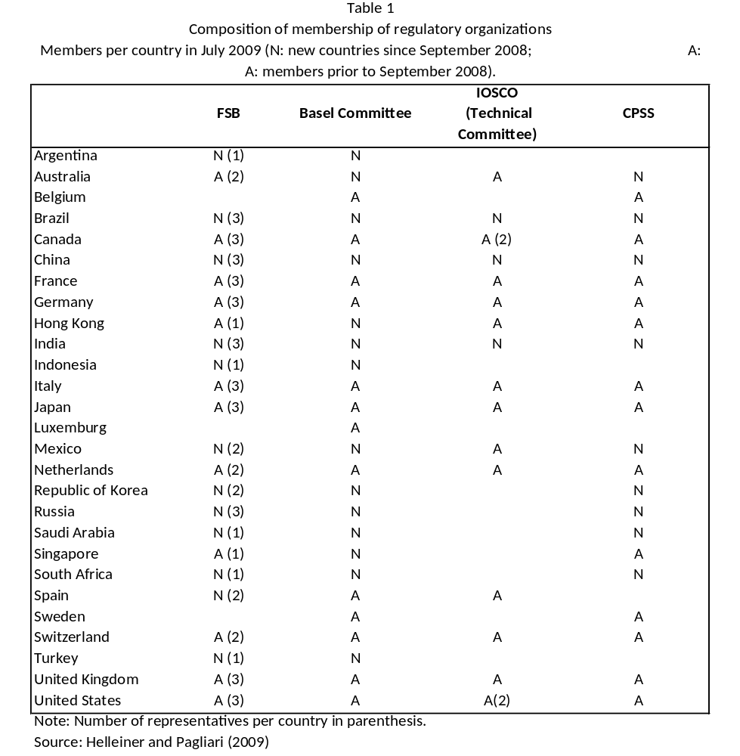
In the midst of the global financial crisis and driven, as we have seen, by the decision of the G-20 of November 2008, an important number of those institutions widened their membership, particularly to include so-called emerging economies. Table 1 summarizes the changes to the regulatory organizations. In early 2009, the Technical Committee of the International Organization of Securities Commissions, which apart from Mexico had not previously included any other developing country, included among its members Brazil, China and India. In March 2009, the Basel Committee included for the first time various developing countries (Brazil, China, the Republic of Korea, India and Mexico), as well as Australia and Russia. In June 2009, it widened its membership still further, including all the G-20 countries which were not already members (Argentina, Indonesia, Saudi Arabia, South Africa and Turkey) as well as Hong Kong and Singapore. As Figure 1 shows, that closed a large gap in the degree of representativeness of the Basel Committee, in relation to the countries that supervised the 50 largest banks in the world. However, countries with relatively small banks are not adequately represented which means banking regulation continues to excessively meet the interests of the large banks in the main industrialized countries. At the same time, the Committee on Payment and Settlement Systems (CPSS) invited the following members: Australia, Brazil, China, India, Mexico, Russia, Saudi Arabia, South Africa and the Republic of Korea. This is another organization based in Basel which serves as a forum to the Central Banks to monitor national payment systems as well as cross-border and multiple-currency agreements.
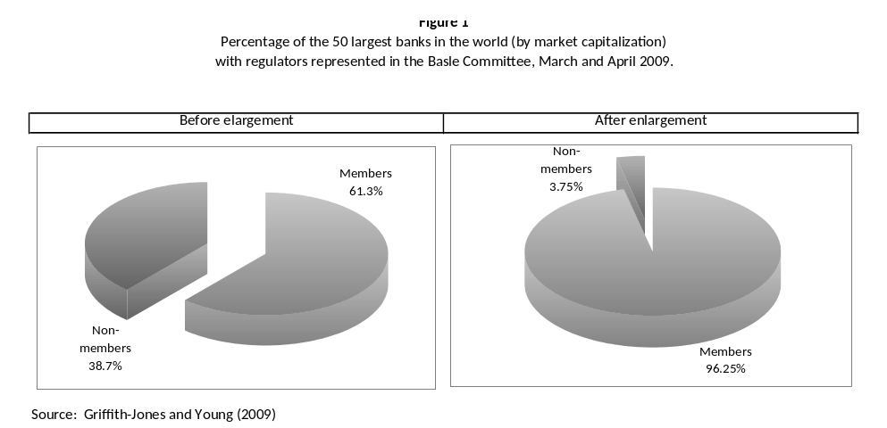
In the second quarter of 2009, the Financial Stability Forum increased its number to include all the members of the G-20, which includes most large developing countries as well as Spain and the European Commission. It was given the new name Financial Stability Board (FSB) to reflect its additional powers. This enlargement to the membership was also significant; as Figure 2 shows, if measured in terms of world foreign exchange reservedistribution, the FSB has a much better representation than its predecessor.
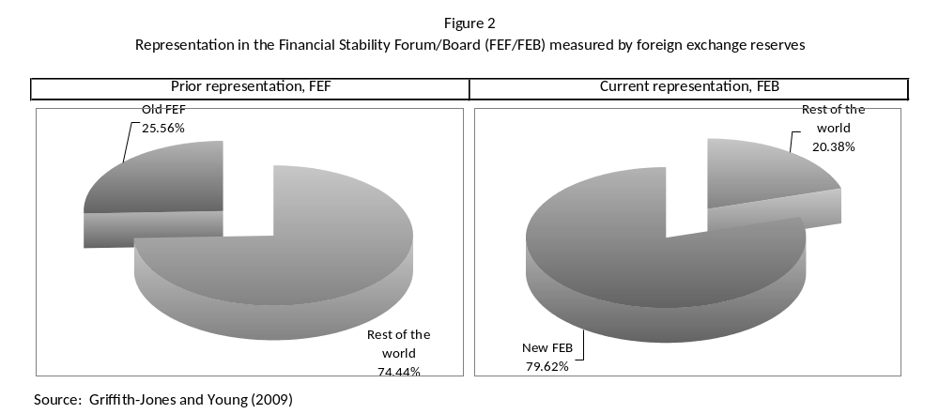
This increase in the participation of developing countries in the FSB is, of course, a positive step. However, it raises two problems. The first has to do with the number of representatives of different countries. With enlargement, three different categories of countries were created: the BRIC (Brazil, China, India and Russia) joined the G-7 group of countries, with three representatives each, while Australia, Mexico, the Netherlands, Spain, the Republic of Korea and Switzerland were assigned two and the rest given one (Argentina, Hong Kong, Indonesia, Singapore, Saudi Arabia, South Africa and Turkey). Therefore, with the exception of the BRICs, the emerging economies represented in the FSB have one or two representatives while the G-7 have three, and even worse, the poorest economies and the small and medium-sized countries do not have any representation.
The second problem is to do with the fact that the FSB is now not only structured around a plenary session but also around a Committee for Initiatives and three additional committees. While this enlargement and specialization is welcome since it strengthens its role, all the heads of those five bodies come from developed countries. A greater diversity would be desirable in the future. One interesting example, which could be imitated, is that of the four working groups set up by the G-20 between November 2008 and April 2009. Each working group was headed by one developed country and another from a developing country.
These critiques are the basis for some of the additional reforms that need to be introduced. We will underline three here. The first is the inclusion of representatives of small and medium-sized countries on the regulatory bodies. That would ensure that their concerns would be listened to –for instance, the preference for simpler regulation, as well as for small and medium-sized countries having greater regulatory powers to regulate the large international banks which are active in their countries (see the Warwick Commission, 2009, in this respect). That could also lead to regulation reflecting the interests and preferences of the largest international banks to a lesser degree and regulation becoming more appropriate for smaller, nationally focused banks. One alternative would be to establish regional representatives instead of individual nations on regulatory organizations (with perhaps just a few exceptions such as some important countries). Those representatives could be chosen by the countries of each region according to votes (as occurs in the IMF and the multilateral banks) and with some rules on rotation to guarantee that small and medium-sized countries are represented. A system of regional representation would also have the advantage that all the countries would have at least one indirect representative. This fact, as well as the representation of small and medium-sized countries, would also have the advantage of increasing the legitimacy and efficiency of those organizations. Introducing such changes soon is, moreover, urgent in order to avoid the new structures becoming fossilized..
Secondly, it is important to include better systems of making regulatory organizations accountable, through national parliaments in the case of national regulators; in the future international regulatory organizations and multilateral representative institutions should be also be more accountable. (United Nations, 2009).
Finally, the benefits of including developing countries in key international regulatory organizations could be reinforced by the creation of a Technical Secretariat to support them in their interactions with those organizations. This Secretariat could prepare, or commission studies, provide a forum for debate between developing countries and help –when appropriate– to define the positions of those countries, especially those which require international action and/or action by developed countries. One example is the possible international regulation of the “carry trade” that has such pro-cyclical effects, which is a subject of particular interest to developing countries. Such a body could play a similar role in regulation to that played by the G-24 in areas related to the Monetary Fund and the World Bank.
2.3 Regulatory fragmentation: towards a global financial regulator?
International prudential regulation has developed in a weak and fragmented international context. But finance is globally integrated and, therefore, there is an imbalance between the global growth of the financial sector and the international regulatory structure. In the past, regulation and financial supervision have been fundamentally national. The majority of regulatory financial agreements simply acquired the form of standard “Best practices” and “Principles” which were not legally binding. Developing countries often found themselves obliged to follow those standards either because it was a condition for IMF or World Bank borrowing, or because the financial markets pressed them indirectly to do so. That is inappropiate.
The need to expand the world’s regulatory institutions is in keeping with the principle that for regulation to be efficient the regulator’s domain should be the same as the market that it is regulating. Important parts of the markets and financial institutions are global; consequently, the regulation should also be global. Moreover, financial activity and risk taking will quickly grow in areas where there are gaps in the regulation or where those gaps give way to regulatory arbitrage.
A global financial regulator would design standards to be applied to all countries and jurisdictions and it would adopt supervision mechanisms to guarantee their application. This is why it is particularly important for such a global regulator to have real power over those countries whose financial systems have an impact on the global system. Nevertheless, the regulator should allow regulation to be adapted to the different conditions of each country, operating, therefore, as a network of national regulators with strong international coordination. That would follow the principle that global regulation be based on good national regulation (Stiglitz, 2010). For example, the criterion of counter-cyclical regulation could be internationally agreed; nevertheless, as has been highlighted, its implementation would work at a national level in relation with the state of the cycle in each country. That is one of the reasons why, as the United Nations (2009) and Brunnermeier et al. (2009) argue, it is better for international bank subsidiaries to be subject to the regulation of the country where they are based. Additionally, national financial institutions without global connections should continue to be nationally regulated (Reddy, 2010).
Given the difficulty of reaching a consensus for the creation of new international institutions it would be a good idea to adapt one or more of the existing ones. One suitable one which could be adapted would be the Bank for International Settlements (BIS) given its interest in the systemic risk in financial markets and the need to regulate them, the high quality of its analysis and its close ties to central banks and regulatory agencies. Nevertheless, a prerequisite for this institution being transformed into a global financial authority would be a considerable enlargement of the membership to make it a global institution. It would also be essential for the Financial Stability Board, to which the BIS contributes a Secretariat, to be a central part of the global regulator.
Additionally, there should be a close process of consultation with the IMF on elements of macroeconomic risks, both at a global level as well as at the level of each country. There is, however, agreement that the IMF is not the appropriate financial institution to assume the task of global regulator.
For reasons of macroeconomic stability, countries will be allowed to segment their markets with regulations on cross-border capital flows, as the Articles of Agreement of the Fund permit. The regulation of those capital flows could be a good idea, especially if financial regulation is seen as insufficient to reduce the volatility of capital flows.
It is important to ensure that the new global regulator is not just effective and efficient but also representative. That is why it is important for developing countries to be adequately represented, in accordance with the criteria outlined in the previous section.
One reason why governments, both in developed as well as developing countries, resist the creation of a global regulator is that they do not wish to relinquish national sovereignty in the field of financial regulation. However, this perception is misguided since the globalization of private finance means that national authorities already no longer have full control over the conditions that determine the financial stability of their respective countries. That is why instead of giving up their sovereignty, efforts to coordinate between countries through a global regulator should be understood as an exercise in shared sovereignty, which will allow countries to increase their joint control over the global financial markets.
2.4 Proposals for a tax on financial transactions
For some time there have been various proposals to create “innovative sources of financing” that would allow both United Nations’ official aid targets to be met (0.7% of gross national income of industrialized countries) as well as the supply of finance for the provision of global public goods. This matter has been explored in academic terms (see, among others, the essays collected in Atkinson, 2005) and has received repeated support in different United Nations summits since 2000, including the Monterrey Summit. The greatest advance in the corresponding international debates was achieved at the World Leaders’ Summit on Action against Hunger and Poverty, which took place at the United Nations in 2004, which highlighted the advantages of predictability and potential stability of such innovative flows.
Some of those innovative sources have begun to be adopted by some countries, in particular in the form of special taxes on air tickets and the issue of bonds backed by cash flow expected from official aid for development (the so-called international finance facility), which allows advance payment on spending of such resources. In both cases, such mechanisms have been used to finance international public health initiatives. Studies already completed show, however, that the greatest flows could come from taxes on carbon emissions and financial transactions. This last one merits some attention in this paper because of its relationship to the matters we are discussing.
The financial crisis has awakened a strong increase in interest in taxes on financial transactions, which have received recent support not just from civil society but also from the governments of various industrialized countries. This proposal has recently received the support of the former Prime Minister and of the head of financial regulation in Great Britain, the country with the largest financial center in the world in currency trading. Similarly, the leaders of France and Germany have given important backing to such an idea, which has also won strong support from other European countries such as Spain, Norway and Belgium, as well as Japan, and of some United States parliamentarians.
There are various important reasons for such strong support for a tax on financial transactions. Firstly, even a small tax (of 0.005%) applied exclusively to large currency transactions in the main currencies could generate a significant sum: more than US$30 billion a year (see Schmidt, 2008, and Spratt, 2006). Those resources are critical at a moment in which the global crisis has caused a significant rise in deficits and levels of public debt in developed countries, which has reduced the possibility of attaining the goals on official aid for development just as the crisis has also increased poverty in many developing countries, making it difficult to reach the Millennium Development Goals. Moreover, governments all over the world need additional resources to fund investment in developing countries to fight climate change at the same time that the global crisis makes it less likely that the private sector will fund such investment. The fact that a high proportion of large currency trades are carried out by high-earning individuals or specialized financial agents, including alternative investment funds, also make the imposition of a tax on those transactions attractive.
The second reason why the idea of charging taxes on financial transactions is becoming increasingly attractive, particularly on currency transactions, is that the implementation would be facilitated by the large centralization and automation of clearinghouses. The use of those systems would reduce collection costs and also reduce the risk of significant evasion of the tax.
Thirdly, political backing for such a tax is greater than before given the perception that the behavior of the financial sector was one of the main causes of the current crisis. As a small tax, the amounts charged would not affect the functioning of the currency markets nor significantly reduce the volume of their business.
There is also an important tradition of applying taxes to financial transactions at a national level, including in Great Britain (the very effective stamp duty on all share sales of 0.5%, in other words 100 times more than the tax proposed above for currency trades). Stamp duties on mortgage deals and some other financial deals are also normal in a lot of countries such as the United States. In Latin America, various countries have for several years set taxes on internal financial transactions and sometimes on external ones; Brazil is the one that stands out most. Some commentators have, moreover, said that the fact that the currency markets are tax free despite their high volume is a real anomaly, which should be corrected (Spratt, 2006). Reserve requirements on capital inflows applied at different times by Spain, Chile and Colombia, have similar effects as, in fact, in several they could be substituted by a payment for the equivalent opportunity cost; Malaysia also introduced a tax on capital outflows during the Asian crisis.
It is worth highlighting that the proposal to tax financial deals has a long and distinguished theoretical tradition. The need to correct the difference generated by negative externalities between the marginal public and private profits of a determined economic activity, by means of taxation, has been recognized at least since Pigou (1920). John Maynard Keynes, in The General Theory of Employment, Interest and Money, proposed more specifically a small tax on financial transactions, especially on the stock exchanges, in order to mitigate the volatility generated by the speculative excesses of some market agents (Keynes, 1936). The US Nobel prize-winning economist James Tobin proposed in 1972 a tax of 1% on currency transactions. In 1996, however, he said such a tax should be considerably lower, at maybe 0.1%. As Tobin (1996) explained , the proposal had two aims: make the exchange rates reflect fundamental long-term factors to a greater extent, not just short-term expectations and risks, and make national macroeconomic policies more independent. Seeing that such a tax could generate significant resources, he suggested that they be used for international purposes. The “Tobin tax”, as it has come to be known, has been widely debated, especially after large financial crises, and was supported by economists of varying points of view (Jeffrey Frankel, PeterKenen, Paul Krugman, Joseph Stiglitz, Lawrence Summers and John Williamson, among others). Recently, a new generation of theoretical models have sprung up based on the “microstructure” of markets (for example Shi and Xu, 2009), distinguishing between “fundamentalist” agents, which tend to reduce volatility, and “noise traders” (speculators), which increase volatility. Those models, as well as others, tend to conclude that a tax, as long as it was small, would tend to reduce volatility in currency markets.
In recent years, though, the proposals to create a tax on currency transactions (currency transaction tax, or CTT) have varied compared to the initial suggestions of Tobin (see, for example, Landau, 2004; Nissanke, 2005; Spratt, 2006). In the context of the search for innovative sources for financing development, a very small international tax (of 0.005%) on currency transactions started to be suggested. The CTT differs, therefore, from that proposed by Tobin, both in its goal, which now would be to raise additional resources and not to act as a disincentive to speculative flows as such, as well as in the percentage proposed, which is much smaller, precisely to avoid distorting the currency market. The proposed tax now would be applied not only to spot market transactions but also to foreign exchange derivative trades whose importance has risen significantly in recent decades. Given the high volume of currency transactions, estimated at around US$3 billion a day, it is estimated that a tax of this type could raise more than US$30 billion a year (Schmidt, 2008).
It is important to underscore that as a result of the bankruptcy of Herstatt Bank in 1974 and its negative effect on the international settlements system, the regulatory authorities, the central banks and private banks have taken a series of measures to reduce risk in the payment systems. That led to the establishment of the Real Time Gross Settlements System (RTGS) that aimed to eliminate the systemic risk in currency transactions. That means that all the transactions in foreign currencies are carried out in real time and in a centralized way. There is a series of institutions that support these activities, which are very centralized and have very complete records, such as SWIFT and the CLS bank. Together with the benefits of recent developments in technology, this makes it easy and inexpensive to charge taxes on currency transactions. Ideally, the tax would be introduced at a multilateral level (or applied to the main currencies), but various recent studies have shown that it could be applied to key individual currencies (detailed studies have been done on that for the euro and pound sterling).
It is worth highlighting that as a result of the global crisis, the authorities in the main financial centers are trying to increase transparency and the centralization of all financial instruments and transactions, including over-the-counter derivatives and credit default swaps, among others. Once such measures are introduced, a small tax on all financial transactions could be considered and used at least in part to finance development. However, that should be considered as a second stage. What could be immediately implemented is a small tax on currency transactions, to gain additional resources to fund development and with some desirable effects, albeit limited ones, on the volatility of the markets. This seems to be an idea whose time has come.
3. PREVENTION AND MANAGEMENT OF CRISES IN THE DEVELOPING WORLD
3.1 The management of problems of over-indebtedness
Macroeconomic coordination, supervision of macroeconomic policies and financial regulation all share the fundamental goal of preventing crises. International financial architecture should also have good mechanisms to deal with crises, in particular to avoid them starting in one country or one group of countries and spreading to others – the phenomenon which is now called “contagion”.
One central problem of the current international financial architecture in this field is the absence of a good mechanism to handle debt crises, similar to the bankruptcy regulation that exists in all national legislations. For more than half a century the Paris Club has been operating, which serves as a framework for debt renegotiation with the governments of the industrialized countries. The London Club was set up in 1976, which serves as an informal framework for the renegotiation of private bank credits.
Time and again, however, the main debt renegotiations have taken place outside those frameworks. That was the case with the negotiations between private banks and developing countries during the debt crisis of the 1980s, which werw driven directly by the economic authorities in the United States, especially through the Baker and Brady plans of the mid to late eighties. The Brady plan provided a definitive solution, albeit a late one, to the crisis. In the case of public debts, the main renegotiations have used the framework of the Heavily Indebted Poor Countries Initiatives, better known by its abbreviation HIPC, launched in 1996 and strengthened in 1999, and the subsequent Multilateral Debt Relief Initiative of 2005.
Those frameworks have two fundamental deficiencies. The first is that the restructuring initiatives have always arrived late when the debt problems have severely affected the countries, and indirectly also the creditors, which have been affected by the lower ability of their debtors to pay, due to their high level of indebtedness. The second deficiency is that the existing mechanisms do not guarantee equal treatment of different debtors nor of different creditors. In fact, a repeated criticism of the member countries of the Paris Club is that the private creditors do not accept the restructuring conditions agreed by the members of the Club and they benefit, by contrast, due to the lower burden which these processes impose on them.
There is, on the other hand, no multilateral framework for dealing with crises in international bond markets. There have been numerous proposals since the 1970s to create international bankruptcy courts or forums for mediation or eventual arbitration. These initiatives proliferated after the Mexican crisis at the end of 1994 and, especially after the Asian crisis in 1997. The corresponding proposals have come from both sectors on the right politically, for whom the elimination of “moral hazard” associated with final public guarantees to private credits is an essential prerequisite for the good functioning of financial markets, as well as from the left, who see excess debt levels as a clear obstacle to development.
The most important initiative was the one led by the IMF in 2001-2003, under the name Sovereign Debt Restructuring Mechanism (SDRM). This was rejected by both the United States, under clear pressure from its financial sector, as well as by various developing countries that feared that a mechanism of this nature would end up limiting, or increasing their costs of, access to international capital markets. There was also a clear opposition from some sectors to the IMF leading debt renegotiations given its clear conflict of interest (since it is also a creditor) and rejection of the conditionality of its credits. This is why ad hoc negotiations continued to be the norm, initiated by indebted countries stopping servicing their debt, often in open confrontation with their creditors. The most notorious example in recent years is, of course, the renegotiation of Argentina’s debt.
One of the main problems of all these mechanisms is that those parties that do not follow the terms of the agreements can go to the courts in the industrialized countries to defend their rights. An alternative solution to this problem was the spread, since 2003, in the use of collective action clauses in international bond issued in the United States, a mechanism that was already used in other markets, especially in the English market. This mechanism defines the majorities necessary to restructure a private bond issue. This alternative had been increasingly favored since the Mexican crisis but it received its final impetus as a result of the search by the US government and financial sector for alternatives to the IMF’s SDRM. As well as the collective action clauses, some “codes of conduct” were added; those which stand out are the “Principles for stable capital flows and fair debt restructuring in emergency markets” adopted in 2005 by the Institute of International Finance, a private organization composed of large international banks.
Although it is still soon to judge if this route –a more decentralized and market-orientated one— is producing the desired effects, the need to count on a multilateral framework for debt resolution problems, which would be legally enforceable in the main financial markets, doubtlessly remains one of the main subjects that still needs to be addressed in the international financial architecture. An institution of this type would, moreover, also have the benefit that it would correct the two main flaws in the ad hoc structure which has arisen over time: it would lead to restructurings that benefit both creditors as well as debtors (the essence of a good agreement in this field, in accordance with relevant national bankruptcy legislation) and it would give equal treatment to different debtors and creditors. The recent United Nations Commission on Reforms of the International Monetary and Financial System has put some alternative proposals on the table in this field (United Nations, 2009).
3.2 IMF’s emergency financing
Despite the flaws highlighted, since the Second World War, the international community has been able to count on emergency financing from the IMF during balance of payment crises. As Figure 3 shows, this mechanism provided increasing counter-cyclical financing until the start of this decade, especially during the debt crisis of the 1980s and the succession of crises that began in 1994: Mexico, East Asia, Russia, South America and Turkey. One of its overriding characteristics was the tendency to concentrate financing on a few large debtors that were considered critical after 1994 in order to avoid the contagion of the financial crises and/or to avoid serious problems for the banks in developed countries (Mexico, Argentina and Russia; the Republic of Korea, Indonesia and Thailand; then Russia and Brazil, Argentina and Turkey, in this order chronologically). Following this pattern, the IMF increased its loans significantly in 2008, and especially in 2009, to countries affected by the global crisis. For the first time in a long period, the IMF included high income countries among its beneficiaries – Iceland and Greece, the latter in 2010 – as well as emerging and low income countries.
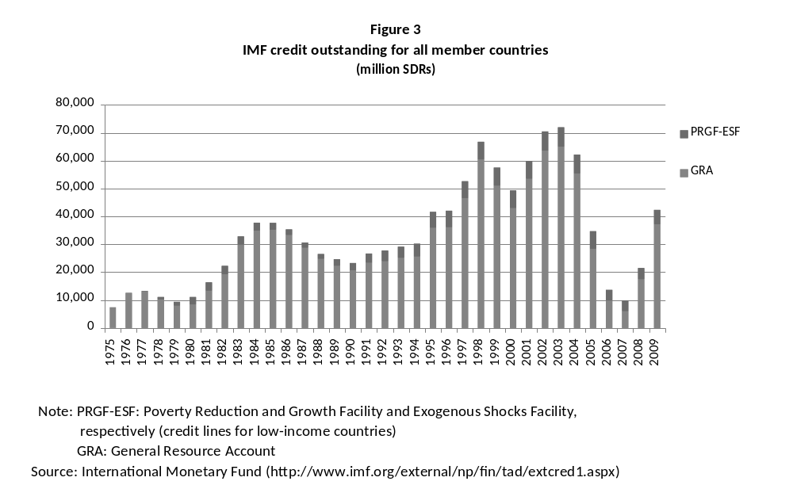
After the Mexican crisis, the need to create new credit lines to mitigate balance of payment crises, caused by abrupt interruptions in external financing or capital outflows, began to be recognized. This problem is exacerbated by the fact that the pro-cyclical behavior of capital flows to developing countries reduces the margin for adopting counter-cyclical macroeconomic policies and the conditionality of IMF credits tends to reinforce the pro-cyclical nature of those policies. In fact, the absence of a multilateral framework aimed at supporting the adoption of counter-cyclical macroeconomic policies could be considered as the main deficiency of IMF actions in developing countries.
Here it is worth highlighting, however, that the IMF has been adopting a more flexible attitude on fiscal policies during the recent crisis, as a result of criticisms it received during the Asian crisis. In fact, in the face of the recessionary risks that the world economy faced, it had taken an openly counter-cyclical perspective on the economic policies that industrialized countries and, with greater caution, developing countries, should adopt.
In the context of the financial crises which the developing world faced after the Asian crisis, the IMF created two new credit facilities. The first, the Supplemental Reserve Facility, created in 1997, served as a framework for the large loans made during the crises at the end of the twentieth century and the start of this century. The other, the Contingent Credit Line, had a more preventive aim. The last was never used because using it was perceived as an indicator of vulnerability, and it was suspended in 2003. In 2006 the IMF proposed an alternative line, called the Reserve Augmentation Line, which was under discussion for a long time. Although the proposal was positive in some respects, since it was automatic, doubts were raised about the prequalification process and the scale of the resources.
For the poorest countries, the structural adjustment lines created in the mid-eighties were transformed in 1999 into the Poverty Reduction and Growth Facility, in order to explicitly put the focus on poverty reduction. In January 2006, a credit line was added for those countries aimed at facilitating recovery after negative shocks – not just trade ones but also natural disasters – and conflicts in neighboring countries. Curiously, the creation of that line has coincided with a weakening of the traditional IMF loan, the Compensatory Finance Facility, which had been designed to cope with negative commercial shocks (especially the deterioration in exchange conditions in middle-income countries). That facility languished due to its excessive conditionality and was finally eliminated.
As well as the deficiencies in the credit lines, there was also another problem which has made the IMF the source of repeated criticism: the excessive conditionality of its programs, which have historically included openly pro-cyclical clauses on macroeconomic adjustment, structural conditions which many countries and analysts have considered antidemocratic because they are not based on decisions by representative national authorities, and the use of the IMF green light for macroeconomic programs which accompany official development assistance (the “gatekeeper” function of those programs, as it has often been called). The excessive conditionality, as well as the absence of credit lines to tackle a world characterized by a high mobility of highly pro-cyclical capital, especially towards medium-income economies, and important fluctuations in terms of trade in poor countries, are some of the most serious problems which this organization faced in designing its crisis management mechanisms when the financial turmoil of 2007 began.
Those problems were tackled, at least partially, as a result of the global crisis. In March 2009, the IMF created the Flexible Credit Line (FCL), which had preventive purposes, for countries with solid fundamentalsbut a risk of facing problems in their capital account. Three countries (Colombia, Mexico and Poland) have used this credit line, although it has not been drawn by any of them. The fact that it has not been used by other countries could indicate that it is not sufficiently attractive. For this reason its terms were improved in August 2010, as the scale of the resources that can be lent was increased and the period for which it can be used was extended. Reflecting the discussions surrounding similar credit lines in the past, the additional problem of this line is that it artificially divides countries into two groups: those which have “good” policies and those which the IMF does not classify under this category, which can obviously increase the risks that the market perceives the second group. This classification implicitly transformed the IMF into a credit rating agency.
This is why the other reforms adopted in March 2009 were probably of greater importance. The first of them was to double the other credit lines for low income countries and to allow a wider use of the ordinary Fund agreements (the stand-by agreements) for preventive purposes (the so-called “high-access precautionary arrangements”). In August 2010, an additional step was taken, with the creation of the new Precautionary Credit Line (PCL) for countries which the IMF deems have good policies, but that do not meet the criteria of the FCL. The other significant reform introduced in March 2009 was to eliminate the relationship between IMF disbursements and structural conditionality.
In terms of low income countries, the IMF made new announcements about its concessional credit lines (IMF, 2009d). Apart from doubling the credit limits, in accordance with the March 2009 reforms –which, although valuable, implies low levels of loans as a proportion of the external shocks in comparison with the emerging economies–, it increased the global capacity of the IMF loans to these countries to US$17 billion until 2014. This lending is done through three facilities; (i) the Extended Credit Facility (ECF), which replaced the Poverty Reduction and Growth Facility (PRGF) and provides help to countries with difficulties in their balance of payments, and lasts various years; (ii) the stand-by lines, which can now be used for dealing with external shocks (which used to be addressed through a special credit line) and other balance of payments needs and (iii) a rapid credit facility for limited support during emergencies (like a natural disaster or a temporary external shock) with a limited conditionality, called the Rapid Credit Facility (RCF). The IMF also decided that all low-income countries would receive an exceptional cancellation of all owed interest payments on concessional loans until the end of 2011, as well as lower rates of interest on future loans.
In December 2009, the IMF reformed its concessional loan lines from a single design to a menu of options (IMF, 2009f). The menu aimed to be more flexible to different situations facing low-income countries in relation to their vulnerability to debt and their macroeconomic and public finance management capacity (“capacity” in IMF terminology). Within this framework, each one of the two factors mentioned previously could take two values: one “inferior” or “superior”. In this way, the framework determines four different concessionary options. Unless the sustainability of the debt is a serious worry (which would be a high value) and the capacity is limited, non-concessionary loans are allowed. On the other hand, countries where the vulnerabilities of the debt are relatively high will always have concessionality.
In this framework, low “capacity” countries with a high vulnerability to the debt are subject to a minimum concessionary threshold of 35%, applied to each loan separately. In countries with lower vulnerabilities to the debt, the threshold is set at 35% and there is room for non-concessionary loans, based on the sustainability analysis of the debt. For countries with greater capacity with larger debt vulnerability, the annual limits would be set based on the average debt accumulation in terms of the present value. Lastly, for countries with the best position, those with greater capacity and lower debt vulnerabilities, a minimum concessionary average is set but that can be completely removed if it is considered appropriate.
Lastly, and in response to the criticisms associated with conditionality, the IMF program for low-income countries is aimed at reinforcing the links between Fund supported programs and the national Poverty Reduction Strategies (PRS), including the critical increase in social spending during the downturn by countries with low levels of debt sustainability. Nevertheless, the IMF still advises and requires member countries to reduce discretionary expenditure aimed at temporarily supporting the economy and/or to cut the fiscal deficit once the economy starts to recover (IMF, 2009e).
The history of the last decade indicates, therefore, that the international system demands the IMF to be more active as a last resort creditor and as guarantor of the stability of the international financial system, but also to be more dynamic in the awarding of emergency financing subject to lower levels of conditionality. The responses it has adopted during the crisis are overall an improvement but it needs to continue making progress on designing financing mechanisms with sufficient resources, that are automatic and which have a simple prequalification process to deal with the external shocks that developing countries face, especially those coming from the capital account, an issue which particularly affects medium-income countries, and the trade shocks that low-income countries face.
3.3 The preventive responses of the developing world
The two problems noted in IMF financing – excessive conditionality and the lack of appropriate credit lines – as well as the evidence that the risks implied by the pro-cyclical nature of the capital movements which affect them, explain one of the most generalized approaches which the developing world has adopted in the last few years: a massive accumulation of international reserves. In contrast to the debt crisis resolution mechanisms and emergency financing of the IMF, this approach is preventive in nature and, in fact, decisively contributes to the lower vulnerability of these countries during the recent crisis.
The foreign exchange reserves of developing countries multiplied by five between 2001 and the end of 2008, reaching 4.4 trillion dollars (Figure 4). By contrast, industrialized countries did not face a similar pressure and the increase reflected in Figure 4 is due almost exclusively to Japan’s current account surplus. In the case of developing countries, accumulating reserves has been seen as a mechanism of “self-insurance” against possible financial crises and to avoid excessive IMF conditionality. The international economic conjuncture which characterized the boom that the developing world experienced between 2003 and mid-2008, of abundant, cheap international financing and high commodity prices, facilitated the accumulation of reserves. As Figure 3 indicates, one of its effects was the massive reduction in the demand for IMF financing, which in fact was obliged to carry out a drastic program of staff cuts.
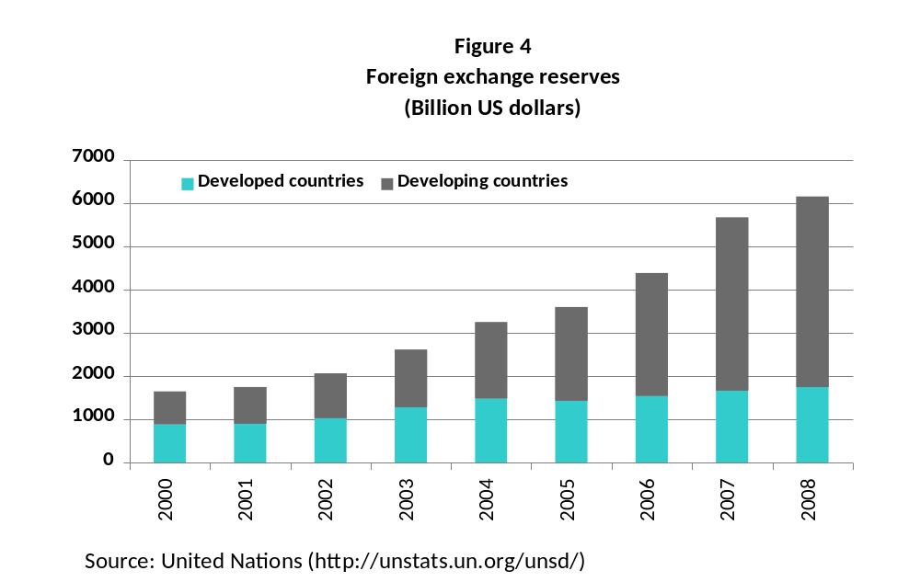
It is worthwhile to add that another mechanism with precautionary effects that was extensively used in the developing world after the Asian crisis was the development of domestic bond markets (public, but also increasingly, private), especially in national currencies (Ocampo and Tovar, 2008). The development of these markets has aimed at avoiding the currency mismatches generated by external liabilities, which implies that depreciations that take place during crises tended to excessively increase the burden of foreign liabilities. The development of an increasing number of institutional investors in industrialized countries which invest in developing countries and the better ratings of those countries (due also to the greater guarantee which growing foreign exchange reserves offer) also contributed to this result; however,they might have generated new mechanisms of pro-cyclical behavior in external financing, to the extent to which those flows respond to the expected evolution of exchange rates in developing countries through the business cycle (appreciation during the booms, depreciation during crises).
The accumulation of reserves for self-insurance reasons was, doubtlessly, a rational response at the level of individual countries to the risks of instability in the international financial system. We should point, however, that this mechanism has costs both for the countries as well as of a systemic character. First of all, it involves the accumulation of assets whose yield is generally lower than that of foreign liabilities. Carrying out policies to “sterilize” the monetary effects of reserve accumulation are very costly when national interest rates significantly exceed the international rates, which is often the case (Rodrik, 2006). Secondly, reserve accumulation generates a “fallacy of composition” that contributes to global imbalances. In order to accumulate reserves, developing countries tend to run a surplus in their current account, which creates a global recessive bias unless it is accompanied with deficits in the current account from other countries, especially from the United States. However, such deficits may be unsustainable and they generate corrections with significant macroeconomic costs. The accumulation of reserves also generates an additional demand for “safe” liquid assets, driving up their prices (and thus reducing their yields), possibly contributing to the generation of asset bubbles. We will return to these issuesin the following section.
Finally, we should underscore that the East Asian crisis led to a very important regional initiative, the Chiang Mai Initiative, adopted in 2000 by the ASEAN countries, China, Japan, the Republic of Korea (ASEAN + 3). The mechanism was initially conceived as a collection of reciprocal bilateral credits between the central banks of the member countries. Using this mechanism, countries could automatically access up to 20% (initially 10%) of the maximum of the credit lines agreed, from when they were obliged to adopt an IMF program, which meant that the regional financing was seen as complementary and not a substitute to the IMF. In 2005, it was further agreed to make the agreed credit lines multilateral in character, so that, in accordance with the decisions adopted in 2007, it would operate as a common reserve fund but managed by each member country and subject to a single contractual agreement. The corresponding multilateral agreement was signed in December 2009 and included resources totaling 120 billion dollars.
We should also add that an institution of this type was set up in the 1960s in Latin America, the Latin American Reserve Fund. The membership of this institution is made up of the Andean countries, Costa Rica and Uruguay.
The history of the last decade indicates, therefore, that an IMF that is more active as a lender of last resort and as a guarantor for the stability of the international financial system would reduce the domestic costs of the self-insurance policies of developing countries and would contribute to reducing the enormous imbalances in the balance of payments that characterize the world economy. Regional financing mechanisms could play a complementary role in this task and, in fact, the IMF should be seen in the future more as a network of reserve funds than as a mere global fund (Ocampo, 2006). A structure of this type would contribute both to global financial stability as well as to reducing global imbalances.
3.4 Reforming the governance of the IMF and the World Bank
The tendency of developing countries to use unilateral solutions has also responded to their perception that they have an insufficient participation in international financial organizations. This has created a debate, which continues today, about changes to the voice and representation of those countries in the IMF and the World Bank.
In April 2008, a modest agreement was adopted on reforming quotas and votes in the IMF Board, which implied a redistribution of the quotas and a tripling of the basic votes to increase the voting rights of developing countries (including the emerging economies) by 2.7 percentage points as a whole. However, the reform had not been ratified before the new reforms adopted in October and November 2010. It should be remembered that for a reform to be effective, it needs to be approved by 112 members representing at least 85% of total votes.
The ministers in the developing and transitional countries demanded in the meetings of spring 2010 an ambitious additional realignment of the quotas, which would imply an increase of 7 percent in the quotas of developing countries, mainly benefiting emerging economies. The specific reforms demanded by the developing countries required greater weight being given in the quota allocation to purchasing power parity GDPs and for more precise measures to be adopted to determine the borrowing needs of countries, through an adequate assessment of the macroeconomic volatility that different countries face.
Just before the meeting of Heads of State in Seoul, the Ministers of the G-20 approved in October 2010 and the IMF Board in November 2010 the principles of the most ambitious reform till the present of IMF governance, which includes several of the elements mentioned: doubling the quotas, revising the allocation of quotas and voting power of developing countries while protecting those of the poorest countries, reducing by two the European representatives in the IMF Board and electing all of its members. However, the increase in the quotas (3.9 percentage points) and voting power (5.3 points) of developing and transition economies was less than the expectations of these countries, in such a way that the large gains by some of them (China, Republic of Korea, Brazil, India, Mexico and Turkey, in that order), which adds up 7.3 and 6.7 percentage points in terms of quota and voting power, respectively, came partly at the expense of other developing countries. In the case of Europe, an interesting reform that could be made would be to consolidate all the chairs of the European Union into one, which would facilitate Europe speaking with one voice in the Board.
An important proposal made on various occasions and that was reiterated by the IMF’s Commission for Governance Reform, headed by Trevor Manuel (IMF, 2009c), is for the threshold of votes needed to approve important political changes in the IMF to be reduced from the current 85% to, for example, 70-75%. That would mean that the United States could no longer exercise a veto in the IMF Board on important policy decisions. This Commission also proposed accelerating the process to reform the quotas, that all chairs on the Executive Board be elected, which has already been agreed, and that a Council of Ministers be formed to adopt the most important policy decisions of the institution.
For its part, in the spring 2010 meetings, the World Bank approved a transfer of 3.13% of voting power from the developed economies to the developing and transition economies (DTEs, which include Saudi Arabia and the Republic of Korea). The DTEs will now hold 47.19% of voting power at the World Bank, and they have received a promise that they will reach parity in the near future. The greatest increase was for China, which gained 1.65% to become the Bank’s third shareholder. The increases were mainly concentrated in middle-income countries, especially in Asia, which were under-represented, while low-income countries saw limited change. In the case of the developed countries, the European Union and Japan will see their voting power reduced but not the United States. The developing and transition countries saw this reform as a step in the right direction towards equal voting power at the World Bank, as expressed in the G-24 statement of April 2010.
The change in voting power will be achieved through an ad hoc capital increase. The objective is, however, to develop a formula based on principles for the next revision in 2015; developing countries expressed their clear preference for a more ambitious calendar. That reflects the fact that there was no agreement on a new dynamic formula for participation, one which would capture the changing economic weight of the countries and contributions to the development objectives of the World Bank. Disagreements arose because many shareholders considered those principles, which followed the G-20 commitments at the Pittsburgh meeting in 2009 and the annual IMF/World Bank meeting in Istanbul, were not applied to the Bank’s proposal, which was based almost totally on the economic weight of the countries. The Bank’s development mission is important both for donors as well as for client countries. For the donors of the International Development Association (IDA), it is important to assign votes in accordance with the size of contributions to the IDA in order to generate incentives to larger contributions to the capital of the Association, which would benefit low-income countries. For medium-income countries, it is also important to bear in mind their character as borrowers.
Finally, it is crucial for the heads of the IMF and the World Bank as well as the senior management of those organizations to be elected on the basis of transparent and open processes, based on the merit of the candidates, regardless of nationality. It is encouraging that in the April 2009 G-20 leaders’ meeting, those principle were approved, which must now be applied. It would also be useful for the personnel of these institutions to be more diverse, not just in terms of nationality but also of education, professional experience, and gender.
4. GLOBAL IMBALANCES AND THE REFORM OF THE INTERNATIONAL MONETARY SYSTEM
4.1 Global imbalances
One field in which international financial architecture has monumentally failed is to provide a mechanism for guaranteeing consistent macroeconomic policies among the major economies. These policies continue to be national in almost all countries, including in the economy which issues the main international currency, and a mix of regional and national policies in the euro zone, where monetary policy is now regional (although not for all members) but fiscal policies remain national. That is combined with an international monetary system and, in particular, with the world reserve system, which is still based to a large extent on a national currency, the US dollar.
The reforms that have taken place over time have added some positive elements to this architecture but they have also suffered significant setbacks and conflicts during certain periods. The creation of the IMF at Bretton Woods represented the most important attempt to establish a mechanism for macroeconomic policy cooperation based on rules that would allow each country to also adopt policies aimed at guaranteeing full employment (internal balance) and to correct fundamental external deficits (external balance) without causing negative effects on the international economy or on other countries. Countries were allowed to modify their exchange rates but to avoid competitive devaluations, which had contributed to the Great Depression in the 1930s, and the IMF was given the capacity to provide partial multilateral official financing to avoid that policies aimed at correcting balance of payments deficits would have recessive effects with again negative impacts on other countries. The IMF also offered a multilateral mechanism for macroeconomic dialogue and cooperation. These forms of international cooperation were also reinforced with the creation in 1969 of a true international reserve currency, the Special Drawing Rights (SDRs) issued by the Fund. Of course, not all the elements were positive, since the Bretton Woods agreement put the dual dollar-gold standard at the center of the international monetary system, which generated its own instabilities and finally collapsed in the early 1970s.
The collapse of the dollar-gold standard and the system of fixed parities and its substitution by a mechanism of variable parities between the main currencies introduced greater flexibility into the international economic system as well as more independence for national macroeconomic policies, at least for the main countries. It also introduced, however, new potential conflicts if the macroeconomic policies of the major economies were not moving in a consistent direction. In the last decade, for example, one endemic problem has been the imbalance between the tendency by the US Federal Reserve to adopt clearly counter-cyclical policies and the greater caution of the European Central Bank to do so. Possible tensions in monetary policy mean that the substitution between alternative reserve currencies (the dollar vs. the euro, in particular), could exacerbate instead of cushion world financial volatility, to the extent that it is reflected in the instability in the exchange rates between major currencies. In any case, the dominant tendency has been toward the use of the dollar as the main international reserve asset (two-thirds in the last decade, according to IMF statistics), which means that the elimination of the dual gold-dollar standard gave way to one fundamentally based on a fiduciary dollar –a “fiduciary dollar standard” as we will call it here.
The macroeconomic coordination mechanisms put in place since the 1970s have also operated outside the IMF and have not been particularly effective. In the 1980s they were ad hoc agreements among the major economies (the Plaza 1985 and the Louvre 1987 Agreements) and subsequently they worked through dialogues within the Group of 7 (the G-7), which clearly left out the main developing countries. The IMF took an interesting step in April 2006 when it created a “multilateral surveillance” mechanism, the aim of which was precisely to consider the macroeconomic and financial interrelations between members of the Fund. That process involved the euro zone, Saudi Arabia, China, Japan and the United States, and its objective was to reduce global imbalances without sacrificing economic growth. Although the motivation of the new mechanism was positive, its results were frustrating.
We should also mention that in June 2007 the IMF Board adopted a new resolution on surveillance of countries’ exchange rate policies, the first in almost 30 years. This resolution put the principle of external stability at the center of the Fund’s activities. To the old principles, which already aimed at avoiding exchange rate interventions which negatively affected other member countries, a new criterion was added: specifically to avoid exchange rate policies which generated external instability. From the outset China expressed strong reservations about this mechanism.
One interesting step in the direction of increasing the number of agents that took part in the dialogues and eventually in macroeconomic cooperation was the G-20 decision in Pittsburgh in 2009 to designate that Group “as the premier forum for our international economic cooperation” under the multilateral supervision of the IMF. However, that solution was only a partial step forward in the necessary task of placing the IMF again at the center of world macroeconomic policies. The solution also created problems because of the ad hoc nature of the cooperation mechanism adopted.
The need for better macroeconomic coordination mechanisms became clear in the light of the large current account imbalances that have characterized the world economy in recent periods, as shown in Figure 5. The strong external deficit of the United States and more recently those of the European Union contrast with the surplus of Japan, China and other developing countries, especially oil producers. The sharp increase in the deficit of the United States became acute during the sequence of crises that developing countries experienced since 1997, when the expansion of the US economy served to cushion the contractionary global effects of those crises. That deficit continued to grow until the middle of the past decade and was kept at high levels until the eruption of the recent global financial crisis despite the dollar’s trend towards depreciation which began, as we will see, in 2003. During the global 2003-2007 boom, the self-insurance policy of the developing countries contributed to the generation of those imbalances. High commodity prices, particularly of oil and metals, also generated surpluses in most commodity exporting countries. The main reflection of this was the rapid increase in the United States’ net foreign liabilities, which reached US$2.1 trillion at the end of 2007.
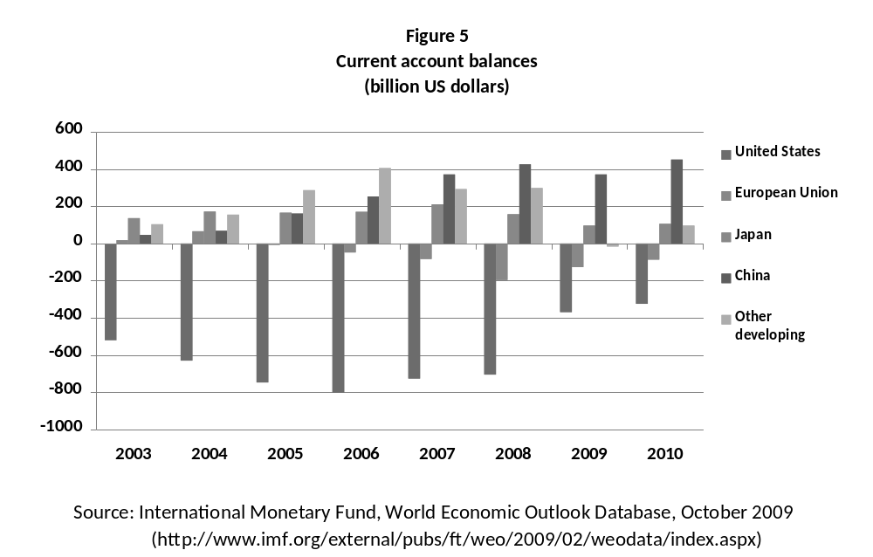
It can also be added that imbalances were reduced as a result of the global financial crisis and especially, as a result of the substantial cut in the United States’ deficit and in the surpluses of Japan and developing countries apart from China (see Figure 5 again). Nevertheless, both the projections of the United Nations (2010) and the IMF (2009a) expect those imbalances to increase again from 2010 and subsequent years. The Fund’s projection for 2010, shown in the figure, also indicate a worrying trend: the deficit of the United States and the European Union continue to fall, but the surpluses of China and the other developing countries increased. These individual trends imply that their net effect will be to reduce global aggregate demand –in other words, they will have a recessionary effect– and in practice they will not work out as projected since the surpluses and deficits will necessarily have to compensate for one another. This reflects the need to maintain expansionary policies at the world level while improving the mechanisms for coordinating national macroeconomic policies to avoid the recessionary trends from materializing.
4.2 Problems with the world reserve system
The magnitude of the recent international financial crisis brought out into the light the problems of the international monetary system and, in particular, the relationship between the world reserve system and global imbalances –and in a wider sense between the monetary system and international economic stability.
The world reserve system shows three fundamental deficiencies (Ocampo, 2009). All of them are related, in turn, to the fact that there is no mechanism to guarantee that surpluses and deficits of different countries offset one another without negative effects on global economic activity.
The first problem, the one highlighted by John M. Keynes during the debates that led up to the creation of the Bretton Woods agreements, is that the present international monetary system –like all systems that preceded it– has a bias against countries running deficits (Keynes, 1942-1943). That tends to generate a global recessionary effect if the corrections that deficit countries need to adopt to balance their external accounts do not find financing in adequate quantities (or if those countries do not think it is appropriate to maintain the deficits and the financing associated with them), and if those adjustments are not offset by expansionary policies in surplus countries. This problem can be called the anti-keynesian bias.
The second deficiency, which has become known as the Triffin dilemma, after the pioneering work by Robert Triffin (1961, 1968), is to do with the fact that an international reserve system based on one national currency (the US dollar) –and, more generally, a limited number of national or regional currencies (the euro currently)– is inherently instable. The only way the rest of the world can accumulate net assets in dollars is if the United States runs a current account deficit. But such deficits can lead to a loss of confidence in the dollar and, more generally, to strong cycles in the value of the main international currency and the current account of the country that issues it, which strongly affects the rest of the world economy. Deficits also encourage the excessive growth in credit in the United States and price bubbles in financial and property assets, which generate the risk of financial crises.
Being the center of the world monetary system means that, apart from appropriating seniorage, the United States also benefits from having its deficits cheaply financed by the reserve accumulation of the rest of the world. Furthermore, the United States also enjoys the additional privilege of being able to carry out a relatively autonomous monetary policy –and even to impose it on the rest of the world. The basic reason for this is the perception (and subsequent use) of the securities issued by the US Treasury as the “safest assets”, which means that the determinants of the US rates of interest are relatively independent of the dollar’s exchange rate against other currencies.
For this reason, the United States has not generally considered the real or probable weakening of its currency as a significant problem that needs to be corrected. The absence of restraints on the US monetary policy has meant that, in contrast to Keynes’ classic theories on the recessionary bias in the international monetary system, the fiduciary dollar standard by which the world economy has functioned over the last four decades can produce exactly the opposite phenomenon during certain periods: an inflationary bias. The boom which preceded the recent crisis could be considered the most noteworthy example of this type of result.
The third deficiency of the current reserve system is its inequitable character. As we have already highlighted, the need to accumulate international reserves forces developing countries to transfer resources to those countries that issue reserve currencies. This inequity bias has been magnified in the last few decades by financial and capital market liberalization and by the strongly pro-cyclical behavior of the capital flows towards developing countries. This behavior has generated, as we have seen, a massive accumulation of international reserves as a form of self-insurance against abrupt interruptions in foreign financing. This accumulation can also be seen as a rational response by each country to a system that lacks a “collective insurance” in the form of a good IMF emergency financing. It also generates the “fallacy of composition” already mentioned, which worsens the distortions in the world balance of payments and can generate, as we have seen, a recessionary bias. We could call this problem the inequality-instability link.
The three problems mentioned have been clearly present in the behavior of the world economy. The first and the third have already received attention in previous sections of this paper. The recessionary biases could present themselves in the next few years if a considerable number of countries try to improve their current account balance (by reducing their deficit or increasing their surplus), as we stated at the end of the previous section. The massive accumulation of reserves by developing countries and their contribution to global imbalances is the clearest demonstration of the third, as we saw in the second part of this paper.
Under the fiduciary dollar standard in which the world has lived, deficits in the United States’ balance of payments have been the rule rather than the exception. During the past three and a half decades, the world has been affected by an ever more intense cycle of growth and contraction in the US current account deficit, which is linked to strong fluctuations in the real exchange rate of the main reserve currency, as we can observe in Figure 6. That implies that the dollar has lacked the main feature that a currency that is at the center of the system should have: a stable value. Moreover, corrections to the US current account have also taken place in a context of world economic downturn, as the recent crisis confirmed yet again.
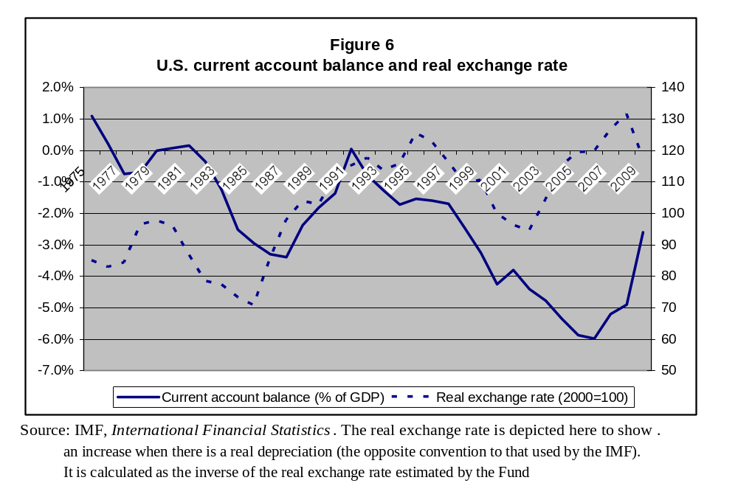
The interaction between the three problems mentioned is particularly clear in the behavior of the US deficit since the end of the 1990s. As Figure 6 indicates, at the end of that decade the greatest deterioration in the US current account in history began. Although it had its equivalent in the deterioration of the domestic deficits of the United States, particularly among households, it should be recognized that the huge size of the current account imbalances are also a result of factors external to the US economy, particularly, as we have seen, the recession or slow growth experienced by large part of the developing world during the succession of crises that started in 1997. The United States deficit served, therefore, to mitigate the anti-Keynesian bias generated by the massive crises experienced by the developing countries.
On the other hand, although the strong US and global slowdown of 2001 allowed the US deficit to decline, the effect was moderate relative to similar past down turns, and the upward trend in the deficit began again the following year. Although that increase is linked again to internal problems in the US economy, it is also related, as we have seen, to developing countries’ strong demand for self-insurance, as well as surpluses of commodity exporting countries. This is why the strong but orderly accumulated depreciation of the dollar since 2003 was not accompanied, as was the case in the second half of the 1980s, by a significant correction in the United States’ current account deficits, which only firmly started in 2008 as a product of the deep US recession –and a world crisis.
4.3 Reforming the system
Among the alternatives for reforming the international monetary system, the first would be to transform the current system into one based on multiple reserve currencies that compete with each other. That alternative is, in fact, already implicit in the system that has operated since the early 1970s and would therefore be in some sense an inertial solution. However, it is not clear that the system would necessarily evolve in that direction, as the problems that the euro has faced during some phases of the current crisis, especially at the end of 2008 and during several conjunctures in 2010, when that currency experienced strong downward pressures as market agents distrusted the strengths of some members of the monetary union.
Additionally, and more importantly for the subjects of this chapter, a system of this type would not correct the main problems of the current monetary standard. It would do nothing to correct the anti-Keynesian bias and each currency would have an unstable value and so would lack what we earlier highlighted as one of the essential characteristics that a reserve currency should have: stability. Furthermore, although this model would offer developing countries the advantage of being able to diversify the composition of their reserves, they would be invested in all forms of industrial country assets, which would maintain the generation of a transfer of resources from developing countries to the industrialized nations. One exception would be if the reminbi were to become a major reserve currency, but that possibility seems a long way away and would only benefit one developing country transformed into a world power.
Curiously, flexibility in exchange rates among major reserve currencies constitutes both the main advantage and disadvantage of the system. The advantage is derived from the fact that a competitive system of reserve currencies would resist attacks on fixed parities that ended up bringing down both the silver-gold standard in the nineteenth century and the gold-dollar standard in the early 1970s. However, that flexibility adds another additional element of instability compared to a system purely based on the dollar, due to the volatility in the exchange rate among the major reserve currencies – a problem that is, in some ways, already present in the current system. Such volatility generates significant profits and losses for central banks in their reserve management and it eliminates one of the characteristics that reserve assets should have: to be “safe” or low risk. That is its main disadvantage.
This disadvantage would be exacerbated if central banks responded to fluctuations in exchange rates by changing the composition of their international reserves, thereby feeding into exchange rate instability. Under those conditions, a system of multiple reserve currencies could generate growing demand for the adoption of an agreement for fixed exchange rates –in other words, a return to the Bretton Woods scheme, at least for reserve currencies. However, setting exchange rates between the main currencies in a world characterized by massive capital mobility would be a difficult or altogether impossible task. We should add that, given the high demand for foreign exchange reserves, developing countries suffer disproportionately from exchange rate instability among reserve currencies.
All this implies that the main deficiencies can only be resolved by a deeper reform of the world reserve system. Although other alternatives could be designed –such as Keynes’ proposal to create an international clearing union and similar solutions– the most viable consists in completing the transition started in the 1960s with the creation of the Special Drawing Rights (SDRs). That involves placing a world fiduciary currency at the center of the system, completing a tendency in the evolution of national and international monetary systems since the nineteenth century (Triffin, 1968). Given the pro-cyclical nature of the capital movements that developing countries face, as well as the high demand for foreign exchange reserves that such behavior generates, the adoption of a scheme of this type should be accompanied with other initiatives aimed at guaranteeing the issuing of the SDRs be used to correct, at least partially, the problems that developing countries face under the current system.
Obviously, the role of the SDRs has changed since the early 1970s with the transformation of the international monetary system towards a fiduciary dollar standard. The questions related to adequate international liquidity, which were the fundamental concern during the early post-war period, and which were still the center of world debate in the 1960s, are no longer important except during extraordinary conjunctures like those caused by the severe liquidity crunch that characterized the world financial meltdown of September and October 2008. As we have seen, the fiduciary dollar standard can show an inflationary bias, which reinforces the boom of the world economy, as happened in 2003-2007. Nevertheless, other problems that were also the object of attention in the 1960s continue to be fundamental or even more important today, especially those linked to the composition of world reserves, the access of developing countries to liquidity and questions of equity related to both processes.
After the initial allocations carried out in 1970-1972 and 1979-81, no more allocations were made for almost three decades. The last of them, approved by the IMF in 1997, for 21.4 billion SDR, only came into effect in mid-2009 with the approval by the United States of the change in the IMF’s Articles of Agreement of which it was part. The current crisis, however, generated renewed interest in this mechanism for international cooperation, as reflected in the G-20 proposal, subsequently approved by the IMF, to allocate SDRs equivalent of 250 billion additional dollars, of which little short of 40% benefited developing countries under the current system of quotas. That meant that SDRs issues reached in 2009 the equivalent of 283 billion dollars. Although that is an important sum and meant that the SDR now represents 5% of world reserves, a proportion that is still inferior even to that at the time of the first allocations in 1970-1972, when it reached 10% (Williamson, 2009). The suspension of the SDR issues for more than a quarter of a century had negative effects for developing countries because it coincided with an increase in demand in the foreign exchange reserves by those countries.
We should highlight that any international monetary reform should involve a considerable increase in the size of the IMF, which has been lagging significantly behind the size of the world economy since the 1998 revision of quotas, and since the 1970s in comparison to the magnitude of world capital flows (IMF, 2009b). Obviously, the form in which the Fund obtains its resources is essential. The SDR allocations and the quota increases are much better mechanisms than “arrangements to borrow” in their different forms, the main option chosen by the G-20 in April 2009, as well as in the past, to increase the resources available for the Fund during crises.
The creation of a system based to a greater degree on SDRs would contribute to a large extent to resolve both the Triffin dilemma as well as the distributive effects caused by the use of the US currency as the principle reserve asset. In the last few years, the proposals to increase SDR issuance have followed two different models. The first consists in issuing them in a counter-cyclical way, concentrating them basically in periods of crisis and possibly destroying them once financial conditions normalize (United Nations, 1999; Camdessus, 2000; Ocampo, 2002). That would create a counter-cyclical element in the management of international liquidity. The second model proposes regular SDR allocations equivalent to the additional demand for reserves at the world level, which is at least 100-150 billion dollars a year, even if we ignore the exceptional recent period of reserve accumulation, but it may be double that sum. That is also the size of the SDRs that should be issued in the long-term for counter-cyclical purposes. One alternative that combines these two options would be to make regular issues, but to keep them inactive and make them effective only under pre-established conditions.
One fundamental problem this reform faces are the distribution of IMF quotas that are also the basis for issuing the SDR and do not reflect the realities of today’s world economy. Apart from the subjects that have been the object of discussion in recent debates on Fund quotas, which have led, as we have seen, to some improvements, the most important issue is the enormous gap between the demand for reserves from developing economies and industrialized ones, which is at the heart of the inequities in the global reserve system and the inequality-instability link. The problem can only be corrected through a reform or a combination of four types of reforms (since they are not mutually exclusive).
The first would be to include the demand for reserves as a criterion for SDR allocations, which would mean in practice awarding a large part of the issues to developing countries.
The second consists in linking counter-cyclical SDR issues to IMF financing during crises in order to thereby improve the provision of a “collective insurance” against balance of payment crises. One option to do that would be to consider those SDR that are not used by countries to be deposits (or loans) to the IMF, which could be employed by the institution to lend to countries requesting emergency financing. Of course, for this task it is essential to improve the Fund’s credit lines and their conditionality in order to overcome the stigma associated with loans from this institution. Another option that could be considered is to adopt at least part of Keynes’ original plan: to create a drawing line that can be unconditionally used by all IMF members for a pre-established sum and period. Another possibility, which might be more politically feasible, would be for the IMF to grant unconditional credit to countries suffering shocks that have a clear external origin, whether the shocks affect a country’s capital account or its current account. The compensatory credit line, which was scrapped in March 2009, worked when it operated with light conditionality rules.
The third proposal would be to create an explicit “development link” in the SDR allocations (which could be an alternative or a complementary proposal to the first one). One of the proposals along these lines is to use the SDR allocation corresponding to industrialized countries to finance official development assistance and the provision of global public goods (Stiglitz, 2006, Ch. 9). This suggestion has many advantages, but poses the problem that such transfers would have a fiscal character, and therefore might need approval by each national parliament. An alternative to this would be a similar scheme to the one suggested by the Group of Experts gathered by UNCTAD in the 1960s (UNCTAD, 1965): allow the IMF to buy bonds from multilateral development banks to then finance the long-term demands for financing of developing countries.
The fourth proposal would be to encourage the creation of funds or other regional reserve agreements in developing countries –such as the Latin American Reserve Fund the Chiang Mai Agreement mentioned earlier– that would provide a complementary form of collective insurance. One very important incentive to such regional agreements would be a provision under which the SDR were proportional not just to the IMF quotas but also to the funds that developing countries have contributed to regional reserve funds (United Nations, 1999, Ocampo, 2002).
Lastly, there are two complementary reforms that many analysts consider necessary to consolidate the role of the SDR in the international monetary system. The first is to allow the use of this currency in some private sector transactions (see, among others, Kenen, 1983). Of course, there are intermediate solutions: allowing the use of the SDRs only for specific purposes, such as those associated with financial institutions’ capital or liquidity requirements.
The second would be creating a “substitution account”, a suggestion made at the end of the 1970s when the dollar faced adverse pressures. That account would allow countries to exchange their dollar for SDR assets issued by the IMF, thus reducing pressures on the dollar in the market. A system like this would give more stability to the current monetary standard and would be, in any case, a necessary transition mechanism for a global reserve system based on SDRs. The IMF decision of July 2009 to allow the issuing of securities denominated in SDR to draw in resources from some emerging economies (Brazil, China and Russia) can be considered a step in that direction. The fundamental problem, underlined in the debates of the 1970s, is how to distribute the losses that the IMF could incur with a mechanism of this type. That said, those costs are not necessarily very high. Retrospective calculations done by Kenen (2009) indicate that, if the mechanism had been in place in the period 1995-2008, those losses would have been minimal.
The current context could be a good moment to introduce these reforms. Firstly, the inflationary risks associated with SDR issues are low and, on the plus side, such issues could reduce the recessionary risks that the world economy is facing because of the fear of running up deficits as reflected in the evolution of global imbalances. Secondly, the United States has embarked on a high fiscal deficit and an aggressive monetary easing. That has potential implications for the stability of the current reserve system, as some countries have pointed out, China especially (Zhou, 2009). In reality, under the current circumstances, the United States could find its central role in the global monetary system rather uncomfortable since it could be an obstacle to its freedom in economic policy.
In any case, abandoning the dollar as the chief world reserve currency is consistent with maintaining its role as the major international means of payment, unless SDRs were used in larger set of financial transactions. The use of the dollar as a means of payment method increases demand for the services of the US financial system and has other implications for the country that have been explored by other authors (see Cooper, 1987: Ch. 7, for instance). It clearly remains to be seen whether the crisis under way will have permanent effects on the role of the United States as the world’s main banker.
5. BY WAY OF CONCLUSION: AN OVERALL LOOK AT REFORM OF INTERNATIONAL FINANCIAL ARCHITECTURE.
The Asian crisis of 1997 and its contagion to Russia and Latin America led to great interest in reforming the international financial architecture. A decade later and in the face of what was the prelude to a new financial crisis, which had its epicenter in the largest economy in the world, progress on reform has been clearly disappointing. In fact, global imbalances were probably more pronounced than at any time since the Second World War, the regulatory deficit in the most developed financial markets was massive and the IMF found itself undergoing its worst crisis in history.
One positive aspect about the period 1997-2007 was the definition of a broad consensus on international financial and development reform, the Monterrey Consensus, adopted in 2002. The following conference on the Monterrey agenda, carried out in Doha (Qatar) at the end of November 2008, and the Summit on the global financial and economic crisis and its impact on development that the United Nations called in June 2009, were important opportunities to look again, in the United Nations, at problems of international financial cooperation. The Doha conference was preceded not just by the eruption of the global financial crisis but also by the creation of the G-20 at the level of leaders, which began by adopting important initiatives in various fields.
The main progress throughout the decade of 1997-2007 was centered on strengthening macroeconomic policies and financial regulation of developing countries and in creating or deepening domestic bond markets in those countries. In turn, developing countries responded to the absence of a good collective world insurance mechanism against financial and balance of payment crises with their own massive self-insurance, through an unprecedented accumulation of foreign exchange reserves. We should add to that East Asia’s Chiang Mai Initiative, which created a regional mechanism to support countries during crises. At an international level, IMF credit lines were improved and a failed debate took place on the introduction of a multilateral mechanism to manage sovereign debt crises.
The efforts that the developing countries themselves made are, therefore, the main achievements in international financial reform in the period 1997-2007. The main paradox of that was that international reform was based more on the national reforms carried by developing countries than on a true reform of the international financial architecture. Those efforts served the cushion the effect of the global crisis of 2007-2008 on developing countries.
As a result of the global financial crisis that hit in September 2008, there have been important advances. Among them is the renewed issuance of SDRs and the creation of new IMF facilities, as well as the widening of existing ones to poor countries, and the proposals under discussion for the introduction of an international tax on currency transactions. There have also been huge debates and commitments to make important financial regulatory reforms in the main industrialized countries. Nevertheless, these last developments have only partially materialized.
One issue emphasized since the Asian crisis, was the need for a world governance structure in which developing countries have adequate “voice and representation” in world economic decision making, to use the terminology of the Monterrey Consensus. Such representation was in some cases inadequate (the IMF and the World Bank) and in other cases partial (the International Settlements Bank) or non-existent (the Basel Committee and the Financial Stability Forum). Greater representation of developing countries would be part of a larger reform aimed at guaranteeing global governance structures that reflect today’s world economy and not that of the closing years of the Second World War when the Bretton Woods institutions were created. An additional element to reform is the veto that the United States has had on the main IMF decisions, aside from excessive informal influence, as it became evident during the Asian crisis.
The IMF made some timid steps on “voice and representation” of developing countries in 2006, which were followed by more ambitious agreements in October and November 2010. The World Bank initiated discussion on the issue with a lag and also adopted a modest reform. It is worthwhile highlighting that in both organizations the changes that the world economy has experienced demanded that a greater weight be given to Asian developing economies mainly at the expense of European countries. That could be achieved, even in a manner consistent with maintaining or increasing European influence in those organizations, if a seat was created to represent the European Union and not individual countries. We should also add that the reform proposals have shown the need to increase the voice of the poorest countries in international organizations. However, given the loss of participation of those countries in the world economy, the only solution in their case is to increase the basic votes of the poor countries in international institutions. That method was adopted in the IMF reforms of 2006.
The most important changes in terms of governance that the international financial crisis produced was, as underlined, the creation of the G-20 at the level of world leaders. The G-20 had previously operated since its creation after the Asian crisis as a forum for finance ministers and central bank governors of limited impact. One of the G-20 decisions was to give access to all its members to regulatory organizations on financial matters, especially to those assigned the task of coordinating the tasks of world financial reform, the renamed Financial Stability Board (previously Forum). These reforms therefore increased the representation of developing countries in those organs. Although that represents progress, it also throws up serious questions, given the ad hoc way in which the membership of such organizations has been defined, which implies the exclusion of some large countries (Nigeria is the case that most stands out). In this sense, the creation of the G-20 at leadership level should be merely seen as a transition to a representative, and thereby legitimate, mechanism.
References
Atkinson, Anthony, ed. (2005): New Sources of Development Finance, New York: Oxford University Press.
Basel Committee (2009a): “Enhancements to the Basel II Framework”, July. . www.bis.org
_____ (2009b): Strengthening the Resilience of the Banking Sector, December, www.bis.org
_____ (2010): The Basel Committee Response to the financial crisis; Report to the G-20. October. http://is.org/publ/bcbs179.pdf
Brunnermeier, Markus, Andrew Crocket, Charles Goodhart, Avinash Persaud and Hyun Shin (2009): The Fundamental principles of Financial Regulation. Geneva: International Center for Monetary and Banking Studies and Centre for Economic Policy Research, January.
Camdessus, Michel (2000): “An Agenda for the IMF at the Start of the 21st Century”, Remarks at the Council on Foreign Relations, New York.February.
Clark, Peter B. and Jacques J. Polak (2004): “International Liquidity and the Role of the SDR in the International Monetary System”, IMF Staff Papers, Vol. 51, No. 1.
Cooper, Richard (1987): The International Monetary System: Essays in World Economics, Cambridge, Mass.: MIT Press.
D’Arista Jane (1999): “Reforming the Privatized International Monetary and Financial Architecture”, Financial Markets and Society, November.
_____ and Stephany Griffith-Jones (2010): “Agenda and Criteria for Financial Regulatory Reform”, in Griffith-Jones, Ocampo and Stiglitz (2010).
Goodhart, Charles (2002): “Basel and pro-cyclicality”, in Andrew Hilton (ed.), Bumps on the road to Basel, London: Centre for the Study of Financial Innovation.
_____ (2010): “How If At All Should Credit Rating Agencies Be Regulated?”, in Griffith-Jones, Ocampo and Stiglitz (2010).
Griffith-Jones, Stephany, Segoviano, Miguel and Spratt, Stephen (2002): “Basel II and Developing Countries: Diversification and Portfolio Effects”, Capital Market Liberalization Program, Initiative for Policy Dialogue, Columbia University, December.
_____ and Avinash Persaud (2008): “The Pro-cyclical Impact of Basel II on Emerging Markets and its Political Economy”, in José Antonio Ocampo and Joseph Stiglitz (eds.), Capital Market Liberalization and Development, New York: Oxford University Press.
_____ and José Antonio Ocampo (2009): “Building on the Counter-Cyclical Consensus: A Policy Agenda”, High-level Roundtable in Brussels “Towards Basel III? Regulating the Banking Sector After the Crisis”, October. www.policydialogue.org, Financial Task Force. G24 Discussion Paper.
_____ and Kevin Young (2009): “Reforming Governance of International Financial Regulation – Policy Brief”, IPD Policy Brief, www.policydialogue.org
____, José Antonio Ocampo and Joseph Stiglitz, eds. (2010): Time for a Visible Hand; Policy Lessons from the 2007 Crisis, New York: Oxford University Press.
______, Damon Silvers and Matthias Thiemann (2010) “Turning the financial sector from a bad master to a good servant: the role of regulation and taxation”, High-level conference in Washington DC on “Global Economic Governance”, October http://policydialogue Silvers_GEG_BkgdPaperx.pdf
Hart, A. G., Nicholas Kaldor and Jan Tinbergen (1964): “The Case for an International Commodity Reserve Currency”, Geneva: UNCTAD. Reproduced in Nicholas Kaldor Essays on Economic Policy II, New York: Holmes and Meier, 1980, Chapter 18.
Helleiner, Eric and Stefano Pagliari (2009): “Crisis and Reform of the Financial Regulatory System”, in Eric Helleiner, Stephano Pagliari and Hubert Zimmerman, Global Finance in Crisis. The Politics of International Regulatory Change, London: Routledge.
Herman, Barry, José Antonio Ocampo and Shari Spiegel, eds. (2010): Overcoming Developing Country Debt Crises, New York: Oxford University Press.
IMF (International Monetary Fund) (2009a), World Economic Outlook, October.
____ (2009b): “Review of the Adequacy of and Options for Supplementing Fund Resources”, January.
____ (2009c): Committee on IMF Global Governance reform: Final Report. Washington D.C., March.
____ (2009d): “IMF Reforms Financial Facilities for Low-Income Countries”, Washington, D.C., July. http://www.imf.org/external/np/sec/pn/2009/pn0994.htm
_____(2009e), “Creating Policy Space—Responsive Design and Streamlined Conditionality in Recent Low-Income Country Programs”, Washington, D.C., September. http://www.imf.org/external/np/pp/eng/2009/091009A.pdf
_____(2009f), “Concessionality and the Design of Debt Limits in IMF-Supported Programs in Low-Income Countries”, Washington, D.C., December, http://www.imf.org/external/np/pdr/conc/
Kenen, Peter B. (1983): “Use of SDR to Supplement or Substitute for Other Means of Finance“, in George M. von Furstenberg (ed.), International Money and Credit: The Policy Roles, Washington D.C.: FMI, Chapter 7.
_____ (2001): The International Financial Architecture: What’s New? What’s Missing?, Washington D.C.: Institute for International Economics, November.
_____ (2009): “Revisiting the Substitution Account”, Initiative for Policy Dialogue, Document presented in “Towards a World Reserve System”, Initiative for Policy Dialogue, Columbia University, November, http://www0.gsb.columbia.edu/ipd/programs/item.cfm?prid=133&iyid=5&itid=1927&list=papers
Keynes, John M. (1936): The General Theory of Employment, Interest and Money, London: Macmillan.
_____ (1942-1943): “The Keynes Plan,” reproduced in J. Keith Horsefield (ed.), The International Monetary Fund 1945-1965: Twenty Years of International Monetary Cooperation” Vol. III: Documents, Washington, D.C.: FMI, 1969, pp. 3-36.
Landau, Jean Paul (2004): Report to Mr. Chirac, President of the Republic of France, Working group on New International Financial Contributions, Paris.
Nissanke,Machiko (2005) “Revenue Potential of the currency transactions tax for development finance”, in Atkinson, ed. (2005).
Ocampo, Jose Antonio (2002): “Recasting the International Financial Agenda”, in John Eatwell and Lance Taylor (eds.), International Capital Markets: Systems in Transition, New York: Oxford University Press, pp. 41-73.
_____ (2003): “Capital Account and Counter-Cyclical Prudential Regulation in Developing Countries”, in Ricardo Ffrench-Davis and Stephany Griffith-Jones (eds). From Capital Surges to Drought: Seeking Stability for Emerging Markets, London: Palgrave Macmillan, pp. 217-244.
Ocampo, Jose Antonio (2006): “Regional financial cooperation: Experiences and challenges”, in José Antonio Ocampo (ed.). Regional Financial Cooperation, Washington D.C.: Brookings Institution and CEPAL, Chapter 1.
_____ (2009), “Los derechos especiales de giro y el sistema mundial de reservas”, in José Antonio Alonso, Santiago Fernández de Lis y Federico Steinberg (coords), La reforma de la arquitectura financiera internacional, Madrid: Real Instituto Elcano, Chapter IV.
_____ and Camilo E. Tovar (2008): “External and Domestic Financing in Latin America: Developments, Sustainability and Financial Stability Implications”, UN workshop: “Debt Finance and Emerging Issues in Financial Integration”, New York, April.
Pigou, Arthur C. (1920): The Economics of Welfare, London: Macmillan.
Reddy, Y.V. (2010): “Regulation of Financial Sector in Developing Countries: Lessons from the 2008 Financial Crisis”, in Griffith-Jones, Ocampo and Stiglitz (2010).
Rodrik, Dani (2006): “The Social Costs of Foreign Exchange Reserves”. International Economic Journal, Vol. 20, No. 3, September.
Rustomjee, Cyrus (2004): “Why Developing Countries Need a Stronger Voice”, in Finance and Development, September.
Saurina, Jesús (2009): “Dynamic Provisioning, The Experience of Spain”, World Bank, Financial and Private Sector Development Vice-presidency, Policy Note No. 7, July.
Schmidt, Rodney (2008): The Currency Transactions Tax: Rate and Revenue Estimates, Tokyo: United Nations University Press.
Shi, Kang and Juanyi Xu (2009): “Entry cost, the Tobin tax, and noise trading in the foreign exchange market”, Canadian Journal of Economics, Vol. 42, No. 4.
Spratt, Stephen (2006), “A Sterling Solution: A Report for Stamp Out Poverty”, London, September, www.stampoutpoverty.org.
Stiglitz, Joseph (2006): Making Globalization Work. New York: W.W. Norton.
_____ (2010): ”Watchdogs need not bark together”, Financial Times, February 10.
Tobin, James (1996): “Prologue”, in Mabul Ul Haq, Inge Kaul and Isabelle Grunberg (eds), The Tobin Tax: Coping with Financial Volatility, New York: Oxford University Press.
Triffin, Robert (1961): Gold and the Dollar Crisis (revised edition), New Haven: Yale University Press.
_____ (1968): Our International Monetary System: Yesterday, Today and Tomorrow, New York: Random House
UNCTAD (1965): International Monetary Issues and the Developing Countries: Report of the Group of Experts, New York: United Nations.
United Nations (1999): Towards a New International Financial Architecture: Report of the Task Force of the Executive Committee on Economic and Social Affairs of the United Nations, http://www.un.org/esa/coordination/ecesa/ecesa-1.pdf.
_____ (2009): Report of the Commission of Experts of the UN General Assembly on Reforms of the International Monetary and Financial System [UN Stiglitz Commission], New York, September.

_____ (2010): World Economic Situation and Prospects, New York, January.
Warwick Commission (2009): International Financial Reform, November, warwick.ac.uk/research/warwickcommission/
Williamson, John (2009), “Understanding Special Drawing Rights”, Policy Brief, Peterson Institute for International Economics, Washington, DC., June.
Woods, Ngaire and Domenico Lombardi (2006): “Uneven patterns of Governance: How developing countries are represented in the IMF?”, International Political Economy, August.
Zhou Xiaochuan (2009): “Reform the international monetary system”, People’s Bank of China, Beijing. http://www.pbc.gov.cn/english//detail.asp?col=6500&ID=178

See the collected essays on this in the recent book by Griffith-Jones, Ocampo and Stiglitz (2010).
It also included the Presidents of the Central Banks of developing countries (Mexico and China) in their Directory. Moreover, at the moment the President of the Directory of the International Settlements Bank is the President of the Central Bank of Mexico.
Read the extensive analysis on these topics in the essays collected in the recent book by Herman, Ocampo and Spiegel (2010).
See, for example, Stiglitz (2010) and D’Arista (1999), as well as the interesting proposal made in the sixties to create a commodity-based reserve system, which has particularly interesting counter-cyclical features (Hart, Kaldor and Timbergen, 1964).
See Kenen (2001) on the deficiencies of arrangements to borrow.
That would involve eliminating the division between the denominated General Resource and the SDR accounts. See Clark and Polak (2004) and Cooper (1987: Chap. 12).

