SOVEREIGN WEALTH FUNDS:
A DEVELOPING COUNTRY PERSPECTIVE

Stephany Griffith-Jones and
José Antonio Ocampo *

I. INTRODUCTION
Although sovereign wealth funds (SWFs) are not a new phenomenon, they have acquired certain notoriety in public debates in recent years, associated to the growing role they have come to play in global financial markets. The growth of these funds are part of larger process of accumulation of foreign exchange assets by developing countries, which also includes the large accumulation of foreign exchange reserves during the boom that these countries have experienced over most of the current decades, reflecting both booming exports (due in part to high commodity, particularly mineral prices) and pro-cyclical capital flows.
This paper analyzes the rationale for such funds and the implications for the world economy. It is divided in six sections, the first of which is this introduction. Section II details the evolution of foreign exchange assets in different parts of the developing world, the relative importance of the current vs. the capital accounts as the source of those assets, and discusses some categorizations of SWFs. In Section III we review the rapidly growing literature on the determinants of reserve accumulation in developing countries, emphasizing in particular the competitiveness vs. self-insurance motives for such accumulation, and briefly examine some of the literature on optimal reserves.
In Section IV, we develop a broader framework for the analysis of the motives for the accumulation of foreign exchange assets, in which we clearly differentiate between the role played by the current and the capital accounts, and between the structural vs. cyclical determinants of such accounts, and raise some political economy issues associated with the nature and management of these funds. In section V, we analyze the systemic implications of the analysis for the global and regional financial architectures and in section VI we draw some conclusions.
II. THE ACCUMULATION OF FOREIGN EXCHANGE RESERVES AND THE RISE OF SWFs
A remarkable feature of the international financial system in the last decade has been the worldwide rapid accumulation of foreign exchange reserves by developing countries. Based on IMF data, between December 2001 and October 2007 (the latest figure available), global reserves tripled, from US$2.1 trillion to US$6.2 trillion. The bulk of the increase has concentrated in the developing world: developing countries as a whole accounted for more than 80 percent of global reserve accumulation during this period, and their current reserves approach US$5 trillion (see Figure 1).
Figure 1
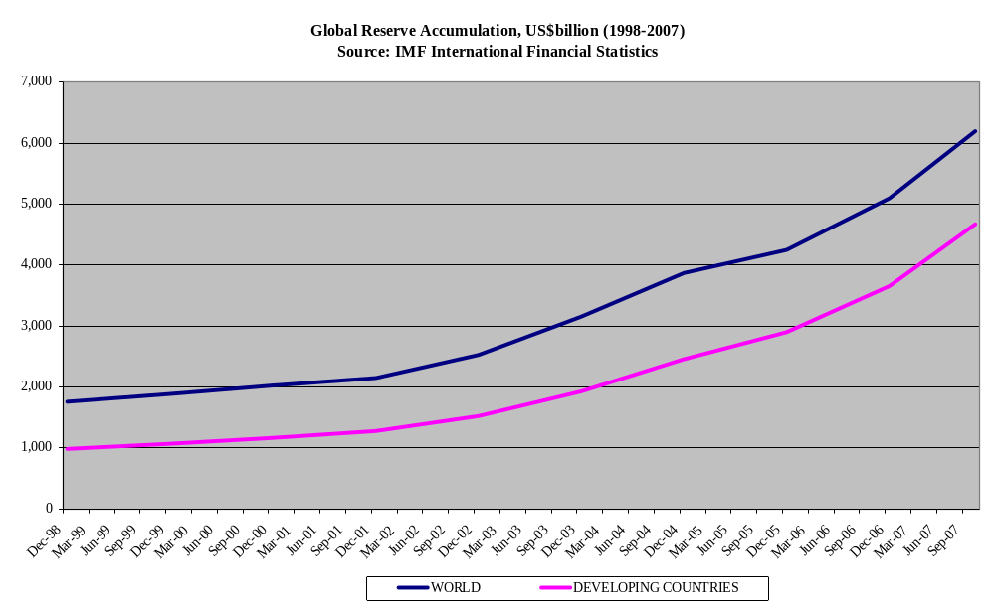

The growth in reserves has been steeper during the last few years. In particular, export-led Asian economies, particularly China and India, and commodity-producing countries, especially oil-exporting countries based in the Middle East, have accumulated the lion’s share of these increases. For example, of the US$1.6 trillion foreign exchange reserves increase in Asia (including Japan) between December 2003 and October 2007, three-fourths are accounted for by China and India. Oil-producing countries have also accumulated foreign exchange reserves at a remarkable pace. At end-October 2007, they had reserves in excess of US$430 billion, an increase of 2.5 times compared to five years earlier (as discussed below, we should add to this figure the amounts placed by these countries in SWFs, which are recorded separately). Combined together, China, India and oil-exporting countries accounted for more than half of the variation in world international reserves. Latin America has also shared in that trend, approximately doubling its international reserves during this period (see Figure 2).

Figure 2
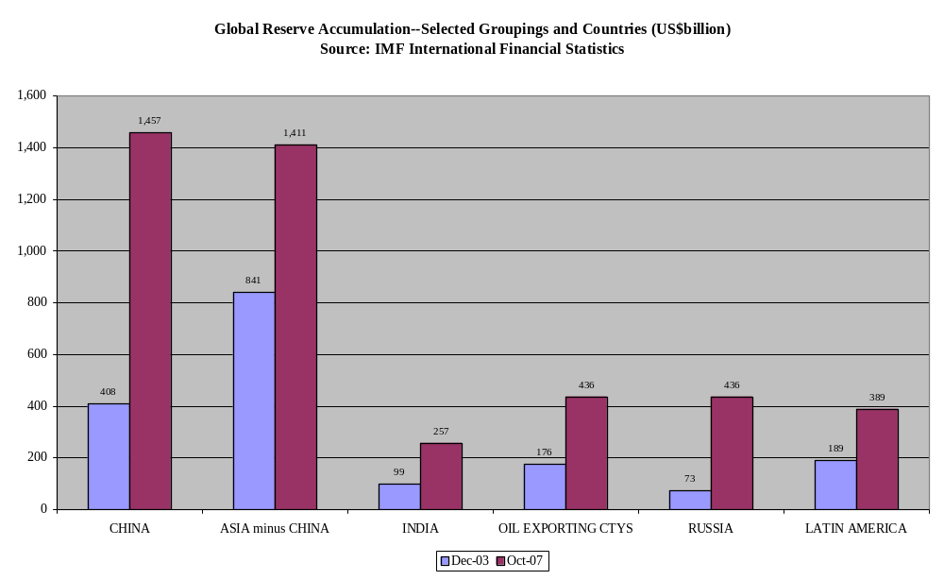
What has driven these developments? At an aggregate level, we can make a distinction between the contribution of the current account and that of the capital accounts. By focusing in particular on three regions, Developing Asia, the Middle East and Latin America (see Figure 3.A), we can see that in all of them there has been a substantial net transfer of resources towards the rest of the world from 2002 to 2006, as the change in reserves has been accounted to a large extent by current account surpluses. However, regional trends hide important differences at the country level. For example, in Developing Asia, while China and Singapore have experienced a net transfer of resources driven by buoyant current account surpluses, India has “borrowed” reserves instead, as the counterpart of its reserves hoarding is represented by net capital inflows (see Figure 3.B).In Latin America too there are some important differences to note. While Venezuela and Argentina show a path similar to China and Singapore, having accumulated reserves essentially as a result of current account surpluses, in Mexico and Colombia this process has been the outcome of net external financing (see Chart 3.C). Note, however, that in several cases the accumulation of official external assets, several of which are SWFs, tends to underestimate the importance of capital inflows as a source of reserve accumulation, as the accumulation of such official assets abroad is accounted for as a negative contribution to the capital account. This is the case of Singapore and Venezuela and, to a lesser extent, Chile, in Latin America.
Figure 3.A
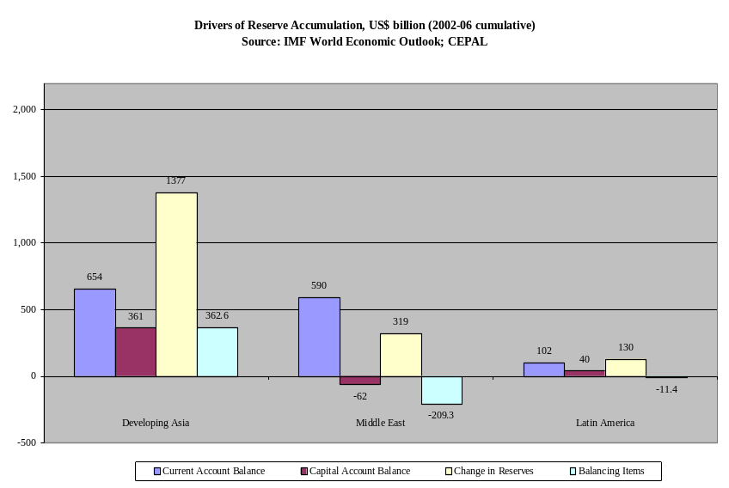

Figure 3.B
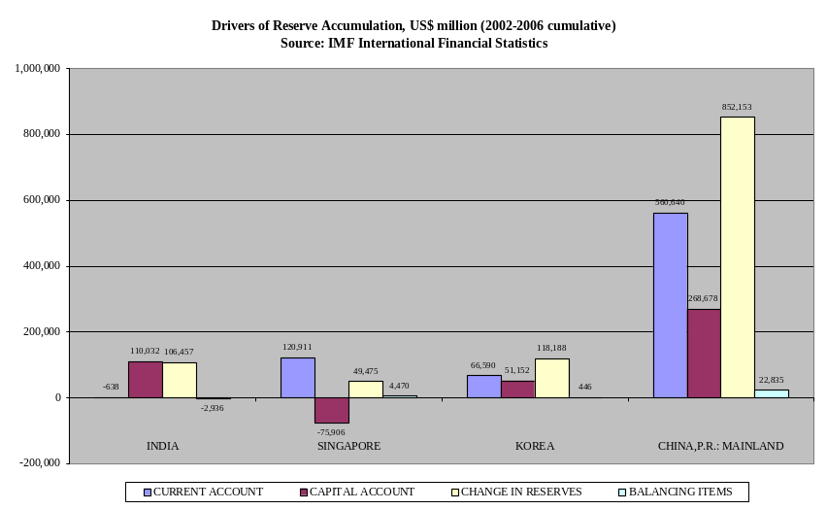

Figure 3.C
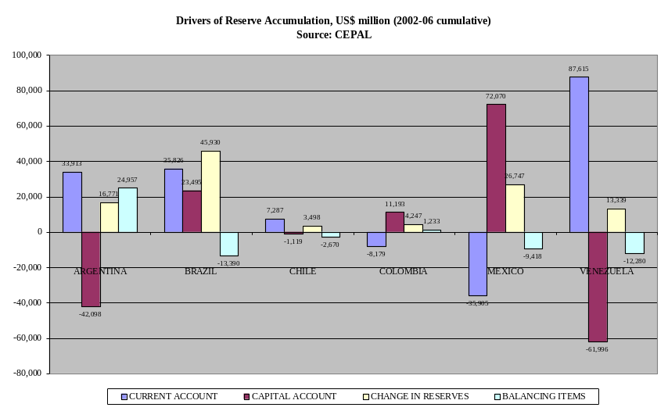
Furthermore, the relative importance of the current vs. capital account balance has changed through time, particularly in Latin America. Figure 4 shows indeed that, while the initial accumulation of reserves had an important component of current account surpluses, the capital account came to play a more important role during the two periods of “exuberance” in capital flows to Latin America identified by Ocampo (2007b): from mid-2004 to the first quarter of 2006 and, between mid-2006 and mid-2007. The second period was particularly buoyant in terms of capital inflows and the accumulation of international reserves. Indeed, three-fifths of the reserves accumulated since the first quarter of 2004 were the result of the booming capital inflows experienced during this second period of “exuberance”. Furthermore, if we take out Venezuela, Latin America ceased to run a current account surplus in 2007.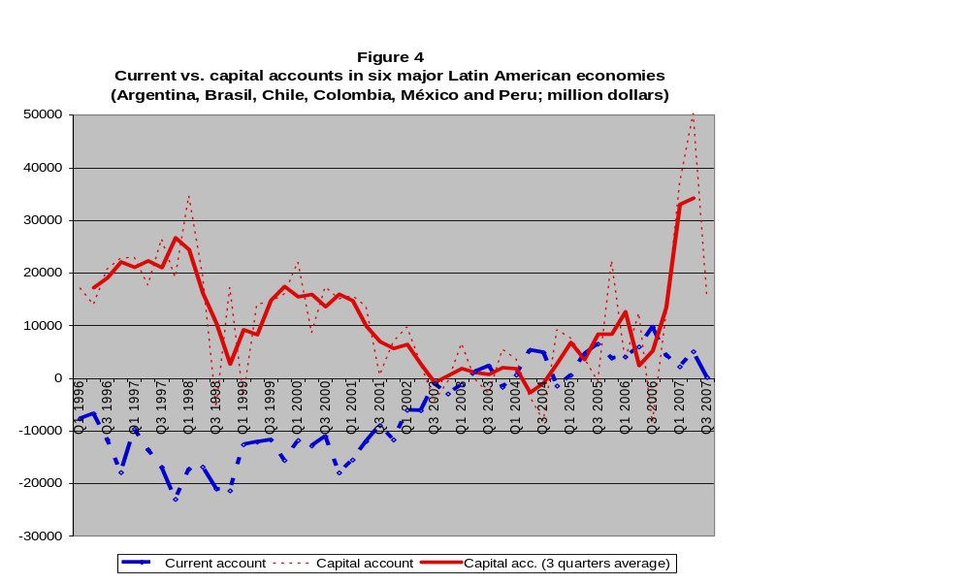
The extraordinary process of reserve accumulation in the last few years is without parallel in recent history; yet it does not tell the whole story. In fact, the total of US$6.2 trillion underestimates the actual increase of foreign exchange assets, as an important part of those assets in some areas of the world has been accumulated in Sovereign Wealth Funds (SWFs), which tend to be run autonomously from traditional reserve management by central banks and/or finance ministries. Official holdings managed by SWFs are difficult to estimate because of limitations of information. In some cases, there may be also double counting (Truman, 2007). However, according to recent research by Morgan Stanley and Standard Chartered, SWFs across the world are thought to have about US$3 trillion of international assets under management, that is, a sum equivalent to fifty per cent of official reserve holdings (see Table 1). This compares with an estimated US$500 billion in 1990 (Johnson, 2007). These SWFs assets are on the whole additional to foreign exchange reserves.
Table 1
Estimated Size of Largest Sovereign Wealth Funds
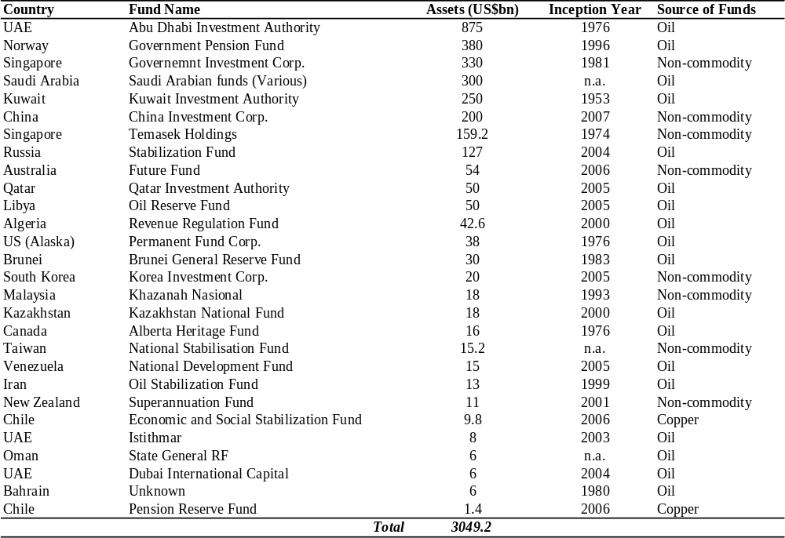
Source: Morgan Stanley; Standard Chartered
Both phenomena are in fact interrelated. Aizenman and Glick (2007) identify two main reasons behind the recent accumulation of foreign assets in SWFs. The first is the recent boom in commodity prices, particularly oil. Mindful of the wastes and inefficiencies associated with the boom of the 1970s, these countries have preferred to save a share of the current gains in SWFs to smooth consumption and preserve the wealth of future generations. This represents by far the main reason behind the exponential growth of SWFs in recent years, as oil-producing countries’ SWFs account for nearly three-quarters of total assets under management by these funds. At end-October 2007 oil-exporting countries managed an estimated US$2.2 trillion of SWFs. Of these, about US$1.5 trillion are related to SWFs of countries of the Gulf Cooperation Council, and “[w]ith oil at or above $90, the future size and market impact of the large gulf funds is hard to overstate” (Setser and Ziemba, 2007).
A second reason for the development of SWFs advanced by Aizenman and Glick (2007) is, as mentioned in other parts of the paper, the hoarding of international assets by non-commodity-exporting countries which are running persistent current account surpluses. Some countries seem to have more reserves than needed for precautionary motives, and have transferred part of them to special investment vehicles to maximize their returns. This is the case of East Asian countries, which have combined SWFs in excess of US$740 billion, to be added to more than US$2.2 trillion of foreign exchange reserves.
While they have been a recurring subject on the headlines in the past few months, SWFs are not new, especially in countries rich in natural resources. SWFs have existed at least since the 1950s, when they were established in Kuwait in 1953 and in the Pacific Island of Kiribati three years later (The Economist, 2008). In the 1970s, many oil-exporting countries, particularly in the Middle East, followed suit, establishing their own SWFs. Recently, SWFs have gained prominence to coincide with the large current account surpluses run by commodity-based developing countries as well as non-commodity exporting countries, particularly (but not only) in East Asia. According to some estimates, SWFs are likely to grow as much as to reach US$10-12 trillion within the next five to seven years (Johnson, 2007; Jen, 2007).
There is no universal and generally agreed-upon definition of SWFs. However, they can be usefully defined as dedicated government-owned investment vehicles, funded by foreign exchange surpluses, which manage those assets separately from official reserves (Lowery, 2007) and invest them with a buy-and-hold perspective (IMF, 2007). A narrower definition focuses on those government assets that are managed only to increase the wealth of a state, targeting high-risk, high-return assets (Kimmitt, 2008). Based on the source of funding, SWFs can be divided into commodity-based funds, which are established through the receipts from commodity exports owned or taxed by the government; and non-commodity-based funds (Lowery, 2007).
Regarding their purposes, SWFs can be broadly categorized into two main types: savings and stabilization funds. Savings funds are intended as permanent funds and are generally associated with non-renewable natural resources. They create a store of wealth for future generations so that they can benefit from the resources after their depletion. They build on economic theory which implies that part of non-renewable resources should be saved to smooth the country's inter-temporal consumption, in ways similar to individuals who save both for their retirement and to leave an inheritance to their children. A stabilization fund is a mechanism designed to reduce the impact of volatile fiscal revenues and/or foreign exchange receipts, linked to the pro-cyclical pattern of export prices or volumes. Stabilization funds often take the form of contingent funds, which accumulate resources when government revenues or the price of exports is high (above some threshold) and pay when they are low.
A third category, sometimes mentioned separately (Davis et al., 2003) is a financing fund, whose operational rules are explicitly designed so it effectively absorbs a budget surplus or funds an overall budget deficit. An example is the Norwegian Fund, where the budget has to transfer to the fund revenues if the budget is in overall surplus; if the budget is in deficit, the latter is financed by the fund. A fourth category could be development funds, which allocate resources for funding priority socio-economic projects, such as infrastructure. If we assume that, almost by definition, SWFs invest abroad, such development funds could, for example, invest in infrastructure and other projects in neighboring countries, possibly benefiting the source country through increased. This could be done bilaterally or through regional and sub-regional development banks.
In practice, SWFs may have different purposes based on the source of funding. For example, Kimmitt (2008) notes that, while commodity-based funds are prone to multiple and changing objectives, including fiscal revenue stabilization and sterilisation of foreign currency inflows, non-commodity-based funds are more commonly used to make stand-alone investments when a county has accumulated reserves in excess of the “optimal” level.
The joint effects of the accumulation of foreign exchange reserves and the rise of SWFs raise important policy issues, of both domestic and international character. At the domestic level, SWFs pose important questions on their role in helping achieve macroeconomic policy goals and the criteria used to allocate their resources. At an international level, questions arise as to the impact of SWFs’ asset allocation and strategic investments on international financial stability. The first area has been recently investigated by Le Borgne and Medas (2007) for very small countries in the Pacific Islands. They find that SWFs, if well designed and integrated with the general budget, may be useful instruments to support a sound fiscal framework. The second area of exploration –i.e., the international financial stability implications—has attracted much more interest. Sections III and IV explore the first issue, whereas Section V explore the second.
III. THE RATIONALE FOR RESERVE ACCUMULATION
The accumulation of foreign exchange reserves by developing countries has given rise to a large body of literature that tries to explain the rationale for such accumulation. Such rationale is usually found in either one of two explanations: the “competitiveness” (or, in more pejorative terms, “mercantilist”) and the “self insurance” motives.
The first has been emphasized by the literature on the “second Bretton Woods” (see Dooley, Folkerts-Landau and Garber, 2003). This school of thought contends that efforts by Asian countries to maintain or enhance export competitiveness in the context of an export-led growth model has led them to run massive current account surpluses, the main counterpart of which is, at the world level, the US deficit. According to this point of view, the economic benefits of stable and weak exchange rates exceed, for the Asian countries, the costs of reserve accumulation. In turn, the persistent accumulation of dollar reserves by central banks allows the United States to rely on domestic demand to drive its economic growth.
Furthermore, the lack of coordination mechanisms among economies may have led to competitive interventions in the foreign exchange market by East Asian countries. Indeed, a few years ago, Sakakibara (2003) built an argument for financial cooperation among East Asian economies along these lines. A major problem in this regard is that competitive interventions reduce the benefits of interventions in foreign exchange markets by each individual country, transforming what from each country’s perspective is a “beggar-thy-neighbor” policy (increase competitiveness vis-à-vis neighbors) into a “beggar-yourself” policy (costly accumulation of an excessive amount of reserves). Hence the potential benefits from cooperation.
However, although the “competitiveness” motives of foreign exchange reserve accumulation, as well as the absence of appropriate coordination mechanisms for exchange rate policies in export-led economies may be part of the explanation, the recent literature comes definitely in favor of “self-insurance” as the main motive for foreign exchange reserve accumulation.
Indeed, there is clear evidence that the large accumulation of developing countries’ foreign exchange reserves started after the series of large and costly crisis, particularly the Asian one. It was, therefore, a rational response of each individual country to self insure against the risks of deep financial integration, particularly the growing exposure to financial instability. For many countries, reducing such risks also included avoiding IMF programs and their associated conditionality, which several countries, particularly in East Asia, regarded as extremely intrusive of national policy autonomy.
Furthermore, the growing literature on this subject has concluded that the risks associated with financial integration go much beyond those that were seen as relevant in the past. In particular, the motive for self insurance against crises goes beyond the Greenspan-Guidotti rule that argues that countries should keep foreign exchange reserves at least equivalent to short term liabilities, as the risks associated with capital account liberalization are broader than those generated by the volatility of short-term capital flows. Furthermore, it must be emphasized that the associated instability, real or potential, comes not just from foreign capital flows but also from domestic financial and non-financial agents, who incur in capital flight during crises and repatriation during booms. Therefore, the resulting precautionary demand would seem to require that a proportion of total external liabilities should be kept as reserves, with that proportion increasing the more open the capital account is (Ocampo, 2007a; Wyplosz, 2007). The two views can be reconciled by recognizing that such precautionary demand should be higher, in any case, if the proportion of short term or more easily reversible capital flows is higher.
This conclusion seems clearly consistent with the practice of developing countries. In a careful empirical investigation, Obstfeld et al. (2007) show a statistically robust and economically significant correlation of reserve levels with financial openness and financial development (proxied by M2/GDP), with the relevance of the latter variable increasing since the 1990s, and especially since the Asian crisis. Though they also find that other variables play a role, such as exchange rate policy and openness to trade (but, interestingly, not short term debt), they emphasize that the key to understanding the evolution of reserves, especially in recent years, is the inclusion of measures of financial openness and financial development into the analysis.
Thus, the spread of financial globalization to developing countries, reflected in their greater financial openness, and the growth of banking systems and financial markets, explain much of the increase in foreign exchange reserves of these countries. Interestingly, there seems to be a long tradition in economic policy for this point of view, as the British economist Henry Thornton argued already in 1802 that reserves were not only important to meet fluctuations in the trade balance, but to head off or respond to “drains” that could happen via the banking system in periods of great and sudden fright, leading to what today would be called capital flight.
An important and interesting question posed by Aizenmann (2007) and Rodrik (2006), among others, is why developing countries protected themselves from financial instability by increasing reserves rather than by reducing financial integration –introducing, for example, prudential capital account regulations. Indeed, as Ocampo (2007a) has argued, “self-insurance” and its associated costs destroy, in a sense, the rationale for capital inflows in the first place, which is to transfer resources from rich to poorer countries. It also implies that the justification of capital account liberalization as a means to diversify risks is clearly insufficient.
The choice of self insurance over some “sand in the wheals” of international capital flows is a puzzle given the growing body of literature, including from the IMF (see Prasad et al., 2003 and Prasad, 2006, among many others), which provide empirical evidence that the costs of financial crises has been very high whereas the gains of financial integration are not as high as expected, because capital flows tend not to smooth consumption in emerging countries as had been predicted by orthodox theoretical frameworks. It is also a puzzle because the parallel accumulation of reserves and external liabilities involved in “self insurance” generate two types of costs. First, it implies that costly liabilities have as a counterpart lower yielding assets. Secondly, it may force authorities to sterilize the accumulated reserves to avoid an excessive expansion of the domestic money supply, but such policy has quasi-fiscal costs, particularly in countries with high domestic interest rates.
In this regard, it is useful to recall that countries that have liberalized their capital account less or more slowly (for example India and China) or have introduced precautionary regulations on the capital account (e.g., Chile and Malaysia) have been far less prone to crises and their massive costs. Therefore, prudential capital account regulations could reduce the costs of self insurance. Also, there may be other, less costly forms of self insurance. One example is the use of hedging techniques to neutralize potential terms of trade volatility, as well as the tendency of capital flow volatility to accentuate pro-cyclical swings in the availability of foreign exchange. Another example could be the use of new counter-cyclical external debt instruments for external borrowing, such as GDP-linked bonds, which could reduce debt service in bad times and increase it in good times
As Rodrik (2006) argues, one reason why countries increased their foreign exchange reserves and did not diminish their external exposure using prudential capital account regulations may relate to the fact that controls on short term capital flows hurt powerful financial interests. Another partial explanation seems to be that financial integration is (or is perceived to be) inevitably linked to trade integration. A third, and perhaps most important explanation, is the perception (as well, as possibly, the reality) that it is difficult, for practical reasons (compounded, no doubt, with ideological ones), to significantly diminish vulnerability to massive capital outflows in the current international financial system. These outflows can include not only short-term debt but also outflows that result from decisions by “long-term” investors, such as FDI ones, who hedge their position via derivatives in a pro-cyclical way (Dodd and Griffith-Jones, 2006). Foreign investors may also use more traditional practices that have similar effects, and which may have been enhanced in recent years, such as substituting domestic for foreign short-term debts, or vice-versa, depending on exchange rate expectations. Purely speculative flows (e.g., the carry trade), particularly in non-transparent and often unregulated instruments (over the counter derivatives) add further elements of pro-cyclicality to capital flows and exchange rates that are difficult to control at the national level. As noticed, capital flight and repatriation by domestic agents add to such pro-cyclical behavior.
Interestingly, the current turbulence in the developed world could lead to regulations in the rich world and globally that could facilitate greater control of speculative flows in and out of developing countries and thus reduce the need to accumulate reserves for self-insurance purposes. It is important for developing countries to participate actively in the undergoing debate on post sub-prime crisis regulations and carefully monitor its results and implications for their own regulations.
Both motives for accumulating foreign exchange reserves by developing countries are associated with the attempt to mitigate the volatility of exchange rates caused by terms of trade shocks and the vulnerability due to financial openness. Aizenmann and Riera-Crichton (2006) found that accumulating foreign exchange reserves mitigates the real exchange rate effects of term of trade shocks, and that this mitigation is especially important for exporters of natural resources. On average, natural resource dependence doubles both the impact of terms of trade shocks on the real exchange rate and the mitigation associated with accumulating foreign exchange reserves. This is very relevant for developing countries as there is growing empirical evidence that mitigating real exchange rate volatility increases growth. Aghion et al. (2006), for example, provide empirical evidence that exchange rate volatility reduces growth. Furthermore, higher international reserves/GDP increases the ability of smoothing adjustment to shocks, which is optimal in an open economy, in the framework of the permanent income hypothesis (Aizenmann, 2006).
There is also an emerging literature that tries to model the “optimal” level of reserves. Perhaps the most interesting is that developed by Jeanne and Rancierere (2007). This model has one possible limitation from our perspective, in that it focuses on sudden stops; however, the probability of a sudden stop is shown to increase with the degree of international financial integration, which makes the model consistent with our analysis.
The Jeanne and Ranciere formula calculates optimal levels of reserves as being higher the larger the output cost of a sudden stop, the higher the probability of such a sudden stop, the lower the cost of holding reserves and the greater risk aversion is. It is therefore more complete than the Greenspan-Guidotti rule, which may explain why the Jeanne and Ranciere model seems to predict better the actual level of reserves than does the alternative rule of thumb.
Regional calculations for optimal levels of reserves since the 1990s by Jeanne and Ranciere show that actual levels of reserves are quite similar to such optimal levels for Latin America. For Asia, this is also true until 1997. However, the estimates of these authors as well as those of Obstfeld et al. (2007) indicate that the accumulation of reserves in Asian countries since the late 1990s, but especially since 2004 seems excessive. One explanation for this could be that the likelihood of a catastrophic financial crisis, which though being fairly small would imply very negative effects, may lead to an overcautious attitude by developing countries to avoid it, leading to excessive reserves (Noyer, 2007). Along the lines that were mentioned at the beginning of this section, some coordination failure among countries following an export-led model may also be in place.
It is also true that countries with lower costs of sterilization –linked to lower interest rates, often related to some level of financial repression, as is the case of China (Ginberg, et. al, 2005)—may have an advantage in this competitive accumulation of reserves. This may oblige countries like Korea to accumulate reserve to avoid further erosion of competitiveness. It has been argued (for example, by Noyer, 2007) that, in the context of great regional trade interdependence, such behavior creates possible trade tensions. This could pose the danger, both regionally and internationally of a costly rise in protectionism.
Two caveats seem relevant in this regard, however. First, though low interest rates in China facilitate significantly accumulation of foreign exchange reserves by reducing the costs of sterilizing such reserves, low interest rates also reduce the profitability of Chinese banks (Yong, Yong Ding, 2007). Paradoxically this has required using part of the Chinese reserves to clean up their banks’ balance sheets. Furthermore, one potential use, and additional justification for large reserves, is that these could be used in the highly unlikely, but always possible, occurrence of a major bank run in China.

IV. A BROADER FRAMEWORK
A. Recollecting useful identities
Although the literature on foreign exchange reserves discussed in the previous section has served to illustrate some of the determinants of foreign exchange asset accumulation by developing countries, it is incomplete for the analysis of SWFs for two major reasons. First of all, it does not clearly differentiate the rationale associated with the management of current account vs. capital account surpluses, an issue which is critical for SWFs, as we will see. Secondly, it does not clearly differentiate between structural vs. cyclical factors resulting in either type of surpluses. A sub-theme in the analysis of cyclical factors is fluctuations in commodity prices.
The importance of differentiating the current vs. the capital account comes clearly from recalling the basic macroeconomic identity of an open economy:
(1) ΔR – ΔF = X – M = S - I
Here ΔR represents the accumulation of foreign exchange reserves (which in this context could be thought to include also the accumulation of resources in SWFs), ΔF are net external capital flows, X – M is the current account surplus, and S – I the savings surplus. To the extent that reserve accumulation merely reflects additional external financing, there is no net transfer of resources or, what is equivalent, no net accumulation of wealth in foreign exchange assets. Such accumulation can only take place when there is net savings or, what is equivalent, a current account surplus. The existence of a current account surplus is therefore critical. If there is no surplus –or, even worse, there is actually a current account deficit— the accumulation of foreign exchange assets (a positive ΔR) can only be seen as the counterpart of capital flows. Another way of expressing it is that when the counterpart of reserves is net capital flows and not a current account surplus, the former are merely “borrowed reserves”
If we consolidate the real and monetary accounts, the identity can also be written as:
(2) S – I = ΔM – ΔL – ΔF
where M is broad money and L is lending by the domestic banking system. So, in order to accumulate net foreign exchange assets, capital flows must not be reflected in the creation of net domestic monetary assets (broad money less domestic lending). If they are, capital flows are merely the way to finance the additional domestic monetary assets, and we can talk of a “borrowed money supply”.
When understanding the rationale for SWFs, it is therefore important to start with the current account, as well as the underlying reasons for a current account surplus. If there is no current account surplus, it is difficult to rationalize the creation of SWFs. Indeed, were a SWF merely created on the basis of “borrowed reserves” –or, more broadly, “borrowed money”—we can think of it really as a form of financial intermediation, as it would not involve really the management of net foreign exchange assets. As we will see, the creation of a development bank or fund, or the accumulation of such borrowed funds in a regional or sub-regional development bank, could make sense under those circumstances, but not a SWF as such.
B. The motivations for the accumulation of foreign exchange assets
Based on these preliminary considerations, we can differentiate four major motives for the accumulation of net foreign exchange assets.
The first can be called the wealth substitution motive. In this case, there is a current account surplus that results from the exploitation of an non-renewable natural resource. We can think of this case as the transformation of an illiquid natural resource asset into net foreign exchange assets, which may be more or less liquid. As countries exploiting non-renewable natural resources generally have negative net investments, if the depletion of the resource is accounted for (Heal, 2006), a partial substitution of assets is the general pattern. Note that if there is no current account surplus, the natural resource would be transformed into domestic investment or merely consumed.
There are, therefore, several factors that must be taken into consideration in this case. The first is that it may make sense to leave the resources under ground, particularly when the revenues it generates are merely consumed. If they are invested, the crucial question is the relation between the marginal profitability of the associated investments vs. the expected increase in the value of the natural resource. Domestic investment of the resource makes sense to the extent that it leads to accumulation of capital assets that result in sustainable long-term growth, particularly by diversifying the productive base of the domestic economy. Of course, if the resource is merely consumed (rentism), the crucial question is the inter-temporal time preference, as well as guaranteeing a smooth trajectory of consumption. The latter is, of course, essential from the point of view of inter-generational equity, but equity considerations also affect the social rate of time preference.
A major problem in relation with these decisions is the political economy pressures that may result in the excessive consumption of the natural resource today or over-investments in infrastructure and “diversification” activities that may have low marginal social benefits. One case in point is, for example, the policy of “sowing the oil” of Venezuela in the 1970s, that led to the development of excessively capital-intensive sectors that experienced serious difficulties or rendered few benefits in the following decades. Some of the current diversification policies of the Gulf countries into financial services or tourism may perhaps be classified under this category.
A second issue is related to the “Dutch disease” literature, and may be seen as the policy decision to use the revenues associated with the exploitation of the natural resource to accumulate foreign exchange assets vs. domestic spending. The crucial question here is that the domestic use of the revenues would be generally reflected in a real exchange rate appreciation that may accelerate growth in non-tradable activities but has adverse effects on other tradable sectors. If there are dynamic economies of scale associated with learning (productive experience today increases productivity in the associated activities) or with building commercial networks (exporting today builds the commercial contacts and reputation of domestic producers in foreign markets), long-term growth may be adversely affected (see Krugman, 1987, in relation to the effects of the loss of production experience). This may be thought as a case in which the exploitation of the natural resource actually reduces productive sector diversification (of tradable goods and services), leading to growth patterns that are unsustainable once the natural resource is exhausted (or, if mixed with the cyclical issues analyzed below, once the price boom is over). So, in this case, the long-term effects of exploiting the natural resource may also be counter-productive.
Both the decision to exploit or leave the resource under ground, and to allocate the associated revenues between the accumulation of financial assets and domestic spending with more immediate development effects should vary by countries’ level of income (Sachs, 2007). Whereas a rich country like Norway rightly may privilege more very long term savings, a middle or, even more, a low income country may maximize welfare by devoting part of the resources to investment with relatively quick development impact. Dutch disease issues may, however, be relatively more important for developing countries.
Note that if the decision is made to accumulate net foreign exchange assets, the crucial question goes back to the comparison of the profitability of these investments vs. the expected increase in the value of the resource. If the political economy leads to risk aversion in those investments, profitability would be low, and it could make sense again to just leave the resource under ground. Risky investments lead, in turn, to questions regarding evaluation criteria (see below), and both lead to questions of transparency.
A second motive could be called the resilient surplus motive (with the surplus referring to the current account). The term “structural” could also be used, if we borrow from the Latin American literature of the 1950s (where it was applied to deficits rather than surpluses) or from the two gap literature that followed. The issue here is the tendency of some non-natural resource based economies to run current account surpluses that are fairly resilient to growth and even to exchange rate appreciation. Depending on the theoretical preferences for which side of identity (1) one prefers to look at, it may be seen as a case of “over-competitiveness” in the production of tradable goods and services, which may be seen as a case of explicit exchange rate undervaluation, as emphasized by the “second Bretton Woods” literature, or a structural saving surplus associated commonly with high levels of savings. Since the cases we can think of situations of this type are all East Asian, perhaps high savings rates are the real determinant factor.
Indeed, the interpretation that the source of such “resilient surplus” is the undervaluation of the domestic currency may some times be correct but it can also be problematic. The point is that there may no “equilibrium” exchange rate that eliminates the surplus because of the many macroeconomic links between the exchange rate, economic activity and the domestic financial system. A strong appreciation of the exchange rate may directly reduce the current account surplus, but it may also generate (generally with a lag) adverse effects on domestic economic activity or on the domestic financial system that may tend to further increase the surplus, by generating a recession that reduces import demand, inducing higher savings or generating a domestic asset bubble that eventually busts. Japan is the best example: after the massive appreciation of the 1980s, the surplus was not eliminated. One explanation is that the massive appreciation led to the domestic financial crises and long-term stagnation that plagued Japan during the 1990s and into the 2000s. A similar explanation has been used by some authors to analyze the Chinese situation today and to claim that a massive sudden appreciation of the Yuan does not make sense (Genberg et al., 2005). Indeed, this argument may be behind the preference of Chinese policy makers for a gradual appreciation of the exchange rate.
The third may be called the counter-cyclical motive. We must differentiate, however, between two entirely different situations. The first case relates to cyclical swings in real exports (volumes) associated with foreign business cycles (global or of the relevant trading partners). The second, and the most relevant for Latin America today, is associated with cyclical swings in external prices, particularly commodity prices. Both issues have certain features in common: the possibility of overheating of the domestic economy during the boom that would lead, depending on the exchange rate regime, to variable mixes of domestic inflation and nominal exchange rate appreciation, resulting in both cases in real exchange rate appreciation.
Such appreciation may play a positive role in managing the boom and in distributing its benefits to economic agents that operate in markets that are “non-tradable” in character, including workers (wages). The major problems result again from the “Dutch disease” effects associated with dynamic economies of scale in tradable sectors. In this case, smoothing out exchange rate trends has positive impacts on long-term growth. A necessary tool would be the official intervention in foreign exchange markets and the accumulation of the associated surplus either in the central bank (reserves) or in a stabilization fund. The alternative is, of course, paying off foreign debts or encouraging other forms of capital outflows.
When the source is a commodity boom, there is an advantage but also a complication for the design of stabilization vehicles. The advantage results from the easy identification and, therefore, design of the stabilization instrument, which would take the form of fund financed by a tax on the booming commodity (which could be used later on to stabilize prices in the downswing, and could then be called a “retention”, to use the terminology that was typical of the National Coffee Fund of Colombia) or part of the associated government revenues (particularly those coming from taxes on mineral resources and revenues from state-owned enterprises operating in that sector). The complication arises because cyclical patterns may be difficult to differentiate from long-term trends, as commodity price dynamics exhibit “random walks” or “shock persistence” –that is, price changes that are not reversed. Some of them may be fairly large, such as the collapse of commodity prices in the 1980s or, according to the view of many observers, the current boom in oil prices (and perhaps other mineral commodities). It is thus difficult to find a rule that identifies the cyclical component of a price boom vs. its possible long-term character that would make it possible to distinguish ex ante between the “transitory” and the “permanent” component of the shock. This leads, in turn, to political economy issues that are well known: the tendency, at least in the past, to think that it is the latter rather than the former, a fact that has led too often to pro-cyclical policies that resulted in unsustainable booms followed by major crises.
The fourth can be called the strict self-insurance motive, which we could argue applies when the source of the abundance of foreign exchange is the capital rather than the current account. In this case, the analysis of the previous section applies. Since capital flows are strongly pro-cyclical for developing countries, the relevant criteria are the risks of capital flow reversibility. Thus, self-insurance should be higher the larger the share of more volatile capital flows (a differentiation which, as we said, is increasingly difficult in practice) and the more open the capital account. And, as identity (2) indicates, its reference should be broad money, an issue that has been underscored in the recent literature on self-insurance.
Precisely because commodity prices and capital flows are pro-cyclical, there are many interactions among the different motives. Thus, savings associated with the first motive tend to take place when there are buoyant commodity prices, and there is thus an implicit stabilization function in the ways funds are managed –only save in the fund above a certain threshold price or if there is a budget surplus, and even use the funds below a lower threshold price or when the government runs a budget deficit (Davis et al, 2003).
Pro-cyclicality of capital flows generates, in turn, an interaction of the first three motives with the fourth. So, any current account surplus will tend to attract capital inflows, not only because of the booming economic activity and high profitability that is usually associated with such surpluses, but also of the tendency to a real exchange rate appreciation that makes domestic currency denominated assets more attractive relative to foreign assets. The major problem is that the booming capital inflows will compound the difficulties of managing the real factors that underlie the current account surplus, basically by adding a component of “irrational exuberance” to the boom, to use the expression popularized by Alan Greenspan (see also Schiller, 2000), fuelling the demand boom, the real exchange rate appreciation and associated Dutch disease effects, and generating excessive risk taking that may be reflected in a financial crises down the road. Indeed, one of the major counter-cyclical issues may be the management of the financial euphoria associated with booms, a fact that may be compounded by the instruments used to absorb the resources. In the limit, of course, the additional demand and real exchange rate appreciation generated by the induced capital account boom may erase the current account surplus or turn it into a deficit. This dynamics has been all too familiar in the gestation of the crises that have plagued the developing world in recent decades.
Table 2 summarizes in a simple table the basic motivations for the accumulation of foreign exchange assets, differentiating two dimensions: the source of the boom (a long-term or short-term current account surplus, or net capital inflows), and the role played by commodities vs. other factors influencing foreign exchange abundance.
Table 2
Basic motivation for the accumulation of foreign exchange assets by developing countries
Long-term Short-term Capital flows
current account current account
surplus surplus
Commodities Wealth Substitution Counter-cyclical
(prices)

Non-commodities Resilient surplus Counter-cyclical Self-insurance
(volumes)

C. The instruments and political economy of foreign exchange asset accumulation
The motives clearly determine the nature of the fund that should be used and the composition of its investments. SWFs are the appropriate instrument when there is a current account surplus and, particularly, when it is clearly long-term in character (or at least when such surpluses are long lasting). Or, to use the terminology of the previous section, savings funds are the appropriate instrument to respond to the first two motives (wealth substitution and resilient surplus).
The polar case is that of the self-insurance motive. It is difficult to justify a SWF in this case. Indeed, as we have argued, any fund that is created on the basis of net capital inflows would in fact be an international financial intermediary, as it would basically channel capital inflows for lending or investment abroad. It could then make a sense to create a development bank or fund if capital flows are deemed to be stable. In that case, the bank or fund could intermediate such capital flows by channeling those resources to neighboring countries, including in infrastructure projects that could encourage trade with them, or accumulate part of those funds in regional or sub-regional development banks that have a similar purpose. And, of course, private financial institutions can do such international financial intermediation. To the extent that not all capital inflows are deemed to be stable, self insurance calls for accumulating foreign exchange reserves in central banks and investing them in very liquid instruments. If reserves are very large, due to massive capital inflows, there is the temptation to use part of them to create a SWF, but this temptation should probably be avoided –though return considerations in the investments of foreign exchange reserves could weight more in reserve asset management.
The stabilization motive lies in between these two polar cases, and could be managed through variable mixes of SWF (stabilization funds in this case) and reserves. The strength and duration of the boom should certainly be a criterion in the choice between the two, as is the estimate of how long it would last.
A major issue in all cases is the private vs. public sector composition of the associated surpluses. This is, of course, crucial to guarantee the “sterilization” of their monetary effects. In this regard, a fiscal surplus is the easiest to manage, as it can be automatically sterilized by either investing directly abroad or in central bank bonds (non-monetary liabilities). Such fiscal surplus can be generated by a general tax or a tax on the source of the boom (if it is a natural resource), or the profits of public sector firms operating in the sector (a typical feature of oil exporting economies, as well as copper in Chile). In the second case, and if the source is a temporary commodity price boom, the instrument can be a “retention” of the excess revenue to be given back to producers when prices fall (as was typical of the National Coffee Fund of Colombia in the past), or simply a tax of the windfall (as is currently done in Argentina). If the source of the surplus is “over-competitiveness” or private capital flows, the appropriation of the resources by the public sector is more complex. However, the allocation of social security assets or “forced savings” imposed by legislation on private agents (as in Singapore) can be used for that purpose.
When there is no public sector surplus, the associated sterilization is a difficult issue –and a costly one, as we have seen, particularly when domestic interest rates are high. The major problem is that sterilization implies that the central bank (or, alternatively, the SWF, if it assigned with the responsibility of doing so) will press domestic interest rates, a factor that attract new capital flows and feed into the domestic financial euphoria. This is particularly complex if the central bank uses (or is forced to do so by domestic regulation) only short-term instruments, as the high rotation of sterilization instruments becomes a risk in itself and feeds into the general environment of excess liquidity.
A related issue has to do with asset allocation strategies for SWFs and whether these should vary by type of fund and by the origin of the surpluses (commodity versus non-commodity). In principle, return may be more important than liquidity for SWFs, and they should therefore invest in longer-term assets with a different risk/return mix that is typical assets held in official reserves. The main reason for this lies in the more long term horizon of these funds, that allows greater tolerance of short-term fluctuations in returns. An example is the Norwegian Fund, which reportedly holds 40% of its assets in equities (Noyer, 2007). Obviously, in all cases asset allocation should be subject to strong prudential rules
Three additional considerations seem relevant here. Firstly, as the assets of SWFs belong to all the citizens of a country and their children (many of whom have low incomes), there may be a greater need for prudence in investment by SWFs owned by developing countries, so as to have lower levels of risk than say wealthy individuals are willing to bear. Therefore, the criteria for choosing a portfolio of assets may be somewhat different for SWFs than for private management of assets. As a consequence, central banks or governments may wish to either manage assets themselves or define clearly and monitor carefully the level of risk that fund managers are accepting on their SWF investments.
Secondly, the investments by SWFs (or a part of them) should serve long term development objectives of the country as well as ensure good long term returns. As in the case of investments in development banks or funds (which could be a potential use of the SWF resources), part of these investments could go into financing projects in neighboring countries or the country may wish to invest in companies abroad in more developed economies for reasons such as gaining access to new and better technologies. However, it is important that such criteria are transparent, and that other objectives are not inappropriately used as an excuse for low financial returns. It is also interesting that, as Ang (2008) points out that, the Norwegian SWF aims at generating a “sound return in the long term, which is contingent on sustainable development in the economic, environmental and social sense.” Emphasis on sustainable development as an aim is equally, or indeed more desirable for developing country SWFs.
Thirdly, it is important to distinguish between savings funds, which can invest with longer term criteria, and stabilization funds, which – given their cyclical role – would seem to need higher proportions of relatively more liquid assets. In this sense, stabilization funds’ liquidity needs can be seen as intermediate between normal foreign reserves –requiring high levels of liquidity– and savings funds, with far longer term horizons. Further research and discussions with policy-makers are required to clarify appropriate criteria of investment for different categories of developing country funds, as well as for countries with different levels of income.
There are, finally, several political economy issues that are not easy to manage. Some, as we have seen, relate political economy pressures that may result in the excessive consumption of the natural resource today or investments with low marginal social benefits. As we have pointed out, there is also the entrenched tendency to think of commodity price booms as permanent rather than transitory, which leads to pro-cyclical policies that result unsustainable. Furthermore, during both current and capital account booms, it is difficult to argue in political terms for counter-cyclical fiscal policies to compensate for private sector “exuberance”—particularly exuberance that benefits in developing countries the richest segments of society (Marfán, 2005). Note, however, that the political economy may lead in the opposite direction, towards excessive regulation of asset allocation by SWFs which indicates strong risk aversion. If the source of the boom is the exploitation of a non-renewable natural resource, the best conservative strategy could actually be to just leave the resource under ground.
An equally important political economy issue relates to the stability of the rules that lead to the accumulation of resources in public funds. In this regard, there are classical time inconsistency issues: large public sector savings during booms may generate strong political incentives to spend them (the pressure that Chile is facing after it accumulated large fiscal savings during the recent copper boom) or to dilapidate them in the form of unsustainable tax cuts (the US experience during the current decade after the fiscal surplus of the 1990s). Latin America does not do well in this regard, as the copious design of stabilization funds and fiscal responsibility rules since the late 1990s has been followed by equally frequent changes in those rules in recent years (Jiménez y Tromben, 2006).
Obviously, the decision to accumulate resources in SWFs must be consistent with general fiscal rules. It does not make sense in this regard to transfer resources to a SWF if broader fiscal rules do not guarantee that the country is running a fiscal surplus. And, for the same reason, it would also be inappropriate to use the resources of the SWF to guarantee public sector debt.
The rules regarding the allocation of resources also raise several political economy questions. As already pointed out, the political economy may lead to risk aversion and low profitability. The opposite problem, as already pointed out, is important: how to avoid excessively risky investments. Both raise issues of evaluation criteria, transparency and accountability. Technical independence of the associated decision making process is also crucial. These issues have traditionally been well managed in the case of international reserves, where clear rules prevail (liquidity over return) and there is technical independence of central banks. For this reason, perhaps the tradition of several countries of assigning the management of either savings or stabilization funds to central banks is a good one.
V. SYSTEMIC IMPLICATIONS OF LARGE RESERVES AND SWFs
As highlighted in section III, the accumulation of foreign exchange reserves by developing countries is partly a consequence of deep financial integration and the instability that it generates. Strong pro-cyclical swings in external financing also limit the room to maneuver that developing countries have to adopt counter-cyclical macroeconomic policies. As we have seen, during the current decade, the most common response of developing countries to the challenges posed by financial instability has been massive “self-insurance” in the form of a large accumulation of foreign exchange reserves, which can also be understood as an attempt to increase macroeconomic policy autonomy. This has been, therefore, a rational response by individual countries to a system that lacks a well functioning collective insurance against balance of payments crises and severely reduces macroeconomic policy autonomy.
On top of that, the recent boom in commodity prices and, more generally, export revenues, has led to the desire by developing countries to save a proportion of the additional export revenues. These counter-cyclical policies are also a rational response to exceptional export income, and serve both to cool the aggregate demand effects of booming export markets as well as to avoid the Dutch disease effects of high commodity prices.
This behavior of developing countries raises, however, two types of concerns. For individual countries, “self-insurance” raises questions about the rationality of capital inflows and capital liberalization in general, as the former do not generate a net transfer of resources, and the second generates a costly accumulation of foreign exchange assets to counter the risks associated with a more liberalized capital account regime.
For the world economy as a whole, self insurance as well as counter-cyclical policies to manage export booms by a large group of developing countries generate, in turn, “fallacy of composition” effects that feed into global imbalances (Ocampo, 2007a). Indeed, if a large group of developing countries follows these routes, they generate current account surpluses and/or additional demand for liquid assets that have contractionary effects on the world economy unless matched by current account deficits and the additional supply of those liquid assets by other, mainly industrial countries. The US has been playing those roles in recent years, but this has generated major imbalances that are subject to ongoing corrections, both at the macroeconomic and the financial sector level.
Therefore, self-insurance and counter-cyclical policies to manage export booms, though rational from the perspective of each individual economy, are also sources of global imbalances and, therefore, of the potential instability to the world economy. What is evident, however, is that these problems cannot be solved simply by asking developing countries to appreciate their currencies to correct the balance of payments surpluses. It must be solved first by coordinated global counter-cyclical policies and by attacking the source of the demand for “self-insurance”, which is the lack of adequate supply of collective insurance against balance of payments crises.
One of the implications of the large accumulation of foreign exchange assets by developing countries has also been –intentionally or unintentionally—less reliance on the International Financial Institutions (IFIs), and especially on the International Monetary Fund (IMF). Current imbalances also reflect, as we have already pointed, coordination problems at the regional level that lead to competitive accumulation of reserves aimed at maintaining weak currencies. The strengthening of regional institutions like FLAR and the macroeconomic policy dialogues that take place in the context of sub-regional integration processes in Latin America, or the Chiang Mai Initiative in East Asia, can play an important role in correcting such coordination failures. These regional institutions can provide both a counter-cyclical supply of foreign exchange that reduces the demand for foreign exchange assets by individual countries, as well as institutional mechanisms for macroeconomic policy dialogue and eventual policy coordination.
Indeed, one of the opportunities generated by the accumulation of foreign exchange assets by developing countries is the possibility of creating strong regional financial institutions, both for macroeconomic policy support but also for development cooperation. It is interesting that if a very small proportion of the total developing country SWF assets and international reserves were invested in existing or new development banks owned by developing countries, this could generate a very large expansion of such developing country owned banks’ lending capacity, which could be devoted to regional public goods, such as infrastructure. As estimated in Griffith-Jones et al. (2008), 1% of SWFs assets allocated to paid-in capital for expansion or creation of developing country owned development banks could approximately generate annual new lending capacity of around US$70 billion annually, which would approximately triple total current lending by World Bank plus the three major regional development banks that provide lending to developing countries (the Inter-American, the Asian and the African Development Banks).
It therefore seems the time is now for developing countries to create strong mechanisms for monetary cooperation (swap arrangements and reserve funds, in particular) and expand their own regional or sub-regional banks, or indeed to increase financial cooperation on a larger scale. Thus a systemic implication of the accumulation of foreign exchange assets by developing countries is that it represents but also feeds into ongoing changes in the global power structure. It potentially gives more bargaining power to developing countries in international negotiations; equally, or more importantly, it allows greater policy space to national policy-makers and provides a major opportunity to expand intra-regional as well as inter-regional financial cooperation among developing countries.
Whereas the large accumulation of foreign exchange assets by developing countries as a group could have fed into current global imbalances, in a rather unexpected way SWFs have also made a significant contribution to international financial stability, by helping recapitalize some of the largest international banks as these faced major losses due to the sub-prime crisis and the financial turbulence it generated (see Table 3). Large banks have been hit by extremely high losses, which could possibly have not only led to serious problems for individual banks, but also potential systemic effects. In every case, purchases of shares by the SWFs – typically announced at the same time as major losses – helped calm fears about banks’ solvency and helped contain the inevitable reduction of share prices. Thus it could be said that SWFs suddenly became the capital provider of first and last resort. This is why the concept of “bail out” has been used to describe these operations, though perhaps inappropriately.
A reason why SWF investment in banks has been welcomed is because they tend to take relatively small shares in banks, and none of them sit on bank boards. Additionally, SWFs are perceived as having longer term horizons (for example as compared with private equity or hedge fund investors) which makes them less sensitive to market volatility.

Table 3
Significant Acquisitions by Sovereign Wealth Funds
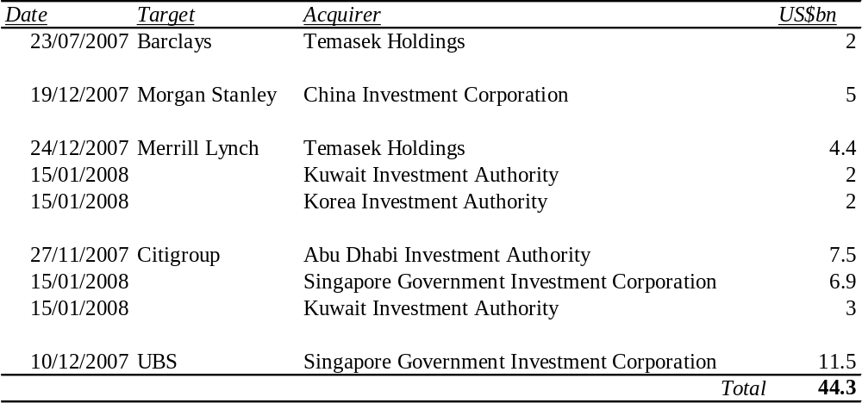
Source: Financial Times
As a result of these reasons (and especially the urgent need for capital), SWFs’ large investments into large banks with high losses have been broadly welcomed. This is in sharp contrast to the protectionist fervor that blocked previous non-financial investments, as was the case with Dubai and US ports and China with a medium-sized US oil company.
Allowing SWFs to invest more generally in OECD countries can have another important, though indirect, effect on global economic stability. To the extent that it is desirable to avoid too high commodity (especially oil) prices, given their negative effects on inflation, it is important that SWFs face no or few restrictions on their investments, so that they can maximize and diversify expected returns on their financial assets. Should they not be able to do so, then it may become more attractive for them to keep the oil and other mineral resources under ground, which is likely to lead to higher oil and commodity prices (see, for example, Reisen, 2008).
More broadly, if “financial protectionism” in developed countries became too widespread –with too many barriers and requirements imposed on developing country SWF investments– the willingness of different types of developing countries to engage in such a cooperative way in the global economy as they currently do could understandably become eroded. Calls for increased transparency of SWFs by a number of developed countries, and by several international institutions, where rich countries are dominant, may have some value in this regard, as transparency could reduce financial protectionism. However, it would be far more legitimate if a similar call is made for other financial actors, such as hedge funds, private equity and investment banks, so that it does not look at a case of “Do as I say, not as I do”, an issue that has led to strong resistance to advice from industrial countries in the developing world. Therefore, the call should be symmetrical: all financial institutions should be transparent.
VI. CONCLUSIONS
The large accumulation of foreign exchange assets by developing countries has become a characteristic feature of the 2000s. Although in quantitative terms the expansion of foreign exchange reserves is the dominant feature, the accumulation of assets in SWFs is of parallel and growing importance. On average, developing countries have been accumulating international reserves to absorb both part of the booming export revenues and the additional pro-cyclical net capital inflows. For those countries facing current account deficits, the accumulated reserves are a reflection of the second phenomenon and are thus essentially “borrowed”. This is indeed the dominant effect in Latin America.
We differentiated four different motives for the accumulation of foreign exchange assets. The first two, which we called the “wealth substitution motive” (transform a natural resource into financial assets) and the “resilient surplus motive” (long-lasting current account surpluses that cannot be corrected in the short-run by exchange rate appreciation. These two motives are behind those SWFs that are savings funds in character –and indeed, we argued strongly that, in strict sense, these are the only two motivations that should lead to the creation of SWFs. A third motive, the counter-cyclical one, calls for either stabilization funds or the accumulation of international reserves to absorb temporary current account surpluses and, in some cases, fiscal effects associated with booming commodity prices or export revenues in general. A fourth motive, self-insurance, aims at reducing the risks associated with pro-cyclical capital flows. In all cases, avoiding the dynamic economies of scale associated with the Dutch disease is a major justification of the accumulation of foreign exchange assets, but they must be weighted against the costs of sterilizing the monetary effects of booming foreign exchange inflows when there are no fiscal surpluses to undertake that function. As we have argued, different motives generate a demand for different types of funds, each category requiring somewhat diverse investment criteria.
Finally, we underscored that fact that, although the accumulation of foreign exchange reserves by developing countries is partly a consequence of deep financial integration and the instability that it generates, such actions feed into global imbalances through “fallacy of composition” effects. Therefore, though these strategies may be rational for each developing country, they feed into global imbalances. The lack of adequate coordination mechanisms, both at the global and regional levels, may have accentuated this problem. At the same time, SWFs have played a somewhat unexpected stabilizing role, by providing the funds that have helped to stabilize the developed countries’ banking system during the current world financial turbulence. And they have also generated an important opportunity to increase financial cooperation among developing countries, both on a regional basis but also on a broader scale. Given these vast new opportunities available, further study and policy action seems highly desirable.
REFERENCES
Aizenman, R. and R. Glick, R. (2007) “Sovereign Wealth Funds: Stumbling Blocks or Stepping Stones to Financial Globalization?”, FRBSF Economic Letter, 38, November 2007.
Aizenman Joshua ( 2007).”Large Hoarding of International Reserves and the Emerging Global Economic Architecture”, UCSC and the NBER

Aizenman Joshua (2007). “Comparing Hoarding Reserves in Latam With East Asia,Mercantilism,Self Insurance, Or Smoothing Reer Volatility.”

Cigdem Akin and M. Ayhan Kose (2007). “Changing Nature of North South Linkages:Stylized Facts and Explanations”, IMF

Davis, J., R. Ossowski, J. A. Daniel and S. Barnet (2003), “Stabilization and Savings Funds for Nonrenewable Resources: Experiences and Fiscal Policy Implications”, in J. Davis, R. Ossowski and A. Fedelino (eds.), Fiscal Policy Formulation and Implementation in Oil Producing Countries, Washington D.C., International Monetary Fund, ch. 11.

Devlin, W. and B. Brummitt (2007) “A Few Sovereigns More: The Rise of Sovereign Wealth Funds”, Economic Roundup Spring 2007, Australian Treasury, December 2007

Dodd, R. and S. Griffith-Jones (2007), “Brazil’s Derivatives Markets: Hedging, Central Bank Intervention and Regulation.

Dooley, M.P., D. Folkerts-Landau and P. Garber. 2003, “An Essay on the Revived Bretton Woods System.” NBER Working Paper, No. 9971, Cambridge, Massachusetts: National Bureau of Economic Research, September.
Economist (2008) “Asset-backed Insecurity”, January 19th 2008
Green Russell and Tom Torgeson (2006). “Are High Foreign Exchange Reserves in Emerging Markets a Blessing or a Burden?”, Dpto of the Treasury:Office of International Affairs,Occasional Papers.

Griffith-Jones S., Griffith Jones, D., and Hertova Dagmar (2007), ”Enhancing the role of regional development banks; the time is now.” Paper for the G24.

Horour David (2005).”A Fiscal Price Tag for International Reserves”, IMF
IMF (2007) “Global Financial Stability Report”, Annex 1.2, September 2007, Washington DC, International Monetary Fund.
Jeanne Oliver, Ranciere Roman(2006) “The Optimal Level Of International Reserves For Emerging Markets Countries:Formulas and Applications”, IMF and CPR.

Jiménez, J. P. and V. Tromben (2006), “Política fiscal y bonanza: Impacto del aumento de los precios de los productos no renovables en América Latina y el Caribe”, Revista de la CEPAL, No. 90, September.
Johnson, S. (2007) “The Rise of Sovereign Wealth Funds”, IMF Finance and Development”, 44, 3, September 2007
Kimmitt, R. M. (2008) “Public footprints in private markets”, Foreign Affairs, 87, 1, January/February 2008
Le Borgne, E. and P. Medas (2007) “Sovereign Wealth Funds in the Pacific Island Countries: Macro-Fiscal Linkages”, IMF Working Paper 07/297, Washington DC
Lowery, C. (2007) “Remarks on Sovereign Wealth Funds and the international financial system”, US Department of the Treasury, June 2007.
Marfán, M. (2005), “Fiscal Policy, Efficacy and Private Deficits: A Macroeconomic Approach,” in J.A. Ocampo (ed.), Beyond Reforms: Structural Dynamics and Macroeconomic Vulnerability, Palo Alto and Santiago: Stanford University Press and Economic Commission for Latin America and the Caribbean, ch. 6.
Obstfeld M. and A. Taylor (2007).”Financial Stability, The Trilemma and International Reserves”,University of California, Berkeley and NBER.Shambaugh Jay
Dartmouth College and NBER.

Ocampo, J.A. (2007a), “The Instability and Inequities of the Global Reserve System”, DESA Working Paper No. 59, November.
____ (2007b), “La macroeconomía de la bonanza económica latinoamericana”, Revista de la CEPAL, No. 93, December.
Prasad, Eswar S., Kenneth Rogoff, Shang-Jin Wei and M. Ayhan Rose (2003), “Effects of Financial Globalization on Developing Countries: Some Empirical Evidence”, International Monetary Fund, Occasional Paper 220.
Ramkishen S Rajan (2007).”Too Much Of A Good Thing? The Adequacy Of International Reserves in the After of Crisis”, Dpto of Economics University Of Surrey.Mason George,University School Of Public Policy

Schiller, R. J. 2000. Irrational Exuberance. Princeton, NJ: Princeton University Press.
Setser, B. and R. Ziemba (2007) “Understanding the New Financial Superpower –The Management of GCC Official Foreign Assets”, RGE Monitor, December 2007
Truman, E. M. (2007) “Sovereign Welath Funds: The Need for Greater Transparency and Accountability”, Policy Brief PB07-6, Peterson Institute for International Economics, Washington DC, August 2007
Wan Leong (2006).”International Reserves Accumulation In East Asia.International review Of Business.Research Papers Vol 2,pp 72-88.

* Executive Director, Initiative for Policy Dialogue, Columbia University and Professor and Co-President of the Initiative for Policy Dialogue, Columbia University, respectively (www.policydialogue.org). Paper prepared for the workshop on Sovereign Wealth Funds organized by the Andean Development Corporation, London, February 18, 2008. We thank Pietro Calice for his support in drafting this paper, and Carmen Seekatz for valuable research assistance. We thank Jedediah Mika and Shruti Pant for administrative assistance.
See, for example, Devlin and Brummitt (2007), Lowery (2007) and Truman (2007).
So, we express it with the “normal” sign (a positive ΔR is an accumulation of foreign exchange reserves), not that which comes in balance of payments accounting, where a negative ΔR reflects the accumulation of reserves –or, what is equivalent, the absorption of a balance of payments surplus.
The “monies” included under M must obviously involve the same agents that intermediate the lending included as L.
Note that if technical change is expected to reduce the demand for the resource, it may make sense to exploit it today. Chilean nitrates are one case in point.
Interestingly, the change from foreign exchange constraints to “structural” foreign exchange surpluses has obviously major implications for development thinking, which are only partly analyzed in this paper.
Some exceptions were the objections (probably temporary) by some UBS shareholders, as they argued that the terms obtained by the SWFs in their capitalization were unfair to original shareholders.

