Untitled
Your Name
2020-04-08

Tables

Table 1
head(mtcars)
- Table 1: caption 1
mpg | cyl | disp | hp | drat | wt | qsec | vs | am | gear | carb
21.0 | 6 | 160 | 110 | 3.90 | 2.620 | 16.46 | 0 | 1 | 4 | 4
21.0 | 6 | 160 | 110 | 3.90 | 2.875 | 17.02 | 0 | 1 | 4 | 4
22.8 | 4 | 108 | 93 | 3.85 | 2.320 | 18.61 | 1 | 1 | 4 | 1
21.4 | 6 | 258 | 110 | 3.08 | 3.215 | 19.44 | 1 | 0 | 3 | 1
18.7 | 8 | 360 | 175 | 3.15 | 3.440 | 17.02 | 0 | 0 | 3 | 2
18.1 | 6 | 225 | 105 | 2.76 | 3.460 | 20.22 | 1 | 0 | 3 | 1

Table 2
head(iris)
- Table 2: iris
Sepal.Length | Sepal.Width | Petal.Length | Petal.Width | Species
5.1 | 3.5 | 1.4 | 0.2 | setosa
4.9 | 3.0 | 1.4 | 0.2 | setosa
4.7 | 3.2 | 1.3 | 0.2 | setosa
4.6 | 3.1 | 1.5 | 0.2 | setosa
5.0 | 3.6 | 1.4 | 0.2 | setosa
5.4 | 3.9 | 1.7 | 0.4 | setosa

Table 3
head(cars)
- Table 3: cars
speed | dist
4 | 2
4 | 10
7 | 4
7 | 22
8 | 16
9 | 10

Figures

Figure 1
boxplot(1:8)
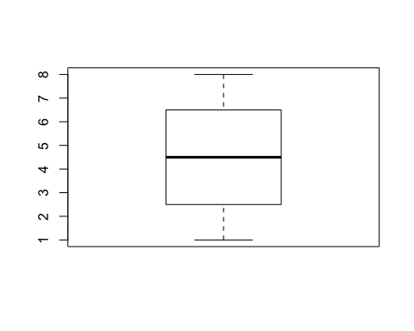
- Figure 1: A boxplot

Figure 3
barplot(1:8)
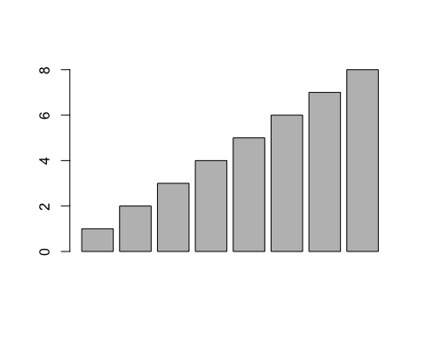

References
see Figure 1: A boxplot and Table 1: caption 1!

