officedown Example
David Gohel
2020-05-06

Prerequisites
This is a sample book written with R package bookdown and R package officedown.
The officedown package can be installed from CRAN or Github:
install.packages("officedown")
# remotes::install_github("davidgohel/officedown")

Introduction
ft_link <- fp_text(font.size = 9, italic = TRUE, color = "#C32900", font.family = "Cambria")
The purpose of this bookdown is to test the functionality of the officedown package. It contains texts of no interest but illustrates most of the functions of the package.

List demo
- This is a linked reference to Chapter .
- This is a linked reference to Chapter .
- This is a linked reference to Chapter .
- Figures and tables can have auto-numbered captions that can also be cross referenced:
  - This is a linked reference to a figure: , its number is computed by Word and it’s linked to the corresponding graphic when clicking on it.
  - This is a linked reference to a table: , its number is computed by Word and it’s linked to the corresponding table when clicking on it.
- An item
- An item
  - An item
    - An item
    - An item
  - An item
- An item

Tables of content

Table of figures

Table of tables
You can use officer code :
block_toc(style = "Table Caption")

Table of content

Tables
This is famous mtcars dataset:
head(dat, n = 10)
Table : mtcars
car | mpg | cyl | disp | hp | drat | wt | qsec | vs | am | gear | carb
Mazda RX4 | 21.0 | 6 | 160.0 | 110 | 3.90 | 2.620 | 16.46 | 0 | 1 | 4 | 4
Mazda RX4 Wag | 21.0 | 6 | 160.0 | 110 | 3.90 | 2.875 | 17.02 | 0 | 1 | 4 | 4
Datsun 710 | 22.8 | 4 | 108.0 | 93 | 3.85 | 2.320 | 18.61 | 1 | 1 | 4 | 1
Hornet 4 Drive | 21.4 | 6 | 258.0 | 110 | 3.08 | 3.215 | 19.44 | 1 | 0 | 3 | 1
Hornet Sportabout | 18.7 | 8 | 360.0 | 175 | 3.15 | 3.440 | 17.02 | 0 | 0 | 3 | 2
Valiant | 18.1 | 6 | 225.0 | 105 | 2.76 | 3.460 | 20.22 | 1 | 0 | 3 | 1
Duster 360 | 14.3 | 8 | 360.0 | 245 | 3.21 | 3.570 | 15.84 | 0 | 0 | 3 | 4
Merc 240D | 24.4 | 4 | 146.7 | 62 | 3.69 | 3.190 | 20.00 | 1 | 0 | 4 | 2
Merc 230 | 22.8 | 4 | 140.8 | 95 | 3.92 | 3.150 | 22.90 | 1 | 0 | 4 | 2
Merc 280 | 19.2 | 6 | 167.6 | 123 | 3.92 | 3.440 | 18.30 | 1 | 0 | 4 | 4
This is famous iris dataset:
head(iris)
Table : iris
Sepal.Length | Sepal.Width | Petal.Length | Petal.Width | Species
5.1 | 3.5 | 1.4 | 0.2 | setosa
4.9 | 3.0 | 1.4 | 0.2 | setosa
4.7 | 3.2 | 1.3 | 0.2 | setosa
4.6 | 3.1 | 1.5 | 0.2 | setosa
5.0 | 3.6 | 1.4 | 0.2 | setosa
5.4 | 3.9 | 1.7 | 0.4 | setosa

Section
Placeholder

A two columns section

End of two columns section

Landscape section

Section margins

Graphics
year <- function(x) as.POSIXlt(x)$year + 1900
ggplot(economics, aes(date, unemploy / pop)) +
geom_line() + theme_minimal()
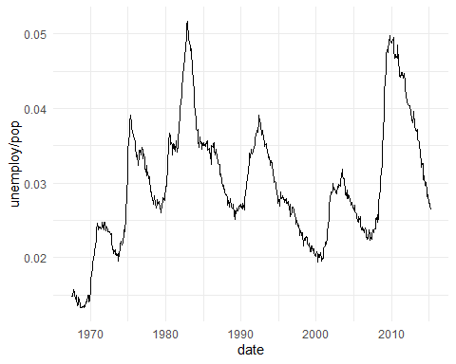
Figure : economics plot

Math latex in captions is supported:
ggplot(mpg, aes(displ, cty, color = trans)) + geom_point() + theme_minimal()
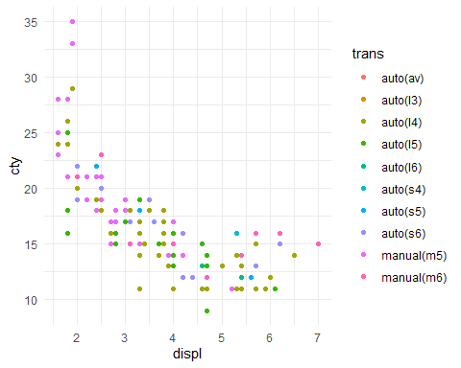
Figure : $\sum_{i=1}^{n}{X_{i}}$

