officedown Example
David Gohel
2020-05-15

Prerequisites
This is a sample book written with R package bookdown and R package officedown.
The officedown package can be installed from CRAN or Github:
install.packages("officedown")
# remotes::install_github("davidgohel/officedown")

Introduction
ft_link <- fp_text(font.size = 9, italic = TRUE, color = "#C32900", font.family = "Cambria")
The purpose of this bookdown is to test the functionality of the officedown package. It contains texts of no interest but illustrates most of the functions of the package.

List demo
- This is a linked reference to Chapter .
- This is a linked reference to Chapter .
- This is a linked reference to Chapter .
- Figures and tables can have auto-numbered captions that can also be cross referenced:
  - This is a linked reference to a figure: , its number is computed by Word and it’s linked to the corresponding graphic when clicking on it.
  - This is a linked reference to a table: , its number is computed by Word and it’s linked to the corresponding table when clicking on it.
- An item
- An item
  - An item
    - An item
    - An item
  - An item
- An item

Tables of content

Table of figures

Table of tables
You can use officer code :
block_toc(style = "Table Caption")

Table of content

Tables
This is famous mtcars dataset:
head(dat, n = 10)
Table : mtcars
car | mpg | cyl | disp | hp | drat | wt | qsec | vs | am | gear | carb
Mazda RX4 | 21.0 | 6 | 160.0 | 110 | 3.90 | 2.620 | 16.46 | 0 | 1 | 4 | 4
Mazda RX4 Wag | 21.0 | 6 | 160.0 | 110 | 3.90 | 2.875 | 17.02 | 0 | 1 | 4 | 4
Datsun 710 | 22.8 | 4 | 108.0 | 93 | 3.85 | 2.320 | 18.61 | 1 | 1 | 4 | 1
Hornet 4 Drive | 21.4 | 6 | 258.0 | 110 | 3.08 | 3.215 | 19.44 | 1 | 0 | 3 | 1
Hornet Sportabout | 18.7 | 8 | 360.0 | 175 | 3.15 | 3.440 | 17.02 | 0 | 0 | 3 | 2
Valiant | 18.1 | 6 | 225.0 | 105 | 2.76 | 3.460 | 20.22 | 1 | 0 | 3 | 1
Duster 360 | 14.3 | 8 | 360.0 | 245 | 3.21 | 3.570 | 15.84 | 0 | 0 | 3 | 4
Merc 240D | 24.4 | 4 | 146.7 | 62 | 3.69 | 3.190 | 20.00 | 1 | 0 | 4 | 2
Merc 230 | 22.8 | 4 | 140.8 | 95 | 3.92 | 3.150 | 22.90 | 1 | 0 | 4 | 2
Merc 280 | 19.2 | 6 | 167.6 | 123 | 3.92 | 3.440 | 18.30 | 1 | 0 | 4 | 4
This is famous iris dataset:
head(iris)
Table : iris
Sepal.Length | Sepal.Width | Petal.Length | Petal.Width | Species
5.1 | 3.5 | 1.4 | 0.2 | setosa
4.9 | 3.0 | 1.4 | 0.2 | setosa
4.7 | 3.2 | 1.3 | 0.2 | setosa
4.6 | 3.1 | 1.5 | 0.2 | setosa
5.0 | 3.6 | 1.4 | 0.2 | setosa
5.4 | 3.9 | 1.7 | 0.4 | setosa

Section

A two columns section

Lorem ipsum dolor sit amet, consectetur adipiscing elit. Nulla eu pulvinar arcu, quis aliquam dui. In at cursus ante. Vestibulum non sagittis lacus. Duis vitae iaculis dui. Vivamus tempor, nibh ut pretium tempus, enim lorem dignissim quam, at euismod massa magna at magna.
Curabitur ligula quam, iaculis faucibus orci quis, vestibulum lobortis lectus. Suspendisse fringilla nisl pulvinar, laoreet tellus sed, sollicitudin tortor. Donec consequat congue erat in iaculis.
Lorem ipsum dolor sit amet, consectetur adipiscing elit. Nulla eu pulvinar arcu, quis aliquam dui. In at cursus ante. Vestibulum non sagittis lacus.

End of two columns section
Lorem ipsum dolor sit amet, consectetur adipiscing elit. Nulla eu pulvinar arcu, quis aliquam dui. In at cursus ante. Vestibulum non sagittis lacus. Duis vitae iaculis dui. Vivamus tempor, nibh ut pretium tempus, enim lorem dignissim quam, at euismod massa magna at magna.
Lorem ipsum dolor sit amet, consectetur adipiscing elit. Nulla eu pulvinar arcu, quis aliquam dui. In at cursus ante. Vestibulum non sagittis lacus. Duis vitae iaculis dui. Vivamus tempor, nibh ut pretium tempus, enim lorem dignissim quam, at euismod massa magna at magna.

Landscape section
Lorem ipsum dolor sit amet, consectetur adipiscing elit. Nulla eu pulvinar arcu, quis aliquam dui. In at cursus ante. Vestibulum non sagittis lacus. Duis vitae iaculis dui. Vivamus tempor, nibh ut pretium tempus, enim lorem dignissim quam, at euismod massa magna at magna. Sed facilisis dapibus diam nec volutpat.
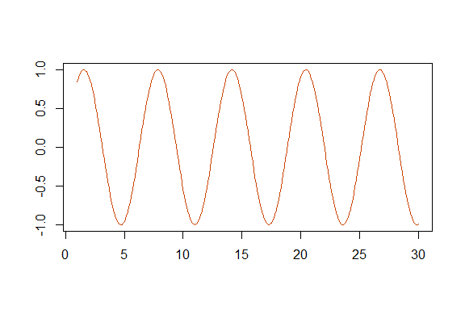
Figure : sin function

Section margins
This is a custom text and the formatting of the paragraph is modified
img.file <- file.path( R.home("doc"), "html", "logo.jpg" )
text_format <- fp_text(bold = TRUE, font.size = 24, font.family = "Bradley Hand", color = "#006699")
fpar_1 <- fpar(
ftext("Hello World, how ", prop = text_format ),
external_img(src = img.file, height = 1.06/3, width = 1.39/3),
ftext(" you?", prop = text_format ), fp_p = fp_par(text.align = "center") )
fpar_1
Hello World, how you?
The following instructions define the section that applies to the text preceding it up to the end of the previous section.
ps <- prop_section(
page_margins = page_mar(bottom = 1, top = 2, left = 1.5),
type = "oddPage"
)
block_section(ps)

Lorem ipsum dolor sit amet, consectetur adipiscing elit. Nulla eu pulvinar arcu, quis aliquam dui. In at cursus ante. Vestibulum non sagittis lacus. Duis vitae iaculis dui. Vivamus tempor, nibh ut pretium tempus, enim lorem dignissim quam, at euismod massa magna at magna. Sed facilisis dapibus diam nec volutpat. Maecenas facilisis dapibus egestas. Curabitur dignissim pharetra pulvinar. Nunc bibendum elit sed cursus congue. Curabitur ligula quam, iaculis faucibus orci quis, vestibulum lobortis lectus. Suspendisse fringilla nisl pulvinar, laoreet tellus sed, sollicitudin tortor. Donec consequat congue erat in iaculis. Curabitur luctus tellus ut turpis iaculis, nec laoreet ligula scelerisque.

Graphics
year <- function(x) as.POSIXlt(x)$year + 1900
ggplot(economics, aes(date, unemploy / pop)) +
geom_line() + theme_minimal()
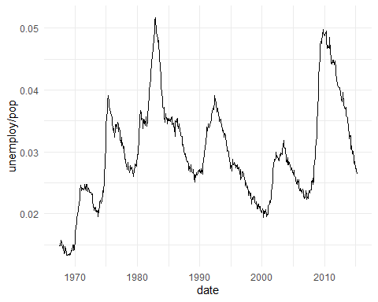
Figure : economics plot

Math latex in captions is supported:
ggplot(mpg, aes(displ, cty, color = trans)) + geom_point() + theme_minimal()
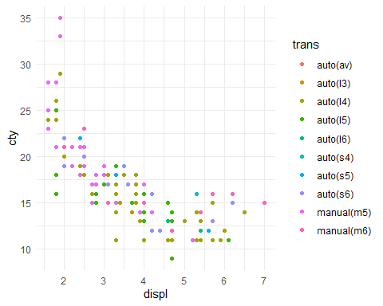
Figure : $\sum_{i=1}^{n}{X_{i}}$

