Sections demo

Default section
Hello World
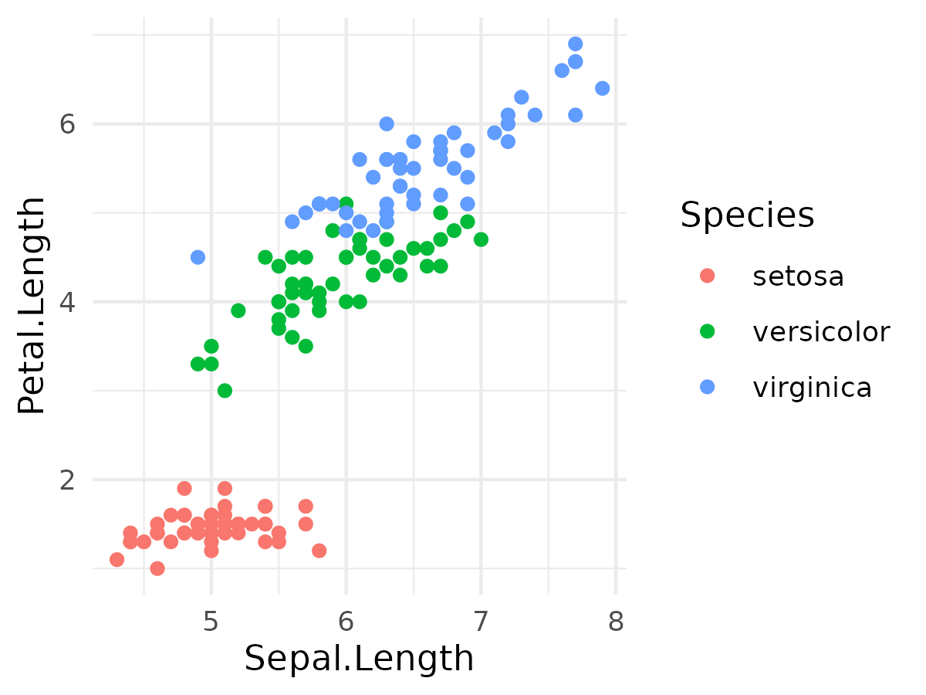

Three columns

Left Title
Centered Title
Right Title

Hello World

Landscape orientation
Hello World

Back to portrait
Hello World

