Here is a class A, two interfaces, and a class B that extends A and implements the two interfaces.

public class A { … }

public interface C1 { …}

public interface C2 { …}

class B extends A implements C1, C2 { … }

We show you what an object of class B looks like in three steps. First, we draw classes B, A, and Object, showing not the full partitions, as we have been doing, but only their names.

Second, since B implements C1, we draw a new line from B upward to C1, and the same for C2.

Third, we draw lines from C1 and C2 to Object, since, as we will see, the perspective of a C1 variable allows access to the methods in Object. Remember, class Object is the superest class of them all: any class or interface that does not explicitly extend something automatically extends Object. We use dashed lines, since they go from an interface upward to a class.

A

Object

B

A

Object

B

C1

C2

Each name represents a partition containing declared components

A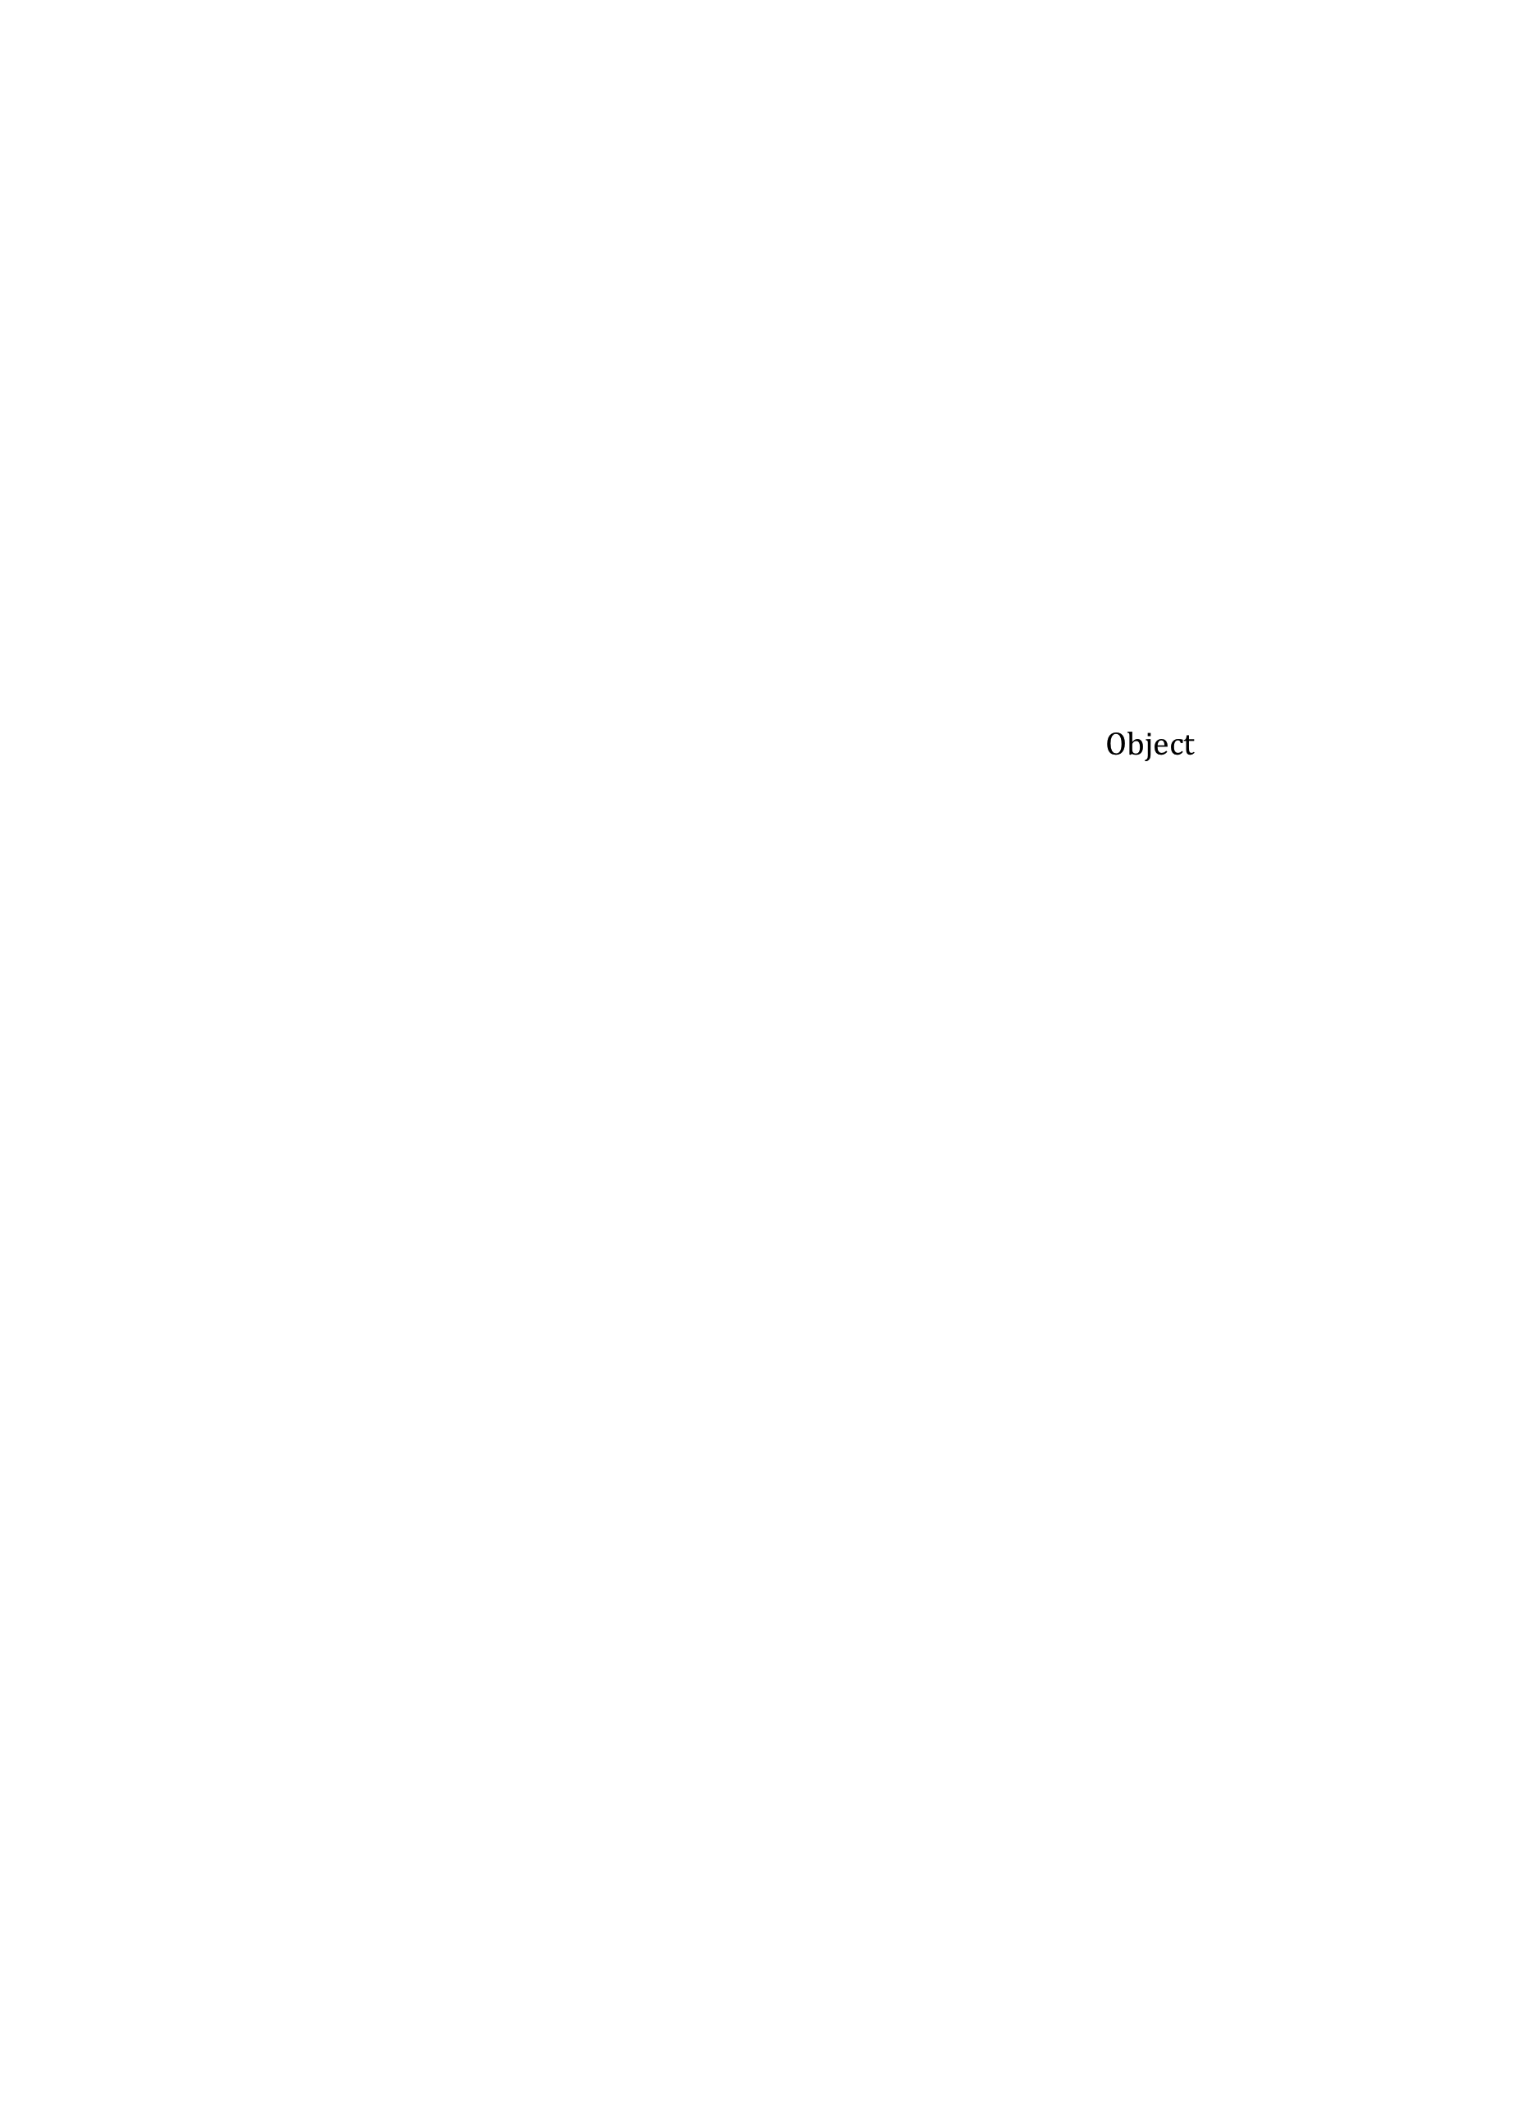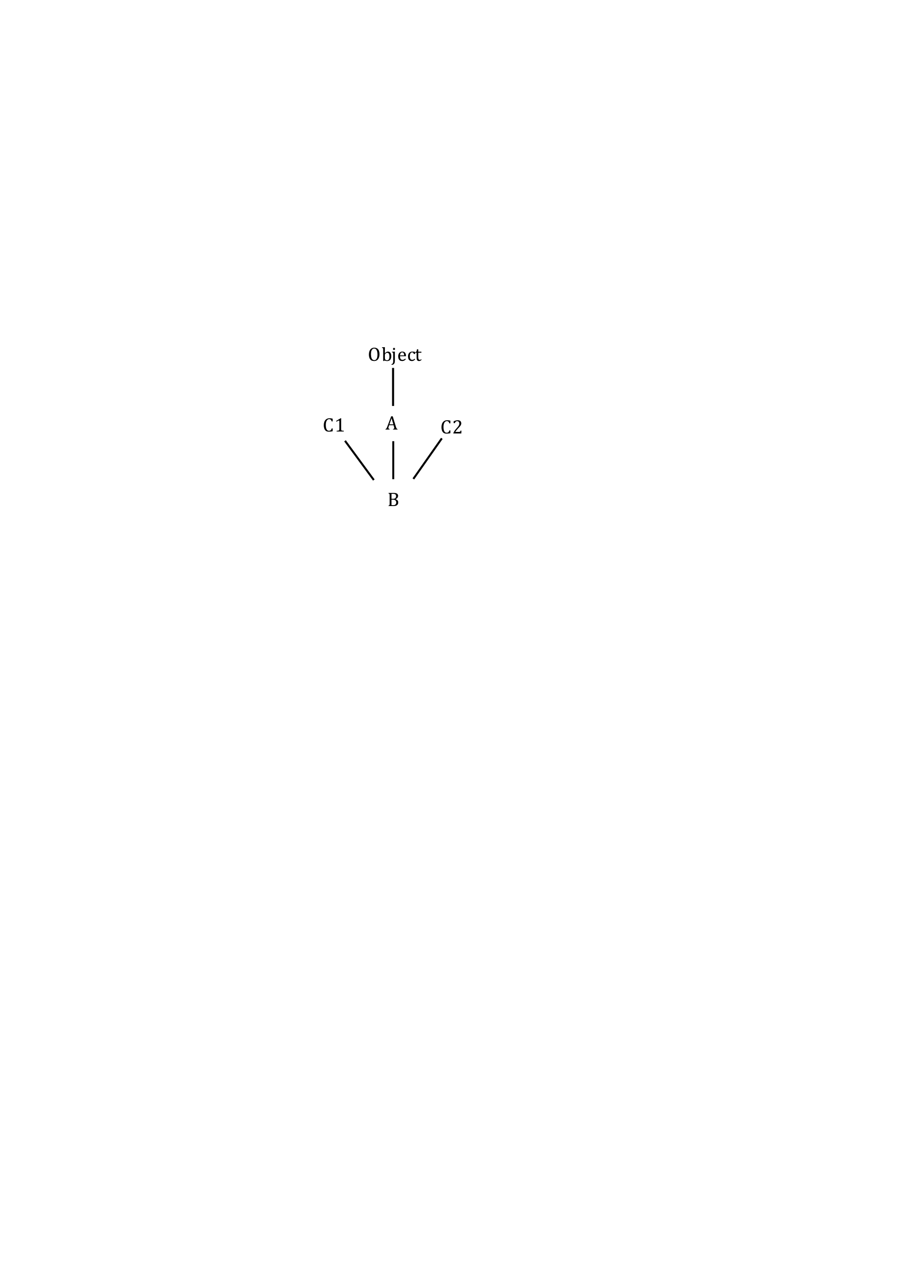

Object

B

C1

C2

B@6

B

b

**Casting**

We also show a variable b that contains a pointer to the object. This object can be cast to any of the classes and interfaces you see in the object, in any order, and to nothing else. For example, b can be cast to A, then to C1, and the result can be stored in variable h.

C1 h= (C1) (A) b;

Java will do upward casts automatically, as you know, but downward (or sideways casts) have to be done explicitly.

What method calls like h.m(…) are legal? Variable h has a C1 perspective. The Java rule, as you know, is that m must be declared in C1 or its superclass, Object. If m is not declared in C1 or Object, the call is illegal and the program will not compile.

If m(…) is legal, which m(…) will be called at runtime? As always, the overriding one.

The call h.equals(…) is legal, since equals is declared in superest class Object. What one is called? Look first in B, then A, then Object.

**Interfaces may appear more than once in an object**

public interface C3 extends C1 { … }

public class D extends B implements C3 { … }

C1

Object

A

C2

B

D



C3

C1

D@50

D

d

You can skip this part and come back to it when you are more at ease with interfaces.

Let’s add a new interface C3 and a new class D. Note that interface C3 extends interface C1. To the right, we draw an object of class D as well as a variable that points to it.

Interfaces C1 appear twice in the object! If we do a cast

(C1) d

which C1 is meant? Well, it doesn’t matter. First, the same methods m(…) are available from both perspectives. Second, the overriding method ((C1) d).m(…) is the same in both —the one in class D. In fact, it would be OK to have just one partition for C1 in the hierarchy, with an upward line from each class or interface that extends it.