We show you how to set the Eclipse formatting actions to perform when a file is saved.

**Save Actions**

Open up the Eclipse Preferences and select

Java -> Editor -> Save Actions

The window should look as it does to the right.

First, make sure that all the boxes are checked as in this image.

Second, look at all the *Additional actions*. If these 15 actions are present, then there is no need to do anything. If they are not all there, then please follow the directions below.

You will be making a bunch of changes. If you want, you can click OK at any time to save what you did so far and then get back in and continue.

**Configuring**

To the right of the *Additional actions* field, you will see a button *Configure*. Press it, and a window title “Additional Save Actions” will appear (shown). It has five buttons in the horizontal bar.

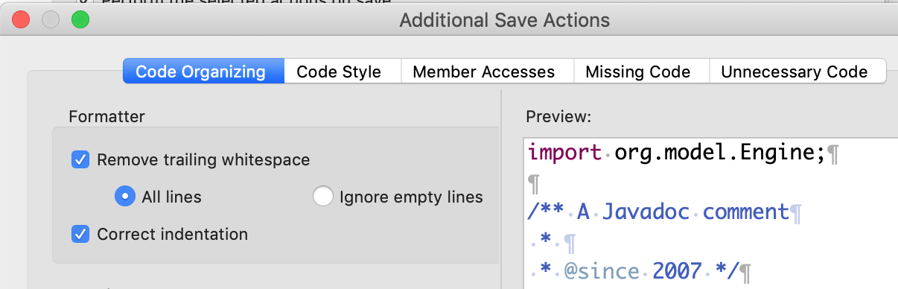**Code Organizing**. Button *Code Organizing*, has been selected. If you don’t see that one selected, select it. Then make sure that three things are selected as shown:   
Remove trailing white space, All lines, and Correct indentation.

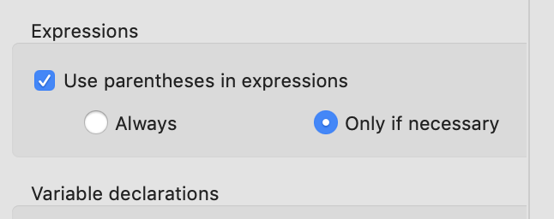**Code Style**. Click the *Code Style* button. You will see partitions for *Control statements*, *Expressions*, *Variable declarations*, and *Functional interface instances*. Select only items in the partition for Expressions, as shown to the right. Select “Use parentheses in expressions,” and also “Only if necessary”.

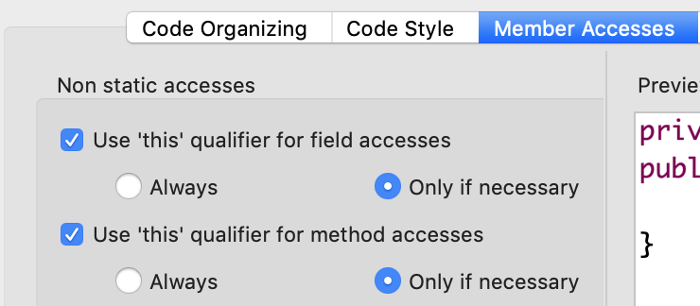

**Member Accesses**. Click the *Member Accesses* button. In the pane that opens, change the partition for *Non static accesses* as shown to the right. Thus, “this” will be used for field and method accesses only if necessary. There is no need to check anything in the partition for *Static accesses*.

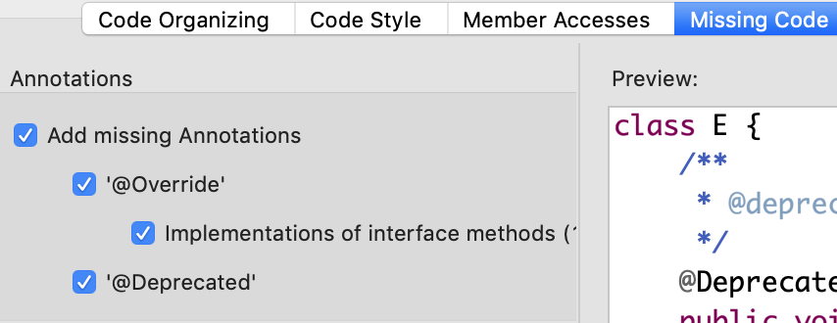**Missing Code**. Click the *Missing Code* button. Make sure the all four check boxes are checked, as shown to the right.

You will soon learn what annotation @Override is for.

To *deprecate* means to lessen in value. Some Java classes and methods within classes in the API package have been deprecated because they have been superseded by newer one that do a better job. You can still use the deprecated entities, but it is better to use their newer replacements.

**Unnecessary Code**. Click the *Unnecessary Code* button. Click the boxes as shown to the right. Thus, these items will be removed:

Unnecessary import

Unnecessary cast

Use diamond operator

Redundant modifier

Redundant semicolon

Useless return

Useless continue

The diamond operator <> will be used to remove unnecessary types. And Autoboxing and Unboxing will be used where possible.

**Finishing up**. Now it is time to click the blue *OK* button.

This opens up the *Additional Save Actions* window.

Click the *Apply and Close* button to save all the changes you made.

That’s it!