Introduction to Graphs

# A *undirected graph* is a pair (V, E) where

1. V is a finite set of objects called *vertexes*, *vertices*, or *nodes*.
2. E is a set of pairs {u, v}, called *edges*, where u and v are nodes in V.

The graph to the right has 5 nodes: V = {A, B, C, D, F}.

The graph to the right has 4 edges: E = {{A, B}, {A, C}, {B, C}, {F, C}}.

We often denote the number of vertices by |V| and the number of edges by |E|. Here, |V| = 5 and |E| = 4.  
Two nodes connected by an edge are said to be *adjacent*.

# A *directed graph* is a pair (V, E) where

1. V is a finite set of objects called *vertexes*, *vertices*, or *nodes*.
2. E is a set of *ordered pairs* (u, v), called *edges*, where u and v are nodes in V.  
   An edge (u, v) is depicted by an arrow leaving u and ending in v.

The graph to the right has 5 nodes: V = {A, B, C, D, F}.

The graph to the right has 4 edges: E = {(A, B), (A, C), (C, B), (F, C)}.

We often denote the number of vertices by |V| and the number of edges by |E|. Here, |V| = 5 and |E| = 4.

A directed graph is sometimes called a *digraph*.

An undirected graph can be easily transformed into an equivalent directed graph. Just replace each edge {u, v} by two ordered pairs (u, v) and (v, u). Thus, each undirected line between two nodes is replaced by two arrows between the two nodes, each in a different direction. Obviously, you can’t transform all directed graphs into equivalent undirected graphs.

We will introduce more terminology and discuss different kinds of graphs later. For now, we show you why the graph is such an important data structure in computing by looking at some examples.

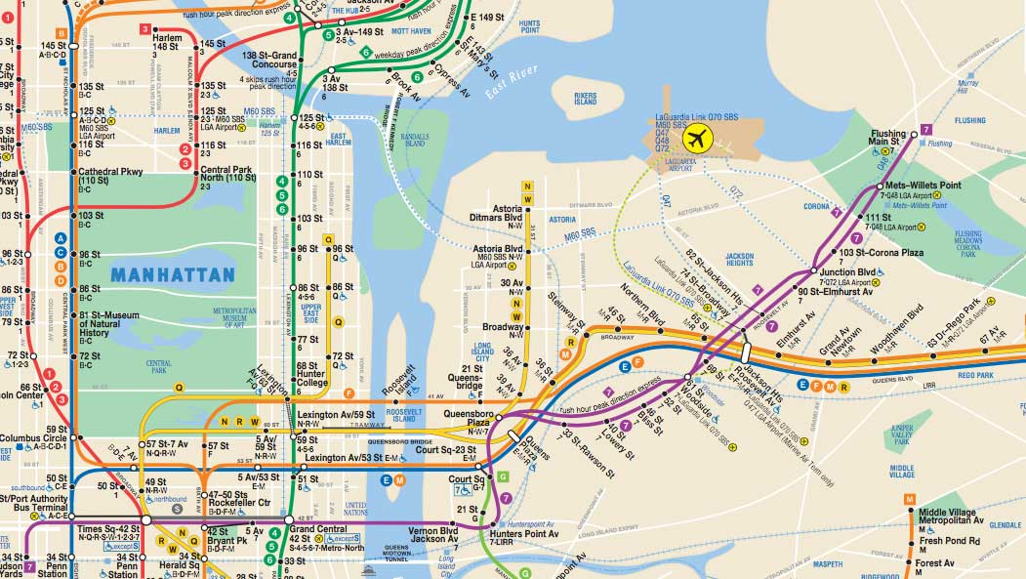**Examples of graphs**

As a first example of a graph, here is part of the subway system in New York City. The nodes are the stations, and the edges are the routes between adjacent stations. This is an undirected graph because, generally, trains go in both directions.

Google “graph new york subway system” to find interesting facts about this map, or graph. On the URL <https://projects.newyorker.com/story/subway/>, The New Yorker has an article about inequality and the NY subway system.

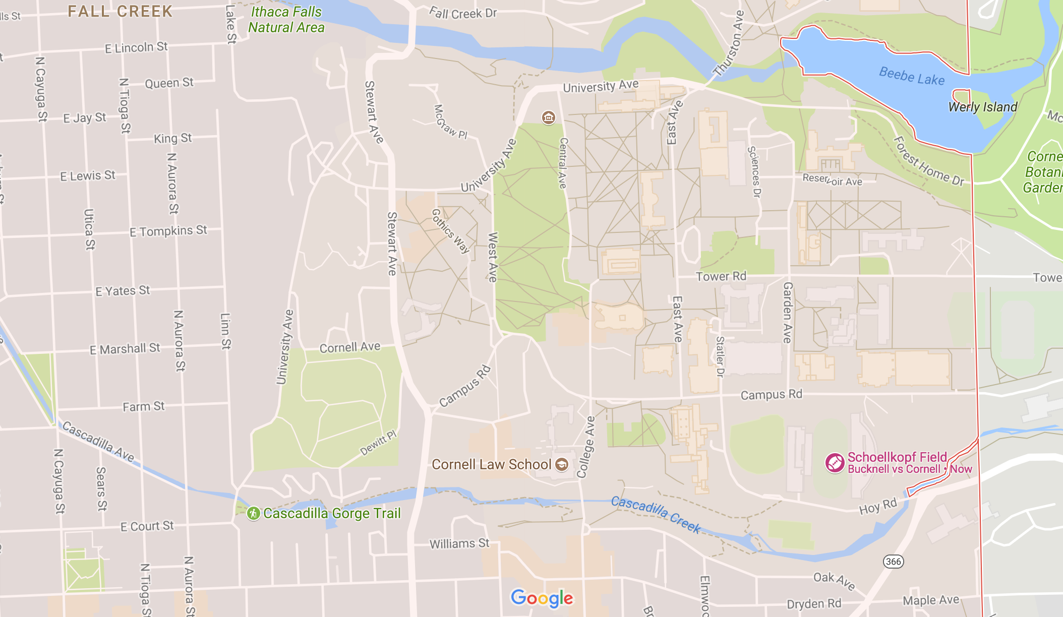Here’s a second example: a map of Ithaca. The nodes are intersections; the edges are the roads between intersections. Such maps are *sparse*, meaning that there are very few edges, because, usually, at most 5 roads and generally 4 roads leave each intersection. These maps are also directed graphs because there are are one-way roads.

Later, we will discuss in detail an algorithm for finding the shortest path from one given node (intersection) to another given node (intersection), This algorithm is used on most cars use these days.

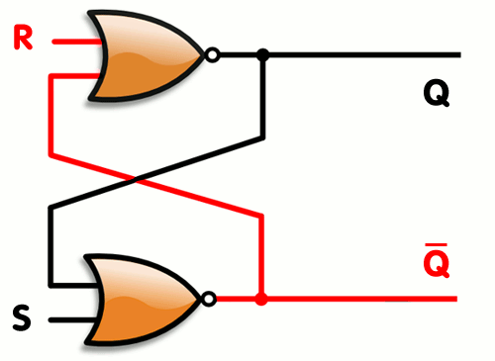Here’s a graph of an electronic circuit, called a flip-flop, a device that stores a single bit. Flip-flops were invented in 1918 and were first implemented in vacuum tubes. This image was taken from Wikipedia. The transistor, a fundamental component of current computers, can also be represented as a graph. It was developed in 1947 at Bell Labs by Shockley, Bardeen, and Brattain.

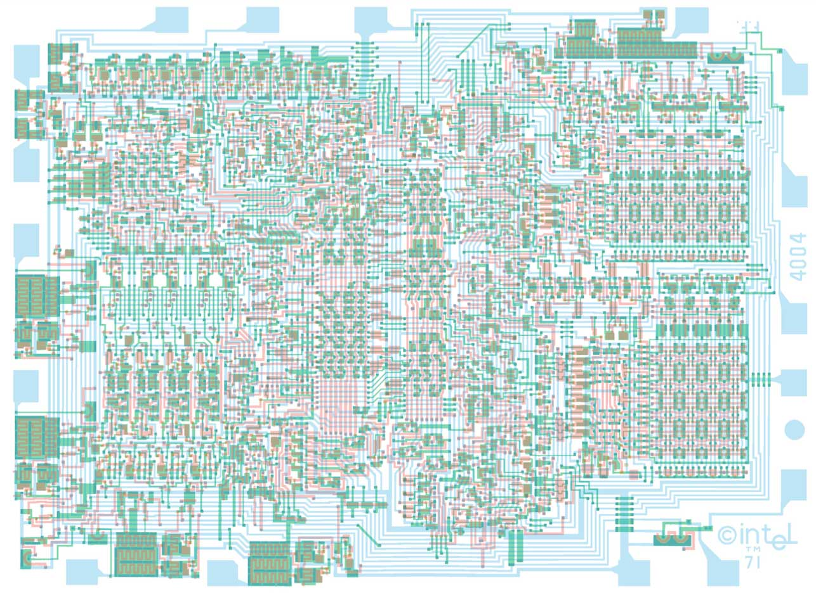

To the right is a circuit graph of the Intel 4004 chip. This 4-bit central processing unit (CPU) was released by Intel in 1971.

This was the first commercially available microprocessor developed by Intel. It was fully integrated on one small chip. It contained 2300 transistors.

You can see a larger image of this graph here:  
http://webcampresence.com/wp-content/uploads/2016/06/ic-reverse-engineering-and-other-adventures-september-2011-vcc-vs-vdd-vss-4004-masks-showing-fets-j3-or.jpg

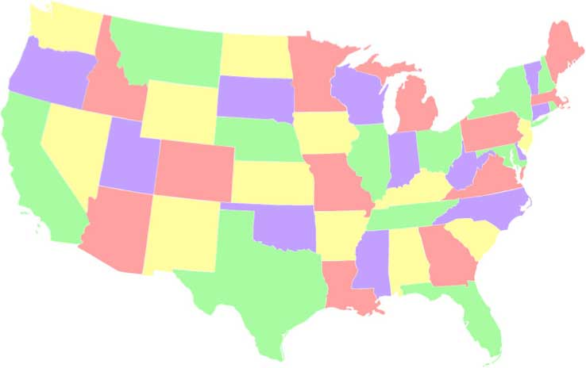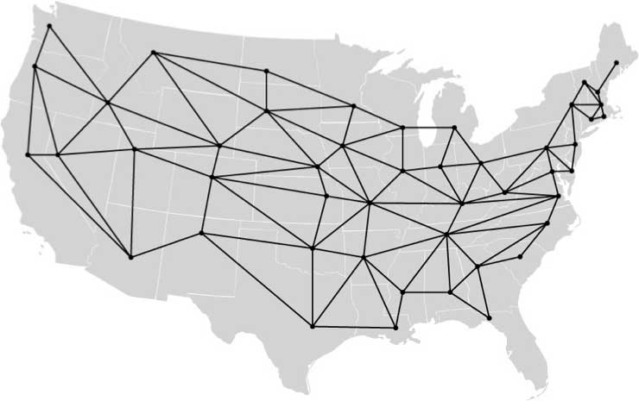The map to the right shows the first 48 states of the US. To its right are the states shown as a graph. The states are the nodes; there is an undirected edge between two adjoining states. How many colors are needed to color all nodes of a planar graph so that no two adjacent nodes have the same color? It was proved in 1879 that only four colors were needed. Ten years later, an error was found in the proof! The theorem remained unproved until 1976, when Appel and Haken proved that only 4 colors were needed. But their proof relied heavily on computer calculations. The use of a computer in a proof aroused considerable controversy at the time. Of course, everyone knows that four colors are needed to color a map because the water has to be blue (joke).

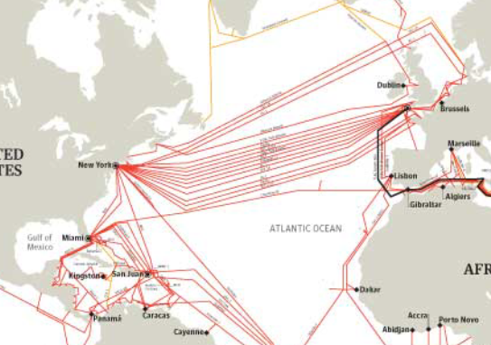To the right is part of the graph of the Internet’s undersea world. See it bigger here: <http://image.guardian.co.uk/sys-files/Guardian/documents/2008/02/01/SEA_CABLES_010208.pdf>. It can be viewed as part of the Internet, “a global system of interconnected computer networks” (Wikipedia). Of course, such graphs have loops, or cycles, but one usually wants a path from one node to another that does not contain loops. A minimum-cost spanning tree —you will learn about spanning trees later— can be constructed, which gives such loopless paths around a graph. The *spanning tree protocol* (STP) builds such a tree. Radia Perlman invented and promote this protocol. For this and later work, she was inducted into the Internet Hall of Fame and the National Inventors Hall of Fame.

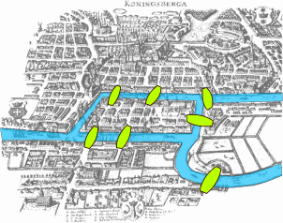Leonard Euler started the theory of graphs in 1736. He was visiting Königsberg, Russia, now Kaliningrad. The Pregel River runs through the city, and there are 7 bridges over the river, as shown to the right. Euler wondered whether he could walk through the city, crossing each bridge exactly once. He formulated the problem in abstract terms, —in our terminology, he considered the graph whose nodes are the 4 landmasses separated by the river and whose edges are the 7 bridges. Euler proved that a necessary condition for any such undirected graph is that the graph be connected and have exactly 0 or 2 nodes of odd degree (the degree of a node is the number of edges leaving it). Euler presented this work to the St. Petersburg Academy in 1735 and published it in a journal in 1741.