Graph coloring

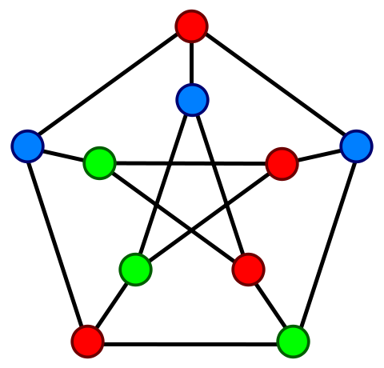A coloring of an undirected graph is an assignment of a color to each node so that adjacent nodes have different colors. The graph to the right, taken from Wikipedia, is known as the *Petersen* graph, after Julius Petersen, who discussed some of its properties in 1898. It has been colored with 3 colors. It can’t be colored with fewer colors.

The Petersen graph has both K5 and bipartite graph K3,3, so it is not planar. That’s all you have to know about the Petersen graph. But if you are at all interested in what mathematicians and computer scientists do, visit the Wikipedia page for *Petersen graph*.

**A flawed proof that four colors suffice**

Thoughts about graph coloring appear to have sprung up in England around 1850 when people attempted to color maps, which can be represented by planar graphs in which the nodes are countries and adjacent countries have a directed edge between them. Francis Guthrie conjectured that four colors would suffice.

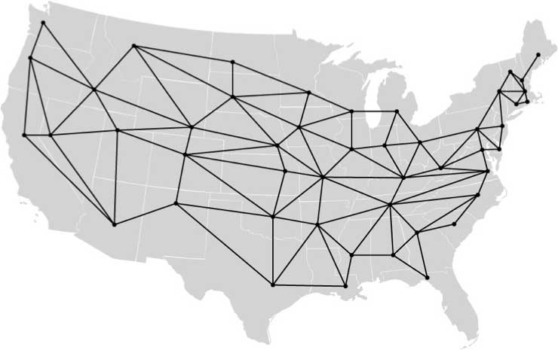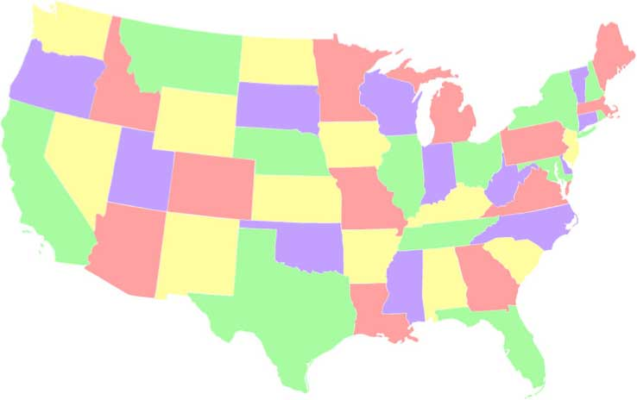

Here’s an interesting bit about mathematical proofs. In 1879, Alfred Kemp, a barrister in London, published a proof in the *American Journal of Mathematics* that only four colors were needed to color a planar graph. Eleven years later, P.J. Heawood found a flaw in the proof. He and Kempe and others tried to fix the flaw but were unable to do so, and the theorem remained only a conjecture until almost one hundred years later. Appel and Haken, who proved the theorem in 1976, said that "Kempe's argument was extremely clever, and although his "proof" turned out not to be complete, it contained most of the basic ideas that eventually led to the correct proof one century later."

Of course, everyone knows five colors are needed to color a map, because the water has to be blue (joke).

Alan Sipka of Alma College gave a presentation titled “Kempe’s flawed proof that four colors suffice,” at the MAA MathFest 2013 in Hartford, CT on 1 August 2013. It’s eminently readable, and if you have time read it! It can be found in JavaHyperText entry “four-color theorem”. In it, Alan gives the map, shown to the right, that Heawood used as a counterexample to Kempe’s proof. Of course, this map can be colored with four colors, but not using the process given by Kempe’s flawed proof.