**Java packages and methods for I/O**

Initially, the main package of classes and interfaces for IO was package java.io. But with release Java SE 7 many years ago, a newer package java.nio was released. And, instead of using class java.io.File for working with files and directories, the Java people advocated using the newer one:

**Old package Package since version 7**  
 packages java.io java.nio  
 Dealing with files: java.io.File java.nio.file.Path, java.nio.file.Files

This webpage explains the reasons for preferring the newer package:

http://docs.oracle.com/javase/tutorial/essential/io/legacy.html

In our discussions of I/O, we will use the new package, but you may come across legacy code that uses the old package. When you see uses of java.io.File, read the Java API documentation to learn about the methods being used. The webpage listed above tells you about dealing with legacy code and how you could modify the legacy code to use the new package instead.

**Files, directories, paths**

The hard drive on your computer is structured as a tree —or perhaps a forest of trees. The leaves are either files or empty directories (also called folders). The internal nodes are directories. The image below displays part of the tree on one laptop in horizontal fashion. The root is named with the empty string (although it looks like it should be Macintosh HD). It has several children, mostly directories. Child Users is selected. It contains three directories, one of which is selected, and so on.

This image actually shows a forest of four trees. Besides the tree for the internal hard drive, there are trees with roots Network, Remote Disc (a portable CD unit), and Seagate … (an attached external hard drive).

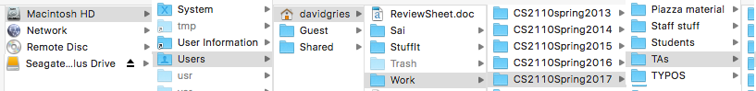A path to a file or directory is simply the list of names from the root of the tree to that file or directory. In the above image, the path to directory Work is: “”, Users, davidgries, Work (the first name is the empty string!)

Different operating systems use different delimiters to separate names on a path. Unix-based systems, including the Macintosh systems, use “/”; Microsoft windows systems use “\”. Here are examples:

Unix operating system: /Users/davidgries/Work  
 Microsoft Windows system: C:\home\sally\statusReport

**Absolute versus relative paths**

The paths shown above are *absolute* paths; they show the path from a root of a file system to a node.

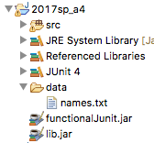A *relative* path shows the path from some node other than the root. For example, here is a relative path in the image shown above:

Work/CS2110Spring2017/Students

Obviously, this relative path can’t be used without having more information.

One can use relative paths in Eclipse projects. Consider the image to the right of Eclipse project 2017sp_a4. The project contains directory data, which contains text file names.txt. Within classes in directory src, we can write code to read file names.txt using the relative path data/names.txt. By default, Eclipse assumes that directory data is in directory 2017sp_a4, which it is.