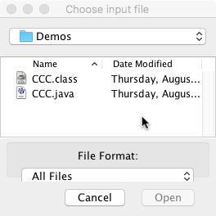Class javax.swing.JFileChooser is used to open a dialog window that the user can use to navigate to a particular directory or file on their hard drive and select it for reading or writing. The example to the right is used to create a java.nio.file.Path object for a file to be read. The user navigates to the directory that contains the file, selects the file, and clicks button *Open*.

Your code gets to put the title at the top, in this case, *Choose input file*.

**Getting a Path to an input file**

Below is a method that uses a JFileChooser to create a Path to a file to be read. Given the Path, one can then create a BufferedReader, as usual, in order to read the file. We discuss each statement of the method body.

1. If new JFileChooser() is used, the dialog window will open to some default place on the hard drive, and a lot of navigating may be necessary to get to the desired directory. For example, on a Windows machine, it may be directory My Documents. If you know the probable directory that will be navigated to, the use new JFileChooser(s) where s is a path to that directory.
2. The second statement sets the title to be used in the dialog window.
3. In the third statement, the call jd.showOpenDialog(null) causes the dialog window to appear. This call terminates only when the user clicks *Cancel* or *Open*. The method call returns one of three integers: (1) JFileChooser.APPROVE_OPTION, (2) JFileChooser.CANCEL_OPTION (the user hit the cancel button), and (3) JFileChooser.ERROR_OPTION (an error occurred or the dialog window was closed. If it was not the first one, return null, as per the spec of getInputPath.
4. About the fourth statement. Class JFileChooser was written before Java version 7 and therefore uses the older class java.io.File to describe a path on the hard drive. Function jd.getSelectedFile() returns the path that the user selected as a File object. The call on toPath() returns an equivalent path in a Path object.

/** Use a JFileChooser to obtain a Path to a file to be read.  
 * If user cancels the dialog window, return null.  
 * Parameter s can be a path on the hard drive or null.  
 * If s is not* null, start the JFileChooser at the path given by s. */  
 public static Path getInputPath(String s) {  
 JFileChooser jd= s == null ? new JFileChooser() : new JFileChooser(s);  
  
 jd.setDialogTitle("Choose input file");  
 int returnVal= jd.showOpenDialog(null);  
  
 if (returnVal != JFileChooser.*APPROVE_OPTION*) return null;  
  
 return jd.getSelectedFile().toPath();  
 }

Class JFileChooser has some more useful features. For example, you can set it up so that the file to be read has to be a .java file, or a .txt file. Visit the API documentation for JFileChooser to learn more.

**Getting a Path to an output file**

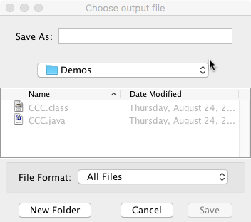To the right is an instance of a dialog window used to retrieve a path to a file to be written, i.e. an output file. Note the title: *Choose output file*. The user types in the name of the file to be written in the *Save as* field, navigates to the directory into which it is to be written, and clicks *Save*. Note that the user can create new folders (directories) if necessary.

The method to open the dialog window and then create and return the Path is quite similar to the method shown above. The main difference is that instead of calling showOpenDialog method showSaveDialog is called. It appears on the next page.

/** Use a JFileChooser to obtain a Path to a file to be written.  
 * If the user cancels the dialog window (and thus does not give a  
 * file name), return null.  
 * Parameter s can be a path on the hard drive or null. If s is not  
 * null, start the JFileChooser at the path given by s.*/  
 public static Path getOutputPath(String s) {  
 JFileChooser jd= s == null ? new JFileChooser() : new JFileChooser(s);  
  
 jd.setDialogTitle("Choose output file");  
 int returnVal= jd.showSaveDialog(null);  
  
 if (returnVal != JFileChooser.APPROVE_OPTION) return null;  
  
 return jd.getSelectedFile().toPath();  
 }