The online Merriam-Webster unabridged dictionary gives this definiton of *polymorphism*:

The quality or state of being polymorphous: such as

(1): capability of assuming different forms: capability of wide variation   
(2): existence of a species in several forms independent of the variations of sex   
 (as in various butterflies whose broods, appearing at different seasons, differ  
 in size or color, or both, or in ants and termites, in which different castes exist)

The prefix *poly* means “many”, as in the word *polygon*, a figure having many sides. The verb *morph* means to undergo transformation, often of an image. Hence the definition (1) of *polymorphism* above.

In 1993, David Gries and Fred Schneider wrote a text “A Logical Approach to Discrete Math”. The back cover contained the pictures below —a picture of Gries on the left below was morphed into a picture of Schneider on the right. The middle image is 50% Gries 50% Schneider. The images were done using an application called *morph*; you can find such applications on the web.



Polymorphism happens in some areas for different reasons. For example, the Wiki page for polymor­phism in lepidoptera[1], which includes butterflies and moths, discusses:

* *Genetic polymorphism*, in which the variation in form occurred because of genetic changes.
* *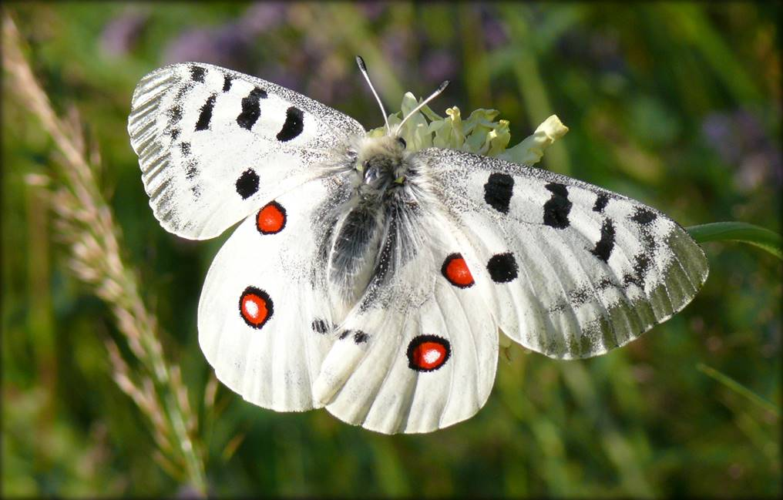Geographical polymorphism*, where geographical isolation causes species to morph in different ways. A prime example of this is the Apollo butter­fly —one is shown to the right. These butterflies live is small local popu­la­tions, with almost no interbreeding. The Wikipedia site says that they have morphed into over 600 different forms, with the size of spots on wings greatly varying. Scientists have studied and cataloged all of them.
* 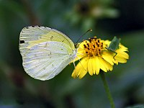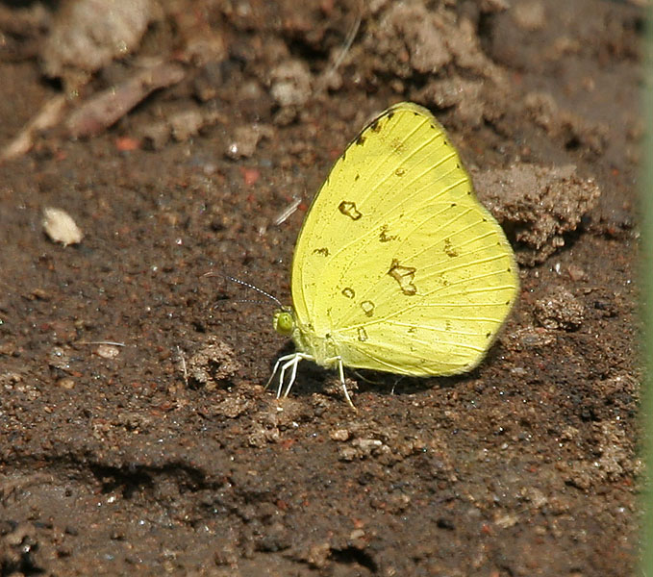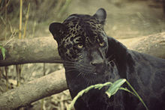*Environmental polymorphism*. The images to the right give an example of environmental polymorphism. It’s the same kind of butter­fly. To the left is its dry-season form, in the sum­mer, when daylight is long. To the right is its wet-season form.

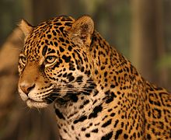To the right are two jaguars[2]. They are both jaguars, but their skin color has morphed in two ways due to their different habitats.

**Polymorphism in Java**

Polymorphism, then, is the notion of one kind of thing having many different forms. Polymorphism exists in Java (and other programming languages) as well, essentially dealing with types. These polymorphic features of Java help achieve easy reuse of program parts and scalability to large programming systems. As with butterflies, polymorphism in Java comes in several different forms, each to be treated in other pdf files.

* *Ad hoc* polymorphism
* *Parametric* polymorphism
* *Subtype* polymorphism

1. en.wikipedia.org/wiki/Polymorphism_in_Lepidoptera
2. en.wikipedia.org/wiki/Polymorphism_(biology)