You already know that:

* A *stack* is a list that supports insertion on and removal from its top. It’s a Last-In-First-Out, or LIFO, list.
* A *queue* is a list that supports insertion at the end and removal from the beginning. It’s a First-In-First-Out, or FIFO, list. The British wait in a queue for their football tickets, Americans wait in a line.

The *priority queue* is another kind of list. Each item in a priority queue has a *priority*. New items are simply added to the list, along with their priority. When removal is performed, the item with the *smallest* priority is removed.

Priority queues are used in a number of applications. We name three:

* In event-driven simulations, events can be kept in a priority queue, with the priority being the time at which an event is to take place. Events are removed from the queue in chronological order and processed.
* 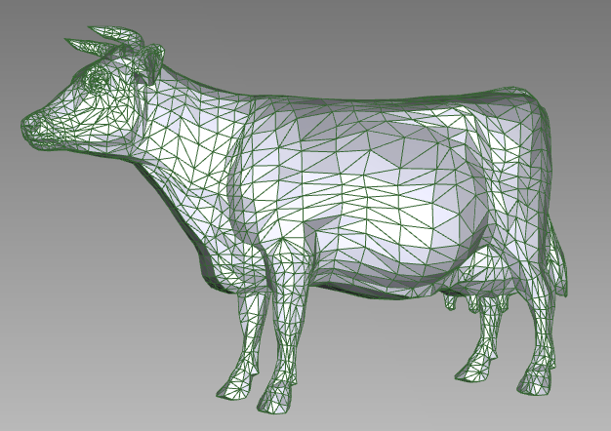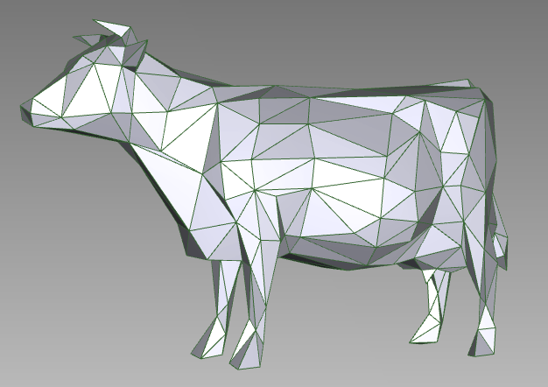Many articles on the web talk about simplifying the representation of objects. In one version, a priority queue contains a bunch of simplifications that can be made, with the priority being the cost of making that simpli­fication. For example, the first cow on the right is represented by a bunch of triangles; the representation is simplified in the second cow with fewer triangles.
* Dijkstra’s algorithm to compute the shortest path from a start node to all other nodes of a graph uses a priority queue in which the values are some of the nodes of the graph and the priority of a node is the shortest path found so far from the start node to that node.

**Operations on a priority queue**

**Operations on priority queue of items of type E**

**int** size()

boolean add(e, p) // add item e with priority p

E peek() // return item with minimum priority

E poll() // remove/return item with min priority

void clear() // remove all items

boolean contains(E e)  
boolean remove(E e)  
void updatePriority(e, p) // change e’s priority to p

The conventional operations on a priority queue are listed to the right. Method add returns true if e is actually added to the list and false if e is already in the list.

Methods contains, remove, and updatePriority are not always included. Their efficient implementation compli­cates the data structures usually used to implement a priority queue, as discussed briefly below.

**Implementing a priority queue**

One can implement a priority queue naively in a Java ArrayList or something similar, but either method add or methods peek and poll will take linear time. That is because finding the item with minimum priority requires a linear search, unless method add did at least linear-time work to make peek and poll faster.

In 1964, J.W.J. Williams invented the *heap* data structure —not to implement priority queues but to develop sorting method heapSort. A *heap* is a tree with certain properties that can be stored in an array. Using a heap, methods size and peek take time O(1) for a heap of size n, while add and poll take time O(log n). Because of this, the heap is used extensively to implement priority queues.

Methods contains, remove, and updatePriority still take linear time unless additional data structures are used, because item e has to be found.

Look at JavaHyperText entry *heaps* for an extensive discussion of this important data structure.

**When priorities are few**

If there are just 2 or 3 (or a few more) different priorities, then the priority queue may be best implemented as a list of normal queues. After all, that is what airlines do at ticket counters. There are two priorities: first-class and everyone-else. First-class customers are in one queue and everyone else is in a second queue. In some applications, this is a good solution to the priority queue problem.

**Java’s class PriorityQueue**

Class java.util.PriorityQueue implements an un­bounded queue using a heap, To the right, we show some of its methods.

**public class** PriorityQueue<E> {

**public** **boolean** add(E e) { … }

**public** E peek() { … }

**public** E poll() { … }

**public** **void** clear()

**public** **boolean** contains(Object ob) { … }  
 **public** **boolean** remove(Object ob) { … }

…

Interestingly, method add, defined to the right, doesn’t have   
a parameter for the priority. That is because either

1. Type E has to implement interface Comparable, and its method compareTo is used to determine the ordering of items in the queue; OR
2. When creating a PriorityQueue object, one can give the comparator as an argument of the call to the constructor.

Class PriorityQueue uses a heap and no other data structure. Therefore, methods contains and remove take time proportional to the size of the heap.

Class PriorityQueue also has an Iterator, allowing one to write a for-each loop over the elements of the queue.