The US Constitution requires that the people of the U.S. be counted every ten years and that the members of the House of Representatives “be apportioned among the States according to their respective numbers”[1]. (The other house of Congress, the Senate, has two members from each state.) Accordingly, every ten years, a census is taken.

By 1880, the census was becoming harder and harder to accomplish. Everything was done on paper. Marks were placed in squares on paper, the marked squares were counted, and of course people made many mistakes. Further, the census was used more and more not just to count people but to get useful data on age, gender, marital status, working status, and so on. There were more and more marks to make and count!

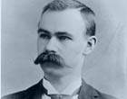**Herman Hollerith: the inventor of mechanical/electrical data processing systems**

Herman Hollerith graduated from the Columbia University School of Mines (in New York City) in 1879 at the age of 19. He knew about the problems with the census and began research into mechanizing part of the counting of the census. In 1882, he taught mechanical engineering at MIT and conducted his first experiments with punched cards. He was extremely successful, and he soon moved to Washington D.C. and set up a company, *The Hollerith Electric Tabulating System*. By the middle of the 1880’s, his first punched-card system was working. His company provided the Census Office with the equipment used in processing the 1890 census —62 million punched cards were processed by his machines, cutting two years off the time to complete the census. His machines performed a [pigeonhole sort](sort5pigeonHole.pdf), and, when applied several times, a [radix 10 sort](sort7Radix.pdf).

Hollerith was granted U.S. Patent 395,782 for his sorter-tabulator in 1989. The profound effect of his inventions was noticed by many. For example, in 1989, he approached Columbia, his alma mater, and asked for a PhD. Columbia said *yes*! They gave him a PhD —the Board of Trustees waived the requirement that he be enrolled in a PhD program. Ask and ye shall receive. A copy of his PhD thesis appears in reference [4] on the web and in [6].

Hollerith’s inventions of punched card tabulating machines was the start of a long period of the use of mechanical/electrical data processing systems. He continued to innovate and invent, producing the first automatic card-feed mechanism and the first keypunch machine. Several countries, insurance companies, and others began using his equipment. In 1896, Hollerith founded the *Tabulating Machine Company*. In 1911, that company and four others were brought together to form the *Computing-Tabulating-Recording Company*. In 1924, it was renamed *IBM* (International Business Machines Corporation). Without Hollerith’s formidable contributions, IBM would not exist today.

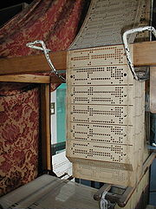**How did Hollerith get the idea of using punched cards?**

In 1804, French weaver Joseph Jacquard developed a mechanical loom with a loop of punched cards that controlled the weaving of a design on the material. You can still see such looms in China. But Hollerith didn’t know about these punched cards. Instead, he was inspired by railroad tickets in which conductors punched holes:

"I was traveling in the West and I had a ticket with what I think was called a punch photograph ... the conductor ... punched out a description of the individual, as light hair, dark eyes, large nose, etc. So you see, I only made a punch photograph of each person."[7]

**Punched cards**

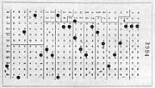To the right is an image of Hollerith punched card, taken from [9]. Its dimensions were those of the paper currency at the time. Many other formats for punched cards were introduced by various companies.

In 1928, the IBM card format was introduced. As shown below, it had rectangular holes, which could be spaced more tightly, allowing 80 columns per punched card, thereby nearly doubling the capacity of the older format, and 12 rows. This became the prevalent card format throughout the latter part of the twentieth century. For a history of punched cards, see reference 11.

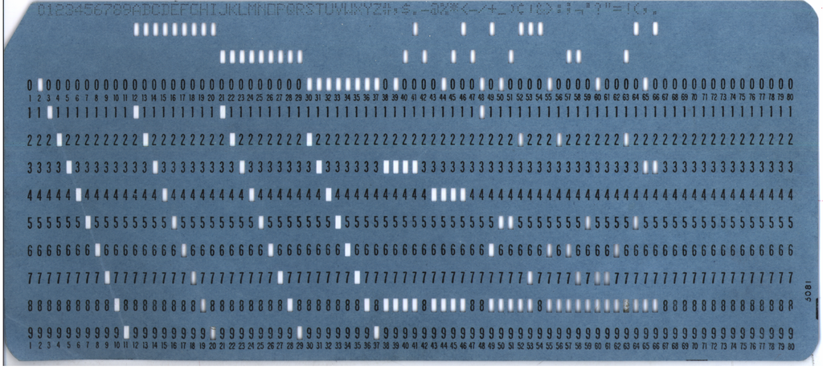

**Sorting using mechanical sorters**

The first method for sorting using Hollerith’s taubulator/sorters was a [*pigeonhole sort*](sort5pigeonHole.pdf), which sorts a deck of cards based on the holes punched in one column. A digital variant of this method of sorting is [counting sort](sort5Counting.pdf); it has the same goal but performs slightly differently. Applying pigeonhole sort on several columns in succession gives what is called [radix 10 sorting](sort7Radix.pdf).

**References**  
This document contains information drawn from a number of online documents, including:

1. en.wikipedia.org/wiki/Radix_sort
2. en.wikipedia.org/wiki/Herman_Hollerith
3. www.columbia.edu/cu/computinghistory/hollerith.html
4. www.columbia.edu/cu/computinghistory/hh/index.html (a copy of his PhD thesis)
5. www.hnf.de/en/permanent-exhibition/exhibition-areas/galerie-der-pioniere/herman-hollerith-1860-1929.html
6. Randell, Brian, ed. (1982). *The Origins of Digital Computers, Selected Papers* (3rd ed.). Springer-Verlag. Contains Hollerith’s PhD thesis.
7. Austrian, Geoffrey D. (1982). *Herman Hollerith: Forgotten Giant of Information Processing*. Columbia University Press. p. 124.
8. en.wikipedia.org/wiki/Punched_card
9. commons.wikimedia.org/wiki/File:Hollerith_punched_card.jpg
10. ed-thelen.org/comp-hist/Knuth-Sort.html
11. https://en.wikipedia.org/wiki/Punched_card#Hollerith%27s_early_punched_card_formats

1. The definition of who is to be counted was “… determined by adding to the whole Number of free Persons, including those bound to Service for a Term of Years and excluding Indians not taxed, three fifths of all other Persons.” The “three fifths of all other Persons” was a compromise struck between the southern and northern states because of slaves in the southern states. The 14th Amendment, ratified in 1968 after the civil war, changed the definition to, “counting the whole number of persons in each State, excluding Indians not taxed”.

   American Indians were not considered citizens at the time, and they were to be counted only if they were taxed. The strange wording, “Indians not taxed”, was never defined. For each census, census takers were given different instructions about what it meant. Its meaning became moot in 1924 when the Indian Citizenship Act granted citizenship to all Indians born in the U.S. However, many issues still remain to be settled between the U.S. and American Indians. Looking back, one can rightly say that the U.S. did not treat Indians fairly, and many law suits against the U.S. still exist. In 1916, the U.S. government agreed to pay $492 million to 17 American Indian tribes for mismanaging natural resources and other tribal assets.