Joyce Kilmer wrote the most famous poem about trees, copied below. It first appeared in print in 1913, *Poetry, A Magazine of Verse*, the oldest monthly magazine devoted to verse in the English-speaking world. When the U.S. entered World War I in 1917, he enlisted in the U.S. army, at the age of 30. He was killed during the battle of Ourcq, France,

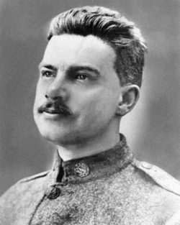

I think that I shall never see

A poem lovely as a tree.

A tree whose hungry mouth is prest

Against the earth’s sweet flowing breast;

A tree that looks at God all day,

And lifts her leafy arms to pray;

A tree that may in Summer wear

A nest of robins in her hair;

Upon whose bosom snow has lain;

Who intimately lives with rain.

Poems are made by fools like me,

But only God can make a tree.