There are places in Java where only objects are allowed and not primitive values. For example, an object of class ArrayList maintains a list of objects, and the int value 5 cannot be put into it. Java’s solution to this problem is to have a class Integer —in package java.lang, so you don’t have to import it— each object of which wraps (or contains) an int. So, if you want to put 5 into an ArrayList, wrap it in an Integer object and place that object in the ArrayList instead.

The word *wraps* and the phrase *wrapper class* are Java’s, not ours. They make sense. Below are a bunch of wrappers. In order, these wrappers wrap a sandwich, a cupcake, spring rolls, and an **int**.

  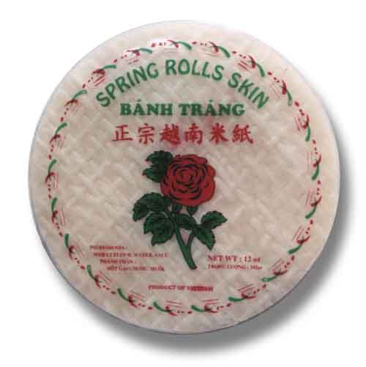

Integer

**Integer@1a**

???

5

Like Strings, Integers are immutable. You can’t change the **int** that is wrapped in an Integer object.

Java makes it easy to go back and forth between **int** and Integer:

Integer d= 5; // Java automatically wraps the 5 in a new Integer object and stores a pointer to it in d  
 // Java calls this *autoboxing*. *Autowrapping* would have been better.

ll.add(4); // Assuming ll is an ArrayList, Java will automatically autobox the 4 as above.

**int** k= d; // Java automatically *unboxes* (*unwraps* is better) the **int** in object d.

Java will autobox and autounbox for you in most situations where you would want it to.

Class Integer has a constructor Integer(int) and a bunch of instance methods, like d.equals(d1), d.intValue(), d.toString().

Class Integer has some useful static variables, like Integer.MAX_VALUE and Integer.MIN_VALUE .

Class Integer has some useful static methods, like Integer.parseInt(String s) .

Each primitive type has its wrapper class, defined in package java.lang so you don’t have to import it explicitly. Each wraps one primitive value and has instance methods, static variables, and static methods appropriate to that type. Here they are:

**primitive type wrapper class**

**byte** Byte

**int** Integer

**long** Long

**float** Float

**double** Double

**char** Character

**boolean** Boolean

Need more information?

1. Type wrapper class Java into a search engine and you will find many tutorials.
2. Look in the Java API specs for class Integer or any of the other wrapper classes.