Q&A The one where you completely remove a process definition
Let’s say you’re completely done with a certain process definition. You no longer run that process, and it’s just cluttering up your deployment, so you want it gone.
First, make sure you want it gone! Once you delete it, it’s gone forever and there is no getting it back! If you still have the .bpmn file that you originally used to create the process you can re-load that, but all the history, statistics, etc. associated with that process will be gone.

So you’ve decided you’re done with the process, now what?
Well then, it’s time to delete it! Again, let’s just check in one more time that you’re sure, like really, really sure that you never want to see this process again.
If you are sure, then let’s proceed with deleting it.

Step by Step Instructions
Login to Cockpit in the Camunda Platform and Look for your Process Definitions:
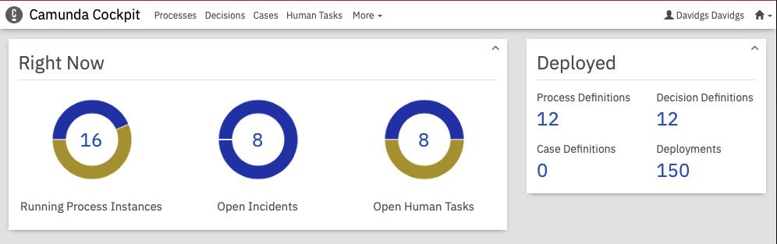
Cockpit Dashboard
Click on the Process Definitions to get to the list off all of your process definitions.
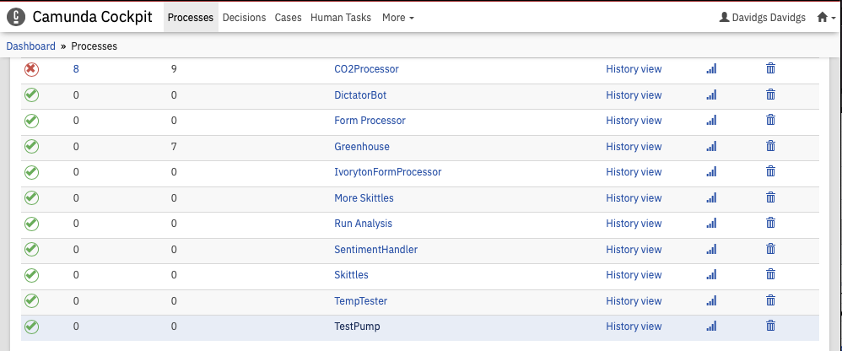
Cockpit Process Definitions
Find the Process you want gone, and click on the Trash Can icon on the right-most column.
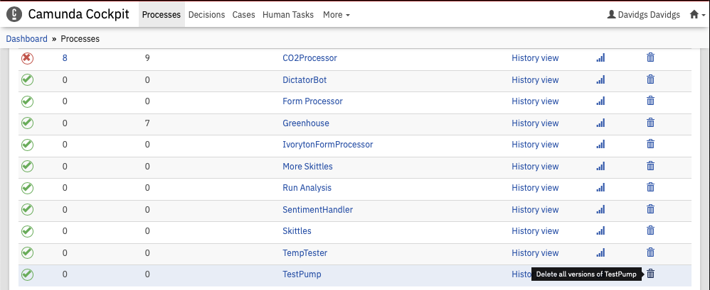
Cockpit defintions trash can
Click on that Trash Can icon. It’s still not too late to change your mind, but it’s getting close to the point of no return.
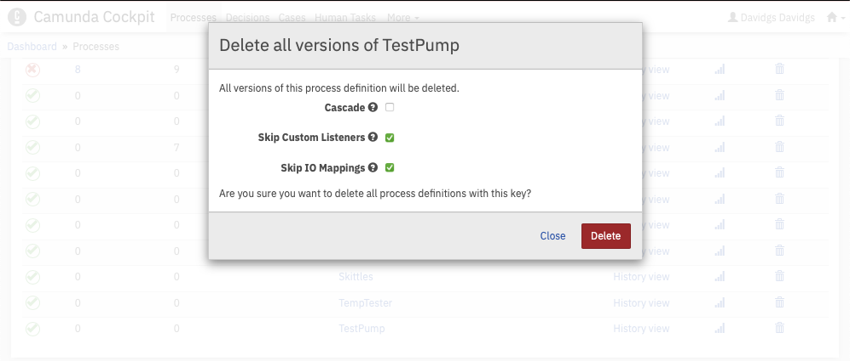
Cockpit Delete process
Now it’s time to actually start the process of deleting the process. Click the ‘Cascade’ button, just to be safe. You want to make sure you get everything the first time.
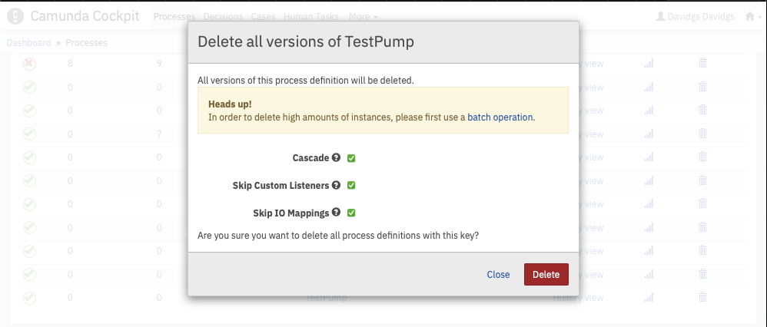
Cockpit Delete Process Cascade
We can safely ignore the “Batch Process” warning message, since of course there are no running instances of the process. Right? RIGHT??!! Of course, because you already said you were no longer using it.
Once you hit the delete button, the process will be permanently and irrevocably deleted. This is your very last chance to turn back.
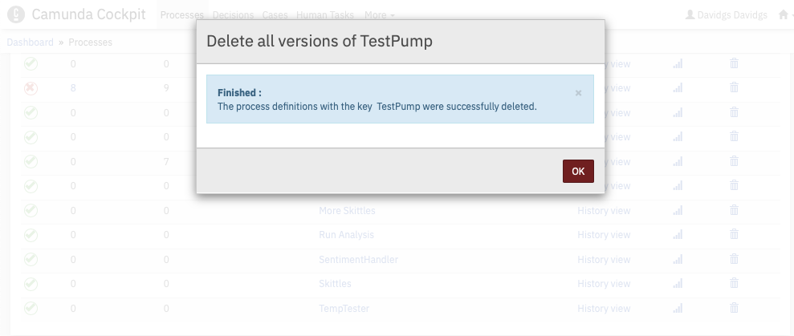
Cockpit delete process cascade
Now that it’s deleted, when you return to your Process list, you will see that the process definition is no longer listed.
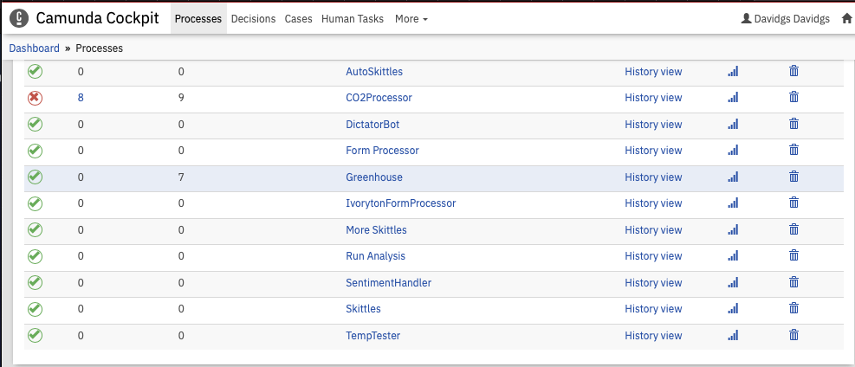
Cockpit porcess list, minus your process
And now it’s gone. Forever. And no, you can’t get it back.

