**Medical Supply Delivery App**

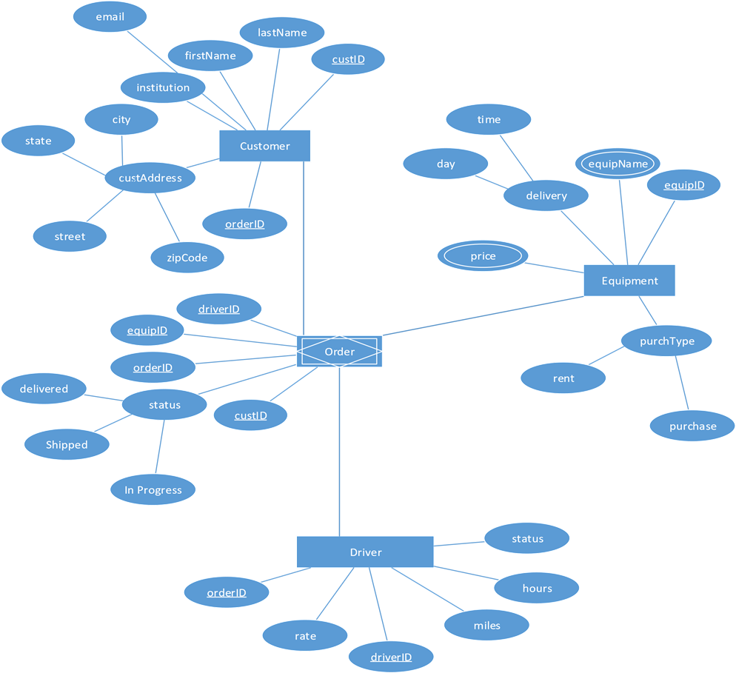

**Accomplishments for the week of February 4, 2019:**

* Navigation menu implemented with connections to other screens
* Database started for customer information through FireBase
* Rough outline of ERD created
* Interface for database started

**Goals for the next two weeks:**

* Finish FireBase database
* Complete interface for database
* Make database information printed to application screen