NN for Images – Ex2

David Guedalia

1. **Practical Task**
   1. **Auto-Encoding**

* On this Section I tried different architecture, with different of convolution layers and change the inner dimensions and finally I decide to go forward with this architecture:

The first net which is the Encoder and one for the Decoder, I decided that the encoder will contain three convolution layers, and two fully connect as I saw it gives performance that are good enough, Also I found that batch nor, layer improving the performance that make regularizes, as we saw in class the Decoder has the same architecture but in inverse order. Also, I used ReLU as the activation function, except of the last activation on the decoder that I used Sigmoid.

* On this section I tried the architecture on different dimension $d$ as the latent.

Where the sizes were $d$ $∈\left\{2, 5, 10, 15, 20, 25, 30,\right\}$

And I concluded that the performances are well when $d=10$ and that why I chose it, and if $d>10$ the improvement is much smaller and less significant.

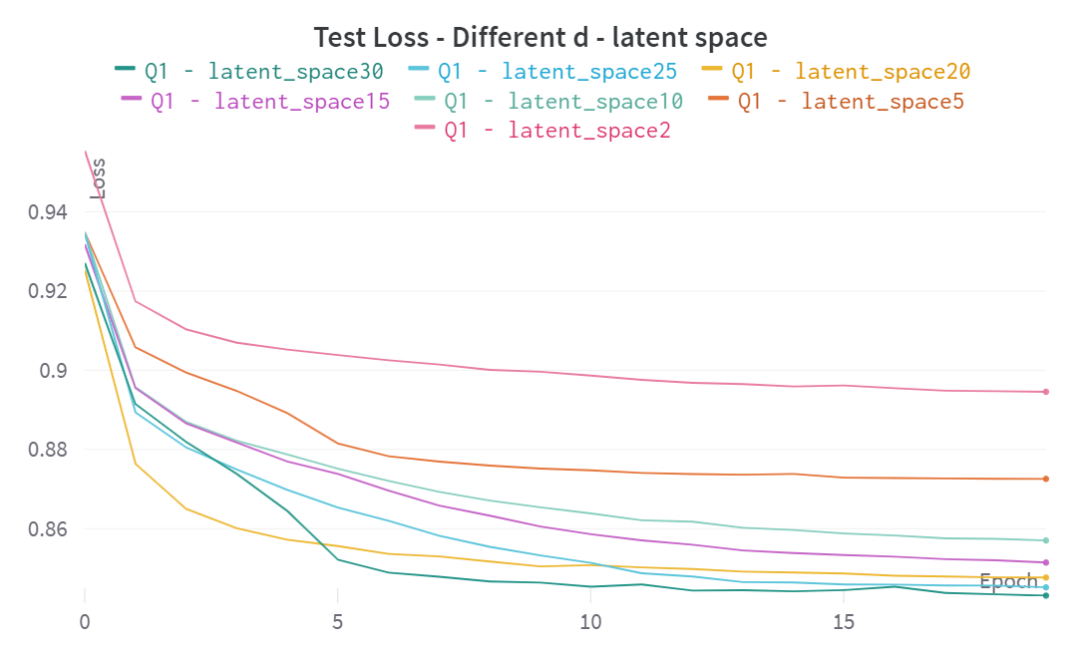

* I chose to work with MSE as the function loss and with this function I trained the model.
* Also, I decided to add on the output of the Decoder the activation function, Sigmoid, as to let the model make the pixels to be more significant, because the modt of pixels in dataset are strongly black or white.
* I compared different architecture where **Deep** is with four convolution and the **heavy** is with bigger weights.

* 1. **Interpolation**

On this section after I trained the autoencoder, I interpolate between two different digits where I chose $αϵ(0, 1)$

1. I add interpolate between two digits:

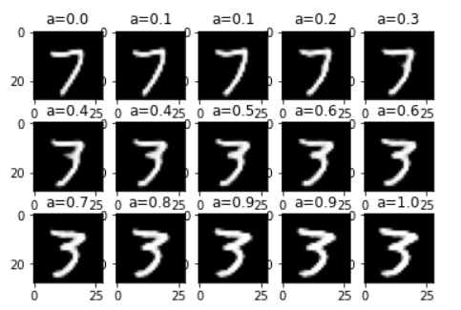

1. Different pairs of digits:

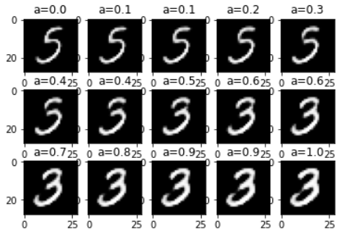

1. When I tried to use higher dimension where .

1. Why the quality does not increase:

After several times I tried with $d\sim 20$ and I saw the results didn’t get better and that's because as much $d$ is getting bigger there is more noise on the image and that’s why I get better performances for .

* 1. **Decorrelation**

In this section, I decided to look on the highest absolute value of the correlation matrix, I calculate this with the average of the all matrix in the dataset, where I trained over $\sim 3300$.

I expected to see that as much the latent space $d$ is bigger the highest absolute value of the correlation matrix is getting higher also, and I think it's because when $d$ is low we won't keep dependent variables.

I add a plot of the trend in correlation versus :

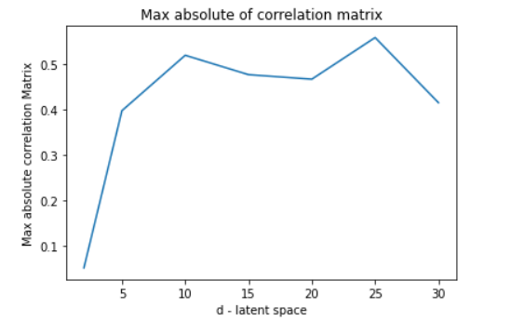

* 1. **Transfer Learning**

On this section I used the trained encoders from the first question and I connect them a MLP net that make a classification.

One time the weights of the Encoder were trained and second time only MLP net were trained, I chose the loss function to be entropy loss.

And after we tried on small data $\sim 80$.

And this is the results I got:

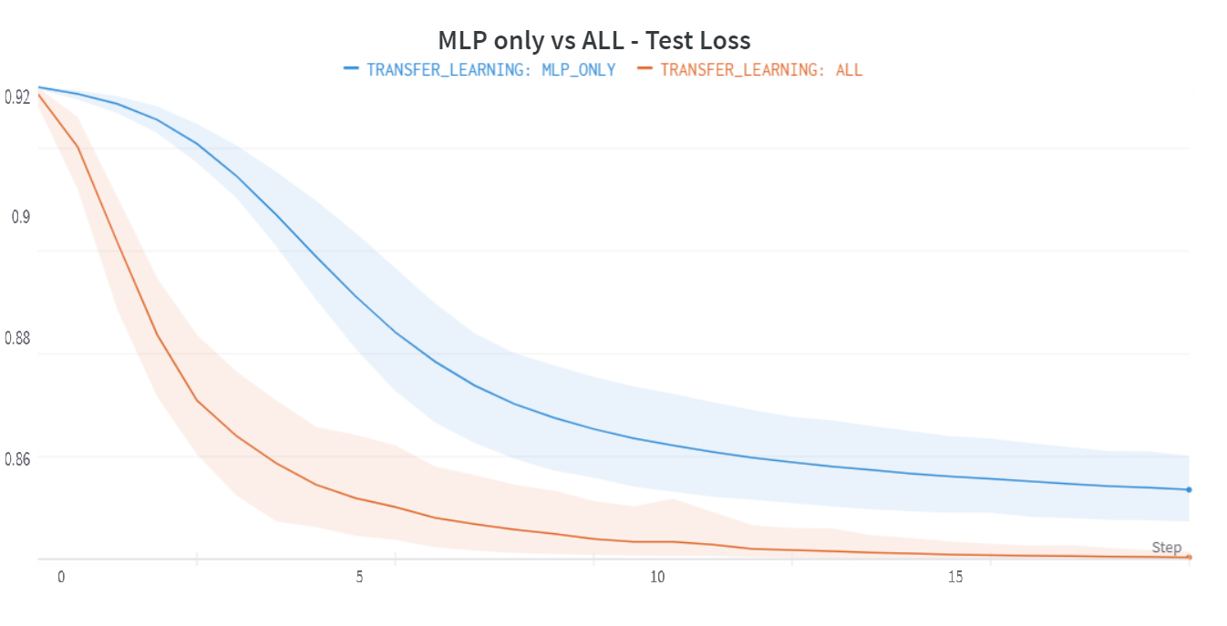

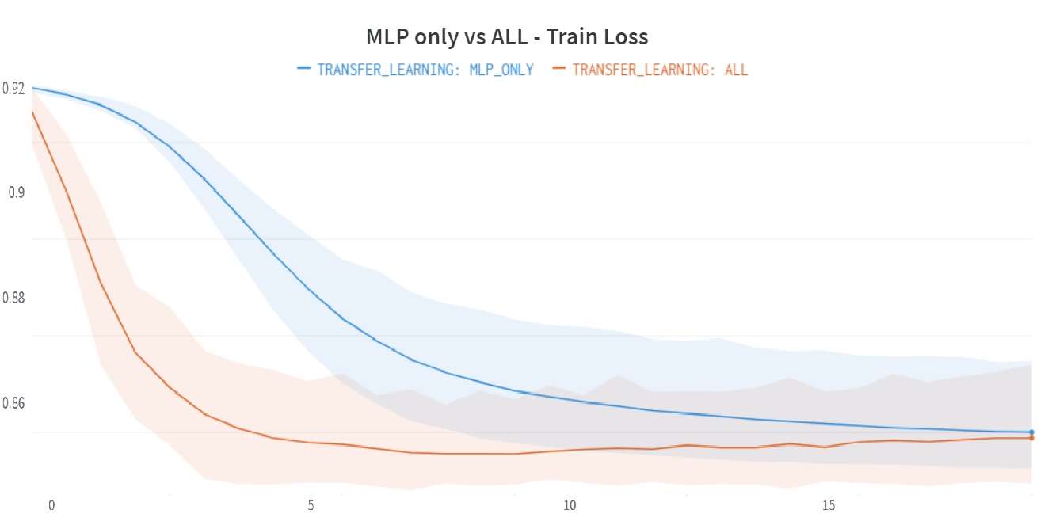

From these graphs we can obtain that when the weights of the encoder are trained, we getting faster to overfit, also after $\sim 15$ epochs the test getting higher, also after try several $d$ I got that I get the best performance for $d\sim 10$.

I saw it also on the accuracy where it was almost 1 on the accuracy and $\sim 0.84$.

And the others model where better on the test although they got worse on the train.