NN for Images – Ex4

David Guedalia Erez Badash,

**Programming Task**

In this section we used pretrained StyleGAN, wikiArt, as a generator.

We modify style the style of a content image to match the target style, for that we used two techniques:

1. **Style Mixing Mechanism**

We insert the W vector of the content image to the first half layers of the StyleGAN and we used the W vector of style image to the other layers of the StyleGAN.  
The first layers of the StyleGAN are responsible for the semantic and geometric details of the image and last layers are responsible for the fine details and the shade of the image color (As you can see in our output results).  
We chose to this division (exactly at the middle) because in our opinion it gives the best results.

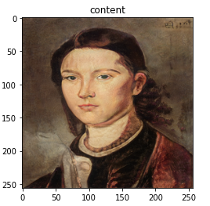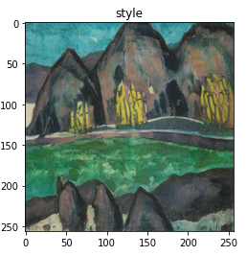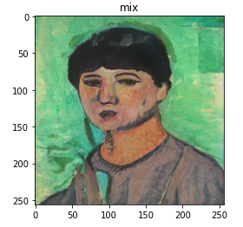

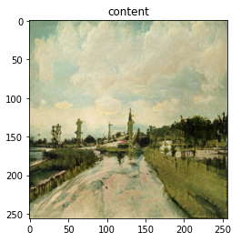 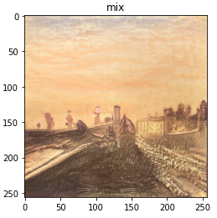

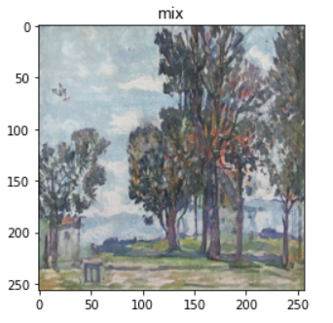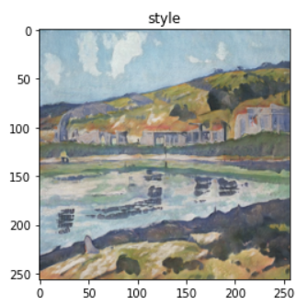

1. **Optimization of W+**

First, we initialized W vector to be the w vector of the content image, we used this initialization for faster converges (the synthetic image is already minimized the content loss) and we saw in that way that the content image's semantic and geometric features are preserves much better this way.

After that we optimized W parameters (in all layers) based on the style loss (with Gram matrixes) and content loss based on the VGG19 model features.

We also used hyperparameter to control the balance of the style and content of the resulted image, each pair of content and style images got different value of this hyperparameter according to our opinion (if we thought that the resulted image needs to get more of the style image's style or the image needs to preserve more the content features).

The result of this process is:

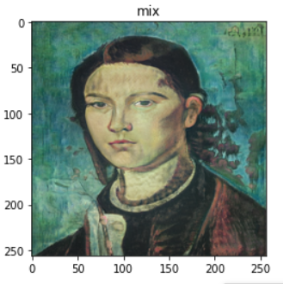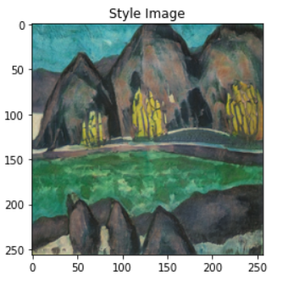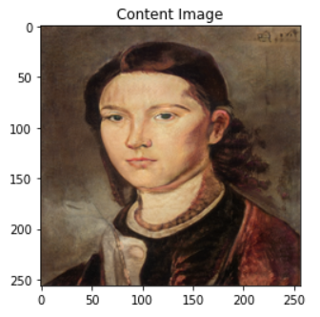

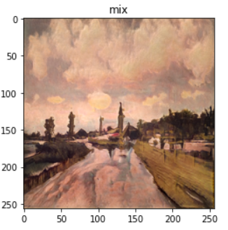 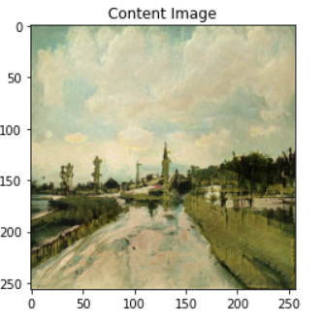 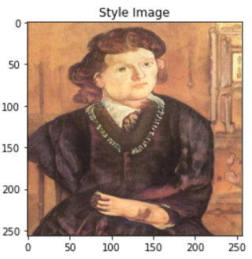

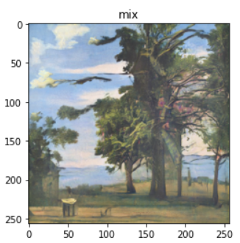 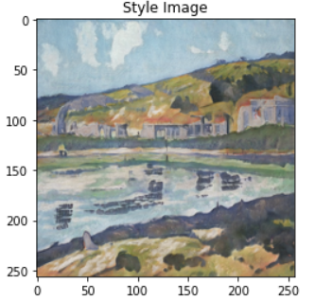

**Comparation**

In our opinion the optimization of W+ gave the best results, the result images look smoother, the geometric and semantic features of the content image are more preserved and still it has the style of the style image.

The reason for that is that in the style mixing mechanism we are limited to a solution in which we choose which W we need to insert to each layer.

And in the optimization on W+ mechanism we have no limitation on the W vector so we don’t need to choose a sharp transition between inputs of the layers of the StyleGAN.  
Also, every solution of the first mechanism can be achieved from the second mechanism (We can even use it be the initialization of the second mechanism), so we expect much better result from the second mechanism.