David Hariprashad

CSCI 381 – Genetic Algorithms

Code Manual

Input file

Example:

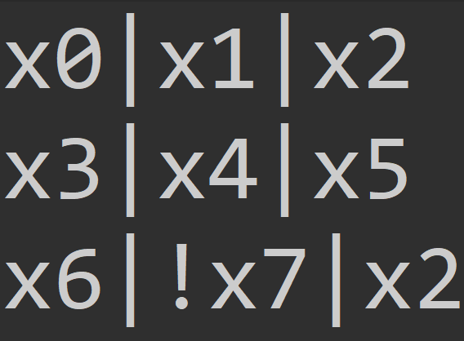

Note: A bad input file would have a blank line at the end of the file.

* Each line has three expressions separated by pipes.
* Each of those expressions has an optional ‘!’ operator and a literal.
* Each literal is ‘x’ followed by an unsigned integer to identify it.

Output file

Example:

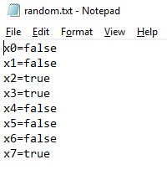

The output file describes the best solution found by the algorithm.

Default Parameters

SAT3

If only one parameter is passed to the program, default output filenames will be used.

*FILENAME_BRUTE* = new String("brute.txt");

*FILENAME_RANDOM* = new String("random.txt");

*FILENAME_GENETIC* = new String("genetic.txt");

RandomAlgorithm

final private static long ***DEFAULT_ITERATIONS*** = 1000000L;

final private static double ***ENTROPY*** = 0.5;

GeneticAlgorithm

final private static int ***DEFAULT_POPULATION_SIZE*** = 20;

final private static long ***DEFAULT_ITERATIONS*** = 1000000;

final private static double ***DEFAULT_CROSSOVER_RATE*** = 0.75;

final private static double ***DEFAULT_MUTATION_RATE*** = 0.02;