Housing prices are Big O of location. In virginia proximiy to areas of high-teck. Proximity to Washington D.C. 40 miles south --- 800K Arlington

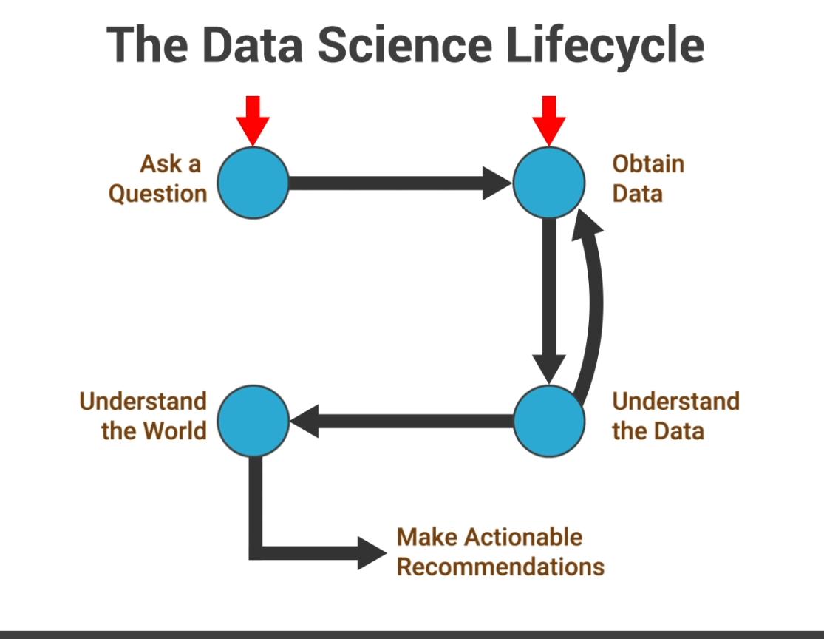

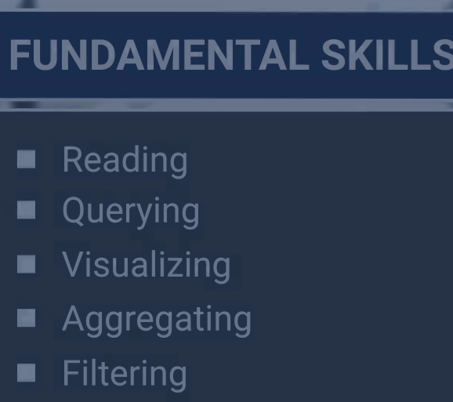
CRISP-DM Framework
Business Understanding and Preparation
- Business Understanding
- Data Understanding
- Data Preparation
Modeling
Evalutation
- Deployment

Why Is CRISP-DM Important to a Data Scientist?
Among a variety of other reasons, the CRISP-DM framework is important to data scientists because it:
- Includes several processes that take care of simple data-mining tasks
- Promotes best practices and facilitates the replication of projects
- Provides a uniform framework for planning and managing projects
- Is a cross-industry standard to be used by any data science project, regardless of its domain
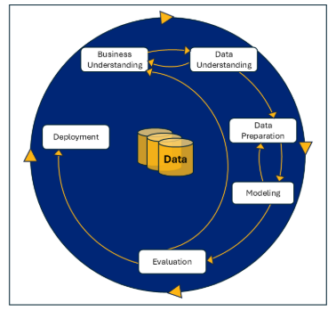

Background

The crisp-dm methodology is new to me. Some research triage revealed a good UTube video[1] discussing its history and criticism, which cited the original 75 page DISP-DM 1.0 documentation [2] *. One of the most prevalent topics of discussion, which is reflected in educational journals is how the waterfall approach prevalent in the 1990’s can be adapted for today’s agile practices [3][4]. Recent publications discuss how it can be used for machine learning [5].

Use Case
I was able to support a data-science project for several years, and the crisp-dm was never mentioned the data-scientists. Adding rigor to the data preparation process would be a welcome addition and give everyone more assurance of the validity of the data and its predictions.
Strengths and Weaknesses
In my work environment, all software development practices some variation of Scrum. Management understands the scrum process, sprints, burn down charts and periodic demos. The exhaustive waterfall DISP-DM process would then need to be modified for SCRUM. The business purpose of data exploration would be predetermined by management, and data scientist would quickly need to determine if the data is well suited for their questions. Modeling and deployment might initially be a presentation, but upon determine its validity be passed on the enterprise deployment into an interactive tool accessible by others. Most often this is a cloud based web project, so full deployment can very expensive.

* The original DIPM-DM guide from 1990 is hard to come by using conventional search, but the 1999 DISPM 1.0 is more frequently cited[3]. IBM seems to be actively taking on the role of the DISPM consortium with documentation[6] and certification classes[7]

- Brown, Meta, Crisp-DM The Dominant Process for Data Mining, PyData London June 2015 YouTube,
- Chapman, Clinton, Kerber, Khabaza , Reinartz Shearer, Wirth CRISP-DM 1.0, 1999 CRISP-DM consortium, NCR, DaimlerChrysler, SPSS, OHRA Bank Group Download
- Shimaoka, A M, Ferreira, R C & Goldman, A 2024, 'The evolution of CRISPDM for Data Science : Methods, processes and frameworks', SBC Reviews on Computer Science, vol. 4, no. 1, pp. 28-43. https://doi.org/10.5753/ reviews.2024.3757, Link
- Andre Massahiro Shimaok, Renato Cordeiro Ferreir, Alfredo GoldmanIntegrating CRISP-DM and eXtreme Programming in Agile Data Science Projects, Tilburg University July 2025 Link
- Singh, Vivek, Singh Anshuaman, Joshi Kailash, Fair CRISP-DM: Embedding Fairness in Machine Learning (ML) Development Life Cycle, Proceedings of the 55th Hawaii International Conference on System Sciences | 2022 Link
- IBM Coursera “Data Science Methodology”
- IBM, CRISP-DM Help Overview 2021 Link

LIST

1) Lightbulb in the aroma light
2) Set up the toe light

