Database Export Report
MasterAntiqueRepair: SQL Server to Oracle
Sanitized Oracle schema and data export
EXPORT COMPLETE
8 tables | 156 rows | credentials sanitized for 12 users | Oracle AI Database 26ai (version 23+)

Run date (UTC): 2026-09-30 08:36:58
Source: (localdb)\MSSQLLocalDB, database aspnet-MasterAntiqueRepair-e93a6129-7f74-4486-97e8-8d4ab1a709b4
Source version: Microsoft SQL Server 2025 (RC1) - 17.0.925.4 (X64)
Tooling version: git commit 7b2b1fa
Contents
1. Executive summary
2. Scope and method
3. Results at a glance
4. Table inventory
5. Schema
6. Business-level summaries
7. Credential sanitization
8. Known differences and exclusions
9. Reproducibility and hand-off
Appendix A. Full row hashes

1. Executive summary
The MasterAntiqueRepair SQL Server database was exported into Oracle-specific files: a schema file (01-schema.sql), a data file (02-data-sanitized.sql) and a metadata file (source-metadata.json) describing the source. All 156 rows across 8 tables were exported. Password hashes and security stamps were blanked before anything was written, so no credential exists in any output file.
This tool only exports. It does not load or check a Oracle database; that is import-oracle, which reads these files on a Linux machine, creates a Oracle database in a Docker container, and verifies it against the metadata described here. Everything in this report was produced by a deterministic script, not by a language model.
Measure | Value | Status
Tables exported | 8 | PASS
Rows exported | 156 | PASS
Users with credentials sanitized | 12 | PASS
Case-insensitive duplicate active usernames | none | PASS

2. Scope and method

What was exported
All application tables in the source database: Roles, Users, AuditLogs, Tickets, Comments, UserClaims, UserLogins, UserRoles. The structure (columns, primary keys, foreign keys with cascade rules, indexes including the filtered unique index that lets a deleted user's name be reused, defaults and auto-number counters) and every row were carried across. The Entity Framework bookkeeping table (__MigrationHistory) was intentionally not exported.

How it was produced
- The tool reads SQL Server's own description of itself (tables, columns, keys, indexes, defaults, counters) and every row, and converts each value to one agreed text form.
- Credentials are blanked in memory before anything is rendered, so an unsanitized data file never exists, not even briefly.
- The Oracle schema and data files are then written from that same sanitized in-memory copy. Identifiers become lowercase snake_case; data values are never lowercased.
- The metadata file records what the source looked like at export: structure, row counts, a SHA-256 per table over the sanitized rows, the answers to ten business questions, and the SHA-256 of the two SQL files. It is computed from the in-memory rows, not from the SQL text, so it is an independent record that import-oracle can check the loaded database against.
- A self-test proves the tooling: two exports are byte-identical, no credential value appears in any output file, the tool refuses to export unsanitized data, row counts match a live count of the source, and this report rebuilds byte-identically.

3. Results at a glance
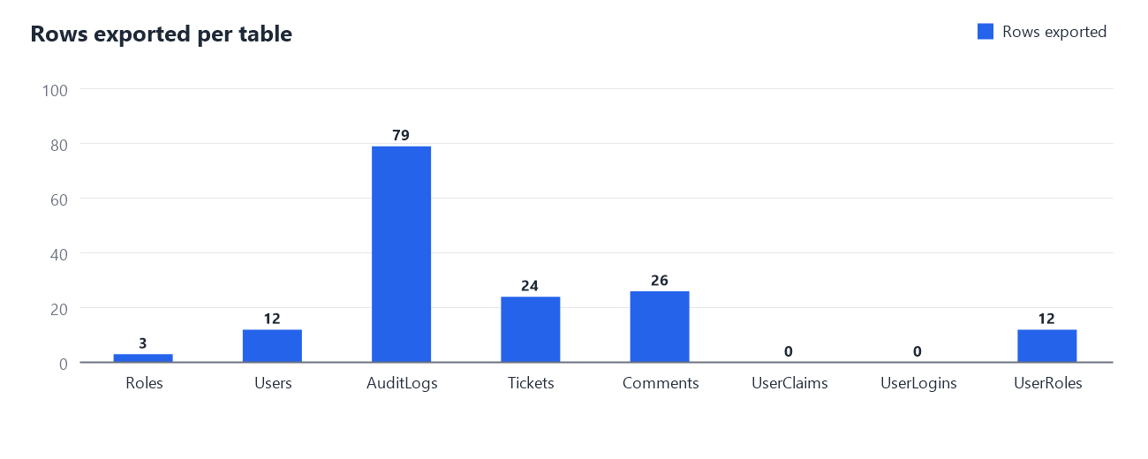
Figure 1. Number of rows exported from each table.

4. Table inventory
Source table | Oracle table | Rows | Last identity | Row hash (SHA-256, first 16)
Roles | roles | 3 | 3 | c0a2efd128356144
Users | users | 12 | 12 | fa415e1421e2d4a8
AuditLogs | audit_logs | 79 | 79 | 812ce44474626ebe
Tickets | tickets | 24 | 24 | c34f64ec58233df7
Comments | comments | 26 | 26 | c954517fcb3a64cb
UserClaims | user_claims | 0 | - | e3b0c44298fc1c14
UserLogins | user_logins | 0 | - | e3b0c44298fc1c14
UserRoles | user_roles | 12 | - | 44553a2bae5a2d40

The hash is computed over all rows of the table in a fixed, database-independent form (Appendix A lists the full values). import-oracle recomputes it from the Oracle database it builds. An empty table hashes the empty string (e3b0c442...).

5. Schema
Identifiers are lowercase snake_case in the SQL; Oracle stores them in upper case. Column types are the Oracle types the schema file declares. The users table also carries one column that does not exist in the source: must_reset_password (see section 7).

Roles -> roles
Column (source -> Oracle) | Type | Nullable | Default | Notes
Id -> id | NUMBER(10) | NOT NULL |  | identity
Name -> name | VARCHAR2(256 CHAR) | NOT NULL

Users -> users
Column (source -> Oracle) | Type | Nullable | Default | Notes
Id -> id | NUMBER(10) | NOT NULL |  | identity
Name -> name | VARCHAR2(256 CHAR) | NOT NULL
CreatedAt -> created_at | TIMESTAMP(3) | NOT NULL
PasswordHash -> password_hash | CLOB | yes
Discriminator -> discriminator | VARCHAR2(128 CHAR) | NOT NULL
DeletedAt -> deleted_at | TIMESTAMP(3) | yes
Email -> email | VARCHAR2(256 CHAR) | yes
EmailConfirmed -> email_confirmed | BOOLEAN | NOT NULL | FALSE
SecurityStamp -> security_stamp | CLOB | yes
PhoneNumber -> phone_number | CLOB | yes
PhoneNumberConfirmed -> phone_number_confirmed | BOOLEAN | NOT NULL | FALSE
TwoFactorEnabled -> two_factor_enabled | BOOLEAN | NOT NULL | FALSE
LockoutEndDateUtc -> lockout_end_date_utc | TIMESTAMP(3) | yes
LockoutEnabled -> lockout_enabled | BOOLEAN | NOT NULL | FALSE
AccessFailedCount -> access_failed_count | NUMBER(10) | NOT NULL | 0
MustResetPassword -> must_reset_password | BOOLEAN | NOT NULL | FALSE | added by sanitization

AuditLogs -> audit_logs
Column (source -> Oracle) | Type | Nullable | Default | Notes
Id -> id | NUMBER(10) | NOT NULL |  | identity
Timestamp -> timestamp | TIMESTAMP(3) | NOT NULL
UserId -> user_id | NUMBER(10) | NOT NULL
Action -> action | NUMBER(10) | NOT NULL
EntityType -> entity_type | NUMBER(10) | NOT NULL
EntityId -> entity_id | NUMBER(10) | NOT NULL

Tickets -> tickets
Column (source -> Oracle) | Type | Nullable | Default | Notes
Id -> id | NUMBER(10) | NOT NULL |  | identity
State -> state | NUMBER(10) | NOT NULL
Description -> description | VARCHAR2(2000 CHAR) | yes
User_Id -> user_id | NUMBER(10) | yes
Customer_Id -> customer_id | NUMBER(10) | yes
SubmittedDate -> submitted_date | TIMESTAMP(3) | yes
AssignedDate -> assigned_date | TIMESTAMP(3) | yes
CompletedDate -> completed_date | TIMESTAMP(3) | yes

Comments -> comments
Column (source -> Oracle) | Type | Nullable | Default | Notes
Id -> id | NUMBER(10) | NOT NULL |  | identity
UserId -> user_id | NUMBER(10) | NOT NULL
TicketId -> ticket_id | NUMBER(10) | NOT NULL
Text -> text | VARCHAR2(2000 CHAR) | yes
CreatedAt -> created_at | TIMESTAMP(3) | NOT NULL

UserClaims -> user_claims
Column (source -> Oracle) | Type | Nullable | Default | Notes
Id -> id | NUMBER(10) | NOT NULL |  | identity
UserId -> user_id | NUMBER(10) | NOT NULL
ClaimType -> claim_type | CLOB | yes
ClaimValue -> claim_value | CLOB | yes

UserLogins -> user_logins
Column (source -> Oracle) | Type | Nullable | Default | Notes
LoginProvider -> login_provider | VARCHAR2(128 CHAR) | NOT NULL |  | primary key
ProviderKey -> provider_key | VARCHAR2(128 CHAR) | NOT NULL |  | primary key
UserId -> user_id | NUMBER(10) | NOT NULL |  | primary key

UserRoles -> user_roles
Column (source -> Oracle) | Type | Nullable | Default | Notes
UserId -> user_id | NUMBER(10) | NOT NULL |  | primary key
RoleId -> role_id | NUMBER(10) | NOT NULL |  | primary key

Foreign keys
Table | Constraint | References | On delete
audit_logs | fk_audit_logs_users_user_id | (user_id) -> users (id) | CASCADE
tickets | fk_tickets_users_customer_id | (customer_id) -> users (id) | NO ACTION
tickets | fk_tickets_users_user_id | (user_id) -> users (id) | NO ACTION
comments | fk_comments_tickets_ticket_id | (ticket_id) -> tickets (id) | CASCADE
comments | fk_comments_users_user_id | (user_id) -> users (id) | CASCADE
user_claims | fk_user_claims_users_user_id | (user_id) -> users (id) | CASCADE
user_logins | fk_user_logins_users_user_id | (user_id) -> users (id) | CASCADE
user_roles | fk_user_roles_roles_role_id | (role_id) -> roles (id) | CASCADE
user_roles | fk_user_roles_users_user_id | (user_id) -> users (id) | CASCADE

Indexes
Table | Index | Unique | Key | Filter
roles | ix_roles_name | unique | name
users | ix_users_name_active | unique | CASE WHEN deleted_at IS NULL THEN LOWER(name) END | WHERE deleted_at IS NULL
audit_logs | ix_audit_logs_user_id |  | user_id
tickets | ix_tickets_customer_id |  | customer_id
tickets | ix_tickets_user_id |  | user_id
comments | ix_comments_ticket_id |  | ticket_id
comments | ix_comments_user_id |  | user_id
user_claims | ix_user_claims_user_id |  | user_id
user_logins | ix_user_logins_user_id |  | user_id
user_roles | ix_user_roles_role_id |  | role_id
user_roles | ix_user_roles_user_id |  | user_id

ix_users_name_active is the important one: Oracle has no partial index, so it is a unique function-based index on CASE WHEN deleted_at IS NULL THEN LOWER(name) END; rows with a deleted_at value produce no key. An account that is soft-deleted keeps its row but frees its user name for reuse, and "Bob" and "bob" cannot both be active. The Filter column above shows the rule the key expression implements.

6. Business-level summaries
Ten business questions were asked of the SQL Server source; the answers are recorded in the metadata so import-oracle can ask the same questions of the Oracle database and compare.
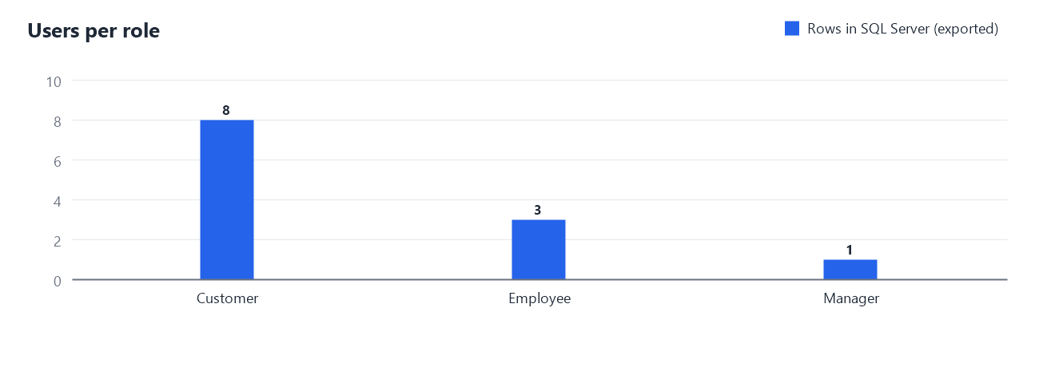
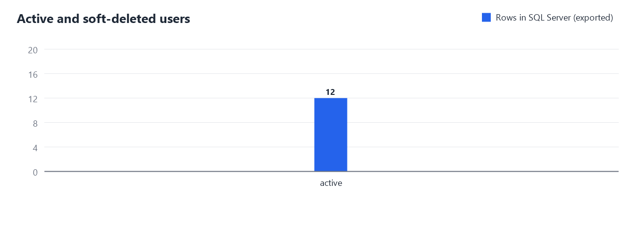
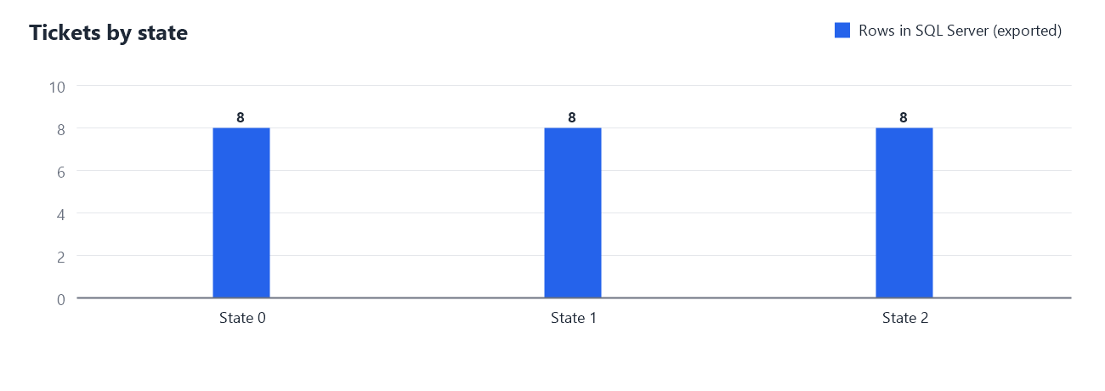
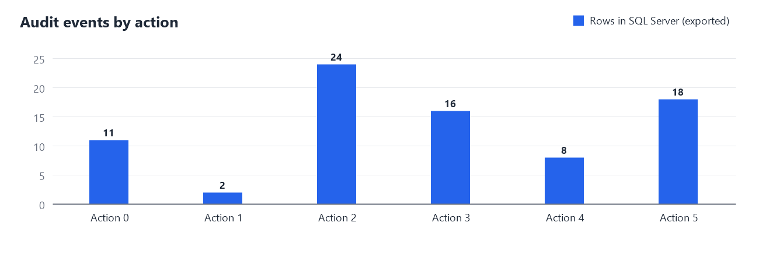
Summary | Answer recorded from the source
Users by type | Customer = 8; Employee = 3; Manager = 1
Users active vs soft-deleted | active = 12
Users per role | Customer = 8; Employee = 3; Manager = 1
Tickets by state | 0 = 8; 1 = 8; 2 = 8
Tickets assigned vs unassigned | assigned = 16; unassigned = 8
Audit events by action | 0 = 11; 1 = 2; 2 = 24; 3 = 16; ...
Comments per ticket (distribution) | 3 = 6; 4 = 2
Comment and commented-ticket totals | 26 = 8
Ticket date ranges | 2026-09-07 08:20:34 | 2026-09-16 08:39:18 | 2026-09-07 11:26:34 | 2026-09-14 10:16:58 | 2026-09-11 00:13:34 | 2026-09-17 14:15:58
Account and audit date ranges | 2026-09-10 14:41:58 | 2026-09-11 16:41:58 | 2026-09-07 08:20:34 | 2026-09-30 03:07:32

7. Credential sanitization
Every users row had its password hash and security stamp set to NULL, and a new must_reset_password column set to true. This is a deliberate one-time-bootstrap policy: forcing a password reset at first login means no usable legacy credential is carried into the target at all (docs/phase1/dbmigrate/DATA_MIGRATION.md 5.2). Nothing else in the users table, or in any other table, was changed.
Check | Result
All users have a NULL password_hash and security_stamp | PASS
All users have must_reset_password = true | PASS
No duplicate active username, ignoring case | PASS

The self-test additionally scans every output file for every original credential value read from the source and finds none.

8. Known differences and exclusions
- The Entity Framework migration history table (__MigrationHistory) is not exported; it only describes the SQL Server schema history and has no meaning in Oracle.
- The SQL Server "dbo" schema prefix is dropped.
- Identifiers are lowercase snake_case in the SQL (for example CreatedAt becomes created_at; User_Id becomes user_id) and Oracle stores them in upper case; foreign key and index names are renamed too. Data values are never lowercased.
- datetime columns become TIMESTAMP(3) without time zone and keep the source values exactly; it is not known whether the legacy application stored UTC or local times (only LockoutEndDateUtc is UTC by name), so no zone conversion is made.
- SQL Server compared text case-insensitively; Oracle is case-sensitive. Username uniqueness is enforced case-insensitively by a function-based unique index on CASE WHEN deleted_at IS NULL THEN LOWER(name) END (Oracle has no partial index), so authentication must compare LOWER(name) = LOWER(input). Role names use a plain case-sensitive unique index.
- bit columns become the native BOOLEAN type (Oracle 23ai and later; not available on 19c); the identity columns become GENERATED BY DEFAULT AS IDENTITY and the data supplies explicit ids (each identity is restarted after the last issued value once the data is loaded).
- Oracle stores an empty string as NULL. The export refuses a source that contains an empty string (there is none), because loading it would silently turn it into NULL.
- ON DELETE NO ACTION is written by leaving the clause out: Oracle rejects the words, and its default already means no action.
- nvarchar(n) becomes VARCHAR2(n CHAR): the length is in characters, but a VARCHAR2 value is also limited to 4000 bytes unless the database has MAX_STRING_SIZE=EXTENDED, so multi-byte text near the limit can overflow.
- The SQL files are pure ASCII: control characters are written as CHR(n) and non-ASCII characters as UNISTR('\XXXX'), so loading does not depend on the client character set.
- Index names that were duplicated across tables in SQL Server (for example IX_UserId) were prefixed with the table name, then renamed to snake_case.
- The single users table keeps its "discriminator" column (Customer / Employee / Manager) unchanged.

9. Reproducibility and hand-off
From a Windows command prompt in the repository root:
tools\phase1\dbmigrate\export-oracle\export-oracle.cmd all --target oracle
runs export, the tooling self-test and this report. Individual steps: export, selftest, report.
Item | Value
Tooling git commit | 7b2b1fa
Source server | Microsoft SQL Server 2025 (RC1) - 17.0.925.4 (X64)
Run time (UTC) | 2026-09-30 08:36:58
01-schema.sql SHA-256 | 1882e31d2963b5435dd99801193e70ed7eb408646ee8ba6ca3b899fd869e159a
02-data-sanitized.sql SHA-256 | 64602aebd2351b79889890b0ae4f9c429bc2018ac4c04654e2349ff1e6d62578

Hand-off to import-oracle: after a successful export, copy 01-schema.sql, 02-data-sanitized.sql and source-metadata.json into tools\phase1\dbmigrate\import-oracle\input\ and commit them. import-oracle (Linux, Docker) reads only that folder. See docs/phase1/dbmigrate/import-oracle/README.md.

Appendix A. Full row hashes
SHA-256 over all rows of each table in the canonical form (rows sorted by their canonical text, joined by line feeds, hashed as UTF-8), computed from the sanitized rows at export.
Table | Rows | SHA-256
Roles | 3 | c0a2efd12835614432929f984bc5568f  0bef002000c247946417e4131f582b14
Users | 12 | fa415e1421e2d4a8ba921f6c7b488354  a8d9de3c06bd754b4b74bb47cc50cf94
AuditLogs | 79 | 812ce44474626ebe36093b66246f9410  72c87b0dbdcf7d4d4325be32a0fc4423
Tickets | 24 | c34f64ec58233df74a39c63e0b2c15c7  a3cc751e747cc9a68f55a3ee6e164711
Comments | 26 | c954517fcb3a64cbb6fa5e8bc5f1619e  e7a64453bc80bfcf1783d9845d4a72ea
UserClaims | 0 | e3b0c44298fc1c149afbf4c8996fb924  27ae41e4649b934ca495991b7852b855
UserLogins | 0 | e3b0c44298fc1c149afbf4c8996fb924  27ae41e4649b934ca495991b7852b855
UserRoles | 12 | 44553a2bae5a2d4035a03bfd1d63a239  e33929a4dd668d4687cacdfa44308007

