Database Migration Verification Report
MasterAntiqueRepair: SQL Server to SQLite
Iteration 1 - SQLite on Windows
VERIFICATION PASSED
42 of 42 checks passed | 155 of 155 rows verified identical | 8 tables

Run date (UTC): 2026-09-24 09:36:10
Source: (localdb)\MSSQLLocalDB, database aspnet-MasterAntiqueRepair-e93a6129-7f74-4486-97e8-8d4ab1a709b4
Target: SQLite masterantique.sqlite, sqlite3 3.53.4
Tooling version: git commit dde75c0
Contents
1. Executive summary
2. Scope and method
3. Results at a glance
4. Data verification in detail
5. Schema and integrity
6. Business-level summaries
7. Behaviour tests and tooling self-test
8. Differences found
9. Intentional exclusions and known differences
10. Reproducibility
11. Sign-off
Appendix A. Full row hashes

1. Executive summary
The MasterAntiqueRepair SQL Server database was exported and loaded into a new SQLite database. Every check passed. All 155 rows across 8 tables in the source were found in the SQLite copy with identical content, the schema objects (tables, columns, keys, foreign keys, indexes) match, and the database rules that the application depends on still work in the copy.
Everything in this report was produced by a deterministic script, not by a language model: the same source database always produces the same export files, and the same verification results always produce the same report.
Measure | Source (SQL Server) | Target (SQLite) | Result
Tables | 8 | 8 | PASS
Rows in all tables | 155 | 155 | PASS
Rows verified identical, field by field | 155 | 155 | PASS
Checks passed | 42 | 42 | PASS

2. Scope and method

What was migrated
All application tables in the source database: Roles, Users, AuditLogs, Tickets, Comments, UserClaims, UserLogins, UserRoles. The table structure, primary keys, foreign keys (including cascade rules), indexes (including the filtered unique index that lets a deleted user's name be reused), default values, auto-increment counters and every row of data were carried across. The Entity Framework bookkeeping table (__MigrationHistory) was intentionally not migrated.

How it was checked
- Row counts: every table is counted in both databases and compared.
- Row content: every value of every row is read from both databases, converted to one common text form, and compared field by field. NULL is distinguished from an empty string, and the way each value is stored (integer, text, binary) is checked too. Special characters, line breaks, quotes and emoji are covered.
- Fingerprints: for each table a SHA-256 hash of all rows is computed on each side. Two identical hashes mean the two sets of rows are identical; any single changed character produces a different hash.
- Schema objects: the structure of the SQLite database is read back and compared with the structure expected from the SQL Server catalog.
- Business summaries: the same query is run on both databases (users by type, tickets by state, and so on) and the answers compared.
- Behaviour tests: rules such as unique active usernames, foreign keys and identity counters are exercised on a throw-away copy of the new database.
- Self-test of the tooling: a second export must be byte-identical to the first, SQLite's own tooling (sqldiff for SQLite, CHECKSUM TABLE for MySQL) must find no differences between two independently loaded copies, and a deliberately damaged copy must be caught and pinpointed.

3. Results at a glance
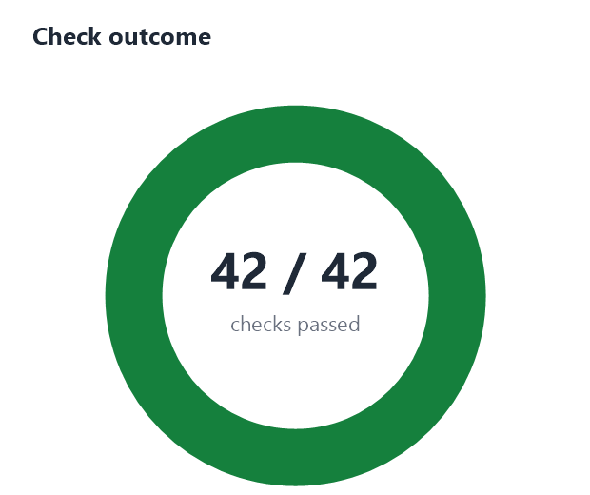
Figure 1. Overall outcome of all 42 checks.
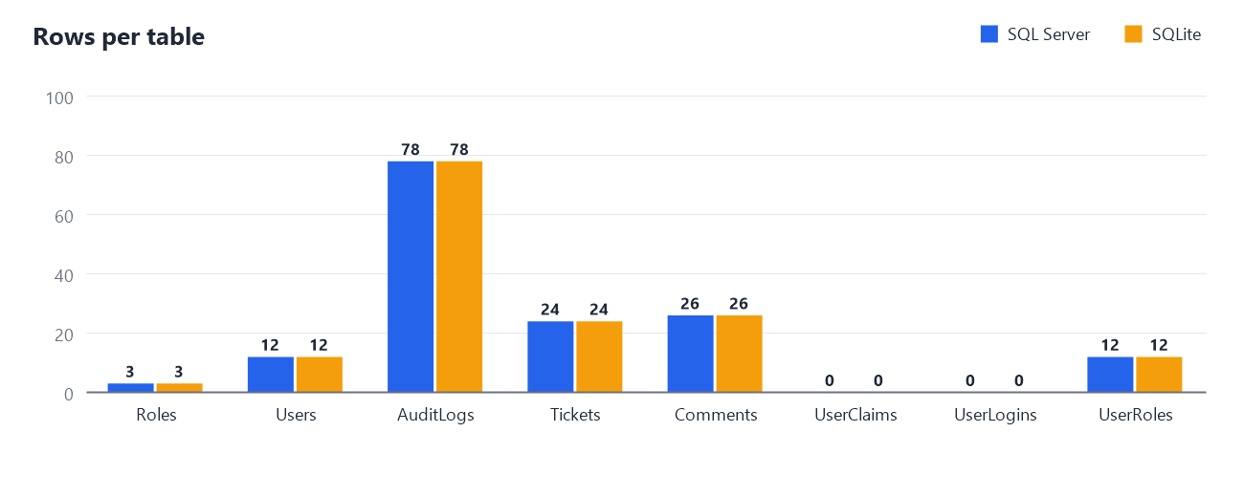
Figure 2. Row count of every table in the source and in the new database.
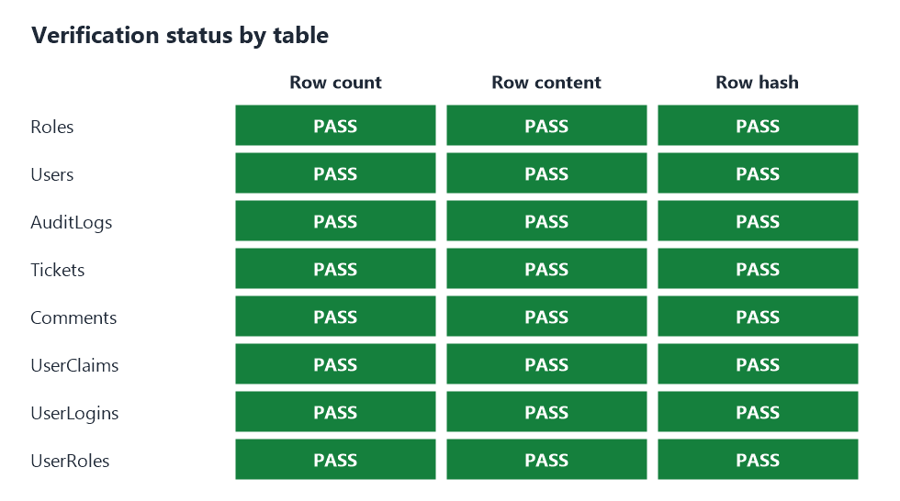
Figure 3. Verification status of each table.

4. Data verification in detail
Table | Source rows | Target rows | Diff | Rows identical | Result | Row hash (SHA-256, first 16)
Roles | 3 | 3 | 0 | 3 | PASS | 083c2efe5cfe6dcb
Users | 12 | 12 | 0 | 12 | PASS | a83eada4f190cd73
AuditLogs | 78 | 78 | 0 | 78 | PASS | f6f5c61f2a17b80f
Tickets | 24 | 24 | 0 | 24 | PASS | 387438d6fd501090
Comments | 26 | 26 | 0 | 26 | PASS | 0f8d22818a8b725a
UserClaims | 0 | 0 | 0 | 0 | PASS | e3b0c44298fc1c14
UserLogins | 0 | 0 | 0 | 0 | PASS | e3b0c44298fc1c14
UserRoles | 12 | 12 | 0 | 12 | PASS | 400a46fd1a653d2b

The hash is computed over all rows of the table in a fixed order. Source and target hashes matched for every table marked PASS; full hashes are listed in Appendix A.

5. Schema and integrity
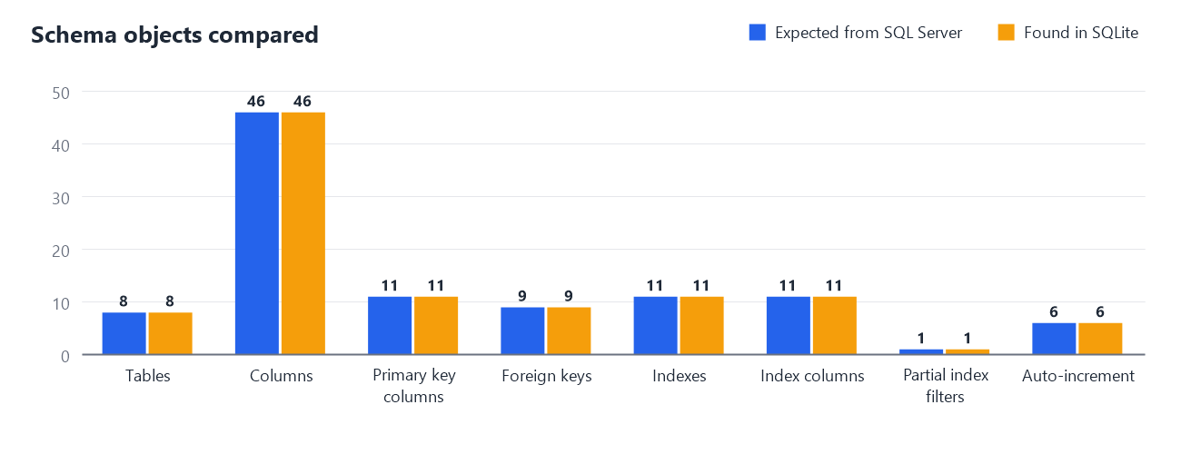
Figure 4. Number of schema objects of each kind, expected from the SQL Server catalog versus found in SQLite.
Check | Expected | Found | Result
Tables | 8 | 8 | PASS
Columns (name, order, type, NOT NULL, PK position, default) | 46 | 46 | PASS
Primary key columns | 11 | 11 | PASS
Foreign keys (column, target, ON DELETE action) | 9 | 9 | PASS
Indexes (name, unique, partial) | 11 | 11 | PASS
Index columns | 11 | 11 | PASS
Partial index filters (e.g. active-username rule) | 1 | 1 | PASS
Auto-increment (identity) tables | 6 | 6 | PASS
SQLite integrity_check | - | - | PASS
SQLite foreign_key_check (orphan rows) | - | - | PASS

6. Business-level summaries
The same question was asked of both databases; the answers must match exactly. The charts below show the answers side by side.
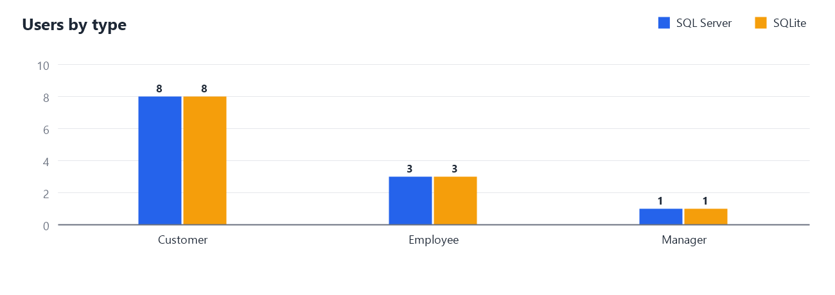
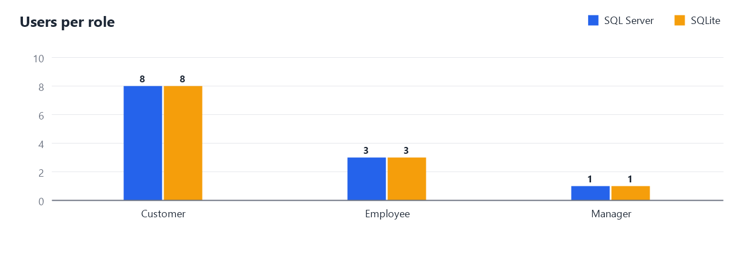
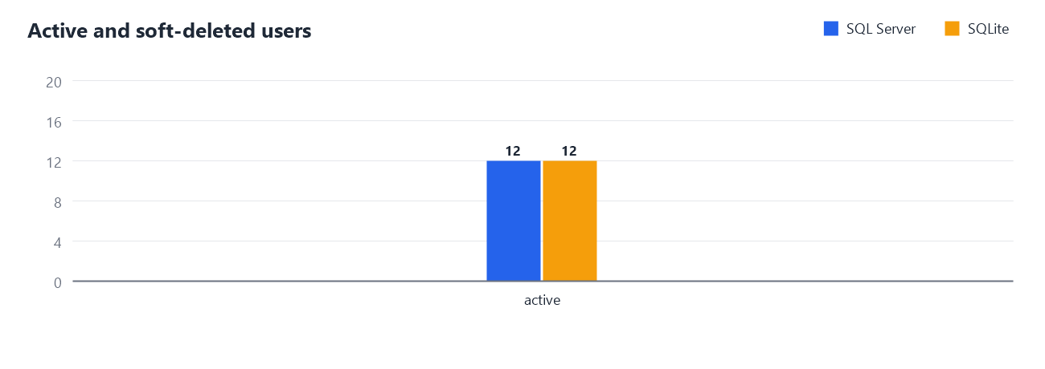
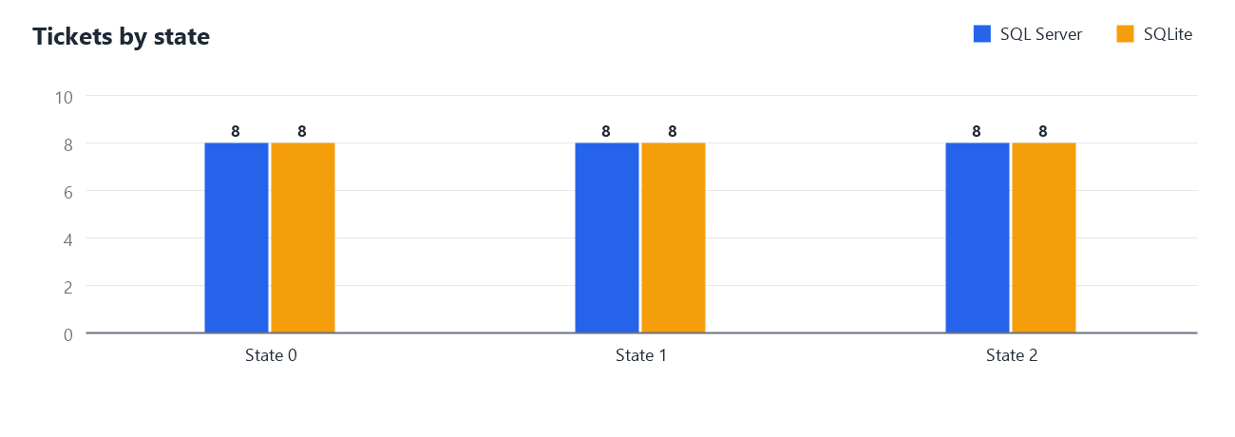
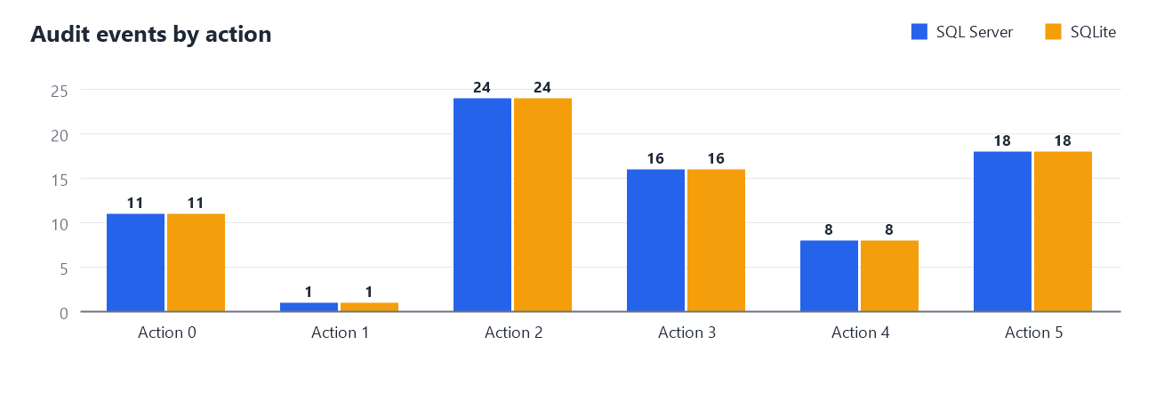
Summary | Answer (source; identical in target when PASS) | Result
Users by type | Customer = 8; Employee = 3; Manager = 1 | PASS
Users active vs soft-deleted | active = 12 | PASS
Users per role | Customer = 8; Employee = 3; Manager = 1 | PASS
Tickets by state | 0 = 8; 1 = 8; 2 = 8 | PASS
Tickets assigned vs unassigned | assigned = 16; unassigned = 8 | PASS
Audit events by action | 0 = 11; 1 = 1; 2 = 24; 3 = 16; ... | PASS
Comments per ticket (distribution) | 3 = 6; 4 = 2 | PASS
Comment and commented-ticket totals | 26 = 8 | PASS
Ticket date ranges | 2026-09-07 08:20:34 | 2026-09-16 08:39:18 | 2026-09-07 11:26:34 | 2026-09-14 10:16:58 | 2026-09-11 00:13:34 | 2026-09-17 14:15:58 | PASS
Account and audit date ranges | 2026-09-10 14:41:58 | 2026-09-11 16:41:58 | 2026-09-07 08:20:34 | 2026-09-17 14:43:56 | PASS

7. Behaviour tests and tooling self-test
Behaviour tests were run on a throw-away copy of the new database, so the delivered database was never modified.
Behaviour | Result
Duplicate active username is rejected | PASS
Reusing a soft-deleted username is allowed (partial unique index) | PASS
Orphan foreign key insert is rejected | PASS
Boolean CHECK constraint rejects values other than 0/1 | PASS
New Roles row continues the source identity sequence | PASS

Self-test of the migration tooling
Area | Test | Result
Determinism | Schema export is byte-identical across runs | PASS
Determinism | Data export is byte-identical across runs | PASS
sqldiff | Imported database equals an independently imported copy (sqldiff) | PASS
Negative | Damaged copy is reported as FAILED | PASS
Negative | Altered comment is pinpointed (Comments, Id, Text) | PASS
Negative | Deleted ticket is pinpointed (Tickets, Id) | PASS

8. Differences found
None. No differences were found between the source and the target.

9. Intentional exclusions and known differences
- The Entity Framework migration history table (__MigrationHistory) is not migrated; it only describes the SQL Server schema history and has no meaning in SQLite.
- The SQL Server "dbo" schema prefix is dropped. Table and column names keep their exact spelling and case.
- SQLite has no separate date type: dates are stored as ISO-8601 text (yyyy-MM-dd HH:mm:ss.fffffff) and compared as such. Yes/no columns are stored as integers 0/1 and protected by a CHECK constraint.
- SQLite does not enforce VARCHAR lengths; the declared lengths are kept for documentation.
- SQLite compares text case-sensitively, whereas the SQL Server database uses a case-insensitive collation. The migrated data already satisfies SQL Server's rules, but new rows inserted directly into SQLite are not protected against case-only duplicates (for example usernames "Bob" and "bob").
- Index names that were duplicated across tables in SQL Server (for example IX_UserId) are prefixed with the table name, because index names are database-wide in SQLite.
- The single user table keeps its "Discriminator" column (Customer / Employee / Manager) unchanged.
- Every migrated Users row had its password hash and security stamp set to NULL, with a new MustResetPassword column set to 1 - a deliberate one-time-bootstrap policy: forcing a password reset on next login means no usable legacy credential needs to be carried into the target at all. Verification confirms every row is sanitized (section 7) and that every other Users column is unchanged from the source.

10. Reproducibility
From a Windows command prompt in the repository root:
tools\phase1\dbmigrate\dbmigrate.cmd all --target sqlite
runs export, import, verification, the tooling self-test and this report. Individual steps: export, import, verify, selftest, report.
Item | Value
Tooling git commit | dde75c0
Source server | Microsoft SQL Server 2025 (RC1) - 17.0.925.4 (X64)
Target client | sqlite3 3.53.4
Run time (UTC) | 2026-09-24 09:36:10
01-schema.sql SHA-256 | 72d62510dfc78e0be541addc5c2f3d15d26fb586b0d52eb487c4b04d0f67a017
02-data-sanitized.sql SHA-256 | 4752e8c463068a5d3767f0f8441c2dd39ced67985db960a1e823894b77b17c32
SQLite target | masterantique.sqlite
Target fingerprint (SHA-256) | 1694d96741ed646b1ec89a356ca8c76bd899eb306469968f327147b858213ef6

11. Sign-off
Role | Name | Signature | Date
Prepared by
Technical reviewer
Business approver

Appendix A. Full row hashes
SHA-256 over all rows of each table (canonical form, fixed order), computed independently on the source and on the target.
Table | Source SHA-256 | Target SHA-256 | Match
Roles | 083c2efe5cfe6dcbbdddee017fc7cfc6  b829e08bb550948356900cfb5e4e6c7e | 083c2efe5cfe6dcbbdddee017fc7cfc6  b829e08bb550948356900cfb5e4e6c7e | PASS
Users | a83eada4f190cd7389d15ac7dbb85001  ac1fb94653b1069726fcff2367bd3003 | a83eada4f190cd7389d15ac7dbb85001  ac1fb94653b1069726fcff2367bd3003 | PASS
AuditLogs | f6f5c61f2a17b80f55ca6a907676eb8e  18cd233473ed136f506401ea30d7f6b8 | f6f5c61f2a17b80f55ca6a907676eb8e  18cd233473ed136f506401ea30d7f6b8 | PASS
Tickets | 387438d6fd501090285858579f69b0ae  7069f3eeda2175be4ff5afbd30fdf53d | 387438d6fd501090285858579f69b0ae  7069f3eeda2175be4ff5afbd30fdf53d | PASS
Comments | 0f8d22818a8b725aa317cef4d6bc9c47  6459d3abbf318192f2ddf28ded27ea0b | 0f8d22818a8b725aa317cef4d6bc9c47  6459d3abbf318192f2ddf28ded27ea0b | PASS
UserClaims | e3b0c44298fc1c149afbf4c8996fb924  27ae41e4649b934ca495991b7852b855 | e3b0c44298fc1c149afbf4c8996fb924  27ae41e4649b934ca495991b7852b855 | PASS
UserLogins | e3b0c44298fc1c149afbf4c8996fb924  27ae41e4649b934ca495991b7852b855 | e3b0c44298fc1c149afbf4c8996fb924  27ae41e4649b934ca495991b7852b855 | PASS
UserRoles | 400a46fd1a653d2b7fc05c424d6abb6d  8657357019d5fd642e815c86ef8fba60 | 400a46fd1a653d2b7fc05c424d6abb6d  8657357019d5fd642e815c86ef8fba60 | PASS

