Database Migration Verification Report

Database Migration Verification Report

MasterAntiqueRepair: independent local build cross-checked against SQLite (custom Docker image)
Iteration 3 — SQLite baked into a custom Docker image (independent verification, credentials sanitized)

VERIFICATION PASSED
44 of 44 checks passed | 155 of 155 rows verified identical | 8 tables
- Source: n/a by design - iteration 3 has no live SQL Server connection and does not consult iteration 1/2’s output artifacts. Correctness is established by cross-checking two independently-built copies of the same sanitized input, both produced fresh in this run on this Linux host: (1) the delivered Docker image, and (2) a throwaway control database built directly with the local sqlite3 CLI, no Docker involved.
- Source database: n/a (see SourceServer)
- Target: SQLite (custom Docker image), /data/masterantique.sqlite, 3.45.3

1. Executive summary
Two databases were built independently on this Linux host from the same sanitized schema and data — a Docker image (the delivered artifact) and a throwaway local control database built directly with the sqlite3 CLI, no Docker involved — and cross-checked against each other. Every check passed. All 155 rows across 8 tables were found identical between the two builds, the schema objects match, the database rules the application depends on still work, and every migrated account’s credentials were confirmed sanitized (see section 7).
Everything in this report was produced by deterministic scripts (bash, Python, sqlite3, docker), not by a language model at run time: the same inputs always produce the same results.
Measure | Reference | SQLite (custom Docker image) | Result
Tables | 8 | 8 | PASS
Rows in all tables | 155 | 155 | PASS
Rows verified identical | 155 | 155 | PASS
Checks passed | 44 | 44 | PASS

2. Scope and method
What was checked. All application tables: Roles, Users, AuditLogs, Tickets, Comments, UserClaims, UserLogins, UserRoles.
A note on source of truth. Iteration 3 has no live SQL Server connection from this Linux host, and does not consult any output artifact from iteration 1 or iteration 2. “Reference” throughout this report means the local control database — built fresh, in this run, directly with the sqlite3 CLI from the same sanitized input the Docker image was built from. Agreement between two independently-built copies is the evidence, not agreement with a stored answer from a prior iteration.
How it was checked:
- Row counts and canonically-ordered row content, hashed and compared between the two independent builds.
- Schema facts (tables, columns, keys, indexes, the partial active-username index, auto-increment tables) introspected independently on both builds and compared to each other.
- The same 10 business-summary queries run on both independent builds, compared to each other.
- 5 behaviour tests exercised on a scratch copy inside the container, so the delivered database was never modified.
- Self-test of the tooling itself: a second build must be byte-identical, an independently copied database must match, and a deliberately damaged copy must be caught and named.

3. Results at a glance
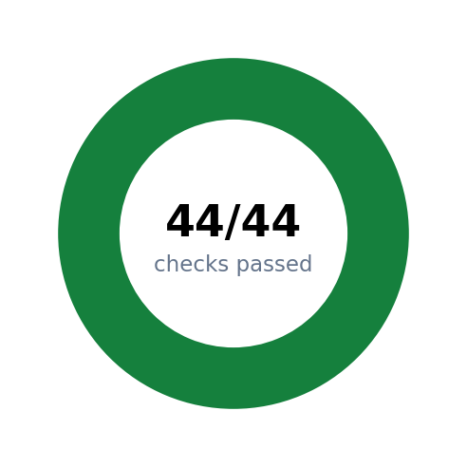
Donut chart: checks passed
Figure 1. Overall outcome of all checks.
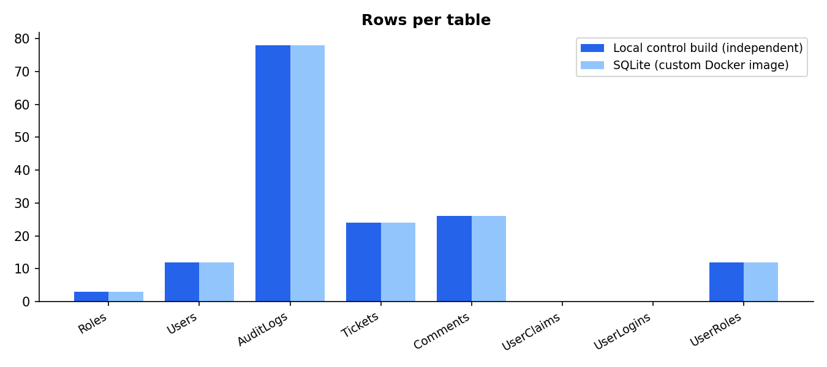
Rows per table
Figure 2. Row count of every table, reference versus this iteration’s built image.
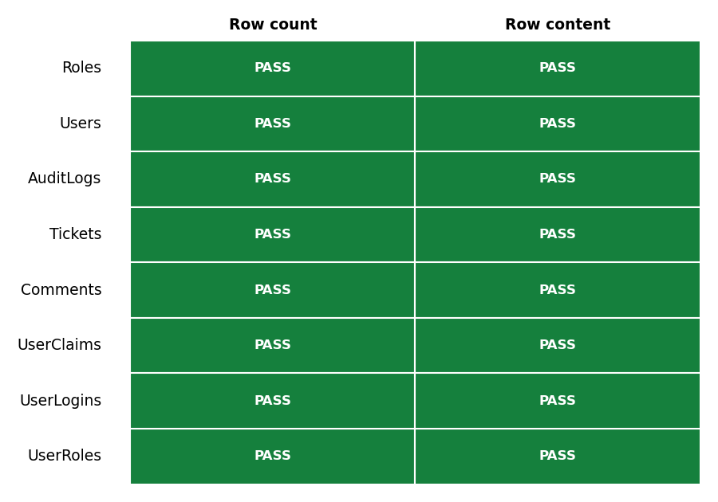
Status grid
Figure 3. Verification status of each table.

4. Data verification in detail
Table | Ref. rows | Target rows | Diff | Rows identical | Result | Row hash (16)
Roles | 3 | 3 | 0 | 3 | PASS | fa72c1c50028b89d
Users | 12 | 12 | 0 | 12 | PASS | 2c7ed480d10ca53f
AuditLogs | 78 | 78 | 0 | 78 | PASS | 92a70e5ba890103c
Tickets | 24 | 24 | 0 | 24 | PASS | 45b74e68185c9356
Comments | 26 | 26 | 0 | 26 | PASS | ba6b7561101ebd73
UserClaims | 0 | 0 | 0 | 0 | PASS | e3b0c44298fc1c14
UserLogins | 0 | 0 | 0 | 0 | PASS | e3b0c44298fc1c14
UserRoles | 12 | 12 | 0 | 12 | PASS | 0b9311fed9992ea3

5. Schema and integrity
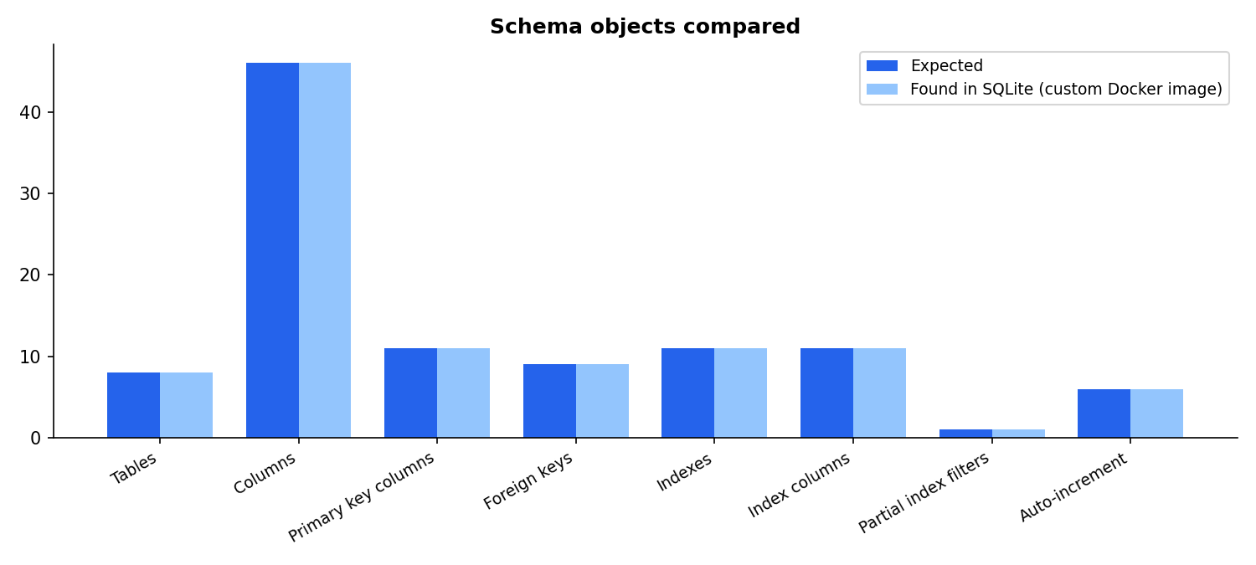
Schema objects compared
Figure 4. Schema object counts, expected versus found.
Check | Expected | Found | Result
Tables | 8 | 8 | PASS
Columns (name, order, type, NOT NULL, PK position, default) | 46 | 46 | PASS
Primary key columns | 11 | 11 | PASS
Foreign keys (column, target, ON DELETE action) | 9 | 9 | PASS
Indexes (name, unique, partial) | 11 | 11 | PASS
Index columns | 11 | 11 | PASS
Partial index filters (e.g. active-username rule) | 1 | 1 | PASS
Auto-increment (identity) tables | 6 | 6 | PASS
SQLite integrity_check (docker image) | - | - | PASS
SQLite foreign_key_check (orphan rows) | - | - | PASS

6. Business-level summaries
The same question was asked of the reference and the built image; the answers must match.
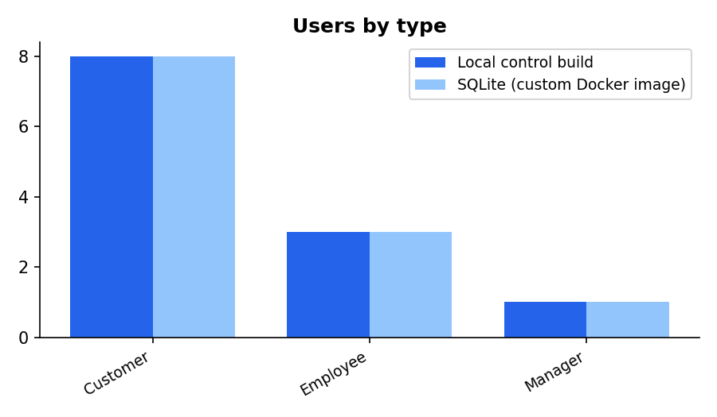
Users by type
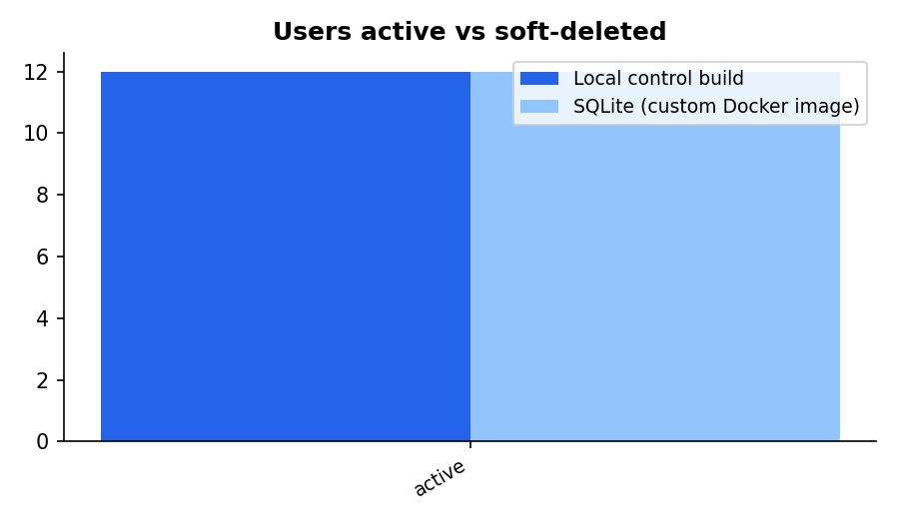
Users active vs soft-deleted
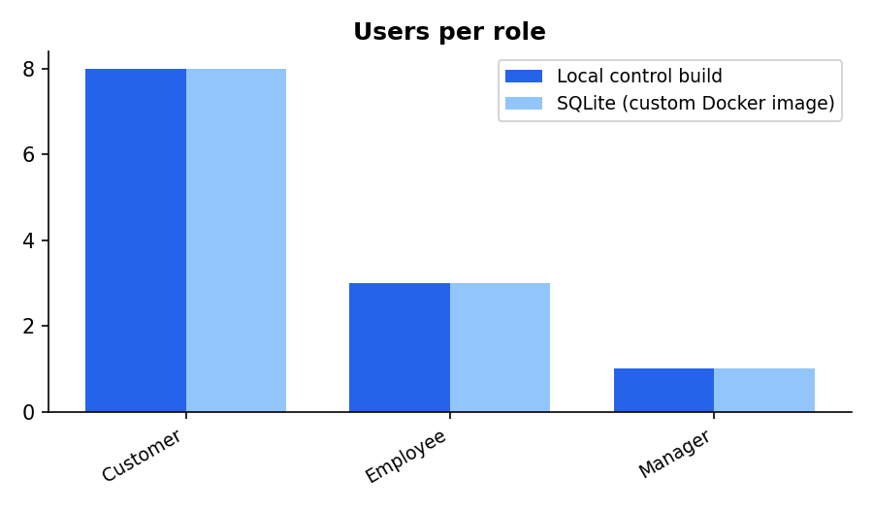
Users per role
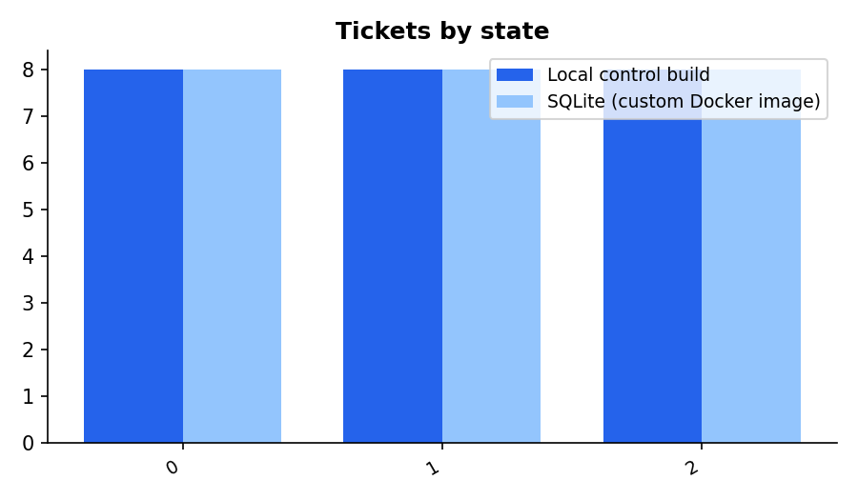
Tickets by state
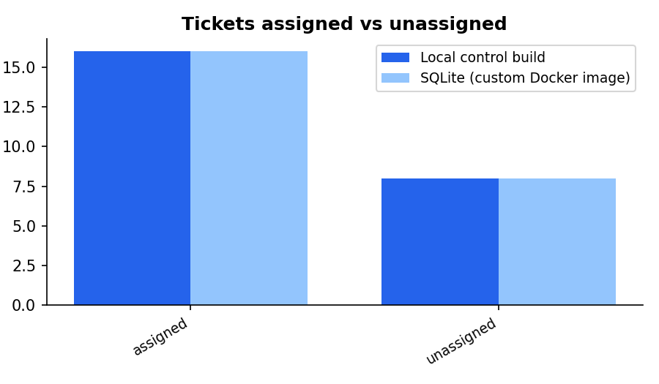
Tickets assigned vs unassigned
Summary | Answer (identical in target when PASS) | Result
Users by type | Customer | 8; Employee
Users active vs soft-deleted | active | 12
Users per role | Customer | 8; Employee
Tickets by state | 0 | 8; 1
Tickets assigned vs unassigned | assigned | 16; unassigned
Audit events by action | 0 | 11; 1
Comments per ticket (distribution) | 3 | 6; 4
Comment and commented-ticket totals | 26 | 8
Ticket date ranges | 2026-09-07 08:20:34.0000000 | 2026-09-16 08:39:18.0000000
Account and audit date ranges | 2026-09-10 14:41:58.9100000 | 2026-09-11 16:41:58.9100000

7. Behaviour tests, credential sanitization, and tooling self-test
Behaviour tests were run on a throw-away copy inside the container; the delivered database was never modified.
Behaviour | Result
Duplicate active username is rejected | PASS
Reusing a soft-deleted username is allowed (partial unique index) | PASS
Orphan foreign key insert is rejected | PASS
Boolean CHECK constraint rejects values other than 0/1 | PASS
New Roles row continues the source identity sequence | PASS

Credential sanitization
This is a one-time bootstrap migration; a forced password reset on next login is acceptable, so no usable credential is carried into the target at all.
Check | Result
All Users rows have PasswordHash/SecurityStamp NULL and MustResetPassword=1 (local build) | PASS
All Users rows have PasswordHash/SecurityStamp NULL and MustResetPassword=1 (docker build) | PASS
Non-credential Users columns unchanged by sanitization (12 rows cross-checked against raw source) | PASS

Self-test of the migration tooling
Area | Test | Result
Determinism | Second build is byte-identical to the first | PASS
Independent | Scratch copy matches the delivered database (dump diff) | PASS
Negative test | A damaged copy (Comments.Id=1 text changed, Tickets.Id=1 deleted) is detected | PASS

8. Differences found
None. No differences were found.

9. Intentional exclusions and known differences
- The Entity Framework migration history table (__MigrationHistory) is not migrated.
- The SQL Server dbo schema prefix is dropped; table/column names keep their spelling and case.
- The database is baked into the Docker image at build time (docker build), not loaded into a running container afterward as in iteration 2.
- Verification does not consult any iteration 1/2 output artifact. It cross-checks two databases built independently in this run from the same sanitized input: the Docker image and a local sqlite3-CLI control build.
- Every migrated Users row has PasswordHash and SecurityStamp set to NULL and MustResetPassword set to 1 - the real password hashes are never baked into this image or committed to git. This is a deliberate one-time-bootstrap policy: a forced password reset on next login is acceptable, so there is no need to carry a usable credential into the target at all.

10. Reproducibility
From tools/phase1/dbmigrate/iteration3/ on a Linux host with Docker:
./dbmigrate3.sh all --recreate
Item | Value
Tooling git commit | 456709f
Target client | 3.45.3
01-schema.sql SHA-256 (includes MustResetPassword column) | 72d62510dfc78e0be541addc5c2f3d15d26fb586b0d52eb487c4b04d0f67a017
02-data-sanitized.sql SHA-256 (committed; credentials redacted) | 4752e8c463068a5d3767f0f8441c2dd39ced67985db960a1e823894b77b17c32
SQLite (custom Docker image) target | /data/masterantique.sqlite

11. Sign-off
Role | Name | Signature | Date
Prepared by
Technical reviewer
Business approver

Appendix A. Full row hashes
SHA-256 over all rows of each table (canonical form, fixed order), computed on the reference database and on the built image.
Table | Reference SHA-256 | Target SHA-256 | Match
Roles | fa72c1c50028b89de1f99d8cbabf3c36ab1379be88059a71a0dcb1bdaff70416 | fa72c1c50028b89de1f99d8cbabf3c36ab1379be88059a71a0dcb1bdaff70416 | PASS
Users | 2c7ed480d10ca53fa56f515ec33eedf9bdd5bae28738706cffbf62dfb7cc132c | 2c7ed480d10ca53fa56f515ec33eedf9bdd5bae28738706cffbf62dfb7cc132c | PASS
AuditLogs | 92a70e5ba890103cb345061041f626f1b7edb586b076af6d2db73bd3f9f8c0ce | 92a70e5ba890103cb345061041f626f1b7edb586b076af6d2db73bd3f9f8c0ce | PASS
Tickets | 45b74e68185c9356cd53ac7da022ace7c26eba07d3e344fdd04fe733fc6954d4 | 45b74e68185c9356cd53ac7da022ace7c26eba07d3e344fdd04fe733fc6954d4 | PASS
Comments | ba6b7561101ebd73f9928dc404a7a6b0a375cb2c48bfded19085e9eb8a72acd9 | ba6b7561101ebd73f9928dc404a7a6b0a375cb2c48bfded19085e9eb8a72acd9 | PASS
UserClaims | e3b0c44298fc1c149afbf4c8996fb92427ae41e4649b934ca495991b7852b855 | e3b0c44298fc1c149afbf4c8996fb92427ae41e4649b934ca495991b7852b855 | PASS
UserLogins | e3b0c44298fc1c149afbf4c8996fb92427ae41e4649b934ca495991b7852b855 | e3b0c44298fc1c149afbf4c8996fb92427ae41e4649b934ca495991b7852b855 | PASS
UserRoles | 0b9311fed9992ea3979f2184d104883da159ceaffe975a81f47d47cbac024987 | 0b9311fed9992ea3979f2184d104883da159ceaffe975a81f47d47cbac024987 | PASS

