|  |
| --- |
| I chose this weekend over Mass Effect |
| Polar Position |
| Game Concept Document |
|  |
| **Lindsay Cox** |
|  |

|  |
| --- |
|  |

# Overview

Polar Position is a hybrid tower defence-third person shooter game developed for Playstation Suite. The game is similar to the game [Trenched/Iron Brigade](http://en.wikipedia.org/wiki/Iron_Brigade_(video_game)) but removes the role playing elements. The player controls Ivan the Polar Bear Tank Commander. The player’s goal is to protect Ivan’s food stock, a mountain of fish form an army of evil hungry penguins.

The game is a waved based game where the penguins assault the player’s base (fish stock) down a number of lanes and is split up into two main phases per round. The first phase is the preparation phase where the player uses the tank to navigate around the map placing turrets in specific places. The type of turret to go in that position can be selected (e.g. Machine gun, sniper, flamethrower, rpg). The player can upgrade and repair turrets during the preparation phase of each round. The phase switches to combat where the player can use the tank to fight against the enemy. The tank will fire automatically, so it is in the players interest to tactically position the tank. The player’s “health” is based on how many fish are in the store. As the penguins access the store, the number of fish inside depletes and the game is over when the player runs out of fish. The overall aim of the game is to see how many rounds the player can survive before the fish stock is cleared out.

# Plot, Characters and Factions

The creatures that inhabit the icy tundra of Polar Position are split into factions and often have disputes. However the dispute between the Polar Bears and the Penguin is something that has never happened before. The penguins' lack of fish has made them starving, desperate and now ruthless and angry and will stop at nothing to get to the Polar Bears' large supply.

## Ivan and the Arctic Avengers

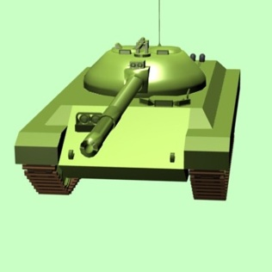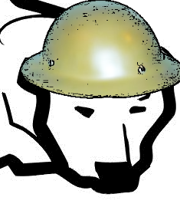

The Arctic Avengers are the faction of Polar Bears that are under assault from the ruthless penguins. They are lead by the Tank Commander Ivan and his elite squad. At the forefront of the force is Ivan's Tank, the most powerful and upgradable weapon ever created by the factions.

## Percy and the Penguin Penetrators

The Penguin Penetrators is an elite faction of Penguins lead by Percy. They employ swarm, tactics and send as many units out as possible

## Cutscene

There will be an in-engine cutscene that plays at the beginning of the game showing the story.

# Gameplay

## Points/Upgrades

The player starts off with a set number of points to build initial turrets. After killing penguins the player accrues points to upgrade both the turrets and Ivan's Tank.

## Turrets

The player can build a variety of turrets each costing different amounts

* Machine gun
* Sniper
* Grenade/Rocket
* Flamethrower

### Turret Placement

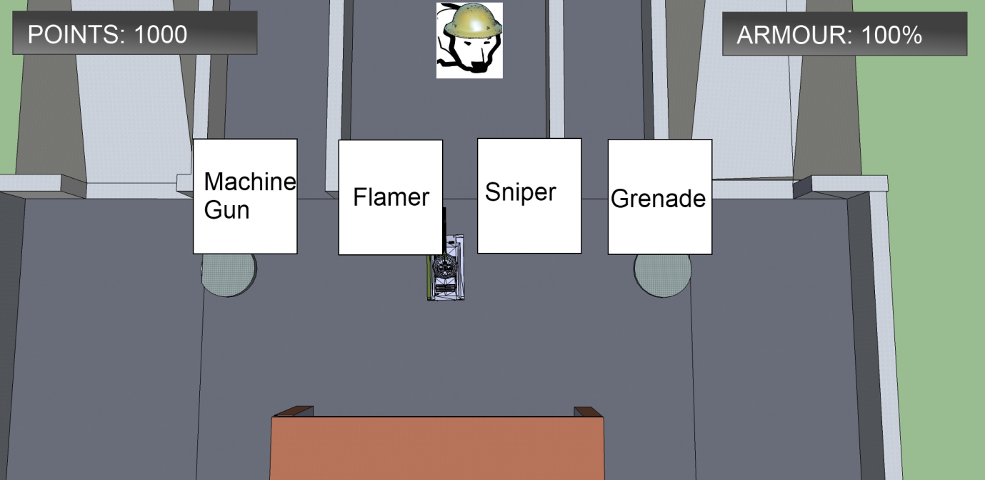

In order to place or upgrade the turrets the player must drive the tank near a turret. The above menu will appear. The player will then use the touch screen to select which turret to place or if they are to upgrade the turret.

## Tank

The tank is controlled by the player and can be navigated up to the boundary. The player can view the Tank from third person camera or top down camera. The tank fires automatically at enemies and is moved by the buttons/joystick.

The tank can be upgraded by driving near the fish store.

### 3rd Person Camera

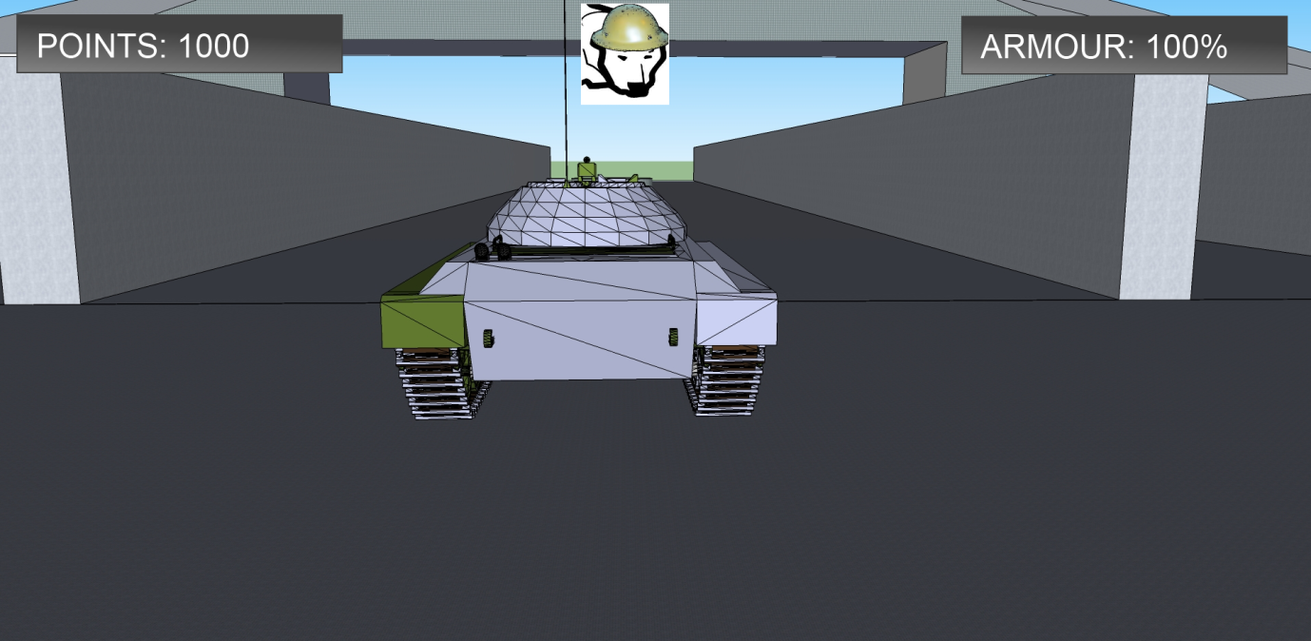

### Top Down Camera

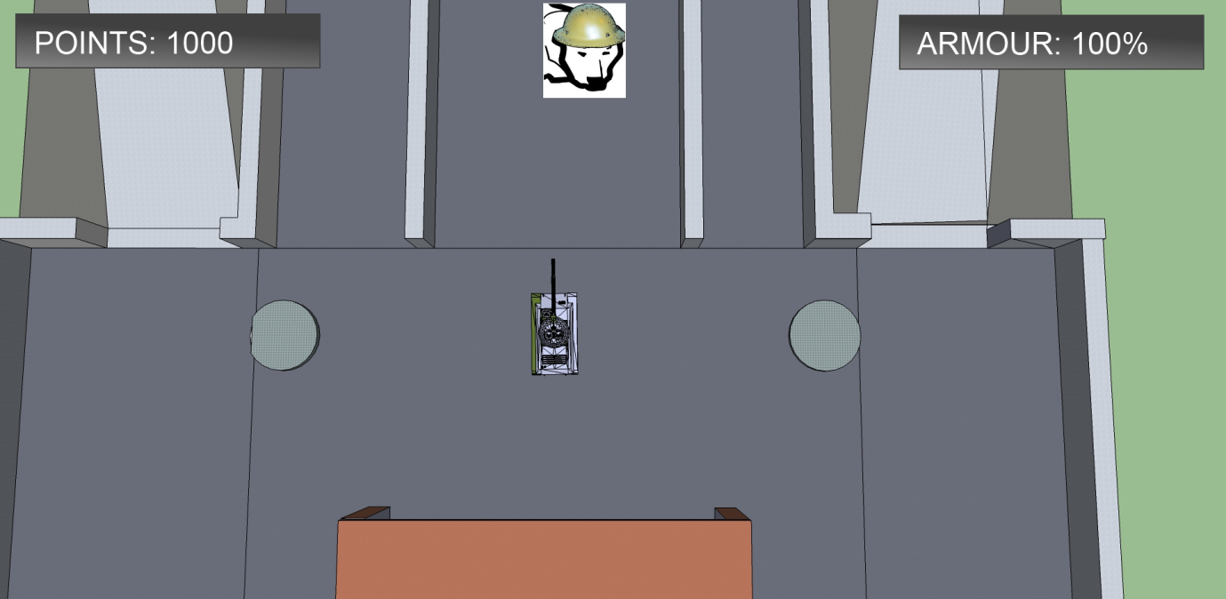

## Level - "Last Stand"

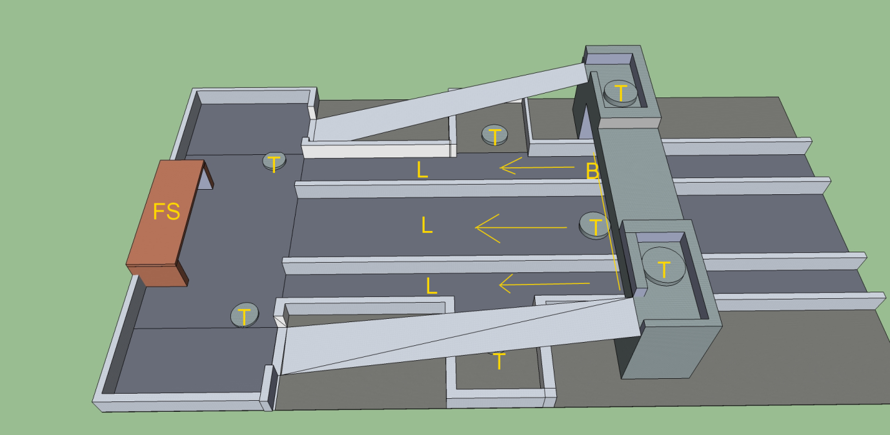

The level featured in the game is the Arctic Avengers "Last Stand" at the main fish store. The level features seven turret placements and two ramps. The following key shows the features of the map:

* FS - Fish Store
* T - Turrets
* L- Lane with arrow to show directions
* B - Boundary