**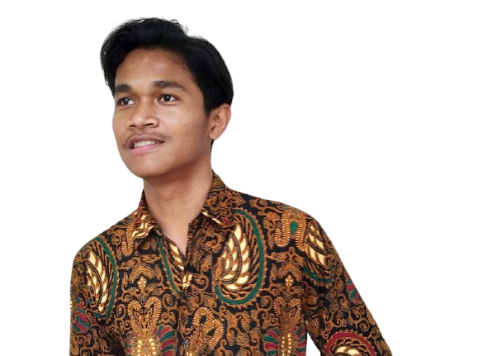****David Simbolon Teknik Informatika**

Bekasi Timur, Mustikajaya, Perumahan Alamanda II, Bekasi, 17158

 [davidhedrin123@gmail.com](mailto:davidhedrin123@gmail.com)

 +62 82110863133

[LinkedIn](http://linkedin.com/in/david-hedrin-64368a20a)

** Skills**

* Fast Learn, Team Work, & Communication (Expert)
* Microsoft Office (Expert)
* Web Development (Expert)
* HTML5 & CSS (Expert)
* JavaScript (Good)
* Laravel Framework & Django Framework (Good)
* Python & PHP (Good)
* CMS WordPress (Expert)
* Adobe Photoshop, Adobe Illustrator, & Adobe Lightroom (Expert)
* Adobe Premiere Pro, Adobe After Effect, & Adobe Audition (Expert)
* Typing >60WPM (Expert)

** Professional Summary**

Likes to develop talents from hobbies and take advantage of learning new things. Being a professional editor is my desire. Being a website developer is a goal I want to achieve, both on the back end and front end. I really like that science related to engineering in the eld of technology, so that's why I choose informatics engineering education.

 **Education**

**Adventist University of Indonesia, Indonesia, Bandung.** Aug 18 - Present

High School Diploma, Technical Information, Present



**Work Experience**

**Assistant Dean of the UNAI Faculty of Education.** Jan. 2021 – Present

*Adventist University of Indonesia - Bandung, Indonesia.*

Become an assistant dean of the education faculty at the Adventist University of Indonesia to help operate or maintain the CMS WordPress-based educational faculty website.

Info: fkip.unai.edu

**Assistant Lecturers Faculty of Philosophy.** Aug. 2020 - Dec. 2020

*Adventist University of Indonesia - Bandung, Indonesia.*

Becoming one of the teaching assistants in the philosophy faculty at Advent Indonesia University.

**Janitor of the UNAI Boys Dormitory.** Jan. 2019 - Dec. 2019

*Dept. Asrama Putra UNAI - Bandung, Indonesia.*

Become a monitoring assistant at the Putra Dormitory Dept. Responsible Indonesian Adventist University to secure and keep the place and clean live student.



**Organizations**

**Multimedia of Badan Executive Mahasiswa (BEM).** Aug 2020 – Present

*Adventist University of Indonesian - Bandung, Indonesia*

Become a member of the Student Executive Board (BEM) Advent Indonesia University in the academic eld of Multimedia.

**Academy of IT Faculty Student Association (HIMA)**. Aug 2019 - Mei 2020  
*Adventist University of Indonesia - Bandung, Indonesia*

Become a member of the UNAI Student Association (HIMA), Faculty of Information Technology, Advent Indonesia University, a key part of the Academy.

 **Certifications**

**Microsoft Technology Associate: Web Development Fundamentals (MTA)** - Feb 2021

*Microsoft*

Get Microsoft International Association Certificate.

**Responsive Web Design** - Mar 2021

*FreeCodeCamp*

Completed all training for responsive website design.

**JavaScript Algorithms and Data Structures** - Mar 2021

*FreeCodeCamp*

Completed 300 hours of learning FreeCodeCamp JavaScript.

**HTML** - Mar 2021

*SoloLearn*

Successful completion of all HTML5 training

**Photoshop 2021 Essential Training: The Basics** - Mar 2021

*LinkedIn*

Completed Adobe Photoshop Basic Training

**Illustrator 2021 Essential Training** - Apr 2021

*LinkedIn*

Completed Adobe Illustrator basic training

**HTML Concepts For Programming** - Apr 2021

*Skill Academy by Ruangguru*

Successfully completion of training materials and final HTML Concepts For Programming exams

**Learn Graphic Design Easily Using Adobe Photoshop** - Apr 2021

*Skill Academy by Ruangguru*

Successfully completed graphic design training materials using Adobe Photoshop

**Python Programming Language For Beginners** - Apr 2021

*Dewatalks, Dewaweb*

Has attended the following webinar presented by Dewatalks.

 **Reward**

**HIMA FTI UNAI'S NEW LOGO DESIGN COMPETITION** - Mar 2021

*Adventist University of Indonesian - Bandung, Indonesia*

Won the logo contest for the Faculty of IT, Advent Indonesia University

 **Soft Skills**

**Music**

Guitar, Piano, etc.

**Sports**

Badminton, BasketBall, etc.