**Project Brief**

**The goal of the project:** The goal of this game is to show the journey that the main character goes through in order to make it to the date with the second main character Fiona!

**Final Product:** Basically Jimmy works a sketchy job in order to pay for things day by but he is super fond of the girl Fiona that he has seen a few times at a club/bar that they regularly go to every Friday night. After a few times of seeing Fiona Jimmy builds up the courage and decides to ask her on a dinner date at Nobu. Fiona is from the south side of Chicago while Jimmy is from the suburbs, he decides to take Fiona on a nice date since she works so hard and helps out with her brothers and sisters so much. Fiona is skeptical but agrees to go on the date with Jimmy. Meanwhile with Jimmy’s sketchy job the day of the date Jimmy goes through many obstacles in order to get to the date and make it special with Fiona.

What Will Be Delivered: A challenge and obstacles.

**Target Audience:** Anyone 18+, romantics

**Game Design Brief**

**Story:** A man trying to juggle work, life, and love life all in one day.

**Characters:** Jimmy (the main character), Fiona, cop, the person in the following way car.

Side characters: Kitchen staff, and people that Jimmy works with.

**Game Play:** The way that the player will interact with the game is just by having two options per page which will have an “option ½” button on the page with a description of each option above which will result in different outcomes throughout the game.

**Visual Art Description**: I used images from pixels which included: cars, the city, and the dining area.

**Persona:** Jimmy has had his eye on Fiona for a while now. He finally got the courage to ask her on a date. At first, she blows him off since she has a lot going on in her life but after a few times of encouraging her, Fiona says yes. She tells him that he better not be like all the other guys in Chicago and blow her off or mess up in any way. He promises that he won't and that it will be the best date she has ever been on. She's still skeptical but they set up a date for the next night. Jimmy has a big day planned ahead, do you think you can help Jimmy get through the obstacles he needs to get through in order to make it on time for the date? If so you are up for a challenge!

**Wire Frame:**

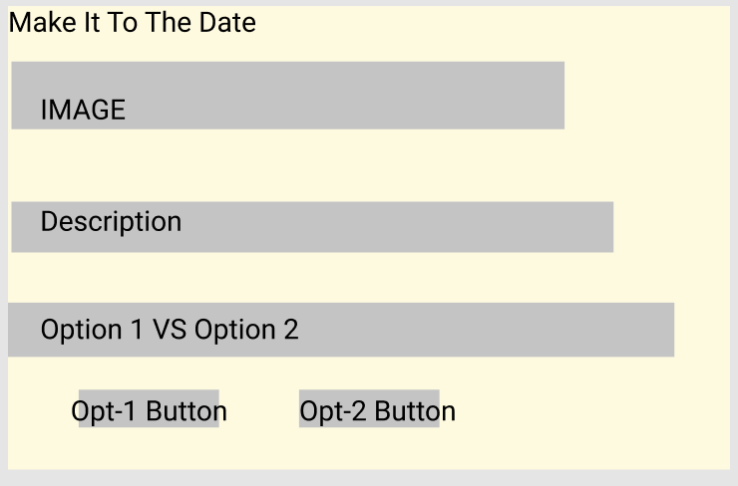-Made on Figma

**Story Map:**

