

cov-lineages /
pango-designation
Code Issues 137 Pull requests Actions Projects Security Insights

New issue
Proposal for new lineage within B.1 #4
rambaut opened this issue on Feb 11, 2021 · 6 comments
Closed
Jump to bottom

Assignees  Labels |     designated | proposed
Milestone | B.1.525

rambaut commented on Feb 11, 2021 • edited
Proposal for new lineage within B.1
Description
Contributor

Sub-lineage of: B.1
Earliest sequence: 2020-12-15 (England/CAMC-C769B3/2020) Most recent sequence: 2021-01-28 (England/MILK-119FD0B/2021)
Countries circulating: England (28), Nigeria (7), USA (7), France (5), Canada (4), Ghana (4), Japan (4), Jordan (2),
Belgium (1), Italy (1), Spain (1)
Characterised by spike mutations: E484K, Q677H, F888L, 69-70 deletion, 144 deletion and 9 nucleotide mutation in nsp6 (as seen in B.1.1.7, B.1.351, P.1).

Genomes
B.1.525_genomes.txt
List of genomes, collated 2021-02-11, attached.

Evidence

Phylogenetic tree PDF image. Proposed new lineage labels in red:
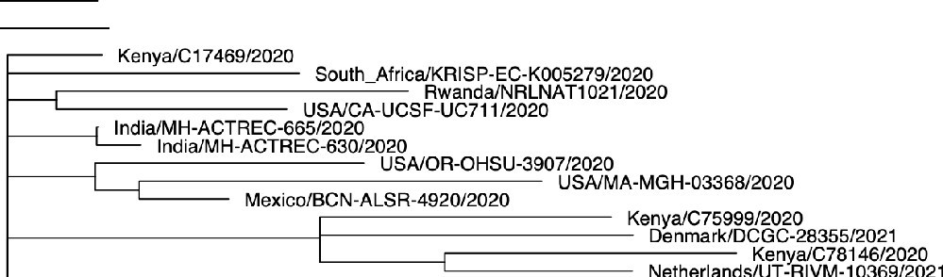
MN908947.3
Nigeria/CV633/2020I2020-12-18
Nigeria/CV648/2021I2021·01-15

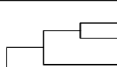
itzerlandNS-32970348/2021
Russia/S1Petersburg-Rll6053S/2020 Scot1and/CVR2784/2020
Spain/GA-IBV-9800605112020
USA/CA-CZB-3916/2020
USA/CA-CZB-13926/2020
USA/CA-CZB-13813/2020
=ln=d=ia=/G=J=-G=B=R=C=-4=228/2020
England(MILK-823 Australia/SAP482/20210 020
10t £8'QEUH-gB8?B /2
lnd1a/GJ-GBRC-422b/2020 England/MILK-859ED9/2020
r L.::En gland/QEUH·989F2E/2020
1812020
lndia/ J'GW g 2Ha/i ii
f------L""" lndia/GJ-GBRC312b/2020
lndia/GJ-GBRC233a/2020
lndia/GJ-GBRC233b/2020
Canada/MB-NML-1182/2020
r AustraliaNIC18092/2021
lndia/GJ-GBRC-410/2020
r---ic_::_c: lndia/GJ-GBRC-408a/2020
f------{_ E ra }XE it i 20
lndia/GJ-l; , 2i-E5204D/2021
'----------r- lndia/GJ-GBRC-440/2020
lndia/GJ-GBRC-439a/2020
lndia/GJ-GBRC-439b/2020 lndia/GJ-GBRC-438/2020
Netherlands/ZH-RIVM-10788/2021
2020
Denm Btb 4 ri2iB/ lceland/396612020
Scotland/QEUH-9B86B1/2020
Sw
England/MILK-BDC1SA/2020
Slovakia/UKBA-210/2020
Spain/MD-IBV-99015948/2020
Ukraine/203100339/2020
Russia/
Latvia/209/2020
Latvia/225/2020
L----1f C=-L;--:a:;:lv:;:ia/-:;_1 52 i gnd/MILK-ACE329/2020
f---c====:--;;N;;;etlhe 1 i2. b J§ f8
England/MILK-ACCFBE/2020 England/MILK-ABB?BA/2020
6501202
England/Ci t i rd6 tg2 England/CAMC-BOAF68/2020
'---------.-::E-ngla 7 g :s J1ii 020
England/ALDP-85D081/2020 England/CAMC-BOAECS/2020

PSK-RII-MH6191$/2020

0

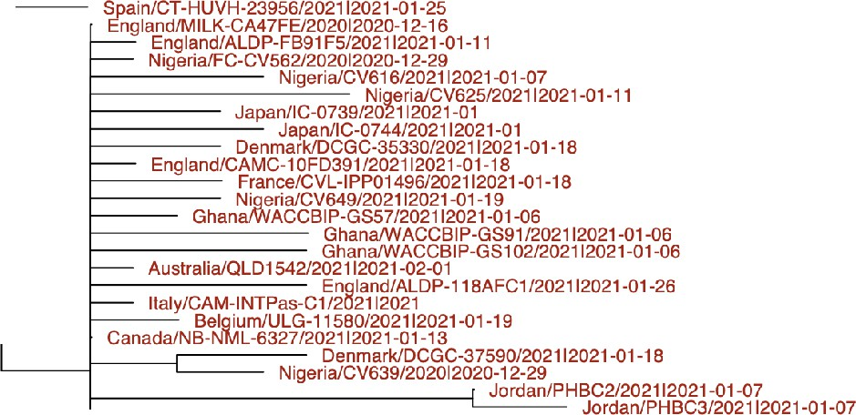
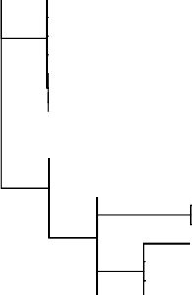
Nigeria/CV641 /2020I2020-12-29 Nigeria/CV642/2020I2020-12-29
f------< England/ALDP-11D5361/2021I2021-01-30
2021I2021 01

England/MILK-t B 3/ ir2JJg rg England/CAMC-C769B3!202012020-12-15 Canada/ON-S2446/2021I2021-01-14
- -so

Nigeria/CV647/2021I2021-01•15
France/IDF-CERBAHC-0056/2021I2021-01-06 France/IDF-IPPO1421/202112021-01-06
Japan!IC-0738/2021I2021-01 Canada/ON-PHL-21-00758/2021I2021-01 Canada/ON-PHL-21-00580/2021I2021-01
Denmark!DCGC-35448!2021I2021-01-18
f---------< Denmark!DCGC-37993/2021I2021-01-18
Denmark!DCGC-38316/2021I2021-01-18
USA/MD-MDH-079312021I2021-01-27
France/lDF-IPP01573/2021I2021-01-19 FrancetlDF-IPP015981202112021-01-18
England/QEUH-E93A7F/202II2021-01-04
r--------< England/OEUH·E93C6A/2021I2021-01-04
England/QEUH-E948CF/2021I2021-01-04
England/QEUH-E93AAC/2021I2021-01-04
---- Japan/lC-0718/2021I2021-01

f +--En_g_la_n_d/A
1
J 'J1i i -gt1 1 021-01-os

England/ALDP-11B2CF6/2021I2021-01-30 Eng1and/ALDP-118750Ef2021I2021-01-25
f
Denmark/DCGC-312 2mb W:6" 0 E4E/202112021-01·26
gg: ft &.-11ft; gg;/I8I i'I8!11111Jg
Eng1and/LOND-12DEC99/2021I2021-01-27 England/MILK-1153635!2021I2021-01-22
gg1 t ?,-gti ii 1 ii (} \iO
,--c==--='En gla& t t- ri i7 6 91Joi -- -11
USA/CA-LACPHL-AF00280/2021I2021-01-17
f------- USA/MI-MDHHS-SC23224/2021I2021-01-20
f
Englaoci/MILK-1 : : ?L2 f Jcfds}Jo2112021-01-28 England/ALDP-F 756/202112021-01-09
USA/IN-PU-B2386/2021I2021-01-10
England!ALDP-10E1E4412021I2021-01-19 England/ALDP-1OE1E08/2021I2021-01-19
USA/CT-Yale-S220/2021I2021-01-22 USA/CT-Yale-1017/202112021-01 USA/CT-Yale-1018/2021I2021-01 USA/CT-Yale-10191202112021·01

2.0E-4


Phylogenetic tree file:
B.1.525.ml.tree.txt

Proposed lineage name
To be determined as the the next available designation within B.1

defining mutations

gene | amino acid | coordinates
ORF1ab |  | C1498T
 |  | A1807G
 |  | T8593C
 |  | C9565T
 |  | 11288-11296del
 | L4715F (L323F) | C14407T
 |  | C18171T
 |  | A20724G
spike | Q52R | A21717G
 | 69-70del
 | 144del
 | E484K | G23012A
 | Q677H | G23593C
 | F888L | T24224C
 |  | C24748T
E | L21F | C26305T
M | I82T | T26767C
N | SD2Y deletion | 28278-28280del
 |  | A28699G
N/ORF10 intergenic |  | G29543T


rambaut added the proposed label on Feb 11, 2021

