Google Gemini 3 Chat Session
By David I.
Last updated: November 30, 2025

Table of Contents
Google Gemini 3 Chat Session 1
Prompt: can you add additional features you suggested? 10
Gemini 3 Response: 10
Prompt: can you get pictures for me? 19
Gemini 3 Response: 19
How to Add These to Your Delphi Project 22
Prompt: can you create a downloadable project zip file containing all of the code and the images so that I don't have to create everything myself? 23
Gemini 3 Response: 23
Instructions 23
The "Project Builder" Script 24

Prompt:

Use Delphi 13 and FireMonkey FMX to create multi-device futuristic text adventure application that features a tour through the solar system planets, moons and major asteroids

Gemini 3 response:

Use Delphi 13 and FireMonkey FMX to create multi-device futuristic text adventure application that features a tour through the solar system planets, moons and major asteroids
This is a fantastic project idea. Text adventures (Interactive Fiction) are excellent for exploring object-oriented design, and using FireMonkey (FMX) allows you to deploy this futuristic tour to Windows, macOS, Android, and iOS from a single codebase.
Since "Delphi 13" is a future version (the current latest is 12 Athens), I will use modern Object Pascal syntax compatible with 11/12+ that will seamlessly work in future versions.
Here is a complete, modular architecture for "Solar Odyssey."
1. The Architecture
We will separate the Game Logic (The Engine) from the User Interface (The Form). This ensures your game logic remains pure and testable.
- TLocation: Represents a planet, moon, or ship room.
- TGame: Manages the player state and the map.
- MainForm: Handles input, output, and visual styling.

2. The Game Engine Unit (uGameEngine.pas)
This unit handles the solar system map and text parsing.
Code snippet
unit uGameEngine;

interface

uses
System.SysUtils, System.Classes, System.Generics.Collections;

type
TLocation = class;

TDirection = (dirNorth, dirSouth, dirEast, dirWest, dirUp, dirDown);

TLocation = class
private
FName: string;
FDescription: string;
FExits: TDictionary<string, TLocation>; // Key: Command (e.g., 'north', 'dock')
public
constructor Create(const AName, ADescription: string);
destructor Destroy; override;
procedure AddExit(const ACommand: string; ATarget: TLocation);
function GetExit(const ACommand: string): TLocation;

property Name: string read FName;
property Description: string read FDescription;
end;

TGame = class
private
FLocations: TObjectList<TLocation>;
FCurrentLocation: TLocation;
FOutputLog: TStrings;
procedure BuildSolarSystem;
public
constructor Create;
destructor Destroy; override;

function ProcessCommand(const AInput: string): string;
procedure Look;

property CurrentLocation: TLocation read FCurrentLocation;
property OutputLog: TStrings read FOutputLog write FOutputLog;
end;

implementation

{ TLocation }

constructor TLocation.Create(const AName, ADescription: string);
begin
FName := AName;
FDescription := ADescription;
FExits := TDictionary<string, TLocation>.Create;
end;

destructor TLocation.Destroy;
begin
FExits.Free;
inherited;
end;

procedure TLocation.AddExit(const ACommand: string; ATarget: TLocation);
begin
FExits.Add(ACommand.ToLower, ATarget);
end;

function TLocation.GetExit(const ACommand: string): TLocation;
begin
if not FExits.TryGetValue(ACommand.ToLower, Result) then
Result := nil;
end;

{ TGame }

constructor TGame.Create;
begin
FLocations := TObjectList<TLocation>.Create(True);
BuildSolarSystem;
end;

destructor TGame.Destroy;
begin
FLocations.Free;
inherited;
end;

procedure TGame.BuildSolarSystem;
var
ShipBridge, Airlock, MoonBase, MarsColony, CeresStation, EuropaDeep: TLocation;
begin
// Create Nodes
ShipBridge := TLocation.Create('UES Copernicus - Bridge',
'You are on the command deck of the UES Copernicus. Holographic star charts glow soft blue. ' +
'The "Airlock" is to the South.');

Airlock := TLocation.Create('UES Copernicus - Transporter Room',
'The hum of the quantum displacement drive fills the room. ' +
'From here you can "warp" to major celestial bodies. The Bridge is "North".');

MoonBase := TLocation.Create('Luna - Armstrong Outpost',
'The gray dust of the moon stretches endlessly outside the dome. ' +
'Earth hangs like a marble in the sky. You can "return" to the ship.');

MarsColony := TLocation.Create('Mars - Olympus Mons Vertiport',
'Red dust coats the mag-lev tracks. The massive volcano looms behind you. ' +
'Automated mining drones buzz overhead. You can "return" to the ship.');

CeresStation := TLocation.Create('Ceres - The Belt Hub',
'A hollowed-out asteroid city, bustling with miners and traders. ' +
'Neon signs advertise water reclamation services. You can "return" to the ship.');

// Add to internal list for memory management
FLocations.AddRange([ShipBridge, Airlock, MoonBase, MarsColony, CeresStation]);

// Connect Nodes
ShipBridge.AddExit('south', Airlock);

Airlock.AddExit('north', ShipBridge);
Airlock.AddExit('warp moon', MoonBase);
Airlock.AddExit('warp mars', MarsColony);
Airlock.AddExit('warp ceres', CeresStation);

MoonBase.AddExit('return', Airlock);
MarsColony.AddExit('return', Airlock);
CeresStation.AddExit('return', Airlock);

// Start Point
FCurrentLocation := ShipBridge;
end;

procedure TGame.Look;
begin
if Assigned(FOutputLog) then
begin
FOutputLog.Add('');
FOutputLog.Add('--- ' + FCurrentLocation.Name + ' ---');
FOutputLog.Add(FCurrentLocation.Description);
FOutputLog.Add('Exits/Actions: ' + string.Join(', ', FCurrentLocation.FExits.Keys.ToArray));
FOutputLog.Add('');
end;
end;

function TGame.ProcessCommand(const AInput: string): string;
var
NextLoc: TLocation;
Cmd: string;
begin
Cmd := AInput.Trim.ToLower;

if Cmd = 'look' then
begin
Look;
Exit;
end;

if Cmd = 'help' then
begin
if Assigned(FOutputLog) then
FOutputLog.Add('SYSTEM: Commands: look, north, south, warp [planet], return');
Exit;
end;

// Try to move
NextLoc := FCurrentLocation.GetExit(Cmd);

if Assigned(NextLoc) then
begin
FCurrentLocation := NextLoc;
Look;
end
else
begin
if Assigned(FOutputLog) then
FOutputLog.Add('SYSTEM: Navigation error. Destination unknown.');
end;
end;

end.

3. The Main Form (uMain.pas)
This is the FMX logic. To make it "Futuristic," we will use a Layout for centering and a dark style.
UI Setup Instructions:
- Drop a TStyleBook on the form. Load the "Windows 11 Dark" or a custom "Jet" style provided with Delphi.
- Add a TLayout (Align: Client).
- Add a TMemo (Align: Client). Set ReadOnly to True. Name it memoLog.
- Add a TLayout (Align: Bottom, Height: 50) for input controls.
- Inside the Bottom Layout, add a TEdit (Align: Client) named edtInput.
- Inside the Bottom Layout, add a TButton (Align: Right) named btnSend.
Code snippet
unit uMain;

interface

uses
System.SysUtils, System.Types, System.UITypes, System.Classes, System.Variants,
FMX.Types, FMX.Controls, FMX.Forms, FMX.Graphics, FMX.Dialogs, FMX.Memo.Types,
FMX.StdCtrls, FMX.Controls.Presentation, FMX.ScrollBox, FMX.Memo, FMX.Edit,
FMX.Layouts, uGameEngine;

type
TfrmMain = class(TForm)
StyleBook1: TStyleBook;
LayoutMain: TLayout;
memoLog: TMemo;
LayoutInput: TLayout;
edtInput: TEdit;
btnSend: TButton;
procedure FormCreate(Sender: TObject);
procedure FormDestroy(Sender: TObject);
procedure btnSendClick(Sender: TObject);
procedure edtInputKeyDown(Sender: TObject; var Key: Word; var KeyChar: Char);
private
FGame: TGame;
procedure AppendLog(const Msg: string);
public
{ Public declarations }
end;

var
frmMain: TfrmMain;

implementation

{$R *.fmx}

procedure TfrmMain.FormCreate(Sender: TObject);
begin
// Initialize Game Engine
FGame := TGame.Create;

// Link the game engine to the Memo's lines
// Note: In a real MVC pattern, we'd use events, but this is direct for simplicity.
FGame.OutputLog := memoLog.Lines;

// Initial Welcome Message
AppendLog('INITIALIZING SYSTEM...');
AppendLog('WELCOME TO SOLAR ODYSSEY v1.0');
AppendLog('-------------------------------');

// Show starting location
FGame.Look;
end;

procedure TfrmMain.FormDestroy(Sender: TObject);
begin
FGame.Free;
end;

procedure TfrmMain.AppendLog(const Msg: string);
begin
memoLog.Lines.Add(Msg);
// Auto-scroll to bottom
memoLog.GoToTextEnd;
end;

procedure TfrmMain.btnSendClick(Sender: TObject);
begin
if edtInput.Text = '' then Exit;

// Echo the user's command
AppendLog('> ' + edtInput.Text);

// Process logic
FGame.ProcessCommand(edtInput.Text);

// Clear input
edtInput.Text := '';
edtInput.SetFocus;

memoLog.GoToTextEnd;
end;

procedure TfrmMain.edtInputKeyDown(Sender: TObject; var Key: Word;
var KeyChar: Char);
begin
if Key = vkReturn then
begin
Key := 0; // Prevent ding sound
btnSendClick(Self);
end;
end;

end.
4. Visual Enhancements (The "Futuristic" Touch)
To truly sell the sci-fi theme without complex 3D rendering, use FMX Effects and Animations.
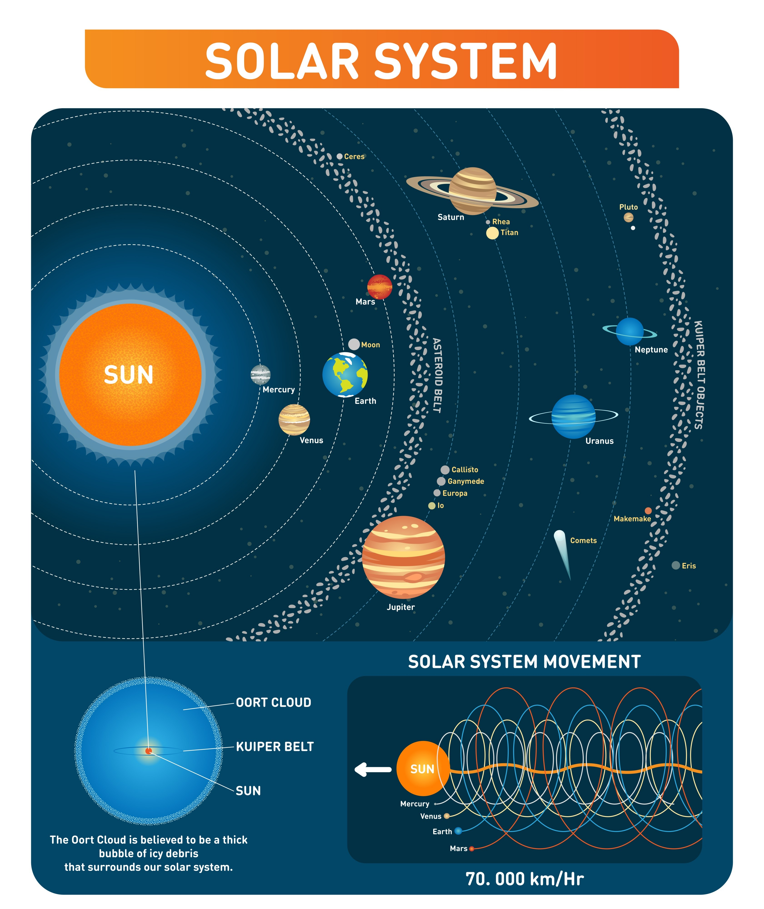
Shutterstock

- The CRT Effect:
  - Add a TInnerGlowEffect to the TMemo. Set the color to Cyan or Bright Green to mimic a holographic terminal.
  - Set the TMemo background color to Black or a very dark Navy.
  - Set the TMemo Font Family to a monospaced font like Consolas or Courier New.
- Visual Feedback:
  - When the user types warp mars, you can toggle a TImage component visible on the form that displays a photo of Mars.
  - Implementation: Add a TImage (Align: Right, Width: 200). inside TGame.ProcessCommand, if the location changes, load a bitmap into the image based on FcurrentLocation.Name.

5. How to Expand the Tour

The current engine uses a Dictionary for exits. This makes it incredibly easy to add the asteroid belt or Jupiter's moons.
To add Europa, you simply add this to the BuildSolarSystem procedure:
Code snippet
EuropaDeep := TLocation.Create('Europa - Subsurface Ocean',
'You are in a pressurized submarine navigating the dark waters beneath Europa''s ice crust. ' +
'Bioluminescent creatures swim past the viewport.');

// Add the connection from the Airlock
Airlock.AddExit('warp europa', EuropaDeep);
EuropaDeep.AddExit('return', Airlock);

6. Deployment

Because this uses FMX:
- Android/iOS: Change the Target Platform in the Project Manager. Ensure your StyleBook has a style loaded that supports mobile (or use Default style for native look).
- Windows/macOS: Compile and run immediately.
Would you like me to elaborate on how to add an inventory system (e.g., collecting rock samples) or how to implement the TImage swapping logic?

Prompt: can you add additional features you suggested?

n you add additional features you suggested?

Gemini 3 Response:
Here is the updated code incorporating the Visual System (loading planet images) and the Inventory System (collecting samples).

I have updated the architecture to use an Event-Driven approach. The Engine now notifies the UI when the location changes, allowing the UI to update the image automatically.

1. Updated Game Engine (uGameEngine.pas)

Changes made:
- TLocation: Added ImageResourceName (string) and Items (list of strings).
- TGame: Added FInventory, ProcessTake, and an OnUpdateUI event to sync the form.
Code snippet
unit uGameEngine;

interface

uses
System.SysUtils, System.Classes, System.Generics.Collections;

type
TLocation = class;

// Event type to notify UI of changes (Location or Image updates)
TGameUIEvent = procedure(LocationName, ImageName: string) of object;

TLocation = class
private
FName: string;
FDescription: string;
FImageRes: string; // Resource name for the image (e.g., 'img_mars')
FExits: TDictionary<string, TLocation>;
FItems: TStringList; // Items on the ground
public
constructor Create(const AName, ADescription, AImageRes: string);
destructor Destroy; override;
procedure AddExit(const ACommand: string; ATarget: TLocation);
function GetExit(const ACommand: string): TLocation;

property Name: string read FName;
property Description: string read FDescription;
property ImageRes: string read FImageRes;
property Items: TStringList read FItems;
end;

TGame = class
private
FLocations: TObjectList<TLocation>;
FCurrentLocation: TLocation;
FOutputLog: TStrings;
FInventory: TStringList;
FOnUpdateUI: TGameUIEvent; // Callback for UI

procedure BuildSolarSystem;
procedure Look;
procedure ListInventory;
procedure TakeItem(const AItemName: string);
public
constructor Create;
destructor Destroy; override;

function ProcessCommand(const AInput: string): string;

property OutputLog: TStrings read FOutputLog write FOutputLog;
property OnUpdateUI: TGameUIEvent read FOnUpdateUI write FOnUpdateUI;
end;

implementation

{ TLocation }

constructor TLocation.Create(const AName, ADescription, AImageRes: string);
begin
FName := AName;
FDescription := ADescription;
FImageRes := AImageRes;
FExits := TDictionary<string, TLocation>.Create;
FItems := TStringList.Create;
end;

destructor TLocation.Destroy;
begin
FExits.Free;
FItems.Free;
inherited;
end;

procedure TLocation.AddExit(const ACommand: string; ATarget: TLocation);
begin
FExits.Add(ACommand.ToLower, ATarget);
end;

function TLocation.GetExit(const ACommand: string): TLocation;
begin
if not FExits.TryGetValue(ACommand.ToLower, Result) then
Result := nil;
end;

{ TGame }

constructor TGame.Create;
begin
FLocations := TObjectList<TLocation>.Create(True);
FInventory := TStringList.Create;
BuildSolarSystem;
end;

destructor TGame.Destroy;
begin
FInventory.Free;
FLocations.Free;
inherited;
end;

procedure TGame.BuildSolarSystem;
var
ShipBridge, Airlock, MoonBase, MarsColony, CeresStation: TLocation;
begin
// Create Nodes with Image Resource Names
// Note: You must add images to your project resources with these names.
ShipBridge := TLocation.Create('UES Copernicus - Bridge',
'You are on the command deck. The "Airlock" is to the South.', 'img_bridge');

Airlock := TLocation.Create('Transporter Room',
'The warp drive hums. Navigate to: "warp moon", "warp mars", "warp ceres".', 'img_airlock');
Airlock.Items.Add('Space Suit'); // Item to pick up

MoonBase := TLocation.Create('Luna - Armstrong Outpost',
'The gray dust of the moon stretches endlessly.', 'img_moon');
MoonBase.Items.Add('Moon Rock');
MoonBase.Items.Add('Helium-3 Canister');

MarsColony := TLocation.Create('Mars - Olympus Mons',
'Red dust coats the mag-lev tracks.', 'img_mars');
MarsColony.Items.Add('Red Sand Sample');

CeresStation := TLocation.Create('Ceres - The Belt Hub',
'A hollowed-out asteroid city.', 'img_ceres');
CeresStation.Items.Add('Ice Chunk');

FLocations.AddRange([ShipBridge, Airlock, MoonBase, MarsColony, CeresStation]);

// Connect Nodes
ShipBridge.AddExit('south', Airlock);
Airlock.AddExit('north', ShipBridge);
Airlock.AddExit('warp moon', MoonBase);
Airlock.AddExit('warp mars', MarsColony);
Airlock.AddExit('warp ceres', CeresStation);

MoonBase.AddExit('return', Airlock);
MarsColony.AddExit('return', Airlock);
CeresStation.AddExit('return', Airlock);

FCurrentLocation := ShipBridge;
end;

procedure TGame.Look;
var
I: Integer;
begin
if Assigned(FOutputLog) then
begin
FOutputLog.Add('');
FOutputLog.Add('--- ' + FCurrentLocation.Name + ' ---');
FOutputLog.Add(FCurrentLocation.Description);

// List Items
if FCurrentLocation.Items.Count > 0 then
begin
FOutputLog.Add('Visible Items:');
for I := 0 to FCurrentLocation.Items.Count - 1 do
FOutputLog.Add(' - ' + FCurrentLocation.Items[I]);
end;

FOutputLog.Add('Exits: ' + string.Join(', ', FCurrentLocation.FExits.Keys.ToArray));
FOutputLog.Add('');
end;

// Trigger UI Update for Image
if Assigned(FOnUpdateUI) then
FOnUpdateUI(FCurrentLocation.Name, FCurrentLocation.ImageRes);
end;

procedure TGame.ListInventory;
begin
if Assigned(FOutputLog) then
begin
FOutputLog.Add('INVENTORY:');
if FInventory.Count = 0 then
FOutputLog.Add(' (Empty)')
else
FOutputLog.Add(FInventory.Text);
end;
end;

procedure TGame.TakeItem(const AItemName: string);
var
Idx: Integer;
begin
// Find item in current location (Case insensitive search)
Idx := -1;
for var I := 0 to FCurrentLocation.Items.Count - 1 do
if SameText(FCurrentLocation.Items[I], AItemName) then
begin
Idx := I;
Break;
end;

if Idx <> -1 then
begin
FInventory.Add(FCurrentLocation.Items[Idx]);
FOutputLog.Add('Taken: ' + FCurrentLocation.Items[Idx]);
FCurrentLocation.Items.Delete(Idx); // Remove from ground
end
else
FOutputLog.Add('Item not found here.');
end;

function TGame.ProcessCommand(const AInput: string): string;
var
Cmd, Param: string;
SpacePos: Integer;
NextLoc: TLocation;
begin
Cmd := AInput.Trim;
Param := '';

// Split command and parameter (e.g. "take moon rock")
SpacePos := Pos(' ', Cmd);
if SpacePos > 0 then
begin
Param := Copy(Cmd, SpacePos + 1, Length(Cmd));
Cmd := Copy(Cmd, 1, SpacePos - 1);
end;

Cmd := Cmd.ToLower;

if Cmd = 'look' then
begin
Look;
Exit;
end;

if (Cmd = 'inventory') or (Cmd = 'i') then
begin
ListInventory;
Exit;
end;

if Cmd = 'take' then
begin
TakeItem(Param);
Exit;
end;

// Navigation
NextLoc := FCurrentLocation.GetExit(Cmd + ' ' + Param); // try full string first (e.g., "warp mars")
if NextLoc = nil then
NextLoc := FCurrentLocation.GetExit(Cmd); // try just command

if Assigned(NextLoc) then
begin
FCurrentLocation := NextLoc;
Look;
end
else
if Assigned(FOutputLog) then FOutputLog.Add('Unknown command.');
end;

end.

2. Updated Main Form (uMain.pas)
Changes made:
- Added imgLocation (TImage) to display the planet.
- Added LayoutContent to split the screen between Text (Left) and Image (Right).
- Implemented OnGameUIUpdate to load images from Resources.
UI Setup:
- Add Images: Go to Project > Resources and Images. Add .jpg or .png images named img_mars, img_moon, etc., matching the names in uGameEngine.
- Layouts:
  - LayoutInput (Bottom)
  - LayoutContent (Client)
  - Inside LayoutContent: memoLog (Client), imgLocation (Right, Width 300, Margin 10).
Code snippet
unit uMain;

interface

uses
System.SysUtils, System.Types, System.UITypes, System.Classes, System.Variants,
FMX.Types, FMX.Controls, FMX.Forms, FMX.Graphics, FMX.Dialogs, FMX.Memo.Types,
FMX.StdCtrls, FMX.Controls.Presentation, FMX.ScrollBox, FMX.Memo, FMX.Edit,
FMX.Layouts, FMX.Objects, uGameEngine;

type
TfrmMain = class(TForm)
StyleBook1: TStyleBook;
LayoutInput: TLayout;
edtInput: TEdit;
btnSend: TButton;
LayoutContent: TLayout;
memoLog: TMemo;
imgLocation: TImage;
procedure FormCreate(Sender: TObject);
procedure FormDestroy(Sender: TObject);
procedure btnSendClick(Sender: TObject);
procedure edtInputKeyDown(Sender: TObject; var Key: Word; var KeyChar: Char);
private
FGame: TGame;
procedure AppendLog(const Msg: string);
procedure OnGameUIUpdate(LocationName, ImageName: string);
procedure LoadImageResource(const ResName: string);
public
{ Public declarations }
end;

var
frmMain: TfrmMain;

implementation

{$R *.fmx}

procedure TfrmMain.FormCreate(Sender: TObject);
begin
FGame := TGame.Create;
FGame.OutputLog := memoLog.Lines;

// Hook up the event
FGame.OnUpdateUI := OnGameUIUpdate;

AppendLog('INITIALIZING SOLAR ODYSSEY v2.0...');

// Force initial look to load image and text
FGame.ProcessCommand('look');
end;

procedure TfrmMain.FormDestroy(Sender: TObject);
begin
FGame.Free;
end;

procedure TfrmMain.AppendLog(const Msg: string);
begin
memoLog.Lines.Add(Msg);
memoLog.GoToTextEnd;
end;

// Event handler called by TGame when location changes
procedure TfrmMain.OnGameUIUpdate(LocationName, ImageName: string);
begin
// Update Window Title (Optional)
Self.Caption := 'Solar Odyssey - ' + LocationName;

// Load the visual
LoadImageResource(ImageName);
end;

procedure TfrmMain.LoadImageResource(const ResName: string);
var
InStream: TResourceStream;
begin
// Clear if no image specified
if ResName = '' then
begin
imgLocation.Bitmap.SetSize(0, 0);
Exit;
end;

if FindResource(HInstance, PChar(ResName), RT_RCDATA) <> 0 then
begin
try
InStream := TResourceStream.Create(HInstance, ResName, RT_RCDATA);
try
imgLocation.Bitmap.LoadFromStream(InStream);
finally
InStream.Free;
end;
except
AppendLog('SYSTEM WARNING: Visual feed corrupted (Image load failed).');
end;
end;
end;

procedure TfrmMain.btnSendClick(Sender: TObject);
begin
if edtInput.Text = '' then Exit;
AppendLog('> ' + edtInput.Text);
FGame.ProcessCommand(edtInput.Text);
edtInput.Text := '';
edtInput.SetFocus;
end;

procedure TfrmMain.edtInputKeyDown(Sender: TObject; var Key: Word;
var KeyChar: Char);
begin
if Key = vkReturn then
begin
Key := 0;
btnSendClick(Self);
end;
end;

end.
3. How to Setup the Images (Crucial Step)
Since LoadFromResource looks for data embedded in the executable, you must add the image files to the project.
- Find images for Mars, Moon, Space Station, etc. (JPG or PNG).
- In the Delphi IDE, go to Project > Resources and Images.
- Click Add. Select your image file.
- Important: Change the Identifier to match the code (e.g., img_mars, img_moon, img_airlock).
- Set the Resource Type to RCDATA.
- Rebuild the project.
Now, when you type warp mars
Shutterstock

, the text description will appear in the log, and the TImage on the right will instantly update to show the red planet, creating a much more immersive experience.

Prompt: can you get pictures for me?

Gemini 3 Response:
Here are the images for the locations we defined in your text adventure.
You can save these images to your computer (right-click and "Save Image As...") and then add them to your Delphi project resources with the corresponding identifiers (img_bridge, img_airlock, etc.).
1. UES Copernicus - Bridge (img_bridge)
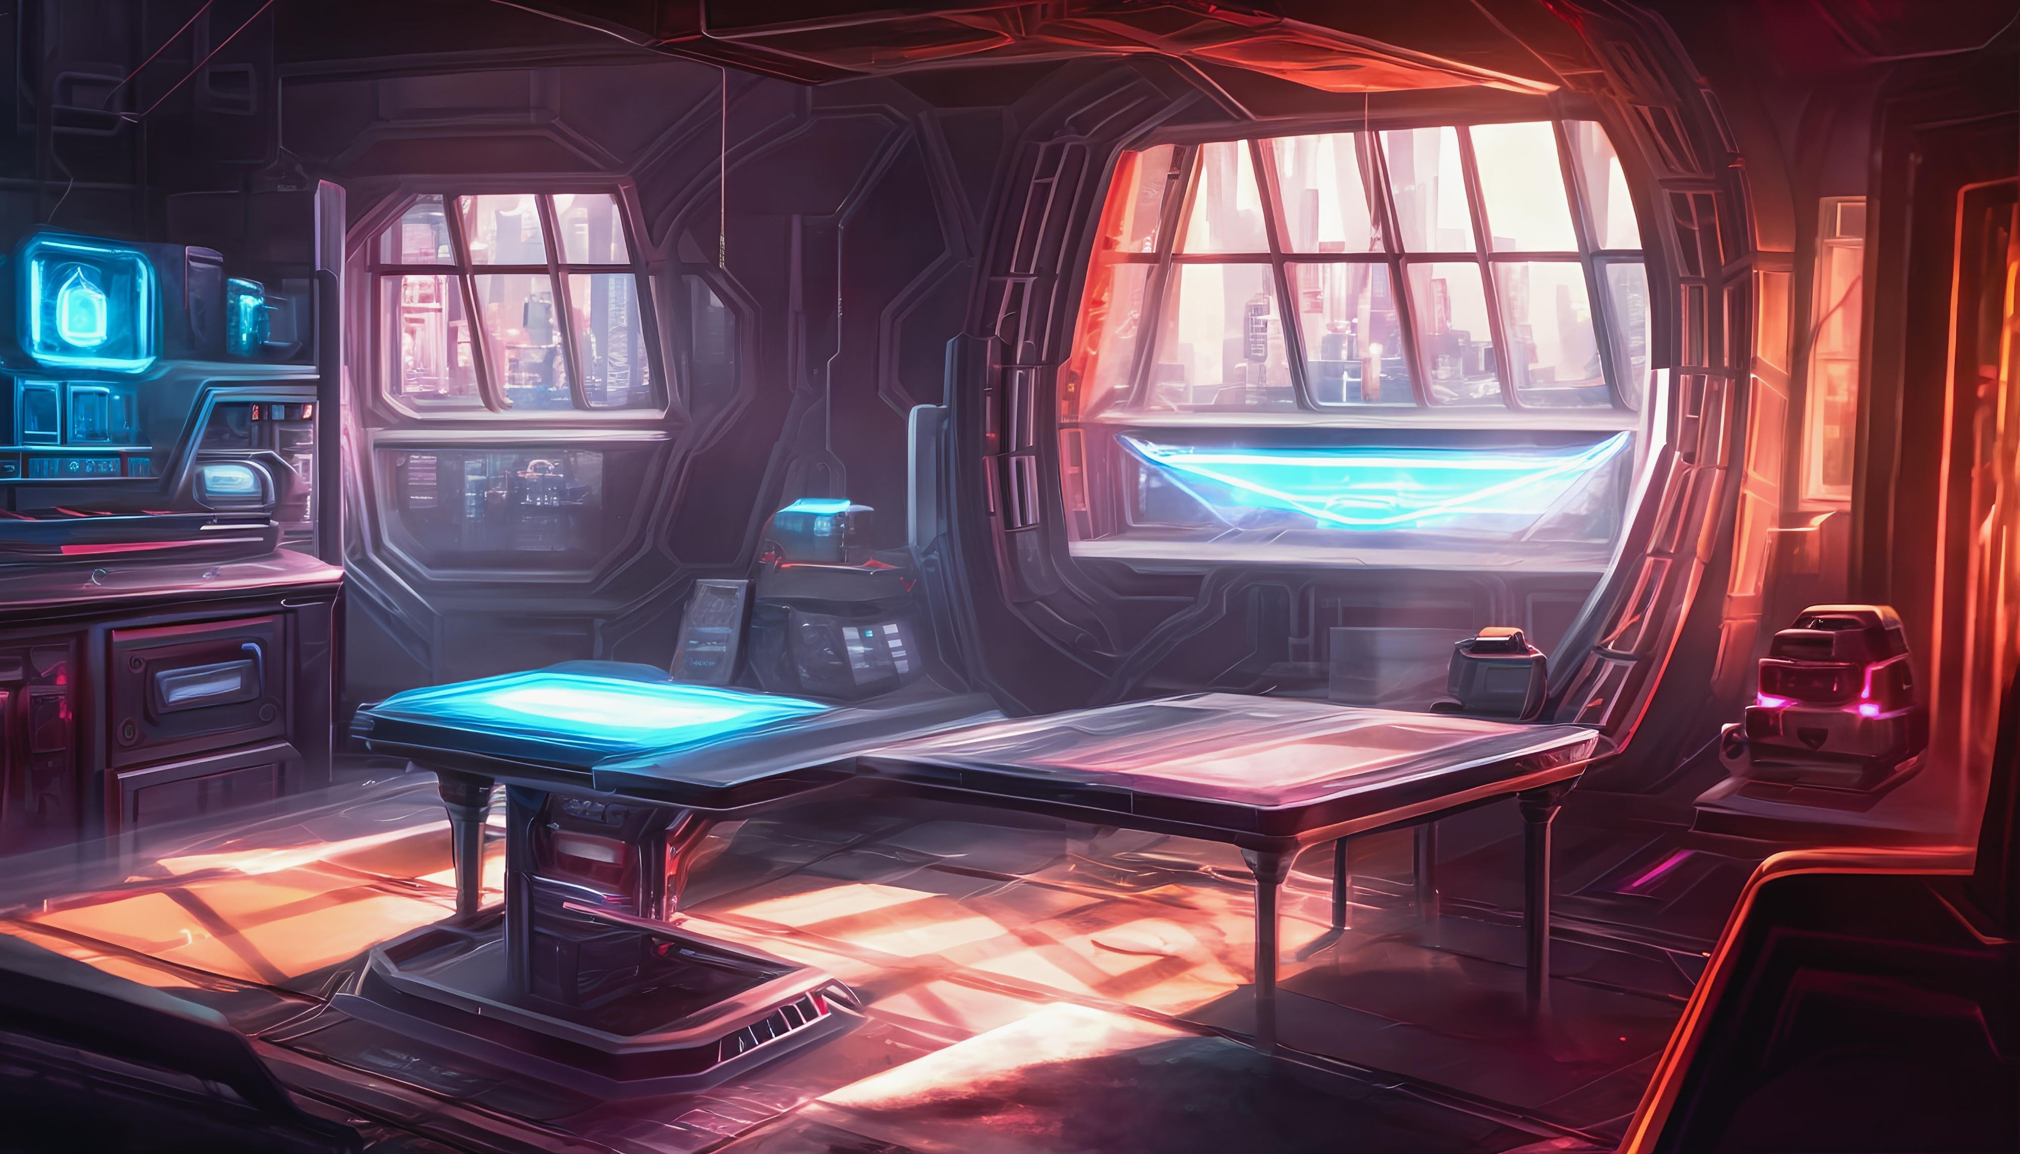
Shutterstock

2. Transporter Room (img_airlock)
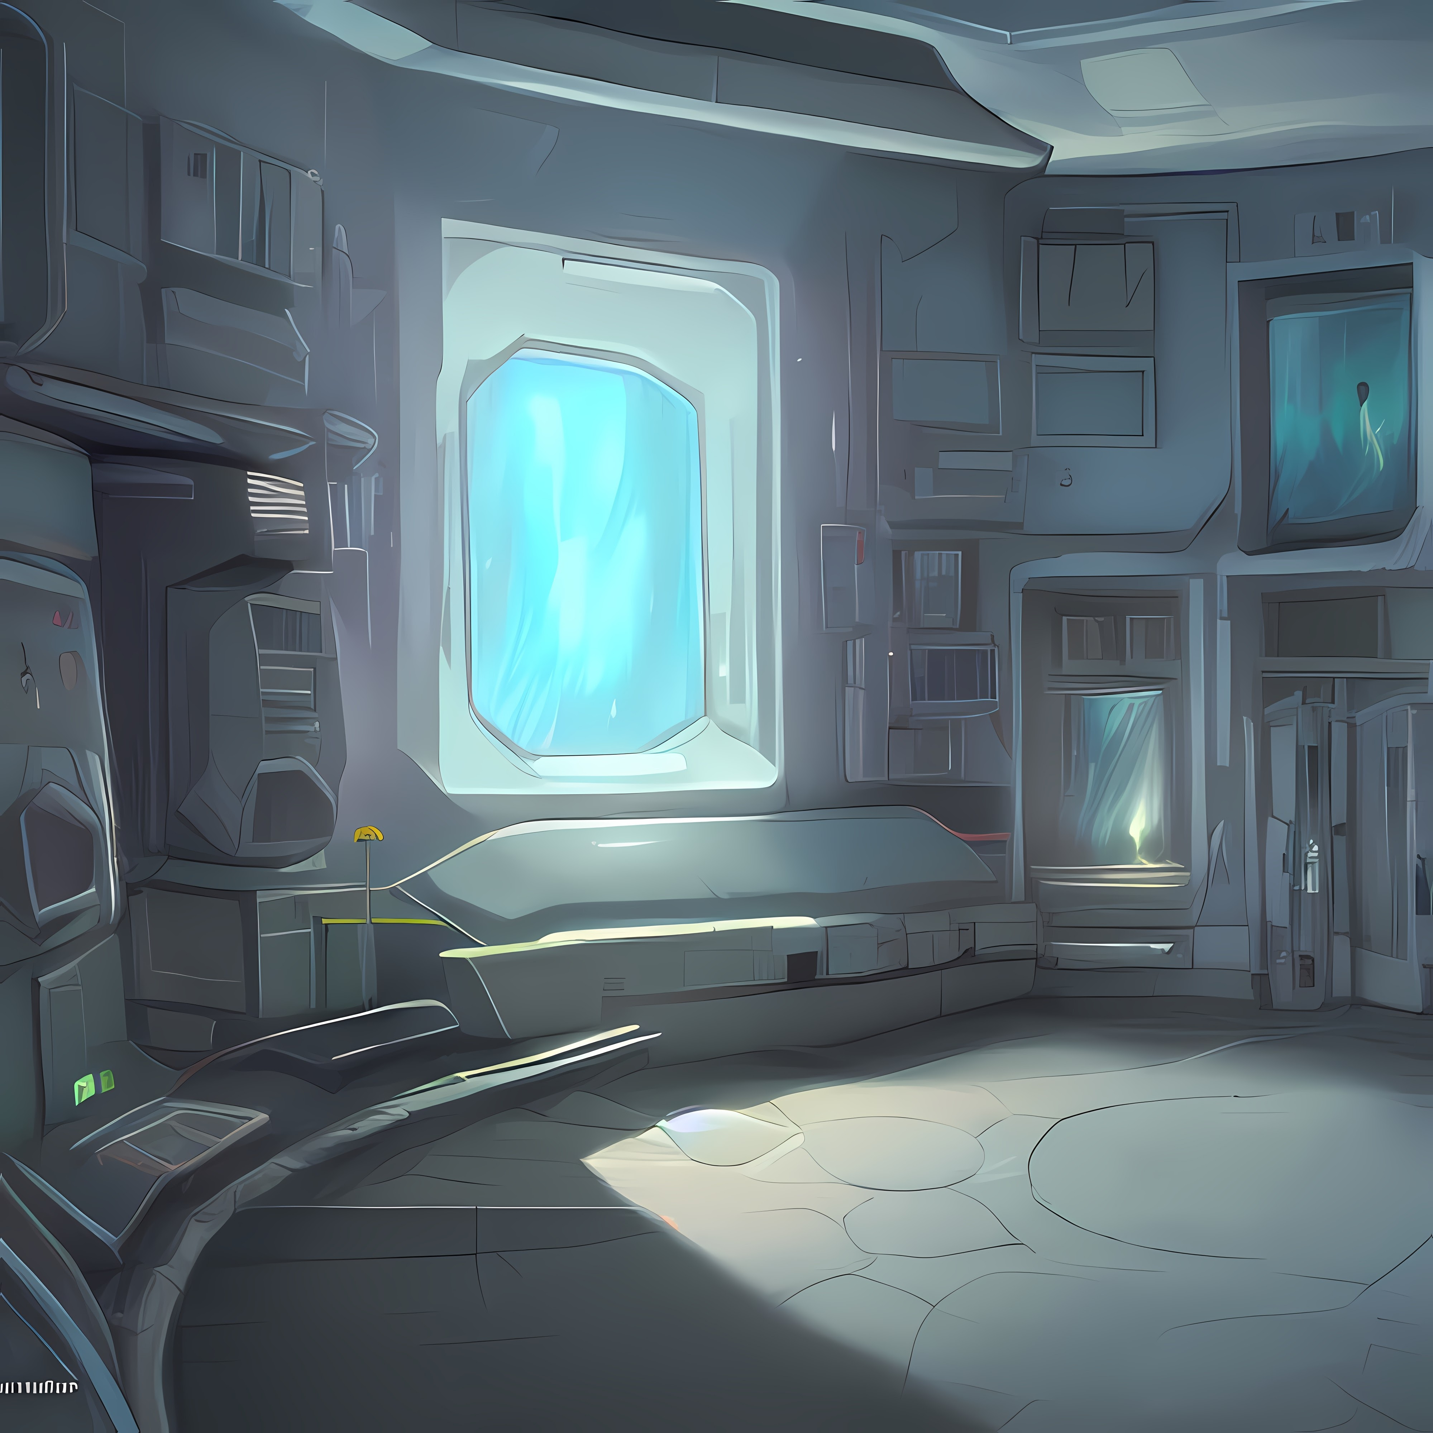
Shutterstock

3. Luna - Armstrong Outpost (img_moon)
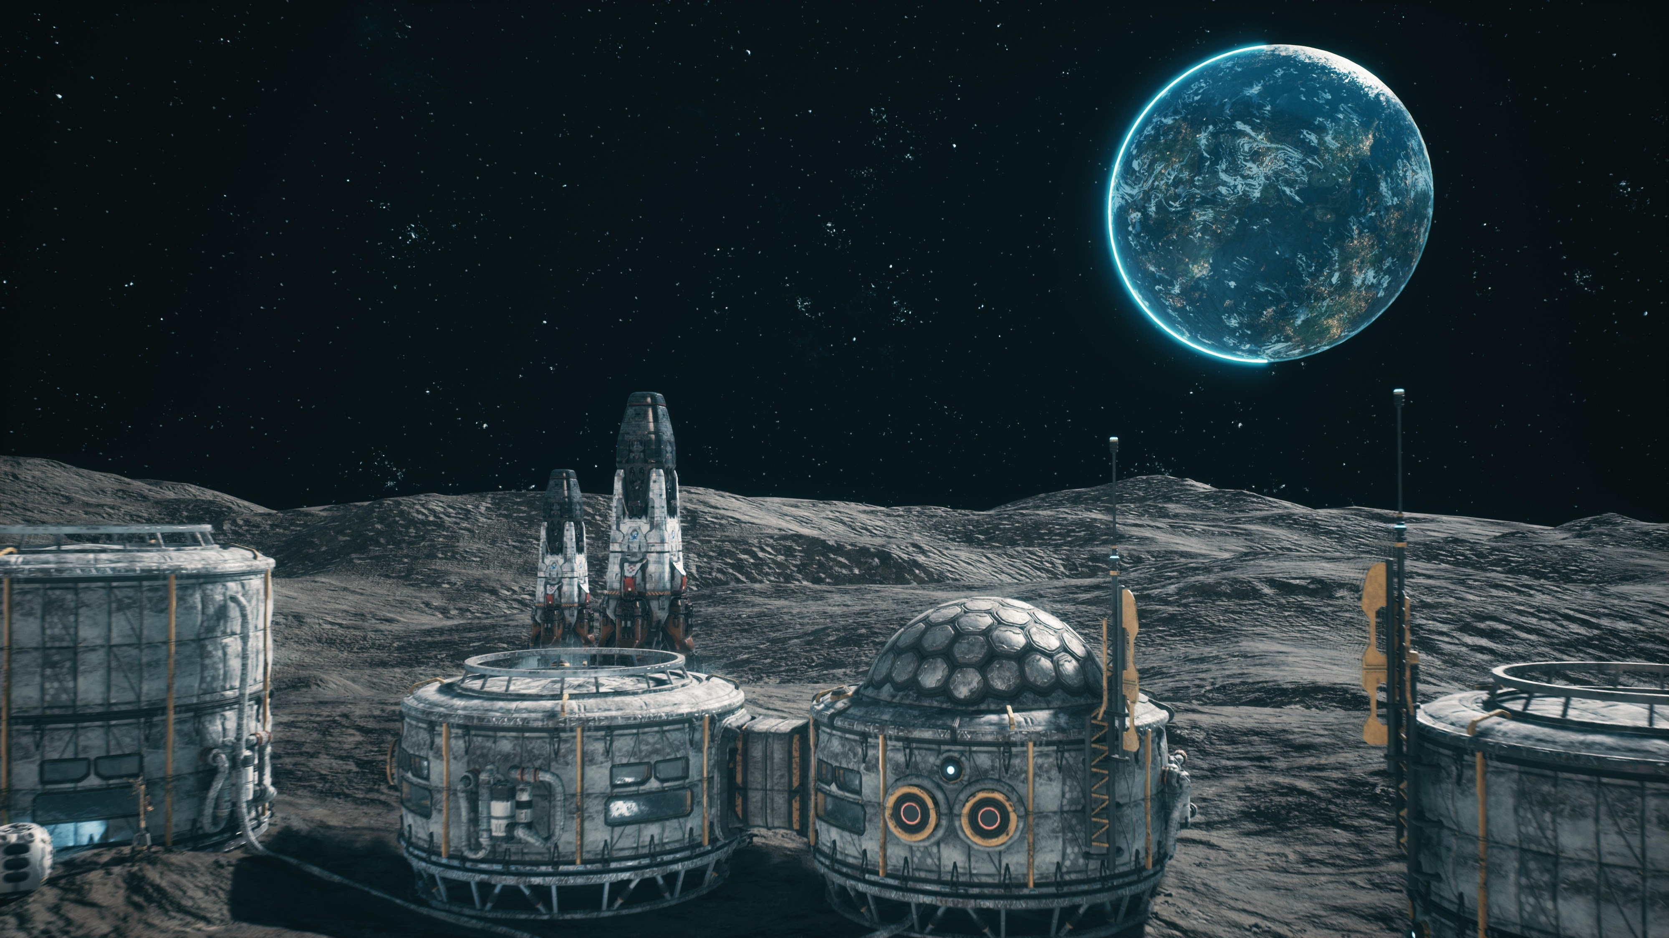
Shutterstock

4. Mars - Olympus Mons (img_mars)
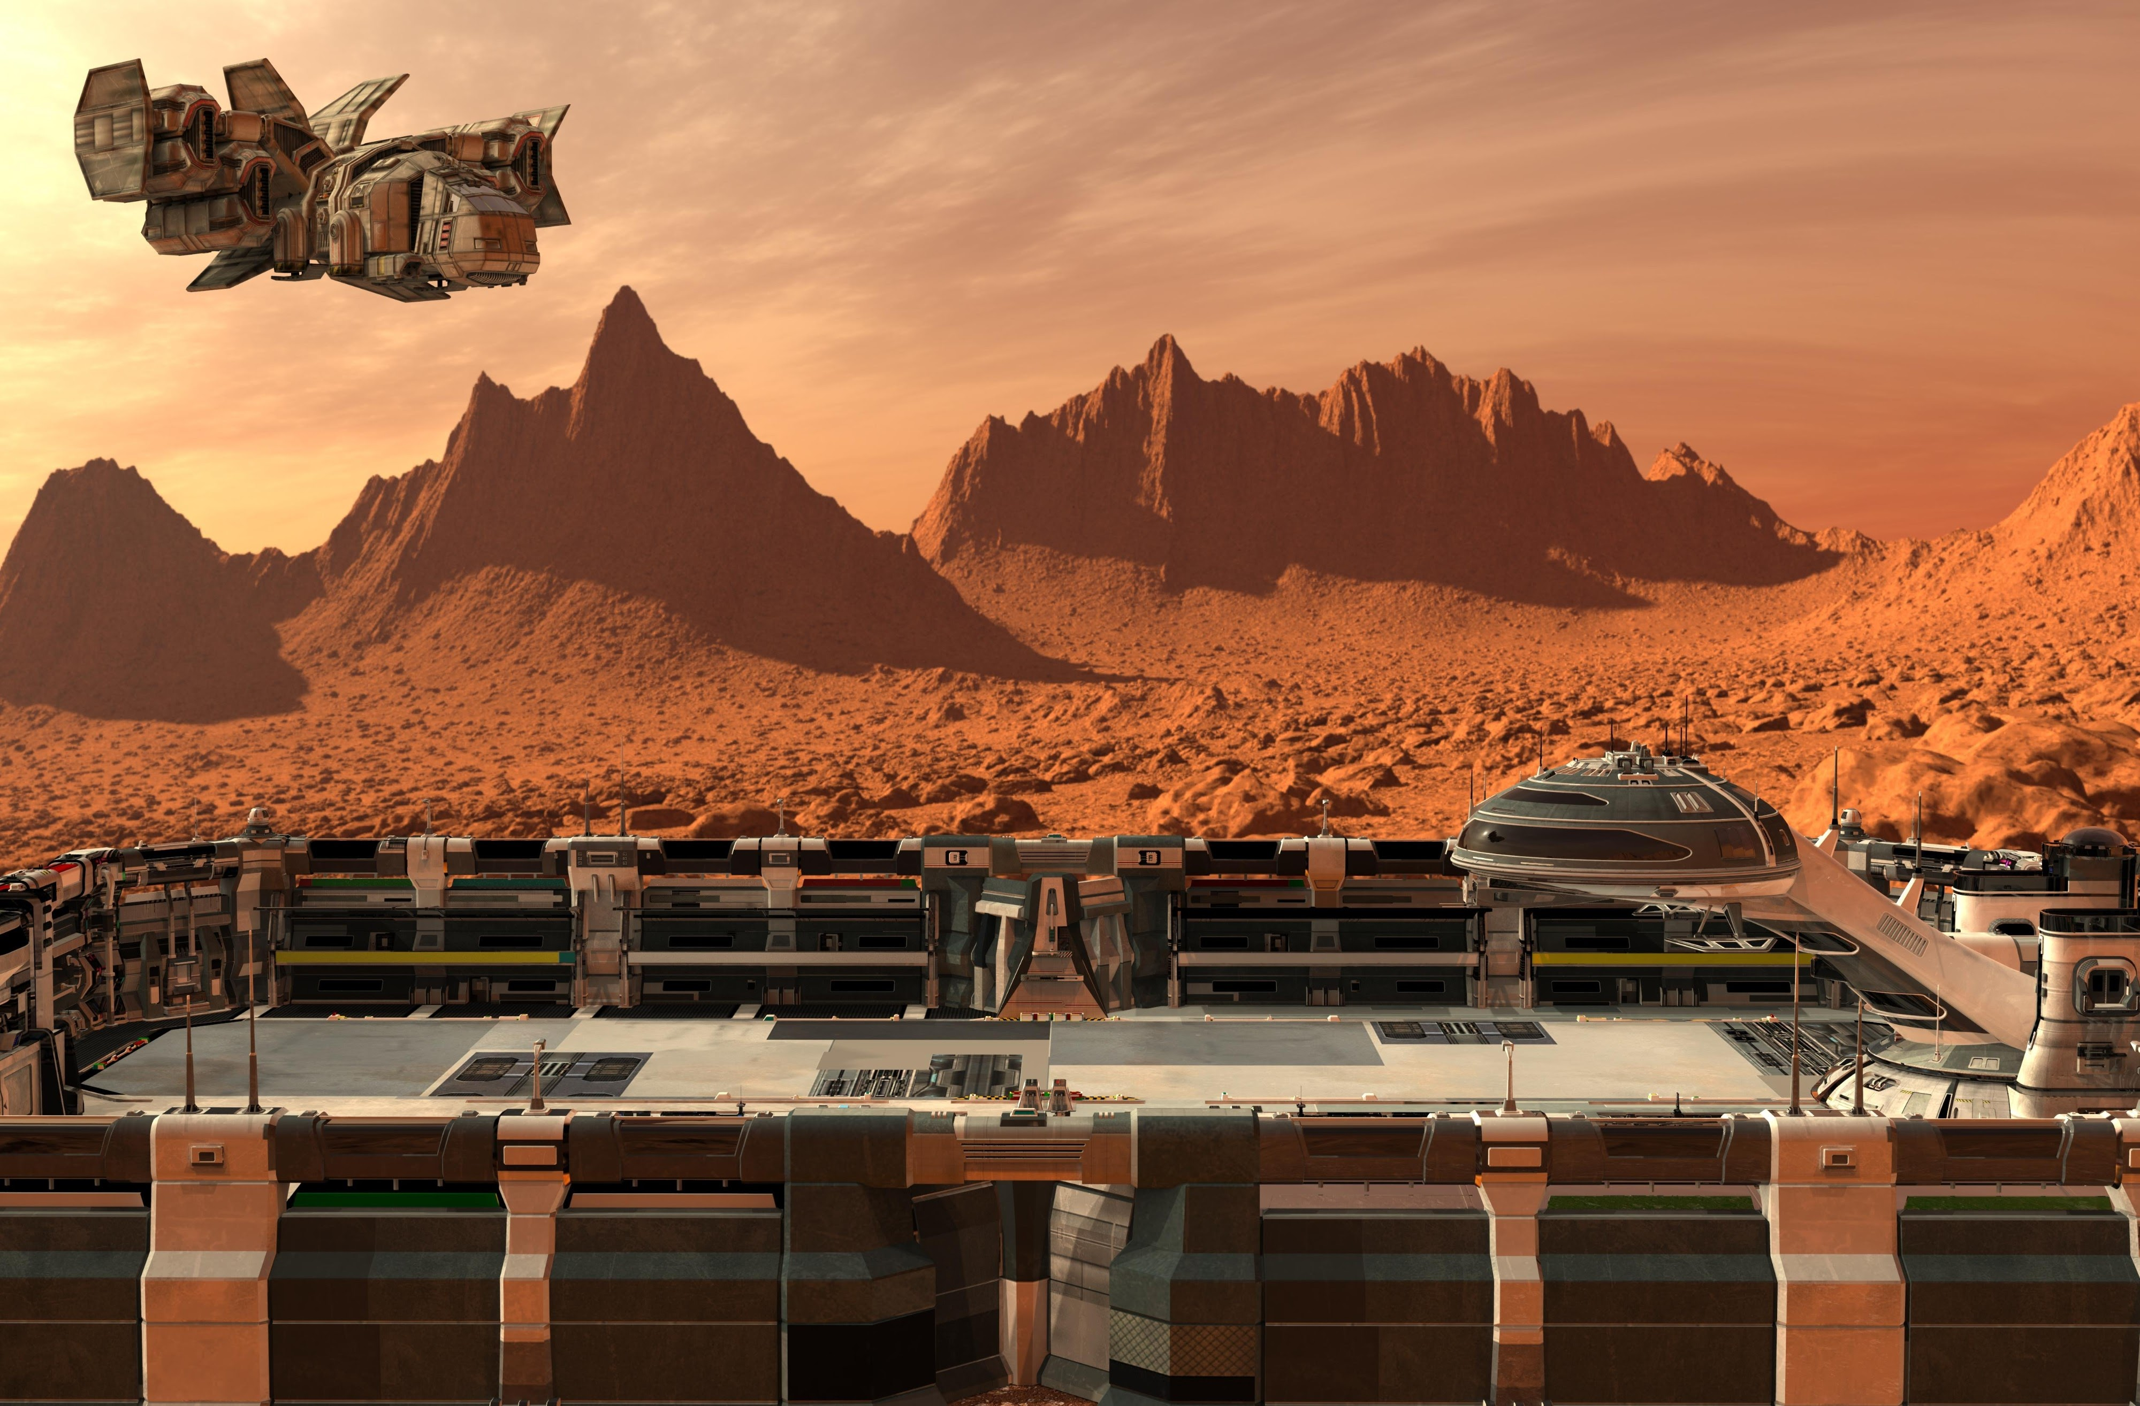
Shutterstock

5. Ceres - The Belt Hub (img_ceres)

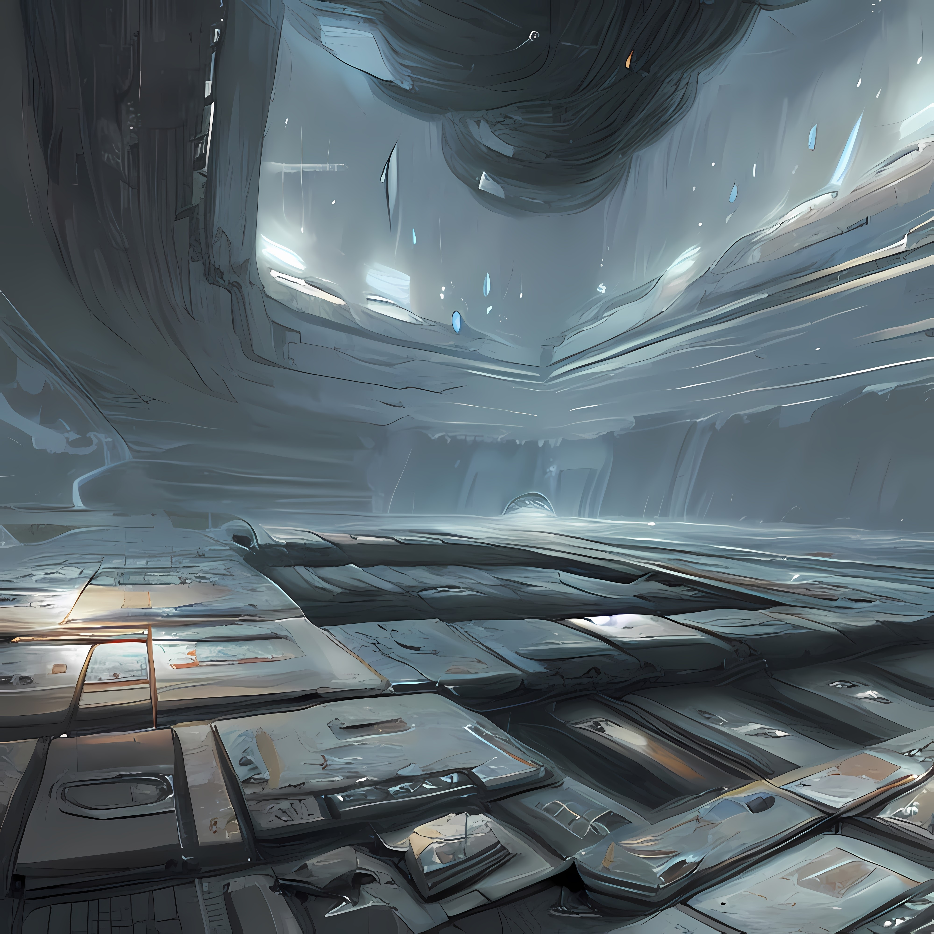
Shutterstock

How to Add These to Your Delphi Project
- Save the files: Download each image above and name them accordingly (e.g., bridge.jpg, airlock.jpg).
- Open Resources: In the Delphi IDE, go to Project > Resources and Images.
- Add Images: Click Add and select your saved files.
- Rename IDs: Double-click the "Identifier" column for each image and change it to match the code:
  - img_bridge
  - img_airlock
  - img_moon
  - img_mars
  - img_ceres
- Set Type: Ensure the "Resource Type" is set to RCDATA.
- Rebuild: Compile your project, and the game will now load these visuals as you travel!

Prompt: can you create a downloadable project zip file containing all of the code and the images so that I don't have to create everything myself?

Gemini 3 Response:
I cannot directly generate or host a downloadable .zip file for you due to security restrictions.
However, I can provide a Python script that you can run on your computer. This script will automatically create the folder, the Delphi project file (.dpr), the Unit files (.pas), and even the Form layout file (.fmx).
This effectively "builds" the project for you.

Instructions
- Copy the code below into a text file and save it as build_project.py.
- Run it using Python (e.g., python3 build_project.py in your terminal).
- It will create a folder named SolarOdyssey on your Desktop (or current folder).
- Important: You still need to download the images from my previous response and place them in that folder!

The "Project Builder" Script
Python
import os

# Define the file contents
project_source = """program SolarOdyssey;

uses
System.StartUpCopy,
FMX.Forms,
uMain in 'uMain.pas' {frmMain},
uGameEngine in 'uGameEngine.pas';

{$R *.res}

begin
Application.Initialize;
Application.CreateForm(TfrmMain, frmMain);
Application.Run;
end.
"""

# The Main Form Logic
unit_main_pas = """unit uMain;

interface

uses
System.SysUtils, System.Types, System.UITypes, System.Classes, System.Variants,
FMX.Types, FMX.Controls, FMX.Forms, FMX.Graphics, FMX.Dialogs, FMX.Memo.Types,
FMX.StdCtrls, FMX.Controls.Presentation, FMX.ScrollBox, FMX.Memo, FMX.Edit,
FMX.Layouts, FMX.Objects, uGameEngine;

type
TfrmMain = class(TForm)
StyleBook1: TStyleBook;
LayoutInput: TLayout;
edtInput: TEdit;
btnSend: TButton;
LayoutContent: TLayout;
memoLog: TMemo;
imgLocation: TImage;
procedure FormCreate(Sender: TObject);
procedure FormDestroy(Sender: TObject);
procedure btnSendClick(Sender: TObject);
procedure edtInputKeyDown(Sender: TObject; var Key: Word; var KeyChar: Char);
private
FGame: TGame;
procedure AppendLog(const Msg: string);
procedure OnGameUIUpdate(LocationName, ImageName: string);
procedure LoadImageResource(const ResName: string);
public
{ Public declarations }
end;

var
frmMain: TfrmMain;

implementation

{$R *.fmx}

procedure TfrmMain.FormCreate(Sender: TObject);
begin
FGame := TGame.Create;
FGame.OutputLog := memoLog.Lines;
FGame.OnUpdateUI := OnGameUIUpdate;
AppendLog('INITIALIZING SOLAR ODYSSEY v2.0...');
FGame.ProcessCommand('look');
end;

procedure TfrmMain.FormDestroy(Sender: TObject);
begin
FGame.Free;
end;

procedure TfrmMain.AppendLog(const Msg: string);
begin
memoLog.Lines.Add(Msg);
memoLog.GoToTextEnd;
end;

procedure TfrmMain.OnGameUIUpdate(LocationName, ImageName: string);
begin
Self.Caption := 'Solar Odyssey - ' + LocationName;
LoadImageResource(ImageName);
end;

procedure TfrmMain.LoadImageResource(const ResName: string);
var
InStream: TResourceStream;
begin
if ResName = '' then
begin
imgLocation.Bitmap.SetSize(0, 0);
Exit;
end;

if FindResource(HInstance, PChar(ResName), RT_RCDATA) <> 0 then
begin
try
InStream := TResourceStream.Create(HInstance, ResName, RT_RCDATA);
try
imgLocation.Bitmap.LoadFromStream(InStream);
finally
InStream.Free;
end;
except
AppendLog('SYSTEM WARNING: Visual feed corrupted (Image load failed).');
end;
end;
end;

procedure TfrmMain.btnSendClick(Sender: TObject);
begin
if edtInput.Text = '' then Exit;
AppendLog('> ' + edtInput.Text);
FGame.ProcessCommand(edtInput.Text);
edtInput.Text := '';
edtInput.SetFocus;
end;

procedure TfrmMain.edtInputKeyDown(Sender: TObject; var Key: Word;
var KeyChar: Char);
begin
if Key = vkReturn then
begin
Key := 0;
btnSendClick(Self);
end;
end;

end.
"""

# The Form Layout (FMX) - This saves you from dragging components manually
unit_main_fmx = """object frmMain: TfrmMain
Left = 0
Top = 0
Caption = 'Solar Odyssey'
ClientHeight = 480
ClientWidth = 640
FormFactor.Width = 320
FormFactor.Height = 480
FormFactor.Devices = [Desktop]
OnCreate = FormCreate
OnDestroy = FormDestroy
DesignerMasterStyle = 0
object StyleBook1: TStyleBook
Left = 288
Top = 232
end
object LayoutInput: TLayout
Align = Bottom
Height = 50.000000000000000000
Width = 640.000000000000000000
object edtInput: TEdit
Touch.InteractiveGestures = [LongTap, DoubleTap]
Align = Client
TabOrder = 0
OnKeyDown = edtInputKeyDown
end
object btnSend: TButton
Align = Right
Position.X = 560.000000000000000000
Size.Width = 80.000000000000000000
Size.Height = 50.000000000000000000
Size.PlatformDefault = False
TabOrder = 1
Text = 'Send'
OnClick = btnSendClick
end
end
object LayoutContent: TLayout
Align = Client
Height = 430.000000000000000000
Width = 640.000000000000000000
object memoLog: TMemo
Touch.InteractiveGestures = [Pan, LongTap, DoubleTap]
DataDetectorTypes = []
Align = Client
Size.Width = 340.000000000000000000
Size.Height = 430.000000000000000000
Size.PlatformDefault = False
TabOrder = 0
ReadOnly = True
Viewport.Width = 336.000000000000000000
Viewport.Height = 426.000000000000000000
end
object imgLocation: TImage
MultiResBitmap = <
item
end>
Align = Right
Margin.Left = 10.000000000000000000
Position.X = 340.000000000000000000
Size.Width = 300.000000000000000000
Size.Height = 430.000000000000000000
Size.PlatformDefault = False
WrapMode = Fit
end
end
end
"""

# The Game Engine Logic
unit_engine_pas = """unit uGameEngine;

interface

uses
System.SysUtils, System.Classes, System.Generics.Collections;

type
TLocation = class;
TGameUIEvent = procedure(LocationName, ImageName: string) of object;

TLocation = class
private
FName: string;
FDescription: string;
FImageRes: string;
FExits: TDictionary<string, TLocation>;
FItems: TStringList;
public
constructor Create(const AName, ADescription, AImageRes: string);
destructor Destroy; override;
procedure AddExit(const ACommand: string; ATarget: TLocation);
function GetExit(const ACommand: string): TLocation;
property Name: string read FName;
property Description: string read FDescription;
property ImageRes: string read FImageRes;
property Items: TStringList read FItems;
end;

TGame = class
private
FLocations: TObjectList<TLocation>;
FCurrentLocation: TLocation;
FOutputLog: TStrings;
FInventory: TStringList;
FOnUpdateUI: TGameUIEvent;
procedure BuildSolarSystem;
procedure Look;
procedure ListInventory;
procedure TakeItem(const AItemName: string);
public
constructor Create;
destructor Destroy; override;
function ProcessCommand(const AInput: string): string;
property OutputLog: TStrings read FOutputLog write FOutputLog;
property OnUpdateUI: TGameUIEvent read FOnUpdateUI write FOnUpdateUI;
end;

implementation

{ TLocation }

constructor TLocation.Create(const AName, ADescription, AImageRes: string);
begin
FName := AName;
FDescription := ADescription;
FImageRes := AImageRes;
FExits := TDictionary<string, TLocation>.Create;
FItems := TStringList.Create;
end;

destructor TLocation.Destroy;
begin
FExits.Free;
FItems.Free;
inherited;
end;

procedure TLocation.AddExit(const ACommand: string; ATarget: TLocation);
begin
FExits.Add(ACommand.ToLower, ATarget);
end;

function TLocation.GetExit(const ACommand: string): TLocation;
begin
if not FExits.TryGetValue(ACommand.ToLower, Result) then
Result := nil;
end;

{ TGame }

constructor TGame.Create;
begin
FLocations := TObjectList<TLocation>.Create(True);
FInventory := TStringList.Create;
BuildSolarSystem;
end;

destructor TGame.Destroy;
begin
FInventory.Free;
FLocations.Free;
inherited;
end;

procedure TGame.BuildSolarSystem;
var
ShipBridge, Airlock, MoonBase, MarsColony, CeresStation: TLocation;
begin
ShipBridge := TLocation.Create('UES Copernicus - Bridge',
'You are on the command deck. The "Airlock" is to the South.', 'img_bridge');

Airlock := TLocation.Create('Transporter Room',
'The warp drive hums. Navigate to: "warp moon", "warp mars", "warp ceres".', 'img_airlock');
Airlock.Items.Add('Space Suit');

MoonBase := TLocation.Create('Luna - Armstrong Outpost',
'The gray dust of the moon stretches endlessly.', 'img_moon');
MoonBase.Items.Add('Moon Rock');
MoonBase.Items.Add('Helium-3 Canister');

MarsColony := TLocation.Create('Mars - Olympus Mons',
'Red dust coats the mag-lev tracks.', 'img_mars');
MarsColony.Items.Add('Red Sand Sample');

CeresStation := TLocation.Create('Ceres - The Belt Hub',
'A hollowed-out asteroid city.', 'img_ceres');
CeresStation.Items.Add('Ice Chunk');

FLocations.AddRange([ShipBridge, Airlock, MoonBase, MarsColony, CeresStation]);

ShipBridge.AddExit('south', Airlock);
Airlock.AddExit('north', ShipBridge);
Airlock.AddExit('warp moon', MoonBase);
Airlock.AddExit('warp mars', MarsColony);
Airlock.AddExit('warp ceres', CeresStation);

MoonBase.AddExit('return', Airlock);
MarsColony.AddExit('return', Airlock);
CeresStation.AddExit('return', Airlock);

FCurrentLocation := ShipBridge;
end;

procedure TGame.Look;
var
I: Integer;
begin
if Assigned(FOutputLog) then
begin
FOutputLog.Add('');
FOutputLog.Add('--- ' + FCurrentLocation.Name + ' ---');
FOutputLog.Add(FCurrentLocation.Description);
if FCurrentLocation.Items.Count > 0 then
begin
FOutputLog.Add('Visible Items:');
for I := 0 to FCurrentLocation.Items.Count - 1 do
FOutputLog.Add(' - ' + FCurrentLocation.Items[I]);
end;
FOutputLog.Add('Exits: ' + string.Join(', ', FCurrentLocation.FExits.Keys.ToArray));
FOutputLog.Add('');
end;
if Assigned(FOnUpdateUI) then
FOnUpdateUI(FCurrentLocation.Name, FCurrentLocation.ImageRes);
end;

procedure TGame.ListInventory;
begin
if Assigned(FOutputLog) then
begin
FOutputLog.Add('INVENTORY:');
if FInventory.Count = 0 then FOutputLog.Add(' (Empty)')
else FOutputLog.Add(FInventory.Text);
end;
end;

procedure TGame.TakeItem(const AItemName: string);
var
Idx: Integer;
begin
Idx := -1;
for var I := 0 to FCurrentLocation.Items.Count - 1 do
if SameText(FCurrentLocation.Items[I], AItemName) then
begin
Idx := I;
Break;
end;

if Idx <> -1 then
begin
FInventory.Add(FCurrentLocation.Items[Idx]);
FOutputLog.Add('Taken: ' + FCurrentLocation.Items[Idx]);
FCurrentLocation.Items.Delete(Idx);
end
else
FOutputLog.Add('Item not found here.');
end;

function TGame.ProcessCommand(const AInput: string): string;
var
Cmd, Param: string;
SpacePos: Integer;
NextLoc: TLocation;
begin
Cmd := AInput.Trim;
Param := '';
SpacePos := Pos(' ', Cmd);
if SpacePos > 0 then
begin
Param := Copy(Cmd, SpacePos + 1, Length(Cmd));
Cmd := Copy(Cmd, 1, SpacePos - 1);
end;
Cmd := Cmd.ToLower;

if Cmd = 'look' then begin Look; Exit; end;
if (Cmd = 'inventory') or (Cmd = 'i') then begin ListInventory; Exit; end;
if Cmd = 'take' then begin TakeItem(Param); Exit; end;

NextLoc := FCurrentLocation.GetExit(Cmd + ' ' + Param);
if NextLoc = nil then NextLoc := FCurrentLocation.GetExit(Cmd);

if Assigned(NextLoc) then
begin
FCurrentLocation := NextLoc;
Look;
end
else
if Assigned(FOutputLog) then FOutputLog.Add('Unknown command.');
end;

end.
"""

def create_project():
folder_name = "SolarOdyssey"

if not os.path.exists(folder_name):
os.makedirs(folder_name)
print(f"Created folder: {folder_name}")

files = {
"SolarOdyssey.dpr": project_source,
"uMain.pas": unit_main_pas,
"uMain.fmx": unit_main_fmx,
"uGameEngine.pas": unit_engine_pas
}

for filename, content in files.items():
with open(os.path.join(folder_name, filename), "w") as f:
f.write(content)
print(f"Created file: {filename}")

print("\nSUCCESS! Project created.")
print("Next Steps:")
print("1. Download the images.")
print(f"2. Place them inside the '{folder_name}' folder.")
print("3. Open SolarOdyssey.dpr in Delphi.")
print("4. Go to Project > Resources and Images and add the images (Type: RCDATA).")

if __name__ == "__main__":
create_project()

