1. Create the inner and outer track limits in a SolidWorks sketch using sketch points.

-Sketches must be created in the XY plane

-The # points must be the same for each of the limits

-The points must be -in pairs- approximately in the same perpendicular line to the track

-The first point must be the (corresponding) same one for both limits

-The contour must be closed (i.e. the last point must be repeated)

To do it, use an aerial photo of the circuit zone. Import it via Tools/Sketch Tools/Sketch Picture, and rescale it by means of the rescaling arrow, using as a reference the scale of Google Maps that should appear in the screenshot. The units should be meters (i.e. you can work in mm as long as 10 mm correspond to 10 m and the data is exported in mm).

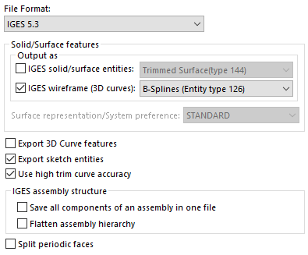2. Export both sketches at once as an IGS with the following settings:

3. Use a text editor like *Visual Studio Code* or *Notepad++* and, by means of the *Shift+alt* option, select the set of points corresponding to each of the track limits, and save each of them in a different file.

3. Run the *module_trackMap* to generate the track map (mesh).