Medicaid Spending

Data Description:
Column | Description
BILLING_PROVIDER_NPI_NUM | ID for provider/entity which billed the service
SERVICING_PROVIDER_NPI_NUM | ID for provider/entity which performed the service
HCPCS_CODE | Procedure/service code billed
CLAIM_FROM_MONTH | Month in which the claims came
TOTAL_UNIQUE_BENEFICIARIES | Number of distinct Medicaid members with at least one claim in that group
TOTAL_CLAIMS | Total number of claims (or claim lines, depending on source definition) in that group
TOTAL_PAID | Total dollars paid for those claims in that group

New Columns:
Column | Description
AVG_CLAIMS_PER_PATIENT | Total Claims / Total Unique Beneficiaries
AVG_PAYMENT_AMT | Total Paid / Total Claims
AVG_PAID_PER_BENEFICIARY | Total Paid / Total Unique Beneficiaries
IS_SELF_BILLING | Binary if Billing = Servicing

Data Ranges from 2018-2024

Total Medicaid paid:
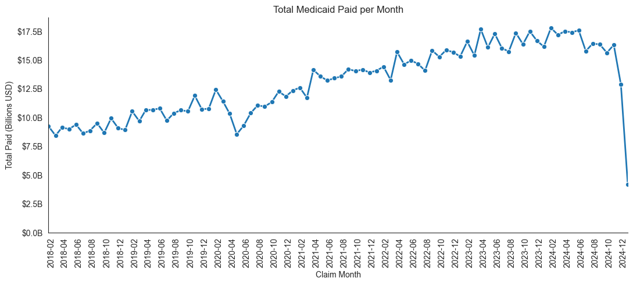
Total Claims:
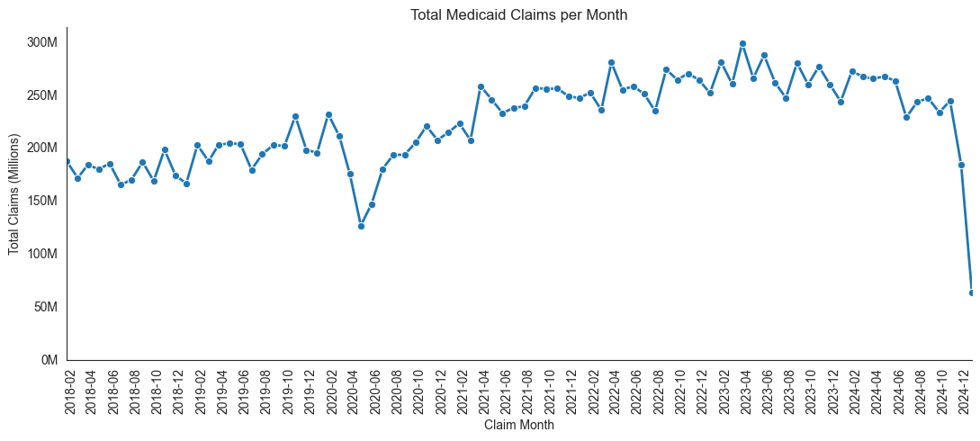

Are more people on Medicaid?
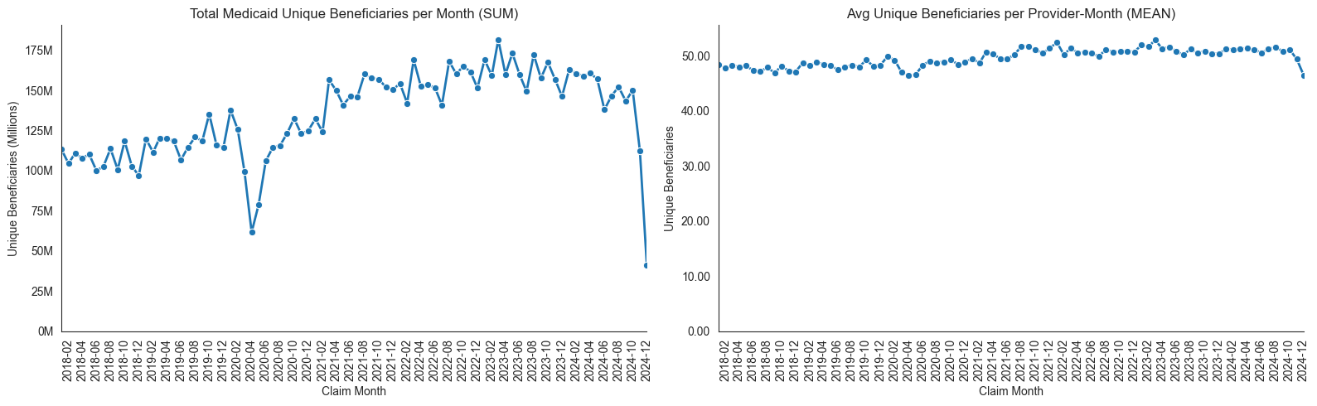

Did Medicaid get more expensive?
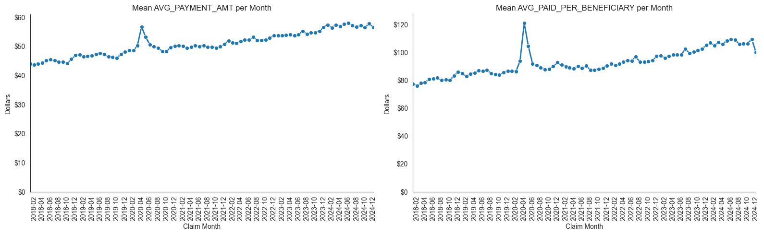
Distributional Data:
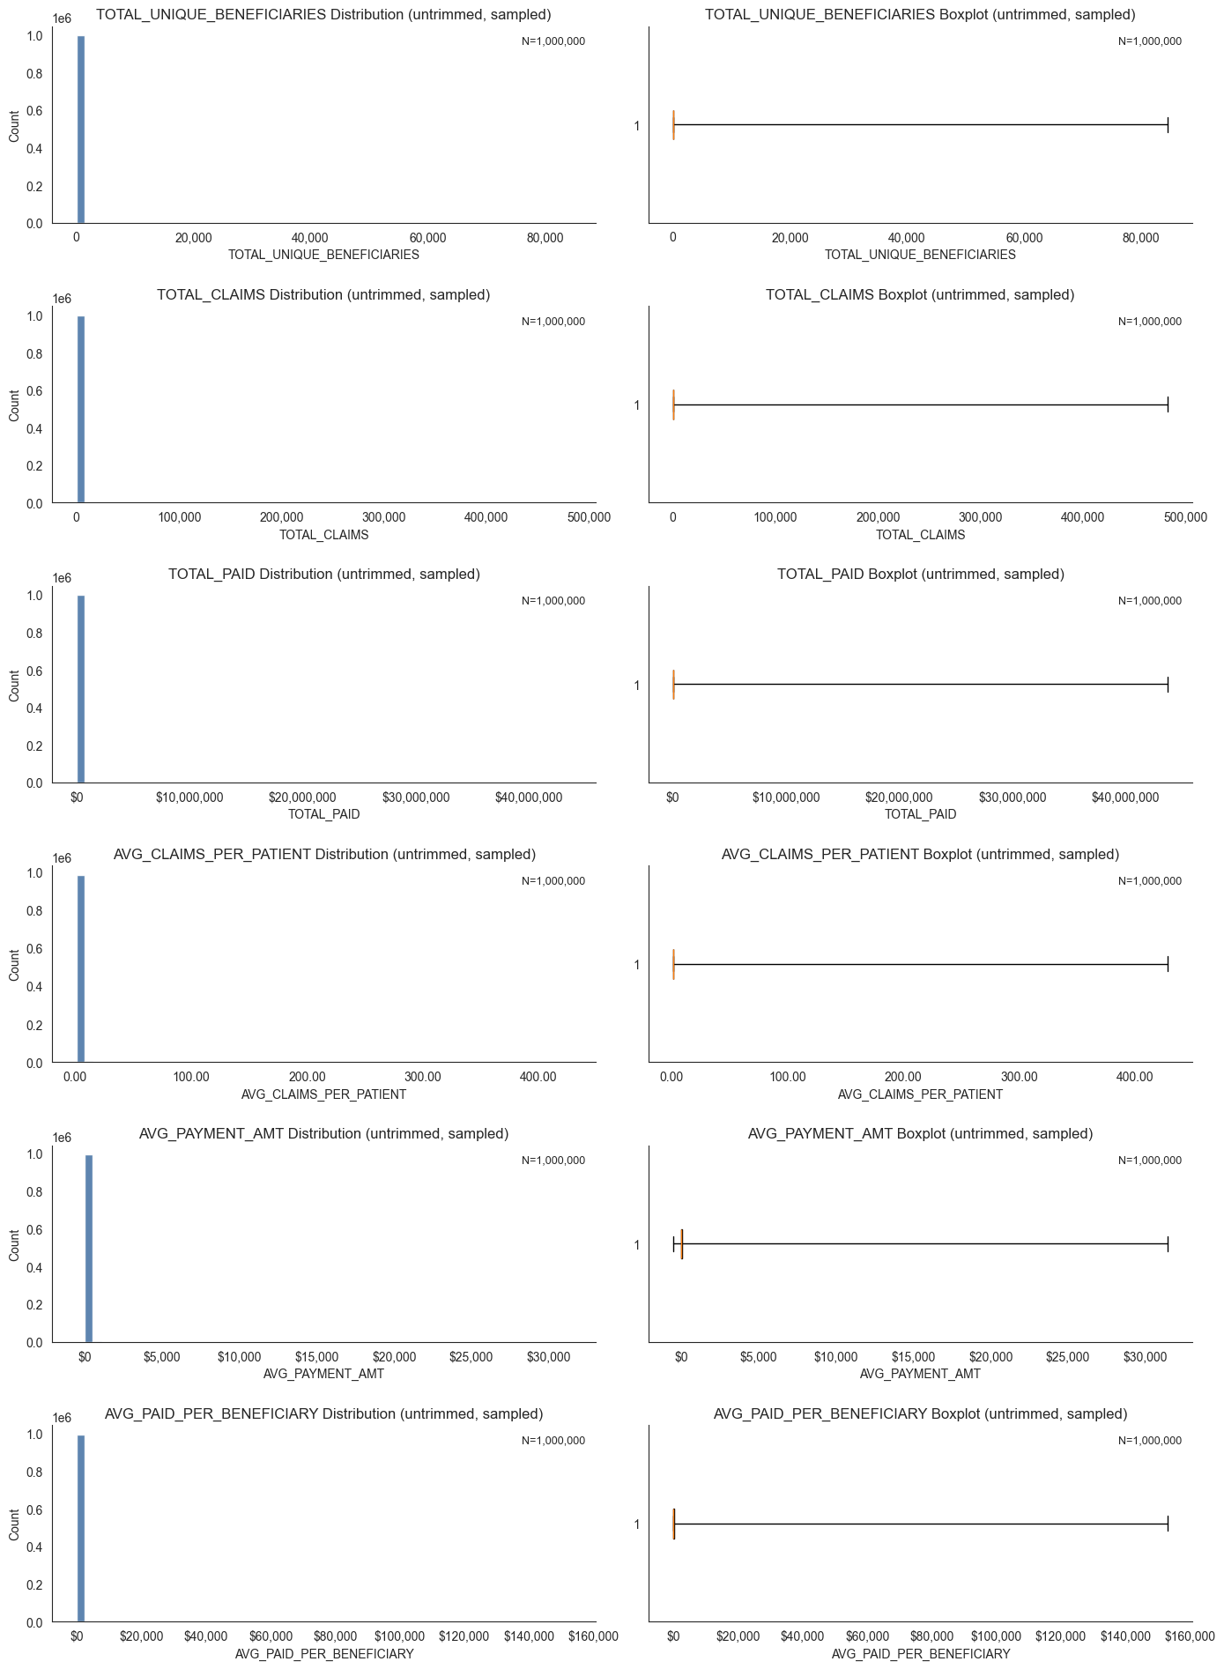
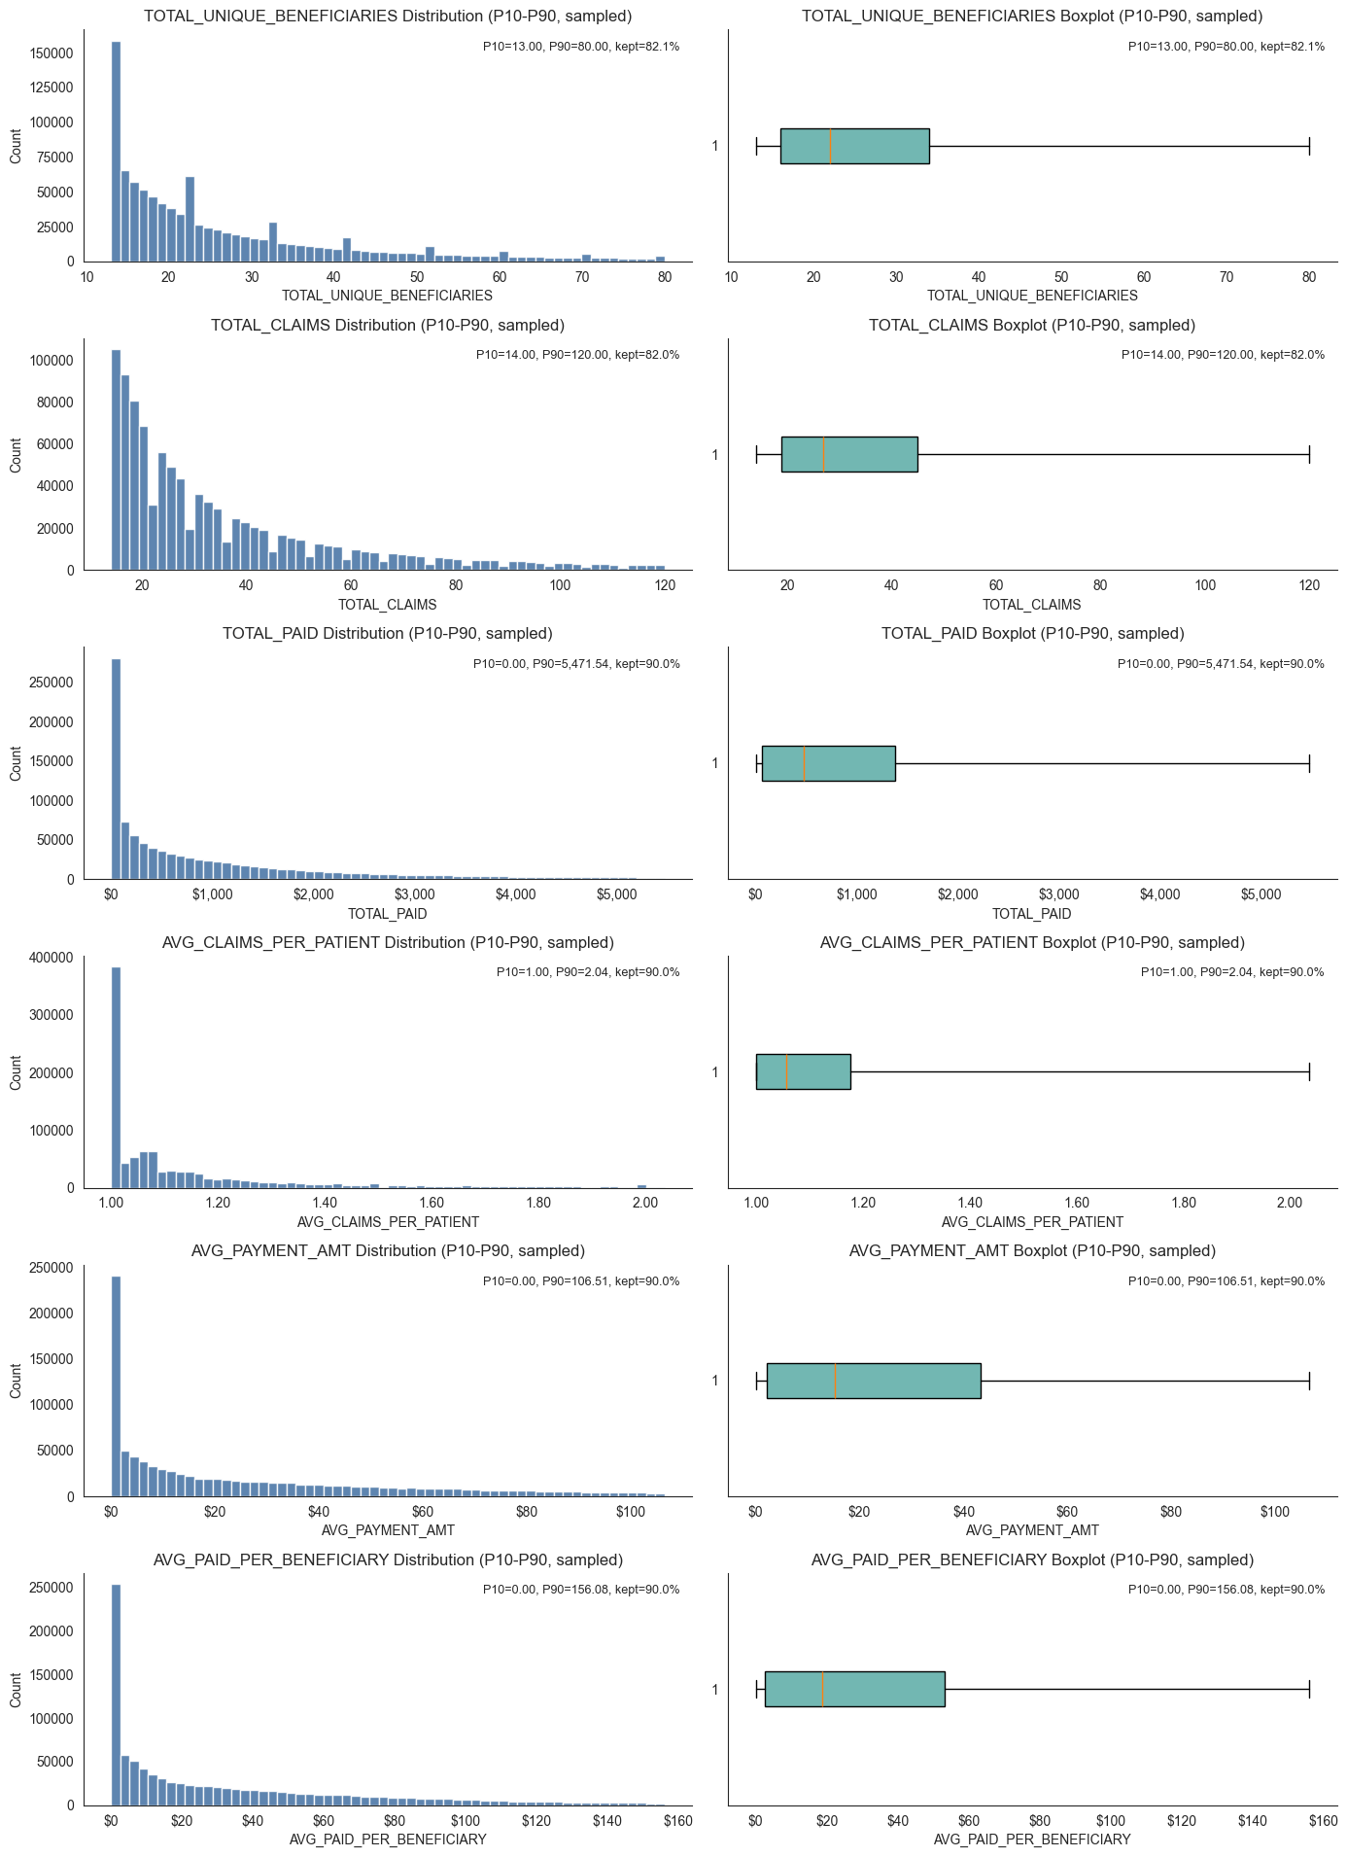
Week2:
Built web scrapers but they didn’t work so well (HCPCS codes). Went off of predetermined ranges for neurology and cardiovascular

https://www.aapc.com/codes/cpt-codes-range/92920-93799/

Cardiovascular:
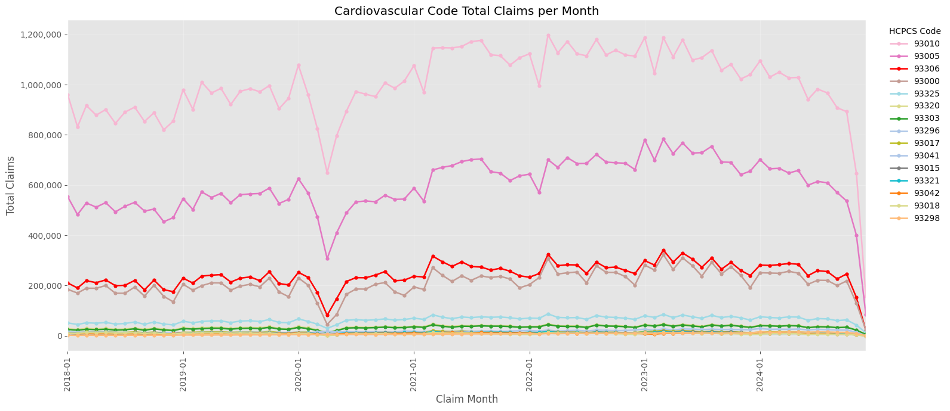
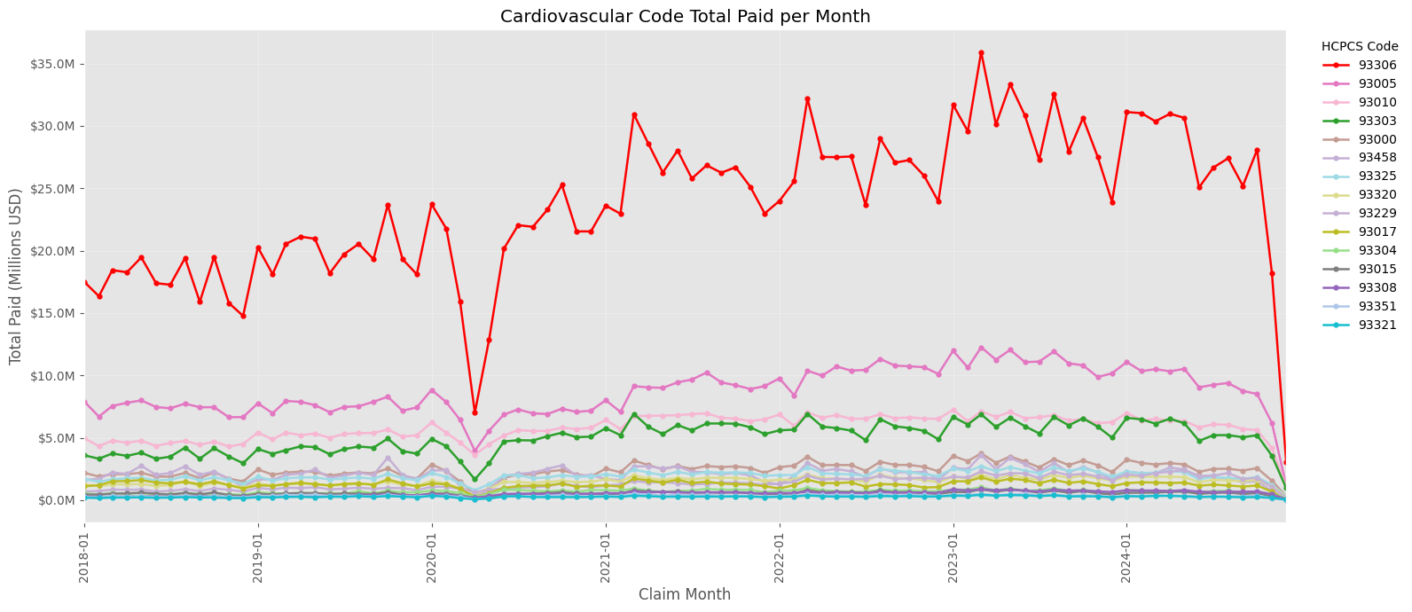

Code ref:
93010 | the professional component (interpretation and report) of a routine electrocardiogram (ECG/EKG) with at least 12 leads
93005 | used to bill for the technical component (the tracing only) of a routine electrocardiogram (ECG/EKG) with at least 12 leads, specifically excluding the physician's interpretation and report
93306 | complete, comprehensive transthoracic echocardiogram (TTE) for adults, including 2D imaging, M-mode recording, spectral Doppler, and color flow Doppler to evaluate heart structure and function
93000 | used to report a routine, global electrocardiogram (ECG/EKG) with at least 12 leads
93325 | Doppler echocardiography color flow velocity mapping
93303 | complete transthoracic echocardiogram (TTE) specifically for diagnosing or assessing congenital cardiac anomalies in infants, children, and adults

Neurology
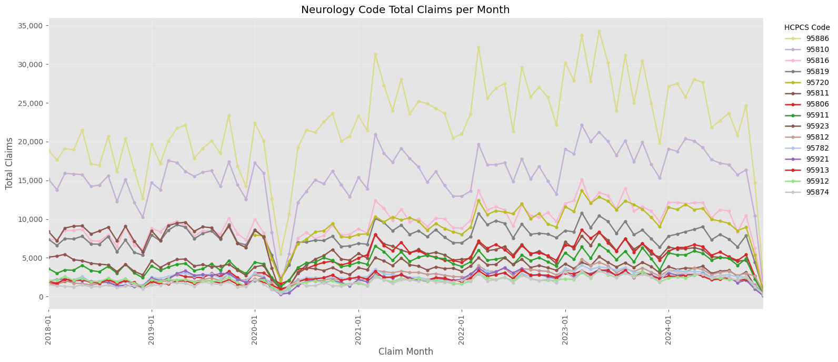
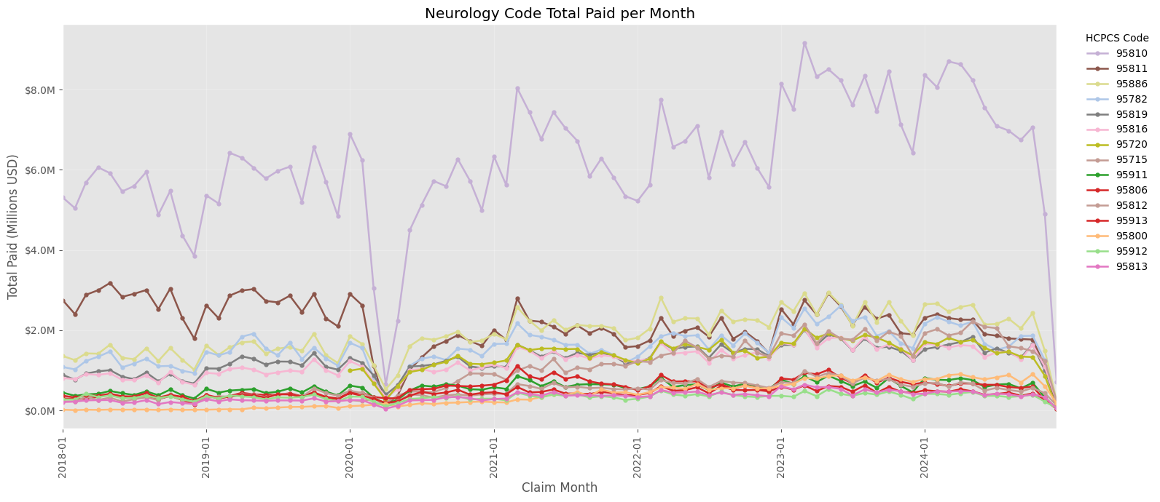

Code ref:
95886 | a complete needle electromyography (EMG) of one extremity (plus related paraspinal muscles if needed) performed on the same day as a nerve conduction study (NCS)
95810 | an in-lab, technologist-attended polysomnography (sleep study) for patients aged 6 years and older, used to diagnose sleep disorders
95816 | a routine EEG (Electroencephalogram) that records brain electrical activity while the patient is awake and drowsy
95811 | attended, overnight polysomnography (sleep study) with PAP (Positive Airway Pressure) titration for patients aged 6 years or older
95782 | attended polysomnography (sleep study) for children younger than 6 years old, involving sleep staging with at least 4 additional parameters
95819 | a routine EEG that records brain electrical activity while the patient is both awake and asleep, typically lasting 20–40 minutes

Week 3:
