## HW07: Cloud Computing

SEIS 752: Advanced Web Application Engineering – Spring 2014

Instructor: Lloyd Cledwyn

Student: Dave Olson

**Summary**

Publish an app into "the cloud".

**Purpose**

To research available web services, discover the functionalities, and implement a solution of a combination of them.

**Why Cloud Computing?**

“Whether you are running applications that share photos or support the critical operations of your business, you need rapid access to flexible and low cost IT resources. The term "Cloud Computing" refers to the on-demand delivery of IT resources via the Internet with pay-as-you-go pricing.”

*From the Amazon Web Services site*

Cloud Computing enables the ‘outsourcing’ of the physical components of information technology. By purchasing shared services an individual or business can host their applications, platforms, and infrastructure as a service. The primary benefits are cost, scalability, dynamic resource allocation based on need, and the ability to focus on providing a product or service that people want or need vs. spending time, money, and resources ‘keeping the lights on’.

Out of the three services I considered - AWS, Google, and Azure - I chose to implement Amazon Web Services because:

* I wanted to ‘experience’ AWS.
* Our project team was considering the option of using S3 as a storage option for assets (photos, videos, etc.) related to our ScrapAttack website.
* I had just worked with Google Developer for OAuth and wanted to expand the number of providers I worked with.
* AWS has a competitive pricing model and a robust suite of web services to choose from.
* Depending on what I choose to do next in my career I may become an AWS power user.

So, depending on what I want to do in the cloud, how do I determine if I want to continue and possibly expand my relationship with AWS?

Let’s look at my current needs. For now my needs are few. I need a web presence that allows me to market my skills and show examples of my work with the end goal of landing freelance work, consulting opportunities, or permanent employment. It will most likely be difficult for AWS to match the offerings of existing web hosts at this level of need.

For a single medium instance of EC2 (Linux) at 100% utilization/mo. my cost is $51.24/mo.:

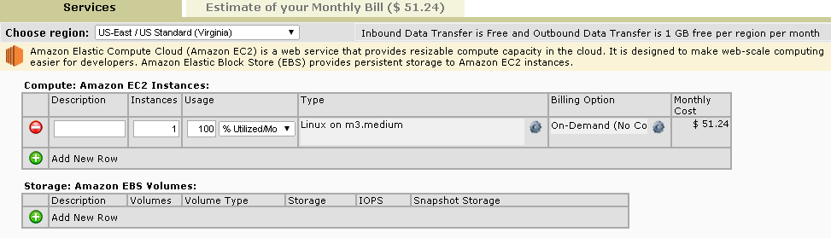

*Figure 1: Amazon EC2 Instance – Linux on m3.medium – Estimated Monthly Cost*

For a single medium instance of EC2 (Windows) at 100% utilization /mo. my cost is $97.36/mo.:

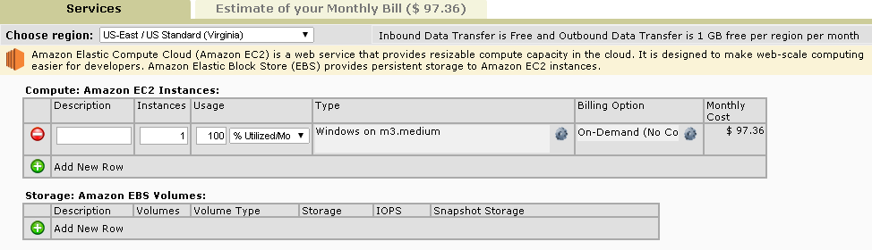

*Figure 2: Amazon EC2 Instance – Windows on m3.medium – Estimated Monthly Cost*

There is a Free Tier option that provides an extremely cost effective hosting alternative but this is available for 12 months at which time I believe the free lunch is over. These micro instances also suffer from performance issues and can cause frustration for anything but the simplest site.

For a single micro instance of EC2 (Linux) at 100% utilization/mo. my cost is $0.00/mo. (then $14.64):

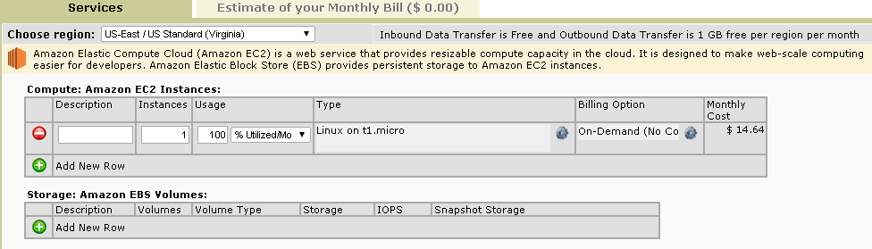

*Figure 3: Amazon EC2 Instance – Linux on t1.micro – Estimated Monthly Cost*

For a single micro instance of EC2 (Windows) at 100% utilization/mo. my cost is $0.00/mo. (then $14.64):

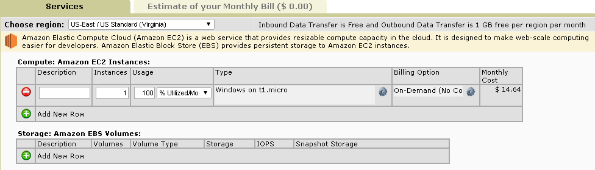

*Figure 4: Amazon EC2 Instance – Windows on t1.micro – Estimated Monthly Cost*

At this minimal need level it makes sense for me to continue hosting with Dreamhost or another web host company.

**My Experience Working With AWS EC2 (and S3)**

My initial foray into AWS was S3. I was able to quickly and easily establish my account and set up a bucket in S3 to hold images. Our project team was going to implement S3 as a possible storage option for our ScrapAttack web site. We were not able to complete the S3 integration due to time constraints. Here is an example of an image in our S3 bucket:

<https://s3.amazonaws.com/scrapattack_000003/Billy_Bobs_First_Flight.jpg>

My next experience with AWS was implementing an EC2 Instance of Linux m3.medium in the US West (Oregon) region (see figure 5). I had a hiccup when I put the cart before the horse and tried to Connect before I had done the initial setup steps. I realized my problem and performed the setup. I then experienced my second hiccup when I tried to Connect while at work. The ‘guest’ network which had previously been open had recently restricted some ports, one of which was required for the connection (SSH on port 22) so I was receiving ‘connection error’ messages despite trying many different permutations of key generation, using Putty and Puttygen with the AWS generated key, generating the key outside of AWS and importing. None of these attempts resolved my connection issue with my Linux Instance. This was an unfortunate case of bad timing – my company’s bad timing in shutting down the port and my bad timing in attempting to connect for the first time post-setup-issue-resolution from my workplace.

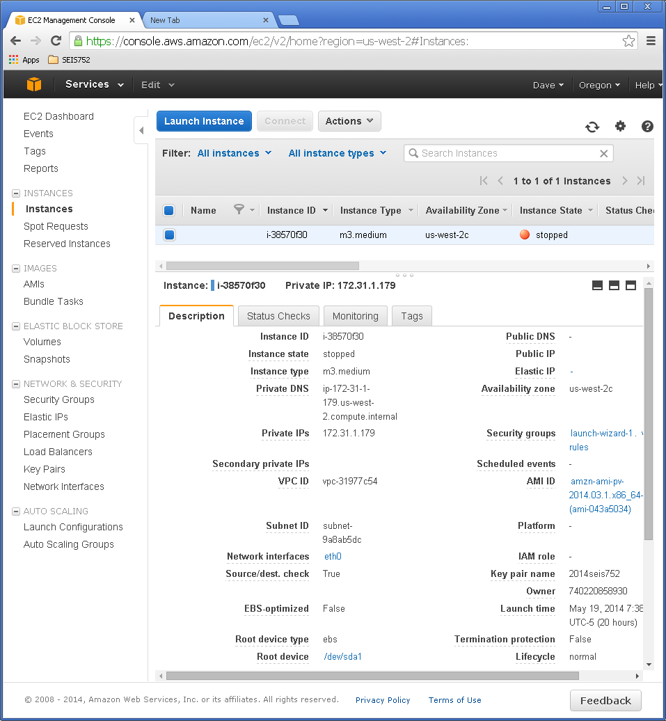

*Figure 5: Amazon EC2 Instance – Linux on m3.medium*

I initially thought that I had mucked up my Linux Instance so I moved over to the US East (N. Virginia) region and created a Windows Instance. This was having the same connection issues which led me to the root of the matter – the port. I realized that I could no longer count on the work ‘guest’ network allowing connections so I moved my testing back home. At this point I was finally able to successfully connect with my Windows instance. I performed the steps necessary to configure IIS through RDP and, in the process of finding the documentation to do that I discovered the install of the Web Platform Installer which led me to the DotNetNuke install. I had deployed DNN at my previous employer and then modified the deployment to rebrand it and use it as the Intranet where I was able to integrate C#.Net Web Forms and C#.Net Apps, Microsoft SQL Server Reporting Services, and other cool stuff. My curiosity got the best of me and I installed DNN on my Windows instance thinking that I’d have time to configure the Linux instance (now that I was fairly certain I hadn’t mucked it up) and get my FriendFace app deployed to that instance. I can say with a fair amount of certainty that that will not be happening now. Time constraints. But I have certainly met the ‘spirit’ of the homework assignment by deploying an app in the cloud. At least I hope that you’ll agree with my conclusion that I’ve met the ‘spirit’!

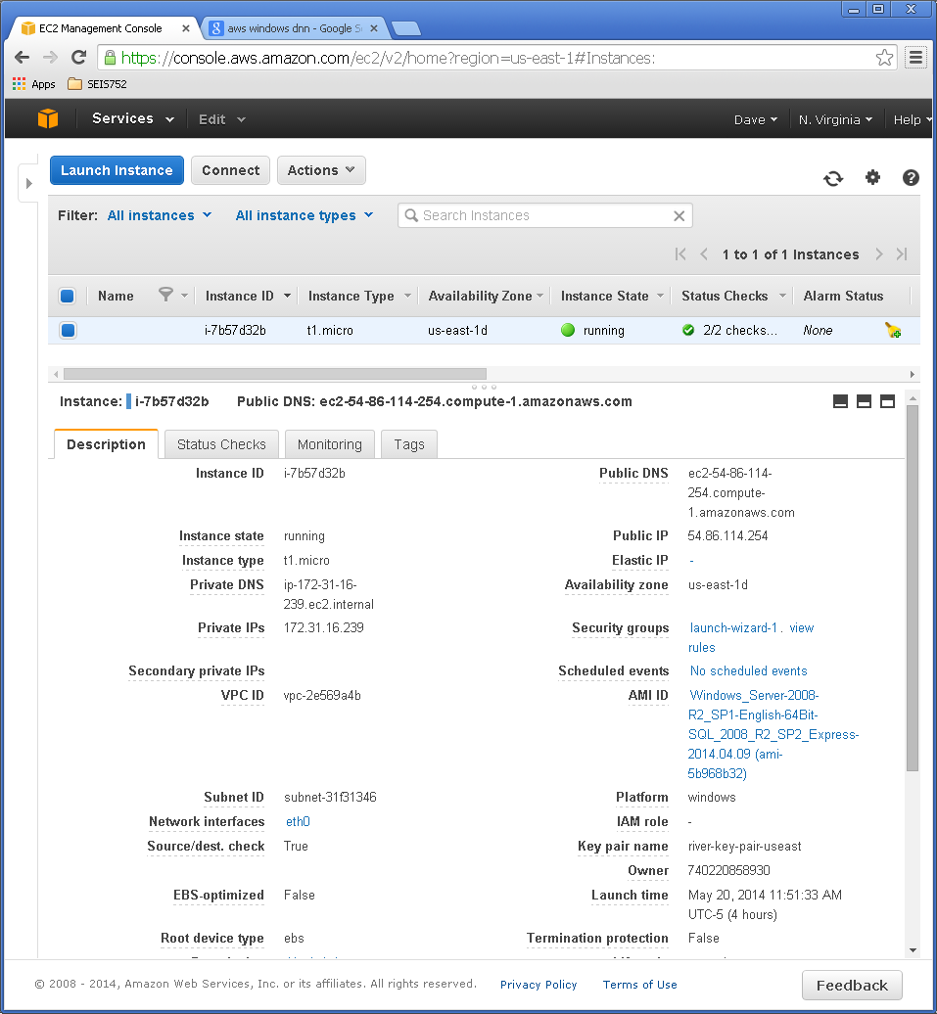

*Figure 6: Amazon EC2 Instance – Windows on t1.micro*

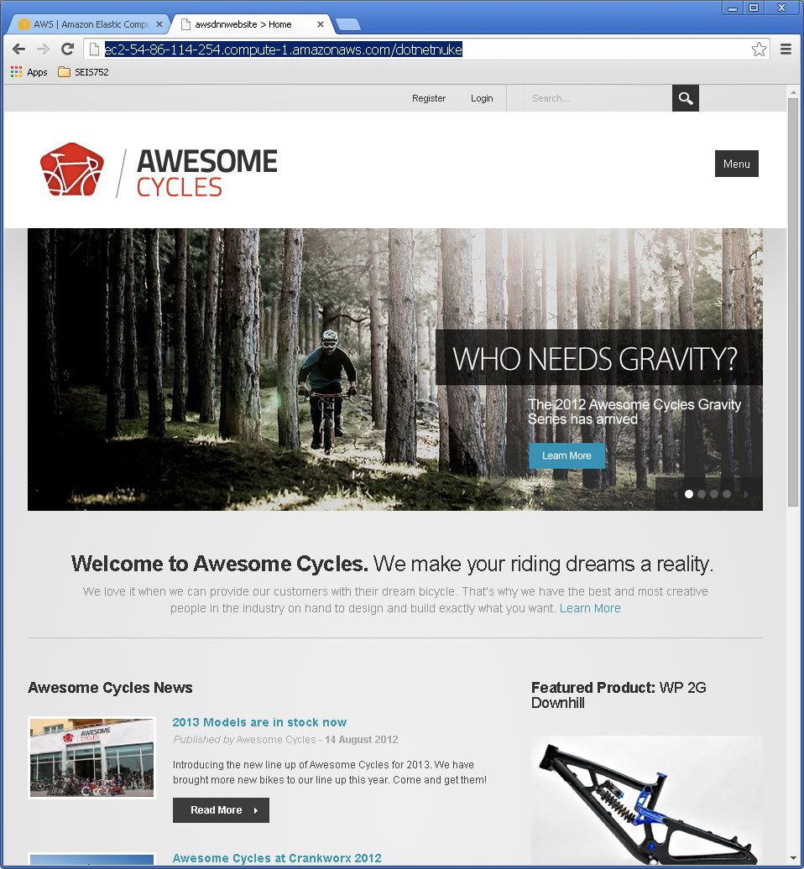

*Figure 7: DotNetNuke site on AWS Windows instance*

[*http://ec2-54-86-114-254.compute-1.amazonaws.com/dotnetnuke*](http://ec2-54-86-114-254.compute-1.amazonaws.com/dotnetnuke)