## HW10: Mobile Web

SEIS 752: Advanced Web Application Engineering – Spring 2014

Instructor: Lloyd Cledwyn

Student: Dave Olson

**Summary**

Make a Mobile Web Site – Technical Option

Choose an existing site or create a new one from scratch:

1 – Do the conversion (convert the existing site to a mobile ready format).

2 – Explain your choice for the intended device audience.

3 – Highlight at least three key changes that you made and explain the choices that you made in making the changes.

**Results – Mobile Web**

For my Mobile Web responsive site I chose to rework my original FriendFace app. There were design issues in the original iteration that had not been addressed due to prioritization – the functionality was the primary consideration – and I felt that it would be a good candidate for a makeover. I used Twitter Bootstrap 3 to rework the navigation and the general layout of the content in the body of the site.

Twitter Bootstrap 3 differs from Bootstrap 2 in that it is mobile first. It uses a responsive grid system that scales up or down as the device/screen size changes allowing it to render correctly from mobile phone to tablet to computer. If you have limited time and resources and want your application to be available to as many users as possible then mobile web and responsive design is the way to go. Native apps give you more control over how they display and function on specific operating systems and devices but responsive design will work for most of what your app requires.

The changes that I made to my site are related to two main categories – design and responsiveness. From a design perspective, I used the ‘Superhero’ theme from Bootswatch.com (<http://bootswatch.com/superhero/>). I liked the look and feel of this theme and felt that it matched what I had envisioned for how I want my site to look. It was as simple as replacing a couple of the CSS files in the Twitter Bootstrap 3 ‘css’ folder with the Bootswatch files and my site was changed. From a responsiveness perspective I used the classes built into the Bootstrap files to rework the navigation, the layout and formatting, the appearance of the Search bar, and the design and responsiveness of everything in the body of the site. For the navigation I used the ‘nav’ classes and built-in glyphicons to change the look and behavior of the main menu including changing its position and attaching it to the top of the screen. Changes to the layout and formatting were primarily accomplished by using the ‘container’ class and the grid (e.g. ‘class="col-md-xx”’). For the Search bar I made it grid-based and put it in its own space by placing it between rule lines. I then used the grid system to align the main contents of the body to display horizontally on larger screens and vertically as the size of the screen decreased making it responsive across any device.

You can see the before-and-after screenshots of my site below and download the files to run the reworked Bootstrap site from <http://bromad.com/misc.php>.

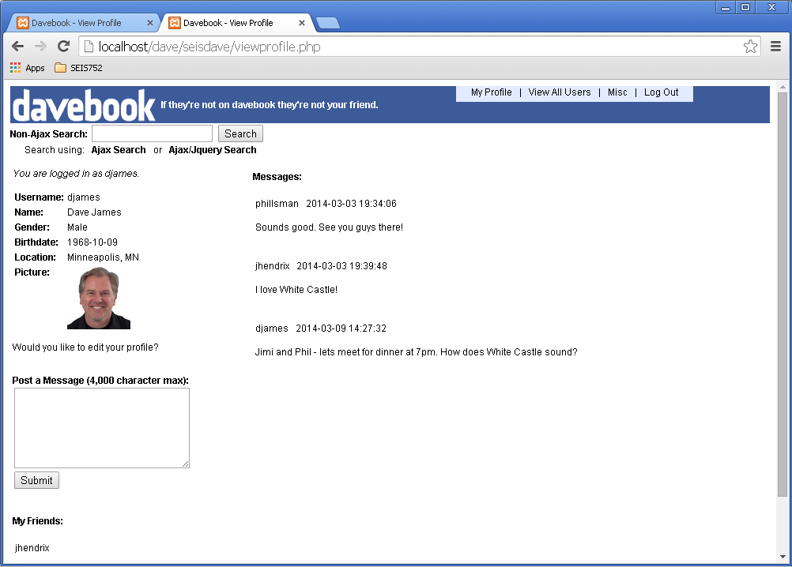

*Figure 1: Davebook – Before*

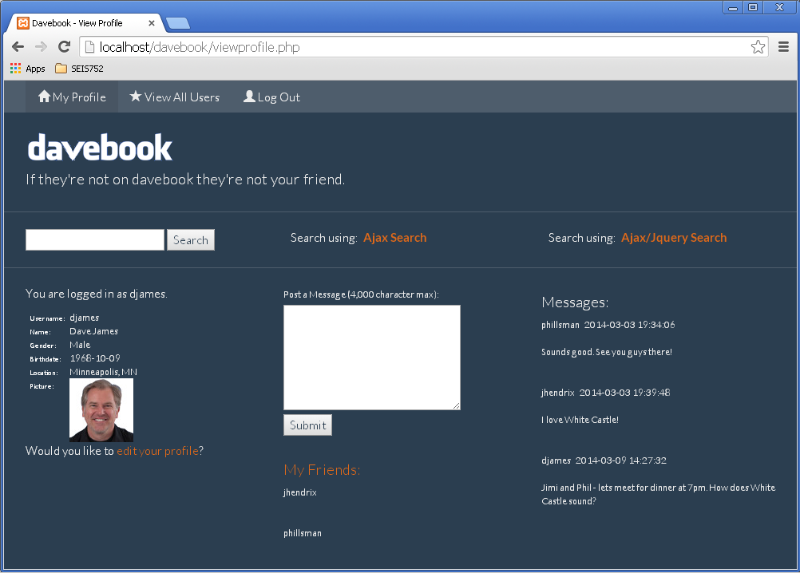

*Figure 2: Davebook - After*