Sample run 1 for license.py:

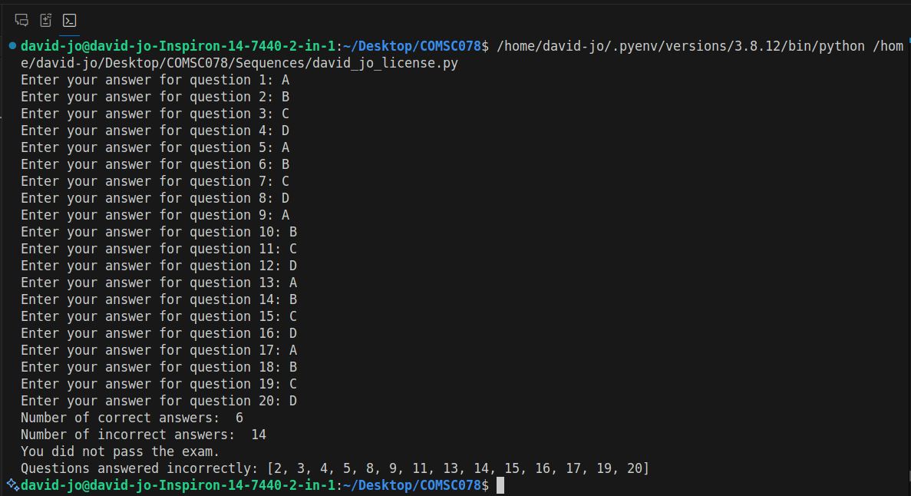

Sample run 2 for license.py:

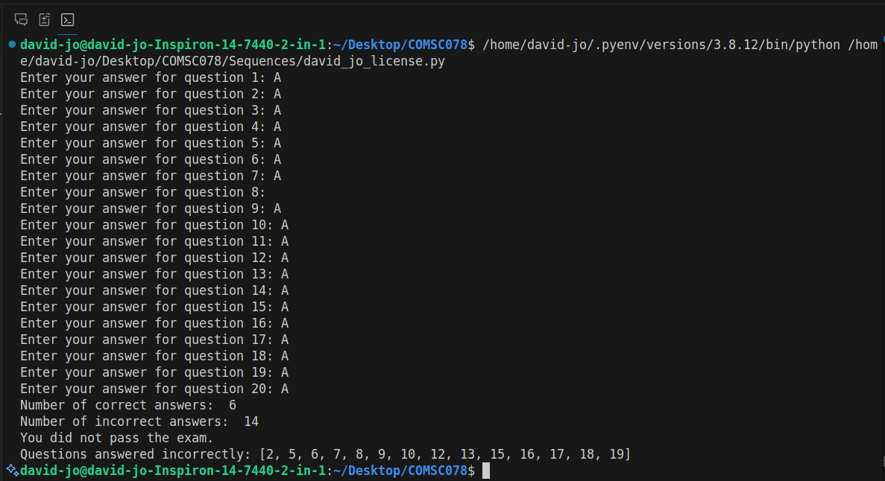

Sample run 3 for license.py:

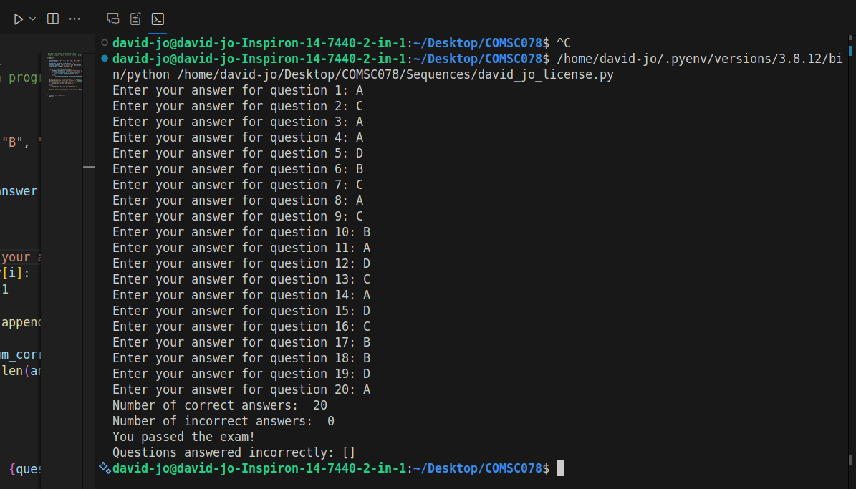

Sample run 1 for pig latin:

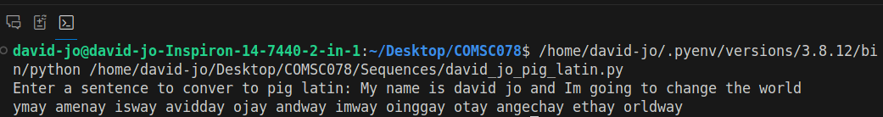

Sample run 2 for pig latin:

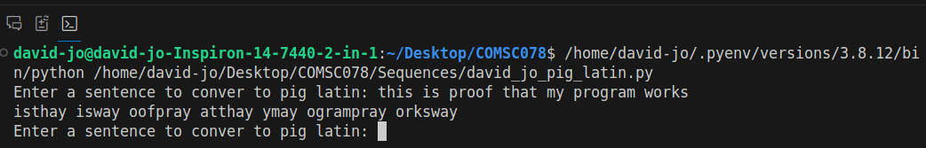

Sample run 3 for pig latin:

