Pilot's Operating Handbook

N750NW SERIAL# 75-10951 STOL CH 750

DAVID JAGOE

Table of Contents
1. General
1.1. Airplane Three View
1.2. Descriptive Data
1.2.1. Engine
1.2.2. Propeller
1.2.3. Fuel System
2. Limitations
2.1. Operating Weights
2.2. Airspeed Limitations
2.3. Maneuvering Limitations
2.4. Types of Operations
3. Emergency Procedures
4. Normal Procedures
5. Performance
6. Weight and Balance
7. Systems Description
8. Servicing and Maintenance

General

Airplane Three View
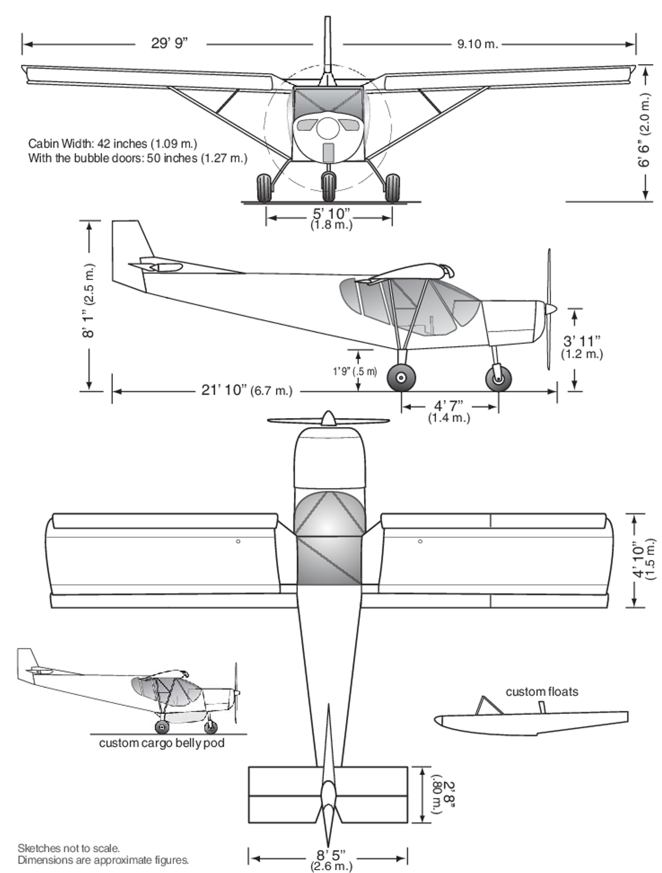 Figure 1.1.1:

Descriptive Data

Engine
Description | Fuel injected inline four cylinder, liquid cooled, gear reduction
Manufacturer | Aeromomentum
Model | AM15
Serial Number | HOLD
Rated Horsepower | 117
RPM Continuous | HOLD
RPM Cruise | HOLD

Propeller
Description | Ground adjustable fixed pitch
Manufacturer | Luga
Model | HOLD
Serial Number | HOLD
Number of blades | 3
Diameter | HOLD

Fuel System
Fuel capacity | 24 U.S. gal
Usable fuel | HOLD
Minimum fuel grade | HOLD

Limitations

Operating Weights
HOLD.

Airspeed Limitations
All airspeeds in knots.
AIRSPEED | DESCRIPTION | KCAS | KIAS | REMARKS
VNE | NEVER EXCEED | 108 | HOLD | Do not exceed this speed in any operation.
VNO | MAXIMUM STRUCTURAL CRUISE | 90 | HOLD | Do not exceed this speed except in smooth air, and then only with extreme caution.
VA | MANEUVERING SPEED | 78 | HOLD | Do not make full or abrupt control movements above this speed.
VFE | MAXIMUM FLAP EXTENSION | 69 | HOLD | Do not operate with flaps extended above this speed.
Maximum crosswind component: 10 knots.

Maneuvering Limitations
CONFIGURATION | POSITIVE G LIMIT | NEGATIVE G LIMIT
Flaps up | +4 g | -2 g
Flaps down | +2 g | -0 g
- Intentional spins are prohibited.
- Aerobatics prohibited.

Types of Operations

Emergency Procedures

Normal Procedures

Performance

Weight and Balance

Systems Description

Servicing and Maintenance

