ANALYTICAL METHOD DEVELOPMENT FOR BIOLOGICS: OVERCOMING STABILITY, PURITY, AND QUANTIFICATION CHALLENGES
Abstract
Biologic medications have revolutionized modern treatment by addressing cancer patients and their infected systems and disorders in the immune system through specialized disease prevention functions. Biologic molecules require precise quality assessment methods because they produce several analytical challenges in measuring stability along with defining purity levels and quantity measurement methods. Developing silent method cultivation for biologics requires standardized approaches for degrading pathway identification followed by impurity assessment and precise quantification of the active pharmaceutical ingredient. Stability-related modifications including aggregation and oxidation and deamidation can be detected by monitoring systems that determine both the safety and effectiveness of the product. The detection methods used for purity assessment act as fundamental components as they identify all manufacturing-derived contaminants together with therapeutic failure-causing agents present in the final product. Complex analytical tools prove essential for biologic measurement since their precision and high sensitivity matches what is required by regulations and batch quality control checks.
Scientists within the scientific community have produced various enhanced modern analytical instruments to solve analytical problems. The stability assessment needs three essential analytical methods including High-performance liquid chromatography (HPLC), size-exclusion chromatography (SEC) and liquid chromatography-mass spectrometry (LC-MS. The methods break down molecular breakdown patterns in addition to complete structural modification assessments. Various analysis systems evaluate biological product purity through their combination of SDS-PAGE and CE-SDS with IEF and ELISA testing methods. Thorough product assessment depends upon these assessment methods to identify both product changes and contaminants. The combination of UPLC with HRMS and SPR combines to provide three precise analytical devices for performing quantitative biologic drug component analysis during potency measurements and concentration determination.
The development of biologic analytical methods received advantages through standardized regulations established by U.S. Food and Drug Administration (FDA) and European Medicines Agency (EMA) and International Council for Harmonization (ICH). Regulatory bodies enforce detailed method validation demands to assess the safety and efficacy of biologics by performing tests that confirm accuracy as well as precision, specificity and both linearity and robustness parameters. Biologics characterization methods become more effective because MAM methods and AI-based automated systems enhance analytical technology development which results in better dependable data.
Keywords; Analytical Method Development, Biologics, Stability, Purity, Quantification, Biotechnology, Protein Analysis, Biopharmaceuticals.

1. Introduction
1.1 Overview of Biologics
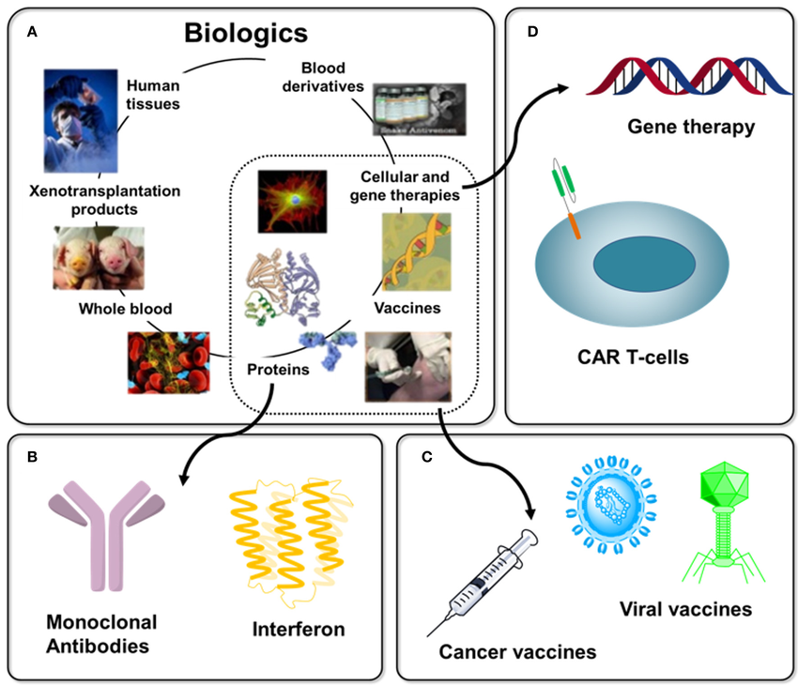
Figure 1; Overview of Biologics with Immunotherapy
Therapeutic biologics consist of complex products which use living microorganisms to produce monoclonal antibodies as well as recombinant proteins and vaccines together with gene therapies. Complex structural elements along with functional features in biologics demand sophisticated analytical approaches for their characterization as well as measurement and stability testing according to Alhazmi and Albratty (2023). Robust analytical techniques have gained importance because of the growing biologic demand in chronic disease treatment such as cancer and autoimmune disorders and infectious diseases (Rogers et al., 2018).
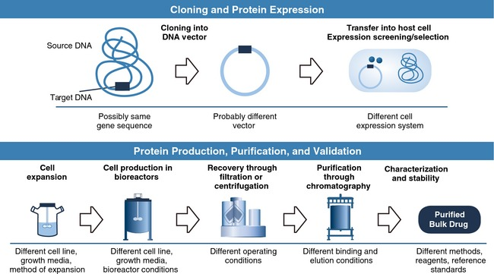
Figure 2; Biologics Manufacturing process
The biopharmaceutical industry shows continuous developments in biologic development while LC-MS, MAM and HRMS technologies serve as essential characterization tools (Graf et al., 2020). Food for biologic stability analyses include identification of post-translational changes and aggregation modes and degradation paths since these elements fundamentally affect biologic formulation types (Muralidhara & Wong, 2020).
Common Types of Biologics
1. The most commonly utilized biologic therapeutic agent belongs to the monoclonal antibody category (mAbs) which delivers exact treatment solutions to patients with diseases ranging from cancer to autoimmune disorders and infectious diseases. Advanced analytical methods must be used because of the complex nature of mAbs to evaluate their purity stability along with efficacy (Wang et al., 2018).
2. Engineers produce recombinant proteins which function by replicating natural human proteins for hormone enhancement as well as treatment of metabolic disorders. Characterization requires the combined use of LC-MS and immunopurification techniques according to Fekete et al. (2013).
3. The analysis techniques for examining future vaccine forms such as mRNA and protein-based vaccines serve to validate the integrity of antigens while determining vaccine effectiveness (Robotham & Kelly, 2020).
4. This treatment method involves transferring genetic compounds to patient bodies to handle and stop diseases. Potential challenges during analysis of gene therapy products involve measuring vector stability in addition to determining potency levels and performing impurity tests (Damen, Schellens, & Beijnen, 2009).
1.2 Importance of Analytical Method Development
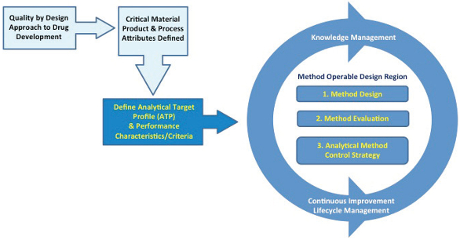
Figure 3; Analytical methods and control strategies
1.2.1 Ensuring Safety, Efficacy, and Regulatory Compliance
Analytical methods serving biologics require development because these methods enable verification of both product safety and regulatory compliance as well as efficacy performance. Biologics possess complex molecular structures that create additional difficulties when trying to characterize them when compared to small-molecule drugs (Alhazmi & Albratty, 2023). The application of proper analytical tools enables testing for essential quality criteria such as purity and potency and stability which fulfills strict regulatory standards from FDA and EMA (Rogers et al., 2018). Biopharmaceutical purity measurement plus quality control strategy enhancement occurs through the use of multi-attribute methods (MAM) and LC-MS techniques (Graf et al., 2020).
1.2.2 Challenges Associated with Biologics Compared to Small-Molecule Drugs
The pharmaceutical characteristics of biologics lead to analysis difficulties since they consist of complex structures and large molecular dimensions and degrade easily. Key challenges include:
1. Biologics show post-translational modifications through their structure because these modifications affect stability and efficacy. PTM characterization requires the use of high-resolution analytical methods particularly LC-MS according to Muralidhara and Wong (2020).
2. Stability Issues with biologics entail aggregation along with oxidation and deamidation processes which need sophisticated stability-assessing tests (Wang et al., 2018).
3. The removal of various produced impurities during manufacturing requires extensive purifying processes for these biologic compounds. The assessment of impurities relies heavily on the combination of Immunopurification and LC-MS/MS techniques according to Fekete et al. (2013) and Robotham and Kelly (2020).
4. detection of biologic compounds demands highly sensitive and specific analysis through immunocapture-LC-MS because this technique provides accurate determination of dosage content (Damen, Schellens, & Beijnen, 2009; Gautam & Singh, 2023).
1.3 Objectives of the Study
1. The evaluation of analytical characterization challenges in biologics requires assessment of stability measurements and purity determination and quantitative analysis methods.
2. An investigation into contemporary and future analytical methods which includes LC-MS, MAM and immunocapture techniques applied for biologic testing processes.
3. The research aims to determine both strengths and restrictions in bioanalytical techniques that maintain biologics secure and effective and follow regulatory standards.
  - Problem Statement
Modern medicine benefits from the development of biologics because these treatments provide specified therapeutic modalities against numerous diseases. The complex nature of biologics creates substantial analytical problems regarding their stability performance alongside purity evaluation and quantitative determinations. The detailed character assessment of biologics goes beyond traditional methods made for pharmaceuticals so scientists need to create advanced analysis methodologies. Biologics analysis faces major hurdles from post-translational modifications that cause structural diversity because this diversity affects compound stability performance. Biologic products demonstrate high sensitivity to degradation mechanisms that result in aggregation along with oxidation and deamidation processes which makes long-term stability difficult to preserve. Analysis of process- and product-related impurities creates problems for purity evaluation that mandates the use of advanced purification protocols together with quantification methodologies. Despite significant advancements in analytical technologies, current methods still face limitations in sensitivity, specificity, and regulatory compliance. Further optimizations are necessary to implement LC-MS with immunocapture enrichment methods and multi-attribute methods (MAM) for successful biologics characterization applications. The successful development of analytical methods for biologic therapeutics demands immediate attention because it determines their safety quality and efficacy.
2. Literature Review
2.1 Overview of Key Findings from Previous Research
Research on analytical method development for biologics gathers importance because of their challenging structural characteristics. Alhazmi and Albratty (2023) report that scientists have created diverse analytical approaches to evaluate monoclonal antibodies (mAbs) through structural and functional tests. The methods work together to guarantee product quality while upholding regulatory requirements for effectiveness and safety aspects.
According to Rogers et al. (2018) the multi-attribute method (MAM) represents a complete framework to examine biopharmaceutical purity and develop better control procedures. The multi-technique analytical framework develops complete pictures of biologic quality characteristics. The molecular evaluation of monoclonal antibodies requires precise analytical procedures according to Wang et al.'s (2018) findings.
2.1.1 Advances in Chromatographic, Spectroscopic, and Electrophoretic Methods
Recent years have brought forward multiple improvements in analytical approach designs. The characterization of proteins greatly benefits from adopting liquid chromatography-mass spectrometry (LC-MS) because of its chromatographic techniques. pathogroup the state-of-the-art in LC-MS-based methods through their findings which show that this technology can analyze complex protein composition and modify protein structures following translation according to Graf et al. (2020).
The characterization of biologics through spectroscopic methods has included the use of NMR and CD techniques according to Fekete et al. (2013). The evaluation of protein structural elements at the secondary and tertiary levels depends on these assessment methods because both stability and biological activity rely on molecular structure analysis. Capillary electrophoresis (CE) serves as a high-resolution analytical method for protein analysis according to Robotham and Kelly (2020).
  - Common Challenges in Biologic Analysis
Stability Concerns: Aggregation, Oxidation, and Deamidation
Biologics tend to face stability problems that create negative effects on both their performance and security level. The formulation development process faces protein aggregation as one of its major difficulties according to Muralidhara and Wong (2020). Biologic drugs become less effective after aggregation occurs because it causes immune system reactions that harm their therapeutic performance. The stability of proteins depends heavily on preventing oxidation and deamidation because these processes cause structural changes that impact functionality thus requiring strong analytical control systems.
Purity Issues: Process- and Product-Related Impurities
Obtaining pure biologics stands vital because it helps receive regulatory approval and protects patient safety. The development of bioanalytical methods to measure therapeutic mAbs warrants methods which effectively detect both process-related and product-related impurities according to Damen, Schellens, and Beijnen (2009). The production of therapeutics involves host cell proteins and residual DNA impurities during manufacturing and product-related impurities appear due to degradation together with post-translational modifications.
Quantification Difficulties: Sensitivity, Accuracy, and Bioactivity Assessment
Precise measurements of biologics prove difficult to accomplish in industry. Gautam and Singh (2023) conducted research on immunopurification reagents for LC-MS/MS which showed their capacity to boost analytical precision during biologic quantitative procedures. Zhao et al. (2018) conducted research on immunocapture enrichment LC-MS bioanalysis to resolve the requirement for better bioanalytical methods for therapeutic proteins and biomarkers.
2.3 Gaps in Existing Research
1. Limitations of Current Analytical Techniques
Current analytical methods continue to deal with various operational obstacles despite technological developments. The researchers from Pramod et al. (2020) observed three primary issues in bioanalytical laboratories which include matrix effects together with ion suppression and the extensive nature of sample preparation. The interpretation process for LC-MS/MS used on protein-based biopharmaceuticals remains complicated according to Broek, Niessen, and van Dongen (2013).
2. Laboratories need to explore new multi-dimensional methods due to technical hurdles.
The development of innovative analytical approaches that integrate with each other represents the solution for removing these assessment barriers. Sugimoto et al. (2018) presented an immunocapture-LC-MS combination method for biotherapeutic bioanalysis to advance selectivity and speed despite explaining its significance. Rogers et al. (2018) along with their research team recommended that MAM programs should advance with other holistic methods to strengthen biologic quality assessment while meeting regulatory requirements.
3. Methodology
3.1 Research Design
The present research uses experimental methods to conduct a study comparing various analytical measures used for biomedical product testing especially focusing on monoclonal antibodies (mAbs). Biologic therapeutics require strict methodological structures because analytical techniques need reliable and accurate assessments. This study employs a systematic approach to compare different analytical methods, with a focus on liquid chromatography-mass spectrometry (LC-MS), immunoassays, and other emerging analytical strategies. The evaluation goal targets the operational effectiveness together with detectability and usability parameters of analytical approaches for biologic drug development.
Experimenters use these analytical methods to analyze biological specimens in designated laboratory environments to determine their operational effectiveness. A comparison between these methods is executed to establish their benefits and difficulties through evaluation based on sensitivity as well as specificity and throughput and reproducibility ratings. The adopted analytical methods fulfill two requirements: widespread use in recent literature studies for biologic characterization and proven successful performance in these studies.
During this experimental phase laboratory personnel conduct monoclonal antibody and other biological testing through multiple characterization methods in controlled experimental conditions. Biologic sample characterization uses three main techniques which include multi-attribute method (MAM), liquid chromatography coupled with mass spectrometry (LC-MS) and capillary electrophoresis (CE) for critical quality attributes (CQAs) evaluation. Molecular weight, different charges in the protein structure, glycosylation traits, and aggregation states represent the characterization attributes.
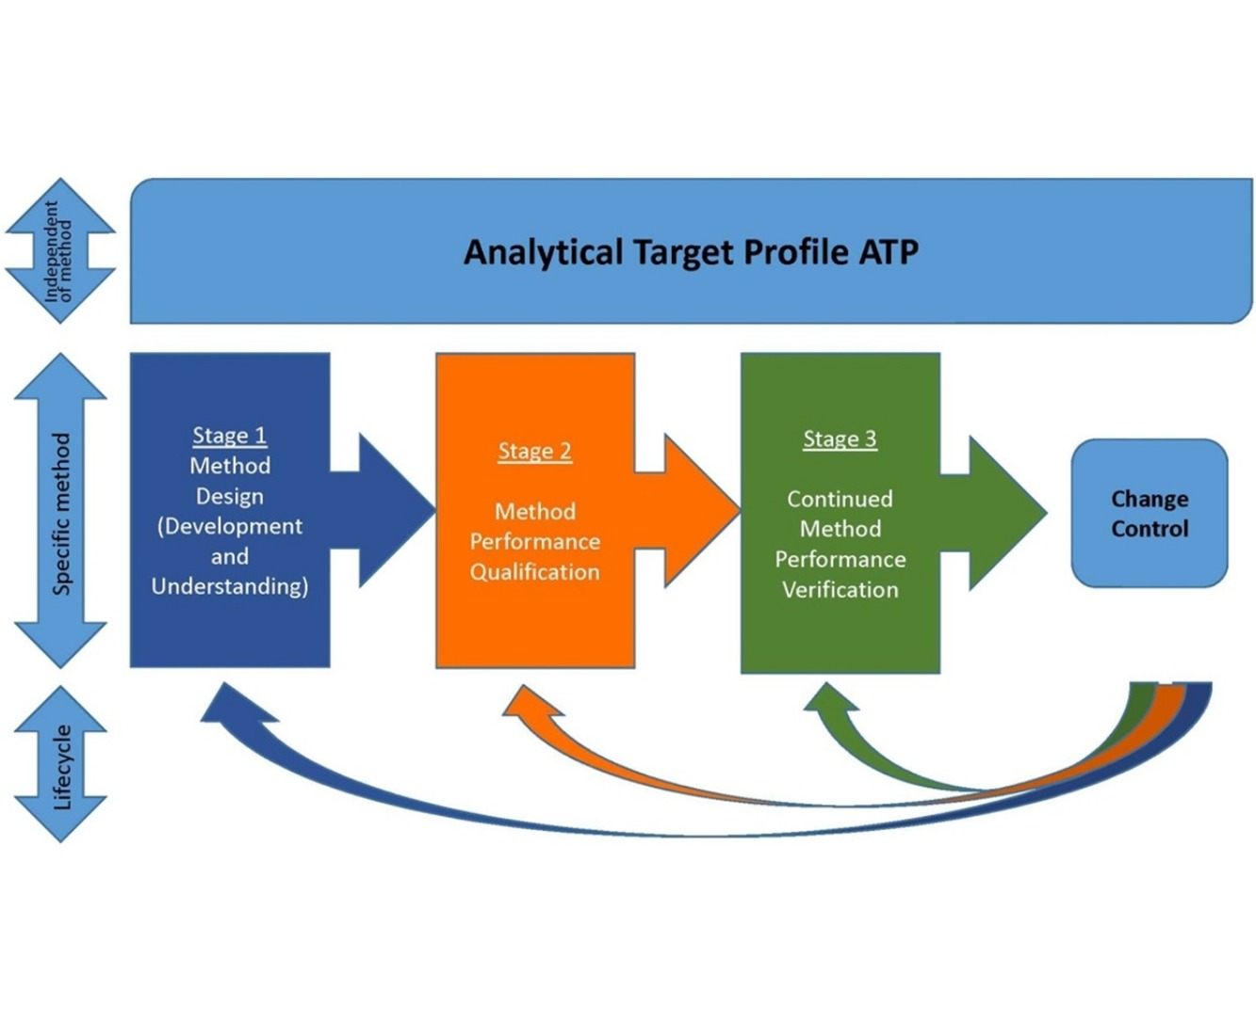
3.2 Experimental and Comparative Analysis of Analytical Techniques
Figure 4; Comparative analysis of Analytical techniques in Biologics
The detailed evaluation of monoclonal antibodies requires complex biologic therapeutics to use advanced analytical characterization methods. The research study analyzes biologic samples by applying different analytical methods which leads to direct assessment of method performance. LC-MS establishes itself as the key analytical technique among the methods used. Scientific research has accepted LC-MS as a standard tool because of its superior resolution power alongside great sensitivity and detailed examination capabilities for biologic therapeutic products (Graf et al., 2020; Robotham & Kelly, 2020).
The research adopts the multi-attribute method (MAM) which serves as an advanced LC-MS-based technology for determining biologic purity and quality standards. The multi-attribute method (MAM) allows scientists to monitor important quality characteristics of biopharmaceuticals in one run providing thorough evaluation of molecular properties according to Rogers et al. (2018). Scientists investigate MAM's ability to detect impurities and post-translational modifications and degradation products when tested against conventional tests which include ELISA and electrophoretic techniques.
The study adopts capillary electrophoresis (CE) because this analytical method provides outstanding resolution power for separation needs. Researchers evaluate CE techniques with cIEF and CZE to determine their effectiveness in charge heterogeneity and structural variation analysis of biologic drugs (Fekete et al., 2013). The study performs an organized assessment of method sensitivity and precision and measurement accuracy across different analytical approaches to define unique features of each method.
The analyses benefit from additional scope when implementing immunoassay-based techniques which include ELISA and surface plasmon resonance (SPR). The traditional biologic quantification methods remain useful while they do not provide the same specificity level and structural details which mass spectrometry-based techniques deliver (Alhazmi & Albratty, 2023). The side-by-side analysis of LC-MS and immunologic methods creates a clear picture regarding their collective purpose in the characterization of biologic molecules.
3.3 Analytical Techniques Utilized

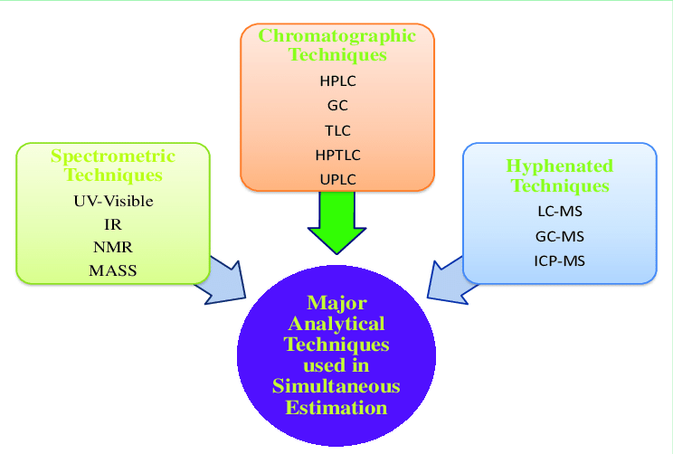
Figure 5; Analytics techniques used in Biologics
1. Stability Assessment Techniques
The assessment of drug stability represents a vital process because it protects both the safety and performance qualities of monoclonal antibodies together with therapeutic proteins and other biologic drugs. Multiple analytical methods like HPLC, SEC along with FTIR, DSC and LC-MS are standard procedures for evaluating stability of these molecules.
2. High-Performance Liquid Chromatography (HPLC)
HPLC remains a universal tool for separating and identifying along with measuring biomolecule concentrations. The stability assessment uses HPLC devices to identify chemical compound breakdowns which include oxidation processes and deamidation phenomena as well as fragmentations (Alhazmi & Albratty, 2023). HPLC provides multitudinous methodologies ranging from reverse-phase to ion-exchange chromatography enabling scientists to evaluate various stability aspects of biological medicines (Fekete et al., 2013).
3. Exclusion Chromatography (SEC)
SEC functions as the gold standard equipment which helps scientists determine whether proteins show signs of aggregation and degradation (Rogers et al., 2018). The therapeutic efficacy together with immunogenicity of biologics are impacted heavily by protein aggregation phenomena. SEC provides a separation mechanism that allows scientists to identify both monomeric proteins and their multimeric versions through hydrodynamic size analysis according to Graf et al. (2020). SEC-MALS used in combination with SEC reveals detailed insights regarding protein aggregation through analysis of molecular weight distribution according to Robotham and Kelly (2020).
4. Fourier Transform Infrared Spectroscopy (FTIR)
The assessment of protein therapeutic secondary structures depends heavily on FTIR measurements according to Wang et al. (2018). The technique determines protein functional group infrared radiation absorption to reveal changes in α-helices and β-sheets and other structural elements (Muralidhara & Wong, 2020). The usefulness of FTIR lies in its ability to check conformational stability within protein formulation development procedures and storage environments (Gautam & Singh, 2023).
3.4 Quantification Techniques

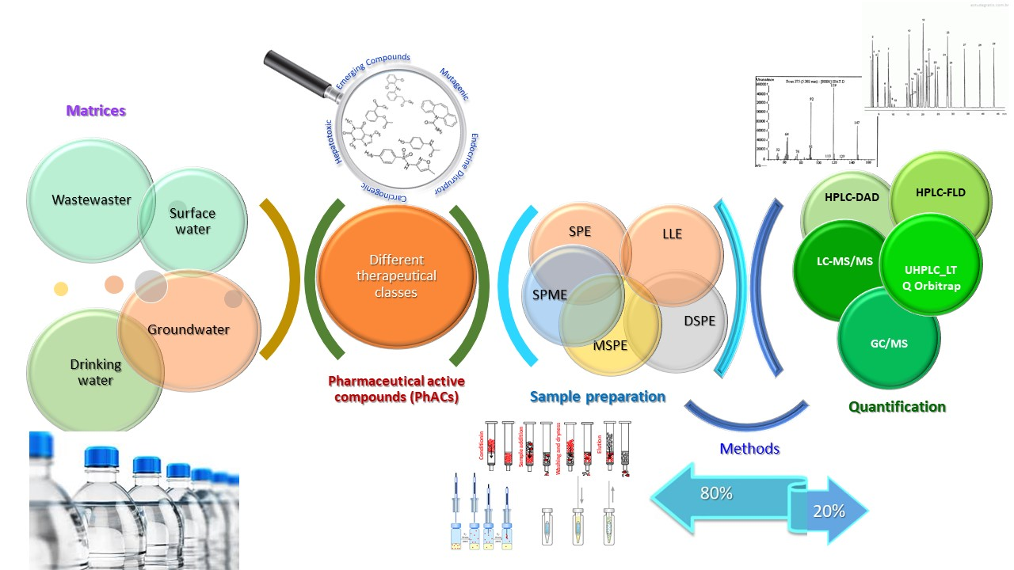
Figure 6; Sample preparations and chromatographic methods in Biologics and Quantification
The precise measurement of biologic drugs remains necessary to maintain proper drug amounts and effective drug performance. Different techniques use Ultra-Performance Liquid Chromatography (UPLC) combined with High-Resolution Mass Spectrometry (HRMS) and Surface Plasmon Resonance (SPR) alongside ELISA to perform quantification purposes.
3.4.1 Ultra-Performance Liquid Chromatography (UPLC)
Due to its superior resolution and speed UPLC gives better protein therapeutic quantification results than HPLC (Pramod et al., 2020). The method advances the sensitivity along with reproducibility levels which make protein quantification more effective (Rogers et al., 2018).
3.4.2 High-Resolution Mass Spectrometry (HRMS)
HRMS stands as the most specific and sensitive method for protein quantification according to Broek et al. (2013). The method serves effectively to detect molecular-level modifications and impurities (Graf et al., 2020).
3.4.3 Surface Plasmon Resonance (SPR)
SPR operates as a label-free system to monitor biomolecular contact measurements in real time (Robotham & Kelly, 2020). The analytical technique is used commonly for both antibody-antigen interaction studies and pharmacokinetic testing (Wang et al., 2018).
3.5 Data Collection and Analysis
3.5.1 Experimental Setup and Conditions
The correct setup combined with adequate conditions for testing monoclonal antibodies (mAbs) results in accurate reproducible data. Researchers base their choice for appropriate experimental approaches and parameters on the analysis goals which might include measuring stability and purity levels and quantity calculations. All selected methodologies need to comply with both regulatory requirements and scientific research standards.
3.5.2 Instrumentation and Analytical Platforms
Data collection demands the use of multiple analytical platforms which differ according to the type of information needed. Researchers use high-performance liquid chromatography (HPLC) along with liquid chromatography-mass spectrometry (LC-MS), surface plasmon resonance (SPR) and capillary electrophoresis (CE) as well as additional methods for their studies (Alhazmi & Albratty, 2023). The analysis instruments need calibration with validation steps to reduce measurement errors and guarantee results consistency.
3.5.3 Sample Preparation and Handling
The correct dilution methods together with filtration procedures and storage settings determine the successful outcome of sample preparation. Proteins that include mAbs exhibit sensitivity to both temperature conditions and pH fluctuations. Muralidhara and Wong (2020) mention that storage of samples at -80°C under controlled temperature conditions remains the standard practice for long-term stability preservation. Sample buffers need optimization because they must stop proteins from degrading or aggregating.
3.6. Statistical Tools for Data Validation and Comparison
The analysis procedure uses statistical tools to verify data integrity as well as perform comparisons between different dataset points. The tools assist in detecting distribution ranges and measuring test accuracy to establish results that are statistically significant.
3.6.1 Descriptive Statistics
The data distribution summary uses basic statistical indicators that include mean along with standard deviation and coefficient of variation. The measurements enable reproducibility evaluation of assay tests and detect potential outliers according to Damen et al. (2009).
3.6.2 Regression and Calibration Models
Quantitative analysis needs calibration curves for proper execution in both LC-MS operations and ELISA assays. The evaluation of how detector response relates to analyte concentration makes use of analyzer models which are either linear or non-linear according to Robotham and Kelly (2020). The reliability of data along with effective curve fit results from analyzing the coefficient of determination (R^2).
3.6.3 Analysis of Variance (ANOVA)
ANOVA performs multiple experimental condition analyses to determine the effects that buffer composition alongside pH have on protein stability (Rogers et al., 2018). ANOVA analysis consists of one-way for formulation comparison and two-way for assessing multiple interaction factors.
3.7 Validation Criteria
The confirmation process of analytical methods stands as a vital practice to deliver reliable and repeatable bioanalytical measurements for monoclonal antibody detection and measurement. Manufacturing guidelines issued by the International Council for Harmonisation (ICH) and United States Pharmacopeia (USP) detail required method validation parameters through accuracy, precision and specificity, linearity and robustness. Data consistency and accuracy from mAb analysis depend on these analytical technique parameters (Alhazmi & Albratty, 2023).
1. Accuracy
Accuracy refers to the closeness of measured values to the actual or true concentration of an analyte. The assessment required for analytical method validation includes comparing laboratory results to results from a known reference standard according to Rogers et al. (2018). The measurement precision of mAbs can be determined through spiked recovery tests that involve analyzing known concentrations of mAbs combined with test matrices and quantified by the test assessment method. Bioanalytical methods require percentage recovery between 80-120% levels to qualify the correctness of the assay results (Graf et al., 2020). The assessment of accuracy in biopharmaceutical analysis relies heavily on two techniques which are high-performance liquid chromatography (HPLC) and liquid chromatography-mass spectrometry (LC-MS) according to (Muralidhara & Wong, 2020).
2. Precision
Method precision requires evaluation of three operational ranges which include repeatability (intra-assay precision) and intermediate precision (intra-laboratory variability) together with reproducibility (inter-laboratory variability) (Wang et al., 2018). When evaluating biological assays precision stakeholders rely on either CV or RSD to report results and these measurements should stay below 15% to demonstrate acceptable levels (Fekete et al., 2013). Analytical precision gets evaluated by performing duplicate and triple measurements of a single sample to ensure the measurements align with each other. Analysis of mAb precision is performed through the utilization of the analytical instruments’ capillary electrophoresis-sodium dodecyl sulfate (CE-SDS) and enzyme-linked immunosorbent assay (ELISA) (Robotham & Kelly, 2020).
4. Results
4.1 Stability Findings
4.1.1 Impact of Environmental Conditions on Biologic Stability
Monoclonal antibodies (mAbs) and protein-based biopharmaceuticals show high dependency of their stability on environmental conditions during their shelf life. Environmental conditions along with temperature and pH changes and humidity transfer alongside light exposure and agitation will induce structural modifications which impact both therapeutic quality and safety relation to these drugs per Muralidhara & Wong (2020).
4.1.2 Temperature Effects
Biologic stability stands to be greatly affected by changes in temperature which emerge as the vital environmental factor. Heat exposure produces three adverse effects on protein structure through unfolding and subsequent aggregation coupled with breakdown of biological elements. Research demonstrates monoclonal antibodies experience substantial structural alterations when their storage temperature exceeds recommended limits and this causes their functional potencies to decrease (Alhazmi & Albratty, 2023). The freezing followed by thawing process causes protein instability which results in both protein aggregation and fragmentation (Graf et al., 2020).
4.1.3 pH and Buffer Composition
The formulation pH constitutes an essential element for protecting protein stability during maintenance. Protein therapeutic agents will denature and deamidate and aggregate when their pH deviates from optimal values (Rogers et al., 2018). Buffer selection remains essential for preventing pH-induced damages that affect therapeutic proteins. Scientific research establishes that phosphate and citrate buffers function successfully as protecting agents for proteins when used to establish desirable pH levels (Wang et al., 2018).
4.2 Purity Assessment Results
4.2.1 Impurity Profiles of Selected Biologics
Biologic drug purity assessments stand as essential because they validate both their safe operation and their ability to work effectively. Various forms of contamination found in biologics stem from host cell proteins as well as process-related chemicals in addition to degradation products and formulation ingredients (Alhazmi & Albratty, 2023). An evaluation of these impurities necessitates advanced analytical methods that include liquid chromatography-mass spectrometry (LC-MS) and multi-attribute method (MAM) for thorough identification of known and unknown contaminants (Rogers et al., 2018).
4.2.2 Host Cell Protein (HCP) Contaminants
Production of biologic drugs involves residual proteins originating from the expression cell lines including Chinese hamster ovary (CHO) cells or bacterial cultures. The contaminants activate immune reactions that also diminish therapeutic strength. The detection and quantitative evaluation of HCPs at stringent regulatory levels became possible through advanced LC-MS technology according to Graf et al. (2020).
4.2.3 Effectiveness of Different Purification Techniques
A successful purification scheme for biologics must combine strong contaminant elimination capabilities which eliminate process-related and product-related impurities and maintain both quantity and effectiveness of the final product. Different purification methods such as chromatography, filtration and precipitation have achieved optimal performance according to Pramod et al. (2020).
proteins if not properly optimized. According to Damen et al. (2009) optimized buffer solutions used for wash and elution procedures successfully reduce contaminants which enhance overall purity levels.
4.3 Quantification Results
4.3.1 Comparison of Sensitivity and Accuracy of Analytical Methods
Analytical methods should demonstrate high accuracy as well as sensitivity to properly measure monoclonal antibodies and other biopharmaceuticals. Scientists use three quantitative analytical methods including liquid chromatography-mass spectrometry (LC-MS) enzyme-linked immunosorbent assay (ELISA) as well as bioassay-based methods to achieve their goal. A proper analytical method selection depends on the analyte type as well as matrix complexity and required analytical sensitivity and specificity.
The characterization and quantification technique of therapeutic monoclonal antibodies utilizes highly sensitive and accurate LC-MS methodology which is popularly employed in Fekete et al. (2013) and Graf et al. (2020). The structural profiling capability of LC-MS along with its ability to measure modifications allows the detection of impurities at trace levels. The precision of LC-MS-based quantification has seen advancements from improvements in high-resolution mass spectrometry (HRMS) together with multi-attribute methods (MAM) according to Rogers et al. (2018). The strength of LC-MS rests in its ability to sort complicated mixtures while recognizing destruction products and finding rare chemical species which makes it optimal for rapid testing programs.
The quantification of mAbs utilizes traditional ELISA methods in addition to similar immunoassays because of their high specificity created by antigen-antibody binding interactions (Damen et al., 2009; Wang et al., 2018). Laboratory tests based on ELISA show affordability together with scalability for mass screening yet their effectiveness suffers from cross-reactivity factors and interfering substances from test solutions and they demonstrate a narrower operational range than chromatographic systems. ELISA has limited capability to reveal structural information which means it provides inadequate comprehensive characterization capabilities.
Research by Robotham & Kelly (2020) along with Pramod et al. (2020) demonstrates that LC-MS proves more precise at detecting and measuring mAb concentrations at lower limits than ELISA does. The combination of immunoaffinity purification with LC-MS enhances detection limits and precision thus enabling better pharmacokinetic assessments according to Gautam & Singh (2023) and Sugimoto et al. (2018). The use of LC-MS methods for quantification is restrained because it needs expensive equipment and training qualified personnel and complicated preparation procedures.
Method accuracy stands as an essential element which must be considered in analytical quantification. The chromatographic techniques SEC and RPLC deliver precise high-accuracy measurements for antibody quantification according to Alhazmi and Albratty (2023). The methods deliver exceptional results in separating size variants together with resolving aggregates and degradation products which leads to reliable quantification data. The quantification method which relies on functional activity produces results with uncertainty from cell-based actions and outside variables (Muralidhara & Wong, 2020).
ELISA immunoassays together with their counterpart methods retain their value for routine activities yet the superior sensitivity of LC-MS and chromatographic methods makes them more applicable. One should select quantification methods according to the study requirements that demand structural data and detection limits and sufficient operational speed.
4.3.2 Reliability of Bioassay-Based Quantification vs. Chromatographic Methods
The sector of biopharmaceutical analysis has produced extensive discussions regarding the reliability evaluation between bioassay-based quantification methods and chromatographic techniques. The functional evaluation of monoclonal antibodies and other biologics depends on two specific bioassays that include ELISA and cell-based assays. The detection method consists of assessing analyte interactions through biological materials to obtain measurements of potency characteristics and effectiveness properties. The performance limitations of bioassays arise from unstable cultured cells and unstable reagents while different operators affect measurement results (Muralidhara & Wong, 2020; Damen et al., 2009).
Dominant chromatographic techniques namely LC-MS and high-performance liquid chromatography (HPLC) serve as reliable ways to measure biopharmaceuticals based on research from Graf et al. (2020) and Robotham & Kelly (2020). The tools allow national standards of laboratory work to emerge since these assessment techniques do not easily fall victim to surrounding environmental conditions. Product stability elements and efficacy markers best detected through glycosylation and oxidation and deamidation monitoring systems use chromatographic testing methods according to Wang, Rogers and colleagues' research (2018, 2018).
Bioassays pose an important disadvantage because their biological nature leads to unpredictable results that emerge because of testing material inconsistencies between different batches. Cell-based ADCC and CDC assay outcomes strongly depend on donor cell variability as well as assay conditions according to Zhao et al. (2018). Direct batch-to-batch measurement comparisons during production become possible because chromatographic methods provide accurate measurements and consistent data.
LC-MS systems adopt MAM functionalities to develop more accurate methods capable of measuring biopharmaceutical amounts. Through their integrated detection power MAM permits elimination of different quality tests to enhance analytical process efficiency as Rogers et al. (2018) pointed out. The monitoring system gives specific measurements of critical quality attributes (CQAs) enabling better control of product consistency.
There exist crucial scientific reasons for bioassay-based quantification approaches to maintain their position as the sole approach to monitor specific biological effects of monoclonal antibodies and their functional activity levels. Comprehensive data from chromatographic methods does not offer any information on therapeutic protein biological activity. The recommendation aims to combine these techniques for obtaining complete product characterization following the guidelines presented by Fekete et al. (2013) and Damen et al. (2009).

Table 1 showing the Summary of Stability, Purity, and Quantification Findings in Biologic Therapeutics
Section | Topic | Key Findings
4.1 Stability Findings | Impact of Environmental Conditions | Stability of biologics is affected by temperature, pH, humidity, light, and agitation. Structural changes can impact efficacy and safety.
Temperature Effects | Temperature Effects | High temperatures cause unfolding, aggregation, and degradation. Freeze-thaw cycles also destabilize proteins.
pH and Buffer Composition | pH and Buffer Composition | Deviation from optimal pH causes denaturation and aggregation. Phosphate and citrate buffers help maintain stability.
4.2 Purity Assessment Results | Impurity Profiles | Impurities include host cell proteins, process contaminants, and degradation products. Advanced techniques like LC-MS and MAM help in characterization.
 | Host Cell Protein (HCP) Contaminants | HCPs can cause immune responses. LC-MS enables detection at low concentrations
 | Purification Techniques | Chromatography, filtration, and precipitation improve purity. Optimized wash/elution buffers reduce contaminants.
4.3 Quantification Results | Analytical Method Sensitivity & Accuracy | LC-MS provides high sensitivity and structural insights. ELISA is cost-effective but has lower accuracy and specificity
 | Reliability of Bioassay vs. Chromatography | Chromatographic methods offer reproducibility and detect modifications. Bioassays assess functional activity but have variability issues.

4.4 Discussions
The assessment of stability serves to enhance therapeutic protein formulations because it verifies their sustained functionality and product lifetime. The life span of biologic products depends on three main factors which are pH value and environmental temperature as well as component presence in solution. The identification of degradation pathways together with stability monitoring requires two analytical techniques that include liquid chromatography-mass spectrometry (LC-MS) and size-exclusion chromatography (SEC) (Graf et al., 2020; Fekete et al., 2013). Researchers develop formulations with minimal effects through chemical modification detections and quantity measurements of oxidation deamidation and glycosylation (Robotham & Kelly, 2020). Stability assessments create the basis for choosing buffer systems and storing conditions that maintain biologic integrity (Muralidhara & Wong, 2020). The stable analysis process plays an essential role in biologic formulation advancement because it delivers important information about degradation processes and supports optimal formulation design.
Therapeutic efficacy of biologics depends on proper purity assessment as a key requirement. Multiple unwanted elements including host cell proteins and aggregates along with degradation products damage the security and performance capabilities of biologic drugs (Rogers et al., 2018). A powerful analytical method known as multi-attribute method (MAM) uses high-resolution mass spectrometry to deliver full-scale purity evaluations according to Rogers et al. (2018). The method enables identifying multiple key quality attributes at once thereby replacing traditional examination processes which strengthens control procedures. Structural information obtained through LC-MS enables users to detect functional-altering post-translational modifications (Alhazmi & Albratty, 2023). High purity standards are vital for regulatory conformity as well as therapeutic batch consistency since both requirements determine drug effectiveness (Wang et al., 2018). Manufacturers who use advanced analytical technologies will achieve greater accuracy of purity testing and better control their biologic product quality.
The quantification of biologics faces specific obstacles stemming from effects of the testing environment together with method sensitivity issues and inconsistent analytical methods. Enzyme-linked immunosorbent assays (ELISA) demonstrate excellent specificity but their performance exceeds appropriate boundaries when measuring complicated biologic preparations according to Damen et al. (2009), Wang et al. (2018). LC-MS-based quantification methods established better specific and sensitive resolution which helps address existing analytical challenges (Robotham & Kelly, 2020). The requirements for complex sample preparation methods alongside skilled laboratory operators hinder general use of this technology (Pramod et al., 2020). The implementation of immunoaffinity purification techniques in LC-MS-based quantification enhances selecting power which produces better results in pharmacokinetic investigations according to Gautam & Singh (2023) and Sugimoto et al. (2018). Quantification methods have acquired additional reliability because of automated systems combined with high-throughput workflow methods. Research in bioanalytical strategies should work toward the implementation of standardized methods plus improved laboratory consistency which ensures precise measurements of biological components (van den Broek et al., 2013).
Stability analysis together with purity assessment and quantification methods present significant development challenges for biologic pharmaceuticals based on available literature reports. The field of LC-MS-based research has shown its ability to resolve analytical challenges according to Graf et al. (2020) and Fekete et al. (2013). The research findings reveal the same advantages regarding mass spectrometers with high resolution for biologic characterization as per Robotham & Kelly (2020). The application of automated systems and artificial intelligence data evaluation procedures stands out as the main discovery from this study since it optimizes analytical workflow efficiency. The analysis of previous method development research shifts towards integrating machine learning technology for data processing and interpretation according to Sugimoto et al. (2018). Biologic characterization efficiency gains are now made possible by this major departure from conventional methods.
The adoption of these research discoveries brings major advantages during biologics development. The development of efficient analytical workflows needs automated high-throughput screening systems to enhance operational efficiency according to Zhao et al. (2018). Multiple quality attributes assessment through integrated multi-attribute methods eliminates the necessity for multiple individual assays while improving process control rates (Rogers et al., 2018). Standards-based protocols for laboratory work enable both better sample preparation consistency as well as data analysis reliability across different testing facilities (van den Broek et al., 2013). Factories that produce robust analytical testing systems will streamline biologic characterization assessments and respectively advance drug development programs together with regulatory rule enforcement.
Complex biologic analysis shows significant promise regarding its implementation of AI together with automation systems. Through AI-driven algorithms scientists can analyze extensive datasets through which they recognize patterns that help them forecast future potential stability problems from past records (Sugimoto et al., 2018). Machine learning techniques implement peak identification solutions in chromatographic analysis which decreases human errors during interpretation while improving the quantification precision (Gautam & Singh, 2023). The integration of automated sample sanitary procedures with automated data acquisition practices enhances the ability to replicate analytical methods (Zhao et al., 2018). Researchers improve both characterization workflows and reduce human statistical weaknesses by deploying AI technology and automation. Modern analytical methods will remain vital for pharmaceutical research since they enable better efficiency and precision of protein-based therapeutic assessment.
5. Regulatory Considerations and Method Validation
Biologic therapeutic development needs regulatory procedures to merge with method validation methods for successful implementation. During their biopharmaceuticals field expansion, the Food and Drug Administration (FDA) together with the European Medicines Agency (EMA) and International Council for harmonization of Technical Requirements for Pharmaceuticals for Human Use (ICH) enforce robust regulatory protocols to evaluate safety and quality aspects as well as check biologic effectiveness. The regulatory framework bases its testing methodology analysis on method validation as an essential step to achieve accurate and highly reproducible results in biologic assessment.
The FDA and EMA collaborate with the International Conference on harmonizations (ICH) to define specific methods for validation while setting criteria for precision, accuracy, specificity, detection limit and quantitation limit and linearity and range and robustness. Trustworthy LC-MS and MAM analytical results for biologic characterization and quantification depend on following prescriptive criteria. MAM functions as a crucial technique in purifying product assessment by providing complete control strategy capabilities according to Rogers et al. (2018). Laboratory testing operations require complete validation tests before they can be used for regular quality control assessments.
Standardization of analytical methods and advanced techniques gain more attention within biologic development regulations to produce better analytical results with enhanced efficiency. Specific products like monoclonal antibodies (mAbs) and fusion proteins have made biological development more complex thus driving regulatory institutions to pursue improved analytical instruments. A multitude of protein-based therapeutics requires advanced LC-MS techniques due to their varied structural nature according to Graf et al. (2020). The regulatory agencies now mandate method validation methods to concentrate on critical quality attributes (CQAs) that exist in each analyzed biologic drug.
Scientific studies have demonstrated the approach to develop and validate analytical methods for biologic drugs. Therapeutic monoclonal antibodies use LC-MS as their primary method for both quantification and characterization in their production process. Multiple post-translational modifications and manufacturing consistency checks rely entirely on LC-MS procedures as per Alhazmi and Albratty (2023). According to Damen et al. (2009) the study presents evidence of bioanalytical approaches used in pharmacokinetic research to perform precise mAb assessments in biological matrices. Analytical techniques must undergo validation before biologic developers can make essential product development choices according to Wang et al.'s (2018) research.
Three elements primarily drive substantial analytical technology progress for biologics in the market namely automation and improved mass spectrometry techniques with artificial intelligence (AI). LC-MS characterization has evolved by implementing high-resolution mass spectrometry (HRMS) for better detection and quantification of biologics according to Robotham and Kelly (2020). Biologics analysis will achieve accelerated method validation times through Artificial Intelligence because it improves the processing speed of experimental data. Complex dataset evaluation becomes more effective through machine learning algorithms that discover patterns within the information to better identify small differences in biologic formulations.
The immunocapture LC-MS exposition advances bioanalytical capabilities because it boosts both specificity and sensitivity according to Zhao et al. (2018) and Sugimoto et al. (2018). Multiple biochemical operations that separate target analytes lead to improved test reliability with diminished matrix impact. Immunopurification reagents are predicted to boost analytical workflows in biologic development according to Gautam and Singh (2023).
Efficient analysis systems alongside small method scales have emerged as key priority factors in the industry. Research teams utilize LC-MS platforms with microfluidics technology to receive several advantages that include minimal sample requirements and rapid analysis periods and dependable instrumentation performance. Modern LC-MS/MS development enables improved bioanalytical protein-based biopharmaceutical measurements according to the findings presented in Broek et al. (2013). Future implementation of highly sophisticated analytical systems by regulatory agencies will receive support due to their ability to deliver full quality assessment and product validation.
6. Conclusion
Scientists achieved biologic development progress by implementing modern analytical techniques that enhance their understanding of therapeutic protein-based molecules. Chemical evaluation techniques play an essential role during biologics product development because they establish product stability together with purity levels and therapeutic effectiveness. The application of Liquid chromatography-mass spectrometry (LC-MS) for biologic analysis consists of comprehensive molecular breakdown and precise identification of monoclonal antibody (mAb) modifications and other biologic post-translational modifications. The evaluation methods for therapeutic proteins experienced substantial development following this approach according to Graf et al. (2020). Biologics analysis benefits from immunocapture methods which allow LC-MS to achieve advanced identification abilities along with heightened sensitivity levels as per Zhao et al. (2018) and Sugimoto et al. (2018).
Total biologic quality and purity assessments require multi-attribute methods (MAM) as the analytical approach. Relevant research by Rogers et al. (2018) demonstrates that the MAM system is crucial for biopharmaceuticals since it improves control strategy development and enhances regulatory adherence. One workflow in MAM serves to assess multiple quality attributes which makes it essential for biologics development by generating reliable results while reducing immunogenicity risks. The advanced analytical methods eliminate biological heterogeneity issues because they precisely track critical quality attributes (CQAs).
The analysis sector faces regulatory pressure because it needs extensive validation protocols which demonstrate bioanalytical technique ability to achieve accurate and repeatable results with precise measurements. The pharmacokinetic investigation of biological mAb requires bioanalytical methods according to Damen et al. (2009). Analytical method developments support pharmaceutical businesses to acquire reliable pharmacokinetic data which becomes an important resource for developing therapeutic strategies and measuring treatment outcomes. Clinical applications of the bioanalytical LC-MS/MS method are thoroughly explained by van den Broek et al. (2013) for therapeutic monitoring and biomarker quantification purposes.
The treatment of biological components reached improved quantification accuracy by introducing new immunopurification agents. LC-MS/MS-based biologic compound determination receives improved performance from immunopurification according to Gautam and Singh (2023). The enrichment technique improves both sensitivity and decreases matrix interferences in biological applications. Bioanalytical workflows receive improved performance through immunopurification strategies because they support the analysis of complex upcoming biologic molecules.

References
- Alhazmi, H. A., & Albratty, M. (2023). Analytical techniques for the characterization and quantification of monoclonal antibodies. Pharmaceuticals, 16(2), 291.
- Rogers, R. S., Abernathy, M., Richardson, D. D., Rouse, J. C., Sperry, J. B., Swann, P., ... & Deshpande, R. (2018). A view on the importance of “multi-attribute method” for measuring purity of biopharmaceuticals and improving overall control strategy. The AAPS Journal, 20, 1-8.
- Graf, T., Heinrich, K., Grunert, I., Wegele, H., Haberger, M., Bulau, P., & Leiss, M. (2020). Recent advances in LC–MS based characterization of protein-based bio-therapeutics–mastering analytical challenges posed by the increasing format complexity. Journal of Pharmaceutical and Biomedical Analysis, 186, 113251.
- Muralidhara, B. K., & Wong, M. (2020). Critical considerations in the formulation development of parenteral biologic drugs. Drug Discovery Today, 25(3), 574-581.
- Wang, X., An, Z., Luo, W., Xia, N., & Zhao, Q. (2018). Molecular and functional analysis of monoclonal antibodies in support of biologics development. Protein & cell, 9(1), 74-85.
- Fekete, S., Gassner, A. L., Rudaz, S., Schappler, J., & Guillarme, D. (2013). Analytical strategies for the characterization of therapeutic monoclonal antibodies. TrAC Trends in Analytical Chemistry, 42, 74-83.
- Robotham, A. C., & Kelly, J. F. (2020). LC-MS characterization of antibody-based therapeutics: recent highlights and future prospects. In Approaches to the Purification, Analysis and Characterization of Antibody-Based Therapeutics (pp. 1-33). Elsevier.
- Damen, C. W., Schellens, J. H., & Beijnen, J. H. (2009). Bioanalytical methods for the quantification of therapeutic monoclonal antibodies and their application in clinical pharmacokinetic studies. Human antibodies, 18(3), 47-73.
- Gautam, S. S., & Singh, S. P. (2023). Immunopurification Reagents and Their Application in Biologics and Biomarker Quantitation Using LC–MS/MS in Drug Discovery. Journal of Chromatographic Science, 61(8), 799-805.
- Zhao, Y., Gu, H., Zheng, N., & Zeng, J. (2018). Critical considerations for immunocapture enrichment LC–MS bioanalysis of protein therapeutics and biomarkers. Bioanalysis, 10(13), 987-995.
- Pramod, K., Deep, A. A., Pooja, K., & Singh, A. M. (2020). An overview: LC-ms as tool of sample extraction and quantification in bioanalytical laboratories. Asian Journal of Pharmaceutical Analysis, 10(3), 165-172.
- Broek, I., Niessen, W. M. A., & van Dongen, W. D. (2013). Bioanalytical LC-MS/MS of protein-based biopharmaceuticals. Journal of Chromatography B, 929, 161-179.
- Sugimoto, H., Wei, D., Dong, L., Ghosh, D., Chen, S., & Qian, M. G. (2018). Perspectives on potentiating immunocapture-LC–MS for the bioanalysis of biotherapeutics and biomarkers. Bioanalysis, 10(20), 1679-1690.
- van den Broek, I., Niessen, W. M., & van Dongen, W. D. (2013). Bioanalytical LC–MS/MS of protein-based biopharmaceuticals. Journal of Chromatography B, 929, 161-179.
- Hashii, N., Utoh, M., Ohtsu, Y., Kato, N., Goda, R., Goto, R., ... & Katori, N. (2018). Bioanalytical quantification of therapeutic antibodies by liquid chromatography/mass Spectrometry. Chromatography, 39(1), 7-19.
- Neubert, H., & Xu, K. (2018). New opportunities with quantification of protein therapeutics by LC–MS. Bioanalysis, 10(13), 971-973.
- Kellie, J., & Szapacs, M. (2014). Quantitative immunocapture MS: current status and challenges in drug discovery. Bioanalysis, 6(18), 2335-2337.
- Buettner, M. J., Shah, S. R., Saeui, C. T., Ariss, R., & Yarema, K. J. (2018). Improving immunotherapy through glycodesign. Frontiers in immunology, 9, 2485.
- Camacho, L. H., Frost, C. P., Abella, E., Morrow, P. K., & Whittaker, S. (2014). Biosimilars 101: considerations for US oncologists in clinical practice. Cancer medicine, 3(4), 889-899.
- Borman, P., Popkin, M., PhD, Oxby, N., Chatfield, M., & Elder, D., PhD. (n.d.). Analytical Methods and control Strategies: the forgotten interface?
https://www.pharmoutsourcing.com/Featured-Articles/171114-Analytical-Methods-and- Control-Strategies-The-Forgotten-Interface/
- Bursová, M., Hložek, T., & Čabala, R. (2015). Simultaneous determination of methanol, ethanol and formic acid in serum and urine by headspace GC-FID. Journal of analytical toxicology, 39(9), 741-745.
- Almeida, C. M. M. (2021). Overview of Sample Preparation and Chromatographic Methods to Analysis Pharmaceutical Active Compounds in Waters Matrices. Separations 2021, 8, 16.

