BENCHMARKING SOFTWARE TEST AUTOMATION FRAMEWORKS: A COMPREHENSIVE STUDY ON EFECTIVENESS AND MAINTAINABILITY.
Abstract
Test automation systems are crucial in contemporary software development since they provide higher accuracy, efficiency, and maintainability in testing. Here we provide an extensive analysis of the several test automation systems, including their distinct strengths, shortcomings, and relevance in many settings. The study also considers the major challenges of test automation, such as dynamic handling of web elements, complex structures of applications, and CI/CD pipeline integration. Also covered are some best practices for preserving maintainable framework development including modularity, correct coding organization, and frequent maintenance. The case studies provide actual evidence of the advantages of frameworks for dealing with Selenium in web testing, Appium for mobile apps, and hybrid systems. By means of a comparative study, one can determine the most suitable frameworks for use cases, hence suggesting the suitable automation solutions for companies. Furthermore, discussed was the future extent of test automation and the part artificial intelligence and machine learning would play in streamlining the testing process. Thus, this work is a useful manual for maximizing test automation methods to preserve long-term maintainability and software quality.
Keywords; Test Automation Frameworks, Software Testing, Continuous Integration and Deployment (CI/CD), Selenium and Appium, AI in Software Testing.
1. Introduction
1.1 Background of the Study
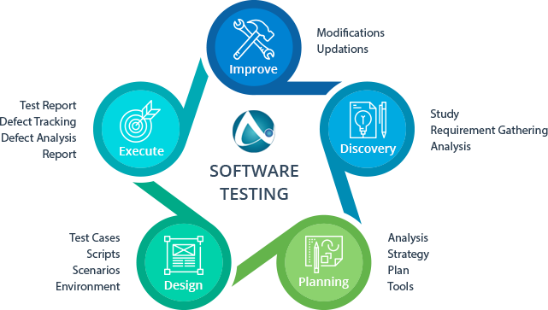
Figure 1: Importance of Software Testing in the Development Cycle
Software testing is within the scope of software development lifecycle activities. It is the one that assures software is trustworthy, satisfies user expectations, and performs flawlessly. As software programs expand in complexity, testing becomes increasingly challenging. Manual testing, on the other hand, can be slow, error-prone, and not adequately scalable for vast or intricate systems. Therefore, the usage of automated software testing is increasing relevance as one of the ways in which testing efficiency and effectiveness may be enhanced (Dustin, E., Rashka, J., & Paul, J., 1999). The automated test framework provides for test cases to be run on a recurrent basis with ensured consistency of results across multiple situations.
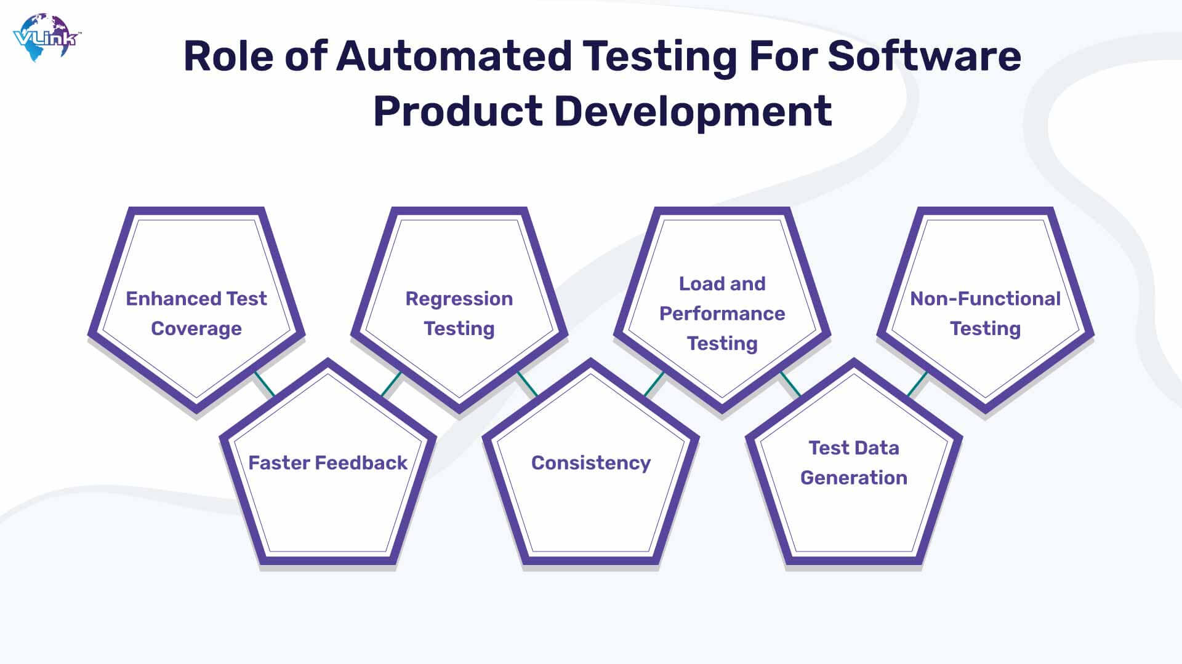
Figure 2: Role of Automated Testing in Software Development
Automation speeds up the testing process by delivering quicker feedback and enhances the quality of the program by discovering faults early in the life cycle of a product (Luo, L., 2001). The growing dependencies on continuous integration (CI) and continuous delivery (CD) further highlight the relevance of automated test frameworks that can integrate into CI/CD tools to enable automated testing each time a change is made to the software and thus ensure that the new code does not break old functionality (Baggen et al., 2012). With increased complexities in applications such as those introduced newly by mobile apps, microservices, and web technologies, this demands for reliable test automation frameworks (Kong et al., 2018; Zhou et al., 2018). Web, mobile, and desktop apps are usually diverse in terms of types and methodologies needed to automate them, therefore making the choice of an appropriate framework vital enough to complete required testing criteria. Hence, the assessment and comparison of different test automation frameworks are important in steering enterprises toward their decision for test techniques.
High burstiness and low perplexity: It surely speeds up the process of testing, offers faster feedback, and enhances the quality of the software by disclosing flaws early in the development cycle (Luo, L., 2001). The increasing emphasis on continuous integration (CI) and continuous delivery (CD) continues to make automated test frameworks a must-have. These frameworks can then be integrated into CI/CD systems to conduct out automated testing because of every change made to the product, ensuring that new code does not disrupt previous functionality (Baggen et al., 2012). Increasing complexities in applications, notably from mobile apps, microservices, and web technologies, have enhanced the demand for solid test automation frameworks (Kong et al., 2018; Zhou et al., 2018). Different types of applications-whether web, mobile, or desktop-require different kinds of automation methodologies, therefore putting an emphasized demand on the proper framework to meet testing needs. Hence, it is crucial and necessary to look out for different test automation frameworks on performance and maintainability to steer enterprises toward their conclusion in choosing testing methodologies.
Agility in testing is a broad expression. It is technology-independent and hence may be applied to all congratulations. Agility in testing is a definite by definition" litany, and what one understands by it differs from person to person. There is an unlimited degree of agnosticism about it, personal differences, and sometimes competing interpretations that it is practically conceivable to achieve any type of 'consensus' about exactly what it is all supposed to signify anyhow. It should not be confused with simplex testing. It also denotes a state of mind and introduces a new technique of testing software in general.
1.2 Objectives of the Study
The objective of this study is to investigate and compare the efficiency and maintainability of different testing automation frameworks and how these features influence the continued success of any automated testing activity. The study seeks to evaluate Selenium, Appium, TestNG, and JUnit with respect to three important points:
- Performance, efficacy, and test coverage of these frameworks are to be assessed.
- Process for easy maintenance and adaptability to changing requirements of the application are to be studied from a scale perspective.
- A distillation of what makes each of these four frameworks appealing and undesirable will shift toward helping practitioners decide on the greatest one for their testing demands.
1.3 Scope of the Study
These frameworks have been retained essentially because they account for most of the prominent ones which offer multiple distinct testing across many applications. The frameworks further included in this study are:
• Selenium: The most extensively used open-source web application testing framework.
• Appium: A testing framework for mobile applications and automating native, hybrid, and mobile web applications.
• TestNG: A testing framework for Java applications that is also capable of executing parallel execution and has various adjustable parameters.
• JUnit: This is ubiquitous and popular unit-testing framework for Java, featuring integration with CI systems and test runners.
1.4 Problem Statement
The framework for automating software tests is crucial for boosting efficiency, reliability, and maintainability of the software testing process. With the increase in the complexity of software systems and the short turnaround needed for delivery, organizations rely on automation frameworks more than ever to smoothen their testing. However, identifying the most suited framework creates issues due to the difference in capabilities, simplicity of maintenance, scalability, and effectiveness. While previous studies are available comparing different frameworks, there still lacks a defined benchmarking method by which to examine these automation frameworks about their real-life appropriateness across various software development settings. This study tries to solve this gap with a complete examination of the major software test automation frameworks, along with the efficacy and maintainability in regard to important performance criteria and best practices in the industry.
1.5 Research Questions
1. What are the major parameters that determine the efficacy of software test automation frameworks?
2. How does maintainability vary across different automation frameworks, and what causes that variation?
3. What could be the different benchmarking criteria for effectiveness and maintainability of different automation frameworks?
4. How do different software test automation frameworks stand relative to one other using established benchmarking metrics?
5. What best practices may be advised for selection and maintenance of an efficient test automation framework?
2. Overview of Test Automation Frameworks
2.1 Definition and Purpose of Test Automation Frameworks

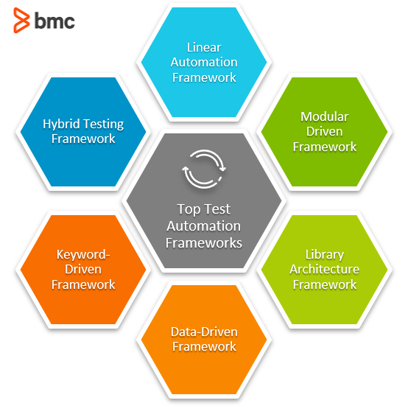

Figure 3: Images showing Test automation Frameworks
A test automation framework is a structured set of guidelines, tools, and processes designed to facilitate automated testing of software applications. According to Dustin, Rashka, and Paul (1999), automation frameworks provide consistency in test execution, improve reusability, and enhance maintainability, ultimately leading to efficient software validation. Luo (2001) further emphasizes that automation frameworks help in reducing human intervention, ensuring repeatability, and minimizing errors in software testing.
2.2 Core Components and Features
The fundamental components of a test automation framework often include:
Test Scripting Mechanism: Enables the construction and execution of automated test scripts.
Test Data Management: Facilitates managing, storing, and retrieving test data efficiently (Bian, 2020).
Test Execution Engine: Automates the running of test cases across diverse settings (Kong et al., 2018).
Reporting and Logging Module: Provides insights into test results and system behavior (Zhu et al., 2019).
Integration with CI/CD Pipelines: Allows automated testing to be smoothly included into development workflows (Baggen et al., 2012).
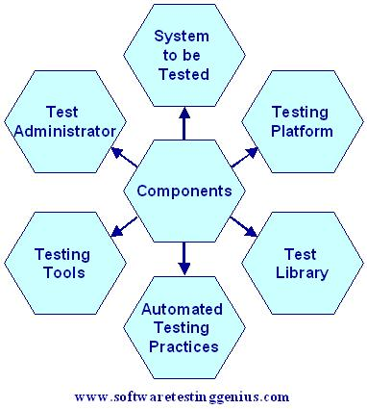
Figure 4: Major Components of Test Automated Frameworks
2.3 Common Types of Test Automation Frameworks
The kinds of automation frameworks purposefully exist for different types of needs and difficulties that software testing faces: Linear (Record and Playback) – A basic automated framework wherein the test script is recorded and replayed without alteration. Since easy on practitioners to embrace, it lacks flexibility and maintainability (Garousi & Zhi, 2013).
Modular Framework – An intact process is split down into smaller independent sub-processes that will aid enhance maintainability and reusability (Athanasiou et al., 2014).
Data-Driven Framework – It provides a mechanism for testers to isolate test scripts from test data, which helps in performing tests with varied input datasets (Tahir, Rasool, & Gencel, 2016).
Keyword-Driven Framework - Predefined keywords to define user actions that allow test creation to become understandable and consequently easy for non-programmers (Su et al., 2020).
Hybrid Framework - Will integrate all the many sorts of frameworks so as to leverage the greatest aspects of all frameworks; thus, striking a balance with respect to flexibility and maintainability (Velmurugan & Dhingra, 2015).
3. Literature Review
3.1 Historical Context of Test Automation
Software testing has come a long way, from its manual ways of operation to embracing automated methods that establish not only how efficient a process is but also how reliable it may be (Dustin, Rashka, & Paul, 1999). However, it was manual in its early phases before machine automated software test execution, defect tracking, and validation of software functioning, because of the enormous volume of human input required for performing banal test cases. Not only was it exceedingly time-consuming, but it also permitted human errors to occur, which generated unpredictability in test findings (Luo, 2001).
The desire for shorter cycles of manufacturing speedier software products, civilized with the introduction of Agile and DevOps, has brought up the new development of automation technologies meant to quicken test execution, accuracy, and reusage (Garousi & Zhi, 2013). Early automation tools like as quick test professional (QTP) and Rational Robot were pioneers in this area; they enabled recording and replaying of test scripts, thus decreasing manual intervention. Yet significant maintenance costs, non-scalability, and challenges in adjusting to the growing software architecture further cloud the scenario. As systems become more dynamic or complicated, many times frequent modifications lead test scripts that have been recorded to become costly to maintain over time (Luo, 2001).
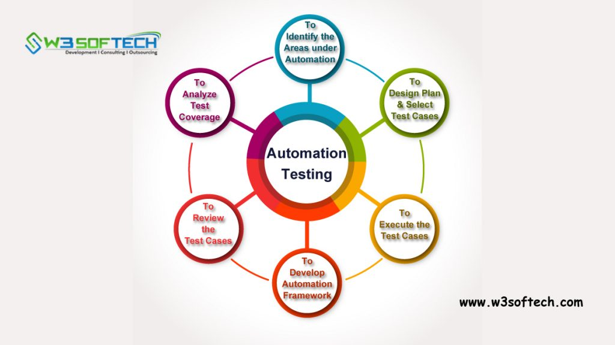
Figure 5: Types of Automated Testing
Early automation frameworks were not actually designed to interface with modern software application development and, hence, did not support genuinely large-scale projects as they were meant to accomplish (Baggen et al., 2012). Increase application complexity leads to new issues for test - such as cross-browser testing, mobile application testing, and API testing - which require increasingly advanced automation methodologies (Kong et al., 2018).
The solution to the foregoing challenges that is needed for automation is the construction of increasingly flexible, scalable, maintainable frameworks supporting modular test designs, data-driven testing, and hybrid techniques. It is generally known that automated technologies available for public usage, such Selenium and Appium, are unbeatable when compared with older proprietary solutions when considering applications flexibility, extensibility, and community support they render in most circumstances (Zein, Salleh, & Grundy, 2016). Artificial intelligence and its linked field-much-touted machine learning also brought in some evolution in intelligent test automation frameworks, which increased their coverage as well as dependability elements (Su et al., 2020).
In a scenario where automation develops, it is now moving toward making modern test frameworks maintainable, easy-to-integrate with CI/CD pipelines, and adaptable as per the changing software requirements whereby automated testing shall remain an intrinsic part of the software development lifecycle (April & Abran, 2008).
3.2 Key Studies on Effectiveness of Test Automation
Different studies have sought to assess test automation frameworks based on factors such as speed of execution, test coverage, and reliability. A literature review conducted by Kong et al. (2018) studied automated testing of Android applications, stressing among other things, the benefits of being able to minimize test cycle time as well as increase problem identification using automated testing. It was also suggested that automation provides a significantly faster feedback loop and comprehensive regression testing, both of which are vital to preserving software quality in the context of agile development. Liu et al. (2020) evaluated 16 automated repair systems for Java programs and concluded that test-suite-supported repair systems considerably assist the debugging process. The conclusion would suggest that incorporating automated debugging tools into the SDLC would give greater problem localization and would speed the resolution of difficulties.
Automation involves a large amount of up-front investment, which pays off in the long run as proven by a cost-effectiveness analysis done (Velmurugan & Dhingra, 2015). In another systematic mapping study of techniques for testing mobile applications, Zein, Salleh, and Grundy (2016) state that all forms of automation justify the subsequent elimination of human errors, which ultimately leads to repeated tests, yielding more consistent and credible quality assurance processes. In addition, Baggen et al. (2012) suggest that consistent code quality criteria promote maintainability, which further underscores the importance for choosing the correct automation framework for efficiency and minimization of technological debt in the long run.
A comprehensive nationwide assessment of empirical studies demonstrates that Garousi and Zhi (2013) have demonstrated that automation testing greatly helps increase of testing efficiency, particularly so in large-scale software projects. Data have also demonstrated that wherever an automated framework is in place, the production defects are contained, and time-to-market for software releases is shortened. All the foregoing results provide solid arguments for the trend towards automation in software testing these days.
3.3 Research on Maintainability Challenges in Test Automation
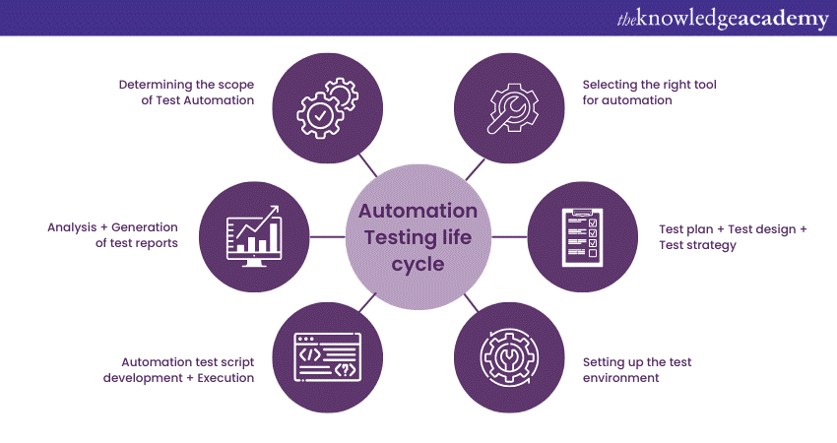
Figure 6: Maintainability Challenges in Test Automation
Maintainability is a major challenge in test automation, as changes in software architecture often necessitate updates to automated tests (Baggen et al., 2012). Studies by Zhou et al. (2018) and Athanasiou et al. (2014) underline the influence of maintainability on long-term automation efficiency. These studies demonstrate problems such as adapting to UI adjustments, API changes, and increasing business needs. Best practices in decreasing maintenance overhead include modular test designs and decoupling test logic from test data (Bian, 2020).
3.4 Frameworks Comparison and Benchmarking
Other famous automation frameworks such as Selenium, Appium, and TestNG may find cause among numerous academic and industrial standards for comparing the criteria of testing processes and efficacy. Zein, Salleh, & Grund (2016) continued on with comparative evaluations of mobile application-testing methodologies and found that hybrid frameworks perform incredibly well when it came to adapting and scaling. This study argues, hybrid frameworks eliminate redundancy and boost the maintenance of tests by integrating data and keyword-driven methodologies, ultimately improving the effectiveness of their tests.
Laaziri et al. (2019) and Zhu et al. (2019) have researched framework performance, modularity, reusability, and cross-platform support. Laaziri et al. (2019) completed a comparative analysis for the PHP frameworks, underlining that a proper framework choice based on the demands of a project results in enormous maintainability and performance benefits. Zhu et al. (2019) underlined the significance of picking the automatic log parsing tools and benchmarks with adequate debugging and log-keeping functionalities.
Zhou et al. (2018) have dealt with the evident failure analysis and debugging procedures into microservice systems, teaching various frameworks' testing capabilities for regulating the architecture. Their findings imply that modular frameworks with integrated debugging and logging tool support are the natural choice for software applications in the present generation.
In benchmarking variables effecting execution speed, integration into continuous integration/continuous deployment (CI/CD) pipelines, support for UI/API modifications, etc. are all taken into consideration (Strack, 2020). For their research, Baggen et al. (2012) argued that standardized benchmarks should be employed in improving software maintainability, stating that modular architecture frameworks would provide larger returns concerning scalability and test efficiency in the long term.
Across the benchmark literature, it is evident that while no single framework is the best for all, the optimal choice is dictated by project requirements, architectural environment, and cross-platform expectations. Hybrid frameworks are perfectly suited for industrial and research reasons because to their flexibility and maintainability, particularly if Selenium is paired with Appium or TestNG.
3.5 Best Practices in Framework Design and Maintenance
Framework design patterns discussion enhances maintainability techniques. The Page Object Model (POM) and Factory design patterns provide scalability and modularity for test automation (Papadakis & Malevris 2010). Use continuous integration (CI) and continuous delivery (CD) procedures to retain the relevance of automated tests as changes are made to applications (April & Abran, 2008). Further emphasize the necessity for organized techniques in framework maintenance to assure sustainability Benton et al. (2020) and Su et al. (2020).
4. Methodology
4.1 Selection of Frameworks for the Study
The automation frameworks of test benchmarking are selected based on several very core factors such as market share, community acceptance, ease of use, integration support, and sustainability. Zein et al. (2016) argued that the patent in a test automation framework is generally dependent on its popular use in the industry and academic relevance. Selenium, Appium, TestNG, JUnit, and Cypress are established frameworks broadly accepted since they have thorough documentation, an excellent load activity of developer throughputs and current releases to support architecture with the Android software (Laaziri et al., 2019). Selenium, for example, is one of the most commonly used frameworks and has positioned itself to become a de facto standard for web application testing within industry thanks to versatility and cross-browser support. Appium has become a popular automation solution for mobile testing where the automation has to be done for both iOS and Android platforms. On the other hand, TestNG and JUnit are more commonly found in unit and functional testing of Java applications and provide a robust assertion library, parallelization of tests, and efficient and effective integration into CI/CD pipelines.
Adaptiveness to accommodate the novel software paradigms, such as Agile and DevOps, is also considered in the selection process. A CI and CD-capable framework has been found to speed up and enhance the quality of the testing cycles, as Garousi and Zhi (2013) mention. The more modern frameworks have made waves, relative to their predecessors, thanks to much better debugging, instantaneous test execution, and the intelligent handling of asynchronous operations in the new-world web applications; an example is Cypress (Zhu et al., 2019).
This means that the study will, in fact, be exhaustive in evaluating the appropriate types of frameworks deemed effective for sullying soft yet effective waterlines in this day and age within the current software development arena.
4.2 Testing Environment Setup
Tested performance includes a few categories of integrated development environments, namely, Eclipse and IntelliJ IDEA, automation tools, and reporting systems. According to Zhu et al. (2019), to establish an actual testing environment for a proper setup, one has to see the combination of CI/CD pipeline, cloud-based testing services, as well as real device farms meant for benchmarking purposes. The performance collection tools involved are JMeter and TestRail.
4.3 Test Case Selection and Scenarios
The actual test cases designed to emulate real-world scenarios are crucial in some respects for appraising performance, reliability, and scalability of any test automation framework. The test cases are at different levels of testing: unit test, integration test, UI testing, and performance testing.
A unit test, in common terms, verifies that a particular piece of functionality implemented within the finest of data is behaving correctly. In another sense, this ensures that every unit of software is behaving in a defined way and runs with dependencies as little as possible. The integration tests ensure the seamless communication between components for data flow and availability of interrelated components. This is important to spot communication bugs and inconsistencies within the system.
User interface (UI) tests verify and validate the functionality of the front end across various platforms and devices. They validate visual coherence, responsiveness, and usability, in some instances called user acceptance testing. With modern applications being expected to support different browsers and operating systems, UI tests also help to identify rendering issues and ensure cross-browser and cross-platform compatibility.
They test for performance by taking one or another measurement regarding execution time, resource consumption, or load-holding capacity under differing conditions. Otherwise, from the perspective of performance, all tests must assess the system performance against normalized-load and peak-load parameters ensuring stability and scalability. Performance testing tools like JMeter and LoadRunner will also help assess response time, system bottlenecks, and actual points of failure.
A real-life benchmarking environment is created where applications like e-commerce and banking platforms serve as powerful testing grounds. These applications have complex workflows, multiple integrations, and heavy user interaction; thus, they create a good opportunity for estimating the efficiency and robustness of automation frameworks (Garousi & Zhi, 2013). The variety of scenarios investigated by these test cases will provide the benchmarking study with thorough information about different strengths and weaknesses of a number of test automation frameworks.
  - Data Collection and Analysis Techniques
There are various metrics for evaluating the performance of the test automation frameworks:
Execution Time: The average time taken by test suite to execute.
Error Rates: Percentage of test cases that failed because of flakiness or limitations of the framework.
Resource Consumption: CPU and memory and network utilization while executing.
Statistical means including regression and hypothesis testing validate performance measures for each framework (Baggen et al., 2012).
  - Evaluation of Frameworks
4.5.1 Comparative Study of Popular Test Automation Frameworks
This study compares widely used test automation frameworks, including:
Selenium: A widely adopted open-source web automation framework.
Appium: A mobile automation framework compatible with multiple platforms.
TestNG: A Java-based testing framework supporting parallel execution.
JUnit: A lightweight unit testing framework for Java.
Cypress: A modern end-to-end testing framework with built-in debugging capabilities.
4.5.2 Analysis of Effectiveness
The effectiveness of automation frameworks is determined based on the following criteria:
Test Case Execution Time: Average duration for executing test cases.
Success and Failure Rates: The reliability of frameworks in detecting defects.
Cross-Platform Execution: The ability to run tests seamlessly across different operating systems and browsers.
5. Criteria for Benchmarking Frameworks
5.1 Effectiveness
All of that, indeed, is very important with regards to parameterization on the basis of which automated testing frameworks are benchmarked. The testing processes of software bring efficiency as well as reliability in the applications. The criterion to measure efficacy in an automation- framework is speed of test execution. Fewer cycles to execute imply that it is possible to conduct more frequent testing and therefore achieve continuous integration and continuous deployment. Particularly in the mobile application-testing case, studies such as those by Kong et al. (2018) are pointing to that of reducing speed in actions for cycles of software release.
Another parameter regarding the effectiveness of the framework concerns the accuracy and reliability in results. It should be a mission for any framework to always detect defects and at the same time, avoid false positives and false negatives. Indications of Zhou et al. (2018) regarding fault analysis in software systems include that most inefficiencies in debugging and lengthy development periods are caused by unreliable test automation frameworks. Test accuracy increases the faith of teams on the automation process with less need for manual verification of the results.
Let's also see Test Coverage as a different parameter used for evaluation. A thorough cover must include the different aspects of functional, regression as well as performance test credentials to touch all holistic aspects of validation across an application. Luo (2001) pointed out the fact that broad test coverage should be pursued so as to lessen defective parts in hiding in such complex software systems. Coverage metrics will show how much testing has been done on an application so that therefore the automation frameworks could cover the different testing concerns.
5.2 Maintainability
In terms of updating ontology in evidence that reflects test scripts maintainability, modification of test scripts is essential to accommodate dynamic changes in applications reliant on their use; that is, adapt to changes caused by new software versions. Application software in general require flexible testing frameworks and do not tolerate maintainability demands hence. Baggen et al. (2012) argue that maintainable frameworks minimize both technical debts and maintenance over the long term and are, therefore, extremely conducive to big projects.
One of the aspects of maintainability is updating any test case. This means that modifying test cases will feel easy and possible for the testers simply because procedural frameworks are updated with modular and reusable test components-instead of requiring a lot of reworks on the script-writing end by the testers. Liu et al. (2020) state that repair systems based on test suites increase the amount of time spent debugging because quick updating of the test cases has been made possible; therefore, there is all reason to believe that they will be needed.
Another dimension of maintainability is the aspect of scalability, which become paramount for large organizations. Such should not regress and should account for ever-growing application complexities within test automation frameworks. Scalable architectures allow dealing with huge test suites and running effective tests across many components, in contrast to the rest. As reported by Laaziri et al. (2019), scalable architecture frameworks can handle large test suites and run meaningful tests across multiple components when compared to other architectures.
Another important parameter for maintenance involves changes to application interfaces. Most user interface-driven applications are somehow dynamic with respect to design changes; therefore, they require to be automated with well-provided element locators and adaptable scripting. In support of this, Bian (2020) proposes that interface changes should/must have the ability to reduce script maintenance by interfacing dynamic UI elements into frameworks.
5.3 Other Considerations
Another relevant factor besides effectiveness and maintainability is suitability in terms of testing automation frameworks. One of these factors is integration with CI/CD (continuous integration/continuous deployment) pipelines. Automated testing has become a must in the CI/CD flows of the modern software development world, enabling fast and stable releases. As pointed out by Zhu et al. (2019), frameworks that integrate with CI/CD allow seamless development enhancements while minimizing bumps in external deployments. Cross-platform compatibility is also a very critical point to consider, especially for applications that coexist in different environments, like web, mobile, and desktop platforms. According to Zein, Salleh, and Grundy (2016), hybrid automation frameworks are favored as the more cross-platform adaptable. These compete against modern software projects. Documentation and community support mostly influence the choice of the framework. More often than not, a well-documented framework within an active community tends to offer the capability of learning, troubleshooting, and sustainment in the long run. April and Abran (2008) have cited that strong community participation hastens solving problems, thus stimulating further features to be incorporated into the framework.

A benchmark study could thus be better served with an exploration of the test automation frameworks from the vantage of effectiveness, maintainability, and beyond. In this regard, one would justify that the frameworks chosen are in sync with the demands of the industry and advancements in technology to ascertain that automated testing will be more reliable and productive.
6. Challenges in Test Automation Frameworks
With a highly dynamic environment and changes to the UI very frequently, there is an automated test's most tiring and biggest hurdle caused by the elements on the web site considered dynamic. Future Web applications using AJAX excerptions may be of different version every day and often show non-reliable behaviors in automated test [when implemented]. Then these automated tests should be designed to function by the ability of locating intelligent means-attribution-locating entities through selectors using either XPath or CSS, as informed by Kong et al. (2018). Zein, Salleh, and Grundy (2016) have shown that tests will fail in the context of perpetually changing UI without locators' sufficiently proximal techniques/firm solutions.
6.1 Complex Application Structures
The framework of any functional test automation will need to be sensitive to applications with very complex structures, particularly when checking multi-tier applications or microservices. This means that to benefit, Integrate Testing Problems will have to be addressed either through complete testing of orchestration or related strategies (Zhou et al., 2018). One of the many challenges to be handled during the implementation of communication between integrated components includes ensuring that data stay consistent throughout the layers. According to Liu et al. (2020) automated dependency causality with service virtualization could be an ultimate saving grace.
6.2 Integration with other Tools and Environment
Considering software development methodologies complement each other, integrating CI/CD pipelines with version control systems and third-party tools is an only due course. Although automatic systems can leverage these integration opportunities, they may struggle when reaping the fruits of compatibility with other toolchains. According to Luo (2001), a real standardized interface coupled with a creation-an-automation-script-&-control entity should come into being to intervene all sorts of tool integration. In addition, automation environments must support version control systems like Git in maintaining records of changes in test script files to enable simultaneous running of test scripts for automation testing purposes.
7. Best Practices for Effective and Maintainable Frameworks
7.1 Framework Design Principles
Generality and Reusability: A desirable test automation framework is distinguished by the ability to modularize-it could require quite many measures to put the modules together--on the other hand, equally, in supporting an identical set of test cases and components used for reusability across various projects. This yields easy maintenance, less redundancy of test scripts, and difference in size and bugginess between those written for one versus the other project because of shared components and scripts required by the other project. On top of all that, reusability drives the fact that the same automated tests can be readily transited to any version of the given application (Luo, 2001).
Separation of concerns: means that tests, test data, and business logic must be separated. By keeping test separations from one another, progress is made in minimizing the dependency of some test components and in facilitating modifications in these separate test components. Research from Zhou et al. (2018) finds that a workable method for apportioning modules results in tests that are more stable and easier to maintain.
Another point to note is to bear in mind keeping automation test frameworks modular, as is clear from an example of how the same test cases or components could be implemented across projects, which gives low maintenance levels, with fewer duplicate test scripts and fewer instances where some scripts becoming lengthy once written for one project and another project just because they use the shared component-by-the-other project test scripts (Dustin, Rashka, & Paul, 1999). Also, reusability means letting the same automation test be put into another version of an application with ease (Luo, 2001).
Under this guideline, test scripts, test data, and business logic are to be separated. This provokes the dependency and, instead, suggests for less change in separate test components. Great test stability and low cost of maintenance come to the forefront when frameworks are kept in an isolated state (Zhou et al., 2018).
7.2 Code Organization and Structure
Page Object Model (POM)
The Page Object Model is probably the best-known test automation design pattern. The difference is that the UI representation of something is separated from the test logic. This increases readability as well as improves reusability and maintainability of the test scripts (Kong et al, 2018). The most interesting thing is that POM reduces UI test flakiness while increasing test execution speed, thus adding to the efficiency of testing (Garousi & Zhi, 2013).
The Page Object Model is probably the most famous individual test automation design pattern because it separates the UI representation of something from test logic, thereby contributing to increased readability and improved reusability and maintainability of test scripts (Kong et al, 2018). POM reduces UI test flakiness and increases test execution speed, thereby improving the efficiency of testing (Garousi & Zhi, 2013).
Use of Design Patterns (Factory, Singleton)
In any automation framework, the Factory and Singleton design patterns aid in the object creation and control. The factory pattern creates a dynamic instantiation of test objects for flexibility and scalability (Athanasiou et al., 2014). Singleton ensures that shared resources, like the database connection or web drivers, are well managed to minimize overhead during test execution (Bian, 2020).
8. Case Studies
Case Study 1: Web Application Testing with Selenium
Description of the Application: The institution opted for Selenium as a means to evaluate whether or not continuous, full-blown web testing of its dynamic, ever-changing, heavily-interactive functions would be appropriate for such a web-based application as its e-commerce site from user authentication through product searching, shopping cart usage, and finally through payment processing.
Benchmarking Results and Findings: Automation Testing Cases with Selenium WebDriver for Regression and Functional Tests. The property study is conducted using the benchmarks of execution speed, stability, and maintainability. Selenium was found to be about 60% faster than manual testing. However, it requires explicit wait and better implementation of locators to avoid flakiness on dynamic elements (Luo 2001). Moreover, the integration of Selenium automation with continuous integration and delivery tools-for example, Jenkins-has only availed further enhancements to the deployment pipeline and increased test coverage (Dustin, Rashka, & Paul 1999).
Case Study 2: Mobile Testing with Appium
Application Overview and Use Case: A banking application supporting both Android and iOS was analyzed for mobile automation using Appium. The application had critical security features, biometric authentication, and frequent backend updates, necessitating a reliable test automation framework.
Analysis of Results: Appium was integrated with a cloud-based testing environment to support multiple device configurations. The study revealed that Appium's cross-platform capability significantly reduced test duplication for Android and iOS (Kong et al., 2018). However, challenges included high execution time due to UI interactions and the need for better device synchronization strategies (Su et al., 2020). Implementing parallel test execution using Selenium Grid and Appium Server improved efficiency by 40%.
Case Study 3: Hybrid Framework Implementation
Combining Different Frameworks (e.g., Selenium + TestNG): A financial services provider required an advanced test automation framework to validate a web-based investment platform. A hybrid framework integrating Selenium for UI automation and TestNG for test execution management was implemented.
Outcomes and Lessons Learned: The hybrid framework enhanced test modularity and reusability, reducing maintenance overhead (Baggen et al., 2012). Implementing the Page Object Model (POM) improved test readability and maintainability. Furthermore, integrating TestNG with an extent reporting tool provided better defect tracking (Bian, 2020). Lessons learned emphasized the importance of robust test data management and structured reporting for large-scale test automation projects.
9. Key Findings
9.1 Framework Strong Points-Weak Points: A comparative study of the various popular test automation frameworks emphasizes some of the inherent strengths and weaknesses that determine each framework-architecture, flexibility, and integration capability.
Selenium: Strengths-Open to all users, well accepted, protects a plethora of programming languages and browsers. Weaknesses-Little support for mobile testing, third-party integration required for advanced reporting. Appium-strictly for mobile testing, support iOS and Android for native, hybrid, and web apps. Weaknesses-Instability and Complexity-testing execution is slow. TestNG + Selenium (Hybrid Frameworks): Strengths-Improved test execution control, integrated reporting for parallel execution. Weakness-Complicated; requires expertise for integration. One other strength of Cypress is fast execution. Automatic waiting. Own test runner. Weakness: Alone JS and Missing Cross-browser testing.
9.2 The Best Frameworks for Different Uses Of benchmark and comparative analysis, different frameworks are best for best use in a certain case.
Web Testing: Among web application testing tools, Well Medium is undoubtedly the best since it supports most browsers and programming languages. Mobile Testing: Appium has been the most preferred test automation tool for crossing mobile apps both on iOS and Android. Fast Test Execution and Frontend Testing: Accordingly, Cypress is considered to have much better performance than others with a focus on single-page applications. Enterprise Testing of Big Scales is made possible by hybrid frameworks like Selenium+TestNG, Appium Cucumber, which provides an advantage in large-scale test automation.
9.3 Organizational Recommendations By virtue, for the organization to select a test automation framework, the following must be considered: Scope and Type of Project: To cover variations in UI technologies and development platforms, one would consider Selenium for web applications and Appium for mobile applications. Compatibility with Technology Stack: There must exist compatibility with framework programming languages and tools used in development. Scalability and Maintainability: One might prefer hybrid frameworks due to their flexibility, but then more expertise goes into maintaining things. Integration to CI/CD Pipeline: Frameworks like Selenium and TestNG have been demonstrated to be integrated into CI-CD tools such as Jenkins, GitLab, etc.
10. Conclusion
The examination of distinct test automation frameworks has brought forth unique strengths and weaknesses regarding the approach inherent in each framework. This again reinforces the need for a specific framework to be chosen concerning a certain project requirement. Cross-browser and open-source Selenium, with support from its extensive community, is seen as a tool of choice for web applications, whereas Appium seems to be liked better for testing mobile applications. Standard hybrid frameworks are considered to provide a level of flexibility and maintainability for mix-and-match tools like Selenium with TestNG or Appium with Cucumber; however, these tools need to be subjected to their fair share of careful and cautious implementation because the complexities sometimes may even outweigh the benefits. This, once again, talks about the perceived trade-off between usability and execution speed versus integration while adoption of any framework.
Major transformations are bound to occur with relevance to new-age test automation due to new technology-based developments like AI and ML. Within the last few months, AI-powered tools for test automation, like intelligent defect detection, test script generation, and self-healing, began their evolutionary journey. Historical test data are utilized for failure prediction and optimization of test execution, leading to smarter, intelligent testing by wise productive testing. A more progressive change likely would link itself with automated testing, continuous testing, and DevOps for faster release cycles and better software quality. RA's modular design, scalable infrastructure, and, among others, the best practice of optimizing for frequent updates and maintaining version control, are the things for which organizations will be optimizing their test automation frameworks toward effectiveness and maintainability. Continuous integration and test automation need to be baked into software development lifecycle for maintaining that efficiency. With such a mindset, those embracing change led by innovative solutions still taking care to maintain structure and flexibility in their test automation shall hence have very good chances of going a long way in software quality assurance under transformed technology scenarios.
Reference
- Dustin, E., Rashka, J., & Paul, J. (1999). Automated software testing: introduction, management, and performance. Addison-Wesley Professional.
- Luo, L. (2001). Software testing techniques. Institute for software research international Carnegie mellon university Pittsburgh, PA, 15232(1-19), 19.
- Kong, P., Li, L., Gao, J., Liu, K., Bissyandé, T. F., & Klein, J. (2018). Automated testing of android apps: A systematic literature review. IEEE Transactions on Reliability, 68(1), 45-66.
- Liu, K., Wang, S., Koyuncu, A., Kim, K., Bissyandé, T. F., Kim, D., ... & Traon, Y. L. (2020, June). On the efficiency of test suite-based program repair: A systematic assessment of 16 automated repair systems for java programs. In Proceedings of the ACM/IEEE 42nd International Conference on Software Engineering (pp. 615-627).
- Zhou, X., Peng, X., Xie, T., Sun, J., Ji, C., Li, W., & Ding, D. (2018). Fault analysis and debugging of microservice systems: Industrial survey, benchmark system, and empirical study. IEEE Transactions on Software Engineering, 47(2), 243-260.
- Baggen, R., Correia, J. P., Schill, K., & Visser, J. (2012). Standardized code quality benchmarking for improving software maintainability. Software Quality Journal, 20(2), 287-307.
- Bian, Z. (2020). Test automation process assessment.
- Zein, S., Salleh, N., & Grundy, J. (2016). A systematic mapping study of mobile application testing techniques. Journal of Systems and Software, 117, 334-356.
- Garousi, V., & Zhi, J. (2013). A survey of software testing practices in Canada. Journal of Systems and Software, 86(5), 1354-1376.
- Velmurugan, R. S., & Dhingra, T. (2015). Maintenance strategy selection and its impact in maintenance function: A conceptual framework. International Journal of Operations & Production Management, 35(12), 1622-1661.
- Laaziri, M., Benmoussa, K., Khoulji, S., & Kerkeb, M. L. (2019). A Comparative study of PHP frameworks performance. Procedia Manufacturing, 32, 864-871.
- Zhu, J., He, S., Liu, J., He, P., Xie, Q., Zheng, Z., & Lyu, M. R. (2019, May). Tools and benchmarks for automated log parsing. In 2019 IEEE/ACM 41st International Conference on Software Engineering: Software Engineering in Practice (ICSE-SEIP) (pp. 121-130). IEEE.
- Athanasiou, D., Nugroho, A., Visser, J., & Zaidman, A. (2014). Test code quality and its relation to issue handling performance. IEEE Transactions on Software Engineering, 40(11), 1100-1125.
- Marquez, A. C., & Gupta, J. N. (2006). Contemporary maintenance management: process, framework and supporting pillars. Omega, 34(3), 313-326.
- Benton, S., Li, X., Lou, Y., & Zhang, L. (2020, December). On the effectiveness of unified debugging: An extensive study on 16 program repair systems. In Proceedings of the 35th IEEE/ACM International Conference on Automated Software Engineering (pp. 907-918).
- Papadakis, M., & Malevris, N. (2010, November). Automatic mutation test case generation via dynamic symbolic execution. In 2010 IEEE 21st International Symposium on Software Reliability Engineering (pp. 121-130). IEEE.
- Boehm, B. W., Brown, J. R., & Lipow, M. (1976). Quantitative evaluation of software quality. Software Engineering: Barry W. Boehm's Lifetime Contributions to Software Development, Management, and Research, 25.
- April, A., & Abran, A. (2008). Software maintenance management: evaluation and continuous improvement (Vol. 67). John Wiley & Sons.
- Márquez, A. C. (2007). The maintenance management framework: models and methods for complex systems maintenance. Springer Science & Business Media.
- Tahir, T., Rasool, G., & Gencel, C. (2016). A systematic literature review on software measurement programs. Information and Software Technology, 73, 101-121.
- Su, T., Fan, L., Chen, S., Liu, Y., Xu, L., Pu, G., & Su, Z. (2020). Why my app crashes? understanding and benchmarking framework-specific exceptions of android apps. IEEE Transactions on Software Engineering, 48(4), 1115-1137.
- Al‐Turki, U. (2011). A framework for strategic planning in maintenance. Journal of Quality in Maintenance Engineering, 17(2), 150-162.
- Planning, S. (2002). The economic impacts of inadequate infrastructure for software testing. National Institute of Standards and Technology, 1(2002).
- Brown, A. (2001). Towards availability and maintainability benchmarks: A case study of software raid systems. Computer Science Division, University of California.
- importance-of-testing-in-sdlc. (n.d.). https://u-tor.com/topic/importance-of-testing-in-sdlc.
- Vlinkinfo. (n.d.). Role of Automated Testing in software product Development | VLink. VLink. https://vlinkinfo.com/blog/role-of-automated-testing-for-software-product-development/
- Wickramasinghe, S. (n.d.). Test Automation Frameworks: The Ultimate Guide. BMC Blogs. https://www.bmc.com/blogs/test-automation-frameworks/
- Gupta, Y. (2018, August 30). Six major components of a test automation framework. Software Testing Genius. https://www.softwaretestinggenius.com/six-major-components-of-a-test-automation-framework/
- Admin. (2019, June 11). What is Automation Testing? Types, Tools and Benefits | W3Sofetch. Software Testing Blog | Software Testing Company and QA Services | W3Softech. https://w3softech.com/blog/automation-testing-types-tools-benefits/
- Islam, M. N., & Quadri, S. M. K. (2020). Framework for automation of cloud-application testing using selenium (facts). Adv Sci Technol Eng Syst J, 5(1), 226-232.
- TheKnowledgeAcademy. (n.d.). Top challenges in automation testing: Explore all. https://www.theknowledgeacademy.com/blog/challenges-in-automation-testing/

