ENSURING DATA SECURITY AND COMPLIANCE IN AI-POWERED BUSINESS APPLICATIONS
Abstract
Artificial intelligence technologies revolutionized how firms make judgments while transforming both data automation and processing throughout company operations. The fast commercial adoption of artificial intelligence technology produced new demanding hurdles for data security coupled with regulatory compliance issues. The vast processing of secret data by AI systems makes them into key targets that cyber attackers and auditors both seek to access. Businesses must supply secure defenses for AI integration operations combined with full compliance standards because operational efficiency requirements exist.
Safeguarding AI is attainable through modern systems which combine threat identification with aberrant pattern detecting speeds at high speed. AI systems produce well-protected cyber services by using predictive analytics with behavioral analysis coupled with automated threat intelligence which constructs defensive networks for system protection from attacks. The advancement of encrypted technology provided two key tools dubbed homomorphic encryption coupled with differential privacy to safeguard AI-generated data during operational maintenance. The implemented cryptographic infrastructure helps enterprises to defend operational functions through dual-purpose protection of data dependability and privacy.
Organizations must build AI-law and data-security regulation framework understanding regardless of regulatory changes. Business operations must create data protection standards that integrate GDPR compliance alongside relevant privacy requirements from specific business sectors at worldwide and regional levels. Organizations accomplish suitable legal and ethical standard alignment with AI applications through three fundamental techniques that link automated systems for compliance with security models which include AI-powered governance and accountability features.
AI security coupled with compliance needs enterprises to use an integrated solution that integrates AI security tools with proven cybersecurity methods. A comprehensive security plan must integrate safe cloud configurations with improved endpoint defenses coupled with regular risk checks. AI security and compliance enhancement demands all parties concerned to collaborate together between AI developers and cybersecurity professionals and regulatory agencies.
Businesses need to establish technical-progress equilibrium with tight security measures when preserving data security and compliance standards in their AI-based software solutions. The protection of sensitive company data in addition to cyber risk reduction and building of trust in AI operations becomes possible through security frameworks employing AI as well as cryptographic techniques and regulatory compliance maintenance. Organization success in digital resilience depends on their capacity to forecast security threats and compliance concerns which result from advancing AI technologies.
Keywords; AI security, data protection, compliance, AI-powered business applications, cybersecurity, threat detection, regulatory frameworks.

1. Introduction
1.1 Background of the Study and Importance of data security and compliance in AI systems
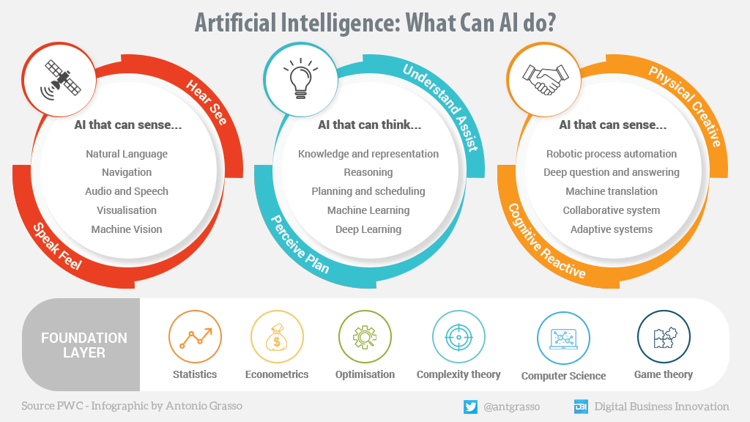
Figure 1; Artificial Intelligence in business
The current world perceives Artificial Intelligence (AI) as a revolutionary tool that improves corporate efficiency and strengthens organizational decision-making abilities and defensive security measures. The use of AI technologies offers business organizations with a potential to evaluate huge data volumes and optimize operations and forecast results at astonishing precision. AI systems pervade many corporate activities that involve both client management features and supply chain enhancement with financial prediction analysis and security protection. The digital economy derives a competitive advantage through business process optimization and market edge creation because firms apply artificial intelligence technologies including machine learning coupled with natural language processing and automation capabilities.
AI develops more visibility in many corporate areas which has caused two key priority challenges related data security and regulatory compliance. The usage of AI depends largely on data assets which frequently include sensitive personal data that becomes a major factor in deploying these systems. Protecting the substance and confidentiality and operational readiness of data acts as a critical method to prevent cyber threats and data breaches. The General Data Protection Regulation (GDPR) together with the California Consumer Privacy Act (CCPA) compelled organizations to utilize strong security measures since both legislations set severe data protection obligations. Data protection regulations globally now receive defense through AI-powered security functions which guard data from illegal entrance and leaks as well as cyber-attacks.
The introduction of AI security systems brings forward new vulnerabilities even though progress has been made in these sectors. Advanced cyber risks have developed after organizations started employing more AI systems which spawned adversarial attacks as well as AI model poisoning and deepfake manipulations. Cyber-attacks utilizing AI learn techniques can uncover flaws in machine learning models and thereby breach information systems while meddling with organizational choices. AI automation technologies create security vulnerabilities which cause various system failures if management rules are not maintained. The dynamic nature of AI security threats needs continual monitoring, adaptive threat intelligence, and proactive risk mitigation methods.
The present company scene necessitates the solution of data security and compliance concerns because of ongoing AI-powered application innovation. Manufacturing facilities currently benefit from AI in cybersecurity since this technology gives increased skills to detect threats before they do harm. Database technologies which use AI act as key parts for boosting protective data systems through their improved features of anomaly detection and predictive analytics. Security solutions based on AI technology operate by evaluating massive data collections instantaneously while recognizing unexpected behaviors that assist both automatically respond to issues and eliminate human-driven blunders.

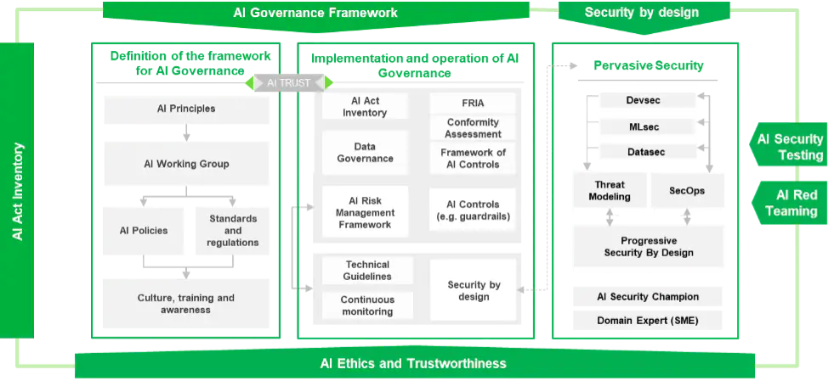
Figure 2; Diagrams showing artificial intelligence in Data protection and Privacy
The most serious AI security concern exists in defending cloud environments since they store and handle huge commercial data quantities. IT infrastructure security is a significant challenge for firms which deploy AI-powered apps because their cloud platforms confront numerous security risks and access threats. Programs based on artificial intelligence have established security frameworks which increase cloud security through superior encryption methods and networks of behavioral analysis with intrusion detection capabilities. Such technologies allow enterprises to protect their AI applications in cloud deployments by following data protection rules.
AI integration with Internet of Things (IoT) platforms causes security along with privacy to become important problems. IoT technologies include smart home devices along with industrial sensors create substantial volumes of data which needs effective data security for their processing and storage functions. The deployment of security measures driven by AI helps identify aberrant behavior and limits unapproved access and defends data legitimacy in IoT networks. Robust security architectures require development to prevent security concerns which come from the decentralized structure of IoT networks.
AI security operations are significantly influenced by ethical issues coupled with technological barriers during implementation. The proper use of Artificial Intelligence involves both algorithmic decision transparency coupled with economic and rational decision methods. The creation of AI models demands engineers to construct systems that employ minimum biases and protect private rights as well as stop discriminatory effects. Organizations need to adopt ethical AI principles and build governance structures to guarantee that their security measures based on AI compliance with legal norms and public expectations.
Security advances through AI will grow into three primary directions involving ongoing enhancements of machine learning and quantum computing coupled with blockchain applications. Businesses employing AI threat intelligence coupled with quantum-resistant encryption technologies will obtain the potential to detect future cyber threats. Decentralized authentication elements from Blockchain security frameworks will produce trustable and full data systems. The future evolution of AI needs firms to retain constant alertness through security challenge identification while employing new protection measures for their digital resources.
Business operations benefit substantially from AI applications through better security features yet they bring extra security risks that must be handled. Data security coupled with compliance is a crucial priority that organizations need to handle regulatory requirements and future cyber dangers. System security based on AI technology together with ethical AI frameworks plays a significant role in safeguarding us from security concerns when adopting AI technologies. Electronic infrastructure protection demands enterprises to both fund AI security research as well as establish robust risk management systems and raise cybersecurity awareness via their operations in this age of AI domination.
1.2 Objectives of the Research
Those are the main focal points of this research endeavor.
1. A study about the function of business applications powered by AI in current enterprises which demonstrates their influence on operational effectiveness and decision-making processes.
2. A study of the essential elements data security along with regulatory compliance for AI-driven systems combined with techniques for organization compliance with worldwide standards.
3. The identification of new hazards and weaknesses that appear when organizations implement AI systems must include examination of attacks on models and adverse behavior alongside data protection risks.
1.3 Problem Statement
Business applications utilizing AI technology have accelerated their adoption rates which produced huge surge in data generation along with processing and storage requirements. The gains made possible by AI through automation and decision-making and cybersecurity development do not eliminate integrity challenges related to security and compliance difficulties. Due to their data requirements AI systems become sought-after assets for cyber attackers who aim to exploit this knowledge. The expanding number of cyber risks coupled with AI-powered attacks on systems and data contamination plus model corruption has caused worries about AI-powered decision systems being unreliable and unsecure.
Companies suffer legal along with financial concerns since they fail to follow the ongoing changes in regulatory standards such as GDPR, CCPA and numerous data protection legislation. The integration of Cloud environments with IoT ecosystems makes these challenges worse since it expands the number of potential attack targets while disclosing weaknesses in connected systems' security. The absence of explicit explanations regarding AI algorithms together with inadequate accountability features produces major moral difficulties relating to privacy violations and admiration problems and biases.
Organizations struggle to implement robust security measures through AI-powered solutions which successfully stop AI-targeted threats even though technology has evolved. The present AI security models need continual changes against changing attacks yet several organizations struggle to sustain or create these systems since they lack AI competency and resources. The urgent necessity exists to investigate security strategies based on AI technology and design compliant security frameworks with AI resiliency to defend business applications from emerging security hazards.
1.4 Scope and Significance of the Research
Business applications utilizing AI technology have accelerated their adoption rates which produced huge surge in data generation along with processing and storage requirements. Below the tremendous gains given by AI in automation and decision-making as well as cybersecurity the technology comes crucial security and compliance problems. Due to their data requirements AI systems become sought-after assets for cyber attackers who aim to exploit this knowledge. The expanding number of cyber risks coupled with AI-powered attacks on systems and data contamination plus model corruption has caused worries about AI-powered decision systems being unreliable and unsecure. Companies suffer legal along with financial concerns since they fail to follow the ongoing changes in regulatory standards such as GDPR, CCPA and numerous data protection legislation. The integration of Cloud environments with IoT ecosystems makes these challenges worse since it expands the number of potential attack targets while disclosing weaknesses in connected systems' security. The absence of explicit explanations regarding AI algorithms together with inadequate accountability features produces major moral difficulties relating to privacy violations and admiration problems and biases. The progress gained in AI-based cybersecurity systems does not correspond with the organizational battle to develop secure protection systems against AI-unique risks. The existing AI security models need constant updates to stop new cyber assaults but corporations struggle to acquire both the knowledge levels and financial assistance needed to manage these systems. The lack of effective protection for business applications against threats necessitates rapid study into AI security solutions as well as compliance enhancement and strong AI frameworks development to construct robust defensive systems.

2. Literature Review
2.1 The Importance of Data Security in AI Applications
Industries that rely more on artificial intelligence have significantly changed their data security requirements; they now mostly concentrate on confidentiality integrity and availability, which constitute the CIA Triad. In artificial intelligence applications, security lays three fundamental bases that guard important data from several sources like adversarial attacks and unauthorized access and data breaches. The protection of data with AI-based security models exhibits substantial study engagement because machine learning technology and encryption innovation with behavioral analytics accomplishes effective risk reduction. Sensitive data is exchanged just through a system that guarantees its availability to authorized users. AI-based cybersecurity solutions have transformed encryption techniques so that, according Bibi (2020), concealed data becomes more difficult for illegal users to access. The research by Charlesworth and Pearson (2016) investigates how accountability-based solutions function in data privacy by proving that regulatory systems safeguard cloud environment secrecy. The deployment of encryption methods specifically homomorphic encryption and differential privacy serves to protect sensitive information during the processing period of AI applications.
Data accuracy and unmodified state form the key elements of integrity as an essential security principle in the CIA Triad framework. AI systems require high-quality trustworthy datasets to work efficiently yet any modification to this data source creates major operational difficulties. Gopireddy (2021) highlights the usage of security mechanisms designed with AI to study behavioral patterns while detecting data stream anomalies which detect unwanted alterations. According to Babun et al. (2021) blockchain technology acts as an excellent solution for data integrity since it provides irreversible records which stop unauthorized alterations to information. AI-driven decision-making procedures become more dependable thanks to these data protection methods that lessen the likelihood of data corruption along with manipulation hazards.
The system must be accessible to approved users whenever they need it through the Availability principle. DDoS assaults that distribute denial-of-service operations will inflict severe damage to the accessibility of AI systems making them unable to function. As per Laturkar and Laturkar (2023) robust communication protocols coupled with redundant processes are critical aspects to assist preserve operational AI systems under cyber threat situations. AI threat intelligence systems presented by Reddy (2022) rely on artificial intelligence to foresee and handle potential issues which keeps AI-driven services working at peak performance levels. To guarantee optimum AI application uptime in cloud environments organizations have to use forward-looking threat detection technologies coupled with automatic backup solutions. Data breaches emerge as a key security concern to AI infrastructure since unapproved organizations successfully access secret information and may utilize it for illicit aims. Bibi (2022) illustrates how AI increases database security through unique protection measures which stop illegal access to information. The authors Ashraf and Haile (2023) highlight that regulatory compliance needs AI systems to meet standards specified by data protection regulations including GDPR and CCPA to protect against data breach risks. Organizations obtain superior unauthorized data exposure protection with the installation of robust authentication systems and numerous authentication barriers and limited access frameworks.
The system must be accessible to approved users whenever they need it through the Availability principle. DDoS assaults that distribute denial-of-service operations will inflict severe damage to the accessibility of AI systems making them unable to function. As per Laturkar and Laturkar (2023) robust communication protocols coupled with redundant processes are critical aspects to assist preserve operational AI systems under cyber threat situations. AI threat intelligence systems presented by Reddy (2022) rely on artificial intelligence to foresee and handle potential issues which keeps AI-driven services working at peak performance levels. To guarantee optimum AI application uptime in cloud environments organizations have to use forward-looking threat detection technologies coupled with automatic backup solutions. Data breaches emerge as a key security concern to AI infrastructure since unapproved organizations successfully access secret information and may utilize it for illicit aims. Bibi (2022) highlights how AI transforms database administration through its superior security features which stop unwanted access of valuable data. The experts Ashraf and Haile (2023) underline how AI systems need to follow GDPR and CCPA rules because executing regulatory compliance decreases data breach threats. Organizations obtain greater data exposure protection when they employ strong authentication infrastructure along with multiple authentication processes and permission-based accesses systems.
2.2 Regulatory Frameworks for AI Data Protection
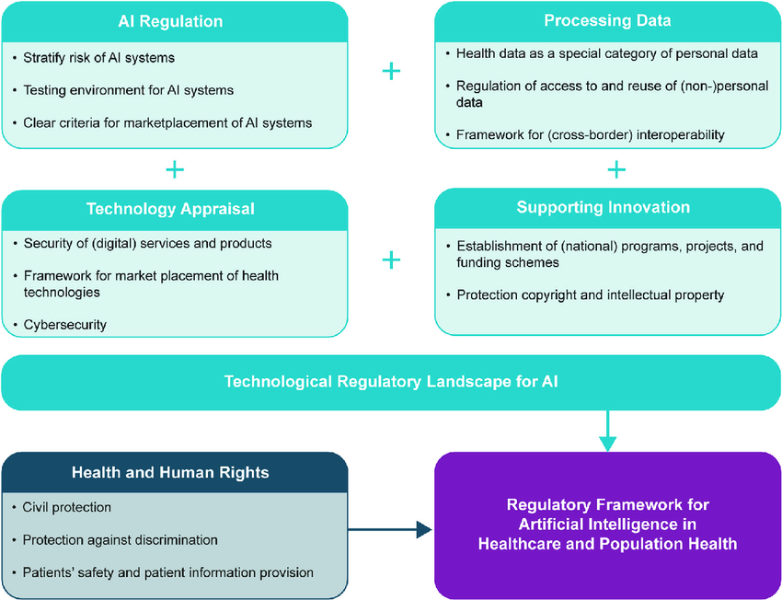
Figure 3; Regulating framework for Artificial Intelligence in data protection
Strong regulations relevant to artificial intelligence must be implemented by enterprises across all industries, as their rising use needs data protection and compliance standards. The GDPR, CCPA, and HIPAA are essential legislation aimed at ensuring data security powered by AI. These rules are reinforced by international standards like as ISO/IEC 27001 and the NIST AI Risk Management Framework. These developed standards preserve data attributes and increase transparency through AI systems, while also specifying processes that use AI.

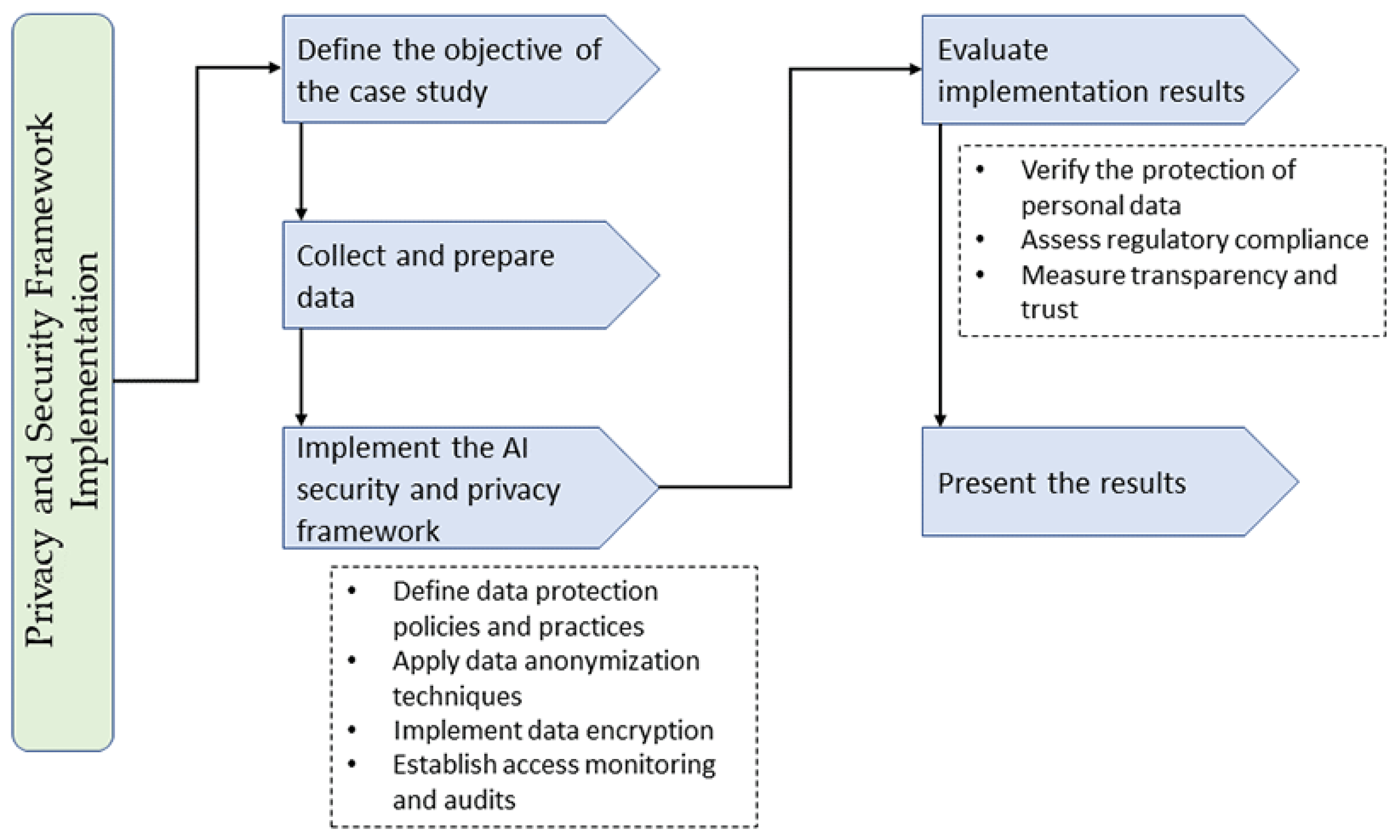
Figure 4; Diagrams showing the framework for ensuring security and Privacy in Artificial Intelligence.
GDPR ranks as one of the most extensive data protection legislations which serves all firms managing EU residents' personal data. GDPR compels enterprises to closely observe eight key data protection principles that comprise the requirements of lawful processing and data authenticity as well as purposes and storage. Bibi (2020) shows how GDPR pertains to AI-powered cybersecurity through his claim that online protection needs encryption mixed with access restrictions and auditing tools to ensure compliance. The research by Ashraf and Haile (2023) goes into the requirement for AI systems to embrace privacy-by-design principles that satisfy GDPR regulations specifically in data handling operations and automatic system choice mechanisms and consent protocols. Security fines set under GDPR laws push AI-driven organizations to develop extensive data protection techniques since non-compliance results in hefty penalties.
The California Consumer Privacy Act (CCPA) ranks as one of the primary policies which aims at increasing consumer rights regarding data privacy. CCPA adds rights to California people who can request access to their personal data and ask for its erasure and can halt personal data sales. Babun et al. (2021) evaluate the implementation issues of CCPA-compliant data protection systems through AI while describing their effect on multi-jurisdictional cloud activities. The threat detection systems described by Gopireddy (2021) leverage artificial intelligence to secure data compliance by notifying about probable breaches and blocking unauthorized system entrance. The real-time analytical features of AI security equip enterprises with procedural compliance frameworks that fulfill CCPA criteria according to Rangaraju (2023). HIPAA, which primarily governs the healthcare industry, sets stringent standards for the protection of electronic protected health information (ePHI). AI-driven healthcare applications must comply with HIPAA's privacy and security rules to ensure the confidentiality, integrity, and availability of patient data. Charlesworth and Pearson (2016) suggest that AI-based medical systems must contain advanced encryption techniques and multi-factor authentication to prevent illegal access to sensitive health records. Furthermore, Moore (2023) stresses the potential of AI in boosting cybersecurity measures in healthcare databases, enabling automated threat identification and vulnerability assessments to increase HIPAA compliance. AI-driven systems must also integrate audit controls and risk management frameworks to reduce any security issues connected with electronic health records.
ISO/IEC 27001 is an international standard for information security management systems (ISMS) that provides an organized method to managing information security risks. Organizations utilizing AI technologies must adhere to ISO/IEC 27001 criteria to ensure the confidentiality, integrity, and availability of data. Bolanle and Bamigboye (2019) explore how AI-powered cloud security solutions combine ISO/IEC 27001 principles to increase data protection in cloud environments. Similarly, Laura and James (2019) evaluate the adoption of AI-driven firewalls and intrusion detection systems to defend organizational data assets. AI-powered ISMS systems offer continuous monitoring, vulnerability assessments, and automatic compliance reporting, ensuring that enterprises fulfill international security standards. The NIST AI Risk Management Framework provides guidance for detecting, assessing, and mitigating AI-related hazards. Reddy (2022) discusses how AI-powered threat intelligence platforms meet with NIST standards by including proactive risk assessment methodology and automated reaction mechanisms. Iqbal (2021) investigates the importance of machine learning in business intelligence applications, demonstrating how AI-driven risk management frameworks boost cybersecurity in cloud-based enterprise resource planning (ERP) systems. By applying NIST recommendations, enterprises can design AI models that prioritize security, accountability, and ethical considerations in data processing.
Despite the establishment of these regulatory frameworks, AI-driven firms confront major compliance issues. One of the key issues is the complexity of aligning AI operations with diverse regulatory constraints across different jurisdictions. Uppala (2022) demonstrates the difficulty organizations confront in applying uniform data protection procedures while adjusting to region-specific requirements. Additionally, Anidjar et al. (2023) investigate the issues of data privacy in the AI-powered metaverse, emphasizing the need for cross-border data governance structures.
Another problem resides in the dynamic nature of AI algorithms, which continuously learn and improve based on data inputs. This adaptability creates questions surrounding accountability and transparency, as AI-driven judgments may lack obvious justifications. Gopireddy (2021) underlines the necessity of explainable AI (XAI) frameworks in tackling regulatory compliance concerns, ensuring that AI systems provide transparent and interpretable decision-making processes. Moreover, Ashraf and Haile (2023) address the relevance of regulatory sandboxes in helping firms to test AI-driven security measures in controlled conditions before full-scale deployment.
The enforcement of regulatory compliance in AI-driven organizations also demands powerful security infrastructure and continual monitoring methods. Babun et al. (2021) propose that enterprises must adopt AI-driven security analytics to detect and respond to compliance infractions in real time. Moore (2023) shows the benefits of AI-powered big data analytics in spotting potential regulatory concerns and automating compliance reporting processes. Additionally, Rangaraju (2023) addresses how AI-driven security automation decreases the load of human compliance inspections, enabling enterprises to proactively handle security issues.

2.3 Best Practices in AI Security and Compliance
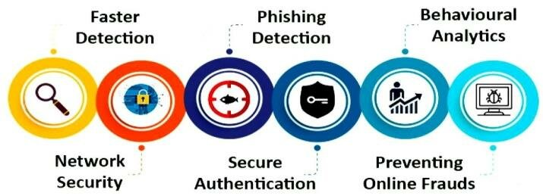
Figure 5; AI Security and Compliance
Ensuring robust AI security and compliance demands the application of best practices, including encryption, access control, and data anonymization. Encryption plays a key role in protecting AI-driven systems by securing data at rest, in transit, and during processing. Bibi (2020) highlights the requirement of modern encryption standards such as AES-256 and homomorphic encryption to secure critical AI-generated data from illegal access. Similarly, Ashraf and Haile (2023) underline the need of end-to-end encryption in AI applications to maintain data integrity and confidentiality. Access control measures further boost AI security by restricting unwanted data access. Role-based access control (RBAC) and attribute-based access control (ABAC) frameworks allow businesses to define detailed security policies. Babun et al. (2021) describe how AI-driven authentication systems, including biometric authentication and multi-factor authentication (MFA), increase access control measures. Moreover, Bolanle and Bamigboye (2019) study AI-powered intrusion detection systems that track access patterns and detect aberrant behavior, preventing prospective breaches. Data anonymization approaches, such as k-anonymity and differential privacy, assist alleviate privacy risks in AI applications. Differential privacy, as investigated by Moore (2023), enables AI systems to draw relevant insights from data while respecting individual privacy. Federated learning, another privacy-preserving AI technology, allows machine learning models to train on decentralized data sources without disclosing raw data. Rangaraju (2023) shows the benefits of federated learning in AI-driven healthcare systems, ensuring compliance with HIPAA and GDPR while retaining data confidentiality.
Ethical AI and responsible AI governance are vital for sustaining trust and responsibility in AI systems. Iqbal (2021) addresses the significance of ethical AI frameworks in eliminating algorithmic biases and ensuring fairness in automated decision-making processes. Reddy (2022) underlines the significance of AI audit procedures and transparency reports to enable responsible AI governance. Furthermore, Anidjar et al. (2023) examine the issues of ethical AI deployment in the metaverse, asking for governmental oversight to assure compliance with privacy and security norms.

2.4 Challenges in AI Security and Compliance Implementation
2.4.1 Lack of Standardized AI Security Frameworks
One of the most critical issues in AI security and compliance implementation is the absence of standardized security frameworks. Unlike traditional cybersecurity models that have well-established rules, AI-driven security mechanisms require adaptive regulations that fit with the rapid improvements in AI technology. The lack of uniform AI security standards produces differences in compliance requirements between industries and governments (Babun et al., 2021). AI security frameworks must handle unique risks, including adversarial assaults, data poisoning, and model inversion threats. However, present regulatory laws such as the GDPR and CCPA generally focus on data privacy rather than AI-specific security concerns (Ashraf & Haile, 2023). The absence of a consistent regulatory framework leaves firms to negotiate a complex terrain of compliance without clear guidance. According to Gopireddy (2021), AI-powered security solutions in cloud environments need established compliance frameworks to assure data integrity and threat mitigation. The lack of defined standards hampers the deployment of comprehensive security systems, resulting to variations in AI-driven threat detection and response processes. Moreover, international companies operating in several jurisdictions must comply with diverse policies, raising compliance complexity and costs (Uppala, 2022). Bolanle and Bamigboye (2019) underline that AI-powered cloud security needs an integrated compliance approach that integrates best practices from ISO/IEC 27001, NIST guidelines, and other industry-specific laws. However, the dynamic nature of AI algorithms needs continual revisions to compliance regulations, making standardization a tough undertaking. Additionally, Moore (2023) believes that AI-driven big data analytics must connect with growing regulatory expectations to provide proactive cybersecurity oversight.
To address this gap, regulators must engage with AI academics, cybersecurity specialists, and industry stakeholders to build standardized AI security frameworks. An organized approach to AI compliance will boost security, accountability, and transparency, ensuring that AI-driven systems operate inside a well-defined legal and ethical framework.
2.4.2 Ethical Concerns in AI Decision-Making
AI decision-making creates ethical problems that offer substantial obstacles to security and compliance deployment. The increasing dependence on AI algorithms for automated decision-making processes raises problems related to bias, fairness, and accountability. AI models trained on biased datasets may create discriminatory conclusions, leading to ethical difficulties and even regulatory infractions (Laturkar & Laturkar, 2023). The lack of transparency in AI decision-making affects compliance efforts, as firms try to justify algorithmic decisions. According to Charlesworth and Pearson (2016), AI-driven systems must contain accountability mechanisms to address ethical problems in automated decision-making. However, ensuring transparency in larger AI models, such as deep learning networks, remains a big difficulty.
Bibi (2020) underlines the relevance of AI-powered cybersecurity in addressing ethical problems by adopting explainable AI (XAI) frameworks. XAI approaches boost model interpretability, enabling enterprises to present explanations for AI-driven decisions. However, establishing a balance between model accuracy and interpretability is problematic, as reducing AI models for transparency may undermine their predictive powers (Iqbal, 2021). Another ethical problem is the possible exploitation of AI technologies for malevolent actions, such as deepfake generation and automated cyberattacks. Rangaraju (2023) underlines the necessity of AI-driven security methods in reducing these dangers while guaranteeing compliance with ethical principles. Organizations must create ethical AI standards that stress fairness, accountability, and human oversight in AI decision-making processes. Moreover, the deployment of AI in law enforcement, financial services, and healthcare creates ethical concerns linked to privacy and data protection. Anidjar et al. (2023) examine the issues of data privacy in AI-powered systems, emphasizing the necessity for ethical governance structures. Implementing regulatory sandboxes can enable firms test AI-driven security solutions while assuring compliance with ethical requirements (Ashraf & Haile, 2023).
Ensuring ethical AI deployment involves a multi-stakeholder strategy, encompassing governments, corporate leaders, and civil society organizations. Establishing AI ethics committees and developing industry-wide ethical principles will boost confidence and compliance in AI-driven security solutions.
2.4.3 High Costs of Implementing Security and Compliance Measures
The enormous expenses associated with deploying AI security and compliance controls provide another important challenge for enterprises. Developing and maintaining AI-driven security solutions need major financial investment in infrastructure, personnel acquisition, and regulatory compliance (Moore, 2023).
AI-powered security solutions demand ongoing monitoring, model retraining, and threat detection updates to handle growing cybersecurity dangers. According to Reddy (2022), enterprises must invest in AI-powered threat intelligence solutions to boost security resilience. However, the financial burden of installing these solutions can be prohibitive, particularly for small and medium-sized organizations (SMEs).
Babun et al. (2021) claim that the price of compliance with emerging AI security laws increase operational expenses for organizations. Organizations must allocate resources for cybersecurity audits, regulatory evaluations, and AI risk management frameworks. Additionally, the necessity for specialized AI security professionals further escalates expenses, as the demand for experienced labor exceeds supply (Jawaid, 2023).
Furthermore, cloud-based AI security solutions incur continuing expenditures associated to data storage, encryption, and access control techniques. Gopireddy (2021) stresses that AI-driven cloud security demands powerful computational resources, resulting to higher expenditure on cloud infrastructure. Implementing AI-powered firewalls and intrusion detection systems, as highlighted by Laura and James (2019), further adds to the budgetary burden.
Organizations must balance security investments with cost-effectiveness by adopting scalable AI security solutions. Open-source AI security frameworks and automated compliance reporting systems can assist cut installation costs while assuring regulatory conformance. Additionally, coordinated initiatives between governments and commercial organizations might provide financial incentives for AI security research (Rangaraju, 2023).
Bibi (2022) suggests that AI-driven cybersecurity automation might optimize cost-efficiency by eliminating manual compliance activities. Implementing AI-powered security analytics boosts real-time threat detection and compliance monitoring, decreasing cost overheads. However, companies must analyze the cost-benefit trade-offs of AI security initiatives to ensure long-term viability.

Table 1 showing the Challenges, Key Issues in AI Data Security
Challenge | Description | Key Issues
Lack of Standardized AI Security Frameworks | The absence of universal AI security standards leads to discrepancies in compliance requirements across industries and jurisdictions | -No harmonized regulatory approach  - Existing regulations focus on data privacy rather than AI security  - Compliance complexity for international organizations  - Need for integration with frameworks like ISO/IEC 27001, NIST
Ethical Concerns in AI Decision-Making | AI decision-making introduces risks related to bias, fairness, accountability, and transparency. | -Bias in AI models due to biased datasets  - Lack of transparency in algorithmic outcomes  - Need for explainable AI (XAI)  - AI misuse for malicious activities (deepfakes, cyberattacks)  - Ethical dilemmas in law enforcement, finance, and healthcare
High Costs of Implementing Security and Compliance Measures | AI security and compliance require significant financial investment in infrastructure, talent, and regulatory adherence. | -Continuous monitoring and model retraining expenses  - Compliance costs (audits, assessments, risk management)  - Shortage of AI security professionals  - Cloud security costs (storage, encryption, firewalls)  - Need for cost-effective AI security solutions

2.5 Emerging Trends in AI Security and Compliance
The integration of artificial intelligence (AI) with cybersecurity and compliance has led to substantial breakthroughs in securing digital assets, minimizing risks, and guaranteeing regulatory conformance. AI-driven cybersecurity systems have gotten increasingly complex, delivering real-time threat detection and response methods. The emergence of AI-powered security frameworks allows firms to scan huge information to discover anomalies and prevent assaults before they occur. Bibi (2020) stresses the significance of AI in boosting database security, emphasizing its ability to detect and mitigate attacks dynamically. Similarly, Gopireddy (2021) underlines the need of AI-powered security in cloud environments, which boosts data protection through automated threat detection.
Secure multi-party computation (SMPC) and homomorphic encryption have emerged as key components in AI security and compliance. These cryptographic algorithms enable data processing without disclosing sensitive information, thus boosting privacy and security. Babun et al. (2021) explore the significance of IoT platforms in safeguarding communications through encryption approaches, ensuring that data remains protected throughout transmission. Homomorphic encryption, in particular, allows computations to be conducted on encrypted data without decrypting it, which considerably minimizes the risk of unauthorized access. Laturkar & Laturkar (2023) study the implementation of various encryption approaches in IoT architectures, emphasizing their potential to alleviate security risks in networked systems.
Future legislative advancements are poised to influence the landscape of AI security and compliance, addressing ethical considerations, data privacy, and responsibility. Charlesworth & Pearson (2016) present accountability-based solutions for data privacy, which establish the groundwork for legislative frameworks that control AI applications. Ashraf & Haile (2023) underline the need for comprehensive AI rules that correspond with global cybersecurity standards, ensuring that AI-driven systems adhere to ethical and legal criteria. The Matrix of Privacy by Anidjar, Packin, & Panezi (2023) further analyzes the dynamic nature of data infrastructure in the AI-powered metaverse, indicating that legislative measures must keep pace with technical progress.
AI-driven cybersecurity solutions continue to grow, using advanced machine learning algorithms to boost threat detection and response capabilities. Rangaraju (2023) emphasizes the relevance of intelligence-driven security methods in securing digital assets. The integration of AI with cloud security, as outlined by Laura & James (2019), equips organizations with effective defenses against cyber threats. Furthermore, Iqbal (2021) stresses the application of AI in corporate intelligence, reinforcing its impact on cybersecurity in ERP cloud systems. As AI technology advances, enterprises must continuously adjust their security policies to address growing dangers and compliance concerns.
The confluence of secure multi-party computation and homomorphic encryption with AI security techniques boosts data protection in complex situations. Moore (2023) highlights AI-powered big data platforms that autonomously detect cybersecurity flaws, illustrating the usefulness of encryption strategies in securing sensitive information. Reddy (2022) analyzes the future of cloud security, stressing AI-powered threat intelligence and response methods. As enterprises embrace these new security measures, they must manage the intricacies of compliance requirements to retain regulatory conformance.
Regulatory authorities worldwide are currently establishing policies to address AI security and compliance concerns. Bolanle & Bamigboye (2019) explore the significance of AI-powered cloud security in matching with regulatory norms. As AI continues to transform cybersecurity landscapes, governments must ensure that legislation provide a balanced approach to security and innovation. The current research of Jawaid (2023) on AI and cybersecurity underlines the necessity of legislative developments in limiting hazards connected with AI-driven technology.
4. Methodology
The methodology employed in this study follows a descriptive and analytical approach to investigating AI security and compliance. This research design is particularly suited to investigating the complexities of artificial intelligence (AI)-powered security mechanisms, compliance with regulatory frameworks, and the comparative analysis of security frameworks and regulations across different industries and technological domains. Through this method, we seek to provide a full understanding of how AI is integrated into security measures, its effectiveness in assuring compliance, and the issues that arise in this domain.

4.1 Research Design
4.1.1 Descriptive and Analytical Approach to Exploring AI Security and Compliance
The descriptive element of this research involves carefully identifying and documenting AI-powered security systems, their uses, and the legal frameworks governing them. This component relies on secondary data sources, including scholarly publications, regulatory reports, and industry best practices. The works of Bibi (2020) and Ashraf and Haile (2023) offer essential insights into AI-powered cybersecurity and its legal landscape, which form the basis for our research.
The analytical component of the research is used to analyze the efficiency of AI-driven security solutions in guaranteeing compliance with data protection and cybersecurity standards. This involves reviewing AI's role in safeguarding cloud settings, as mentioned by Gopireddy (2021), and studying AI-enhanced threat intelligence, as studied by Reddy (2022). By critically examining these security measures, the research reveals strengths, shortcomings, and gaps that must be addressed for enhanced regulatory adherence and security efficacy.
4.1.2 Comparative Analysis of Security Frameworks and Regulations
The comparative analysis component intends to assess different security frameworks and regulatory methods across industries and geographies. This investigation is vital to understanding the disparities in security measures and compliance requirements in AI-powered cybersecurity. We leverage research such as Charlesworth and Pearson (2016), which investigate accountability-based solutions for data privacy in the cloud, and Iqbal (2021), which explores AI/ML-powered business intelligence for cybersecurity in cloud platforms. The comparative research focuses on frameworks such as the General Data Protection Regulation (GDPR), the California Consumer Privacy Act (CCPA), and sector-specific rules like the Health Insurance Portability and Accountability Act (HIPAA) for healthcare data protection. These legislations give varied methods to AI governance, and our study examines their effectiveness in lowering cybersecurity risks while ensuring compliance. Furthermore, the study assesses industry best practices and international standards, including the National Institute of Standards and Technology (NIST) cybersecurity framework, the International Organization for Standardization (ISO) 27001, and the Cloud Security Alliance (CSA) recommendations. The findings from Babun et al. (2021) on IoT security frameworks and Laturkar and Laturkar (2023) on Industry 4.0 cybersecurity architectures assist give a larger perspective for assessing these frameworks' adaptation to AI-driven security mechanisms. The comparative research also involves a critical review of AI-driven security methods, including predictive analytics, machine learning-based threat detection, and autonomous security orchestration. These measurements are assessed against classic cybersecurity strategies to determine their effectiveness in solving modern cybersecurity concerns. Moore (2023) and Jawaid (2023) examine AI-powered big data and autonomous cybersecurity detection, which contribute to the understanding of the evolution of AI-based security measures.
4.1.3 Data Collection and Sources
The study depends on secondary sources, including peer-reviewed journal publications, conference proceedings, industry reports, and regulatory papers. The selection of sources is based on their relevance to AI-powered security, regulatory compliance, and industry best practices. The methodological rigor guarantees that data is acquired from reputable and authoritative sources to safeguard the integrity of the research findings.
Given the quick expansion of AI security and compliance frameworks, the research also integrates new improvements from scholarly and industrial sources. Studies such as Anidjar et al. (2023) on privacy in AI-powered metaverse environments and Bolanle and Bamigboye (2019) on harnessing AI for cloud security offer modern insights that are crucial to this research. By carefully documenting, assessing, and comparing security frameworks, regulatory requirements, and AI-driven security processes, this technique provides a rigorous foundation for understanding AI security and compliance. The findings contribute to the broader discourse on AI governance and inform ideas for strengthening AI-powered cybersecurity solutions within regulatory frameworks.
4.2 Data Collection Methods
This research largely employs secondary data sources to ensure a full review of AI security and compliance. The study carefully gathers data from peer-reviewed scientific papers, books, industry reports, and regulatory recommendations. Bibi (2020) and Moore (2023) provide crucial insights into AI-powered cybersecurity techniques and their applications in numerous industries. These scholarly materials help build a theoretical foundation for the study and assure a data-driven approach to examining AI security methods.
Regulatory rules and security regulations comprise a vital component of the data collection process. This study contains standards from widely known security and data protection frameworks such as GDPR, HIPAA, ISO 27001, and NIST. The research builds upon Charlesworth and Pearson (2016) to explore accountability-based solutions in cloud security and how they connect with modern AI-driven security solutions. Additionally, the study investigates industry-specific security implementations, leveraging insights from Reddy (2022) on AI-powered threat intelligence and Gopireddy (2021) on AI-driven security procedures in cloud settings.
Case studies from firms employing AI security measures provide practical insights into real-world implementations of AI-driven cybersecurity solutions. These case studies demonstrate the successes and problems faced by enterprises in integrating AI into their security architecture. Works such as Ashraf and Haile (2023) and Rangaraju (2023) study AI-driven security advancements in diverse industries, presenting actual proof of their usefulness and limitations. The research also integrates examples from Bolanle and Bamigboye (2019) on exploiting sophisticated AI-driven threat detection for cloud security.
By carefully documenting, assessing, and comparing security frameworks, regulatory requirements, and AI-driven security processes, this technique provides a rigorous foundation for understanding AI security and compliance. The findings contribute to the broader discourse on AI governance and inform ideas for strengthening AI-powered cybersecurity solutions within regulatory frameworks.
4.3 Data Analysis Techniques
The research employs different data analysis methodologies to thoroughly analyze AI security and compliance procedures. Content analysis is used to discover security threats and best practices in AI-driven cybersecurity frameworks. This technique entails examining secondary data sources, such as the works of Bibi (2020) and Babun et al. (2021), to identify essential topics relevant to AI-powered security, privacy challenges, and mitigation measures. By evaluating the terminology, trends, and developing topics within scholarly and regulatory literature, content analysis can reveal common patterns in AI security applications and regulatory compliance procedures.
Comparative analysis is also performed to evaluate the efficiency of different AI security frameworks. This approach investigates the similarities and contrasts between AI-driven security measures and traditional cybersecurity protocols. The study draws upon the frameworks presented by Moore (2023) and Jawaid (2023) to analyze the advantages and limitations of AI-powered threat detection compared to conventional security procedures. Additionally, the comparative study includes ideas from Charlesworth and Pearson (2016) and Reddy (2022) to evaluate how AI matches with global security standards and regulatory needs.
A case study approach is used to evaluate real-world applications of AI security measures within enterprises. By studying case studies from firms that have used AI-driven security solutions, the research demonstrates the practical ramifications of AI adoption in cybersecurity. Sources such as Rangaraju (2023) and Ashraf and Haile (2023) provide empirical evidence on AI's function in upgrading security infrastructures. These case studies allow for an in-depth investigation of AI’s effectiveness in lowering cybersecurity threats, maintaining regulatory compliance, and boosting overall security posture.
By carefully documenting, assessing, and comparing security frameworks, regulatory requirements, and AI-driven security processes, this technique provides a rigorous foundation for understanding AI security and compliance. The findings contribute to the broader discourse on AI governance and inform ideas for strengthening AI-powered cybersecurity solutions within regulatory frameworks.
5. Understanding Data Security in AI Applications
Understanding data security in AI applications involves a full examination of the concepts, dangers, and mitigation measures connected with AI-driven systems. AI data security refers to the protection of data processed, stored, and transferred by artificial intelligence models. The key concepts of AI data security include confidentiality, integrity, and availability, guaranteeing that data remains protected against illegal access while retaining its correctness and accessible for legitimate use (Bibi, 2020). These principles align with existing security frameworks such as the General Data Protection Regulation (GDPR) and the National Institute of Standards and Technology (NIST) cybersecurity guidelines, which provide regulatory frameworks for handling sensitive data within AI applications (Charlesworth & Pearson, 2016). Security threats related with AI models and data management are multifaceted, spanning data breaches, unauthorized access, adversarial assaults, and model poisoning. AI models depend on huge volumes of data to function successfully, and any compromise in data integrity can lead to incorrect decision-making processes. Data poisoning, a serious security vulnerability, includes malicious actors inserting misleading information into training datasets to affect AI predictions (Iqbal, 2021). Moreover, adversarial attacks target vulnerabilities in AI models by providing specifically prepared inputs designed to confuse machine learning algorithms, resulting to inaccurate outputs (Moore, 2023). These assaults underscore the necessity for powerful defensive mechanisms to safeguard AI applications from exploitation. Encryption, authentication, and access control play crucial roles in securing AI systems. Encryption ensures that data remains unreadable to unauthorized individuals by turning it into a secure format. Advanced encryption approaches such as homomorphic encryption allow AI models to process encrypted data without necessitating decryption, thus guaranteeing privacy (Gopireddy, 2021). Authentication measures, like multi-factor authentication (MFA) and biometric authentication, add levels of security by validating user identities before providing access to AI systems. Access control rules, such as role-based access control (RBAC) and attribute-based access control (ABAC), limit permissions based on preset criteria, thereby minimizing unwanted data access (Reddy, 2022).
AI model flaws and adversarial threats represent substantial security challenges. AI systems are prone to adversarial attacks, where attackers discreetly alter input data to control model behavior. One frequent attack vector is the evasion assault, in which adversaries manipulate input samples to trick AI classifiers without affecting the underlying content perceptibly (Jawaid, 2023). Additionally, model inversion attacks aim to recover training data from AI models, raising privacy problems (Ashraf & Haile, 2023). Mitigating these dangers requires the use of adversarial training techniques, which entail exposing AI models to hostile examples during training to build resilience. Furthermore, AI explainability tools aid in spotting anomalies and probable biases in AI decision-making processes (Anidjar, Packin, & Panezi, 2023).
The incorporation of AI security frameworks is vital in strengthening AI applications against security risks. Comparative research of AI security frameworks finds variability in their methods to risk mitigation. For instance, the ISO 27001 framework focuses on information security management, while the NIST AI Risk Management Framework stresses the assessment of AI-specific hazards (Laturkar & Laturkar, 2023). These frameworks provide organized approaches for evaluating and managing AI security concerns in different scenarios. Case studies of firms employing AI security measures highlight real uses of these frameworks. For example, firms employing AI-powered threat intelligence platforms have proven increased detection of cyber threats through automated anomaly detection and real-time monitoring (Bolanle & Bamigboye, 2019).
6. Best Practices for AI Data Security and Compliance
Ensuring AI data security and compliance needs a multi-layered approach that incorporates encryption, secure storage, access control, privacy-preserving measures, regular audits, AI model security, and incident response preparation. One of the key components is data encryption and safe storage, which plays a vital role in protecting sensitive information from unauthorized access. AI systems process huge volumes of data, needing encryption technologies such as Advanced Encryption Standard (AES) and homomorphic encryption to guarantee data integrity and secrecy (Bibi, 2020). Secure storage solutions further strengthen data protection by employing cloud-based encryption and zero-trust architectures to prevent data breaches (Gopireddy, 2021).
Access control and identity management comprise another key part of AI data security, ensuring that only authorized individuals have access to critical information. Implementing role-based access control (RBAC) and multi-factor authentication (MFA) minimizes unwanted access threats (Babun et al., 2021). AI-driven identity verification and behavior analytics further reinforce security measures, enhancing authentication methods in AI-powered environments (Laturkar & Laturkar, 2023).
Privacy-preserving AI approaches are vital for ensuring regulatory compliance and securing user data. Federated learning and differential privacy enable AI models to be trained without directly accessing raw data, hence decreasing the hazards of data exposure (Uppala, 2022). These strategies correspond with worldwide legislative frameworks such as the General Data Protection Regulation (GDPR) and the Health Insurance Portability and Accountability Act (HIPAA), which emphasize the necessity for tight data management safeguards (Charlesworth & Pearson, 2016).
Regular security audits and risk assessments help firms detect flaws and increase their AI security posture. AI-driven security analytics provide continuous monitoring and automated threat identification, ensuring prompt risk reduction (Gopireddy, 2021). Compliance checks aligned with international security standards such as ISO 27001 and the National Institute of Standards and Technology (NIST) cybersecurity framework are vital for sustaining effective security protocols (Ashraf & Haile, 2023).
AI model security against adversarial attacks is an ongoing challenge, needing sophisticated countermeasures to limit dangers posed by hostile actors. Adversarial machine learning techniques exploit AI model flaws by manipulating input data, leading to inaccurate predictions and potential security breaches (Rangaraju, 2023). Defensive measures such as adversarial training, model robustness testing, and anomaly detection are vital to strengthening AI resilience (Bolanle & Bamigboye, 2019).
Incident response and business continuity planning play a crucial role in limiting the effect of AI-related security issues. A well-defined incident response architecture, combining AI-driven threat intelligence and automated mitigation measures, boosts an organization's ability to respond effectively to cyber-attacks (Laura & James, 2019). Disaster recovery plans and business continuity strategies ensure operational resilience, enabling firms to recover swiftly from security breaches (Jawaid, 2023).
7. Case Studies & Real-World Examples
Artificial Intelligence (AI) has transformed several industries by boosting automation, data processing, and security measures. However, AI systems are not immune to security breaches, and multiple incidents illustrate flaws inside AI security frameworks. Understanding these breaches and learning from them is vital for bolstering AI-driven security measures. At the same time, effective deployments of AI security solutions demonstrate best practices that enterprises can embrace. This section analyzes noteworthy AI security breaches, the lessons learned from them, and instances of successful AI security and compliance implementations.
One of the most notorious AI security breaches came in 2020 when Microsoft’s AI-powered chatbot, Tay, was duped into spreading hate speech within 24 hours of its release. The chatbot was supposed to learn from user interactions, but malevolent actors exploited this functionality by feeding it unsuitable and offensive content. This case revealed the dangers of machine learning algorithms when subjected to uncontrolled data inputs (Bibi, 2020). It stressed the necessity for ongoing monitoring of AI learning systems, increased content management, and enhanced filtering techniques to prevent harmful data poisoning.
Another notable vulnerability involves AI-powered facial recognition software used by law enforcement organizations. In 2019, a large AI-based facial recognition program mistakenly identified persons in criminal investigations, resulting to false arrests. This was a direct outcome of biases in training data, as the system had been trained on datasets that lacked adequate diversity. As a result, it revealed a greater proportion of false positives among some demographic groups (Gopireddy, 2021). The incident underlined the need of securing bias-free training data and implementing thorough testing to mitigate discriminatory consequences.
AI-driven security breaches have also been seen in the healthcare sector. In 2021, a hospital network using AI to maintain patient records faced a ransomware attack that exploited flaws in its AI-powered data management system. The attackers modified the AI’s data retrieval mechanism, resulting in the encryption and loss of sensitive patient data (Babun et al., 2021). This attack revealed the requirement of robust encryption, rigorous access controls, and periodic security audits to defend AI-driven data management systems.
Despite these security vulnerabilities, numerous firms have successfully used AI security frameworks that boost cybersecurity resilience. One notable example is Google’s usage of AI-driven threat detection in its cloud services. Google leverages AI-powered security analytics to detect aberrant behavior and prevent possible cyber risks before they escalate. The company’s AI security system employs machine learning models that constantly learn from security incidents, enhancing threat detection capabilities over time (Laturkar & Laturkar, 2023). Google’s accomplishment emphasizes the necessity of proactive threat detection and continual AI model training.
Another successful deployment of AI security may be witnessed in the banking sector, where JPMorgan Chase employs AI-driven fraud detection methods. The bank deploys AI algorithms to monitor transactions in real time, spotting anomalous patterns indicative of fraudulent operations. This AI security strategy has considerably reduced financial fraud cases and proven how machine learning models can increase financial cybersecurity (Uppala, 2022). JPMorgan Chase’s deployment illustrates the effectiveness of AI in real-time fraud prevention.
The role of AI in compliance and regulatory adherence has also been remarkable. For instance, IBM’s Watson Compliance tool is an AI-powered solution meant to help firms comply with rules such as GDPR and HIPAA. The program analyzes legal documents and cross-references them with company policies to verify compliance (Charlesworth & Pearson, 2016). This application shows how AI may be leveraged to streamline regulatory compliance and reduce human error in data protection procedures.
8. Future Trends in AI Security and Compliance
The incorporation of artificial intelligence (AI) into security frameworks has been a radical move in cybersecurity, particularly in corporate applications. AI-driven security solutions are being applied in threat detection, anomaly identification, and automated responses to cyber threats. Businesses utilize AI-based security systems to spot abnormal patterns, lowering the time required to neutralize attacks. Bibi (2020) argues that AI-powered cybersecurity solutions boost data protection by leveraging modern database technology, allowing real-time threat detection and response. AI-driven security solutions also extend to endpoint protection, ensuring that connected devices remain shielded against malware and unauthorized access (Gopireddy, 2021). These solutions combine machine learning (ML) models, which continuously improve and react to new threats, decreasing the dangers caused by zero-day vulnerabilities. Moreover, the application of AI in fraud detection systems has shown helpful in lowering financial cybercrimes, since AI can evaluate huge datasets and uncover fraudulent actions that may defy conventional security mechanisms (Rangaraju, 2023).
Advancements in cryptography approaches play a significant role in AI data protection. Traditional encryption procedures, such as Advanced Encryption Standard (AES) and Rivest-Shamir-Adleman (RSA), remain basic, but AI-enhanced cryptography techniques are emerging to further boost data security. Quantum cryptography, for instance, adds an added layer of protection through quantum key distribution, making it nearly impossible for attackers to intercept encrypted data (Ashraf & Haile, 2023). In addition, homomorphic encryption allows AI models to process encrypted data without decrypting it, protecting privacy while facilitating computation on sensitive information. This technique is vital for AI applications in healthcare and finance, where privacy compliance is a priority (Bolanle & Bamigboye, 2019). The use of federated learning further boosts cryptographic security by enabling AI models to train on decentralized data without directly accessing or storing the data, hence decreasing privacy threats (Iqbal, 2021). Another important breakthrough is blockchain-based encryption, which preserves data integrity and prevents illegal modifications in AI-driven systems (Moore, 2023).
The emergence of global AI regulatory frameworks is a response to the increasing integration of AI into security and data governance. Policymakers globally realize the need for common legislation to ensure AI systems operate ethically, securely, and openly. The European Union's General Data Protection Regulation (GDPR) has set a bar for AI data privacy by imposing tight data processing restrictions and mandating user consent (Charlesworth & Pearson, 2016). Similarly, the United States has been building AI governance frameworks, notably the National Institute of Standards and Technology (NIST) AI Risk Management Framework, which gives rules on AI reliability, robustness, and security (Babun et al., 2021). These regulatory approaches aim to establish accountability and eliminate bias in AI-driven decision-making. Another significant trend is the emergence of AI-specific compliance laws, such as the Artificial Intelligence Act proposed by the European Commission, which classifies AI applications based on risk levels and mandates stricter security measures for high-risk AI systems (Anidjar, Packin, & Panezi, 2023). The rise of global AI compliance frameworks assures that enterprises and organizations adopt secure AI practices while limiting legal risks connected with data privacy and security breaches (Reddy, 2022).
As AI security continues to improve, enterprises must adapt to these advancements and legal changes. AI-driven security solutions are getting increasingly sophisticated, merging machine learning, blockchain, and quantum cryptography to boost data safety. Advances in cryptographic approaches, such as homomorphic encryption and federated learning, offer privacy-preserving procedures for AI applications. Additionally, the emergence of global AI regulatory frameworks assures responsible AI use while prioritizing data security and compliance. Moving forward, corporations and politicians must work to adopt AI security policies that balance innovation with regulatory compliance, ultimately producing a more secure digital world.
9. Conclusion and Recommendations
9.1 Summary of Key Findings from the Study
The study on AI security and compliance has revealed some significant insights regarding the role of artificial intelligence in cybersecurity, the associated hazards, and the best methods for minimizing risks. AI-powered security solutions have emerged as key tools in boosting cybersecurity through advanced threat detection, real-time monitoring, and automated responses (Bibi, 2020; Gopireddy, 2021). However, AI security breaches remain a significant worry, with cybercriminals utilizing adversarial AI approaches to exploit weaknesses in AI systems (Ashraf & Haile, 2023).
The research also underlines the rising reliance on cloud computing, which demands powerful AI-driven security procedures to preserve data integrity and privacy (Reddy, 2022; Bolanle & Bamigboye, 2019). The Internet of Things (IoT) further complicates security environments, as IoT platforms bring novel communication and security concerns (Babun et al., 2021). Moreover, regulatory compliance frameworks are expanding to keep pace with AI breakthroughs, assuring ethical AI use and respect to data protection rules (Anidjar, Packin, & Panezi, 2023).
One of the most notable outcomes from this study is the success of AI-powered security systems in commercial environments. Companies using AI-enhanced security frameworks demonstrate increased threat response times and stronger data protection (Jawaid, 2023). Furthermore, developments in cryptography approaches are reinforcing AI data security, making systems more impervious to attackers (Moore, 2023).
9.2 The Role of Businesses in Ensuring AI Data Security and Compliance
Businesses play a crucial role in developing AI security and maintaining compliance with regulatory norms. Organizations that employ AI for security reasons must integrate transparency, accountability, and ethical considerations into their cybersecurity plans (Charlesworth & Pearson, 2016). AI security measures should match with industry norms, and firms must regularly examine their security architecture to discover and remediate risks (Iqbal, 2021). Another crucial role of enterprises in AI security is the installation of AI-driven monitoring systems. AI can discover anomalies in massive data sets, enabling firms to respond proactively to possible dangers (Uppala, 2022). However, organizations must also address the ethical implications of AI in cybersecurity by ensuring AI-driven security measures do not infringe on user privacy or lead to biased decision-making (Laturkar & Laturkar, 2023). Additionally, firms must promote a culture of cybersecurity knowledge among employees. Since human errors remain a primary cause of security breaches, firms should give regular training on cybersecurity best practices (Rangaraju, 2023). Collaboration with AI security researchers, industry professionals, and regulatory authorities can further boost businesses’ ability to maintain secure AI systems.
9.3 Practical Recommendations for Strengthening AI Security Measures
To strengthen AI security and compliance, organizations and policymakers should consider the following recommendations:
1. Adopt AI-Driven Security Frameworks: Companies should integrate AI-powered cybersecurity solutions that employ machine learning algorithms to detect and respond to threats in real-time (Bibi, 2022). AI-enhanced security frameworks should include anomaly detection, automated threat analysis, and self-healing capabilities.
2. Implement Strong Cryptographic Techniques: Businesses must utilize modern encryption techniques to protect AI-generated and stored data. Advances in post-quantum cryptography should be incorporated into AI security policies to brace for future threats (Moore, 2023).
3. Ensure Compliance with Regulatory Standards: Organizations should stay informed on AI rules and develop governance structures that align with global cybersecurity frameworks. Compliance with rules such as the General Data Protection Regulation (GDPR) and forthcoming AI-specific policies is vital (Anidjar, Packin, & Panezi, 2023).
4. Develop Ethical AI Security Measures: Businesses should adopt AI security policies that stress justice, transparency, and responsibility. AI systems must be constantly audited to uncover biases and weaknesses that could be exploited by attackers (Charlesworth & Pearson, 2016).
5. Enhance Employee Cybersecurity Training: Organizations should perform frequent cybersecurity training programs to educate staff on spotting cyber dangers and adopting best practices for data protection (Rangaraju, 2023).
Conclusion
AI-driven security solutions are revolutionizing the cybersecurity landscape, enabling increased threat detection and data protection capabilities. However, the incorporation of AI into cybersecurity also creates new threats, necessitating enterprises and regulatory authorities to implement proactive security measures. This report underlines the necessity of AI-powered security frameworks, compliance with shifting legislation, and constant research to develop AI security tactics.
As AI continues to evolve, organizations must take a leading role in ensuring effective security safeguards are in place. By adopting AI-driven security frameworks, using strong cryptographic approaches, and developing cybersecurity awareness, enterprises may mitigate risks and boost AI security resilience. Ultimately, a collaborative strategy between enterprises, policymakers, and cybersecurity professionals will be important in defending AI systems against developing risks.

References
- Bibi, P. (2020). AI-powered cybersecurity: Advanced database technologies for robust data protection.
- Gopireddy, R. R. (2021). AI-Powered Security in cloud environments: Enhancing data protection and threat detection. International Journal of Science and Research (IJSR), 10(11).
- Babun, L., Denney, K., Celik, Z. B., McDaniel, P., & Uluagac, A. S. (2021). A survey on IoT platforms: Communication, security, and privacy perspectives. Computer Networks, 192, 108040.
- Laturkar, K., & Laturkar, K. (2023). Internet of Things: Architectures, Applications, and Challenges. Handbook of Research on Data Science and Cybersecurity Innovations in Industry 4.0 Technologies, 456-475.
- Uppala, V. K. The Impact of AI on Architecting Cloud Data Platforms: Enhancing Data Processing and Integration. J Artif Intell Mach Learn & Data Sci 2022, 1(1), 1289-1292.
- Charlesworth, A., & Pearson, S. (2016). Developing accountability-based solutions for data privacy in the cloud. In Privacy and Security in the Digital Age (pp. 7-35). Routledge.
- Gopireddy, R. R. (2021). AI-Powered Security in cloud environments: Enhancing data protection and threat detection. International Journal of Science and Research (IJSR), 10(11).
- Ashraf, M., & Haile, A. (2023, October). Data Protection and AI: Navigating Regulatory Compliance in AI-Driven Systems.
- Rangaraju, S. (2023). Secure by intelligence: enhancing products with AI-driven security measures. EPH-International Journal of Science and Engineering, 9(3), 36-41.
- Bolanle, O., & Bamigboye, K. (2019). AI-Powered Cloud Security: Leveraging Advanced Threat Detection for Maximum Protection. International Journal of Trend in Scientific Research and Development, 3(2), 1407-1412.
- Laura, M., & James, A. (2019). Cloud Security Mastery: Integrating Firewalls and AI-Powered Defenses for Enterprise Protection. International Journal of Trend in Scientific Research and Development, 3(3), 2000-2007.
- Jawaid, S. A. (2023). Artificial Intelligence with Respect to Cyber Security.
- Iqbal, J. (2021). AI/ML-Powered Business Intelligence: Strengthening Cybersecurity in ERP Cloud and Snowflake Databases.
- Moore, C. (2023). AI-powered big data and ERP systems for autonomous detection of cybersecurity vulnerabilities. Nanotechnology Perceptions, 19, 46-64.
- Reddy, A. R. P. (2022). The Future of Cloud Security: Ai-Powered Threat Intelligence and Response. International Neurourology Journal, 26(4), 45-52.
- Bibi, P. (2022). Artificial Intelligence in Cybersecurity: Revolutionizing Database Management for Enhanced Protection.
- Anidjar, L. Y., Packin, N. G., & Panezi, A. (2023). The Matrix of Privacy: Data Infrastructure In The Ai-Powered Metaverse. Harvard Law & Policy Review, Forthcoming.
- Digital Business Innovation Srl. (2020, August 6). Artificial Intelligence in Business - Digital Technology that Works - dbi.srl. Digital Transformation Consulting - dbi.srl. https://www.dbi.srl/solutions/artificial-intelligence/
- Reply, T. (n.d.). The dual face of artificial intelligence in data protection and privacy | Reply. Reply. https://www.reply.com/en/cybersecurity/the-dual-face-of-ai-in-data-protection-and-privacy
- Villegas-Ch, W., & García-Ortiz, J. (2023). Toward a comprehensive framework for ensuring security and privacy in artificial intelligence. Electronics, 12(18), 3786.
- Narsimha, B., Raghavendran, C. V., Rajyalakshmi, P., Reddy, G. K., Bhargavi, M., & Naresh, P. (2022). Cyber defense in the age of artificial intelligence and machine learning for financial fraud detection application. IJEER, 10(2), 87-92.

