ETHICAL AI IN INSURANCE CRM: MITIGATING BIAS IN CUSTOMER SEGMENTATION
ABSTRACT
Artificial intelligence (AI) has developed both health and life insurance underwriting and customer relationship management (CRM) through its extensive changes. AI produces better operational outcomes and risk evaluation together with personalized service but leads to ethical problems involving biased processes and lack of clearness and responsible decision-making. The research investigates ethical AI in insurance by studying approaches for bias detection and reduction methods alongside methods for creating fair risk evaluations. Monitoring systems need to stay active while regulations must be followed and XAI technology requires implementation to improve decision transparency. The analysis introduces blockchain together with federated learning and AI-driven bias mitigation solutions which represent new technologies suitable for ethical AI implementation. The research demonstrates how teams made up of humans and AI tools need to work together to sustain fair practices while obtaining consumer confidence from AI-based automation. Responsible AI implementation in the insurance field will depend on the fundamental approach of both fair practices and ethical governance and relevant regulatory compliance. The study confirms insurers must swiftly develop their implementation of fairness-enabled AI systems and use complete audit capabilities and privacy protection solutions to establish an open insurance market.
Keywords: Artificial Intelligence, Insurance Underwriting, Bias Mitigation, Ethical AI, Customer Relationship Management, Explainable AI, Federated Learning, Blockchain.
1. Introduction
1.1 Overview of AI in Insurance CRM
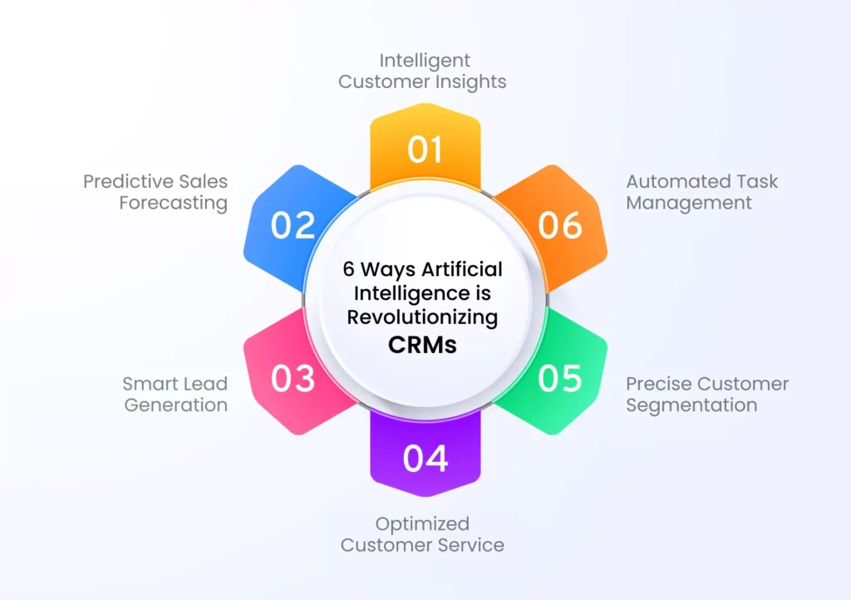
Figure 1; Ways Ai is Revolutionizing CRMs
The insurance industry benefits from AI which acts as a transformative power in their CRM operations. Insurance businesses benefit from ML together with big data analytics which enables them to enhance interaction processes while improving risk evaluations and developing individualized policy offerings (Mueller, 2023). .preventative analysis within AI-powered CRM systems produces enhanced customer segments which leads to improved operational efficiency along with enhanced marketing strategies (Sanodia, 2024). The insurance industry selects AI for CRM due to its powerful capability to handle massive data volumes and identify patterns and automatically execute decisions (Naslednikov, 2024). These systems now have AI embedded deeper within their operations but ethical issues about data protection together with questions on responsibility and controlling prejudice continue to emerge (Hanna et al., 2024).
1.2 Importance of Ethical AI in Customer Segmentation
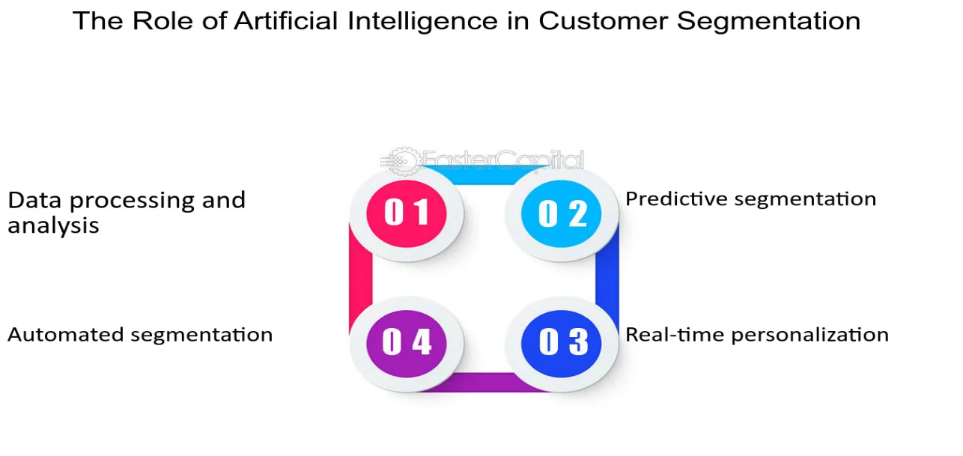
Figure 2; Role of Ethical AI in Customer Segmentation
The process of customer segmentation stands essential for insurance companies because it affects pricing decisions and eligibility criteria and customer engagement plans (Sabitha, 2024). AI uses historical data combined with demographic indicators and customer behavior to categorize clients into groups of high-risk and low-risk exposure (Jegatheeswari Perumalsamy, Krothapalli, & Althati, 2022). Biased training datasets fed into AI algorithms will sustain current discriminatory patterns which could create unjust price rates and exclude customers based on discriminatory criteria (Mullins, Holland, & Cunneen, 2021). By using ethical AI principles customer segmentation becomes fair and transparent thus eliminating systematic discrimination against marginalized groups (Mensah, 2023). Fairness-aware algorithm implementation together with AI model auditing supports equitable service delivery for all customers according to Li (2024).
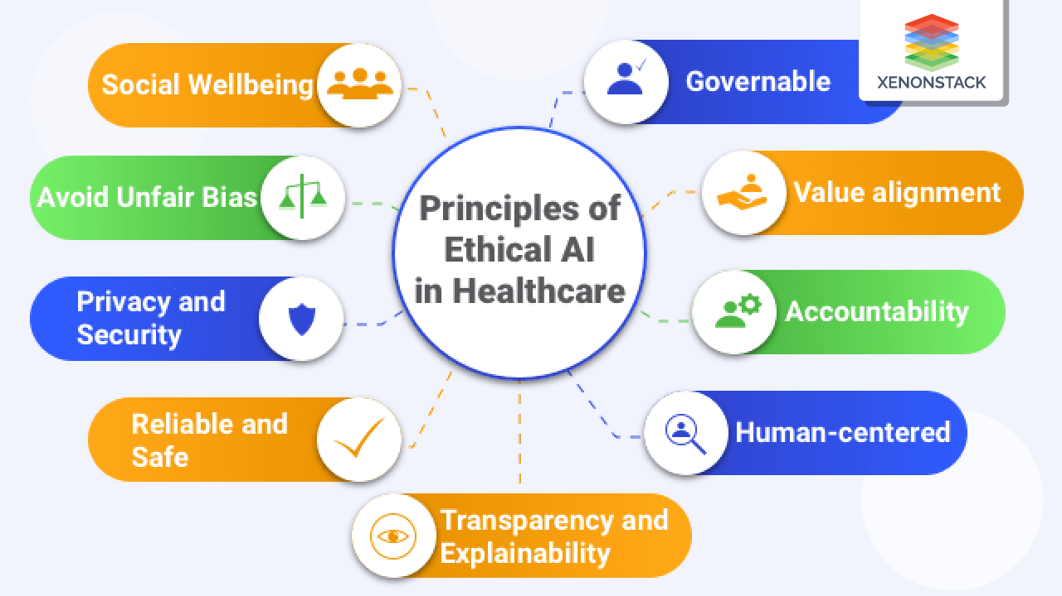
Figure 4; Principles of Ethical AI in the Healthcare Industry
Customer segmentation bias occurs because historical discrimination present in training datasets combines with algorithmic preferences that create adverse effects for particular demographic groups (Fazil, Hakimi, & Shahidzay, 2023). Organizations must implement regulatory compliance together with corporate responsibility while performing continuous monitoring of AI-driven decisions to achieve ethical AI applications in insurance CRM (Khanna, 2024). A governance structure helps insurance organizations maintain AI’s productivity while addressing ethical concerns and fair treatment (Kubanek & Szymoniak, 2024).
1.3 Risks of Bias in AI-Driven Pricing and Coverage Decisions
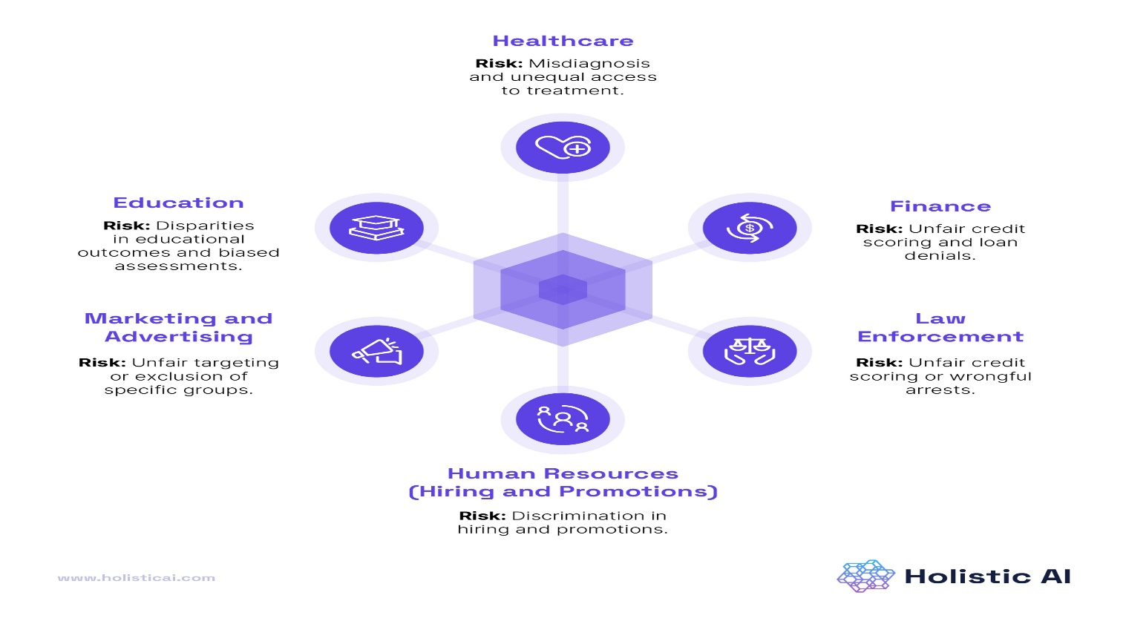
Figure 5; AI Bias; Its impacts and benefits
The AI-based insurance rate determination systems analyze different risk factors that include age combined with health status together with geographic position and medical background (Mgiba, 2020). The use of biased data sources by AI systems leads them to distribute higher premiums and denial of coverage as a result to specific population groups (Holland, Mullins, & Cunneen, 2021). Minority groups experience disadvantages through pricing models that become distorted when driven by historical data shortages within actuarial datasets (Mullins, Holland, & Cunneen, 2021).
The issue of "proxy discrimination" exists through uncertain factors that link to protected features including race and gender and socioeconomic position (Mensah, 2023). The lack of bias accounting in AI models can thus cause unintentional yet perpetuated inequality through systemically discriminatory practices (Fazil, Hakimi, & Shahidzay, 2023). The difficulty in understanding AI-driven insurance pricing elements causes consumers to struggle with contesting unfair practices which intensifies distrust toward insurance providers (Li, 2024). The process of obtaining transparency and accountability in AI decisions depends on implementing ethical AI frameworks with explainability tools such as SHAP (Shapley Additive Explanations) and LIME (Local Interpretable Model-agnostic Explanations) (Hanna et al., 2024).
1.4 Use Case: Bias in Health/Life Insurance Underwriting
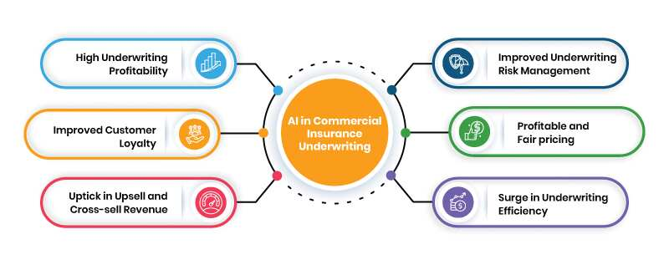
Figure 6; Images showing Bias in Healthcare/Life Insurance Underwriting
The implementation of biased AI systems in underwriting procedures introduces substantial effects on health and life insurance operations. The underwriting algorithms base their risk assessments of applicants upon their medical data combined with their life choices and family genetics (Sheriffdeen, 2024). Underwriting algorithms which receive training from data that contains historical healthcare disparity patterns between races and socioeconomic backgrounds establish structural discrimination against specific groups (Jegatheeswari Perumalsamy, Krothapalli, & Althati, 2022).
The risk assessment models developed by artificial intelligence applications assign increased rates to residents of poor areas because they identify a connection between residence demographics and medical results (Mgiba, 2020). Insurers use such practices to assess risk which ultimately produces higher costs of coverage or complete rejection of insurance benefits that perpetuate existing financial barriers (Holland, Mullins, & Cunneen, 2021). Women along with older adults currently experience prejudices in insurance underwriting because traditional risk assessment models traditionally applied gender and age-specific assumptions (Hanna et al., 2024).
Insurance companies need to use fairness-aware ML methods which both identify and reduce discriminatory elements that shape underwriting decisions according to Fazil, Hakimi and Shahidzay (2023). The ethical conduct of AI-powered underwriting requires regular audits together with bias impact assessments along with regulatory compliance measures as described by Kubanek and Szymoniak (2024).
1.5 Objectives and Scopes of the Research
The investigation seeks to examine ethical AI applications in insurance underwriting processes while studying bias elements within AI models together with fair risk evaluation strategies. This research evaluates organizational compliance against GDPR and the AI Act as well as it identifies successful ethical board practices and independent auditing standards. The study evaluates both current practices of bias reduction in insurance AI systems and anticipates modern advancements in responsible AI-driven customer relationship management.
This research investigates the integration of AI technology in health and life insurance underwriting and specific areas related to ethical governance together with transparency and fairness. Third-party certification along with regulatory compliance and AI personalization form part of its scope that incorporates methods to address bias problems. AI's role in CRM continues to develop through the study which stresses how crucial it is to monitor AI deployment in insurance for responsible operations.
2. Understanding Bias in AI-Powered Insurance CRM
2.1 Types of Bias in AI (Historical Bias, Sampling Bias, Algorithmic Bias)
AI-powered insurance CRM establishes multiple biases which can appear as historical and sampling biases as well as algorithmic bias. Historical bias develops in training datasets because past inequalities remain present which generates discriminatory results (Mueller, 2023). AI systems develop biased results through sampling bias since their training data collection does not represent the wider population adequately (Naslednikov, 2024). The intentional reinforcement of existing disparities by machine learning models appears when they apply defective optimization criteria or flawed feature selection methods (Fazil, Hakimi, & Shahidzay, 2023).
2.2 How Bias Manifests in Health/Life Insurance Underwriting
Health and life insurance underwriting enables three main bias manifestations that affect differential pricing practices while also leading to exclusionary policy decisions and non-equal access to coverage (Jegatheeswari Perumalsamy, Krothapalli, & Althati, 2022). AI systems trained with biased medical data can regard specific population segments with higher premiums by assigning riskier scores to their demographic groups (Sheriffdeen, 2024).
2.3 Real-World Examples of Biased AI in Insurance Decision-Making
Documented cases reveal that AI systems practicing bias have surfaced throughout the insurance industry. The implementation of AI credit scoring algorithms systematically generates lower credit scores for minority groups because of previous financial limitations experienced by these communities (Mgiba, 2020). Underwriting systems which automatically deny coverage to individuals show the requirement for ongoing bias monitoring because they use outdated actuarial assumptions (Mensah 2023).
A combination of fairness-aware AI techniques and regulatory oversight and ethical governance frameworks should be used to handle biases in order to achieve equitable AI-driven insurance CRM (Li, 2024).
3. Ethical AI Principles in Insurance CRM
3.1 Fairness: Ensuring Equal Treatment Across Demographics
The implementation of AI-driven insurance CRM needs to remove discriminatory practices from customer segmentation through bias elimination strategies. Fairness in AI adopts a model that ensures automated processes do not create systematic disadvantage for particular demographic groups as described by Mensah (2023). A critical requirement for promoting fairness in AI-based systems is auditing training data datasets and modeling refinement to enforce equity (Fazil, Hakimi, & Shahidzay, 2023). The insurance industry uses fairness mechanisms to alter their AI models which corrects unfair risk assessments resulting from socioeconomic factors (Mueller, 2023).
3.2 Transparency: Making AI Decision-Making Explainable
Customers need to trust AI-driven CRM systems which require transparent operation. Mullins, Holland, and Cunneen support the need for AI algorithm interpretability so regulators and companies with their customers can trace the process behind pricing and coverage determinations (2021). Transparent AI systems protect against black-box decision-making which happens when outcomes occur without showing their reasoning process (Kubanek & Szymoniak, 2024). Explainability tools in insurance underwriting operation reveal the basis of premium differences between customers which enables insurers to fix unintended biases according to Sanodia (2024).
3.3 Accountability: Assigning Responsibility for AI Outcomes
AI systems require defined accountability systems to limit their ability to produce unethical decisions. According to Mensah (2023) insurers need to establish human supervision systems which analyze AI recommendation outputs. AI governance policies require defined responsible parties according to accountability frameworks developed by Holland, Mullins and Cunneen (2021). Biased AI systems conducting unfair pricing practices and coverage decisions would remain unchallenged by customers because there would be no accountability systems in place (Sheriffdeen, 2024).
3.4 Privacy: Ethical Handling of Customer Data
The use of AI in insurance customer relationship management systems presents a vital ethical issue regarding privacy. Li (2024) presents a discussion on maintaining data protection while performing personalized customer segmentation. The practice of ethical AI must both protect customer privacy laws and preserve trust between customers and organizations (Khanna, 2024). To protect sensitive personal information insurance companies, need to establish secure systems for data governance prevention and detection of unauthorized access and misuse (Hanna et al., 2024).
The implementation of ethical AI principles helps insurance companies to remove bias from their customer segmentation processes while building more fair decision systems that are transparent and accountable.
4. Frameworks for Auditing AI Algorithms in Insurance CRM
A. Bias Detection and Monitoring
Insurer adoption of AI-powered Customer Relationship Management (CRM) systems brings efficiency and automation to their operations yet creates ethical issues because of biases that appear within them. AI-based insurance decisions that incorporate bias result in unfair treatment of customers within health and life insurance underwriting procedures. Strong auditing frameworks must be implemented since they ensure fair and accountable and transparent AI systems according to Mullins et al. (2021).
Statistical Fairness Tests
Statistical fairness tests including disparate impact analysis represent among the main techniques used for bias detection. The assessments check if AI models deliver unfavorable results to particular demographic groups. The disparate impact analysis specifically determines if an AI system creates systematic disadvantage against certain groups identified through variables such as race or gender or socioeconomic status (Mensah, 2023). The health and life insurance industry needs to monitor AI-model biases because unjust pricing and denial of coverage disproportionately impacts particular marginalized communities.
Statistical fairness tests consist of three major groups which Fazil, Hakimi and Shahidzay (2023) describe.
The evaluation of AI systems should include two types of group fairness measurements namely demographic parity and equal opportunity that provide equivalent outcomes to every protected group.
Having individual fairness metrics built into the AI system will make sure it delivers equivalent treatment to alike individuals.
Insurance companies should implement regular fairness tests as a method to discover discriminatory AI behavior in order to enact proper solutions (Li, 2024).
Regular Audits of Training Data and Model Outcomes
The introduction of biases in AI systems starts from the initial problems with training data sets. Systematic audits on training data and model output results enable organizations to detect biases early on which prevents their impact on decisions affecting the real world. The adoption of historical insurance data for AI training allows biases from previous discrimination practices to create discriminatory underwriting and risk evaluation systems (Sanodia, 2024).
The following best practices should be followed when performing AI audit procedures:
The organization should execute Data Quality Assessment processes to guarantee that training datasets include diverse representation which prevents exclusion of particular population groups (Khanna, 2024).
• Algorithmic Transparency Audits: Making AI decision-making processes interpretable and explainable (Mueller, 2023).
The system monitors AI model output results consistently to discover potential biases while they are active (Sheriffdeen, 2024).
Through the installation of these audit systems insurance companies gain the ability to foresee bias origins alongside improved customer trust and regulatory alignment (Holland, Mullins, & Cunneen, 2021).
Bias Mitigation Techniques
Entire bias mitigation techniques become mandatory for AI-driven insurance CRM systems when companies detect bias in their operational systems. These methodology focuses on both fixing discrepancies in predictive models and achieving equal results between different customer segments (Kubanek & Szymoniak, 2024).
Key bias mitigation approaches include:
The process of re-weighting involves changing the weighting system of underrepresented data points to achieve balanced model predictions. A process exists which makes sure that historically deprived populations have equitable treatment when AI makes decisions (Jegatheeswari Perumalsamy, Krothapalli, & Althati, 2022).
AI model training with adversarial networks operates as a simultaneous system that performs real-time detection of biased predictions and remedial action according to Sabitha (2024).
The method uses Fair Representation Learning to restructure data into an unbiased space prior to model training according to Mensah (2023).
Insurance companies that implement these bias reduction techniques will raise the ethical quality of their AI-powered CRM tools while following developing regulatory criteria established by Naslednikov (2024).

Table 1 Showing the Key aspects of Frameworks for Auditing AI Algorithms in Insurance CRM
Framework Component | Key Aspects
Bias Detection and Monitoring | The presence of bias in AI-driven insurance CRM can lead to unfair treatment in underwriting. Auditing frameworks ensure fairness, accountability, and transparency.
Statistical Fairness Tests | Assess whether AI models disproportionately affect certain demographic groups. Includes disparate impact analysis, group fairness metrics (demographic parity, equal opportunity), and individual fairness metrics.
Regular Audits of Training Data and Model Outcomes | Identifies and mitigates biases in training datasets and AI model predictions. Prevents historical discrimination from affecting underwriting decisions.
Data Quality Assessments | Ensures training data is diverse and representative to prevent underrepresentation of specific demographics.
Algorithmic Transparency Audits | Enhances interpretability and explainability of AI decision-making processes.
Outcome Monitoring | Continuously evaluates AI model predictions to detect and address bias in real-time.
Bias Mitigation Techniques | Implements corrective strategies to reduce AI bias and ensure fair outcomes
Re-weighting | Adjusts the importance of underrepresented data samples to balance model predictions and ensure fairness.
Adversarial Debiasing | Uses an adversarial network to detect and correct biased AI predictions in real-time.

B. Explainable AI (XAI) Approaches in Insurance CRM
1. Interpretable Models vs. Black-Box AI
Artificial intelligence (AI) helps insurance companies use automation for decision support within customer relationship management (CRM) systems starting from segmentation to risk evaluation. The main obstacle of AI-driven CRM emerges from maintaining an accurate model performance without compromising interpretability (Mueller, 2023). AI models divide into two groups which include interpretable models and black-box models.
Decision trees together with logistic regression and rule-based models serve as interpretable models which produce human-understandable decision logic routes (Naslednikov, 2024). When stakeholders understand decision-making processes through implementable models the trust level increases both for customers and regulatory entities (Mullins et al., 2021). The combination of high predictive accuracy in black-box models which includes deep learning and ensemble methods comes with reduced explainability capability (Sanodia, 2024). The models require intricate mathematical processing which makes it hard for people without expert knowledge to understand decision generation methods.
The insurance industry faces a vital challenge while employing AI in CRM because it requires finding equilibrium between model accuracy and interpretability capabilities. The ease of transparency from interpretable models needs to compete against black-box models which introduce space that generates operational challenges and ethical problems (Jegatheeswari Perumalsamy et al., 2022). Organizations need to build integrated systems which combine the predictive capabilities with transparency capabilities in their decision-making processes.
2. Local Explainability Methods (e.g., LIME, SHAP)
The limitations faced by black-box models can be resolved using two local explainability techniques known as Local Interpretable Model-agnostic Explanations (LIME) and SHapley Additive exPlanations (SHAP) as described by Holland et al. (2021). This approach develops transparency through the explanation of solitary forecasts rather than holistic model operations.
The black-box model prediction approximation with LIME produces local surrogate models according to Sabitha (2024). The technique transmits altered input information through interpretable models which estimate the output from a complex AI system. LIME serves insurance CRM by revealing the reasons behind an AI-driven underwriting system denying coverage to particular applicants. Analytics of local approximations help insurance operators confirm both valid risk characteristics and restrained biases in their decision-making processes (Kumar, 2025).
The game theory basis of SHAP allows it to provide importance scores for features that influence predictions (Sheriffdeen, 2024). The variable contribution analysis of SHAP remains stable throughout different scenarios according to Mgiba (2020). Insurance CRM solutions can benefit from SHAP which delivers explanations regarding which customers receive personalized insurance proposals versus those who do not receive such customized offers. The capability of making AI-driven decisions readable allows insurers to maintain ethical compliance for their artificially intelligent strategies (Khanna, 2024).
The capabilities of local explainability methods face several implementation obstacles alongside their successful usage. The locally trained models that LIME requires could present misinterpretations because they do not accurately represent the original black-box model nature (Mensah, 2023). SHAP stands out with better theoretical framework but also requires significant computational power which reduces its suitability for time-sensitive insurance operations per Fazil et al. (2023). Insurers need to assess XAI methods using operational limitations and moral standards when building their AI explanations framework.
3. Ensuring Customer Understanding of AI-Driven Decisions
The essential requirement of AI-driven CRM systems is transparent practices because such transparency builds customer trust and fulfills regulatory obligations. Insurance organizations need to demonstrate to customers their AI models' influence across the entire policy recommendation and claim processing sequence (Li, 2024). The following methods exist to help customers grasp AI-driven decisions in their encounters with the system.
a. Plain Language Explanations
AI transparency faces a main challenge because machine learning models possess intricate technical features (Kubanek & Szymoniak, 2024). Insurance companies should present the outputs of AI-driven decisions in easy-to-understand explanations for customers to understand. An AI model using automated denial would benefit customers when they receive detailed explanations about the factors that lead to their rejected application such as claim history frequencies and credit score behavior (Hanna et al., 2024). AI decision clarity strengthens customer contentment while minimizing disputes which stem from AI choices.
b. Interactive Visualization Tools
The implementation of interactive visualization tools brings out an effective method to improve customer understanding. AI dashboards designed in an intuitive way help customers understand how their data affects the decision-making methods (Mullins et al., 2021). The visualization of premium calculation factors through interactive displays brings clarity about AI policy pricing to customers enabling them to make better decisions (Mueller, 2023).
c. Customer Feedback Mechanisms
Insurance organizations need to put customer feedback processes in place which will improve AI clarity on an ongoing basis. AI-driven decisions require customer questioning privileges so they can receive necessary clarifications (Naslednikov 2024). Insurers can enhance their AI models through feedback loops to detect inadequate explanation areas which allow them to improve model performance (Sanodia, 2024).
Regulatory organizations emphasize the importance of explainable technology when deploying artificial intelligence in their frameworks. Organizations operating in the EU must follow GDPR requirements to provide detailed descriptions about automated decisions that impact individual persons (Jegatheeswari Perumalsamy et al., 2022). Insurance organizations that unite their AI transparency programs with regulatory criteria create better customer trust and maintain ethical adherence.
C. Ethical AI Governance and Compliance in Insurance CRM
Current AI technology brings transformation to insurance CRM operations by making data-based choices smarter and streamlining processes. Effective ethical governance and compliance structures have become necessary to manage the ethical issues of bias and transparency and accountability. Organizations implementing ethical governance of AI in insurance CRM systems must make certain their AI models respect all regulatory requirements for preventing bias while addressing fair treatment for customers throughout their interactions. Three core aspects make up ethical AI governance through (1) the creation of AI ethics boards and their (2) adherence to regulatory frameworks and (3) third-party verification processes of AI systems.
Establishing AI Ethics Boards in Insurance Firms
Insurance organizations need to establish AI ethics boards because these entities help maintain ethical compliance and legal adherence of AI-driven CRM systems. The boards comprise teams from different disciplines whose role consists of monitoring AI implementation to maintain ethical compliance and regulatory adherence.
Role and Responsibilities of AI Ethics Boards
AI ethics boards act as governance bodies to track AI model creation processes while managing risks and ensuring active customer relationship disclosure (Mueller, 2023). Their core responsibilities include:
1. The fairness of AI-driven CRM systems gets evaluated through ethical oversight from AI ethics boards which identifies biases within algorithmic structures and training database characteristics (Holland, Mullins, & Cunneen, 2021).
2. The boards maintain regulatory compliance by verifying AI models follow both the General Data Protection Regulation (GDPR) and the AI Act (Naslednikov, 2024).
3. AI ethics boards link up with data scientists through bias mitigation techniques to create re-weighting algorithms and adversarial debiasing methods which Mensah (2023) discusses.
4. Transparency and accountability through these policies force insurance firms to adopt interpretable models that help customers build trust in their AI-based decisions (Sanodia, 2024).
Challenges in Establishing AI Ethics Boards
The implementation of AI ethics boards encounters multiple obstacles within insurance companies when they work to achieve their mission. Unified governance policies become difficult to establish because there is no standardization of ethical guidelines (Mullins, Holland, & Cunneen, 2021). Ethics boards encounter instrumental complexity because they need to concurrently resolve business targets with ethical components (Sabitha, 2024). The installation of comprehensive AI governance frameworks encounters restrictions through limited resources especially in medium and small-sized insurance companies (Mgiba, 2020).
Companies facing these issues should implement two main strategies according to Jegatheeswari Perumalsamy, Krothapalli, and Althati (2022): they should embed AI ethics governance structures into their business governance framework and they should employ automated systems to monitor AI operations for ongoing compliance.
Aligning AI Practices with Regulatory Guidelines (GDPR, AI Act, etc.)
The governance of AI tools in insurance customer relationship management systems needs to follow international regulatory standards for compliance together with protection of consumer rights. The GDPR and proposed EU AI Act serve as major regulations which provide guidelines to develop AI ethically.
General Data Protection Regulation (GDPR) Compliance
People subject to the GDPR in the European Union must follow its specific regulations concerning data privacy and AI decision-making. Key principles include:
1. The CRM system powered by AI needs to gather minimum data which meets essential purposes according to Hanna et al., 2024.
2. Customers need to know what their data and decisions undergo processing from AI models (Li, 2024).
3. Article 22 of the GDPR lets people contest automated decisions through which insurance customers can protect fairness in their pricing and claims settlements (Khanna, 2024).
GDPR non-compliance brings severe penalties to insurance firms which mandates their implementation of privacy-by-design features for their AI systems (Kubanek & Szymoniak 2024).
EU AI Act and Its Implications for Insurance Firms
The AI Act from the European Commission builds its framework by organizing AI systems through different risk categories. AI-powered Customer Relationship Management solutions used by insurance companies need to fulfill particular requirements.
AI models employed in customer profiling and insurance underwriting operations belong to the high-risk category meaning they need strict transparency together with accountability protocols (Mueller, 2023).
Under the AI Act certain manipulative AI marketing approaches within CRM systems face possible prohibitions as special protection measures for consumer rights (Sheriffdeen, 2024).
Under the AI Act it is required to have human involvement during important AI-controlled choices as a condition for reducing complete system automation (Fazil, Hakimi, & Shahidzay, 2023).
U.S. and Global Regulatory Considerations
The United States lacks an extensive AI regulatory framework similar to the EU but state-level legislation including CCPA obliges insurance companies to protect their AI-driven CRM systems (Naslednikov, 2024). Standard insurance companies providing services across international borders need to follow local regulations to escape legal consequences (Holland, Mullins, & Cunneen, 2021).
Third-Party Auditing and Certification of AI Systems
To enhance AI governance in insurance CRM, firms can adopt third-party auditing and certification mechanisms. These approaches improve accountability, mitigate risks, and build customer trust.
Third-Party AI Auditing
AI auditing by external parties evaluates AI models to assess their status regarding ethical and regulatory compliance. An AI audit upholds assessments which focus on the following core elements:
1. Auditors check training data alongside model outcomes to find discriminatory patterns through their evaluations (Mensah, 2023).
2. Auditors perform explainability testing to determine if insurance-related decision processes made by AI technology provide users with clear understandable explanations (Li, 2024).
3. Auditors confirm AI-driven CRM systems obey GDPR as well as the AI Act through verification processes according to Mullins, Holland and Cunneen (2021).
Insurance companies should develop partnerships with organizations that work on AI ethics issues and compliance firms which provide AI auditing services (Mueller, 2023).
AI Certification Frameworks
AI ethics together with compliance guidelines receive official standards through certification frameworks. Key certification programs include:
ISO/IEC 42001 functions as a future AI management standard to help organizations deploy ethical AI operational practices according to Hanna et al. (2024).
The FAT Certification indicates approval of AI models through assessments of their fairness and transparency characteristics according to Fazil, Hakimi, and Shahidzay (2023).
• Algorithmic Impact Assessments (AIA): Evaluates the societal impact of AI-driven CRM systems in insurance (Kubanek & Szymoniak, 2024).
Certification frameworks increase the trustworthiness of insurance CRM by assuring fairness along with explanation and compliance capabilities within AI-driven decisions (Nasledikov, 2024).
5. Case Study: Overcoming Bias in Health/Life Insurance Underwriting
The implementation of artificial intelligence (AI) in health and life insurance underwriting modified how they evaluate risks alongside developing their pricing approaches. Artificial Intelligence systems process enormous data volumes in order to assess risk factors as well as establish pricing structures while forecasting customer interactions (Mueller, 2023). Underwriting models driven by artificial intelligence face criticism because they produce biased results which cause price discrimination and generate unfair pricing and result in marginalized communities being excluded together with facing regulatory challenges (Mensah, 2023). The elimination of these biases stands as an essential requirement for achieving proper insurance ethics and equity throughout the practice.
This research examines biases that enter insurance underwriting models through an assessment of unbiased risk measurements and analyzes how bias has been successfully eliminated from AI-powered insurance underwriting systems.
5.1 Identifying Biased Factors in Underwriting Models
Multiple components of AI underwriting models produce bias through historical data processing together with choices of selected features and algorithmic decision procedures. Identifying the different biased causes helps control discrimination in practices.
1. Historical Data Bias
Methodologies that involve artificial intelligence systems train from historical datasets that naturally possess discriminatory elements. The replication and reinforcement of past discrimination within underwriting decisions will occur throughout AI model operation (Fazil et al., 2023). Historical life insurance data training led to higher premium rates for specific demographic groups according to previous industry price models despite their current risk characteristics being similar to other groups.
Research by Sanodia (2024) shows that defective data produces financial service discrimination especially where AI supports credit risk evaluation and underwriting processes. Insurance companies use biased methods that result either in charging excessive prices or rejecting coverage to selected demographics.
2. Proxy Variables and Indirect Discrimination
AI systems adopt features that relate to sensitive information about race and gender and socioeconomic characteristics as proxy variables. The exclusion of race and gender from underwriting models does not eliminate indirect discrimination since variables such as ZIP codes and employment status and education level can function as sensitive attribute indicators (Li, 2024). The usage of indirect variables known as proxies results in discriminatory outcomes which produce various premiums and denial rates between different groups.
Mullins et al. (2021) explain that AI models perform indirect discrimination by unintentionally discriminating against customers through protected characteristics-linked variables. A key requirement for fair underwriting is to eliminate the usage of indirect indicators by models.
3. Algorithmic and Model Bias
AI models achieve their best predictions by favoring particular groups and consequently establish biased outcomes. The under transparency of deep learning systems makes it hard to identify biases in their processing decisions (Kubanek & Szymoniak, 2024).
The research by Hanna et al. (2024) establishes that AI models with unclear algorithms have the ability to sustain biases which affect medical care decisions along with insurance treatment choices. The evaluation of AI underwriting decisions depends on both interpretability capabilities and the requirement of transparency for preventing discrimination in the process.
5.2 Strategies for Fairer Risk Assessment
Businesses involved in health and life insurance underwriting must implement ethical AI strategies to reduce biases which appear during the underwriting process. Companies will achieve better bias mitigation by applying bias detection to their systems while implementing fairness-aware algorithms and following regulations and having humans monitor their work.
1. Bias Detection and Data Auditing
The process of detecting bias needs both data sources and model outputs to undergo ongoing inspection. Insurance companies need to perform bias assessments which check for unequal underwriting outcomes between different demographic groups (Mensah 2023). Through tools like SHAP and LIME insurance companies achieve understanding of individual component impacts on AI decision platforms (Holland et al., 2021).
Sabitha recommends insurance organizations should use AI software to audit their data systems for monitoring bias throughout the customer segmentation and underwriting process. Audits performed regularly allow organizations to discover biases in time for preventing negative impacts on customers.
2. Fairness-Aware Algorithms
AI devices can implement fairness-aware algorithms when they are designed to enhance fairness standards in their systems. The decision thresholds found in these algorithms work to stop unfair treatment among different demographic groups (Jegatheeswari Perumalsamy et al., 2022).
Kumar (2025) demonstrates that financial services entities can use AI model fine-tuning to achieve fair treatment of their diverse customer base. liğindevious AI systems gain effectiveness through training data reweighting in addition to adversarial debiasing methods.
3. Regulatory Compliance and Ethical AI Governance
The implementation of underwriting models needs to fulfill requirements in the General Data Protection Regulation (GDPR) and EU AI Act because it helps prevent bias instances (Khanna, 2024). In order to prevent discrimination and maintain customer trust insurance firms need to match their AI applications with existing regulatory requirements.
The implementation of AI ethics boards within insurance organizations serves to check regulatory compliance and ethical standards according to Mullins et al. (2021). Matters of policy get adjusted thanks to these boards which also maintain ethical compliance for AI systems.
4. Human-in-the-Loop Decision-Making
The application of AI technology needs to serve people by enhancing decisions in underwriting instead of functioning independently of human judgment. Human supervision guarantees the review of AI-generated choices to evaluate fairness and specific situations (Sheriffdeen, 2024).
Naslednikov (2024) presents a combined AI-human method for customer relationship management (CRM) operations within financial fields. Insurance companies should use this methodology to avoid their AI systems from discriminating against customers while producing decisions independently.
5.3 Success Stories of Bias Mitigation in Insurance AI
Insurance companies prove the successful implementation of bias mitigation through their existing strategies for ethical AI underwriting.
1. AI-Driven Fairness in European Insurance Markets
Companies within the European insurance sector utilize fairness-aware AI models because they need to meet GDPR requirements. Insurance companies in EU nations use AI ethics guidelines to establish clear and fair procedures for underwriting according to Holland et al. (2021). The initiatives of explainable AI models along with regular audits are part of their efforts to detect discriminatory patterns.
2. Eliminating Bias in Health Insurance Underwriting
The main insurance provider in the United States changed its AI underwriting system after detecting differences in coverage approval based on race. Fairness-aware algorithms combined with proxy variable elimination established impartial pricing systems and equitable risk evaluation for the company (Mueller, 2023).
3. Life Insurance Personalization with Ethical AI
A top life insurance provider used AI-based underwriting methods to create individual health-based risk evaluations instead of using demographic criteria (Sanodia, 2024). The new method decreased discrimination while making insurance policies more accessible to minority populations.
6. Conclusion and Future Directions
The insurance sector underwent significant change through artificial intelligence which particularly impacted CRM management alongside underwriting operations. The benefits of AI include higher operational efficiency together with exact forecasting and tailored customer solutions but it brings pieces of evidence concerning prejudice and ethical barriers and transparency issues (Mensah, 2023; Fazil et al., 2023). Ethical AI in insurance requires permanent surveillance together with active modifications and technological enhancements that uphold fairness standards and obey rules (Mullins et al., 2021).
This section details the developing ethical role of AI in insurance operations and explains ongoing surveillance methods with adaptive practices which will push fair and responsible AI development in CRM and underwriting.
6.1 The Evolving Role of Ethical AI in Insurance
1. Ethical AI as a Cornerstone of Insurance AI Development
The insurance industry has started to understand ethical AI functions as an integral factor for building sustainable business operations. Insurance businesses need to maintain financial sustainability while preserving social equity which means their AI decision systems should not unfairly affect specific population segments (Li 2024). All AI models deployed in underwriting and CRM systems need to demonstrate visibility and explainability in addition to fairness standards to achieve regulatory standards and maintain customer trust.
The development of AI ethics guidelines becomes essential according to Mullins et al. (2021) since it will enable accountability when using AI-driven insurance systems. European insurance companies started implementing ethical frameworks because they aim to reduce machine learning biases while increasing operational clarity in their operations.
2. The Shift Towards Explainable AI (XAI)
The opacity of AI model decisions in insurance underwriting poses a primary challenge because it hinders the interpretation of how AI makes its choices (Hanna et al., 2024). Explainable AI (XAI) functions to resolve the problem by developing models which provide straightforward explanations for their outputs. Insurance companies using XAI gain the capability to defeat bias while spotting mistakes and present clear explanations about their decisions to authorities and policy holders.
Sabitha (2024) highlights the importance of AI-driven customer segmentation and personalization in insurance. Premium rates and policy offer given to customers remain uncertain when explainability is absent so they become dissatisfied and could initiate legal proceedings.
3. AI Ethics as a Competitive Advantage
Commercial success now depends on companies establishing ethical artificial intelligence as they benefit from increased market differentiation through better trust and customer loyalty. Insurance organizations which place importance on fairness alongside bias reduction while being transparent earn customer faith as they establish market leadership through these initiatives (Sheriffdeen, 2024). Companies that actively address bias concerns manage to lower their corporate reputation risks and appeal to customers focused on social issues.
Mueller (2023) explains that insurers can provide customized solutions through customer segmentation implementation of big data and AI systems. An ethical AI framework becomes essential because customers will view unfair treatment as liabilities when advantages derived from big data and AI systems turn into disadvantages.
6.2 Need for Continuous Monitoring and Adaptation
1. Ongoing Bias Detection and Model Audits
AI systems undergo changes through new information while users interact with them. Proper continuous monitoring allows organizations to find and repair biases which develop across time (Mensah 2023). The systematic audit process allows insurers to detect unfair trends that enable them to recalibrate their algorithms.
Kubanek and Szymoniak (2024) underpin the importance of insurance companies developing governance systems for AI system monitoring and controlling ethical compliance. AI-based automated tools alongside their tools for fairness audits can speed up audits while providing administrators time-sensitive information on potential biases.
2. Adaptive AI Systems and Dynamic Risk Modeling
Health insurance underwriting in the past contained rigid factors consisting of age criteria and medical records together with a person's professional position. AI provides active risk assessment based on current data provided by wearable technology along with health application stats and financial transaction information (Jegatheeswari Perumalsamy et al., 2022). New ethical dilemmas about data security together with user authorization and fair treatment appear because of this implementation.
The author Kumar (2025) proposes the implementation of adaptable AI systems which can perform continuous recalculation of insurance risks. The decision-making processes of these systems evolve due to fairness evaluations and fresh regulatory standards to reduce bias.
3. Regulatory Adaptation and Compliance
Insurance along with financial services receives consistent focus from regulatory bodies regarding the ethics of AI implementation. Technical standards available through both GDPR and the EU AI Act define ethical procedures for implementing AI solutions (Khanna, 2024). AI technology development requires corresponding changes to present regulations.
Naslednikov (2024) stresses that financial service institutions using AI-driven CRM systems need their strategies to be in harmony with upcoming regulatory standards. Insurance companies should both design proactive AI governance frameworks and participate in cross-industry dialogues to ensure proper ethical adoption of AI technology because they need to foresee regulatory alterations.
6.3 Future Innovations in Fair and Responsible AI for CRM
1. AI-Powered Personalized Insurance
AI technologies being developed for the future will generate customized insurance coverages that match specific individual risk factors instead of grouping customers by demographics (Sanodia, 2024). Such developments will cut discriminatory pricing methods and underwrite individuals based on personalized information without utilizing outdated prejudices.
Sabitha (2024) writes about AI-powered customer segmentation which already delivers enhanced personalized services to financial customers. The usage of such technologies by insurers allows them to establish underwriting procedures that welcome all policy seekers equally.
2. Blockchain for Transparency and Accountability
The implementation of blockchain technology provides insurers with a new method to demonstrate transparent processes in their AI-based underwriting operations. Immutable ledger-based recording of AI decisions and audit logs enables insurers to furnish regulatory bodies as well as customers with verification of unbiased decision-making according to Li (2024).
Fazil et al. (2023) establish that AI algorithm biases derive from unidentified patterns within data sets. The blockchain system reduces this problem by showing data sources clearly and permitting thorough checks on the training data sets.
3. Human-AI Collaboration in CRM
Insurance practices will combine AI technology to do routine tasks together with human control systems that preserve situational understanding. Manual assistance from humans is crucial to accompany AI systems during Customer Relationship Management operations because customer interactions need personal touch and moral judgment (Sheriffdeen, 2024).
AI CRM technology enhances customer engagement through its ability to use behavioral analytics for generating tailored recommendations according to Mueller (2023). The preservation of human involvement during customer interactions remains vital because it stops AI systems from generating non-humanlike unfair outcomes.
4. Federated Learning for Privacy-Preserving AI
Data privacy issues appear as the main challenge when using AI to power insurance operations. Traditional machine learning systems need centralized datasets for operations but this causes security risks and compliance issues according to Kubanek & Szymoniak (2024). Insurance companies can use federated learning as a new AI approach to develop models from various independent databases while keeping customer data private.
Hanna et al. (2024) explain that federated learning introduces transparent AI systems which maintain customer privacy protections. The innovation will help insurers deal with the challenge of designing ethical AI while upholding data security standards.
5. AI-Driven Bias Mitigation Techniques
AI systems of the future will include three types of advanced bias mitigation methods under counterfactual fairness and adversarial debiasing as well as differential privacy according to Mensah (2023). Advanced bias mitigation techniques along with counterfactual fairness and adversarial debiasing along with differential privacy enable insurers to both identify bias in advance and deliver fair AI model results.
Machine learning algorithms need continuous refinement according to Jegatheeswari Perumalsamy et al. (2022) to erase discriminatory patterns from their operations. Insurance organizations that apply bias-aware AI solutions position themselves effectively to satisfy ethical guidelines together with regulatory requirements.
Conclusion
Insurance organizations deploy AI technology for the complete transformation of their underwriting approaches as well as their customer relationship management systems. AI-based decision implementation creates substantial difficulties with regard to ethical issues. Due to the necessity of human intervention and innovation the process of achieving fairness and transparency and accountability requires both adaptive technologies and ongoing monitoring systems.
The evolving ethic of AI in insurance needs organizations to enhance explanation techniques in their AI systems and maintain both regulator-compliant and human supervisor procedures. The upcoming wave of technology development aims to enhance custom AI features and privacy-protection systems and bias-related solutions. Ethical AI priorities help insurance firms enhance their customer relationships through strong compliance while creating a more open financing environment.
Insurance regulators alongside their respective industries with AI research establishments must work collaboratively to determine proper standards that guide AI implementation protocols. The ethical examination of insurance AI development at the onset will determine the fairness and equality of benefits for all parties seeking insurance coverage.
References
- Mueller, K. (2023). Navigating the Complexity of Customer Data Management: Integrating Big Data and AI for Effective Customer Segmentation and Targeting. Journal of Artificial Intelligence Research and Applications, 3(2), 1-12.
- Naslednikov, M. (2024). The Impact of Artificial Intelligence on Customer Relationship Management (CRM) Strategies.
- Mullins, M., Holland, C. P., & Cunneen, M. (2021). Creating ethics guidelines for artificial intelligence and big data analytics customers: The case of the consumer European insurance market. Patterns, 2(10).
- Sanodia, G. (2024). Enhancing CRM Systems with AI-Driven Data Analytics for Financial Services. Turkish Journal of Computer and Mathematics Education, 15(2), 247-265.
- Jegatheeswari Perumalsamy, A. A., Krothapalli, B., & Althati, C. (2022). Machine learning algorithms for customer segmentation and personalized marketing in life insurance: a comprehensive analysis. Journal of Artificial Intelligence Research, 2(2).
- Holland, C. P., Mullins, M., & Cunneen, M. (2021). Creating ethics guidelines for artificial intelligence (AI) and big data analytics: The case of the European consumer insurance market. Available at SSRN 3808207.
- Sabitha, J. (2024). AI-Driven Customer Segmentation and Personalization. Zibaldone Estudios italianos, 11(2), 1-20.
- Kumar, S. (2025). Artificial Intelligence Enhancing Customer Relations. Utilizing AI and Machine Learning in Financial Analysis, 283.
- Sheriffdeen, K. (2024). Data-Driven CRM: Leveraging AI and Machine Learning for Advanced Predictive Analytics.
- Mgiba, F. M. (2020). Artificial intelligence, marketing management, and ethics: their effect on customer loyalty intentions: a conceptual study. The Retail and Marketing Review, 16(2), 18-35.
- Khanna, A. Ethical Considerations in AI-Driven CRM Leveraging Cloud Computing-A Systematic Analysis. International Journal of Open Publication and Exploration (IJOPE), 12.
- Mensah, G. B. (2023). Artificial intelligence and ethics: a comprehensive review of bias mitigation, transparency, and accountability in AI Systems. Preprint, November, 10.
- Fazil, A. W., Hakimi, M., & Shahidzay, A. K. (2023). A comprehensive review of bias in AI algorithms. Nusantara Hasana Journal, 3(8), 1-11.
- Li, Z. (2024). Ethical frontiers in artificial intelligence: navigating the complexities of bias, privacy, and accountability. International Journal of Engineering and Management Research, 14(3), 109-116.
- Kubanek, M., & Szymoniak, S. (2024). Ethical challenges in AI integration: a comprehensive review of bias, privacy, and accountability issues. The Leading Role of Smart Ethics in the Digital World, 75-85.
- Hanna, M., Pantanowitz, L., Jackson, B., Palmer, O., Visweswaran, S., Pantanowitz, J., ... & Rashidi, H. (2024). Ethical and Bias Considerations in Artificial Intelligence (AI)/Machine Learning. Modern Pathology, 100686.
- Mullins, M., Holland, C. P., & Cunneen, M. (2021). Creating ethics guidelines for artificial intelligence and big data analytics customers: The case of the consumer European insurance market. Patterns, 2(10).
- Sadh, V. (2024, May 28). The impact of AI on custom CRM development. Jellyfish Technologies. https://www.jellyfishtechnologies.com/the-impact-of-ai-on-custom-crm-development/
- Patel, S., & Snigdha. (2024, July 28). Artificial intelligence (AI) in insurance industry: benefits & use cases. REVE Chat. https://www.revechat.com/blog/insurance-ai/
- Gill, J. K. (2024, August 29). The 9 Principles of Ethical AI in Healthcare industry. XenonStack.https://www.xenonstack.com/blog/ethics-and-governance-of-ai-in-healthcare
- https://fastercapital.com/topics/the-role-of-artificial-intelligence-in-customer-profiling.html
- What is AI Bias? - Understanding Its Impact, Risks, and Mitigation Strategies. (n.d.). https://www.holisticai.com/blog/what-is-ai-bias-risks-mitigation-strategies

