“TECHNICAL DEBT IN SOFTWARE QUALITY ENGINEERING: A QUANTITATIVE MODEL FOR RISK MITIGATION”
Abstract
Technical debt is now one of the significant challenges pertaining to modern software development, as they affect software maintainability, scalability, and future costs. This paper discusses a quantitative approach toward reducing an accumulated technical debt using risk assessment models, automated monitoring, and software engineering best practices. The study set up a structured framework of measuring and prioritizing technical debt based on defect density, code complexity, and technical debt ratio analysis. Real industry case studies demonstrate the visible and unarguable effectiveness of risk-based application strategies toward improvements in software quality and sustainability of a project. In addition, the paper proposes future research directions based on the results obtained about contributions from AI and automation in the area of technical debt management. It was discovered that integrating proactive risk mitigation strategies with Agile-and-DevOps workflow could significantly improve the software development process.
Keywords: Technical debt, risk mitigation, software maintainability, defect density, Agile, DevOps, risk assessment models, software quality, automated monitoring, artificial intelligence in software engineering
1. Introduction
1.1 Background and Importance
1.1.1 Definition of Technical Debt in Software Engineering
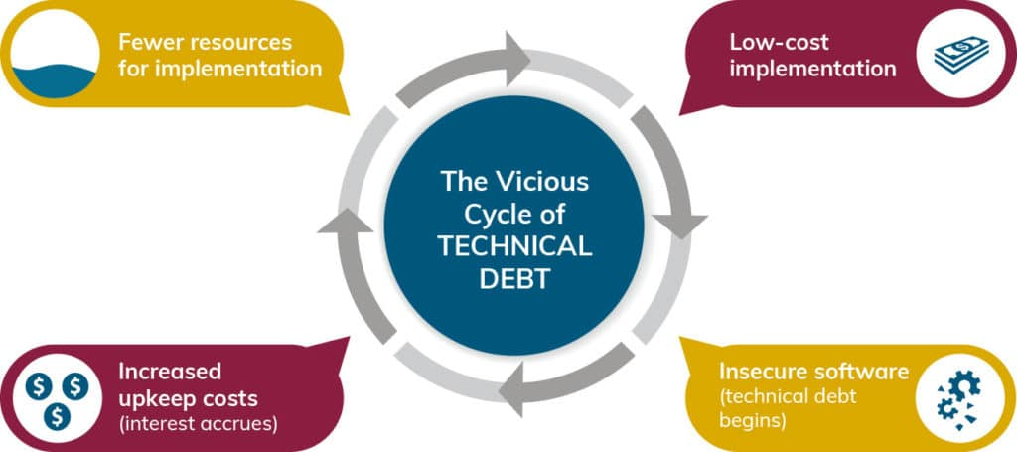
Figure 1: Vicious Cycle of Technical Debt
Technical debt (TD) refers to the cost of additional redoing work incurred owing to the fast and less-than-optimal choice of ways of doing software delivery instead of making the right choice. Software development teams tend to accumulate TD over time as they prefer short delivery periods instead of quality. Such decisions result in an added maintenance burden later (Maldonado & Shihab, 2015). Idealistically, TD can be broken down into categories that include code debt, architectural debt, and documentation debt, each of which has potential negative effects on the sustainability and reliability of the software systems under consideration (Tsintzira et al., 2019).
Siavvas et al. state the definition of technical debt as something beyond a software development artifact; it is also a genuine security risk. Threats arising from unresolved TD can engender software systems' vulnerabilities to security breaches. Hence, measuring and managing TD becomes all-important to ensure that the software product is sustainable over time.
1.1.2 Relationship between Technical Debt and Software Quality
Technical debt holds measurable relevance to software quality engineering. Higher levels of technical debt generally result in deterioration of maintainability aspects affecting user code and performance as per Lenarduzzi et al. (2021). Developers-writers grappling with technical debt disregard debugging or refactoring of existing software but just add newer functionality into the already cluttering mess of bad code and really bad design choices (Skourletopoulos et al., 2015).
Studies exist that indicate just how technical debt interferes with testing and QA for software. For example, one of the cores RBT paradigms treats some types of technical debt as fundamental test case prioritization factors in terms of defect probability versus the system impact (Souza, Gusmão, & Venâncio, 2010; Redmill, 2004). Automated metrics for technical debt are claimed to help software developers assess risk to software quality (assuming that it does indeed correlate with technical debt) in strengthening their decision-making capabilities (Khomyakov et al., 2020).
1.1.3 The Need for a Risk Mitigation Model in Software Quality Engineering
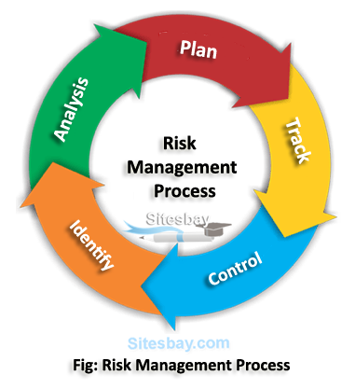
Figure 2: Images showing the Risk Management Process
The long-term implications of technical debt have necessitated the development of risk mitigation strategies plagued by issues of sustainability and security. Given that old-style debt-reduction techniques have been largely based on refactoring and code reviews every so often, they often tend to lack a proper systematic framework for risk assessment (Skourletopoulos et al., 2014). On the other hand, ML and predictive analytics provide quantitative risk models that can be much more descriptive of how debt gets acquired and its consequences (Siavvas et al., 2022).
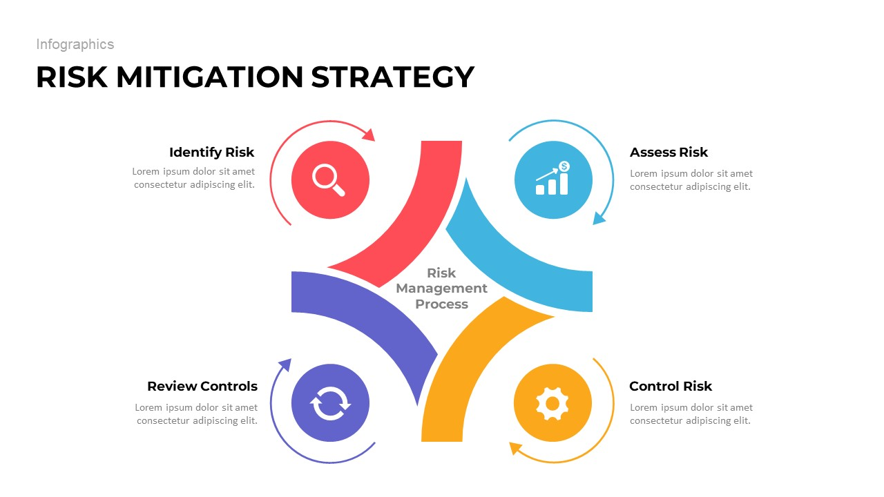
Figure 3: Images showing the Risk Mitigation Strategy
Models for mitigating risks combine technical debt prioritization with software quality metrics for proactive management. Quantitative risk analysis techniques present a way of providing structured means for assessing the financial and operational risks posed by TD (Bayaga and Mtose, 2010). Risk monetization frameworks can assist software companies to balance development speed in the short term against maintenance cost in the long term (Doerry & Sibley, 2015).
In cloud software engineering, TD management assumes even greater importance in view of continuous delivery and fast deployment cycles. Some predictive lead times suggest that integrating TD quantification into DevOps pipelines can lift software quality while reducing operational risks (Skourletopoulos et al., 2015).
A robust risk mitigation model for technical debt must incorporate:
- Automated TD assessment tools for real-time monitoring (Khomyakov et al., 2020).
- Risk-based testing approaches to prioritize high-impact defects (Alam & Khan, 2013).
- Financial risk assessment models to measure the cost-benefit trade-offs of TD remediation (Sweetser et al., 2020).
1.2 Problem Statement
Consequently, technical debt (TD) has remained an enduring challenge for software quality engineering, emanating from bad coding styles, hurried development, and architectural compromises made in favor of short-term profits over long-term maintainability. As software projects grow, the TC that comes in with the projects takes its toll on maintenance costs, system performance, and security vulnerability (Siavvas et al., 2022). The authors also note that while the awareness of the impact of TD is slowly increasing, the strategies that exist until now towards the mitigation of TD hardly follow a structured and data-driven approach that would allow for effective quantification and management of the conjoined risks (Lenarduzzi et al., 2021).
Traditional approaches to managing technical debt rely on a continuous cycle of manual code reviews, periodic refactoring, and qualitative assessments, none of which can be considered effective in large software systems (Maldonado & Shihab, 2015). In addition, because of the absence of a standard risk assessment framework, organizations are unable to decide which TD to address first, which results in misallocating resources to trivial issues, thus letting serious quality deficiencies to persist (Skourletopoulos et al., 2014). In the absence of a quantitative model for measuring and predicting the risks associated with technical debt, the decision-making of software development teams with respect to debt management strategies is hampered.
Although various technical debt quantification techniques have already been proposed in the literature (Tsintzira et al., 2019), there appears to be a vacuum in the integration of these techniques into a coherent risk mitigation framework for software quality assurance (Khomyakov et al., 2020). The need for an fully automated, data-driven approach toward TD risk assessment and mitigation is critical, especially in cloud-based and agile software development environments, where rapid iteration and continuous integration create conditions that facilitate the build-up of TD (Skourletopoulos et al., 2015).
1.3 Research Objectives
The creation of a quantitative model intended to help in identifying risks and manage technical debts towards improving software engineering quality is what this research endeavors to achieve. This research therefore concentrates it objectives on the following:
1. To define and analyze the effects of technical debt on software quality - To understand how different types of technical debt (that is, code and architectural documentation debt) directly relate to software maintainability, reliability, and security.
2. To find key risk factors in the constraints of technical debt accumulation - Identify what causes, impacts, and the long-run risks unmanaged technical debts pose for software development projects.
3. Assessment of existing techniques for measuring technical debt - Assess and compare the current approaches found in industry and academia to perform assessment and quantification of technical debt.
1.4 Research Questions
It is in order to enable the objectives that this study intends to realize that the following research questions would actually guide the inquiry:
1. In what way does technical debt affect maintainability, reliability, security, and performance with regard to the software quality attribute?
2. What is the major risk for accruing technical debt in software projects?
3. What are the methods and tools used for measuring and quantifying technical debt, and what are the limitations of such methods and tools?
1.5 Scope of the Study
In software quality engineering, the management of technical debt has been considered; in particular, the development of a quantitative risk management model is at the center of attention. The study seeks to explore technical debt in terms of definition, classification, and impact on key software quality attributes such as maintainability, reliability, security, and performance threshold levels. Other areas of interest include existing measurement techniques and critical risk factors that influence technical debt accumulation. In such respects, predictive analytics and Machine learning techniques would assist towards establishing a certain set of risk assessment modeling structures to further enhance decision-making in technical debt management.
This refers to a quantitative research design which was grounded on data-driven analysis, especially predictive modeling and statistical evaluation methods. Some empirical data would be sampled directly from software projects with reference to both open-source and enterprise applications as a means of validating the proposed model. The automated tools for assessing technical debts powered by machine learning algorithms will contribute toward risk assessment through prediction. Furthermore, its effectiveness would be evaluated through comparison with currently existing technical debt management methods.
The research context shall be on software development environments with the major push around Agile, DevOps, as well as Cloud-Based Software Engineering Practices where technical debt management becomes an inevitable concern. The findings may find relevance in other software domains, though the focus of the paper shall lie in relevant matters concerning enterprise software, cloud-based applications, and large-scale systems. No attention is given to hardware-related technical debts, but rather to software engineering aspects such as design quality, architecture, and security.
The study has certain limitations. The findings will be made available based on a few case studies and empirical data from selected software projects that probably would not be generalizable across all industries. The quantitative model proposed is going to be examined on a few data sets, while its scale to the various software development environments may be pursued for future study. There could be machine-learning attempts to predictive analysis; however, this research will concentrate on the application of existing AI algorithms for the assessment of technical debt rather than on the development of new ones.
2. Literature Review
2.1 Concept of Technical Debt
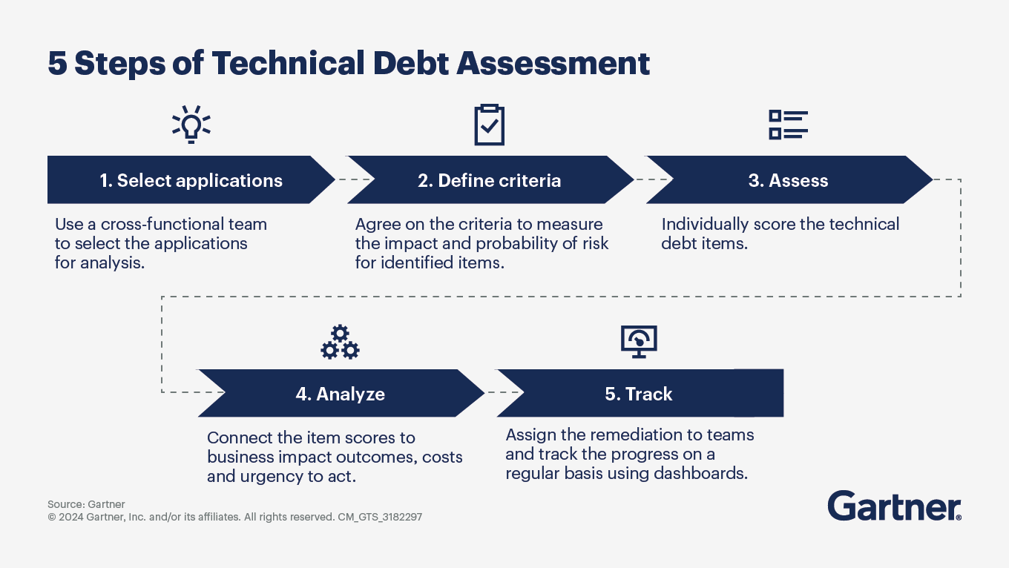
Figure 4: Steps of Technical Debt Assessments
Technical Debt introduced by Ward Cunningham in 1992 is explaining making easy optimum decisions during software development that keep long-term maintenance costs. Words used to resonate are so different today, there being a broad shrink from simply being one of programming short cuts to a very wide tent, potentially even having to do with architectural flaws for voice control, poor documentation, and bad processes, (Maldonado & Shihab, 2015). Much of technical debt's meaning can be further subdivided for such terms as code debt, architectural debt, documentation debt, and process debt. Code debt refers to bad coding practices and failure to adhere to coding standards, whereas architectural debt refers to making design decisions born from immediate pressures, compromising future scalability and flexibility of the system. Documentation debt happens when one establishes technical documentation not adequate for later use by other developers to understand and maintain the system. When software development methodologies are inefficient themselves, turning into variances in the execution and delivery of a project, then process debt is produced (Lenarduzzi et al., 2021).
There are several studies of the causes and effects of technical debt in software engineering. For example, Siavvas et al. (2022) state that technical debts can be indications of security risks in the software, since in general, the very low quality of the code makes it vulnerable. Also, as indicated by Skourletopoulos et al. (2014), it would seem that predicting and measuring the occurrence of technical debt in software systems developed under fast-paced development projects would give rise to heaps of technically indebted systems. Most importantly, modern software systems are in a typically complex form, and in the end, will demand effective methodologies of recognition, measurement, and mitigation in the technical debt to ensure sustainability in the long running (Tsintzira et al., 2019).
2.2 Impact of Technical Debt on Software Quality
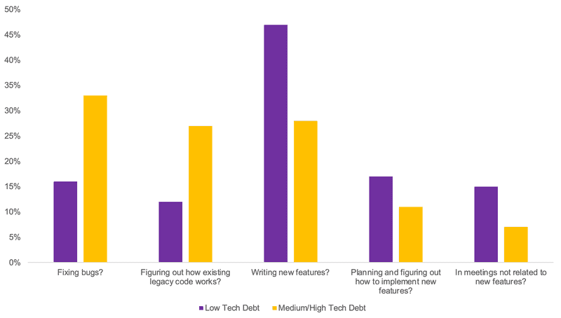
Figure 5: Impacts of Technical Debt on Software Quality
Somebody invented the term technical debt to impose wonders and liken it to many software quality attributes like maintainability, reliability, security, and performance. The unmanaged accumulation of technical debt results, among others, in increasing maintenance work until the point when developers start fixing obsolete technical issues instead of completing progress or new functionalities (Maldonado & Shihab, 2015). Therefore, more technical debt translates into less maintainability, increased costs of change, and delays in sustaining and upgrading activities.
Yet, another serious concern is the oboian ellipse of soaring technical debt, in which faults-and-inconsistencies start creeping into the very software systems it was supposed to protect. For Kilyakov et al. (2020) the automated measure of technical debt makes all the good sense in the world. Manual evaluations
rarely catch hidden risks with technologies and apparent manifestation. Technically debt systems are vulnerable for a security reason, not the least of which are infringements of sound security practices in order to hasten development-time completion under time pressure. According to Siavvas et al. (2022), organizations bearing high technical debt tend to be more exposed to security break-ins supporting thereby proactive shield measures to mitigate such risks.
Technical debts-for-the-performance-of-software manifest as inefficient algorithms, code duplication, rejected designs, which in turn further mar a system's responsiveness and highly increase resource consumption (Skourletopoulos et al., 2015). Unmanageable technical debts reside with the software from one version to the next, escalating long-term costs where refactoring or re-engineering ought to have been performed just to keep the life of the existing software system (Lenarduzzi et al., 2021). Hence, ignoring technical debt exposes the organization to financial and operational risk; therefore, technical debt must form a focal point in risk assessment models.
2.3 Existing Technical Debt Measurement Approaches
In general, qualitative and quantitative models have been suggested for measuring technical debt. Qualitative models are presented as expert judgment, code reviews, and subjective assessments to evaluate the level of technical debt for a software system (Maldonado & Shihab, 2015). These methods usually serve more as a compass rather than indicating an exact value; therefore, they prove inconsistent and biased because of human involvement. On the other hand, the quantified models operate on software metrics, predictive analytics, or automated tools and thus assess or quantify even more objectively (Tsintzira et al., 2019).
Tools such as SonarQube, SQALE, and CodeScene have gained much popularity in technical debt assessment. SonarQube, for instance, demonstrated automatically analyses the code and estimates how much technical debt is implicated through the rules being violated and complexity of code (Khomyakov et al., 2020). SQALE (Software Quality Assessment based on Lifecycle Expectations) is another framework that assesses technical debt by scoring various software quality attributes (Lenarduzzi et al., 2021). CodeScene uses techniques of machine learning to do the analysis of the code evolution and predicts the future technical debt accumulation (Siavvas et al., 2022).
Barriers still exist despite the tool availability to prepare standard tools and ways to quantify technical debt since, as noted by Skourletopoulos et al. (2014), models fail to consider the underlying context, i.e. size of a project, development methodology, or team expertise. Predictive modeling would also call for top-quality data input and constant monitoring to provide a clear picture of such assessments. It implies an integral quantitative model, which would include different tools of risk assessment, to improve decision-making concerning technical debt management (Tsintzira et al., 2019).
This might serve as some contribution to the fact that technical debt is a prime quality-controlling factor for software within-structured measures for effective management. Thus, the use of machine learning in conjunction with risk-based testing strategies may prove beneficial for future improving measurement and mitigation of technical debt. Research is designed for further extensions into developing sound frameworks that will foster proactive technical debt management and, consequently, long-term sustainability of software as such systems evolve.
2.4 Risk Management in Software Engineering
Risk management is one of the fundamental areas of software engineering, where all the issues surrounding software quality, security, and maintainability are identified and either avoided or minimized. Risk assessment techniques range from the classical risk-based approaches, such as risk-based testing with respect to software quality, to modern-day predictive analytical models. The activities that characterize risk assessment in the area of software engineering include risk identification, impact estimation, and formulation of mitigation that minimizes cost and maximizes reliability of software that has been developed (Souza, Gusmão, & Venâncio, 2010).
In general, risk-based testing can be considered one of the most important classes of techniques for software risk management. In risk-based testing, test cases are prioritized based on the risks that they represent with respect to different parts of the software, which could further be elaborated by associating a calculated risk exposure level with every testing of a certain test case. This means that appropriate test cases will be run on high-risk areas of the software to maximize the chances for successful validation. Many studies have provided evidence in favor of risk-based testing, particularly for identifying defects of high severity at a very early time when it could be expected to affect the course of development of the software (Alam & Khan, 2013). Nonetheless, all advancements in risk-based testing have kept alive the methodologies that are still based on manual examination, thus incurring inefficiencies and human errors (Amland & Garborgsv, 1999).
The optimal combinations of predictive analytics and machine learning act further in favor of adopting risk management methodologies in software engineering. Predictive models estimate ongoing risks and implement preventive actions from historical data acquired on software development quality trends (Siavvas et al., 2022). Classification and anomaly detection-based machine learning algorithms are being incorporated to automate the assessment of technical debt so that software components are identified in real-time that are most likely to suffer defects (Khomyakov et al., 2020). Such methodologies brought the companies from traditional risk management toward advanced resolutions with guaranteed cost savings for software maintenance.
As far as risk assessment is concerned, however, in a realm that predictive analytics have laid the foundation for great feats, all the same, plenty of room remains to make actual forecasts. The majority of these models existing today largely depend on a good amount of data but fail quite often due to inconsistent data availability in software repositories that undermines the reliability of the data for any estimation of risk (Sweetser et al., 2020). This is also coupled with the issue of interpretability concerning machine learning models, for this, in turn, makes the understanding of developers and project managers impeded from being able to comprehend the rationale based on which risk predictions were performed (Narania et al., 2008). Thus, hybrid systems are in urgent demand.
2.5 Gaps in Existing Research
Technical debt management and risk mitigation are among the few adoption areas actually having the gaping presence of existing research. One of the significant flaws with the current set up of technical debt models is that they fail to represent the dynamic nature of software evolution. Most of the available works keep static assessments of technical debt ignoring the evaluations through time and the evolving risk landscape (Maldonado & Shihab, 2015). Current models are usually oriented towards a particular type of technical debt, like code debt or architectural debt; they never take into account dependencies among different forms of technical debt (Lenarduzzi et al., 2021).
The standardization lack on measuring technical debts also arises as a challenge in the field. Tools like SonarQube, SQALE, and CodeScene would automate the assessment of debts but not a universal framework against which to hold different projects relative to debt (Tsintzira et al., 2019). This allows organizations to determine the actual cost that technical debt bears on software quality and, therefore, allows them to make informed trade-offs between speed of development and maintainability (Skourletopoulos et al., 2014).
The limitations of existing models on technical debt have been further exposed by the increased complexities that accompany the modern software applications themselves, such as cloud-based applications and large-scale enterprise applications. When put against distributed, microservices-based architectures, traditional techniques for risk assessment are poor at scaling up because there is an accumulation of technical debts between many services and dependencies, which means that microservices architectures have technical debt building up across many services and dependencies (Skourletopoulos et al., 2015). Current models, however, hardly ever integrate a real-time monitoring capability, which limits their ability to provide continuous risk assessment along with proactive mitigation strategies (Siavvas et al., 2022).
An integrated quantitative model that automates prediction analytics, debt measurement, and risk-based decision making is thus an immediate requirement of any model. Thus, these would project into continuous yet dynamic capturing of technical debt as historical trends of software, machine learning predictions, and expert-driven modeling of an entire risk mitigation strategy (Khomyakov et al., 2020). Enable development of frameworks for managing technical debt in order to achieve quality and sustainability of the software amassing long-term is paving the future research routes by closing gaps between qualitative expert assessments and quantitative predictive models.
3. Research Methodology
3.1 Research Design
The study adopts a quantitative approach to technical debt analysis, using empirical data to establish the effect of technical debt on software quality in order to devise a risk mitigation model for prediction. Quantitative research enables the systematic evaluation of different technical debt assessment methods and their effectiveness in reducing software quality risks (Siavvas et al., 2022). The comparison study of various technical debt assessment methods will therefore include assessments made in both traditional and machine learning-based ways, thus attempting to identify if there is any one method of risk mitigation that works best (Skourletopoulos et al., 2014). The study endeavors to provide a data-driven framework to identify and mitigate technical debt in software engineering by analyzing the combination of code complexity, defect density, and software maintainability metrics (Maldonado & Shihab, 2015).
3.2 Data Collection Methods
This endeavor follows a methodological triangulation approach to enable deeper insight into the impact of technical debt on software projects across the board. Data for study will chiefly be obtained from three sources:
1. Case studies from real-life software projects: Empirical data will be gathered from large-scale software projects from open-source and commercial fronts in order to understand how technical debt could pile on and affect the entire lifecycle of the software project (Tsintzira et al., 2019). In this study, software repository analysis was done using automated estimation of technical debt using tools like SonarQube and CodeScene to measure some major indicators of debt (Lenarduzzi et al., 2021).
2. Surveys and Interviews with Experts: Structured surveys and interviews will complement the quantitative results in validating with practitioners, i.e., software engineers, project managers, and software quality assurance specialists. Furthermore, alongside empirical contributions, insights from this would check for the relevance of other strategies for mitigating technical debt, aiming at identifying gaps in the currently utilized risk assessment methodologies (Skourletopoulos et al., 2015).
3. Investigating open source and commercial software repositories: In this study, historical data extracted from software repositories (e.g., GitHub, GitLab) would serve well to account for the flow of technical debt from one version of the software to another. At the same time, automated static code analysis would obtain the count of measurable data on levels of code complexity, defect density, and maintainability scores concerning varying projects (Khomyakov et al., 2020).
3.3 Model Development
The identification and analysis of the various technical debt metrics is critical to the successful implementation in predictive risk assessment models. The previous evaluation of technical debts already identified such metrics as code complexity, defect density, duplication percentage, and architectural violation as very useful (Maldonado & Shihab, 2015). The body of formulated metrics from the above were then used in creating the training set for that machine-learning model, which predicts the accruing technical debt and the likely effects on software quality (Siavvas et al., 2022).
The Activities Involved in Building the Model:
• Feature Selection: Select the technical debt measurement with the highest relevance according to previous studies and empirical analyses of data (Tsintzira et al., 2019).
• Data Preprocessing: It will clean and normalize various types of software repositories' data into a clean and reliable set (Lenarduzzi et al., 2021).
• Model Training and Validation: Uses machine learning methods like Decision Trees, Random Forest and Neural Networks to design predictive model within context assessment on risk posed by technical debt (Skourletopoulos et al., 2014).
• Evaluation: Test predictive quality of modeling against common evaluative measures in application, such as precision, recall, and F1-score (Sweetser et al., 2020).
The model is expected to be a partial result in the quantitative holistic model for technical debt risk mitigation which sources empirical data, expert judgment, and predictive analytics towards better software management quality. Quite likely possible is maintaining results for later standardizing operational processes for technical debt appraisal while also containing actional recommendations related to development companies (Doerry & Sibley, 2015).
4. Understanding Technical Debt in Software Quality Engineering
4.1 Types of Technical Debt
The many aspects of technical debt can change in respect to different aspects of software development. Code Debt is defined as coding, poor or too complex, by reducing maintainability (Maldonado & Shihab, 2015). Architectural Debt is created when some software architecture cannot be scaled and becomes ineffective in renewing systems (Skourletopoulos et al., 2014). Documentation Debt currently occurs when documentation is relatively insufficient or outdated and poses difficulty in understanding functionality of the system on the part of the developers (Lenarduzzi et al., 2021). Process Debt is derived from development inefficient processes such as partial testing and non-distributed workflows, which slow the whole development down and have a high error rate (Siavvas et al., 2022).
4.2 Causes of Technical Debt
Technical debt arises for various reasons. One major reason, as Tsintzira et al. (2019) highlight, is when delivery times are really close; thus, the need to deliver takes precedence over code quality, and one sometimes hurriedly implements code. The other practices contributing to the entity called technical debt may involve improper coding practices, like no code review or consistency in coding style (Khomyakov et al., 2020). Furthermore, these inefficiencies in code structure, or possibly architectural flaws, are compounded by a not-so-strict adherence to software engineering standards and best practices that make software systems even more difficult to maintain (Skourletopoulos et al., 2015).
4.3 Consequences of Technical Debt
Technical debt greatly affects software development in terms of costs and efficiency. More often than not, maintenance departments get to pay for refactoring or bug fixing, thus robbing the resources allocated for newer development (Siavvas et al., 2022). A piece of technical debt can also reduce the efficiency of the software; for example, inefficiencies in the code can cause a major increase in the time it takes to process and can work the computational resources overtime instead (Maldonado & Shihab, 2015). Another major challenge is the difficulty in scaling software applications: platform-wide technical debt means that any new change entails the huge cost of modifying the legacy code (Lenarduzzi et al., 2021).
4.4 Key Software Quality Attributes Affected
Many software quality characteristics are directly enhanced by technical debt. Among them, maintainability has a prominent position here, as high levels of technical debt can make it very hard to change or extend code without risking adding additional errors (Tsintzira et al., 2019). Furthermore, security becomes vulnerable to attacks as technical debt may mean that security updates are neglected and poorly-written code retains a plethora of known defects (Siavvas et al., 2022). Performance is also harmed as inefficient code architecture and excessive dependencies aggravate execution time and consumption of system resources (Skourletopoulos et al., 2014). Finally, reliability is on the decline, as software systems with high technical debt are becoming very prone to defects and unexpected failures, hence leading to high rates of production failures (Khomyakov et al., 2020).
Techniques to reduce technical debt will, therefore, involve proactive solutions such as constant refactoring, best coding practices, and automated tools for analyzing technical debt (Lenarduzzi et al., 2021). Hence, having an in-depth understanding of the nature and ramifications of technical debt will help software-development teams adopt better risk mitigation measures designed to enhance long-term software quality.
5. Development of a Quantitative Model for Risk Mitigation
Establishment of a quantitative model for risk mitigation in software engineering is entirely futile without an accurate assessment of technical debt. Metrics such as code complexity and defect density, which typically embody technical debt, enable understanding in the dimensions of software maintainability and risk factors. Cyclomatic complexity is considered to be the prominent metric using which a program is looked upon in terms of possible independent paths with the number of lines, as indicators of maintainability (Tsintzira et al., 2019). Technical debt ratio measured cost incurred for performing any related activities on technical debt as a ratio to the whole development effort and has, thus, been recommended for prioritizing remediation of debts (Lenarduzzi et al., 2021). Moreover, analyzing defect density and code smell perform the necessary identification of probable risk and inefficiency domains but present within the codebase itself; Khomyakov et al., 2020).

The entire risk assessment framework essentially sythesizes the risks associated with technical debt and the impacts related to that same vale of work assumed as debt. Risk identification thus indicates analyzing how different types of debt render software unstable, insecure, and expensive to maintain on the whole (Siavvas et al., 2022). A prioritization model for decision making on debts will guarantee that high-risk technical debt is solved even before it starts negatively affecting the performance of the software. Predictive analytics with machine learning techniques and statistical models could further predict future outcomes emergent from unresolved technical debt that could inform resource allocation for software teams (Skourletopoulos et al., 2015).
The implementation of the model itself cannot happen outside the existing software development workflow processes. In real time, technical debt following this route can include an automatic process, such as static code analysis or continuous integration pipelines (Maldonado & Shihab, 2015). Integrating the lifecycle software to monitor technical debt enforcement of best practices while preventing the accumulation of debt is thus made possible by organizations (Skourletopoulos et al., 2014). Facilitating better access to improved efficiency in work of developers regarding actionable insights concerning code quality and maintainability, these automation tools do improve efficiency for developers (Lenarduzzi et al., 2021).
The case study and comparison to existing techniques in terms of technical debt mitigation validate and refine the model. Real-world examples from ongoing software projects serve as direct test cases against which the model may be validated in terms of predicting and mitigating technical debt risks (Tsintzira et al., 2019). A comparative study between conventional strategies for mitigation such as manual code reviews and periodic refactoring can best show how much the model excels at efficiency and accuracy (Siavvas et al., 2022). Fine-tuning the model empirically in this way increases the predicting power and optimizes the strategies within which the software teams would optimize their cost beneficial strategy for managing the technical debt.
6. Risk Mitigation Strategies for Technical Debt
It incorporates individual prevention and correction as well as the business aspect, to achieve the successful mitigation of technical debt with regard to the software quality and long-term maintainability. Since preventive strategy primarily addresses accumulation of technical debt at the development stage, the clear and effective codebases remain intact by the developer through best coding practice and compliance to coding standards with continuous integration. Moreover, it encompasses processes such as automated testing and quality assurance, by which introduction of absents coding is therefore decreased into the accumulation of technical debt (Maldonado & Shihab, 2015). Continuous integration ensures that all new pieces of code are automatically tested and integrated into the main branch of the software, thus would minimize the potential of defects building up over time (Siavvas et al., 2022).
The aspects of corrective strategies include refactoring, modularization, and automated monitoring tools for the management and clearance of existing technical debt. Refactoring makes maintainability increase by lowering complexity without changing the external behavior. Modularization prepares a clearer escalation of the software, reducing its dependencies so its components are easier to manage and upgrade without adding debt. Automated debt-monitoring tools conduct real-time tracking of technical debt levels so that critical areas can be identified and tackled early by programs (Khomyakov et al., 2020). Other predictive models are also studied that would quantify and predict technical debt, thereby enabling its proactive management (Skourletopoulos et al., 2015).
Business and management strategies are as key in the technical debt mitigation as they allow deprioritization in repaying debts based on impacts and resource-efficient strategies. The debt prioritization frameworks would consider elements such as severity and risk associated with each specific type of technical debt so that organizations can appropriately allocate resources to them (Lenarduzzi et al. 2021). Another trade-off analysis provides balance between short-term development goals and long-term sustainability at the software level, telling when it incurs technical debt and when it should be paid back. Further integration of Agile and DevOps methodologies will prove more useful in managing technical debt because they favor iterative development, automated testing, and continuous delivery. Keeping as much technical debt manageable throughout the software- lifecycle as possible (Siavvas et al., 2022). Measurement of this tool moved agile methodology from the frequent code reviews and continuous improvement of software in managing the technical debts gathered during deployment environments (Skourletopoulos et al., 2014).
The tight-knit, effective risk-mitigation strategies for technical debts can include using software forensics in conjunction with legal security of data and working in conjunction with support from the software house. For all these reasons and considerations, people in the industry would want technical debt to be taken care of in an elicit, effective, and efficient, profitable manner. بعد, this is a present and growing concern in the computer world.
7. Case Studies and Real-World Applications
The great importance of technical debt management in large projects can be evidenced through several case studies, which highlight its significance on software quality and long-term maintainability. Organizations have developed predictive models that quantify and mitigate technical debt regarding their cloud software engineering, which increases productivity while reducing maintenance costs (Skourletopoulos et al., 2015). One of those case studies is found in Tsintzira et al. (2019) validating the employment of technical debt metrics into an industrial context showing how systematic measurement could allow companies to streamline and prioritize refactoring activities to reduce software complexity.
The effective mitigation of technical debt is manifested in improved maintainability of the software, scalability improvement, and cost reduction. For example, Siavvas et al. (2022) highlighted that better risk management and reputable systems were achieved by organizations applying machine learning models in detection of technically deferring debts related to security. Likewise, corporations utilize automated technical debt measurement tools, reported by Khomyakov et al. (2020), and have experience with a significant decrease in defect density and inefficiencies in software.
In Agile and DevOps contexts, the concept of technical debt management is strongly related to continuous integration and automated testing to keep the debt at a manageable level throughout the software lifecycle (Lenarduzzi et al., 2021). Risk-based testing approaches have further fortified the argument in favor of early detection of debt, helping teams remove vulnerabilities before they escalate into costly system failures (Souza et al., 2010). Large organizations that have structured prioritization frameworks of debts have made huge cost savings, proving that successful proactive management of technical debt does not only enhance software quality but makes financial sense in the long run as well (Doerry & Sibley, 2015).
Application in the field of real-world requirements has justified what debt mitigation strategy needs to be integrated in software development lifecycles. Companies that have affected modularization and refactoring techniques successfully have reported such benefits in scalability and maintainability, with a better capacity to evolve according to the business (Maldonado & Shihab, 2015). Thus, technical debt may be mitigated collectively through predictive models and automated tracking tools. In such cases, technical debt may be reduced and overall performance improved in the light of sustainability over the long haul by keeping software in a state of readiness.
Table1 showing the case Studies and Real-World Applications of Technical Debt Management
Case Study | Key Findings | Benefits
Predictive Models for Cloud Software Engineering | Quantifies and mitigates technical debt | Increased productivity, reduced maintenance costs
Technical Debt Metrics in Industrial Contexts | Systematic measurement aids refactoring prioritization | Reduced software complexity
Machine Learning for Technical Debt Detection | Improves risk management and security | Better system reputation, reduced security risks
Automated Technical Debt Measurement Tools | Reduces defect density and inefficiencies | Improved software quality
Technical Debt Management in Agile & DevOps | Uses continuous integration and automated testing | Keeps debt manageable, early risk detection
Risk-Based Testing for Early Debt Detection | Prevents vulnerabilities from escalating | Reduces system failures
Structured Prioritization Frameworks | Enables cost savings through proactive management | Enhances software quality, financial benefits
Modularization  and Refactoring Techniques | Improves scalability and maintainability | Software adapts better to business needs

8. Conclusion and Recommendations
This research proves that a quantitative approach is adopted for technical debt reduction and thereby improving software quality. The organization now has measurement-defect density, code complexity, and automatic monitoring- to know how much it can measure, and proactively mitigate technical debt to prevent the origination of serious problems (Tsintzira et al., 2019). Again, according to the literature, risk assessment models together applied with software development workflows lead to a better decision-making process and also improved technical debt prioritization (Lenarduzzi et al., 2021). Furthermore, case studies have shown that those following a structured strategy while decreasing technical debts get improvements in software maintainability and scalability and decreased operational costs (Siavvas et al., 2022).
Thus, the above practical implications mean that now software engineers and managers have to apply risk assessment models that would ensure timely detection and mitigation of technical debt. This will enable the tracking and resolution of these debts on a continuous basis through automated debt measurement tools integrated into Agile and DevOps (Khomyakov et al., 2020). Likewise, risk-based testing techniques could ascertain potential vulnerabilities earlier in the life cycle of the software project, and therefore save maintenance costs in the long run while making systems more reliable (Souza et al., 2010). Hence, analyzing the consequences of repaying the technical debt can take an organization through reasonable trade-offs between the immediate supply target and the long-term sustainability of the software (Doerry & Sibley, 2015).
Future research directions would have encouraged applying artificial intelligence in technical-debt management, especially in automation for detection, prioritization, and resolution of the technical debt. Machine learning models have shown a good chance in predicting the increment of technical debt and assessing security risks (Siavvas et al., 2022), and great algorithms in this area may bring the speed and smartness of debt reduction. Other improved automated risk assessment frameworks would result in far better capability to convert into long-term financial damage towards the organization context the technical debt (Sweetser et al., 2020). Therefore, the expectation is that organizational economic-technological debt management strategies keep evolving as they develop continuously. Software development changes leaps and bounds, resulting in each improvement being easier since it will be the first priority to achieve reliability of modern software systems.
References
- Siavvas, M., Tsoukalas, D., Jankovic, M., Kehagias, D., & Tzovaras, D. (2022). Technical debt as an indicator of software security risk: a machine learning approach for software development enterprises. Enterprise Information Systems, 16(5), 1824017.
- Skourletopoulos, G., Mavromoustakis, C. X., Bahsoon, R., Mastorakis, G., & Pallis, E. (2014, December). Predicting and quantifying the technical debt in cloud software engineering. In 2014 IEEE 19th international workshop on computer aided modeling and design of communication links and networks (CAMAD) (pp. 36-40). IEEE.
- Maldonado, E. D. S., & Shihab, E. (2015, October). Detecting and quantifying different types of self-admitted technical debt. In 2015 IEEE 7Th international workshop on managing technical debt (MTD) (pp. 9-15). IEEE.
- Tsintzira, A. A., Ampatzoglou, A., Matei, O., Ampatzoglou, A., Chatzigeorgiou, A., & Heb, R. (2019, May). Technical debt quantification through metrics: an industrial validation. In 15th China-Europe International Symposium on software engineering education.
- Lenarduzzi, V., Besker, T., Taibi, D., Martini, A., & Fontana, F. A. (2021). A systematic literature review on technical debt prioritization: Strategies, processes, factors, and tools. Journal of Systems and Software, 171, 110827.
- Skourletopoulos, G., Bahsoon, R., Mavromoustakis, C. X., & Mastorakis, G. (2015). The technical debt in cloud software engineering: a prediction-based and quantification approach. In Resource management of mobile cloud computing networks and environments (pp. 24-42). IGI Global.
- Khomyakov, I., Makhmutov, Z., Mirgalimova, R., & Sillitti, A. (2020). An analysis of automated technical debt measurement. In Enterprise Information Systems: 21st International Conference, ICEIS 2019, Heraklion, Crete, Greece, May 3–5, 2019, Revised Selected Papers 21 (pp. 250-273). Springer International Publishing.
- Souza, E., Gusmão, C., & Venâncio, J. (2010, April). Risk-based testing: A case study. In 2010 Seventh International Conference on Information Technology: New Generations (pp. 1032-1037). IEEE.
- Redmill, F. (2004). Exploring risk‐based testing and its implications. Software testing, verification and reliability, 14(1), 3-15.
- Alam, M. M., & Khan, A. I. (2013). Risk-based testing techniques: a perspective study. International Journal of Computer Applications, 65(1), 33-41.
- Amland, S., & Garborgsv, H. (1999, November). Risk based testing and metrics. In 5th International Conference EuroSTAR (Vol. 99, pp. 1-20).
- BAYAGA, A., & MTOSE, X. (2010). QUANTITATIVE RISK ANALYSIS: DETERMINING UNIVERSITY RISK MITIGATION AND CONTROL MECHANISMS. Journal of International Social Research, 3(12).
- Sweetser, T. H., Braun, B. M., Acocella, M., & Vincent, M. A. (2020). Quantitative assessment of a threshold for risk mitigation actions. Journal of Space Safety Engineering, 7(3), 318-324.
- Narania, S., Eshahawi, T., Gindy, N., Tang, Y. K., Stoyanov, S., Ridout, S., & Bailey, C. (2008, September). Risk mitigation framework for a robust design process. In 2008 2nd Electronics System-Integration Technology Conference (pp. 1075-1080). IEEE.
- Doerry, N., & Sibley, M. (2015). Monetizing risk and risk mitigation. Naval Engineers Journal, 127(3), 35-46.
- Team, Z. (2021, August 23). Tech debt: What is it & how to reduce it? Zartis. https://www.zartis.com/technical-debt-management/
- Sitesbay.com. (n.d.). Risk Management in Software Engineering - Software Engineering tutorial. https://www.sitesbay.com/software-engineering/se-risk-management-in-software-engineering
- Slidebazaar. (2020, April 6). Risk Mitigation Strategy Template for PowerPoint and Keynote. SlideBazaar. https://slidebazaar.com/items/risk-mitigation-strategy-powerpoint-template/
- concept of technical debt. (n.d.). concept of technical debt.
- Gilboy, T. (n.d.). The impact of Technical Debt - 2022. https://sourcery.ai/blog/impact-of-tech-debt/

